Level1

Task 1:Top Cuisines

Determine the top three most common cuisines in the dataset.

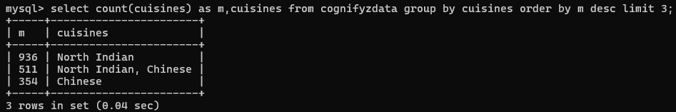

Calculate the percentage of restaurants that serve each of the top cuisines

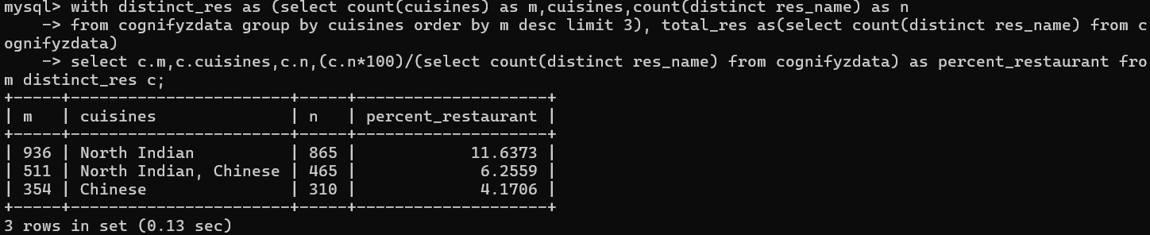

27-12-24

Task 2

Identify the city with the highest number of restaurants in dataset.

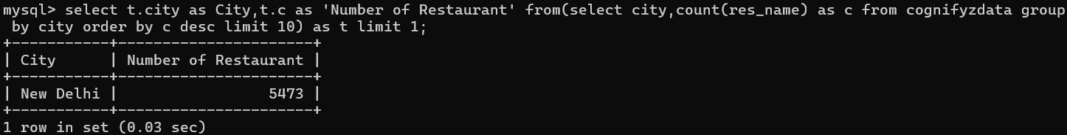

Calculate the average rating for restaurants in each city.

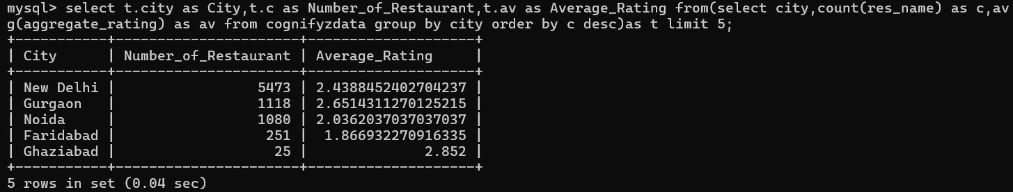

Determine the city with the highest average rating.

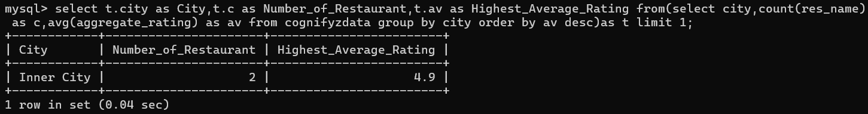

Task: 3

Task: Price Range Distribution

Create a histogram or bar chart to visualize the distribution of price ranges among the restaurants.

Calculate the percentage of restaurants in each price range category.

Task 4

Task: Online Delivery

Determine the percentage of restaurants that offer online delivery.

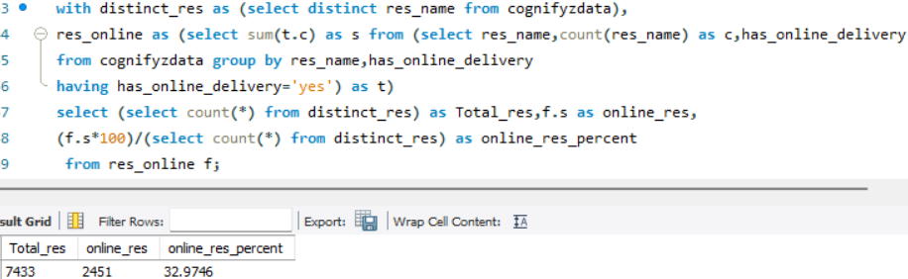

Compare the average ratings of restaurants with and without online delivery.

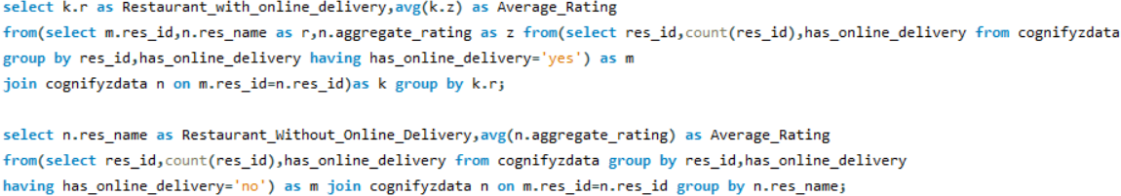

This query is not fully completed