Solution Architecture – Intranet renewal
Proposed target-state architecture for the Architecture Review Board
Date: November 2, 2026
Version: 0.1 draft for review
Author: Enterprise Architecture
Branch: Enterprise Architecture

Document control

Version history
Version | Date | Author | Change
0.1 | 2026-11-02 | Enterprise Architecture | Draft for review

Approval
Name | Title | Date

Executive summary
The the intranet is a bilingual, on-premises departmental intranet that gives staff one trusted place to find current, owned information in English and French. This document proposes its target-state architecture so the development phase can build on it.
- First release: publish, find, and prove content is current and owned (recorded decision).
- Built from the CMS with the design system, the search engine and self-hosted analytics, on an isolated network (recorded decision).
- Every major part traces to a recorded decision; 19 are recorded, 11 accepted and 8 proposed (Appendix A).
Decision requested: endorse the target-state architecture and its constraints. Detail is refined throughout delivery.

Contents
Right-click here and choose Update Field to build the table of contents.

Overview
The intranet is a bilingual, on-premises departmental intranet that gives staff one trusted place to find current, owned information in English and French. It is built on the CMS with the design system (the design system), search and self-hosted analytics analytics, and it runs on an isolated network built to department security standards, with no external connectivity (recorded decision).
The current intranet is failing: search response time is acceptable but relevance is poor (common queries such as HR policy and pay scales are not findable), remote access (staff reaching the intranet from outside the corporate network, for example when overseas) is poor, bilingual and accessibility support is limited, and there is a real risk of total failure. Replacement is tied to the Digital Experience Platform (the digital experience platform) framework and to Government of Canada accessibility, bilingual and security obligations.
What the first release delivers: publish, find, and prove content is current and owned (recorded decision).

Scope
This is a proposed scope, aligned to the architecture principles, so that:
- enhancements can be added as the project and the product progress
- The project can be gated, closed and handed off in a stable, sustainable manner
In scope for the first release
- The CMS with Recipes, no distribution, built full-stack (recorded decision)
- The design system theme with all assets self-hosted, no CDN (recorded decision)
- Bilingual EN/FR publishing, with parity measured per language
- search with one bilingual index and language-specific fields (recorded decision)
- self-hosted analytics and the content health report: what is stale, and who owns it (recorded decision)
- Recorded video: upload through the CMS, transcoding, in-browser player (recorded decision)
- Automatic archiving of retired content to the records system through the records API, after owner and publisher approval (recorded decision)
- People directory fed nightly from the HR data service
- Offline build pipeline, pre-production alpha, then isolated development, staging and production, accreditation and go-live (recorded decision)
Out of scope for the first release
- The service management tool service catalog sync and the "My Tasks" pattern (a later release)
- Personalization and role-based targeting (a later release)
- On-premises BI tool as the reporting surface (a later release)
- Departmental policy: it has its own site and is not in intranet search
- Live video production: stays on the Communications streaming platform; the intranet links to it (recorded decision)
- BYOD, mobile and tablet: The first release targets managed desktop PCs only (recorded decision)

High Level Requirements
Source: The business requirements dated. Provided Phase shows when the architecture delivers each requirement: The first release is the first release, a later phase is a later phase, and Define means the business requirements asks for a definition, including benefits realization.
The business requirements requirement | Provided Phase | How the architecture meets it | Architecture impact | Refs
Integrated, effective, intuitive search | The first release | The search engine with one bilingual index and language-specific fields, shared taxonomy as facets, zero-result reporting from go-live | Supported | A recorded decision
Quick links dynamic and user-configurable | The first release | Proposed: a per-user list delivered as a personal element outside the shared page cache | Supported | A recorded decision
Clear content ownership with governance workflows and expiry dates | The first release | Named owner and last-reviewed date on every page; review reminders; owner-approved archiving to the records system; nothing migrates without an owner | Supported | recorded decisions, recorded decisions
Analytics built in so you know what people actually use | The first release | The analytics tool joined to the CMS metadata in an IT-owned reporting schema; content health report | Supported | A recorded decision
Effective two-way, interactive features | A later phase | Per-page feedback link in the first release; richer features later | Extension, no major change | P1, P4
Personalized experience with curated news and announcements | A later phase | Deferred to a later release; the shared taxonomy and cache design keep the door open | Extension, no major change | recorded decisions
One-stop-shop to access key information | Define | Search, quick links, people directory and links to systems the intranet does not replace. To refine in delivery: definition and benefits measure | To be defined
New and innovative social collaboration and gamification | Define | Not in the first release scope. To refine in delivery: definition and benefits measure before it is sized | To be defined
Content feedback capabilities | The first release | Per-page "was this useful?" and accessibility feedback link, reported by owner | Supported | P1, P4
Content management workflows with approval processes | The first release | Draft, review, published workflow; tiered publishing authority (Proposed) | Supported | A recorded decision
Automated notifications | The first release | Review reminders and digests through the departmental mail relay; pointer, not payload | Supported | A recorded decision
Lifecycle content management | The first release | Review dates, stale flags, owner decisions, archiving to the records system | Supported | A recorded decision
Data analytics and reporting | The first release | Content health report by audience: executives, Communications, IT | Supported | A recorded decision
Video streaming | The first release | Recorded video in the intranet; live video through the Communications platform | Supported | recorded decisions

Architecture impact. Supported means the proposed architecture already covers it. Extension, no major change means it can be added later on the same architecture. To be defined means the item needs a definition before its impact can be judged.

Growing on the same architecture
Most later items build on the architecture without major change. That is the intent: steady, incremental improvement on a solid base.
Later capability | What in the architecture makes it possible | Architecture impact
The service management tool service catalog and "My Tasks" | The batch integration pattern already used for the people directory | Extension, no major change
Personalization and recommendations | Shared taxonomy on all content; personal elements delivered apart from the page cache | Extension, no major change
Captions drafted on upload | The upload workflow and caption files; the local AI service plugs in through an API | Extension, no major change
Calendar availability beside people | The people directory exists; the source and cache pattern are settled (recorded decision) | Extension, no major change
Other channels, such as signage or a mobile view | The CMS's built-in a read-only content API | Extension, no major change
A BI tool on the reporting data | The reporting schema already joins content and traffic data | Extension, no major change
A content delivery network for video | Video is already packaged as adaptive-stream segments, the form a CDN distributes | Extension, separate project
Social collaboration and gamification | Not yet defined; may need new components | To be defined

Mandatory integrations in the business requirements
The business requirements item | Design in the intranet | Note
Identity management (the identity provider) | A standard sign-in protocol to the identity provider; roles from dedicated security groups | recorded decisions. To refine in delivery: where the identity provider fits
The records system (content lifecycle) | The records API for archiving | A recorded decision
Employee and contractor systems | Nightly batch from the HR data service into the people directory | Privacy Impact Assessment underway
Email system | SMTP relay to the departmental the mail and calendar system | A recorded decision
Logging and auditing systems | One-way security feed to the departmental security platform | A recorded decision
Video platform (vBricks, as-is) | Playback link only | A recorded decision. To refine in delivery: that vBricks is the Communications streaming platform

Optional integrations in the business requirements: ServicePlus, the Learning Management System (LMS), the legacy platform, Software Center and other systems. None is designed yet. The existing batch and link patterns apply, and priority and availability are to be refined in delivery.

Terminology
Term | Plain meaning | Why it matters here
CMS | Software authors use to write, review and publish pages. Here: The CMS | Owns content, translations, owner and review date
Front end / component framework | The code that draws the page in the browser, built from reusable blocks. The design system is the component framework | Build a block accessibly once and every page inherits it
The design system | The Government of Canada design system | Consistent, accessible look. It is built for public sites, so intranet-only patterns need custom components
Single Directory Component | The CMS's way of packaging one component in one folder | How intranet-only components are built and tested
Full-stack vs headless | The CMS draws the page itself, instead of a separate JavaScript app asking the CMS for data | Keeps the CMS's translation, caching and accessibility features (recorded decision)
Recipe | A repeatable bundle of the CMS configuration | Same site, rebuilt identically in every environment
Taxonomy | A controlled list of terms applied to content | One vocabulary shared by CMS, search and analytics
The search engine | The search engine. One bilingual index with language-specific fields | Both languages are searched together, each handled on its own terms
The analytics tool | Self-hosted web analytics | No data leaves the network
Reverse proxy cache | A server in front of the CMS that serves stored copies of pages | Replaces a CDN in the first release (recorded decision)
Part | Something in the architecture that is deployed and run separately, such as the CMS, the search engine or a database. In figures it is a box. It does not mean a software container | Figures show the main parts and how they connect. Where and how each part is hosted is a separate decision (Technology Architecture)
Container | A packaged, immutable unit of software, such as a Docker or the container runtime image. Databases and files are not containers here (recorded decision) | The unit that crosses to the isolated network and is accredited (recorded decision)
Isolated network | A network with no internet connection | Every tool and package must already be inside
Pre-production alpha | Short-lived build and demo environment on the pre-production network | Proves the shape of the solution, not real data or integrations (recorded decision)
Staging | Production-like isolated environment with real data and connections | Where confidence is built before production
Calendar availability | A coarse status from the mail and calendar system (available, busy, out of office) | Deliberately not called presence (recorded decision)
The records system / the records API | The corporate records system and its archiving interface | Where retired content is kept as a record
An archival PDF format | The ISO long-term preservation format | The archive copy of retired pages (recorded decision)
SBOM | A bill of materials listing every component in a release | Evidence for patching and accreditation (Proposed, a recorded decision)
Remote access | Staff reaching the intranet from outside the corporate network, for example when working overseas | Poor remote access is one reason the current intranet is failing
Observability | Being able to tell what a system is doing from the signals it gives out: logs, metrics and, later, traces | The site team sees a fault, in either language, before a user does (section 13, a recorded decision)
One-way feed | A device or path that lets data pass in one direction only. Nothing, including a reply, can pass back | The only way out of the secure zone. It cannot filter, so data is cleansed before it reaches it (recorded decision)
Runbook | A short page for one alert: what it means, what to check, what to do and who to call | Kept in Git beside the alert rule. Not the same as a pipeline runner, the worker that runs pipeline jobs
Service level | A target for how the site should behave, such as page time or search delay | Says what healthy means in numbers. The service owner sets the real targets; the ones shown are examples
Telemetry contract | A versioned file in Git listing the fields, event names, severities and owners of each stream that leaves the zone | Nothing can be sent back, so this file is how the enterprise's needs reach the site team

Solution
One the CMS site, served in English and French, with search, analytics and video built from open-source parts that all run inside the department. Every part traces to a recorded decision.
Part | Choice | Decision
CMS and front end | The CMS, full-stack, the design system theme with self-hosted assets | A recorded decision
Search | The search engine, one bilingual index with language-specific fields | A recorded decision
Analytics | self-hosted analytics, IP anonymized, EN and FR measured separately | A recorded decision
Performance | No CDN; application cache, reverse proxy cache, long-lived static assets | A recorded decision
Signed-in caching | Cache per path, language and role; personal parts delivered separately | recorded decisions
Video | Transcoding to four qualities, an open-source player player, live video by link | recorded decisions, a recorded decision
Archive | An archival PDF format to the records system after owner and publisher approval | A recorded decision
Hosting | Containers; the image is the unit of deployment | A recorded decision
Delivery | Build on the low side, signed artefacts, deploy on the high side | recorded decisions
Delivery method | Small project, waterfall, nine evidence-based payment milestones | recorded decisions

Architecture principles
Six principles guide the proposed architecture. The proposed scope is aligned to them, so enhancements can be added without rework.
Principle | What it means | How the architecture applies it
P1 Accessible by default | Accessibility is a build requirement, checked automatically, never a fix applied at the end | The accessibility standard (which includes WCAG 2.1 AA) is pass/fail; automated accessibility checkers in the build; scheduled crawls of live English and French pages; accessible video player; status never carried by colour alone
P2 Bilingual parity, provable | English and French are equal at every layer, and the system can prove it at any time | Linked English and French page pairs; both languages released together; search handles both with language-specific fields; every measure counted per language
P3 Automated | Where a task repeats, the system does it; people decide | Workflow states, scheduled publishing, review reminders and stale flags; infrastructure and configuration as code; build, test and patch in the pipeline. Automation flags content; it never removes it
P4 Transparent | Anyone who publishes can see how their content is doing, without asking | Owners see their own pages, Communications the whole site, executives a roll-up by division; reports are aggregate and self-service
P5 Secure by design for an isolated network | Security is built into every layer, assuming any one layer can fail | Single sign-on through the identity provider; roles from dedicated security groups; audit logs; deploy-only production; the narrowest rights on other systems
P6 Extensible, not headless | The intranet can feed other channels later without a rebuild | The CMS renders the pages and also exposes a read-only content API; components update independently; documented integration contracts; a plugin interface where a supplier may change

Patterns. Four patterns show how the principles are applied in practice: measuring each language on its own (PAT-011), checking accessibility at every gate (PAT-013), publishing a status page (PAT-015) and delivering one ranked queue (PAT-016). They are in section 5.4, Key patterns.
Constraint to manage: the design system the CMS theme loads CSS and JavaScript from the design system CDN by default. That breaks on the isolated network. Every external reference, including fonts and icons, must be inventoried and replaced with a self-hosted copy (a recorded decision, the work plan).
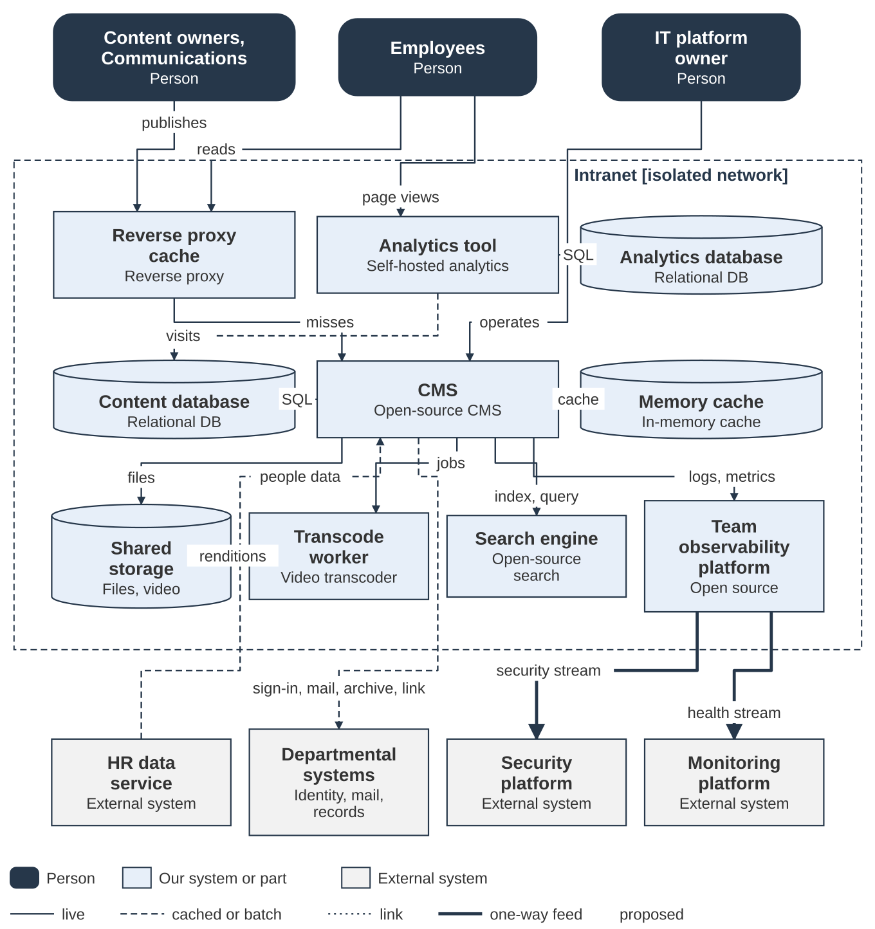
Figure 1. Logical architecture: main parts and their connections
How to read Figure 1. Each box is a part: something deployed and run separately. It does not mean a software container. An arrow points from the caller to the part it calls. A solid line is a live call, a dashed line is cached or batch, a dotted line is a link, and a thick line is a one-way feed. Each box names its technology and the decisions behind it.
The parts in Figure 1
Part | What it does | Owner | Decisions
Reverse proxy cache | Serves stored page copies keyed by path, language and role; no CDN in the first release (recorded decision). Purges by cache tag, per language, when content is published. | IT platform owner | —
CMS | One application for pages, workflow, translation, media and access control, with the design system theme built as single directory components (recorded decision). Every item carries an owner and a last-reviewed date, and both languages are released together. Reads people data nightly, asks the mail and calendar system for availability through a cache, and archives retired content to the records system. | IT platform owner | —
Search engine | One bilingual index with language-specific fields and a language field on every item (recorded decision). Per-language indexing lag, document counts and zero-result rate are reported. | IT platform owner | —
Analytics tool | Self-hosted; IP addresses anonymized; English and French measured separately (recorded decision). Video plays are sent as events, per video and per language. | IT platform owner | —
Analytics database | Holds raw visit data; retention is set in a recorded decision. | IT platform owner | —
Content database | Content, revisions in both languages and the people directory; primary and replica in production. | IT platform owner | —
Reporting schema | IT-owned schema that joins content metadata with traffic each night; neither the CMS nor the analytics tool owns the join. | IT platform owner | —
Memory cache | The CMS cache store and the short-lived availability cache (recorded decision). | IT platform owner | —
Shared storage | Uploaded files and video renditions; renditions never change once made, so they cache well (recorded decision). | IT platform owner | —
Transcode worker | Queue worker that makes four renditions of each upload with the transcoder (recorded decision). A modern codec with an a widely supported codec fallback is proposed in place of an older codec (recorded decision). | IT platform owner | —
Team observability platform | A small platform inside the secure zone for the site team. It stores logs and metrics, runs health probes from inside, and gives dashboards and alerts, with English and French side by side (recorded decision). The CMS, the search engine, the cache and the analytics tool send it logs and metrics through a local forwarder. It is not a security platform. It feeds the two one-way feeds as separate streams: security events, and health metrics with no personal detail (recorded decision). | IT platform owner (role not yet assigned) | —
Content health report | Scheduled report built from the reporting schema, with five measures each counted per language. Delivered to owners, Communications and executives without anyone asking IT. | Communications | —
Identity provider | A standard sign-in protocol through the CMS a standard sign-in protocol module is the only sign-in route; the CMS's own login is blocked apart from one break-glass administrator (recorded decision). Roles come from dedicated security groups, mapped at every sign-in (recorded decision). | The identity provider team | —
HR data service | Supplies HR and contractor data for the people directory as a nightly batch (recorded decision). A minimum set of work-contact fields; a Privacy Impact Assessment is under way. | The HR data service team | —
Mail and calendar system | Mail relay for review reminders and digests; messages point to a page and never carry content (recorded decision). Availability service read through a queue worker: status only, cached, never fetched while a page renders (recorded decision). | Messaging team | —
Records system | Receives retired content through the records API after owner and publisher approve (recorded decision). Both language versions go as an archival PDF format with the original HTML and metadata; the page is unpublished only after the records system confirms receipt. | Records (Information Management) | —
Streaming platform | Live events stay on the Communications platform; the intranet publishes the playback link only (recorded decision). | Communications | —
Security platform | Receives security events on a one-way feed that carries identifying detail (recorded decision). | Security operations | —
Monitoring platform | Receives health and logs on a one-way feed that carries no identifying detail (recorded decision). | Network operations | —

How the parts connect
From | To | What happens | Protocol | Mode | Decisions
Employees | Reverse proxy cache | Reads pages | HTTPS | live | —
Content owners and Communications | Reverse proxy cache | Authors and publishes | HTTPS | live | —
Employees | Analytics tool | Reports page views | HTTPS | live | —
IT platform owner | CMS | Operates and patches (admin interface) | HTTPS | live | —
Reverse proxy cache | CMS | Forwards cache misses | HTTP | live | —
CMS | Identity provider | Signs users in and maps roles | A standard sign-in protocol | live | —
CMS | Search engine | Indexes content and runs searches | Search API | live | —
CMS | Content database | Reads and writes content | SQL | live | —
CMS | Memory cache | Stores render cache | Cache protocol | live | —
CMS | Shared storage | Stores files and video | File access | live | —
CMS | Transcode worker | Queues video jobs | Queue | live | —
Transcode worker | Shared storage | Writes four renditions | File access | live | —
Content database | Reporting schema | Provides content metadata nightly | Nightly batch | batch | —
Analytics tool | Reporting schema | Provides visits nightly | Nightly batch | batch | —
Analytics tool | Analytics database | Stores visit data | SQL | live | —
CMS | Mail and calendar system | Sends review reminders | Mail relay (SMTP) | live | —
CMS | Mail and calendar system | Reads calendar availability (status only) | Availability service | cached | —
CMS | Records system | Archives retired content after approval | The records API | live | —
HR data service | CMS | Supplies the people directory | Nightly batch | batch | —
CMS | Streaming platform | Links to live events | Link | link | —
Team observability platform | Security platform | Sends the security stream | One-way feed | one-way | —
Team observability platform | Monitoring platform | Sends the health stream, metrics only | One-way feed | one-way | —
CMS | Team observability platform | Sends logs and metrics | Local forwarder | live | —
Team observability platform | Observability data store | Stores logs and metrics | Store API | live | —
Health probes | Team observability platform | Sends health checks every minute | Local call | live | —

Staff reach the CMS through a reverse proxy cache. The CMS uses search, analytics, storage and the department's own systems, and only two one-way feeds leave the network.

Current state
Today the intranet is the legacy platform: A web front end serving intranet sites and pages, application services for search, profiles and metadata, the legacy content databases, and the identity provider sign-in. It is not connected to a security platform (security platform, vulnerability scanning), a monitoring platform (health, logs, alerts) or an analytics platform (usage, search insights).
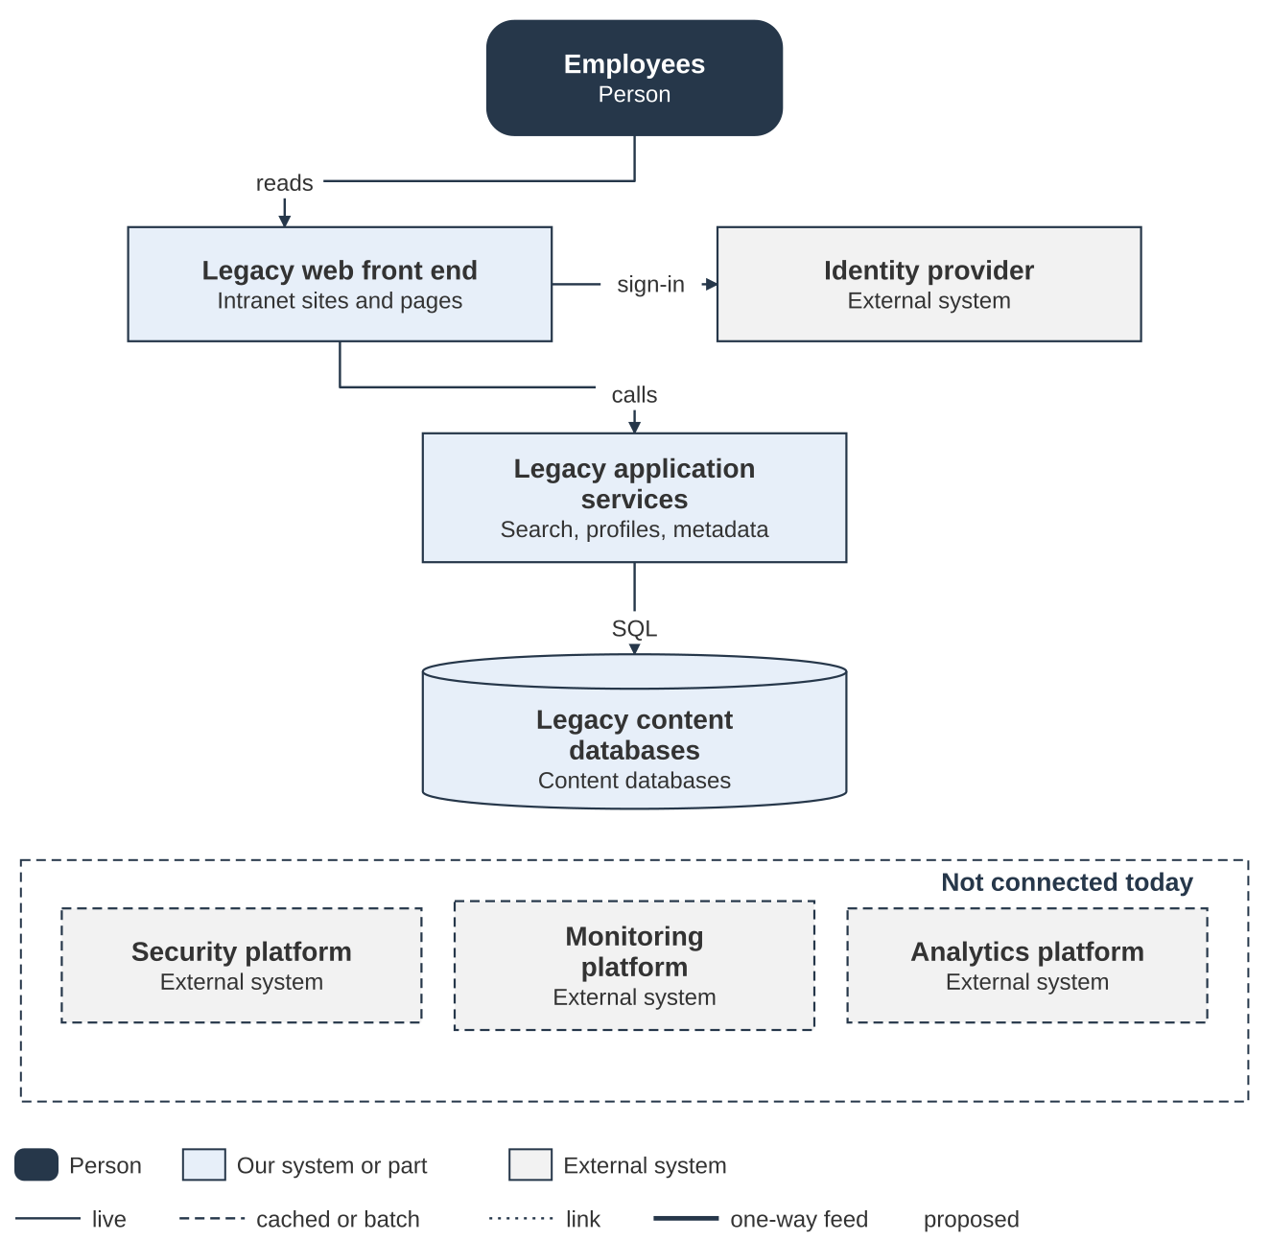
Figure 2. Current state: The legacy platform and what is not connected
Figure 2 in detail. The table says what each part does today and what replaces it or connects it in the target state.
Today | What it does and its limits | In the target state
Legacy web front end | Serves intranet sites and pages; not patched or enhanced since launch. Configuration is left alone for fear of an unrecoverable failure. | Replaced by the CMS, built full-stack with the design system theme (recorded decision).
Legacy application services | Search response time is acceptable but relevance is poor: results include retired platforms, and common queries such as HR policy and pay scales are not findable. | Replaced by the CMS workflow and the search engine, one bilingual index (recorded decision).
Legacy content databases | Holds the current intranet content. | Replaced by the content database and the IT-owned reporting schema (recorded decision).
Identity provider | Staff sign in to the web front end. | Sign-in continues through the identity provider, now by a standard sign-in protocol (recorded decision).
Security platform | Not connected today. | Connected by a one-way security feed (recorded decision).
Monitoring platform | Not connected today. | Connected by a one-way health and logs feed (recorded decision).
Analytics platform | No usage or search insight is available today. | The analytics tool measures use, with English and French counted separately (recorded decision).

The platform has not been patched or enhanced since launch. Its configuration is left alone for fear of a failure with no way to recover. Search response time is acceptable, but relevance is poor: results include platforms that no longer exist, and common queries such as HR policy and pay scales are not findable.

Target state: integrations
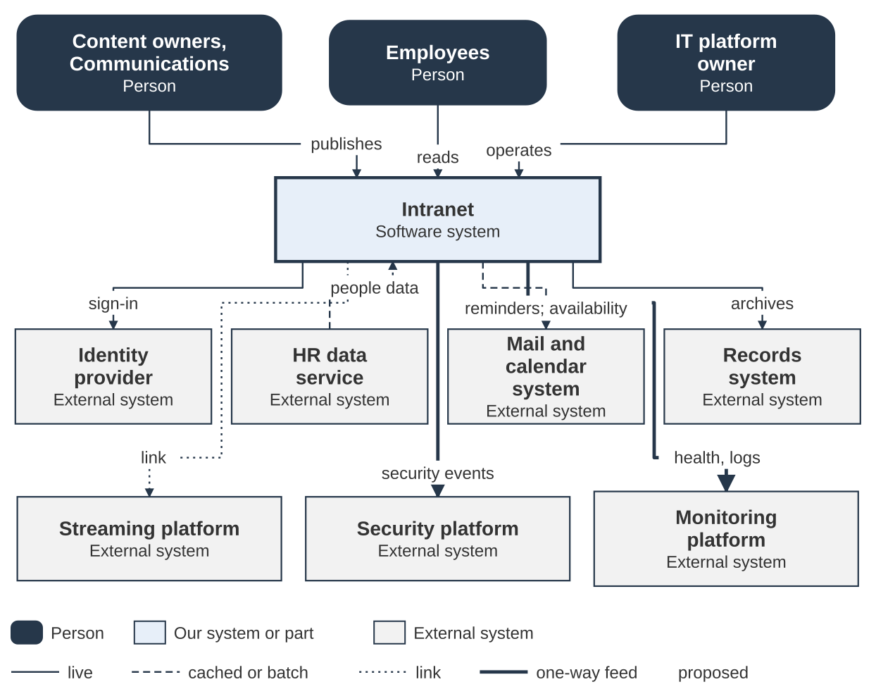
Figure 3. System context and integrations
Figure 3 in detail. The first table lists every connection in the figure. The second says what each outside system provides or receives and who owns the other side.
From | To | What happens | Protocol | Mode | Decisions
Employees | The intranet | Reads pages, searches, watches video | HTTPS | live | —
Content owners and Communications | The intranet | Authors, reviews, publishes and retires content | HTTPS | live | —
IT platform owner | The intranet | Operates and patches the platform | HTTPS | live | —
The intranet | Identity provider | Signs users in and maps roles | A standard sign-in protocol | live | —
HR data service | The intranet | Supplies the people directory | Nightly batch | batch | —
The intranet | Mail and calendar system | Sends review reminders | Mail relay (SMTP) | live | —
The intranet | Mail and calendar system | Reads calendar availability (status only) | Availability service | cached | —
The intranet | Records system | Archives retired content after approval | The records API | live | —
The intranet | Streaming platform | Links to live events | Link | link | —
The intranet | Security platform | Sends security events | One-way feed | one-way | —
The intranet | Monitoring platform | Sends health and logs | One-way feed | one-way | —

Outside system | What it provides or receives | Owner of the other side
Identity provider | A standard sign-in protocol through the CMS a standard sign-in protocol module is the only sign-in route; the CMS's own login is blocked apart from one break-glass administrator (recorded decision). Roles come from dedicated security groups, mapped at every sign-in (recorded decision). | The identity provider team
HR data service | Supplies HR and contractor data for the people directory as a nightly batch (recorded decision). A minimum set of work-contact fields; a Privacy Impact Assessment is under way. | The HR data service team
Mail and calendar system | Mail relay for review reminders and digests; messages point to a page and never carry content (recorded decision). Availability service read through a queue worker: status only, cached, never fetched while a page renders (recorded decision). | Messaging team
Records system | Receives retired content through the records API after owner and publisher approve (recorded decision). Both language versions go as an archival PDF format with the original HTML and metadata; the page is unpublished only after the records system confirms receipt. | Records (Information Management)
Streaming platform | Live events stay on the Communications platform; the intranet publishes the playback link only (recorded decision). | Communications
Security platform | Receives security events on a one-way feed that carries identifying detail (recorded decision). | Security operations
Monitoring platform | Receives health and logs on a one-way feed that carries no identifying detail (recorded decision). | Network operations

The new intranet reads from three systems and sends to five, two of them one-way feeds. Each integration is kept small and bounded, using a batch, a cache, a link or one API call, so a change on the other side cannot break the intranet. Policy stays on its own site and is linked only. Sizing and deployment are described in section 9.

Key patterns
A pattern is a repeatable way of building something. A principle says why, a decision says what was chosen, and a pattern says how, so the same problem is solved the same way each time. Four patterns are described here. They support the business requirements points Trust it and Know what works, and they give later phases (Grow into it) a repeatable way to build and measure new features.
Pattern | What it does | The business requirements point | Principles
PAT-011 Measure each language on its own | Every number is shown for English and French side by side, so a gap cannot hide in a total | Know what works | P2, P4
PAT-013 Check accessibility at every gate | Automated checks where themes and templates are built, and where content is published, plus scheduled checks of live pages | Trust it | P1, P2, P3
PAT-015 Publish a status page | A page, served apart from the site, shows staff whether each feature they use is working | Trust it, Know what works | P1 to P5
PAT-016 Deliver one ranked queue | One prioritized list per person, in views for owners, managers and the product owner, with bulk decisions | Trust it | P3, P4

PAT-011 Measure each language on its own
The rule. Record the language of every page, event and record. Report every measure for English and French side by side, with the gap. Never report one total or one average. This gives the bilingual principle (P2) a proof: numbers, in both languages, on an ongoing basis.
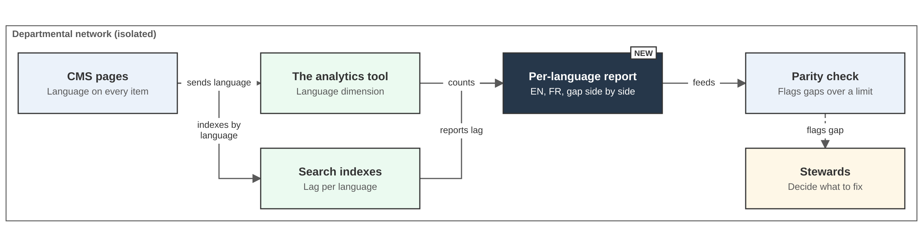
Figure 6. PAT-011: language is a dimension on every page and event
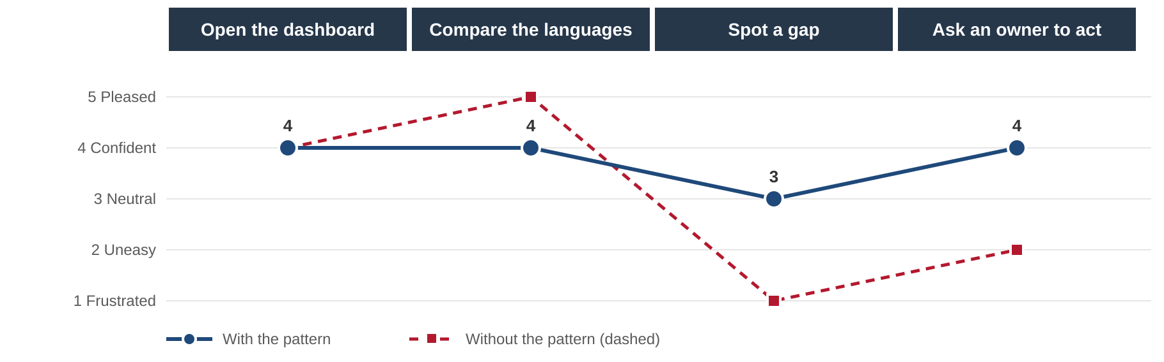
Figure 7. PAT-011 journey map: An executive checks the languages, with and without the pattern
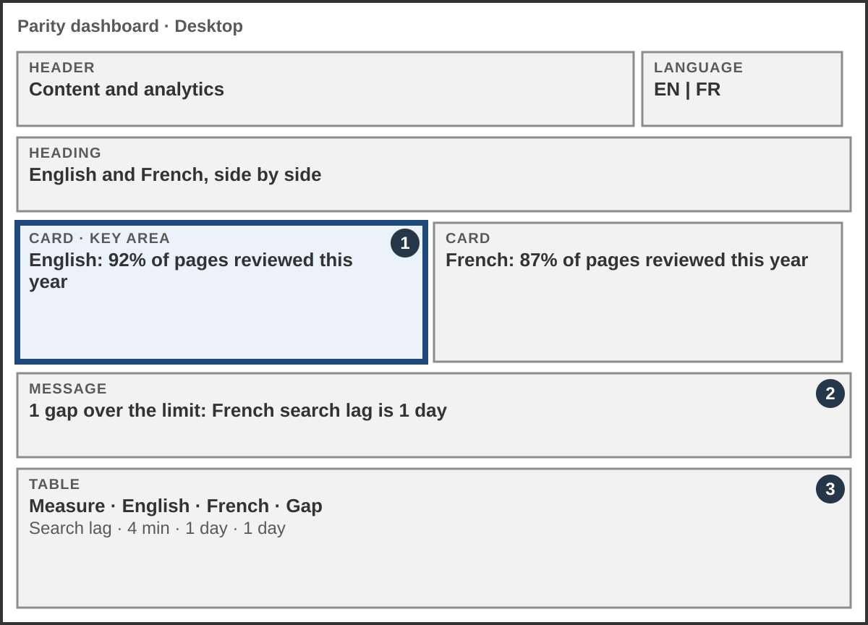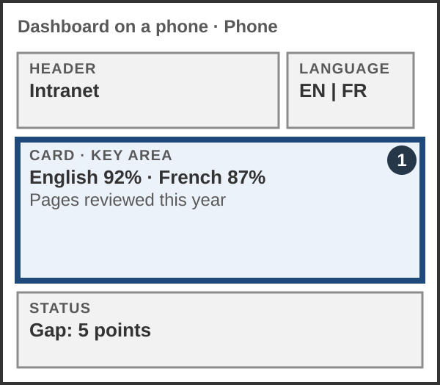
Figure 8. PAT-011 mock-ups: The parity dashboard on a desktop and on a phone
Applies. Principles P2 and P4.
When this comes up. The department must prove it is bilingual and unbiased on an ongoing basis (P2), and proof needs numbers in both languages. Totals are easy to produce and they hide the problem. Many measures exist: page counts, freshness, search lag, search success, accessibility results, traffic and flags.
What pulls in different directions. A simple dashboard against an honest one. One shared definition against each team's own count.
Who sees what. Executives see a one-page view of both languages and the gap. Communications sees which pages or terms cause a gap. IT sees search and processing lag per language. Nothing is changed automatically: The parity check flags a gap and the stewards decide what to fix.

PAT-013 Check accessibility at every gate
The rule. Run an automated accessibility gate on both sides of the work: The build side (themes and templates) and the content-authoring side (publishing). A scheduled check of the live English and French pages follows. People test what tools cannot. A tool never removes live content; a person decides. This applies a recorded decision and principle P1.
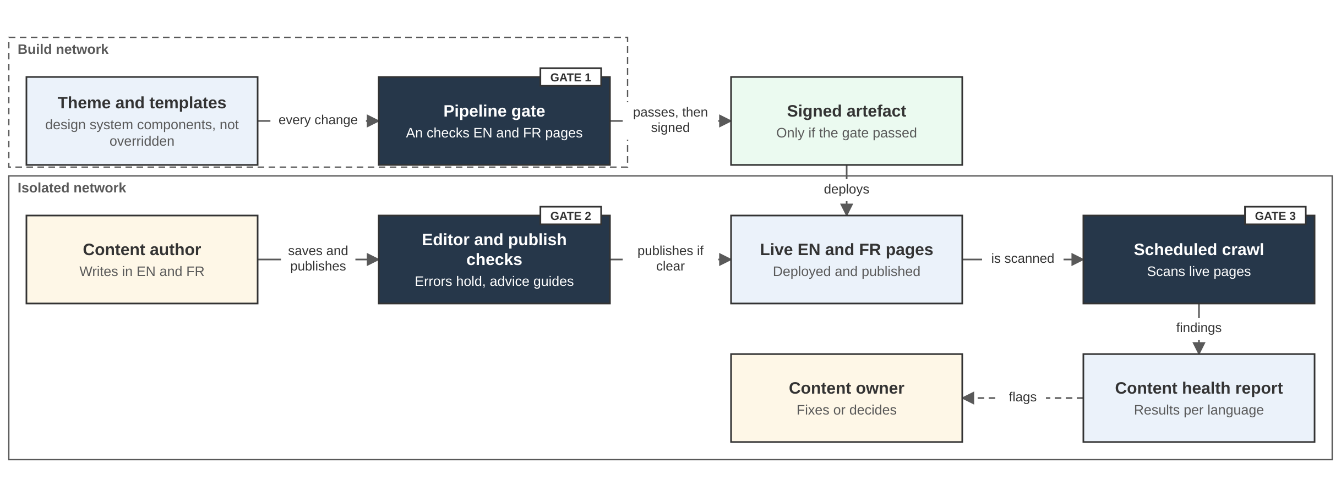
Figure 9. PAT-013: automated gates on the build side and the content-authoring side
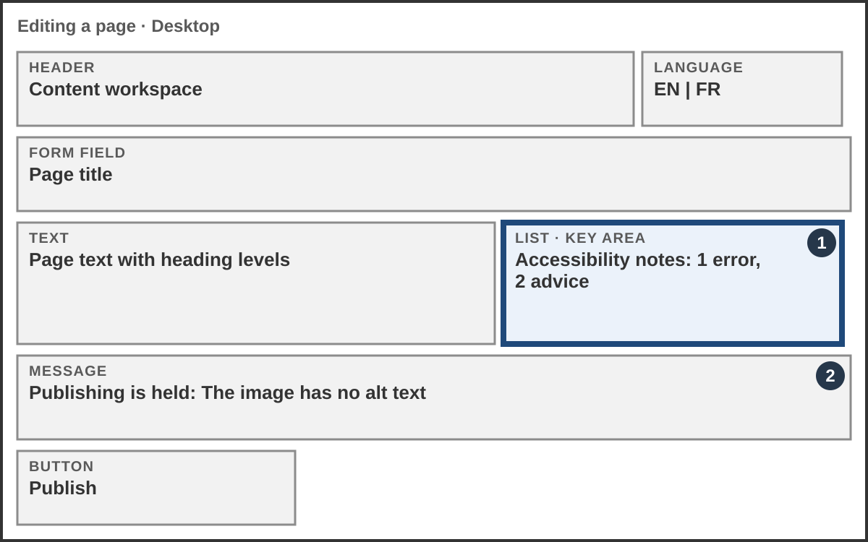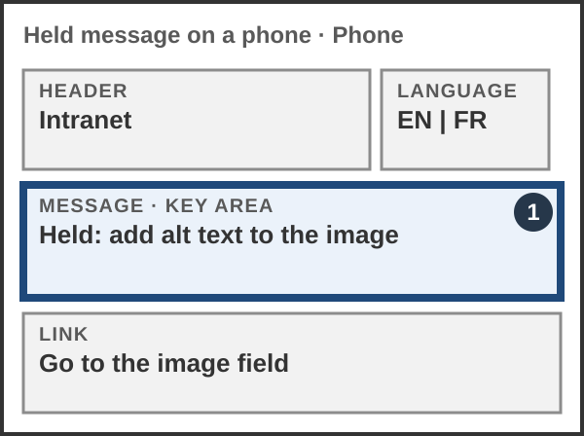
Figure 10. PAT-013 mock-ups: The author is told what to fix before publishing
Applies. Principles P1, P2 and P3.
When this comes up. WCAG 2.1 AA is pass or fail. Problems arrive from two sources: code (templates, theme, components) and content (images, headings, links, documents, video). A check on only one misses half. Content changes every day, so a site that passed at go-live can fail next month, and French pages can fail in ways English pages do not. Automatic tools find only part of the problems, so people, including people who use assistive technology, test the rest.
What pulls in different directions. Strict gates against authors who need to publish. Automatic speed against human judgment. One shared standard against two languages with different text lengths.
Build side. Every change to a theme or template runs through a pipeline gate. The design system components are used, not overridden, and an accessibility checker scans English and French pages. Only a build that passes is signed and moved to the isolated network.
Content-authoring side. When an author saves or publishes, editor and publish checks hold errors and give plain advice. Errors hold publishing; advice does not. Each finding on live pages has an owner who fixes it or decides.

PAT-015 Publish a status page
The rule. List each staff-facing feature in everyday words, with one status from a fixed set of values, set by automated signals and explained by a short note from a named owner, in English and French. Serve the page apart from the site it reports on, so it still loads when the site does not. Do not rely on a banner inside the main site: it goes down with the site. This is how the transparency principle (P4) is applied to the system itself, so the product shows its own status.
Applies. Principles P1 to P5.
When this comes up. When search, sign-in or the calendar view stops working, staff do not know whether it is them, their browser or the platform. Each person who cannot tell calls or emails the help desk, and the same question is asked many times. The team has the facts (logs, heartbeats, checks) but no simple place to share them with staff.
What pulls in different directions. Telling staff early against not publishing a guess. Plain feature names against the technical names the team uses. A page that stays up when the site is down against one more thing to run. Automatic status against a person who can explain what staff should do.
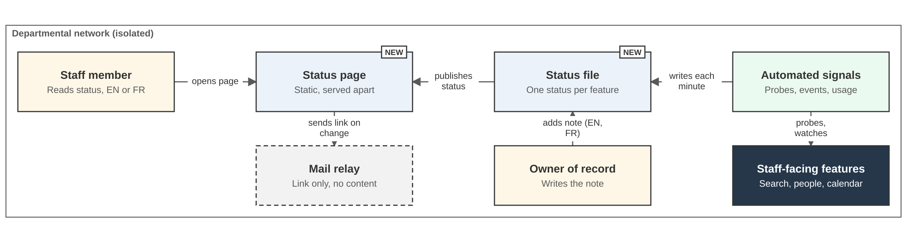
Figure 11. PAT-015: A status page served apart from the main site
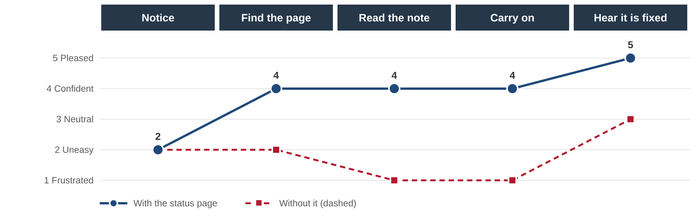
Figure 12. PAT-015 journey map: A staff member whose search stops working
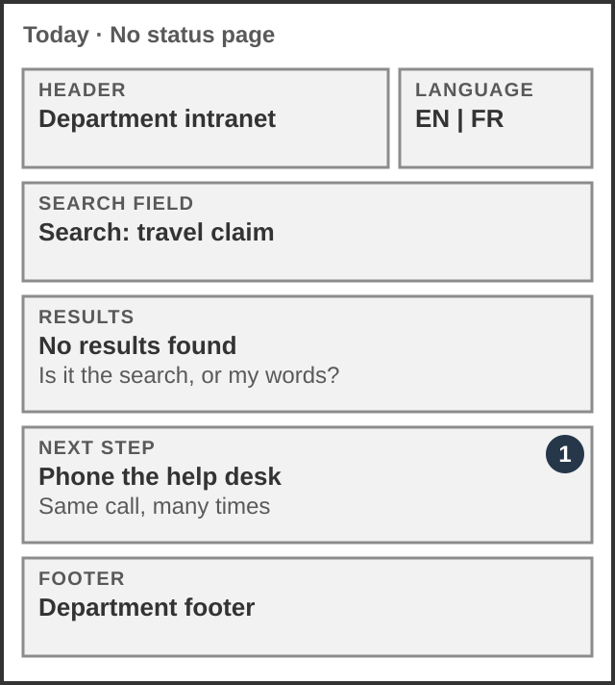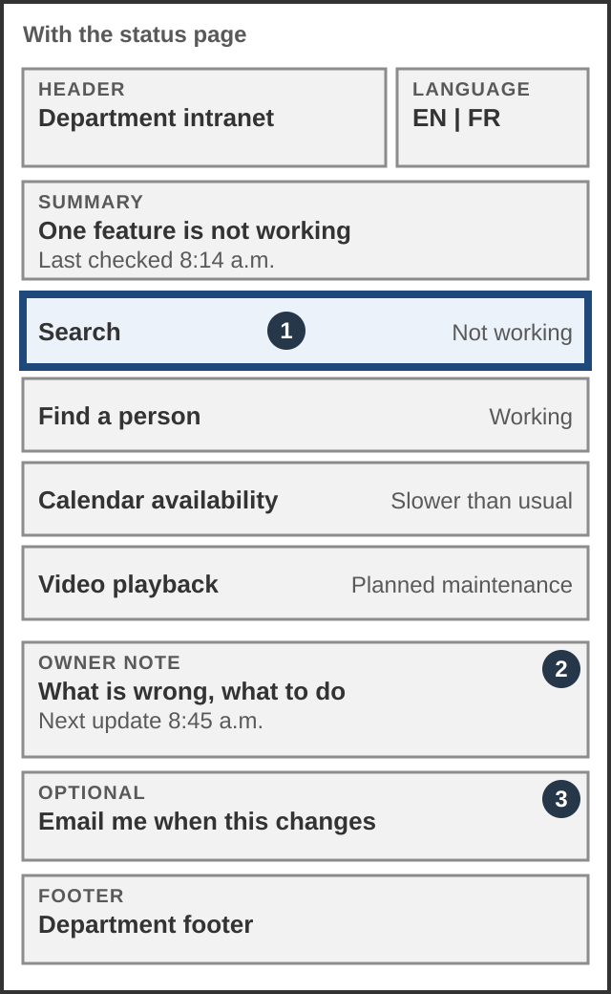
Figure 13. PAT-015 mock-ups: today, and with the status page
Figure 14. PAT-015 status page: the suite of services, shown with five example features
Feature | Status | What it means for you | Past 30 days
Search | ✕ Not working | Search is returning no results. We are looking into it. For now, browse the directory by topic. Next update 8:45 a.m. | Last 30 days: 29 days working, today not working
Find a person | ✓ Working | No known problem. | Last 30 days: working every day
Calendar availability | ▲ Slower than usual | Availability can be a few minutes old. Next update 9:30 a.m. | Last 30 days: 26 days working, 4 slower than usual
Video playback | ■ Planned maintenance | Planned maintenance on Sunday, 2 a.m. to 4 a.m. | Last 30 days: working every day
Usage reports | ? Not known | We have not heard from the reporting check since 7:50 a.m. Numbers may be incomplete. | Last 30 days: working, but unknown since 7:50 a.m.

How to read the status page. Each feature is named in everyday words and has one status from a fixed set: Working, Slower than usual, Not working, Planned maintenance and Not known. Colour is never the only signal: each status has a word, a symbol and a border style. Not known appears when the automated check has not reported, so the page never guesses. A named owner writes the plain note in English and French, and the 30-day history shows whether a problem is new or recurring. The five features above are examples that show the concept, not final content.

PAT-016 Deliver one ranked queue
The rule. Give each person one ranked list of what is waiting on them, not one message per flag. Show it in three views of the same data: content owners see their own pages, managers see their team's, and the product owner sees the whole site by branch. Let people apply one decision to many items at once, and log every decision. Use the same data as the content health report. Notifications carry a link to the queue, not the content (recorded decision). This is the people side of principle P3: The system flags, and people decide.
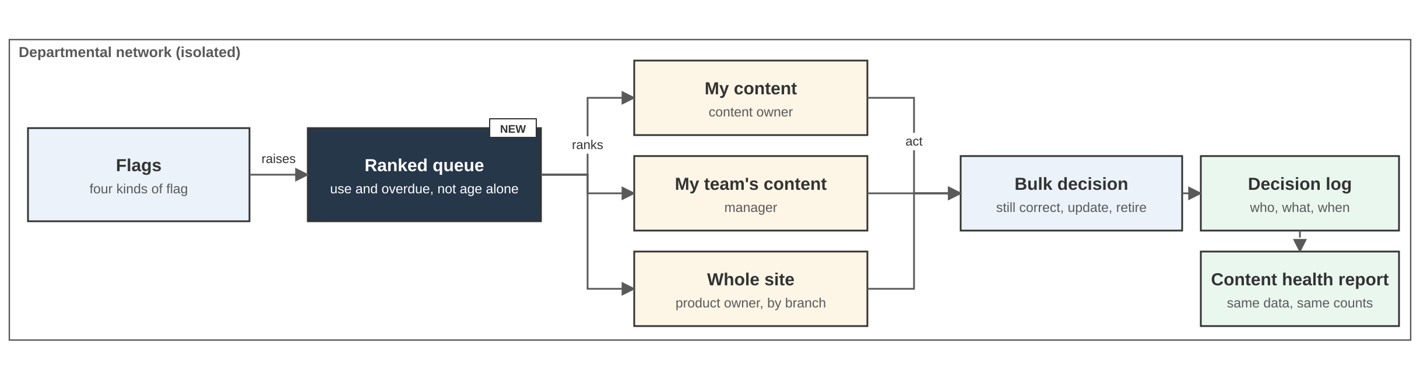
Figure 15. PAT-016: flags feed one ranked queue, with three views and bulk decisions
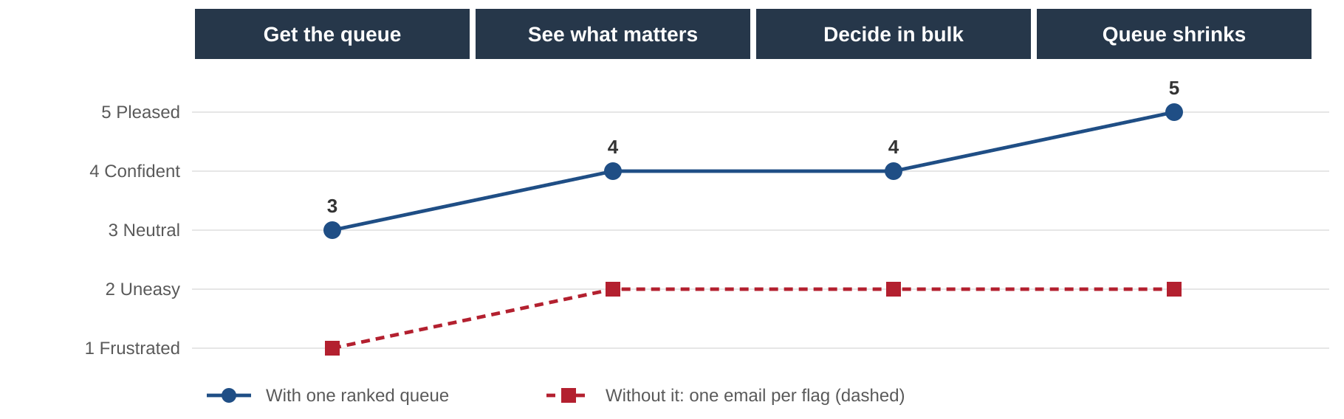
Figure 16. PAT-016 journey map: A content owner clears their queue
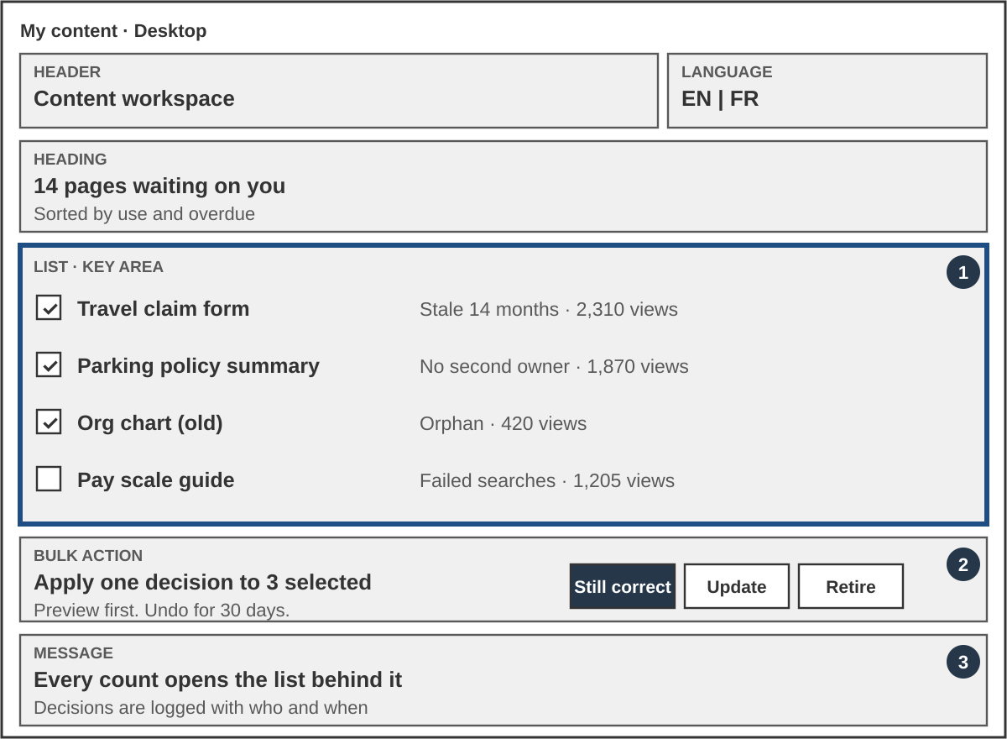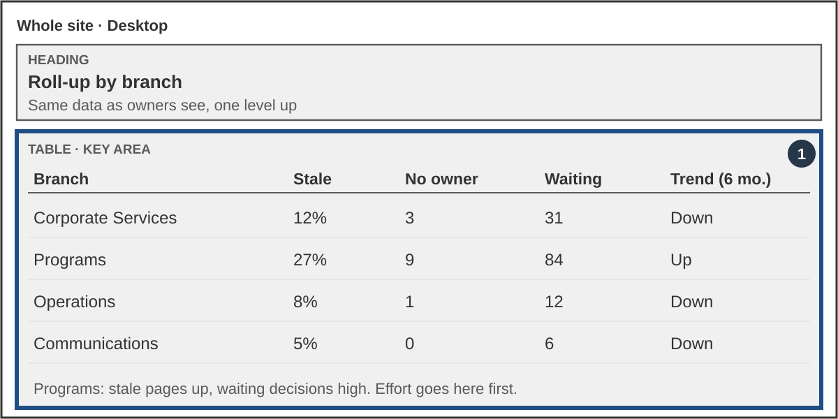
Figure 17. PAT-016 mock-ups: The owner queue with bulk decisions, and the roll-up by branch
Applies. Principles P3 and P4. Supports the business requirements point Trust it.
When this comes up. Flags help only if people act on them. A separate notification for each flagged page is noise, and people learn to ignore it. A long, unranked list has the same effect. Many items need the same quick decision: still correct, update or retire.
What makes the queue useful.
- Ranking: priority reflects how many people use a page as well as how overdue it is. A rarely read old page can wait.
- Grouping: similar decisions are batched so they can be made together.
- Bulk actions: select several items and apply one decision. The most common answer takes seconds. Each action shows a preview and can be undone.
- Honest roll-ups: header counts show whether the backlog is growing or shrinking, and every count opens the list behind it.
- One source of truth: owners and managers see the same numbers at different levels, so there is no dispute about the figures. The content health report uses the same data.
- A short queue: A queue that stays long is a sign that thresholds or page volume need attention.
What pulls in different directions. Bulk speed against careful review. Ranking by use against pages that matter but are rarely read. One shared queue against each team's own list.
Role | View | What they do
Content owner | My content: The pages they are responsible for, with ranked tasks | Decide to keep, update or retire
Manager | My team's content: The same data plus ownership | Spot overloaded people or stalled piles, and rebalance
Product owner | Whole site: A roll-up by branch | Direct effort to where the problems are largest

Observability
The site gets its own observability platform inside the secure zone, beside the two one-way feeds. It watches the CMS, the search engine, the cache and the analytics tool, per language, and every alert has a runbook. It feeds the two existing one-way feeds as separate streams (recorded decision). Full detail, a diagram and a dashboard mock-up are in section 13. Decision: A recorded decision.

Business Architecture

Business value
What is forcing the change (drivers):
Driver | What it means
Catastrophic failure risk | Poor search relevance, poor mobile and remote access, limited bilingual and accessibility support, real risk of total failure
Strategic alignment | Replacement is a business outcome tied to the Digital Experience Platform (the digital experience platform) framework
Regulatory compliance | Government of Canada accessibility, bilingual and security standards (WCAG, departmental security controls)
Technological obsolescence | Existing platforms cannot support current or future digital communication needs

What the department wants (goals):
Goal | How the intranet delivers it
Improved productivity | Faster discovery through search, quick links and consistent templates
Stronger security posture | Isolated, standards-based deployment, signed artefacts, configuration as code
Accessibility and inclusion | WCAG 2.1 AA tested in the build and again after publishing, in both languages
Lower total cost of ownership | Standard platform, reusable components, open-source parts, community support
Better analytics and governance | Content health report, owner-based publishing, lifecycle with archiving
Engagement and communication | Alignment with ExCom policy to improve employee engagement

When each group starts to win (Proposed, from the stakeholder value paper):
Group | Wins at | What they get
Communications | Go-live | Publishing, editorial control in both languages, taxonomy governance
Information Management | Go-live | Automatic archiving of retired content to the records system as bilingual an archival PDF format
Security | Go-live | Infrastructure as code, configuration as code, signed build, evidence for accreditation
IT Operations | Go-live | Automated pipeline, no manual deploys, containers
Employees | Go-live | Searchable, bilingual, accessible, current content
Executives and leadership | First release after go-live | Content health dashboard: what is stale and who owns it

Users and use cases
User | Main need
Employee | Find current information in English or French; find a colleague; watch a video
Content owner and author | Publish, keep current, decide to keep, refresh or retire
Reviewer and publisher (Communications) | Check, approve and release both languages together
Executive | See content health by division
IT platform owner and the analytics tool owner | Run, patch and measure the platform
Information Management | Receive retired content as a record
Security Authority | Accredit and audit

# | Use case | Result
UC1 | Search in EN or FR | Relevant results in the chosen language; zero-result searches reported
UC2 | Use quick links | A personal, configurable list (Proposed)
UC3 | Find a colleague | Name, title, branch, location, contact from the nightly directory feed
UC4 | Watch a recorded video | Plays in the browser at a quality that suits the connection, with EN and FR captions
UC5 | Publish a page | Draft, review, publish; both languages released together; owner and taxonomy required
UC6 | Keep content current | Reminder to the owner at the review date; owner decides keep, refresh or retire
UC7 | Retire content | Owner and publisher approve; both languages archived to the records system; old address shows an archived notice
UC8 | See content health | Reports by owner, language and topic for executives, Communications and IT
UC9 | Prove bilingual parity | Pages, search lag and traffic counted per language
UC10 | Give accessibility or content feedback | Per-page link to the department's feedback process

Operating model
Status: proposed, not confirmed. The roles below are hypothetical. They are based on the anticipated resources in the project plan and describe the work that has to be done once the intranet is live. They are not approved posts.
Service model. The IT web team provides the site as a service. Communications uses it to serve clients and staff. The aim is a site that stays fresh through automated lifecycle and disposition workflows, without heavy manual oversight. Two existing management roles carry accountability: The business owner for content, and the IT service owner for the platform.
Anticipated resources. Nine positions are anticipated: six in Communications and three in IT development. None is in place today. The staffing target is the staffing target date and is assessed as high risk. Five of the nine are needed before that date, and two of them in week 2 of the project, when the content architecture workshops run.
Hypothetical role | What the role does | Anticipated position
Content manager (lead) | Leads the content function, sets publishing tiers, works the review queue, onboards content owners | Communications
Taxonomy and information architecture steward | Owns the shared taxonomy used by the CMS, search and analytics | Communications
Designer and design system steward | Look, layout and components; keeps the theme true to the design system | Communications
Digital analytics lead | Reads the measures and brings the evidence to owners and executives | Communications
Content authors and publishers (two, bilingual) | Load, publish and keep content current in both languages | Communications
CMS developers (two, one the technical lead) | Build and change the site; configuration as code; release through the pipeline | IT development
analytics platform owner | Runs the analytics tool platform and its instrumentation | IT development
Platform administrator | Patches and runs the CMS, the search engine, the cache and containers; backups; monitoring; owns the team observability platform and its runbooks (section 13) | Not covered by the nine positions: A new post or named IT operations capacity

Taxonomy and accessibility. The link is indirect. Without a taxonomy steward, category and label terms drift, English and French terms fall out of step, and search and menus get harder to use. People who rely on screen readers or magnification depend on search and clear navigation more than most. The direct accessibility work sits with the designer, the content authors and the automated checks (PAT-013).
Operating rhythms (proposed). Daily: work the review queue (the ranked queue in PAT-016) and clear flags that are due; the notification digest goes out automatically (recorded decision). Weekly: A digest of upcoming review dates. Monthly: review flag rates by business line and confirm or adjust publishing tiers. On every release: patch and release through the pipeline.
If the roles are not provided or secured. The impact falls on both the project and the product.
Role | Impact on the project | Impact on the product
Content manager and taxonomy steward (needed in week 2) | Content architecture and taxonomy are decided by people who will not live with them, and reversing them later is expensive | Inconsistent categories, weaker search, reports that do not line up; harder navigation for people who rely on search
Designer and design system steward | The theme and component plan slips | Accessibility and consistency slip
Digital analytics lead and analytics platform owner | The analytics model and the analytics tool install are delayed | Reports exist but nobody acts on them; freshness and bilingual parity are not proven
CMS developers | The offline build design and the build are delayed; vendor knowledge transfer has no recipient | The department cannot change or safely patch what it has
Platform administrator | The operations plan and accreditation evidence are incomplete | On an isolated network nothing refreshes itself, so software goes unpatched
Content authors and owners | The content load and English and French parity arrive late | Pages go stale and unowned, and the department pays the migration cost for stale content again

Data Architecture
Answers to the template questions. Where the project has not decided yet, the answer says to be refined in delivery.
Question | Answer
What organizational data constraints were considered? | Data residency (no data leaves the network); department security standards; privacy law and a Privacy Impact Assessment for the people directory; official languages law; accessibility; the departmental retention schedule; ATIP and legal search needs. Addressed by on-premises-only hosting, minimum directory fields, anonymized analytics, bilingual records and the records system for records (recorded decision)
Does the solution add risk from data flowing or persisting in an external system? | No external system holds data. Nothing is sent to a cloud service, CDN or SaaS tracker. Two one-way feeds leave the isolated network through approved controls, with fixed content definitions (recorded decision)
New or replacement data component, and does it fit the Enterprise Data Architecture Target State? | It replaces the current intranet content store and adds an IT-owned reporting schema. It will consume enterprise reference data as appropriate.
Does it duplicate an existing data component? | The people directory holds a minimum copy of the HR data service data, by design, so the intranet keeps working if the HR data service is down. Calendar availability is read from the mail and calendar system, cached for minutes, and never copied elsewhere (recorded decision)
Can the data components be reused? | Yes: The shared taxonomy, the people directory as reference data, the reporting schema, and content through the built-in a read-only content API. AI captioning is a later use case
How is data controlled? | Roles come from dedicated security groups, mapped at sign-in (recorded decision). Access filtering is done in the CMS and applied to search by Search API; the security position on this (F3 in a recorded decision) is accepted as a risk
Is the data tightly coupled to an application? | Content is coupled to the CMS's content model. Exit paths: A read-only content API, and the records system archive of an archival PDF format, original HTML and a metadata file
Has business intelligence been considered? | Yes. The reporting schema joins the CMS metadata to the analytics tool traffic. A BI tool can be added if the benefits warrant integrating the product's analytics with other systems.
What metadata is captured, and can it go to a data catalog? | Owner, last-reviewed date, language, content type and taxonomy terms on every page. The department has no data catalog.
Who is the data steward? | Content owner per page. Taxonomy and IA Steward (Communications, unfilled) for the vocabulary. HR and the HR data service owners for directory data. analytics platform owner (IT, unfilled) and Digital Analytics Lead (Communications, unfilled) for analytics
Is there a data model or dictionary? | Not yet. The shared taxonomy model (the work plan) and the content model (the work plan) are design deliverables

Data flow
Data | At rest | How long | Form | Volume (planning estimate) | Zones crossed
Pages, news, revisions (EN and FR) | The CMS database, primary and replica | Until retired and archived | Structured | Database about 100 GB | Stays in the isolated environment
Files and images | The CMS files directory on departmental shared storage | Same as the page | Unstructured | About 200 GB | Stays in the environment
Recorded video | Shared storage: source plus four renditions | Until the owner retires it; archive keeps source and captions | Media | About 6.5 GB per hour, about 650 GB a year, 2 TB provisioned | Stays in the environment
Search index (bilingual) | The search engine | Rebuildable from the CMS | Index | About 50 GB | Stays in the environment
People directory | The CMS database, fed nightly from the HR data service | Refreshed nightly | Structured personal information | About 4,000 people | The HR data service to the intranet, on the isolated network
Web analytics | The analytics tool's own database | Retention period to be set in a recorded decision | Structured, IP anonymized | About 200 GB | Stays in the environment
Content health data | IT-owned reporting schema | Rebuilt nightly | Structured | Small | Stays in the environment
Calendar availability | The memory cache only | About 10 minutes | Status value | Small | The mail and calendar system to cache, on the isolated network
Archive packages | The records system | Per the retention schedule | An archival PDF format per language, HTML, metadata | Per retired page | The CMS to the records system, on the isolated network
Security and operational feeds | security platform and monitoring platform | Per the departmental schedule | Events and metrics | Continuous | One-way out through approved controls

Zones. The pre-production alpha holds no real content and no personal data. Real data lives only in the isolated staging and production environments, accredited to the same level (recorded decisions). Code crosses the gap as signed artefacts, one way, low side to high side. To refine in delivery: how real content reaches staging (the work plan, a recorded decision E3).
Data quality on ingest. Migrated content is inventoried, given a named owner and a keep, refresh or retire decision, tagged with the taxonomy, and checked for EN and FR parity page by page (recorded decision). New content must pass the bilingual gate and carry mandatory metadata at save (the work plan). Directory data quality depends on the HR data service.
Use and export. Staff read it. Owners and executives see it in the content health report. Retired content leaves for the records system. Nothing is exported to partners.

Application Architecture
What it does. Staff publish and find information in both official languages, and the department can see which content is stale and who owns it.
Does it serve the whole business community, and can it grow? It serves all staff on managed desktop PCs. Content is also available to other channels through the CMS's built-in a read-only content API. Later sites, such as a low-side intranet or a public site, would each be a separate site that reuses this architecture.

Components and how they relate
Component | Role | Relates to
Reverse proxy cache | Serves stored copies of pages, keyed by path, language and role | In front of the CMS; purged by cache tag per language
The CMS with the design system theme and custom components | Pages, workflow, translation, media, access | Database, the memory cache, the search engine, the analytics tool, identity provider
Database | Content, revisions, people directory | The CMS
The memory cache | The CMS cache, availability cache | The CMS
The search engine | Bilingual search index | The CMS Search API
The analytics tool and its database | Page views and video play events | Browser tracking; reporting schema
Reporting schema and content health pipeline | Joins the CMS metadata to the analytics tool traffic nightly | The CMS database, the analytics tool
Transcode worker (the transcoder) | Makes four renditions from each uploaded video | Queue job from the CMS; shared storage
An open-source player player | In-browser playback, captions, 10-second skip | Self-hosted; sends play events to the analytics tool
The build pipeline | Builds, tests, signs; deploys on the high side | Container registries on both sides of the gap

Application type. Highly configurable open-source platform plus targeted custom code: custom Single Directory Components on the design system design tokens, and small integration modules. There is no distribution and no vendor-hosted service.
Maintenance cycle. the CMS advisories run on a weekly cycle and the analytics tool has its own announcements. The IT platform owner watches both. The security operations centre watches the operating system, container base image, PHP, database, the search engine and web server. Patching is a rebuild and a transfer, timed by the enterprise patch standard (recorded decision). The transfer cadence and the emergency patch path are to be refined in delivery with Security (recorded decision).
How the custom parts are built. Composer and npm builds from internal mirrors, the CMS Recipes and configuration as code, custom components tested against the design system updates (the component registry model is Proposed). One existing API is used for archiving (the records API) and standard protocols for the rest. No new external API is created. Skills risk: CMS developers posts are not yet filled, so knowledge transfer from the vendor is a named RFP deliverable.
Can parts be released independently? Yes. The CMS, the search engine, the analytics tool, the cache and the transcoder each run and update on their own. The same image is promoted from development to staging to production, and only configuration differs (recorded decision).

Integrations
System | Why | How | Phase
The identity provider | Sign-on and roles | A standard sign-in protocol; roles from dedicated security groups; one break-glass admin account | The first release
The HR data service (HR and contractor data) | People directory | Nightly batch, minimum fields | The first release
The mail relay | Review reminders and digests | SMTP; no content in the message | The first release
The calendar service | Status beside people | Queue worker writes to cache; page reads cache only; free/busy only | Source confirmed; phase refined in delivery
The records system | Archive retired content | The records API after owner and publisher approval | The first release
Communications streaming platform | Live events | Playback link only | The first release
Policy site | Policy | Link only | Out of scope

Replaces or adds? It replaces the current intranet. To refine in delivery: the decommissioning plan for the old intranet and any integrations it holds. This is not yet a work package in the project plan.

Technology Architecture

System architecture
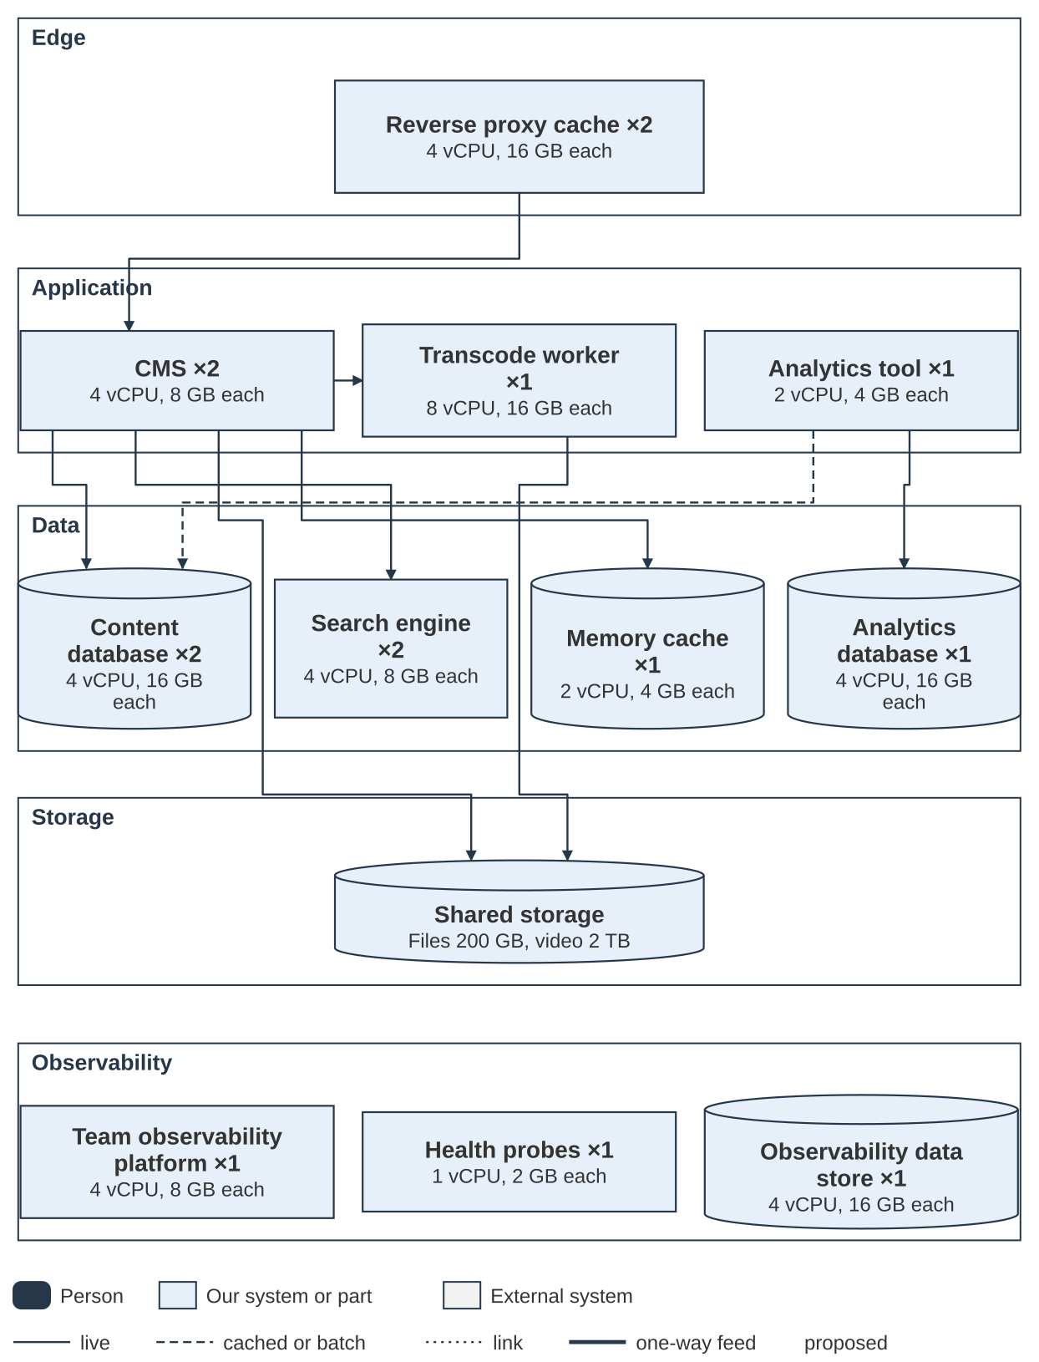
Figure 4. Production deployment by tier
Figure 4 in detail. Nodes are the parts from Figure 1. Counts and sizes are stored once in the architecture model, so the totals below are computed, not typed.
Environment | Nodes | vCPU | RAM
Development | 7 | 13 | 38 GB
Staging | 11 | 27 | 70 GB
Production | 15 | 57 | 162 GB
Total | 33 | 97 | 270 GB

Planning basis. 4,000 staff; about 70% sign in on a working day; about 8 page views each, so about 22,000 a day; the busy hour carries about 20% of the day; bursts run 10 times the average. Video: about 100 hours added a year, each encoded at four (4) different bitrates for adaptive, variable bit rate streaming, and up to 200 people watching at once. These are planning estimates, to be validated in load testing (the work plan).
Production (15 instances)
Component | Instances | Each | Why
Reverse proxy cache | 2 | 4 vCPU, 16 GB, 200 GB SSD | Two for resilience; holds page copies and video segments
The CMS (web and PHP-FPM) | 2 | 4 vCPU, 8 GB | About 12 dynamic requests a second at peak burst; two so patching needs no downtime
Transcode worker | 1 | 8 vCPU, 16 GB | CPU-heavy; may need 16 vCPU if a modern codec is accepted (recorded decision)
Database | 2 (primary and replica) | 4 vCPU, 16 GB, 100 GB SSD | Content, revisions in both languages, people directory
The memory cache | 1 | 2 vCPU, 4 GB | The CMS cache and availability cache
The search engine | 2 | 4 vCPU, 8 GB, 50 GB SSD | Bilingual index plus people search
The analytics tool application | 1 | 2 vCPU, 4 GB | Tracking and nightly archiving
The analytics database | 1 | 4 vCPU, 16 GB, 200 GB SSD | Raw visit data grows steadily
Team observability platform | 1 | 4 vCPU, 8 GB | Logs, metrics, dashboards and alerts for the site team (recorded decision)
Observability data store | 1 | 4 vCPU, 16 GB, 200 GB SSD | Local copy of logs and metrics, kept 14 days. Size is checked against event volume at design
Health probes | 1 | 1 vCPU, 2 GB | A separate small host, so a fault in the platform does not silence the probe
Shared storage |  | Files 200 GB, video 2 TB | About 6.5 GB per hour of video

Production totals: 57 vCPU, 162 GB RAM, 1.1 TB SSD, 2.2 TB shared storage.
How each part is hosted. The application parts (reverse proxy cache, the CMS, the transcode worker, the search engine, the analytics tool and the observability platform) run as container instances (recorded decision). The databases (content and the analytics tool) and the observability data store run on virtual machines or servers, not in containers. For these, the vCPU and RAM shown are the size of the host. The health probes run on their own small virtual machine. The observability sizes are planning estimates. Event volume is not yet measured, so the data store is checked at design.
Environment path (recorded decision). Four environments, in this order. Only the last three are permanent.
Environment | Network | Instances | vCPU | RAM | What it proves
Alpha | Pre-production | Not sized here |  |  | The shape of the solution with synthetic data: content model, workflow, design system components, bilingual gate. No real content, no personal data, no the records system access. One and done (recorded decision)
Development | Isolated | 7 | 13 | 38 GB | Does the code work; free to break
Staging | Isolated | 11 | 27 | 70 GB | Does the solution work with real data and real connections; the last gate before production
Production | Isolated | 15 | 57 | 162 GB | Deploy-only; nothing is built or changed here (recorded decision)

All three isolated environments together: 33 instances, 97 vCPU, 270 GB RAM, 1.57 TB SSD, 2.7 TB shared storage. Development does not run the observability platform. Staging does, because that is where it is proved (recorded decision).
Other rationale the template asks for
Topic | Position
Operating system and runtime versions | Base images come from the internal registry and mirrors. To refine in delivery: versions against the departmental standard, including the Java version the search engine needs (a recorded decision F5)
Performance | Layered caching: The CMS render cache in the memory cache, reverse proxy cache, long-lived static assets. Tag-based purge makes a publish visible in seconds without a full flush (recorded decision)
Scalability and availability | Two instances of the proxy, the CMS and the search engine tiers; database primary and replica. Staging runs single instances, so failover is proven only in production (flag S2)
Maintenance | Rolling patch with no downtime on the two-instance tiers (Proposed). Single-instance services need a change window. Patching is a rebuild; rollback is redeploying the previous image tag (recorded decision)
BCP and DRP | Backup and restore is verified before accreditation (the work plan) and storage backup needs explicit design. To refine in delivery: recovery time and recovery point targets
Fallback | If no accredited container platform exists, virtual machines with configuration management (recorded decision)

Flags
- S1: dev and staging carry no production-scale video or caching capacity, so load and performance testing runs on production before go-live (the work plan). Schedule it with time to act on the result.
- S2: single-instance staging does not prove failover. A second the CMS instance in staging is the cheapest fix.
- S3: staging holds real content and real personal data, so it needs the same accreditation, access control and audit as production.
- S4: all figures are planning estimates. Validate with the vendor at design.

Network architecture
Topic | Position
Bandwidth | The network constraint is video, not servers. 200 viewers at about 2 Mbps is roughly 400 Mbps leaving the proxy. A modern codec would cut that by about 20 to 30% (a recorded decision, Proposed). To refine in delivery: the network can carry it to the regions
Network connections | Everything sits inside the departmental network with no outbound connection. Staff browsers reach the reverse proxy over HTTPS. The intranet reaches the identity provider, the mail and calendar system, the records system and the HR data service on the isolated network. Only two one-way feeds leave, through approved controls (recorded decision). No inbound management channel
Protocols and ports | HTTPS for staff, a standard sign-in protocol to the identity provider, SMTP to the mail relay, an HTTPS lookup to the calendar service, and the records API. Exact ports and protocols are listed in the vendor design and the firewall request. To refine in delivery
Network failures | Identity provider down: all access is blocked, so one break-glass admin account exists. calendar availability down: The badge is absent and the page renders. The HR data service down: The directory keeps the last nightly copy. The records system call fails: The page stays published and the owner is alerted. The search engine indexing lag is monitored per language
Loss and inconsistency of data | Cache purge is by tag and by language so one language is never left stale. A failed archive leaves the page as it was. Two registries on either side of the gap need a defined reconciliation (recorded decision)
Inconsistent timing | The directory is up to a day old by design. Availability is cached about 10 minutes, served stale up to 30. Sign-on needs tight clock agreement between the identity provider and the intranet, so the internal time source is a sign-on dependency (recorded decision)

Digital Architecture

Metrics
Analytics are captured with self-hosted analytics, IP anonymized, with no personal information in tracking. English and French are always measured separately (recorded decision). The new intranet provides five measures, and the people who need them see them without having to ask.
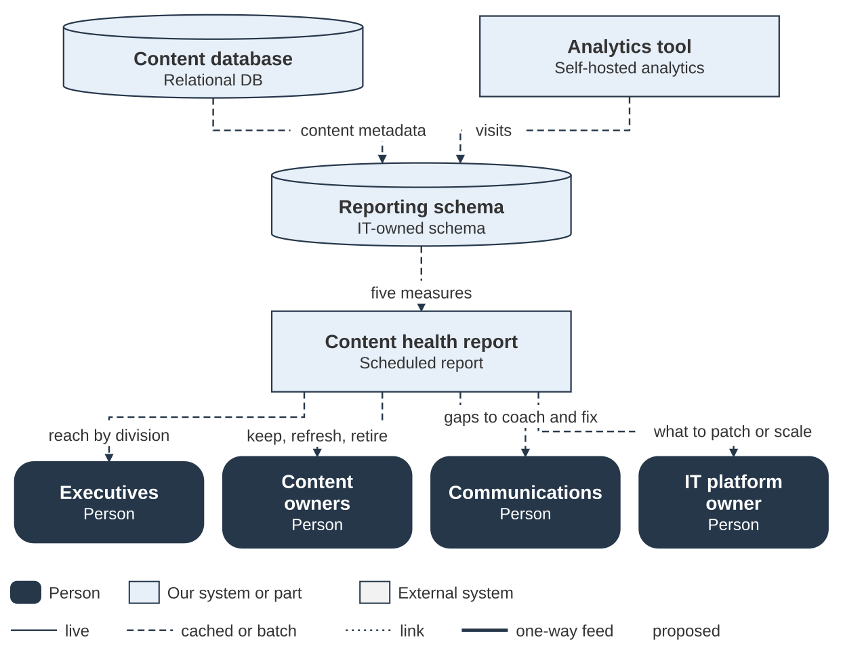
Figure 5. Analytics: from content and traffic data to the people who act on it
Figure 5 in detail. The data flows in three steps, then reaches four audiences. Reports are aggregate, so no one sees an individual's browsing.
Step | From | To | What happens | How | Decisions
1 | Content database | Reporting schema | Provides content metadata nightly | Nightly batch (batch) | —
2 | Analytics tool | Reporting schema | Provides visits nightly | Nightly batch (batch) | —
3 | Reporting schema | Content health report | Builds the five measures each night | Scheduled report (batch) | —

Audience | What they see | What they do with it
Executives | Shows reach by division | Reach by division
Content owners | Shows their own pages and review status | Keep, refresh, retire
Communications | Shows readership and gaps across the site | Gaps to coach and fix
IT platform owner | Shows platform health | What to patch or scale

Measure | What it shows | Who benefits | How they use it
Content health | What is stale, what has no owner, what nobody reads | Executives, Communications, content owners | Decide what to refresh or retire
Disposition | What has been kept, refreshed, retired and archived, by branch and by quarter | Executives, Communications | See whether ownership is real, and where to push
Bilingual parity | Publishing lag, indexing lag and traffic, English and French counted separately | Communications, executives | Catch a stalled French queue early
Accessibility | Open findings, where they are, and who owns the page | Content owners, Communications | Fix the pages they own and report progress
Readership | Views by page, owner and branch, with the English and French split | Executives, content owners | Judge reach and decide whether to send again

Self-service. Nobody has to ask for a report. Owners and publishers see their own pages, on the page itself: views, trend and the English and French split. Communications sees readership and content health across the site. Executives see a roll-up by division. IT sees platform health. Everyone sees the same numbers, so what an owner sees is what rolls up into the report. Reports are aggregate, so no individual's browsing is visible to anyone. Low traffic is information, not a verdict: mandatory pages are flagged so nobody retires them for being quiet. Calendar availability is never sent to the analytics tool (recorded decision).

Content health measures
Content health turns the question "how good is our content?" into counts that someone can act on. Four measures start the report. The list is kept short on purpose.
Measure | Plain definition | Source | Who acts
Stale | A page that has not been reviewed within its review cycle, for example 12 months | The CMS review date | Page owner
No owner | A page with no named owner or owner position | The CMS owner field | Branch lead, who assigns an owner
Orphan | A page that no other page links to, so it is found only through search or a bookmark | The CMS link data; the link check is to refine in delivery | Owner and Communications: link, merge or retire
Failed searches | Searches in an area that return nothing or are abandoned | The search engine zero-result reporting | Product owner: add or fix content

From report to action. Each flag goes to the person who can act on it. Stale pages go to the page owner's queue, pages with no owner go to the branch lead, and failed searches go to the product owner. IT is not the default recipient. Reminders, escalation and archiving are automated, and a person makes every decision to keep, update or retire (P3, recorded decisions). Owners and managers work from one ranked queue, described in PAT-016, and it uses the same data as the report.
How to use the report.
- Report by branch or team, not by page. Managers can act on groups, not on thousands of rows.
- Show owners their own numbers, so they can fix issues without waiting for IT.
- Track the trend. A falling share of problem pages is the goal.
- Use it to find worthwhile work, not to assign blame. Reports are aggregate, and no one sees an individual's browsing.

Accessibility
Objective. The standard is the accessibility standard, the Government of Canada standard for ICT accessibility. It includes WCAG 2.1 Level AA, which is pass/fail. The vendor provides a conformance report against the standard and a logged remediation plan for gaps, reviewed each release. The system falls under the department's accessibility law plan, so every page carries an accessibility feedback link.
How it is verified across the lifecycle
Stage | Check
Build | automated accessibility checkers in the pipeline; code that fails does not reach production
After publishing | Scheduled crawls of live EN and FR pages
Before go-live | Manual audit with screen readers and keyboard only (the work plan)
Ongoing | Usability testing with employees who use assistive technology; gap log reviewed each release
Video | EN and FR captions, accessible player
Design | Status never by colour alone; pages reflow at 400% zoom (recorded decision)

Is the system accessible, and to what standard? It is designed to the accessibility standard, which includes WCAG 2.1 AA. Proof arrives at M6, the accessibility audit.

Personas
The source records define no personas. These are Proposed starting points, to be validated with Communications and used in design and test.
Persona | Goal | What the intranet must do
Everyday employee | Find a policy-adjacent answer, form or contact fast | Search that works, relevant results, quick links
French-first employee | Work fully in French | Equal content, search and captions in French; parity proven
Employee using assistive technology | Use every page and video | Keyboard, screen reader, captions, reflow
Content owner | Keep a branch's pages current without effort | Reminders, a clear keep, refresh or retire choice, "My content" view
Communications reviewer and publisher | Release both languages together | Review queue, bilingual preview, approval workflow
Executive | See whether information can be trusted | Roll-up of stale and unowned content by division
IT platform owner | Run and patch it | Health signals, repeatable deploys, advisories handled

Information Architecture

Lifecycle management
# | Question | Answer
1 | Transitory or standard information? | Drafts and working revisions are transitory. Published pages are retired to the records system as records of business value after owner and publisher approval. All content will carry an IM classification.
2 | Range of file number primaries? | To refine in delivery with IM and records. Not defined in the project records
3 | Will the system generate new file numbers? | No. The records system returns a record ID, which the CMS stores against the page.
4 | Will it record business decisions? | No. The new intranet is a means to communicate to employees. Publishing and retirement approvals are kept in the audit trail and the archive metadata.
5 | Does it integrate with the corporate retention system (the records system)? | Yes, through the records API at the content-archive stage (recorded decision).

eDiscovery and ATIP search
# | Question | Answer
6 | Federated search on metadata, keywords and values for legal review? | Search by metadata and keywords across the intranet content, in each language, for authorized users. Federation across other systems is not designed.
7 | Litigation hold? | Not designed. Proposed: a hold flag that blocks retirement and deletion.
8 | Export of all records? | Live content is exposed by a read-only content API, and archived pages leave as an archival PDF format with original HTML and a metadata file.
9 | Users apply metadata tags? | Yes. Authors pick taxonomy terms from a controlled list, with owner and dates mandatory (the work plan)
10 | Users comment on content? | Per-page feedback and owner flags only (the work plan). Open commenting is not in the first release. Comments would become records.
11 | A "chat" capability? | No. It is not in scope. If added, chat would create records with ATIP and retention consequences
12 | Electronic redaction? | Not in the intranet. The archived an archival PDF format in the records system is the record copy. To refine in delivery: where Legal and ATIP redact

Access controls
# | Question | Answer
13 | Compartmentalized or restricted data? | Yes. Roles come from dedicated security groups, with author groups per branch (recorded decision). Access is enforced in the CMS and applied to search by Search API. Caches are keyed by role, and restricted content never enters a role-keyed entry that a broader role can request (recorded decision)
14 | Sequestering on request of the court? | Not designed. Linked to the litigation hold in row 7.
15 | Mandatory security categories on all records? | The whole system is handled to department security standards. Each record will have a security classification.

GoC legislation and policy
# | Question | Answer
1 | Is the data covered by a Personal Information Bank? | The people directory holds personal information. To refine in delivery: the applicable Personal Information Bank with Privacy and ATIP. Web analytics carry no personal information
2 | Is a Privacy Impact Assessment necessary? | Yes. It is underway for the people directory and needs an addendum for calendar availability (recorded decision)

Standards and law referenced: official languages law, accessibility law, privacy law, the accessibility standard (includes WCAG 2.1 AA), the central agency Content and Information Architecture specification, the government security control profile.

Security Architecture
Security categorization. The system runs on an isolated network built to department security standards. All content carries a security categorization, and the formal confidentiality, integrity and availability categorization comes from the threat and risk assessment (the work plan). Security controls follow the government security control profile.

Technology security architecture
Topic | Position
Network segmentation and zones | An isolated network with development, staging and production. The pre-production alpha sits on a separate network and is one and done. Break-glass administration is limited to the management subnet. Zone detail is to be refined in delivery with Security
NAC, intrusion prevention, DDoS protection | Inherited from the isolated network and not designed by the project. The intranet is internal only. To refine in delivery
Firewalls | Each the intranet flow needs a firewall request. The vendor design lists protocols and ports
Proxies | A reverse proxy cache sits in front of the CMS. There is no outbound proxy because there is no outbound path
Supply chain risk and vetting | Internal package mirrors; signed artefacts with a manifest and checksums; vendor update checks and telemetry disabled (C8); no cloud build runners. Proposed: a signed software bill of materials from the build (recorded decision), an offline advisory snapshot (recorded decision) and named component owners (recorded decision). Three small an open-source player dependencies have unidentified licences and must be resolved before accreditation (recorded decision)

Identification, authentication and access control
Topic | Position
Local and system accounts | The CMS holds no user register. Its own login form is blocked except for one break-glass administrator, limited to the management subnet (recorded decision)
Authentication | A standard sign-in protocol to the departmental on-premises identity provider. Accounts are matched on the provider's persistent subject identifier. Session cap of 8 hours
RBAC | Roles come from dedicated security groups, mapped at every sign-in: author (per branch), reviewer, publisher and admin. No role is assigned by hand (recorded decision)
Logon | Logon follows department policy. The Security Authority confirms the position at accreditation (recorded decision)
Privileged access | Named accounts only. Administrative actions and role changes go to the security platform. Alerts fire on break-glass use and on configuration change in production. Production is deploy-only
Service accounts | Narrowest rights that work. Credentials come from the secret store and are never in code, configuration files or deployment variables. calendar availability uses free/busy read rights only (recorded decision)
Exceptions | The logon position (recorded decision); the F3 search access position (recorded decision). Both are recorded with Security

Logging, monitoring and alerting
Topic | Position
Which data is logged | Security events: account name, source address, session identifier, content and node identifiers, directory access, role and configuration change, outcome. Not page content, record bodies or uploaded files
Destinations | Two separate one-way feeds over the approved one-way feed: security events to the departmental security platform, and operational health to the monitoring platform (recorded decision). Both are fed by the team observability platform inside the secure zone, which also gives the site team its own dashboards and alerts (section 13, a recorded decision)
Protection of logs | One-way path with no inbound channel. Cleansing is done at the source, on the high side, before data crosses. The security platform is run by the security operations centre, separate from the intranet administration
Retention | The departmental retention schedule. The intranet sets no period of its own
Monitoring use cases | Break-glass use, role changes, production configuration change, bulk directory listing or export (rate-limited and logged). Operations: service state, response times, queue depth, the search engine index lag per language, certificate expiry, backup result
Alerting and reporting | The security operations centre handles the security feed. The network operations centre handles health. Owners are alerted when an archive call fails. A parity report flags a page updated in one language only

Patch management
Topic | Position
What must be kept current | Operating system, container base image, PHP, database, the search engine, web server, the memory cache, the CMS core and contributed modules, the analytics tool, an open-source player and npm packages, design system assets, the transcoder
Roles and responsibilities | The security operations centre watches the operating system, base image, PHP, database, the search engine and web server. The IT platform owner watches the CMS, contributed modules and the analytics tool. Both raise transfer requests through the a recorded decision path (recorded decision)
Timing | The enterprise patch standard governs. The build, sign, transfer and deploy path must meet it for a critical advisory, including out of cycle, and is rehearsed (the work plan). Transfer cadence is to be refined in delivery
Vulnerability scans | Scans run in the pipeline and in security testing before go-live (the work plan). Frequency in production is to be refined in delivery
Penetration testing | Before go-live (the work plan). Recurrence is to be refined in delivery
List of exceptions | Held by Security. First entries: The logon position and the F3 search access position

Dependency. The certificate authority and secret store are being modernized during the intranet build. The intranet inherits that schedule. A target date and a named platform contact are needed (recorded decision).

Observability
Observability means being able to tell what a system is doing from the signals it gives out: logs (what happened), metrics (numbers over time) and, later, traces (the path of one request). The aim is plain. The site team sees a problem, in either language, before a user reports it. Decision: A recorded decision, proposed. It builds on a recorded decision, which sets the two one-way feeds out of the secure zone.

Three lanes
- Lane 1, the team (new). A small observability platform inside the secure zone. It stores logs and metrics, runs health probes from inside, and gives the site team dashboards and alerts. The IT platform team owns it and the site team uses it.
- Lane 2, security events. To the departmental security platform (security platform), for the security operations centre (recorded decision).
- Lane 3, health metrics. To the monitoring platform, for the network operations centre (recorded decision). Numbers and state only: no names, addresses or request paths.
- It is not a security platform. It does no detection that duplicates the security operations centre, and no second security platform is built.
- Nothing flows back. Settings arrive only through the signed release (recorded decision).
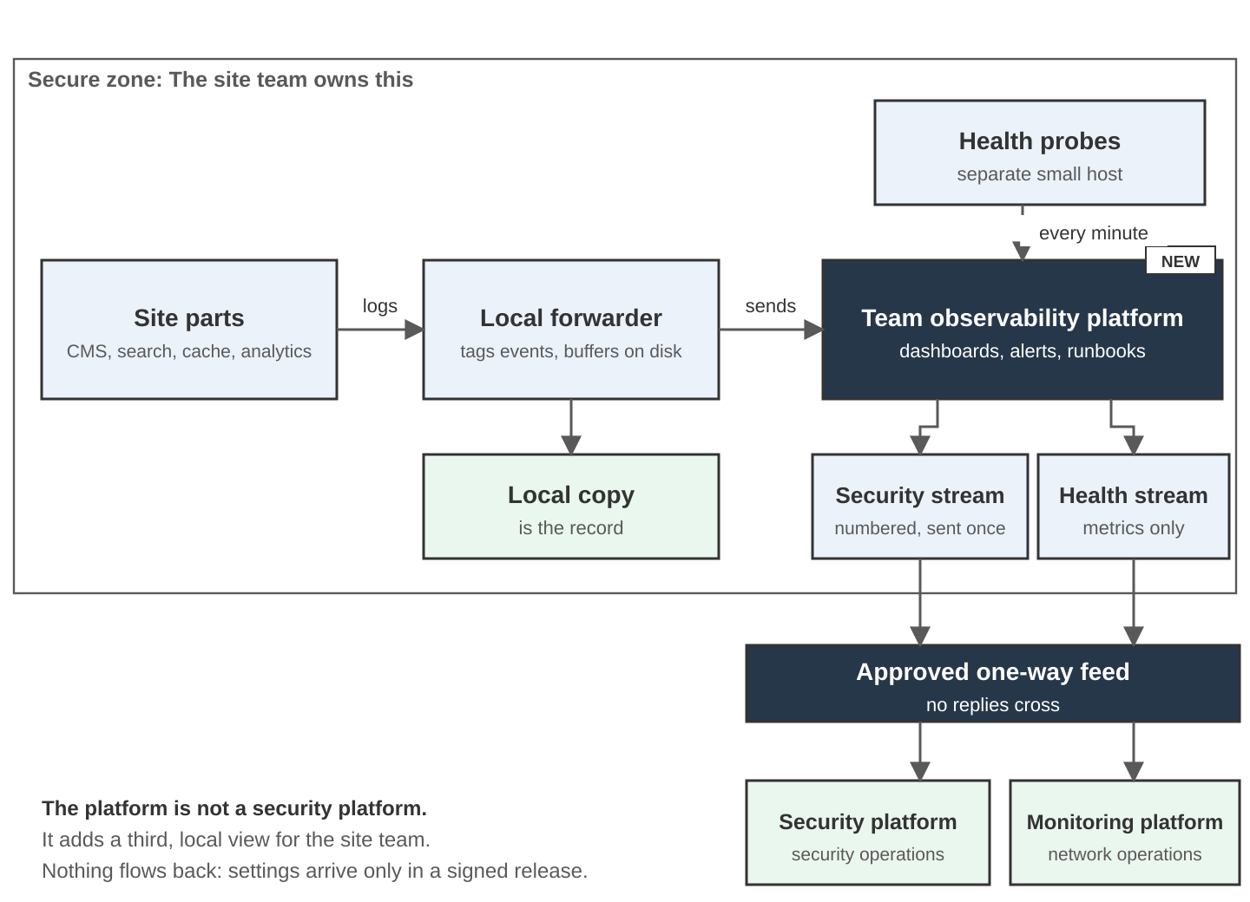
Figure 18. Observability: three lanes, with the team platform beside the two one-way feeds

What the platform watches
Wherever a number can differ by language, it is kept per language (a recorded decision, principle P2).
Part | What is watched | Per language?
The CMS | Error rate, page time (95th percentile), queues waiting (video, availability, mail, archive), last cron run, deploy marker with the release number | Errors and page time, yes
The search engine | Index delay, documents indexed, query time, searches with no results, memory | Yes. This number stops a stalled French queue hiding behind an average
Cache | Proxy hit ratio, purges by tag, the memory cache memory and evictions, and a stale-page check: any page newer in one language than the other | Hit ratio and purges, yes
The analytics tool | Tracker receiving, last hit received, nightly archive last success, language dimension set on hits, database growth | Context only. Traffic is use, not health, so it has no target
The platform itself | Heartbeat, forwarder buffer, export numbers and gaps per stream, certificate expiry, disk | No
Content health (from the CMS) | Pages overdue for review, pages with no named owner, pages in one language only | Yes

The analytics tool stays the visitors' view. Content freshness counts come from the CMS, not from visitor tracking. Use both and do not mix them.

Mock-up: The site team's dashboard
This is an illustration with sample numbers. The vendor chooses the tool and designs the real screens against the outcomes in "How it is proved" below.
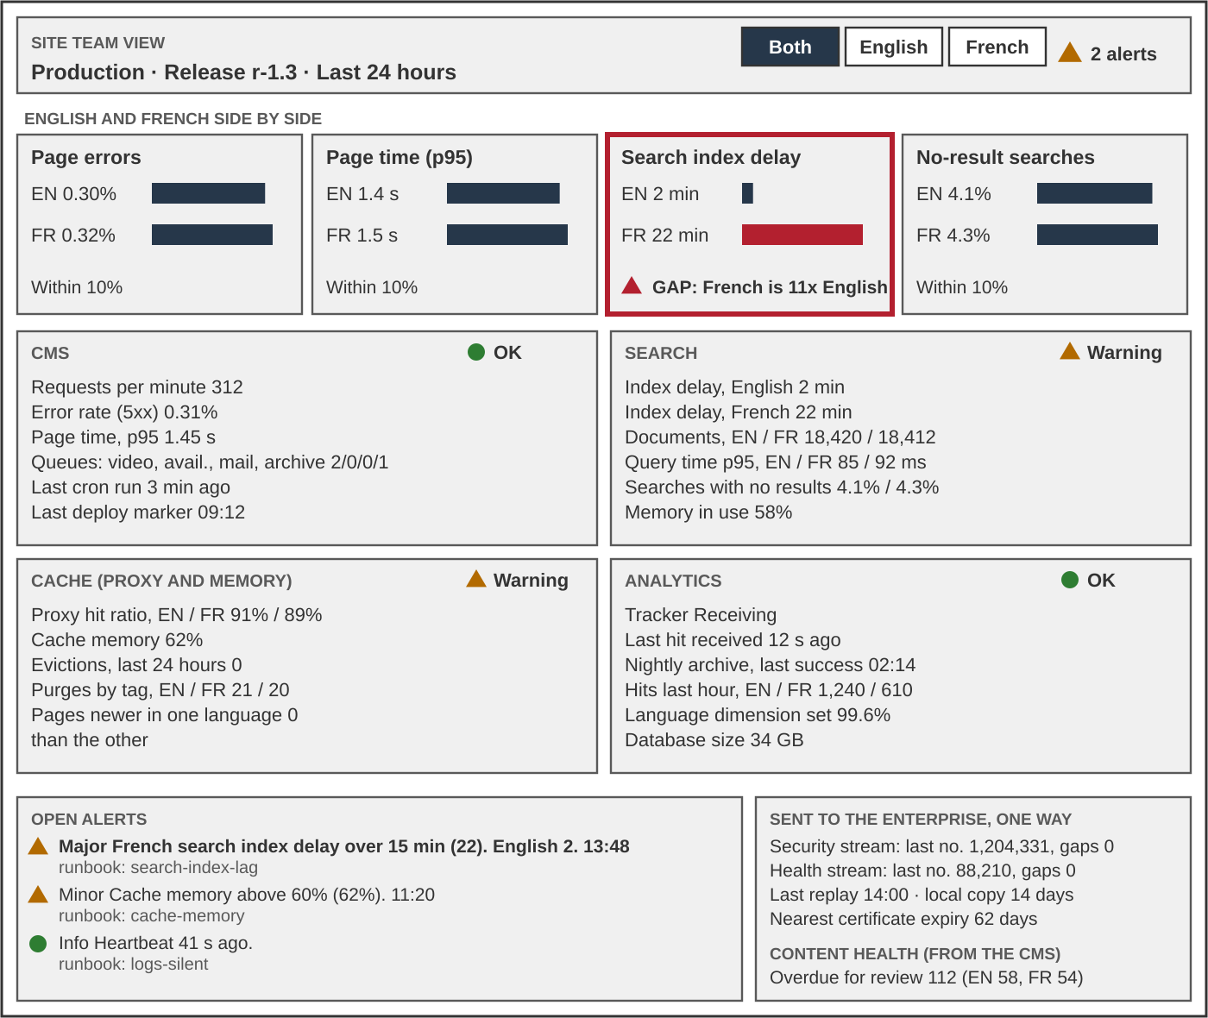
Figure 19. Mock-up: The site team's dashboard (sample numbers)
How to read it.
- Language first. English and French are side by side at the top. A gap of more than 10% on any tile raises an alert, as the French search delay does here.
- One panel per part. Each has a text status, a few numbers and a trend. Status is always text plus a symbol, never colour alone (the WCAG contrast and colour rule).
- Alerts say what to do. Every row links to a runbook with an owner.
- The export is visible. The team can see that both streams are leaving and that no numbers are missing, without the enterprise reaching in.

Alerts and runbooks
A runbook is a short page for one alert: what it means, what to check, what to do and who to call. It lives in Git beside the alert rule and goes through the same review. It is not a pipeline runner. A runner is the worker that runs pipeline jobs, and it may carry out the automated steps of a runbook.
Alert | Fires when | Goes to
Search index delay, one language | Over 15 minutes in either language | Site team
Language gap | Any measure differs by more than 10% between English and French | Site team
Heartbeat silent | No heartbeat for 15 minutes in business hours | Site team. The operations centre also sees the silence on its side
Stale page | A page is newer in one language than the other beyond the agreed time | Site team and content owner
The analytics tool archive late | No successful nightly archive in 26 hours. The content health report depends on it | Site team
Export gap | A running number is missing in a stream | Security operations (security stream) or network operations (health stream)
Certificate expiry | 60 days before expiry, which leaves time for a controlled transfer into the isolated network | Site team

Rules. One runbook per alert. Each has a named owner and a review date. Automated steps go through the pipeline, never by hand on production. Someone who did not write a runbook follows it in each quarterly drill.

What leaves the secure zone
This restates a recorded decision so the platform is built to it. The one-way feed moves bytes without reading them, so data is cleansed before it reaches it. Health numbers are built from metrics, never filtered from logs, because a request path can identify both a person and a record.
Stream | Goes to | Carries | Does not carry
Security events | Departmental security platform | Account name, source address, session and content identifiers, role and setting changes, outcome. Also the heartbeat and the deploy marker | Page content, record bodies, uploaded files
Health metrics | Monitoring platform | Host, container and service state, response times, queue depth, search delay per language, certificate expiry, backup result. Also the heartbeat and the deploy marker | Account names, source addresses, content identifiers, request paths, search terms, anything personal

- No replies cross the feed. There are no acknowledgements, so each stream carries a running number. The receiver spots gaps and alerts. The sender replays on a schedule and the receiver drops repeats.
- The local copy is the record. The platform keeps every event for 14 days. The export is a copy. Once a stream has been received, its security platform or monitoring platform is responsible for it.
- The enterprise cannot reach in. It cannot probe, pull logs, push rules or send test events. Probes run inside the zone and the results go out. Its needs reach the site by change request against a versioned telemetry contract in Git. The contract lists the fields, event names, severities and owners of each stream.
- Protect the logs. Only the forwarders write to the platform. The people who run the site can read logs but cannot edit or delete them.

How it is proved
The outcomes below are stated for the vendor. The vendor chooses the design.
- The site team sees logs, metrics and alerts for its own system without hands-on access to production hosts.
- Security events and health metrics leave as two separate streams. A scan of sample health events finds none of the forbidden fields, and a planted test field makes the build fail.
- With the French search queue paused for an hour in test, the French delay alert fires while the combined number stays quiet.
- With the receiver cut for an hour in test, the silence alert fires, then the replay fills the gap and repeats are dropped.
- Every alert links to a runbook, and someone other than its author resolves one from the page alone.
- Nobody who runs the site can edit or delete a stored log.

Service levels
These service levels are set for the first release. The site team watches the system in business hours, about 7 a.m. to 5 p.m. The recovery objectives are the department's existing ones.
Measure | Service level
Availability | 99.5% in business hours
Page speed | 95% of pages in under 3 seconds, English and French measured separately
Search index delay | Under 15 minutes in each language. An alert fires over 15 minutes in either
Language gap | No more than 10% between English and French on any measure. An alert fires beyond it
Silence | A silent platform is noticed within 15 minutes in business hours
Local log copy | 14 days. After export, the receiving platform owns what it received
Certificate warning | 60 days before expiry
Backups | Daily
Recovery point objective | One week of content at most
Recovery time objective | One business day

Transparent by design. For the first release, the simplest approach is to measure the service levels on the observability platform and let the right stakeholders view them there, read-only. Access follows roles:
- The site team sees everything live, per language (Figure 19).
- The business owner, the IT service owner and executives have a read-only view of the service levels and their trend.
- Staff see the current status of each feature on the status page (PAT-015), which is served apart from the site.
Nothing is built in the CMS for this. A service level report inside the CMS can follow in a later phase if it is wanted.
Read the availability and recovery numbers together. At 99.5% in business hours, the allowed downtime is about 50 minutes a month. One major outage that uses the full one-business-day recovery time would exceed it. Treat 99.5% as the target for normal running, and the recovery time as the limit for a major failure.

Constraint check and items to refine
- Constraint flag. Hosted observability and security services (cloud-managed monitoring or security platform) fail the on-premises constraint and are not allowed. Any component that calls home, such as update checks or usage telemetry, is switched off and shown in the hardening record, as for the analytics tool (recorded decision).
- No inbound path. The security and operations centres cannot probe the platform or send test events across the feed. Tests are sent from inside, and receipt is confirmed by ticket or on a test path.
- The platform has no named owner yet. This is the unassigned platform administration role in the operating model. Name it before go-live.
- One-way feed details to refine in delivery: who owns it, which protocol it accepts, whether it can carry running numbers, its speed and its status signal.
- Proved on staging, not on the pre-production alpha (recorded decision). The alpha has no one-way feed and no real data, so it proves build-side checks only.

Refinement and sources
This architecture is a point-in-time proposal for the review board. The items marked To refine in delivery are detailed throughout delivery, led by the RFP vendor with the department, and the architecture decisions are recorded as they are made.
Not in the source records. A data model, and recovery time and recovery point targets. They are refined in delivery.
Derived from: the project's business case and requirements, including the business requirements dated.
How decisions are cited. A reference in brackets, such as (recorded decision), cites the decision in the Architecture Decision Log (ADL) in Appendix A. Select it to go to the entry. Each figure also shows the decisions behind each part; a dagger (†) means the decision is still proposed.
Cited as | Cited document | What it holds
The business requirements | Business requirements document, | The requirements this architecture derives from

Appendix A. Architecture decisions
This appendix lists the architecture decisions behind this document, with a short record for the eight that shape the most. Statuses are a point in time at the review board.
- Accepted: agreed by the Enterprise Architect.
- Proposed: recommended, and agreed throughout delivery.
- Superseded: replaced by a later record.
A record is not edited once it is shared. A change is a new record that supersedes the old one.

Decision log
Nineteen decisions shape the target state: 11 accepted and 8 proposed.
Decision | Why | Status
The CMS, full-stack, with design system assets self-hosted | Keeps the CMS's translation, workflow, caching and accessibility features. Fewer parts to accredit. | Accepted
The search engine, one bilingual index with per-language fields | Deepest the CMS integration and existing skills. Separate fields stop English skewing French results. | Accepted
self-hosted analytics, IP anonymized, English and French measured separately | Runs on our own infrastructure. Supports content freshness and ownership reporting. | Accepted
No CDN; layered internal caching | A CDN cannot exist on the isolated network. Page build time is the real cost. | Accepted
Dynamic Page Cache and BigPipe for signed-in staff | Everyone is signed in. Shared page parts are cached; personal parts stream in. | Proposed
Container images are the unit of deployment | What is tested is what is accredited. Rollback is the previous image. | Proposed
Signed build on the low side, deploy-only on the high side | One provenance chain from code to running system. Nothing is built in production. | Accepted
Video: upload through the CMS, the transcoder, four renditions, adaptive streaming | A clear gain on today's intranet without an enterprise video platform. | Accepted
An open-source player player; a modern codec with an a widely supported codec fallback | Both are free of licence cost. A modern codec plays in current browsers and needs 20 to 30 percent less network than an older codec. | Proposed
Live video stays on the Communications platform; the intranet links to it | The capability exists. A link is the smallest coupling. | Accepted
Retired content archived to the records system as an archival PDF format through the records API | A self-contained record that lasts decades. English and French archived as equals. | Proposed
Tiered publishing authority, with review after publication | Authority follows the content tier, not the tool. | Proposed
Notifications through the department's the mail and calendar system, carrying no content | Cloud notification services are not available. An email points to content; it never contains it. | Proposed
Calendar availability from the on-premises mail and calendar system: status only, cached | Reuses an existing accredited service. Meeting detail is never shown. | Accepted
Signed software bill of materials with each release, offline vulnerability matching, named component owners | Shows what is inside each release and who answers for it. | Proposed
A team observability platform inside the secure zone, with health measured per language and a runbook for every alert | The site team needs its own view. A combined number cannot prove English and French parity. | Proposed
Sign-in through a standard sign-in protocol to the identity provider | One sign-in route. The CMS's own login form is blocked. | Accepted
The CMS roles come from dedicated directory groups | No role is assigned by hand. | Accepted
Two separate one-way feeds out, to security and monitoring platforms | No inbound path. Data is cleansed before it leaves. | Accepted

Project and security decisions referenced
These decisions are cited in the document but are not in the log above. Their full records are held in project knowledge.
ID | Decision | What it decides | Status
Small project, limited artifact set | The Project Brief is the governing document; extra artifacts need a specific risk to justify them. | Accepted
Waterfall, paid against evidence | Nine payment milestones, each paid against evidence rather than a status report. | Accepted
Migrate existing content | Every page gets a named owner and a keep, refresh or retire decision; nothing migrates without an owner. | Accepted
Build and accept an alpha first | A working pre-production alpha is accepted before the isolated network is touched, and stakeholder training happens there. | Accepted
Deliver an MVP first | The first release publishes, finds and proves content is current and owned, and the deferred scope is named. | Accepted
The alpha is one-and-done | After go-live, development moves to the high-side development environment and no pre-production environment is kept. | Accepted
Managed desktop PCs only | The first release is designed and tested on the standard departmental PC image; no BYOD, mobile or tablet. | Accepted
The environment path | Alpha, then isolated development, staging and production; confidence is built in staging, not in the alpha. | Accepted
Logon position | Logon follows department policy, and the Security Authority confirms the position at accreditation. | Accepted
Split watch for security advisories | Security operations watches the operating system layers, the IT platform owner watches the CMS and the analytics tool, and the enterprise patch standard sets timing. | Accepted
Pages cached per role | Pages are cached by path, language and role, never per person, and personal content is delivered separately. | Accepted
Certificate authority and secret store | The system uses the enterprise certificate authority and secret store and holds no credentials in code or configuration. | Accepted
People directory minimum fields | The directory holds a minimum set of work-contact fields, and real data lives only in environments accredited like production. | Proposed

Decision records
Nine records follow for the decisions that shape the most. The others are in the log above, with full records held in project knowledge.

the CMS, built full-stack
Accepted ·
- Context: A bilingual internal site on the isolated network. It must meet the accessibility standard (which includes WCAG 2.1 AA) and the official languages law.
- Decision: the CMS packaged with Recipes, no distribution. The CMS renders its own HTML. The design system web components are self-hosted.
- Why: Translation, workflow, caching and accessible markup come with the CMS. A separate JavaScript front end would double the stack to accredit and turn bilingual routing into custom code.
- Alternatives rejected: Decoupled the CMS, a Government of Canada the CMS distribution, WordPress, the legacy platform.
- Consequence: the design system is built for public sites. Intranet-only parts (directory, internal navigation, search page) are custom components on the design system design tokens.

the search engine, one bilingual index
Accepted ·
- Context: Today's search responds quickly but returns poor results. English and French must each be analysed by their own rules.
- Decision: a self-hosted search engine. English and French share one index, with language-specific fields and a language field on every item.
- Why: Deepest the CMS integration, existing team skills, and one service to patch instead of two. Separate fields stop one language skewing the other's ranking.
- Alternatives: OpenSearch is held, and returns only if one of five named triggers fires. Managed cloud search is not possible. The CMS core search is too limited.
- Consequence: Indexing lag, document counts and zero-result searches are reported per language. The written security position on access filtering is refined in delivery.

self-hosted analytics
Accepted ·
- Context: The department needs usage measures, plus content freshness and ownership reporting for owners, Communications, IT and executives.
- Decision: the analytics tool runs inside the network, tagged by the CMS the analytics tool module. IP addresses are anonymized, no personal information is tracked, and English and French traffic are measured separately.
- Why: Open source, makes no outside calls, already used by other federal departments, and supports the custom dimensions that freshness and ownership need.
- Alternatives rejected: Google or Adobe analytics (external services). Server logs only (too thin). Lighter self-hosted tools (fewer features).
- Consequence: IT owns the platform. Communications owns the reports and what they mean.

No CDN; layered internal caching
Accepted ·
- Context: No outside connectivity means no commercial CDN. Staff are on the internal network, so the cost is page build time and Monday-morning peaks.
- Decision: No CDN in this project. Three internal layers: The CMS caches, a reverse proxy, and long-lived static assets.
- Why: It removes a dependency that cannot exist here. On an internal network, speed comes from building less, not from distance.
- Alternatives rejected: No caching (fails at peak load). Static site generation (loses preview and the authoring workflow).
- Consequence: Cache purge is by tag and by language, so one language is never left stale. Load testing proves it. Products are refined in delivery.

Container images are the unit of deployment
Proposed ·
- Context: Production is isolated. What is built elsewhere must be carried in, and what is accredited must be what runs.
- Decision: the CMS, the web tier, the search engine, the analytics tool and the cache run as containers. The image is the unit of deployment. Databases and files sit outside, on managed storage.
- Why: An image is versioned, signable and identical in every environment. Rollback is redeploying the previous image.
- Alternatives: Virtual machines with configuration management is the fallback if no accredited container platform exists. Hand-built servers are rejected.
- Consequence: Image registries are needed on both sides, with a controlled import. Base images are mirrored internally. The container platform must exist and be accredited, which has its own lead time.

Signed build on the low side, deploy-only on the high side
Accepted ·
- Context: Code is built on the low side, which can reach internal mirrors. Production cannot fetch a single package.
- Decision: One the build pipeline builds, tests and signs on the low side. A Security-owned transfer carries the signed artefacts across. A high-side pipeline deploys them. Nothing is built or fixed by hand in production.
- Why: Every dependency is resolved where the mirrors are. The signature and manifest give the assessor a chain from commit to running system.
- Alternatives rejected: Building on the high side (more tools to patch and prove). Manual deployment (no repeatability).
- Consequence: Transfer cadence sets patch speed, so an emergency patch path is agreed with Security. Hotfixes go around the loop, not into production.

Archive retired content to the records system as an archival PDF format
Proposed ·
- Context: Retired content is archived to the records system after owner and publisher approval. A record must be readable in decades, without the intranet.
- Decision: The archive copy is tagged an archival PDF format (an archival PDF format-2a proposed), one per language, with the original HTML and a metadata file. It is delivered through the records API. Video is archived as its source file and captions, with an archival PDF format cover sheet.
- Why: an archival PDF format is self-contained and long-lived, and tagging keeps it accessible.
- Alternatives rejected: HTML only (degrades over time). Plain PDF (external dependencies). Web archive format (needs special software to view).
- Consequence: Every content type needs an archive rendering that converts cleanly, so this shapes the content model. Files are validated first. A failure stops archiving and tells the owner. The level and package the records system accepts are refined in delivery.

Video codec: A modern codec with an a widely supported codec fallback
Proposed ·
- Context: an older codec was the first choice, but browsers play it unevenly. The client asked for an older codec and a newer codec by name. The need is video that plays everywhere and is light on the network.
- Decision: Encode recorded video in a modern codec, with a small a widely supported codec fallback. A newer codec is not used in the first release because no mainstream browser plays it.
- Why: a modern codec plays in current Chrome, Edge and Firefox, is royalty-free, and needs roughly 20 to 30 percent less network than an older codec. A widely supported codec plays everywhere.
- Alternatives: Keep an older codec (depends on hardware, licensing unclear). another codec (larger files, a fallback option). A widely supported codec only (about twice the network).
- Consequence: Encoding takes more CPU, so the transcode worker is sized up. Test on the department's own recordings and oldest PCs. Confirm the need with the client before closing.

A team observability platform inside the secure zone
Proposed ·
- Context: The two one-way feeds (recorded decision) serve the security and network operations centres, not the people who run the site. The project must prove bilingual service on an ongoing basis, and a combined number cannot do that.
- Decision: The site runs a small observability platform inside the secure zone, owned by the IT platform team. It sits beside the two feeds and feeds them as two separate streams. It is not a security platform. Health is measured per official language, and a gap between English and French raises an alert. Every alert has a runbook.
- Why: The site team gets its own view without reaching into production or into the other teams' feeds. Per-language measures are the only way to prove parity over time. Runbooks turn alerts into action and give accreditors evidence.
- Alternatives: Use only the two feeds (no team view). A platform outside the secure zone (detailed logs hold personal information). A second security platform inside (duplicates detection). Use the analytics tool as the operations view (it measures visitors, not systems). One export stream split on the far side (a one-way feed cannot filter).
- Consequence: A new platform to build, patch and own, with a named owner before go-live. It holds sensitive detail, so it is inside accreditation scope. Only the forwarders write to it, and the people who run the site cannot edit or delete logs. Proof is on staging, not the pre-production alpha. The service levels are set in section 13.

