Departmental Data Analysis
A Project Work Synopsis
Submitted in the partial fulfilment for the award of the degree of
BACHELOR OF ENGINEERING
IN
COMPUTER SCIENCE WITH SPECIALIZATION IN
BIG DATA ANALYTICS
Submitted by:
Alisha Gakhar (21BCS3850)
Raghav Deshwal (21BCS11849)
Under the Supervision of:
Mr. Swapnil Raj


CHANDIGARH UNIVERSITY, GHARUAN, MOHALI -140413, PUNJAB
March, 2023

Abstract

The effective analysis of data is crucial for informed decision-making in any department. To develop a robust system for departmental data analysis, it is necessary to follow a structured approach. This abstract outlines the steps to be taken for proposing a new system for departmental data analysis.

The first step is to define the goals and objectives of the data analysis system, including the type of data to be collected and the insights expected from it. Next, identifying the data sources is critical, including both internal and external sources.

Choosing a suitable data analysis tool, such as a software package or custom-built solution, is essential for efficient analysis of the data. Developing a data analysis process that is flexible and adaptable is the next step, which should guide data collection, cleaning, analysis, and reporting.

Setting up a data governance framework is crucial to ensure data integrity and security, including who can access the data, how it can be used, and how it will be protected. Finally, providing adequate training and support to staff who will be using the data analysis system is essential for optimal utilization of its capabilities.

By following these steps, a department can develop an effective and reliable system for data analysis, enabling them to make informed decisions and gain valuable insights from the collected data.

Other than the above steps, we can use Power BI to analyse and work on the departmental data and may computerize traditional method of taking attendance and analysing the absence and notices and circulars, etc.

Keywords: Data analysis, decision-making, internal sources, external sources, data analysis tool, data collection, data cleaning, data reporting, data integrity, departmental data analysis, power bi.

Table of Contents

Title Page
Abstract
1. Introduction
1.1 Problem Definition
1.2 Project Overview
1.3 Hardware Specification
1.4 Software Specification
2. Literature Survey
2.1 Existing System
2.2 Proposed System
3. Problem Formulation
4. Research Objective
5. Methodologies
6. Conclusion
7. Reference

1. INTRODUCTION

1.1 Problem Definition
Many organizations have large amounts of departmental data that could be used to inform decision-making and drive business growth. However, analysing and interpreting this data can be complex and time-consuming task, especially when dealing with multiple departments within an organization. The lack of an efficient data analysis process can lead to mislead opportunities, ineffective decision-making, and ultimately, a decrease in productivity and revenue.
Therefore, the problem statement is how to develop an efficient and effective departmental data analysis process that enables organizations to leverage their data to make informed decisions, improve performance, and achieve their analysis goals. This process should consider the various data sources, the complexity of the data, and the different departmental needs while also ensuring data accuracy, consistency, and privacy.

1.2 Project Overview
The purpose of developing a department data analysis system is to do analytical operations on a given attendance dataset of any department.
In addition, we will be trying to computerize the traditional way of taking attendance

1.3 Hardware Specification
RAM: 4 GB
Hard Disk: 128 GB
Processor: Intel Pentium 4(1.50 GHZ) or above

Software Specification

- Power BI
Power BI is a powerful business intelligence and data visualization tool developed by Microsoft. It is designed to help users analyze and present data in a visually compelling and interactive way. Power BI provides a range of features and capabilities that enable users to connect to various data sources, transform and shape the data, create meaningful visualizations, and share insights with others.

Here are some key aspects and functionalities of Power BI in data analysis:

- Data Connectivity:
Power BI allows you to connect to a wide range of data sources, including databases, spreadsheets, online services, and cloud-based platforms. It supports both on-premises and cloud data sources, making it flexible for accessing and consolidating data from different systems.

- Data Transformation and Modeling:
Power BI provides a user-friendly interface for data transformation and modeling. You can clean, reshape, and combine data from multiple sources using Power Query, a data transformation and ETL (Extract, Transform, Load) tool. Additionally, Power BI offers a powerful data modeling language called DAX (Data Analysis Expressions) for creating calculated columns, measures, and relationships between tables.

- Data Visualization:
One of the core strengths of Power BI is its ability to create rich and interactive visualizations. It offers a wide range of charts, graphs, maps, tables, and other visual elements to represent data in compelling ways. You can customize the visuals, apply various formatting options, and create interactive reports and dashboards.

- Analytics and Insights:
Power BI includes built-in analytical capabilities such as aggregations, filters, sorting, and drill-downs that allow you to explore and analyze data in depth. It also supports advanced analytics features like forecasting, clustering, and key influencers analysis. With these capabilities, you can uncover trends, patterns, and insights from your data.

- Collaboration and Sharing:
Power BI provides options for sharing and collaborating on data analysis and reports. You can publish your reports and dashboards to the Power BI service, where you can securely share them with others in your organization or make them accessible to a broader audience. Power BI also offers real-time collaboration features, allowing multiple users to work together on the same report simultaneously.

- Integration and Extensibility:
Power BI integrates well with other Microsoft products such as Excel, SharePoint, and Azure. It also supports integration with various third-party applications and services, enabling you to extend its functionality. Power BI provides an extensive collection of connectors, APIs, and developer tools for customizing and integrating the tool into existing workflows.

Overall, Power BI is a comprehensive tool for data analysis that empowers users to connect, transform, visualize, and share data insights. Whether you are a business analyst, data scientist, or decision-maker, Power BI can help you derive meaningful insights from your data and make informed decisions.

- Microsoft Excel
Microsoft Excel is a widely used spreadsheet program that offers a range of functionalities for data analysis. While Excel is primarily known for its ability to organize and manipulate numerical data, it also provides several features that support data analysis tasks. Here are some key aspects of Excel in data analysis:

1. Data Organization and Manipulation: Excel provides a grid-based interface where users can input and organize data in rows and columns. It supports various data types, including numbers, text, dates, and formulas. Excel allows users to perform basic data manipulation tasks such as sorting, filtering, and conditional formatting to explore and clean data.

2. Formulas and Functions: Excel offers a vast library of built-in formulas and functions that can be used for performing calculations and data analysis. These formulas range from simple arithmetic operations to complex statistical and mathematical functions. Users can create formulas to derive new values, perform calculations on data, and summarize information.

3. Data Visualization: Excel provides charting and graphing capabilities to visualize data. Users can create a variety of charts, including bar charts, line graphs, scatter plots, and more. Excel also offers formatting options to customize the appearance of charts, allowing users to create visually appealing and informative visual representations of data.

4. Pivot Tables and Pivot Charts: Pivot Tables are powerful tools in Excel for data summarization and analysis. They allow users to aggregate, filter, and analyze large datasets quickly. Pivot Charts can be created based on PivotTable results to provide dynamic visualizations of summarized data, offering an interactive way to explore and analyze information.

5. Data Analysis Add-ins: Excel supports various add-ins and tools that extend its capabilities for advanced data analysis tasks. For example, the Analysis ToolPak provides additional statistical functions and tools for regression analysis, correlation, sampling, and more. The Solver add-in allows users to solve optimization problems, and the Data Analysis ToolPak offers additional data analysis features such as descriptive statistics, histograms, and Fourier analysis.

6. Data Connections: Excel enables users to connect to external data sources such as databases, text files, online services, and more. Through data connections, users can import data into Excel for analysis, create dynamic links to external data sources, and refresh data automatically.

While Excel is a versatile tool for data analysis, it may have limitations when dealing with large datasets or complex analyses. For more advanced data analysis tasks, dedicated data analysis and visualization tools such as Power BI, R, or Python may be more suitable. Nonetheless, Excel remains widely used due to its accessibility, familiarity, and broad range of features for data analysis.

2. LITERATURE SURVEY

2.1 Existing System
There are many existing systems for departmental data analysis that works on Android/web. They have many features including registrations/logins-logouts.
The complexity of these systems makes it difficult to work on them and simply perform analytical operations using them.
Some of them are:
- Online Student Attendance Management Information System: It had features like Prevent Time Theft, improve efficiency and productivity, and increasing productivity.
UTB-SAMIS is based on the database, object-oriented programming language, and networking techniques. This system uses PHP as the front-end software which is an object-oriented programming technique and has connectivity with MySQL, the back-end software, and some advanced client-side technologies.
The given figure displays the Student-side DFD of this system:

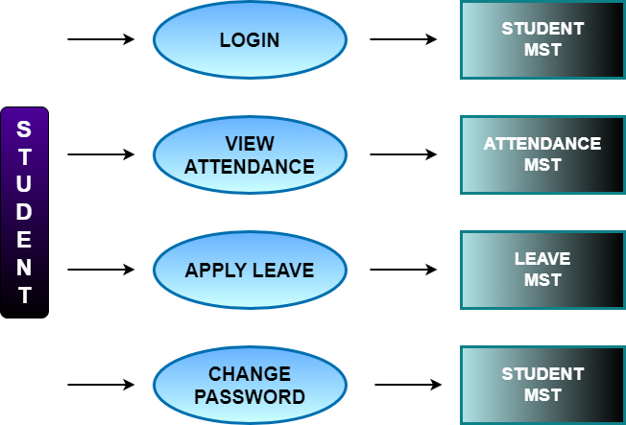
- Attendance Management System: It used an Android app, a database, GUI, and an API with Microsoft SQL as a query language and ASP.NET framework for the backend as it is capable of handling web applications, dynamic websites, and mobile applications effectively.
In this system, users are categorized as non-managerial employees, Managers, and HR admin. The checking and check-out times of employees are tracked using fingerprint scanners and that data is used in the proposed system. Mainly using that data working hours of the employees are calculated. This proposed system allows each and every employee to view his/her attendance for a desired time period. As well Managers and HR admin can view the attendance of all employees. By analyzing these data reports are generated. Other than that, employees are allowed to apply for leaves using this system. Here leaves are categorized and employees can view their leave balance in each category.

- Attendance System Based on Fingerprint and Arduino Board: The key modules of the fingerprint attendance system are the attendance module, report module, fingerprint module, schedule module, lecturer module, and student module.
Figure 1 depicts the designed block diagram in the portable attendance system. In the hardware implementation, Arduino Mega was attached to the SD card and the Fingerprint scanner. As for the software, the code was compiled using the Arduino compiler IDE.

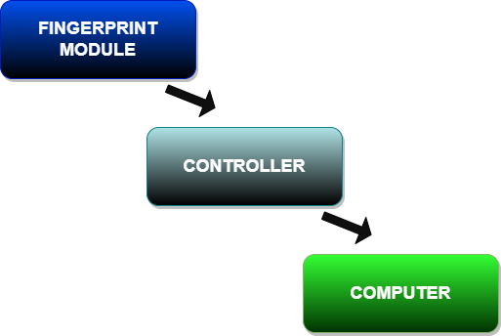
- Attendance Management System from Islamic University of Technology (IUT): This system had concrete functionalities, Efficiency, and accuracy, framework, web services, and availability of both computer and Android versions. The purpose of developing this attendance management system was to computerize the tradition way of taking attendance. Another purpose for developing this software is to generate the report automatically at the end of the semester.
The given figure displays the home page of AMS-IUT:

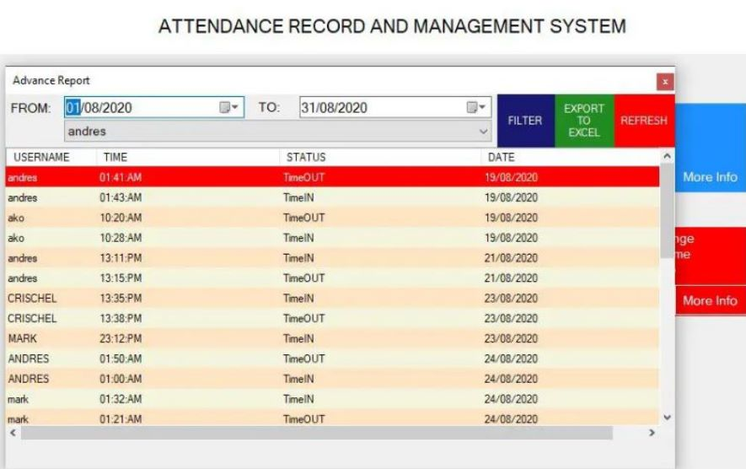

2.2 Proposed System
The Departmental Data Analysis System is a software tool that enables the collection, analysis, and reporting of data from various sources to support informed decision-making within an organization. This system aims to provide valuable insights that can help improve business processes, optimize resource allocation, and enhance overall performance. This Analysis project will roll out managerial software to digitize the management of departmental data which, otherwise, would need to be done in conventional on-paper methods.
The software will also provide analytical reports of attendance to users, with different access rights (For example Faculties can view all students’ attendance reports). The software will keep a record of Time-Tables for departmental Divisions.
The software will also provide an E-Notice-Board service which will be used to circulate notices for department members. The software will provide a means for faculty members to start a communication session with students.

Data Sources:
The data sources for the Departmental Data Analysis System may include:
- The data source for the Departmental Data Analysis System may include a self-made dataset.

Data Analysis Tool:
The Departmental Data Analysis System will utilize a data analysis tool to analyze and visualize data effectively. The chosen tool should be user-friendly, scalable, and able to integrate with various data sources.
Here, we may be using Power BI for analysing purpose on this data.

Data Analysis Process:
The Departmental Data Analysis System will follow a normally defined data analysis process that includes:
- Data collection and cleansing,
- Data analysis and modelling,
- Data visualization and reporting,
- Ongoing monitoring and optimization.

Data Governance Framework:
To ensure the security and integrity of the data, a data governance framework may or may not be established. This framework might define:
- Access control policies
- Data storage and encryption standards
- Data usage guidelines
- Data backup and recovery procedures

Training and Support:
The Departmental Data Analysis System may or may not provide training and support to users to ensure they can effectively use the system. This might include:
- User manuals and documentation
- Training sessions and workshops
- Technical support for system issues

Overall, this proposed system may combine the benefits of a computerized attendance system with a robust data analysis system. The system will also help circulate circulars and will also work as a notice board for important notices.

2.3 Literature Review Summary

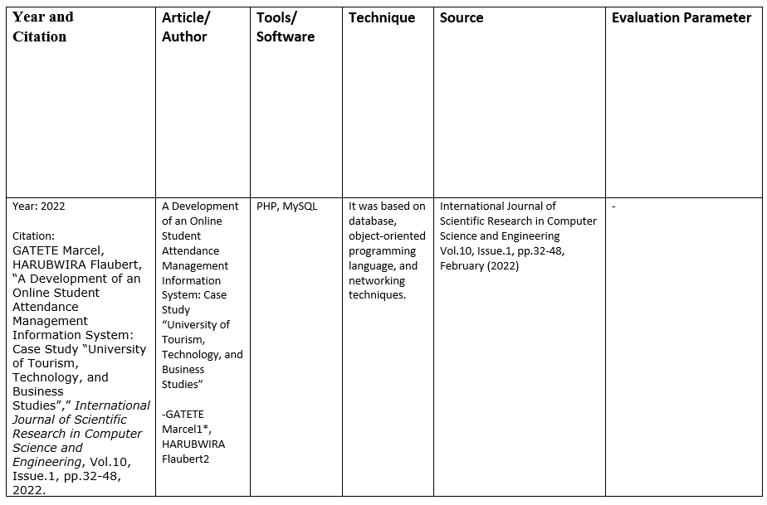
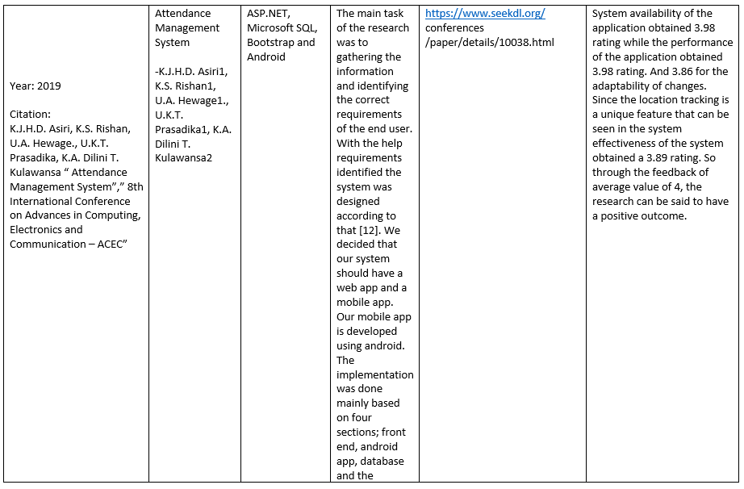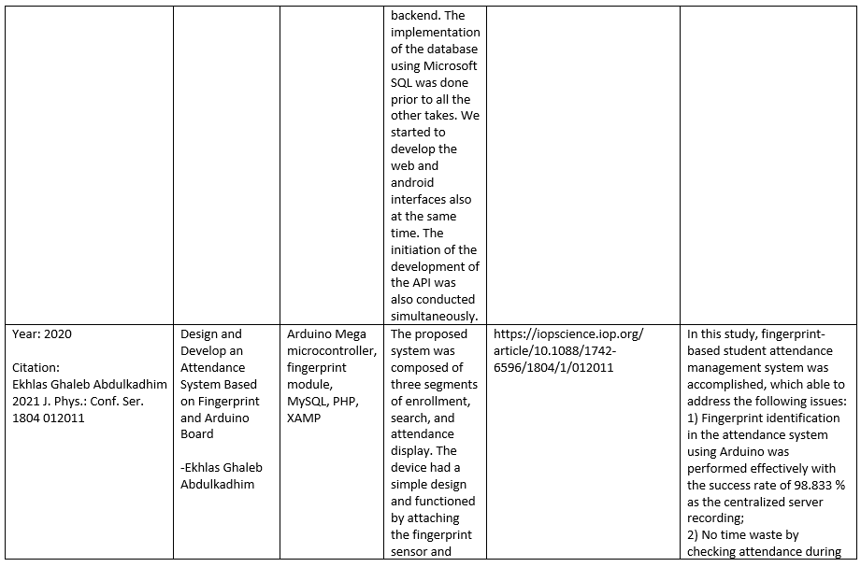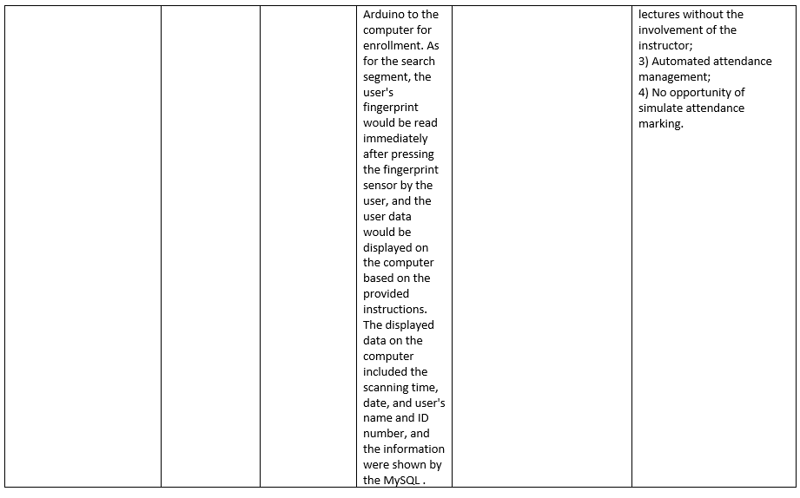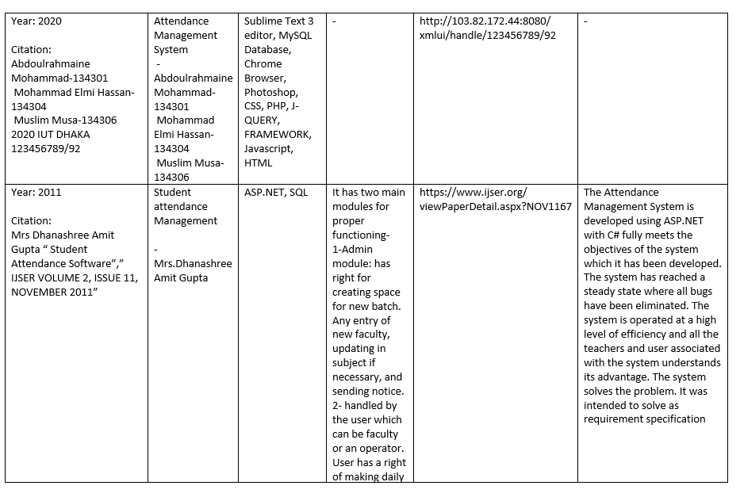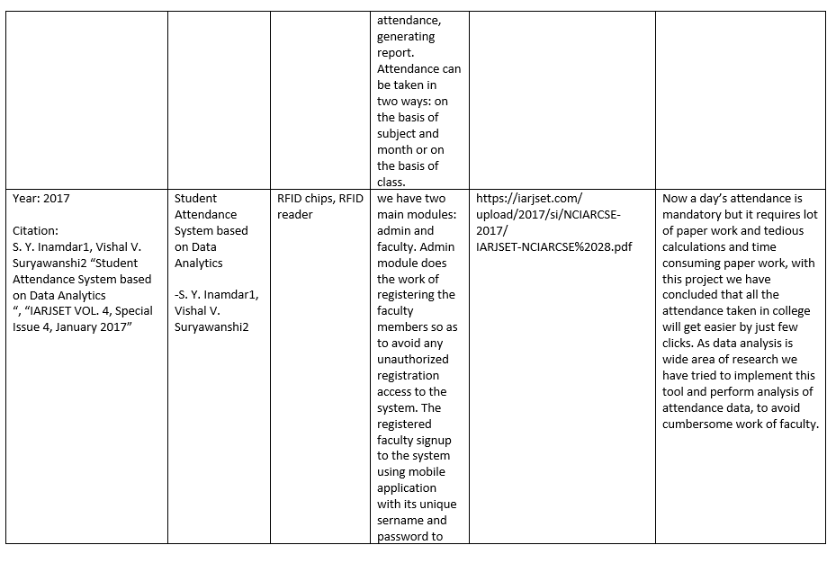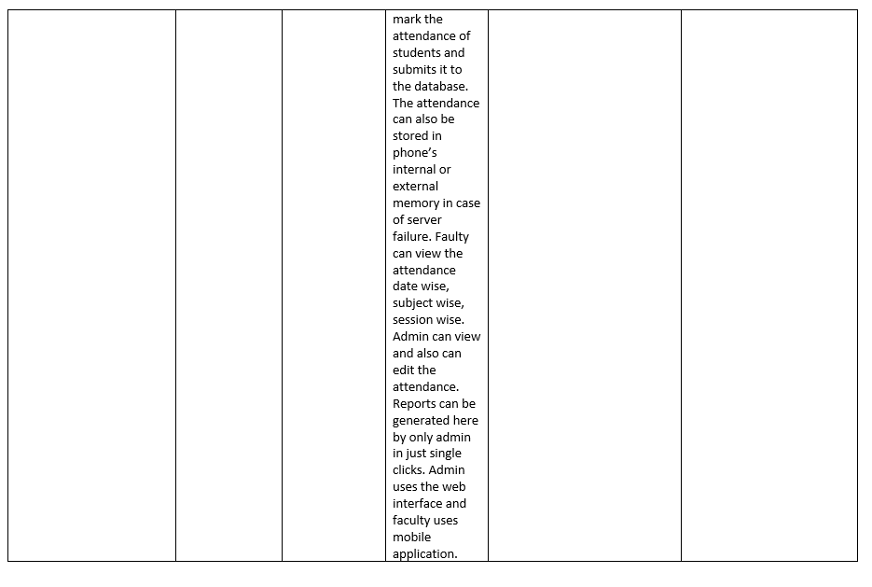

3. PROBLEM FORMULATION
Many organizations have large amounts of departmental data that could be used to inform decision-making and drive business growth. However, analysing and interpreting this data can be a complex and time-consuming task, especially when dealing with multiple departments within an organization. The lack of an efficient data analysis process can lead to misleading opportunities, ineffective decision-making, and ultimately, a decrease in productivity and revenue.
Therefore, the problem statement is how to develop an efficient and effective departmental data analysis process that enables organizations to leverage their data to make informed decisions, improve performance, and achieve their analysis goals. This process should consider the various data sources, the complexity of the data, and the different departmental needs while also ensuring data accuracy, consistency, and privacy.

4. RESEARCH OBJECTIVES
The goals of the Departmental Data Analysis System are to:
- Collect and analyze relevant data to support informed decision-making,
- Identify trends, patterns, and insights to improve departmental processes and outcomes,
- Provide accurate and timely information for reporting and planning purposes,
- Get a user-friendly introduction to Power BI-MySQL/Android-MySQL, PHP.

5. METHODOLOGY
A general methodology for conducting departmental data analysis:
- Define the objective: Start by identifying the objective of the analysis. Ask yourself what problem you are trying to solve or what question you are trying to answer. This will help you stay focused throughout the analysis.

- Identify the data sources: Next, identify the data sources that you will need to collect or access. This may include internal databases, external sources, or surveys that need to be conducted.

- Collect the data: Once you have identified the data sources, collect the data needed for the analysis. This may involve cleaning and transforming the data, such as removing duplicates or missing values.

- Analyze the data: Use statistical techniques, charts, and other tools to analyze the data. You may want to segment the data by different categories, such as time periods, customer segments, or products.

- Interpret the results: Once you have analyzed the data, interpret the results to draw conclusions and make recommendations. This may involve identifying trends, patterns, or relationships in the data.

- Communicate the findings: Finally, communicate the findings to stakeholders in a clear and concise manner. This may include creating visualizations or reports that highlight the key insights and recommendations.

- Take action: After communicating the findings, take action based on the insights and recommendations. This may involve implementing new strategies or making changes to existing processes. Monitor the results of these actions and continue to iterate and improve the analysis as needed.

CONCLUSION
The departmental Data Analysis System is designed to support informed decision-making by providing valuable insights from various data sources. By following a defined data analysis process and implementing a data governance framework, this system can ensure the security and integrity of the data while providing accurate and timely information to support business goals.
We propose a departmental data analysis system that may or may not have one or more of the following features-
  - Attendance Management System

  - Analysis of the departmental data

  - Power BI Dashboard.

Moreover, to preserve the traditional attendance system– We may also work on the traditional attendance methods and prepare a separate analysis for spam/fake/proxy attendance. The analysis may not only ensure that the attendance is safe but may also specify whether there is spam/proxy or not.

REFERENCES
- GATETE Marcel, HARUBWIRA Flaubert, “A Development of an Online Student Attendance Management Information System: Case Study “University of Tourism, Technology, and Business Studies”,” International Journal of Scientific Research in Computer Science and Engineering, Vol.10, Issue.1, pp.32-48, 2022.
- K.J.H.D. Asiri, K.S. Rishan, U.A. Hewage., U.K.T. Prasadika, K.A. Dilini T. Kulawansa “ Attendance Management System”,” 8th International Conference on Advances in Computing, Electronics and Communication – ACEC”
- Ekhlas Ghaleb Abdulkadhim 2021 J. Phys.: Conf. Ser. 1804 012011
- Abdoulrahmaine Mohammad, Mohammad Elmi Hassan, Muslim Musa -2020, “IUT DHAKA 123456789/92”
- Mrs Dhanashree Amit Gupta “ Student Attendance Software”,” IJSER VOLUME 2, ISSUE 11, NOVEMBER 2011”
- S. Y. Inamdar1, Vishal V. Suryawanshi2 “Student Attendance System based on Data Analytics“, “IARJSET VOL. 4, Special Issue 4, January 2017”

