E-Commerce Sales & Customer
Performance Analysis
A Data Analytics Case Study — Olist Brazilian E-Commerce Dataset
Prepared by Muhammad Yusuf Jamil
Data Analyst Portfolio Project
2026

1. Executive Summary
This report analyzes two years of transactional data (2016–2018) from the Olist Brazilian E-Commerce platform to answer six core business questions on sales trends, product performance, regional logistics, customer satisfaction, payment behavior, and customer value concentration. Key findings:
- Strong growth, now plateauing: Monthly orders grew nearly 10x from January to November 2017, peaking during the November seasonal shopping period (Black Friday), before stabilizing at 6,000–7,000 orders/month through 2018.
- Revenue concentration in top categories: The top 5 product categories (health & beauty, watches & gifts, home goods, sports & leisure, computer accessories) generate 39.8% of total revenue, while the top 10 generate 62.4% — out of 73 active categories.
- Delivery speed strongly predicts satisfaction: Late deliveries are associated with a review score drop from 4.29 to 2.27 (out of 5) — a statistically significant negative correlation (r = -0.39, p < 0.001, n = 96,353).
- Geographic logistics gap: São Paulo (SP) accounts for ~42% of all orders with the fastest average delivery (8.7 days), while remote states (RR, AP, AM) face delivery times 3x longer (26–28 days).
- Moderate customer concentration: The top 20% of customers by spend generate 56.5% of total revenue — a meaningful but not extreme concentration, suggesting a broad-based customer foundation rather than dependence on a few high-value accounts.

2. Business Context & Objective
Acting in the role of a newly onboarded Data Analyst at an e-commerce company, this project simulates a management request to evaluate two years of sales performance ahead of next-quarter planning. The analysis uses the publicly available Olist Brazilian E-Commerce dataset, which contains relational tables covering orders, customers, products, payments, and reviews.
The objective is purely descriptive and diagnostic — identifying what happened and why — as a foundation for the actionable recommendations in Section 6. This complements a separate causal-inference project (price elasticity and discount analysis on the same dataset), which addresses causal "what if" questions rather than descriptive ones.

3. Methodology

3.1 Data Source
Olist Brazilian E-Commerce Public Dataset (Kaggle), covering 99,441 orders placed between September 2016 and October 2018 across multiple relational tables: orders, order_items, customers, products, order_payments, and order_reviews.

3.2 Data Preparation
- Loaded all raw CSV files into a MySQL relational database for structured querying.
- Corrected column data types (order timestamp fields were initially imported as text and converted to DATETIME) to enable accurate date-based calculations.
- Created a clean_orders view restricted to orders with status = 'delivered' and a non-null delivery date, yielding 96,470 valid orders (out of 99,441 total) used as the analytical base for all six business questions.
- Derived two business-relevant metrics: delivery_days (purchase to delivery) and delay_days (actual delivery vs. estimated delivery date).

3.3 Tools
- SQL (MySQL) — data cleaning, joins across relational tables, and aggregation for all six business questions.
- Python (pandas, seaborn, matplotlib, scipy) — exploratory visualization and statistical hypothesis testing.

4. Key Findings

4.1 Monthly Sales Trend & Seasonality
Order volume grew from 750 orders in January 2017 to a peak of 7,288 orders in November 2017 — a clear seasonal spike aligned with Brazil's Black Friday shopping period. Growth then moderated, with monthly order volume stabilizing in the 6,000–7,000 range throughout 2018, suggesting the platform transitioned from a rapid-growth phase into a more mature, steady-state phase.
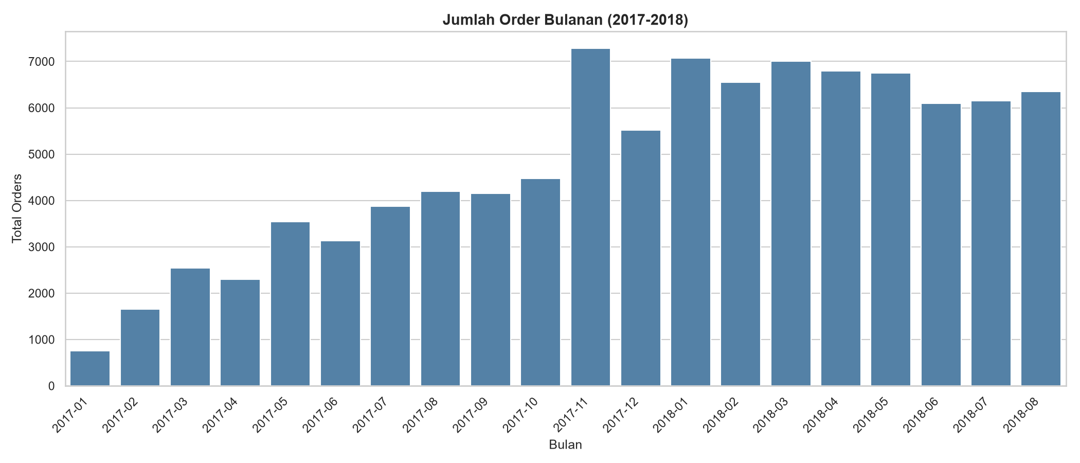
Figure 1. Monthly order volume (2017–2018), excluding the September–December 2016 pilot phase.
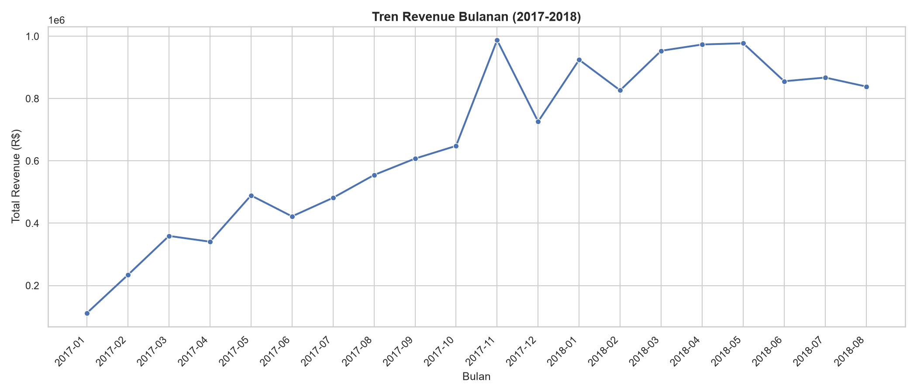
Figure 2. Monthly revenue trend (2017–2018), mirroring the order volume pattern.
Data note: September, October, and December 2016 were excluded from both charts due to extremely low order counts (1, 265, and 1 orders respectively), consistent with an early pilot phase rather than representative business activity.

4.2 Product Category Performance
Out of 73 active product categories, revenue is concentrated at the top: health & beauty (beleza_saude) leads with R$1.23M across 8,647 orders, followed by watches & gifts (relogios_presentes) and home/bed/bath goods (cama_mesa_banho). Combined, the top 5 categories account for 39.8% of total revenue, and the top 10 account for 62.4%.
At the opposite end, categories such as insurance & services (seguros_e_servicos), children's fashion, and music CDs/DVDs each generated fewer than 15 total orders across the full two-year period — indicating these are peripheral, low-priority categories for this marketplace rather than declining core business lines.
Category | Total Revenue (R$) | Orders
beleza_saude (Health & Beauty) | 1,233,131.72 | 8,647
relogios_presentes (Watches & Gifts) | 1,165,898.98 | 5,493
cama_mesa_banho (Home / Bed / Bath) | 1,023,434.76 | 9,272
esporte_lazer (Sports & Leisure) | 954,673.55 | 7,529
informatica_acessorios (Computer Accessories) | 888,613.62 | 6,529
Table 1. Top 5 product categories by revenue.

4.3 Regional Performance & Delivery Logistics
São Paulo (SP) dominates with 40,494 orders (~42% of total volume) and the fastest average delivery time (8.7 days). Delivery time increases markedly with distance from the country's economic center: Rio de Janeiro and Minas Gerais average 12–15 days, while remote northern states — Amazonas (AM), Amapá (AP), and Roraima (RR) — average 26–28 days, roughly three times longer than São Paulo.
This pattern reveals an inverse relationship between regional revenue contribution and delivery performance: high-revenue states enjoy faster fulfillment, while low-revenue, geographically remote states face the greatest logistics friction — a gap directly relevant to the customer satisfaction finding below.
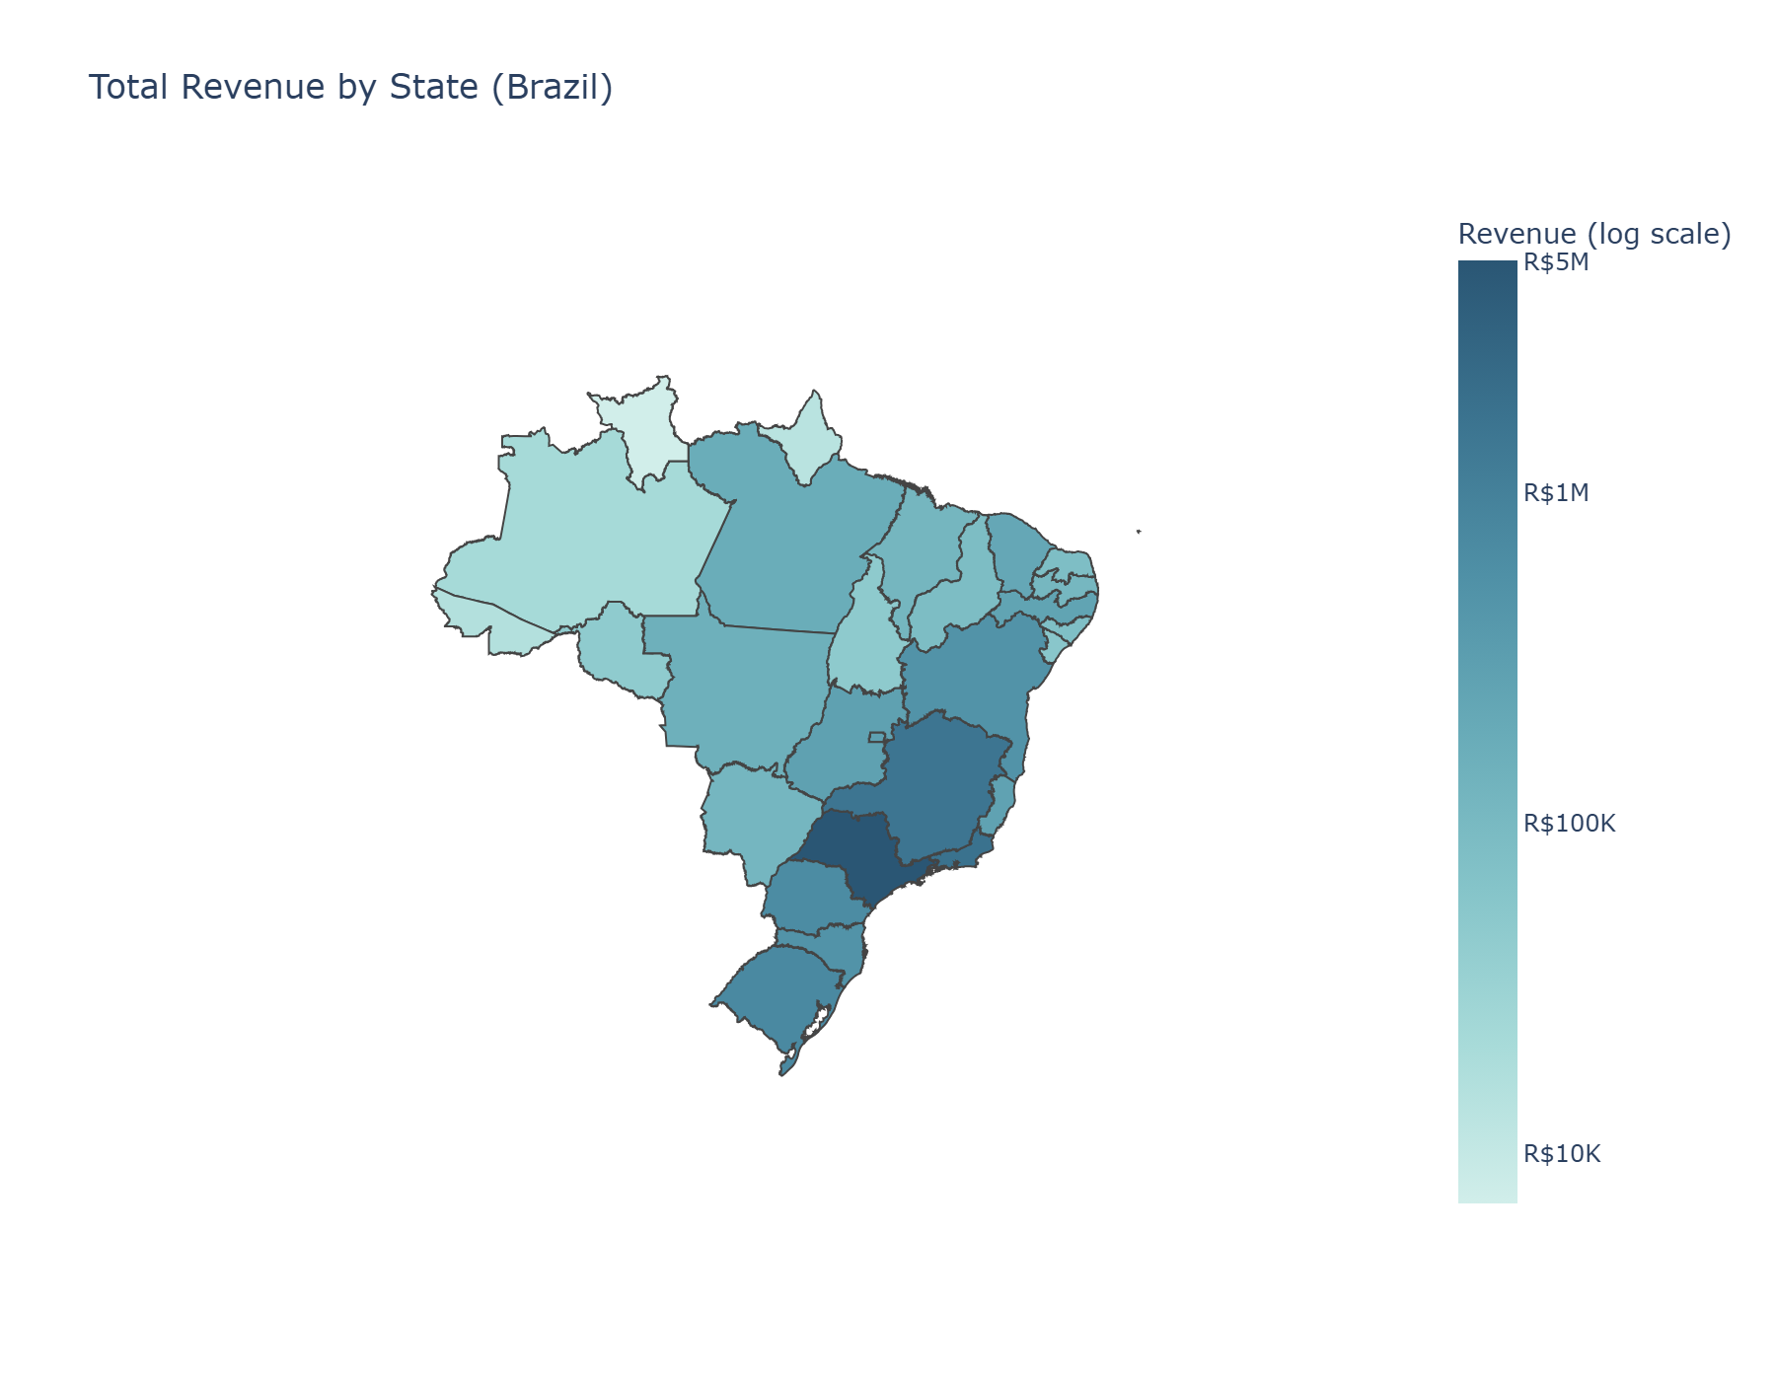
Figure 3. Total revenue by state (log color scale, actual R$ values shown on legend). São Paulo (SP) and neighboring southeastern states dominate revenue contribution.

4.4 Delivery Delay vs. Customer Satisfaction
This is the strongest and most actionable finding in this analysis. Orders delivered on time or early received an average review score of 4.29 out of 5, compared to just 2.27 for delayed orders — a drop of exactly 2 points on a 5-point scale.
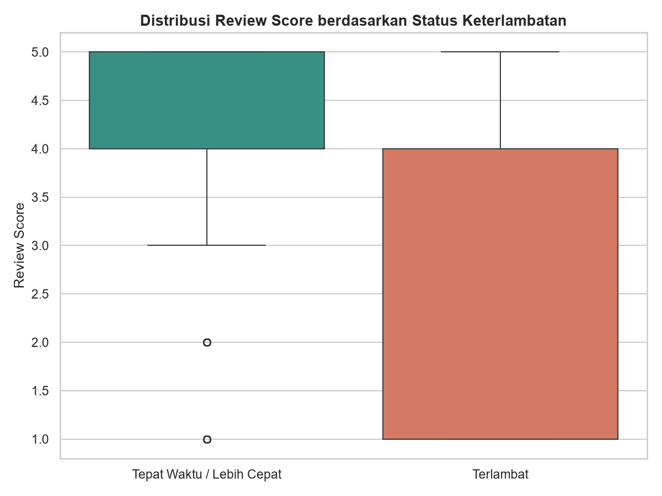
Figure 4. Distribution of review scores by delivery status.
A formal point-biserial correlation test confirms this relationship is statistically significant: r = -0.3915, p < 0.000001 (n = 96,353 reviewed orders). A correlation of this magnitude is considered moderate-to-strong in a business/behavioral context, and the near-zero p-value indicates this pattern is virtually certain not to be due to chance.

4.5 Payment Method Behavior
Credit card is the dominant payment method, used in 74,297 transactions (approximately 74% of all payment records) with an average transaction value of R$162.25. Boleto (a common Brazilian payment slip/transfer method) follows with 19,191 transactions. Vouchers show a markedly lower average value (R$62.45), consistent with their typical use as a partial discount mechanism rather than a standalone payment method.
Note: the sum of orders across payment types (98,651) exceeds the total number of clean orders (96,470), because a single order can be settled using more than one payment method (e.g., a voucher combined with a credit card).

4.6 Customer Value Concentration (Pareto Analysis)
The top 20% of customers by total spend (19,344 customers) generated 56.5% of total revenue, while the remaining 80% (77,126 customers) generated 43.5%. This is a moderate concentration pattern — notably less extreme than the classic 80/20 Pareto rule — indicating a relatively broad-based, diversified customer base rather than heavy dependence on a small group of high-value accounts.

5. Recommendations
- Prioritize logistics investment in remote states: States such as RR, AP, and AM combine the slowest delivery times (26–28 days) with the lowest revenue contribution. Piloting a regional fulfillment partnership or adjusted carrier SLA in these states could reduce delay-driven dissatisfaction, given the demonstrated 2-point review score impact of late delivery.
- Set delivery-time alerts ahead of estimated dates: Given the strong statistical link between delay and review score (r = -0.39, p < 0.001), proactively flagging at-risk shipments before they breach the estimated delivery date could allow customer service intervention (e.g., proactive communication or compensation) to soften the satisfaction impact.
- Plan inventory and staffing around the November peak: The clear November seasonal spike (Black Friday) suggests operational capacity — warehousing, customer support, and delivery partner capacity — should be scaled up 4–6 weeks in advance of Q4 each year.
- Deepen investment in top 5 categories while monitoring long-tail categories: With 39.8% of revenue concentrated in 5 of 73 categories, marketing and merchandising resources are likely best allocated toward expanding these categories, while the ~15 categories generating fewer than 20 total orders warrant a review of whether to maintain, deprioritize, or delist them.
- Explore mid-tier customer growth programs: Because customer value concentration is moderate (56.5% from top 20%) rather than extreme, there is room to grow revenue from the broader base of "Bottom 80%" customers through loyalty or repeat-purchase incentives, rather than relying solely on retention of top-tier accounts.

6. Limitations
- The September–December 2016 period reflects an early pilot phase with extremely low order volume and was excluded from trend visualizations; it remains in the underlying database but should not be interpreted as representative business activity.
- A small number of orders (8, out of 96,478 marked as 'delivered') had a missing delivery date and were excluded from the clean_orders dataset; this is a negligible data quality gap (<0.01%) and does not materially affect the findings.
- Delivery time figures include some extreme outliers (maximum observed delivery time of 210 days, maximum delay of 188 days versus the estimated date). These were retained in the analysis rather than removed, since no clear data-entry error could be confirmed; they are noted here for transparency.
- This analysis is descriptive and diagnostic, not causal. The relationship between delivery delay and review score is statistically significant but does not by itself prove that improving delivery speed will cause proportional improvements in review scores — other factors (product quality, packaging, customer expectations) may also contribute. A separate causal-inference project on this same dataset addresses causal pricing questions using instrumental variables and difference-in-differences methods.
- The dataset covers a fixed historical window (2016–2018); findings reflect patterns from that period and may not fully generalize to current market conditions.

