FŐOLDAL

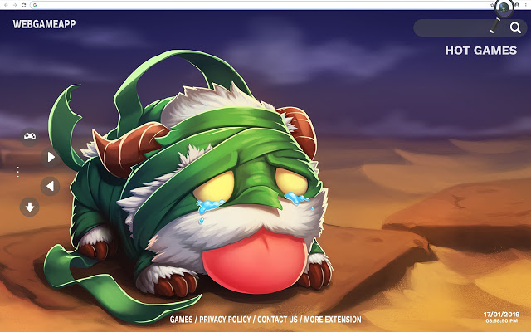

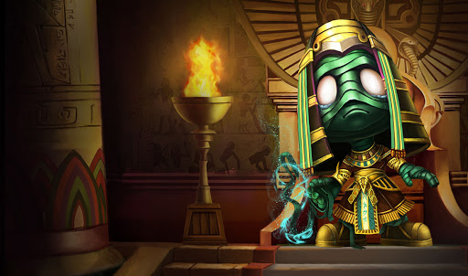

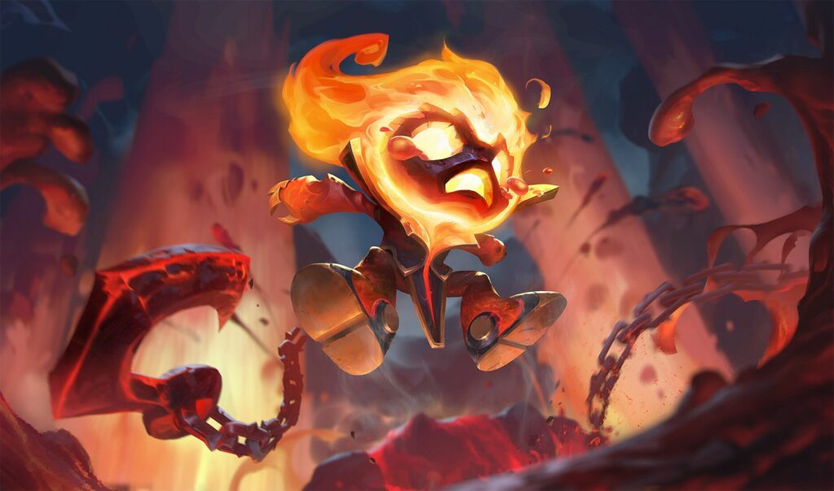

me and amumu:

I'm itsNeyoo! I started playing League of Legends in Season 3 and since then I have loved to play jungle. I chose to make a guide on Amumu because he is a fun champion I came across.

Amumu is an incredibly strong champion with high ratings and high potential. He's fun, and I'll speak more about why to play him in later on!

Why is Amumu jungle??? because he's LONELY! The monsters are his friends and you'll see how friendly Amumu is to pick up and play with. This guide will teach you how to jungle as Amumu and climb the rank ladder quickly

I hope you guys like the guide. If you have any feedback or comments, please leave it in the "Discussion" section!

amumu in general:

Amumu likes the color blue. Is this good? Probably not. He's mana reliant and therefore blue reliant. His first few blues, or his first at the very least is CRUCIAL. However let's not forget about how great he is. He's so friendly to new players, and offers two builds. He's a strong tank or an AP carry who can act like an assassin.

Tanks are NOT boring! People tend to get this idea- but I assure you- you'll find fun playing them. With the Season 11 changes, you can now build Demonic Embrace, dealing surprising amounts of damage even if you go rest tank items.

and now his ultimate. OH MY. where do I start?

backstory:

A lonely and melancholy soul from ancient Shurima, Amumu roams the world in search of a friend. Cursed by an ancient spell, he is doomed to remain alone forever, as his touch is death and his affection ruin. Those who claim to have seen him describe Amumu as a living cadaver, small in stature and covered in bandages the color of lichen. Amumu has inspired myths, folklore, and legends told and retold for generations – such that it is impossible to separate truth from fiction.

read more: <https://na.leagueoflegends.com/en/featured/shurima/amumu>

abilities:

passive:

Cursed Touch

Amumu's basic attacks cause 10% of all magic damage dealt to the target (before resists) to be dealt again as true damage.

A significantly underrated passive. This makes Amumu synergy well with mages (such as Malzahar or Ryze) and also assassins that deal magic damage such as Akali or Diana.

q:

Bandage Toss

Active: Amumu throws a bandage. If it hits an enemy, Amumu pulls himself to the enemy, stun s them for 1 second, and deals 80/130/180/230/280 (+70% of ability power) magic damage

Level 3 or 4, level up Bandage Toss(Q) as your 3rd ability. You should start to gank your allies by now, give them an early boost for a better turnout in the late game. If you get Bandage Toss level 4, give another level into Tantrum for better sustain while clearing camps.

w:

Despair

Toggle: Amumu cries, dealing 10/15/20/25/30 magic damage plus 1/1.25/1.5/1.75/2% (+1% per 100 ability power) of their maximum health to nearby enemies each second.

Despair ticks for half the damage every half-second. Despair refreshes Cursed Touch on all enemies hit.

Start with Despair(W). It clears faster than Tantrum and your mana will be compensated once you kill the Blue Sentinel.

e:

Tantrum

Passive: Amumu takes 2/4/6/8/10 reduced damage from physical attacks. Also gains +3% bonus armor and +3% magic resist.

Active: Amumu deals 75/100/125/150/175 (+50% of ability power) magic damage to surrounding units. Each time Amumu is hit by an auto-attack, Tantrum's cool down is reduced by 0.5 seconds.

r:

Curse of the Sad Mummy

Active: Amumu entangles surrounding enemies, NOW STUNNING them for 2 seconds, and dealing 150/250/350 (+80% of ability power) magic damage to them.

Curse of the Sad Mummy applies Cursed Touch to enemies after the damage is dealt.

a videó: <https://www.youtube.com/watch?v=dceS7yaTV5g>

runes:

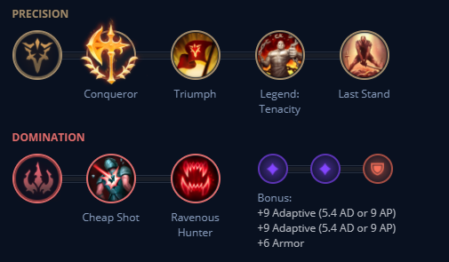

sustain:

Conqueror provides Amumu with a lot of what he misses and more. First off, it allows Amumu to have a better early game (note that if you want a better chance in early duels, Electrocute may be the way to go) since it gives him improved stats during skirmishes. Next, in the mid and late game, it allows him to be a MONSTER in extended fights, which is most of the times at this stage of the game. You will consistently heal for damage you deal, and that allows you to survive, almost like a juggernaut.

We run Triumph since it gives even more sustain and survivability during team fights, the person you engage on with Bandage Toss is almost definitely dying, and Triumph will heal you back the damage that their allies deal to you (because you're pretty much in their faces) while you reposition yourself.

We run Tenacity so, well, quite frankly so you don't get locked down.

Overgrowth is excellent because it allows you to scale your health (while Conditioning scales your defenses). Another very viable option I'm testing is Unflinching, which would help you when you engage and take a lot of damage, but given the fact Despair stays toggled on when you are stunned, you probably don't need the Tenacity.

Cheap Shot is nice because you get some extra damage when you engage and a ton more if you build Rylai's Crystal Scepter as your Despair will continuously proc this.

Ultimate Hunter allows your most useful ability- that turns the fight around- to be up more often

tank:

Aftershock gives you extra tank and damage and when you engage in a team fight with Bandage Toss. Your Despair with Rylai's Crystal Scepter will help you keep enemies in range for the damage burst.

Font of Life is good both in ganks and team fights- in ganks, you are less likely to lose an ally and furthermore more likely to get a kill down due to the heal, especially if you allies are struggling. Even though the effects seem minimal, they do really help! If you are going to be very active around the map, Demolish may be a good option to pack punches to turrets after successful ganks and break turret plates.

Conditioning is awesome to have despite its delay because you won't be very active before you get its effects. It adds onto your tank and allows you to peel for your carries more.

Overgrowth is excellent because it allows you to scale your health (while Conditioning scales your defenses). Another very viable option I'm testing is Unflinching, which would help you when you engage and take a lot of damage, but given the fact Despair stays toggled on when you are stunned, you probably don't need the Tenacity.

Cheap Shot is nice because you get some extra damage when you engage and a ton more if you build Rylai's Crystal Scepter as your Despair will continuously proc this.

Ultimate Hunter allows your most useful ability- that turns the fight around- to be up more often

ap:

Bandage Toss, Despair, Tantrum + Electrocute. More damage!! If you didn't proc it with these three, just aa. Electrocute is relatively strong since it does a lot of damage, especially early game, and the cooldown is alright since you'll only need it for ganks. Some people run Dark Harvest as well- I'm not completely opposed to that except that's more for one-shot builds, and it's difficult for Amumu to be able to do this. Feel free to, however!

Cheap Shot is nice because you get some extra damage when you engage and a ton more if you build Rylai's Crystal Scepter as your Despair will continuously proc this. If you can reliably land Bandage Toss I would suggest Sudden Impact (in other words experienced) as it allows you to deal more damage in ganks or team fights once you engage- this is for burst AP damage.

Eyeball Collection gives you AP per kill/assist. After all, that's what you want.. right? YOU CAN SWITCH THIS OUT BASED ON PREFERENCE! Don't feel restricted to do so!

Ultimate Hunter allows your most useful ability- that turns the fight around- to be up more often.

Transcendence works well with Amumu due to the CDR- you'll be popping off more Tantrum's and more Bandage Toss's not to mention ultimates. This does indeed mean more damage! This rune is best for a mid-game push, you can substitute this rune with: (A) Nimbus Cloak for a gap closer in ganks and extra boost if you Flash-R (B) Nullifying Orb against AP threats, for a defensive option (C) Absolute Focus or Gathering Storm for more damage.

In the current meta, capturing objectives (Dragon, Baron, Rift Herald) is insanely important and the Rift Scuttler is AWESOME! Since both of these are within the river, you're more likely to be able to contest these objectives. Also many fights (both duels and team fights) will occur in the river- why not gain an advantage? Would not substitute.

iteams:

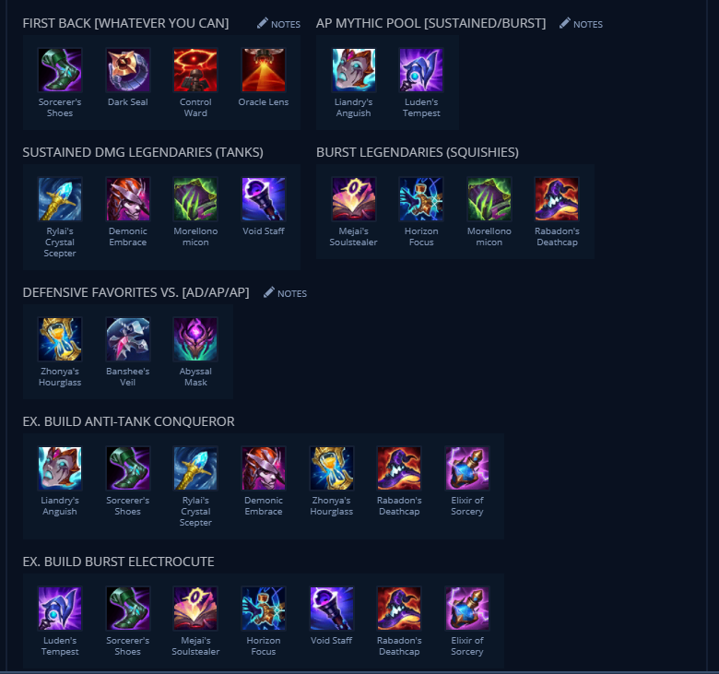

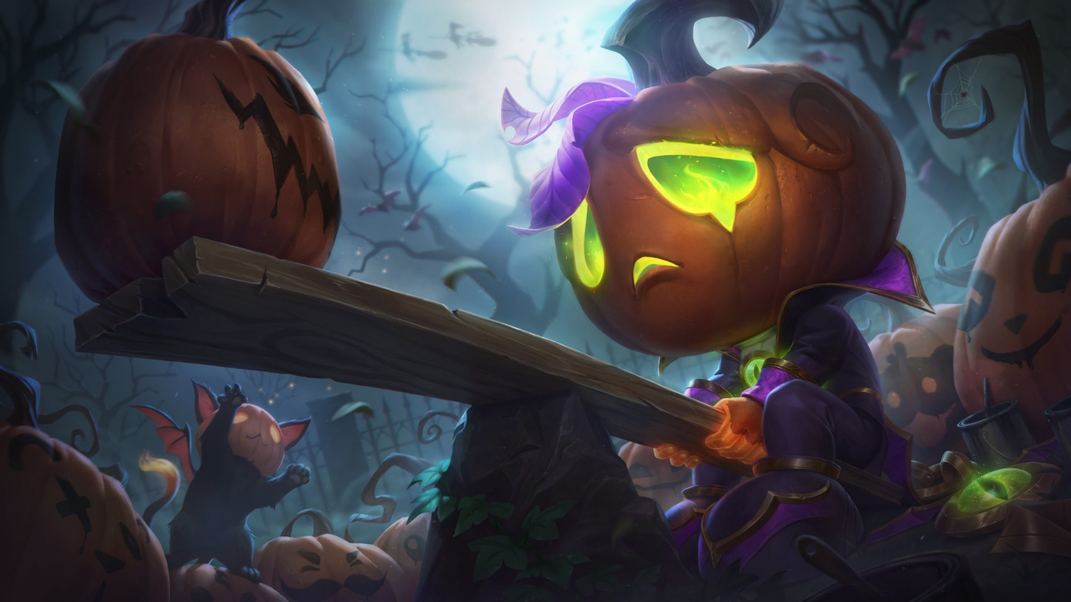

skill order:

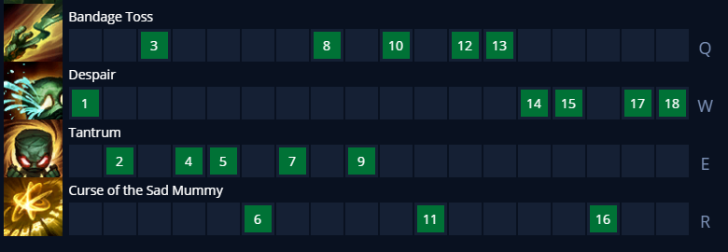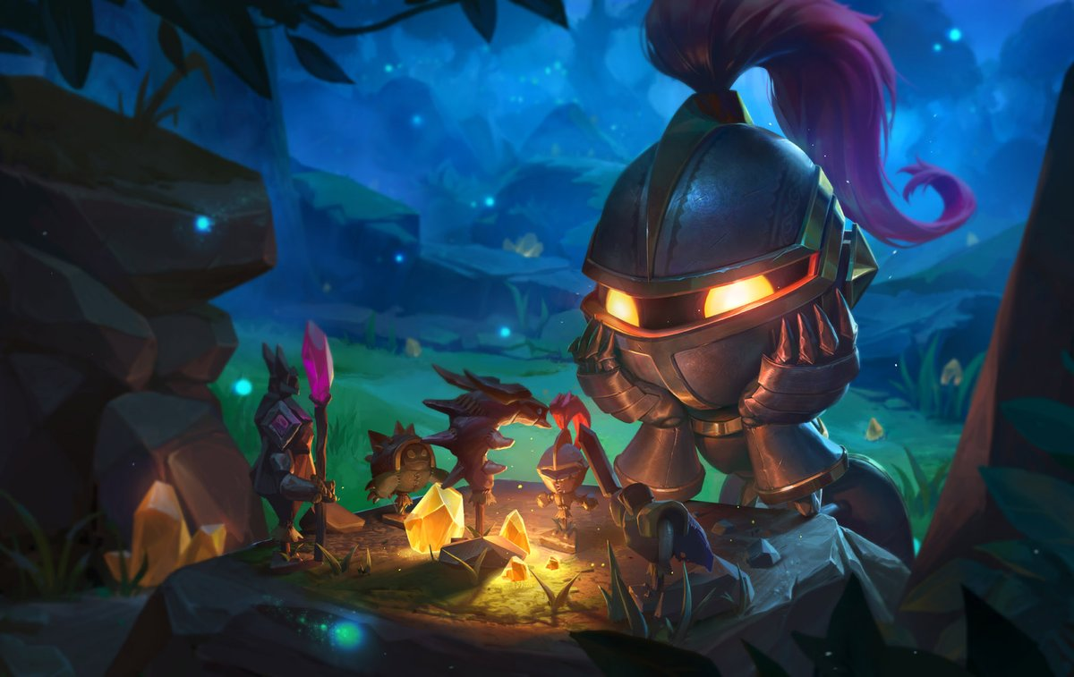

counters:

u lost:

nocturn,olaf,shaco,trundle.heca,jax,udyr,vi,xin

u won:

graves,ivern,kayn.yi,taliah,twitch,pantheon