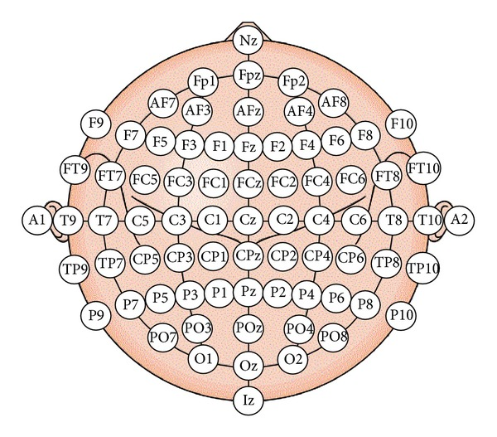

|  |
| --- |
| Auditory Tones |
| Somatosensory |
| Visual |

