**1.Introduction**

Our goal is :

-Identify signals found in raw IQ samples received through a SDR.

- FM Demodulate the detected signals and save the resulting audio to a WAV file.

Input :

-iq samples (complex)

- sample rate (Hz)

- Lo Freq( Hz)

Output:

1. Table printout of signals found inside the samples with the following features:

- RF Center Frequency in Hz

- Bandwidth in Hz

- Power Spectrum in dBm

2. Audio file for each detected signal

**2. Analyze the problem**

2.1 Fm bandwith:

-in general the the frequency of an FM broadcast station (more strictly its assigned nominal center frequency) is usually a multiple of 100 kHz.

(<https://en.wikipedia.org/wiki/FM_broadcasting>)

-More-over the carson bandwith rule states that the approximate bandwidth requirements of communications system components for a carrier signal that is frequency modulated is:

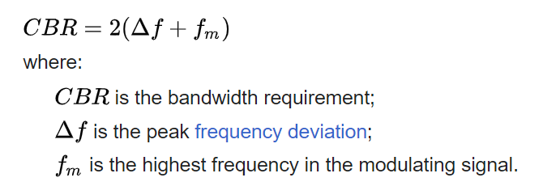

-broadcast stereo FM, with a peak deviation of 75 kHz, has a highest modulating frequency (which combines L+R and L-R) of 53 kHz. Most of the energy therefore falls within an approximate bandwidth of 2 * (75 + 53) = 256 kHz.

(<https://en.wikipedia.org/wiki/FM_broadcasting>)

The Fm bandhwith can be represented as following around baseband.

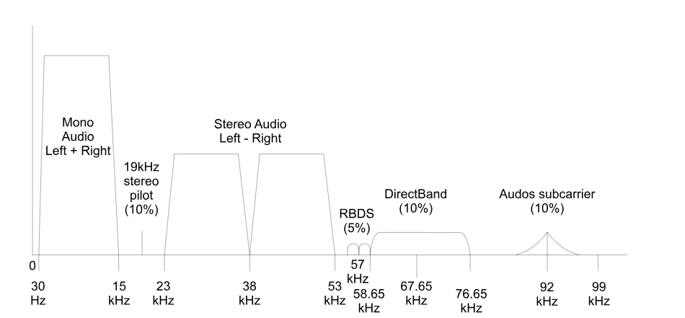

The 30-15khz represent the mono stereo which is the sum of left and right.

the tone at 19Khz is pilot indication for existence for stereo data used by the receiver to regenerate the 38 kHz sub-carrier

The 23-38 and 38-53 khz is stereo data which modulate in double-sideband suppressed-carrier.

Rds-Radio Data System signal, providing extra features such as station name, Alternative Frequency (AF) and convey Digital data.

* We will check for existence of stereo data by the pilot.

2.2 Fm representation

Let analyze problem analytically, our Fm transmission can be represented as following:

$$x_{FM}\left(t\right)=\sum_{i}{A_{fm}*\cos\left(2πf_{c_{i}}t+ϕ\left(t\right)\right)}=A_{fm}\sum_{i}{\cos\left(2πf_{c_{i}}t+2π*f_{Δ}\int_{0}^{t}{x\left(α\right)dα}\right)}$$

*Now we have i-q samples meaning we have analytic representation(phasor) in the form of*  ���(��+�)*so we have –*

$$x_{FM}\left(t\right)=\sum_{i}{{A_{fm}e}^{j(2πf_{c_{i}}t+2π*f_{Δ}\int_{0}^{t}{x\left(α\right)dα})}= \sum_{i}{A_{fm}e^{j(2πf_{c_{i}}t+2π*f_{Δ}\int_{0}^{t}{x\left(α\right)dα})}= }}$$

*And By sampling the signal , and approximate the integral by sample and hold we will get:*

$$x_{FM}\left(n\right)=\sum_{i}{{A_{fm}e}^{j(\frac{2πf_{c_{i}}n}{Fs}+2π*f_{Δ}\sum_{n}{x(n)})}}$$

*2.3 FM demodulation*

*Our first purpose is to understand how to demodulate FM signal.*

*For this let us take a look on one FM*

$$x_{FM_{i}}\left(n\right)=A_{fm}e^{j(\frac{2πf_{c_{i}}n}{Fs}+2π*f_{Δ}\sum_{n}{x_{i}(n)})}=A_{fm}e^{j(w_{i}n+2π*f_{Δ}\sum_{n}{x_{i}(n)})}$$

*And by looking and this component around baseband we will get- $A_{fm}e^{j(2π*f_{Δ}\sum_{n}{x_{i}(n)})}=A_{fm}e^{j(ϕ(n))}$.*

*We know that $f\left(t\right)=\frac{dϕ\left(t\right)}{dt}→\frac{\lim_{Δt→0}\left(ϕ\left(t+Δt\right)-ϕ\left(t\right)\right)}{Δt }$*

*By approximate the derivative according to our sample we will get $f\left(n\right)=ϕ\left(n+1\right)-ϕ\left(1\right)$*

*And in this way get our signal x(t) at the specific channel.*

*we can find this difference by multiply the delayed signal with the conjugate of current signal and extract the phase of this expression:*

$$x_{i}\left(n\right)*x_{i}{\left(n-1\right)}^{*}=b_{fm}e^{j\left(2π*f_{Δ}\sum_{n}{x_{i}\left(n\right)}\right)}e^{-j\left(2π*f_{Δ}\sum_{n}{x_{i}\left(n\right)}\right)}=b_{fm}(e^{j\left(2π*f_{Δ}\sum_{n}{x_{i}\left(n\right)}-\sum_{n-1}{x_{i}\left(n\right)}\right)}=b_{fm}(e^{j\left(2π*f_{Δ}x_{i}\left(n\right)\right)})$$

$$\arg\left(x_{i}\left(n\right)*x_{i}{\left(n-1\right)}^{*}\right)=2π*f_{Δ}x_{i}\left(n\right) =cx_{i}\left(n\right)$$

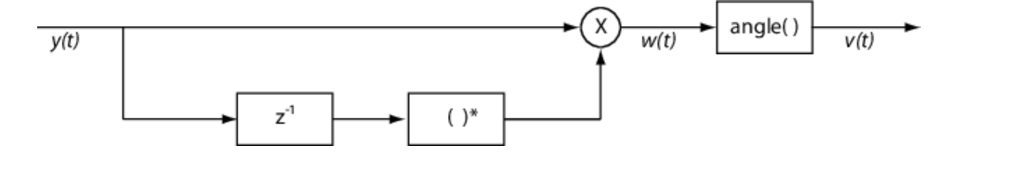

*So we get the sample of single Fm channel up to scale the consistent along all channels.*

*In practice the $f_{Δ}$ in the last expression is regularly noted as $h or moudaltion index$ and equal to $h=\frac{Δf}{fm}$,the fm come from integral over the data in the baseband.*

*For digital modulation systems where a binary signal modulates the carrier, the modulation index is given by: $h=\frac{Δf}{fm}=\frac{Δf}{fs}$* *we will use it it to scale(the use of fs is because of iq samples as explained latter).*

***3. general strategy(algorithm) :***

*From this understanding we can derive our strategy:*

*-Detect all Fm channels that exist- find their fc and their bandwidth.*

*-For each channel do:*

*1. apply bandpass filter*

*2.moudlate each channel to baseband*

*3.apply Fm demodulation*

*4.implemnation*

*4.1 detection of channels:*

*As first step we take a look on the spectrogram of the signal :*

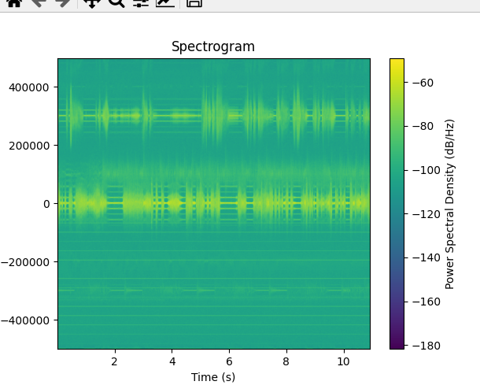

*(We used overlap of 50%,hann window, where each window is psd with 1024 coefficient  
which give frequency resolution of 1k approx)*

*We clearly see that there is two dominant channel across dc and 300Khz.*

*\*Here is worth to say that because of we have complex data ,iq samples , the foruiour transform is no more symmetric as in the real numbers data scenario ,and by adding the extra samples of the imaginary part which in practice means that we add more data , our spectrum is now expand to negative frequencies(which are negative offset from the carrier where the data was sampled) meaning that Fn=Fs .*

*by taking close look one can see there is suspicious channels also in 100Khz and -300Khz.*

*To examine this better we can take a look and the psd(power spectrum density)-*

*At first step we tried to plot regular psd but the variance of the data is to big there for we used welch method(average over overlapped psds) to reduce the variance in the samples ,we take window of 16384 bins- meaning the frequency resolution is Fs/N~60Hz*

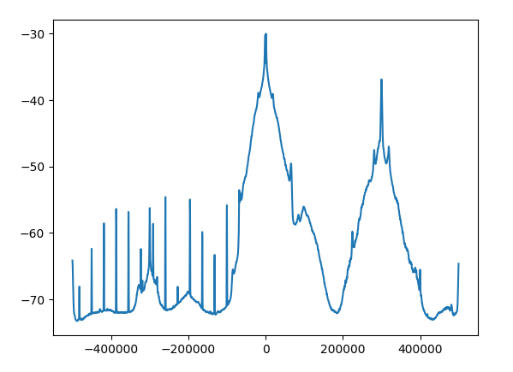 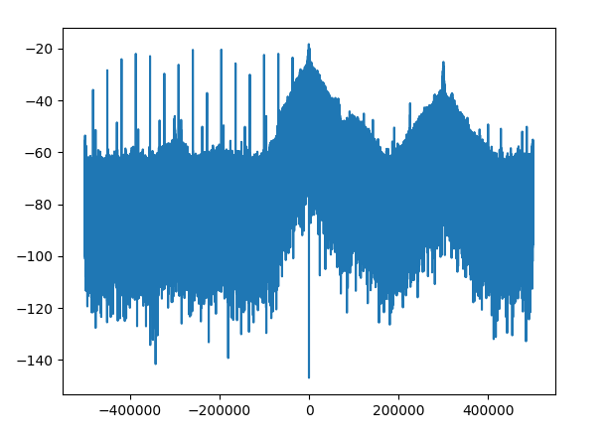

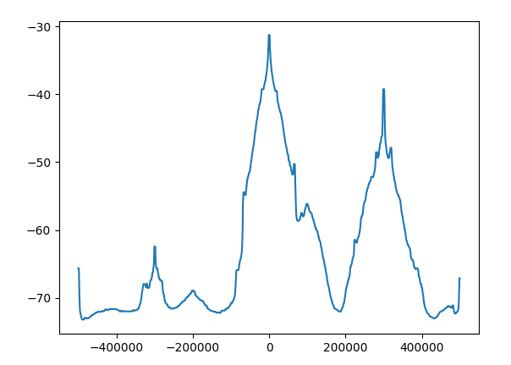

*To clean the psd and find relevant carriers we used median filter with 10 taps ,  
~ 600hz aprox.*

*Now we can see there is 4-5 suspicious channels.*

