**HW2: Optical Flow and Video Stabilization**

Gal oren 206232506

Odai _________

**1. What is the constant brightness constraint? In you answer relate to:**

**a. How does it help us to solve the optical flow between two images?**

**b. Is this assumption correct in real world scenarios? (what happens when there are reflective objects in the image?)**

**answer**

The constant brightness constraint is a fundamental assumption in optical flow estimation that states that the brightness of a point in an image remains constant over time. In other words, if a point moves between two frames of a video, the intensity of that point will remain the same.

1. The constant brightness constraint is used in optical flow estimation to solve for the motion of each pixel between two consecutive frames of a video. By assuming that the brightness of each pixel is constant, we can set up a system of equations that relates the motion of each pixel to the gradient of the image intensity at that point. This system of equations can then be solved to estimate the motion of each pixel.

Its expressed in the equation by the assumption that brightness doesn't change with u,v changes.

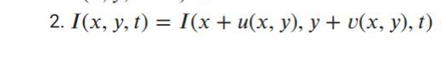

1. No in reality it is not always accurate scenarios. In particular, the constant brightness constraint may be violated in the presence of reflective objects in the image. This is because the intensity of a reflective object may change as it moves, due to changes in the lighting conditions or the reflection angle

.it is often necessary to preprocess the image data to remove specular reflections and other image artifacts that can affect the accuracy of optical flow estimation

**2.What is the aperture problem and what can we do about it?**

**answer**

the aperture problem refers to the fact that the motion of a one-dimensional spatial structure, such as a bar or edge, cannot be determined unambiguously if it is viewed through a small aperture such that the ends of the stimulus are not visible.

To illustrate this problem, consider a vertical edge like in the image below that is moving horizontally. If we estimate the motion of the edge based only on the local image features within a small neighborhood around the edge, we may incorrectly infer that the edge is moving vertically, rather than horizontally. This is because the local image features do not provide enough information to distinguish between these two possible motions.

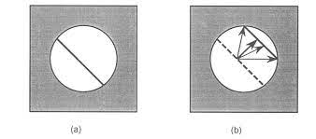

Mathmaticly this problem arose from the fact that if we take a look on the equation 

So we have two unknowns and cannot be solves as such (we need two constraints to solve for v, and we only have one).

3. **How did Lucas-Kanade solve the optical flow problem? (what did they assume about the movement of each pixel?). Hint: it is related to the movement of the neighbourhood of each pixel.**

**answer**

The Lucas-Kanade suggest solve the optical flow problem by assuming that the motion of each pixel in the image can be approximated by a linear motion model, which is based on the motion of its local neighborhood. Specifically, the algorithm assumes that the image intensity in a small neighborhood around a pixel moves by a constant amount between two consecutive frames.

To estimate the optical flow using this assumption, the Lucas-Kanade algorithm first selects a small neighborhood of pixels around each pixel in the first image. It then assumes that the motion of the pixel in the second image can be approximated by the motion of this neighborhood in the first image.

The algorithm then solves a set of linear equations to estimate the motion parameters that best fit the pixel motion in the second image. Specifically, it solves for the u and v displacement vectors that minimize the sum of squared differences between the intensities of the corresponding pixels in the two images, subject to the linear motion model assumption.

The mathematically description is like this :

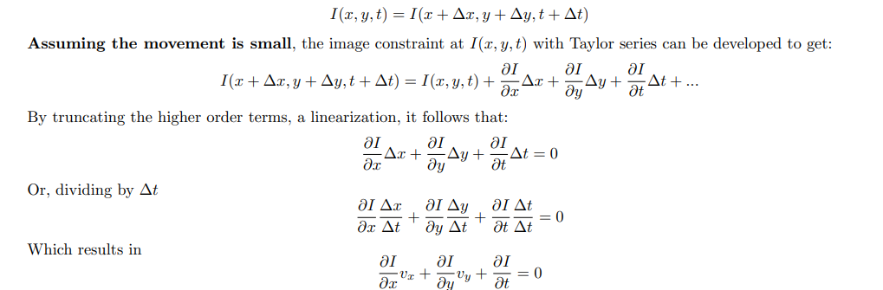

where $v_{X} v_{y}$ are the x and y components of the velocity, or optical flow, of I(x, y, t), and $\frac{∂I}{∂x}=Ix ,\frac{∂I}{∂y}=Iy \frac{∂I}{∂t}=It$ at (x, y, t) in the corresponding directions.

4. **Is the Lucas-Kanade assumption true around the object boundaries? Why?**

**answer**

Around object boundaries, the LK assumption may not hold true. This is because object boundaries often contain sharp changes in brightness, which can cause errors in optical flow estimation. When the brightness changes abruptly, the LK algorithm may not be able to accurately track the motion of features across the boundary.

5. **Propose a general idea how to correctly find the optical flow on the object’s boundaries, given you can get any input you desire (except from the true movement of each pixel). For example, you can get a depth map / label image (you know for each pixel to which object it belongs to or what is its depth). Write which inputs you assume to have and the general idea of your solution**

**answer**

Assuming we have access to a depth map we can use the following approach:  
First, we use the depth map to segment the image into distinct objects or regions. This can be done using standard image segmentation techniques, such as thresholding or clustering

Next, we estimate the optical flow within each segmented region separately. This helps to avoid errors at the boundaries of objects, where intensity changes can cause the local motion assumption of optical flow estimation to break down.

The idea is that if we segment the objects and perform optical flow on them then this will strengthen the assumption that all the pixels in the window move in the same way with the same u and v.