**HW1: Harris Corner Detection and Intro to Video Processing**

**Name: gal oren**

**Id:206232506**

**Section 1 – Python Basic (0 points):**

1. **. How can we select and run a portion of the code without running the rest of the code?**

Highlight the portion of code you want to run, right-click on it, and select "Run selection" or a similar option from the context menu, common shortcuts are Shift+Enter or Ctrl+Shift+Enter.

1. **How is it possible to stop the code execution at a certain point? For example, before execution of a line of code that may raise an exception. Can we see the call stack and run commands with existing variables?**

In most programming languages and environments, its possible to add a breakpoint to the code to pause the execution at a certain point, such as before the execution of a line of code that may raise an exception. A breakpoint allows to inspect the current state of the program, including the call stack and the values of variables at that point in time.

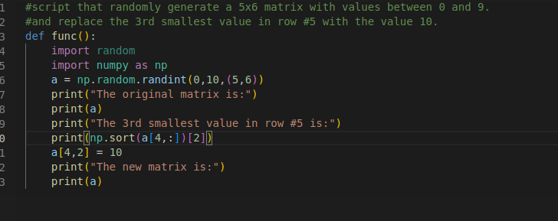

**Section 2: Harris Corner Detector :**

**2**.**1.1** Is Harris corner detector invariant to translation? Yes/No? Explain

YES,If we look at a square around the original point and around the translated point, then the derivatives in the x and y direction in this square will be the same and therefore it is not affected by the translation and there will be no change in the eigenvalues (it should be noted that the position of these eigenvalues will be in a different position depending on the translation)**2.1.2** Is Harris corner detector invariant to rotation? Yes/No? Explain.

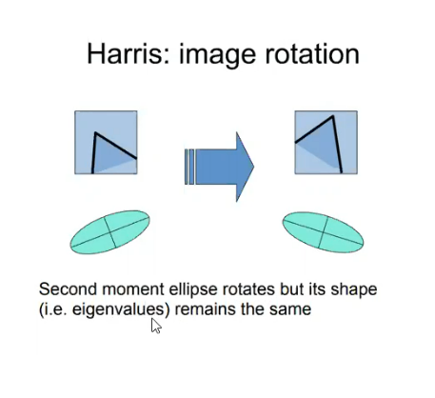

YES, as before the value of the eigenvalue will not change, the rotation will just change the eigenvector but the derivatives will remain the same, though will get the same corner.

**2**.**1.1**  Is Harris corner detector invariant to constant illumination (𝐼 ? Yes/No? 𝑜𝑢𝑡 = 𝑎 * 𝐼 𝑖𝑛 + 𝑏)?

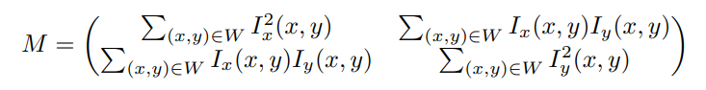

NO,As we see in the matrix M, the eigenvalues depend on the values of the derivatives, and while the change in intensity (b) does not change, the change in contrast (a) will result in a change in the values of the derivatives and, accordingly, in the value of the eigenvalues. Intuitively, the size of the corners changes but the size of the window remains the same, so we get a different result.

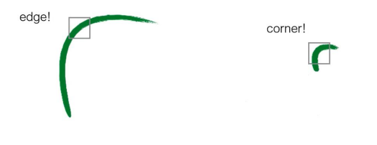

**2.4**

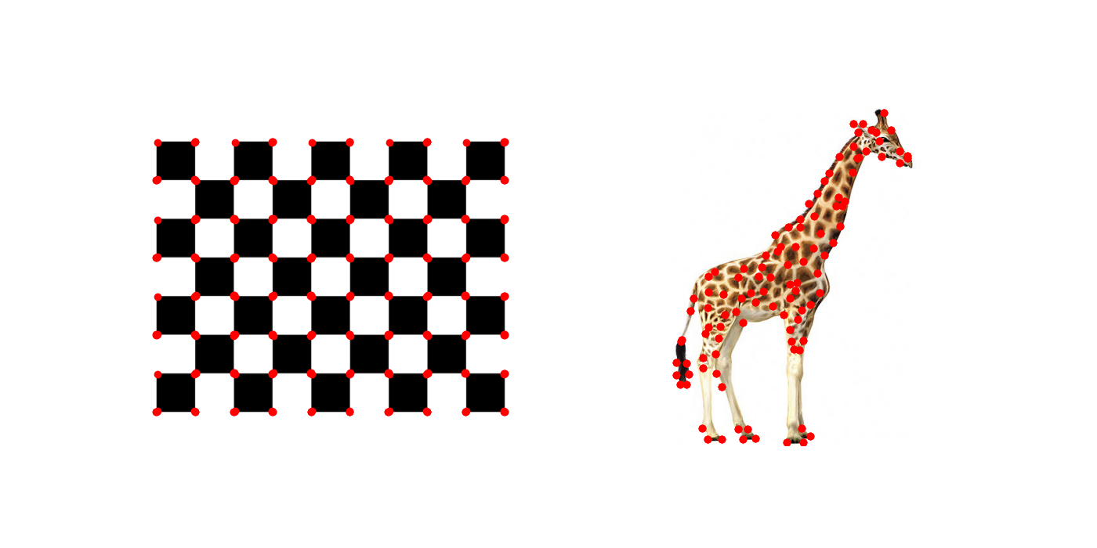

We make this image with k=2 , in general, the optimal values of the parameters such as K and depend on the specific image and application.   
Therefore To find the optimal values of these parameters, we try different values of K and evaluate the performance of the algorithm and take the once that that yield the best performance.

For the initial K, you can see that in the chessboard image there are points that are not corners, so it was clear that we had to increase K.

**Section 3 – Video Manipulation Basics (30 points):**

The Sobel operator is a spatial filter for edge detection. It works by computing the gradient of the image intensity at each pixel.  
The Sobel operator consists of two kernels, one for detecting horizontal edges and another for detecting vertical edges. The horizontal kernel is:

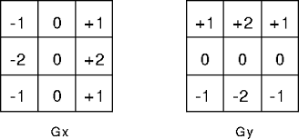

To obtain the edge map of each frame of a video, the Sobel operator can be applied to each frame individually. The resulting output image will contain the edges detected in that frame.  
since the edge map may contain a lot of noise, it is common to apply additional processing, such as thresholding meaning setting all pixel values below a certain threshold to zero and all pixel values above the threshold to one as we did in 3.2 part In this exercise.