**PEMROGRAMAN MOBILE**

**TUGAS 1**



**MUHAMMAD IQBAL MAKMUR AL-MUNIRI**

**2241720099**

**TEKNIK INFORMATIKA**

**TEKNOLOGI INFORMASI**

**Instalasi GIT**

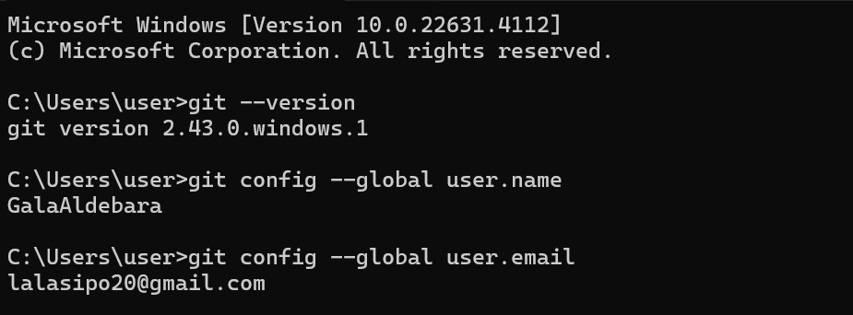

**Instalasi VScode + Plugin Flutter**

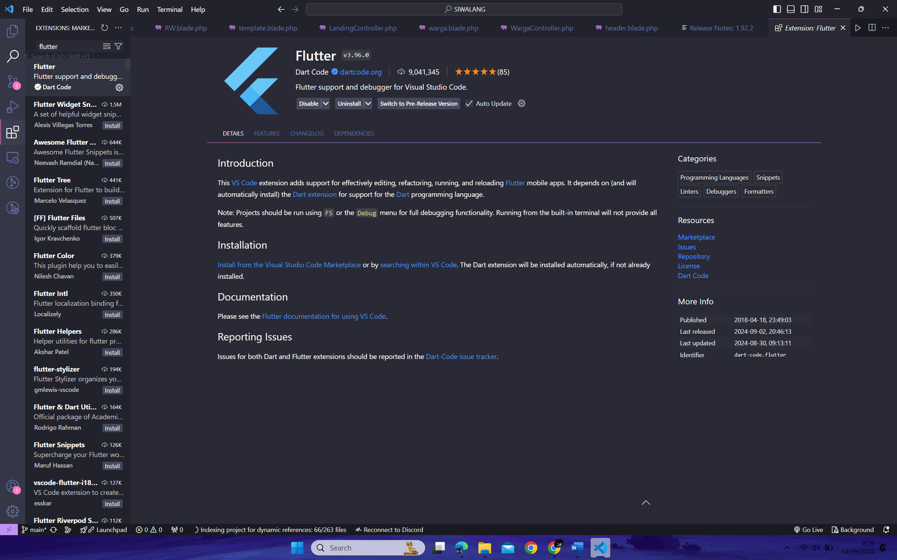

**Instalasi Flutter SDK**

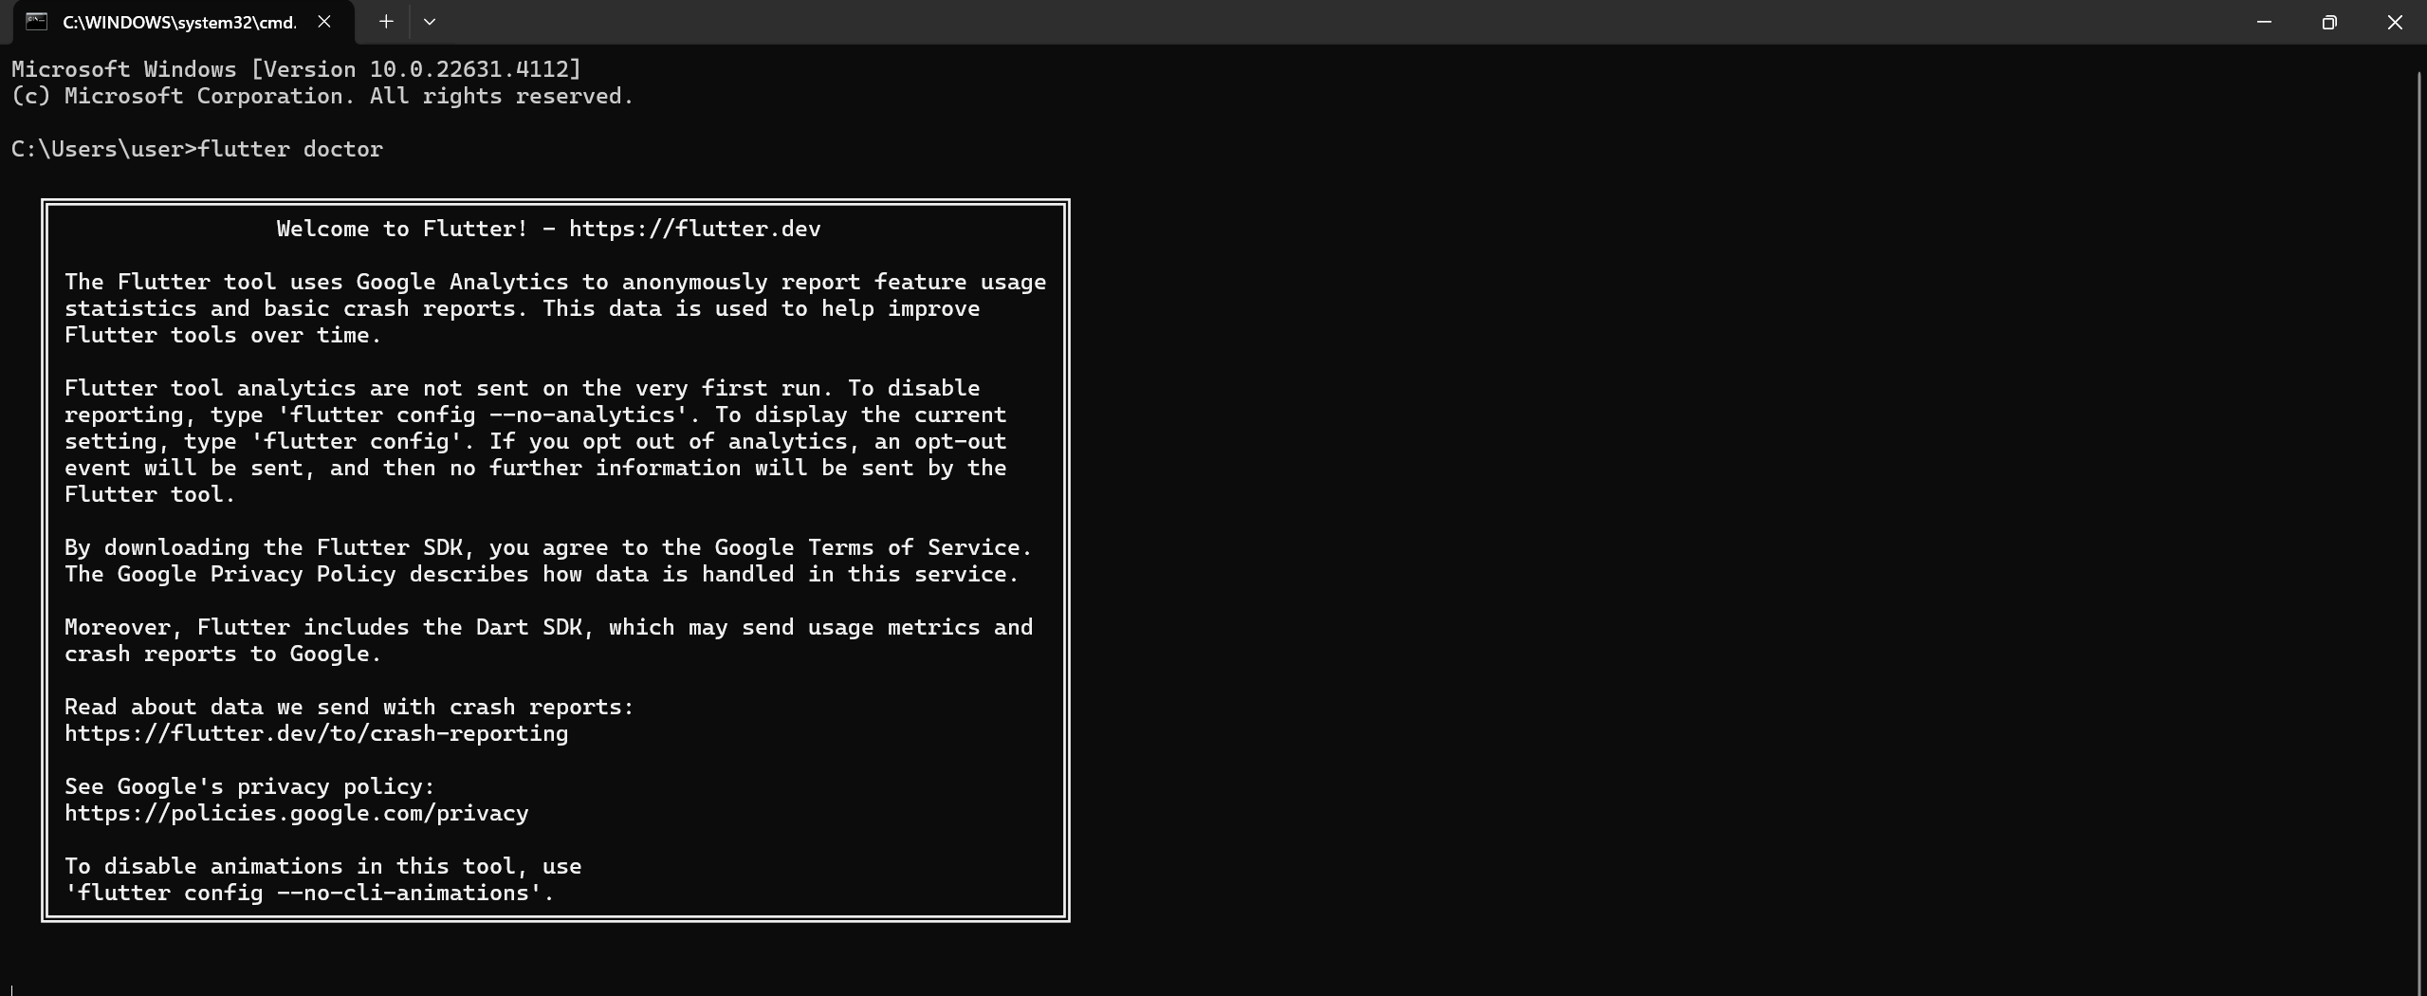

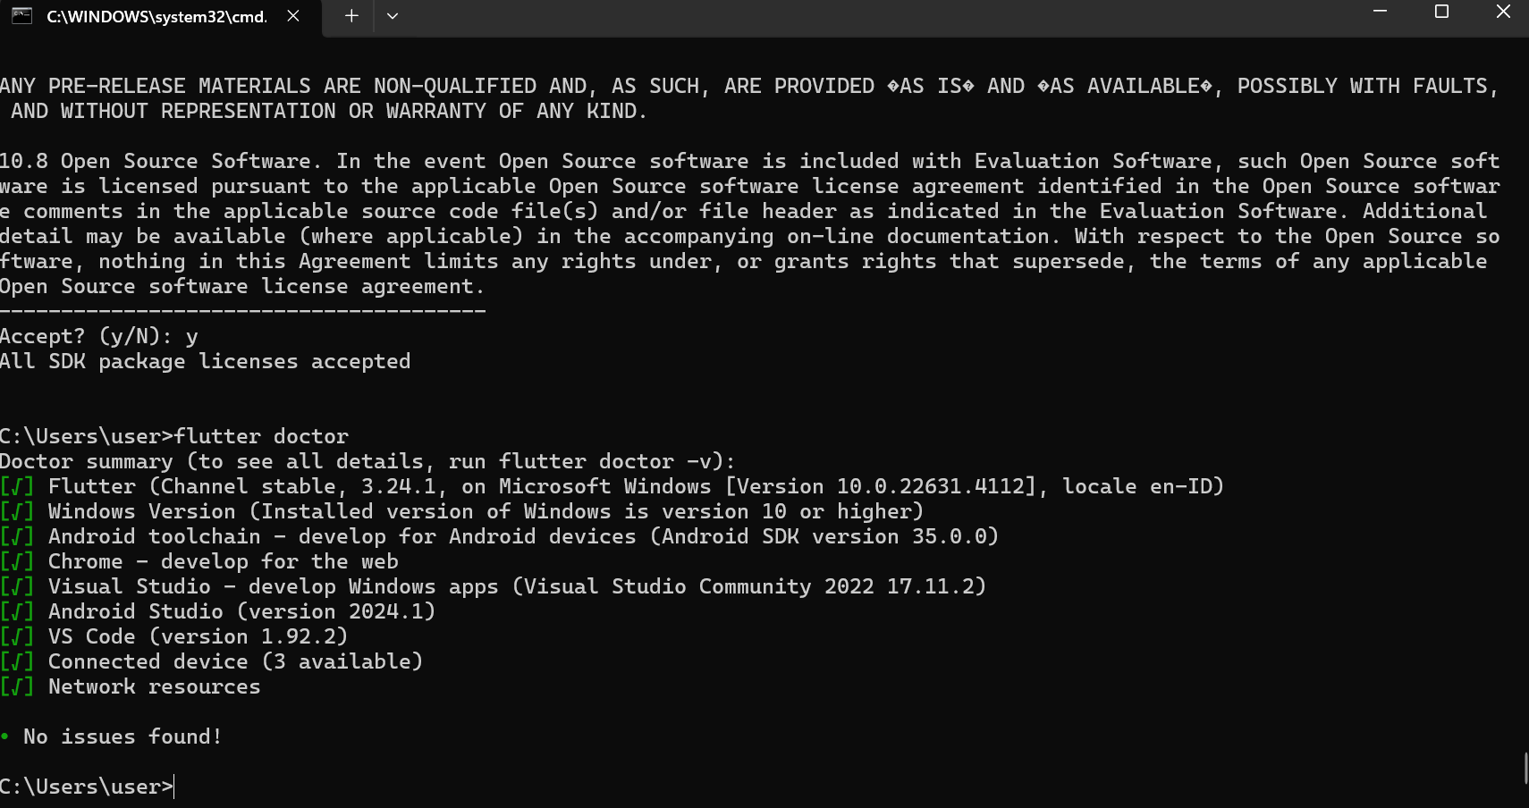

**Instalasi Android Studio**

