Task 1
Develop a Gantt Chart for the project, including major development activities, durations, and dependencies. [1.5 marks]
Project Schedule and Dependencies
The schedule translates the SAMS analysis and design scope into a dependency-based plan. Requirements work is completed first, after which prototyping and DFD modeling proceed in parallel. Later UML and database activities follow the models on which they depend, while dedicated integration and quality-review periods are reserved before the final submission. Dependencies are finish-to-start unless parallel work is stated in the schedule.
Activity | Start | Finish | Duration | Dependency
Requirements Gathering | 18 Jul 2026 | 19 Jul 2026 | 2 days | None
Requirements Analysis | 20 Jul 2026 | 20 Jul 2026 | 1 day | Requirements Gathering
Prototype Design | 21 Jul 2026 | 22 Jul 2026 | 2 days | Requirements Analysis
DFD Design | 21 Jul 2026 | 23 Jul 2026 | 3 days | Requirements Analysis
Use Case Model | 24 Jul 2026 | 26 Jul 2026 | 3 days | DFD Design
Mid Progress Report | 26 Jul 2026 | 26 Jul 2026 | Milestone (0 days) | Use Case Model
Activity Diagrams | 27 Jul 2026 | 27 Jul 2026 | 1 day | Use Case Model
Class Diagram | 28 Jul 2026 | 30 Jul 2026 | 3 days | Use Case Model
Database Design | 31 Jul 2026 | 2 Aug 2026 | 3 days | Class Diagram
Integration and Consistency Check | 3 Aug 2026 | 5 Aug 2026 | 3 days | Prototype Design, Activity Diagrams, Database Design
Final Quality Review and Formatting | 6 Aug 2026 | 8 Aug 2026 | 3 days | Integration and Consistency Check
Milestones: Mid Project Progress Report - 26 Jul 2026; Final Project Submission - 9 Aug 2026 at 23:59.

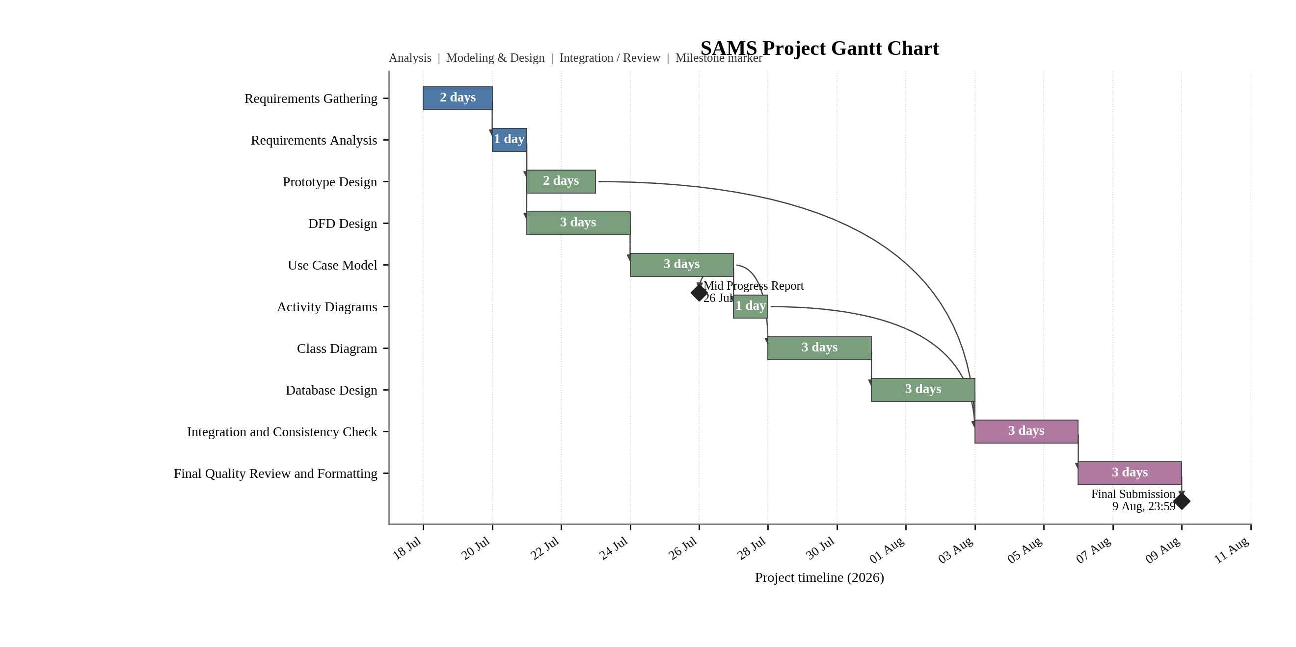
Figure 1. SAMS project Gantt chart showing major activities, durations, dependencies, parallel work, and submission milestones.
Schedule Rationale
The sequence is intentionally dependency-driven: requirements gathering establishes the project scope, and requirements analysis provides the common baseline for both prototype and DFD development. These two activities run in parallel because they use the same approved requirements but produce different analysis outputs. The Use Case Model then refines the functional interactions needed for the activity and class models, while the relational database design follows the class model so that entities, relationships, and keys remain consistent. The mid-project report is treated as a formal milestone on 26 July. After all core models are completed, the schedule reserves three days for cross-model integration and consistency checking, followed by three days for final quality review and formatting. The final submission is shown as a separate milestone on 9 August at 23:59, directly matching the official deadline.

