Student Activities Management System (SAMS)
Task 2 - Prototyping
Course | System Analysis and Design (IT-353)
CRN | 50268
Assigned Student | Gala Algodah - S240031741

Task Requirement
Select ONE prototyping approach (Evolutionary Prototyping or Throwaway Prototyping). Develop low-fidelity prototypes for three main screens of the system and justify why the chosen approach is more appropriate for this project. [2 marks]

Selected Prototyping Approach: Evolutionary Prototyping
Evolutionary Prototyping is appropriate for SAMS because the system combines several interdependent services and serves three stakeholder groups with different needs. The team can begin with a low-fidelity version, obtain feedback from students on browsing and registration clarity, from activity organizers on activity information and registration rules, and from Student Affairs on approval and policy requirements. The same prototype can then be revised, validated, and progressively refined toward implementation. This iterative cycle is particularly useful for SAMS because changes to registration, waitlist, notifications, attendance, certificates, and activity-history functions must remain consistent across connected screens.
Throwaway Prototyping would be more suitable if the purpose were only to explore an uncertain requirement and discard the prototype once the requirement became clear. SAMS already has a stable core scope and several related workflows, so repeatedly discarding complete prototypes would create unnecessary rework and make cross-screen consistency harder to maintain. The main trade-off of Evolutionary Prototyping is the risk that temporary design decisions may become permanent. This risk can be controlled by maintaining a stable requirements baseline and reviewing each iteration against the approved scenario before it is accepted into the evolving prototype.

Low-Fidelity Prototype Screens
The following wireframes intentionally remain low fidelity. They focus on information structure, navigation, system feedback, and the student workflow rather than visual styling. Each screen is directly traceable to requirements stated in the SAMS scenario.

Requirements Traceability
Prototype screen | Scenario requirements represented | Design evidence
Browse Activities | Browse by category, campus, or date; discover available activities. | Search field, three filters, activity cards, availability status, and View Details action.
Activity Details and Registration | View details; reserve a seat; apply eligibility, capacity, deadline, and waitlist rules. | Schedule, location, deadline, eligibility, attendance method, capacity/availability, and state-dependent primary action.
My Activities | Cancel before deadline; receive waitlist updates; use electronic attendance; view history, hours, certificates, and transcript. | Cancel Reservation, waitlist status/exit, QR attendance, summary, certificates, and Activity Transcript access.
Traceability purpose: the table shows that the three screens were selected from the official scenario rather than added as generic interface examples.

Screen 1: Browse Activities
This screen supports activity discovery through search and filters for category, campus, and date. Activity cards show availability status and direct the student to the details screen, where registration rules and the appropriate next action can be evaluated consistently.
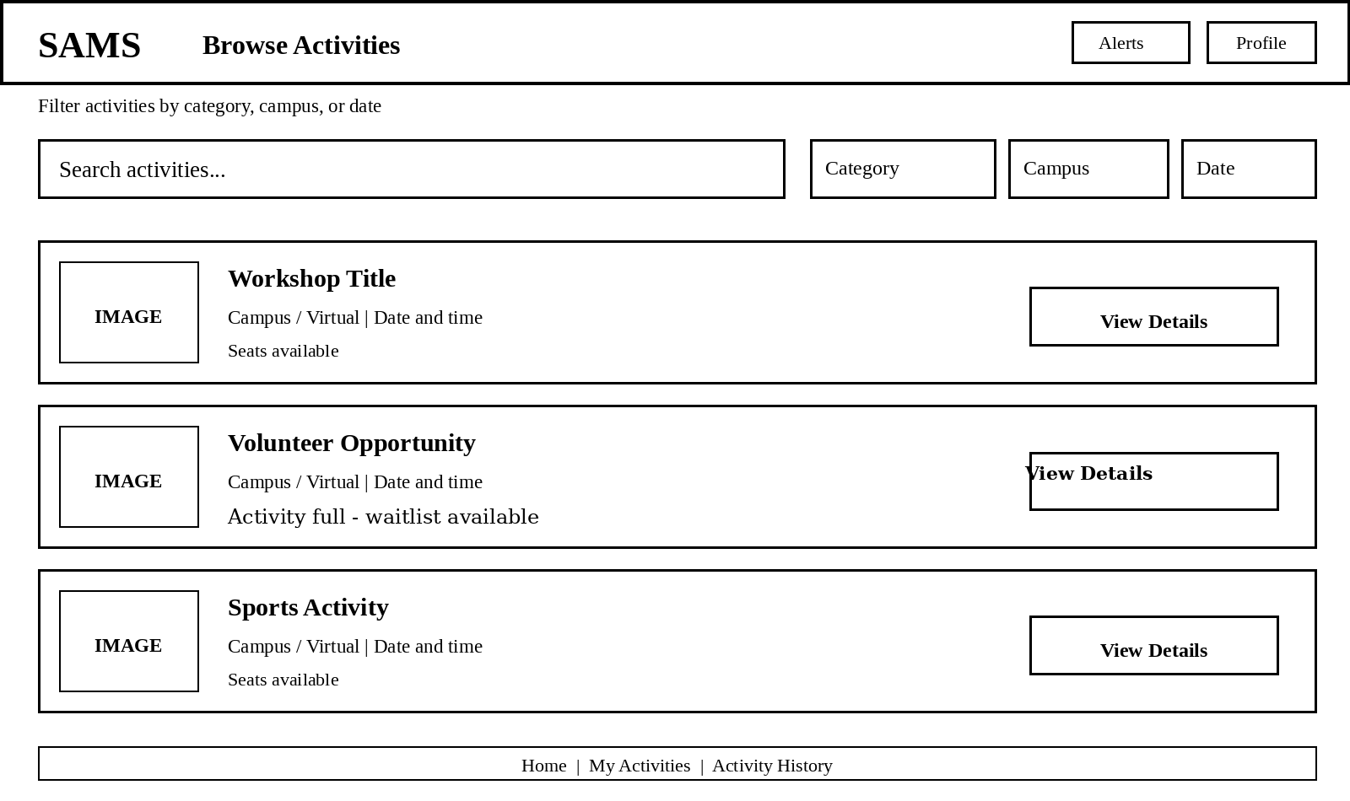
Figure 1. Low-fidelity Browse Activities screen.

Screen 2: Activity Details and Registration
This screen presents the information required for an informed registration decision: category, campus, schedule, location, registration deadline, eligibility requirements, attendance method, capacity, and current availability. The primary action is state-dependent: Register when registration is open and the student is eligible and a seat is available; Join Waitlist when capacity is full; Registration Closed after the deadline; and Not Eligible when eligibility rules are not satisfied.
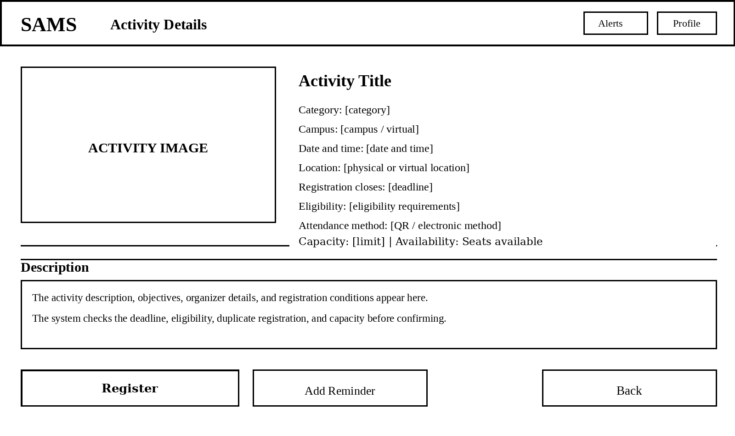
Figure 2. Low-fidelity Activity Details and Registration screen.

Screen 3: My Activities
This screen supports the student after registration by combining confirmed activities, waitlist status, attendance access, activity history, participation hours, certificates, and the activity transcript. A confirmed reservation can be cancelled before the registration deadline, and the electronic attendance code is available for the upcoming activity. Waitlisted students can also leave the waitlist and receive automatic status updates when a vacancy becomes available.
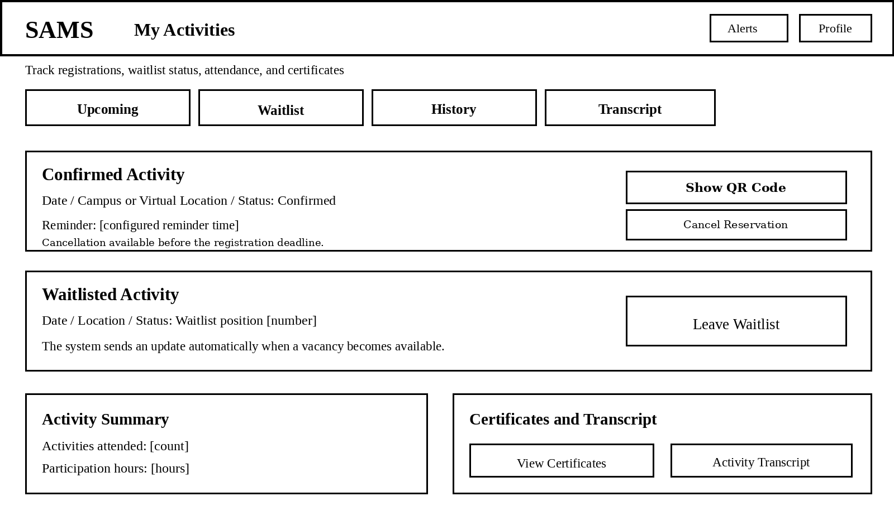
Figure 3. Low-fidelity My Activities screen.

Prototype Interaction Flow and Design Rationale
Student flow: Browse Activities -> View Activity Details -> Register or Join Waitlist -> My Activities -> QR Attendance / History / Certificates / Activity Transcript.
Design rationale: Screen 1 reduces discovery effort by grouping the required filters with concise availability feedback. Screen 2 places eligibility, deadline, capacity, and attendance information before the primary action so invalid or unavailable actions can be prevented. Screen 3 centralizes the post-registration lifecycle, including cancellation, waitlist status, attendance, certificates, and the graduation transcript.
Evolutionary iteration cycle: low-fidelity draft -> stakeholder feedback -> revise navigation and information -> validate business rules and workflow -> evolve the accepted prototype toward implementation. This keeps the prototype simple enough for early feedback while ensuring that each revision remains traceable to the approved SAMS requirements.

