Task 6
Develop a UML Class Diagram including classes, attributes, methods, associations, multiplicities, and inheritance where appropriate. [3 marks]
The UML class model translates the SAMS functional requirements into an object-oriented structure. The model uses User as an abstract superclass and represents registration, waiting-list placement, approval, attendance, certificates, notifications, achievements, and the activity transcript as separate domain classes. Association classes are used where the scenario contains many-to-many relationships.
UML Class Diagram
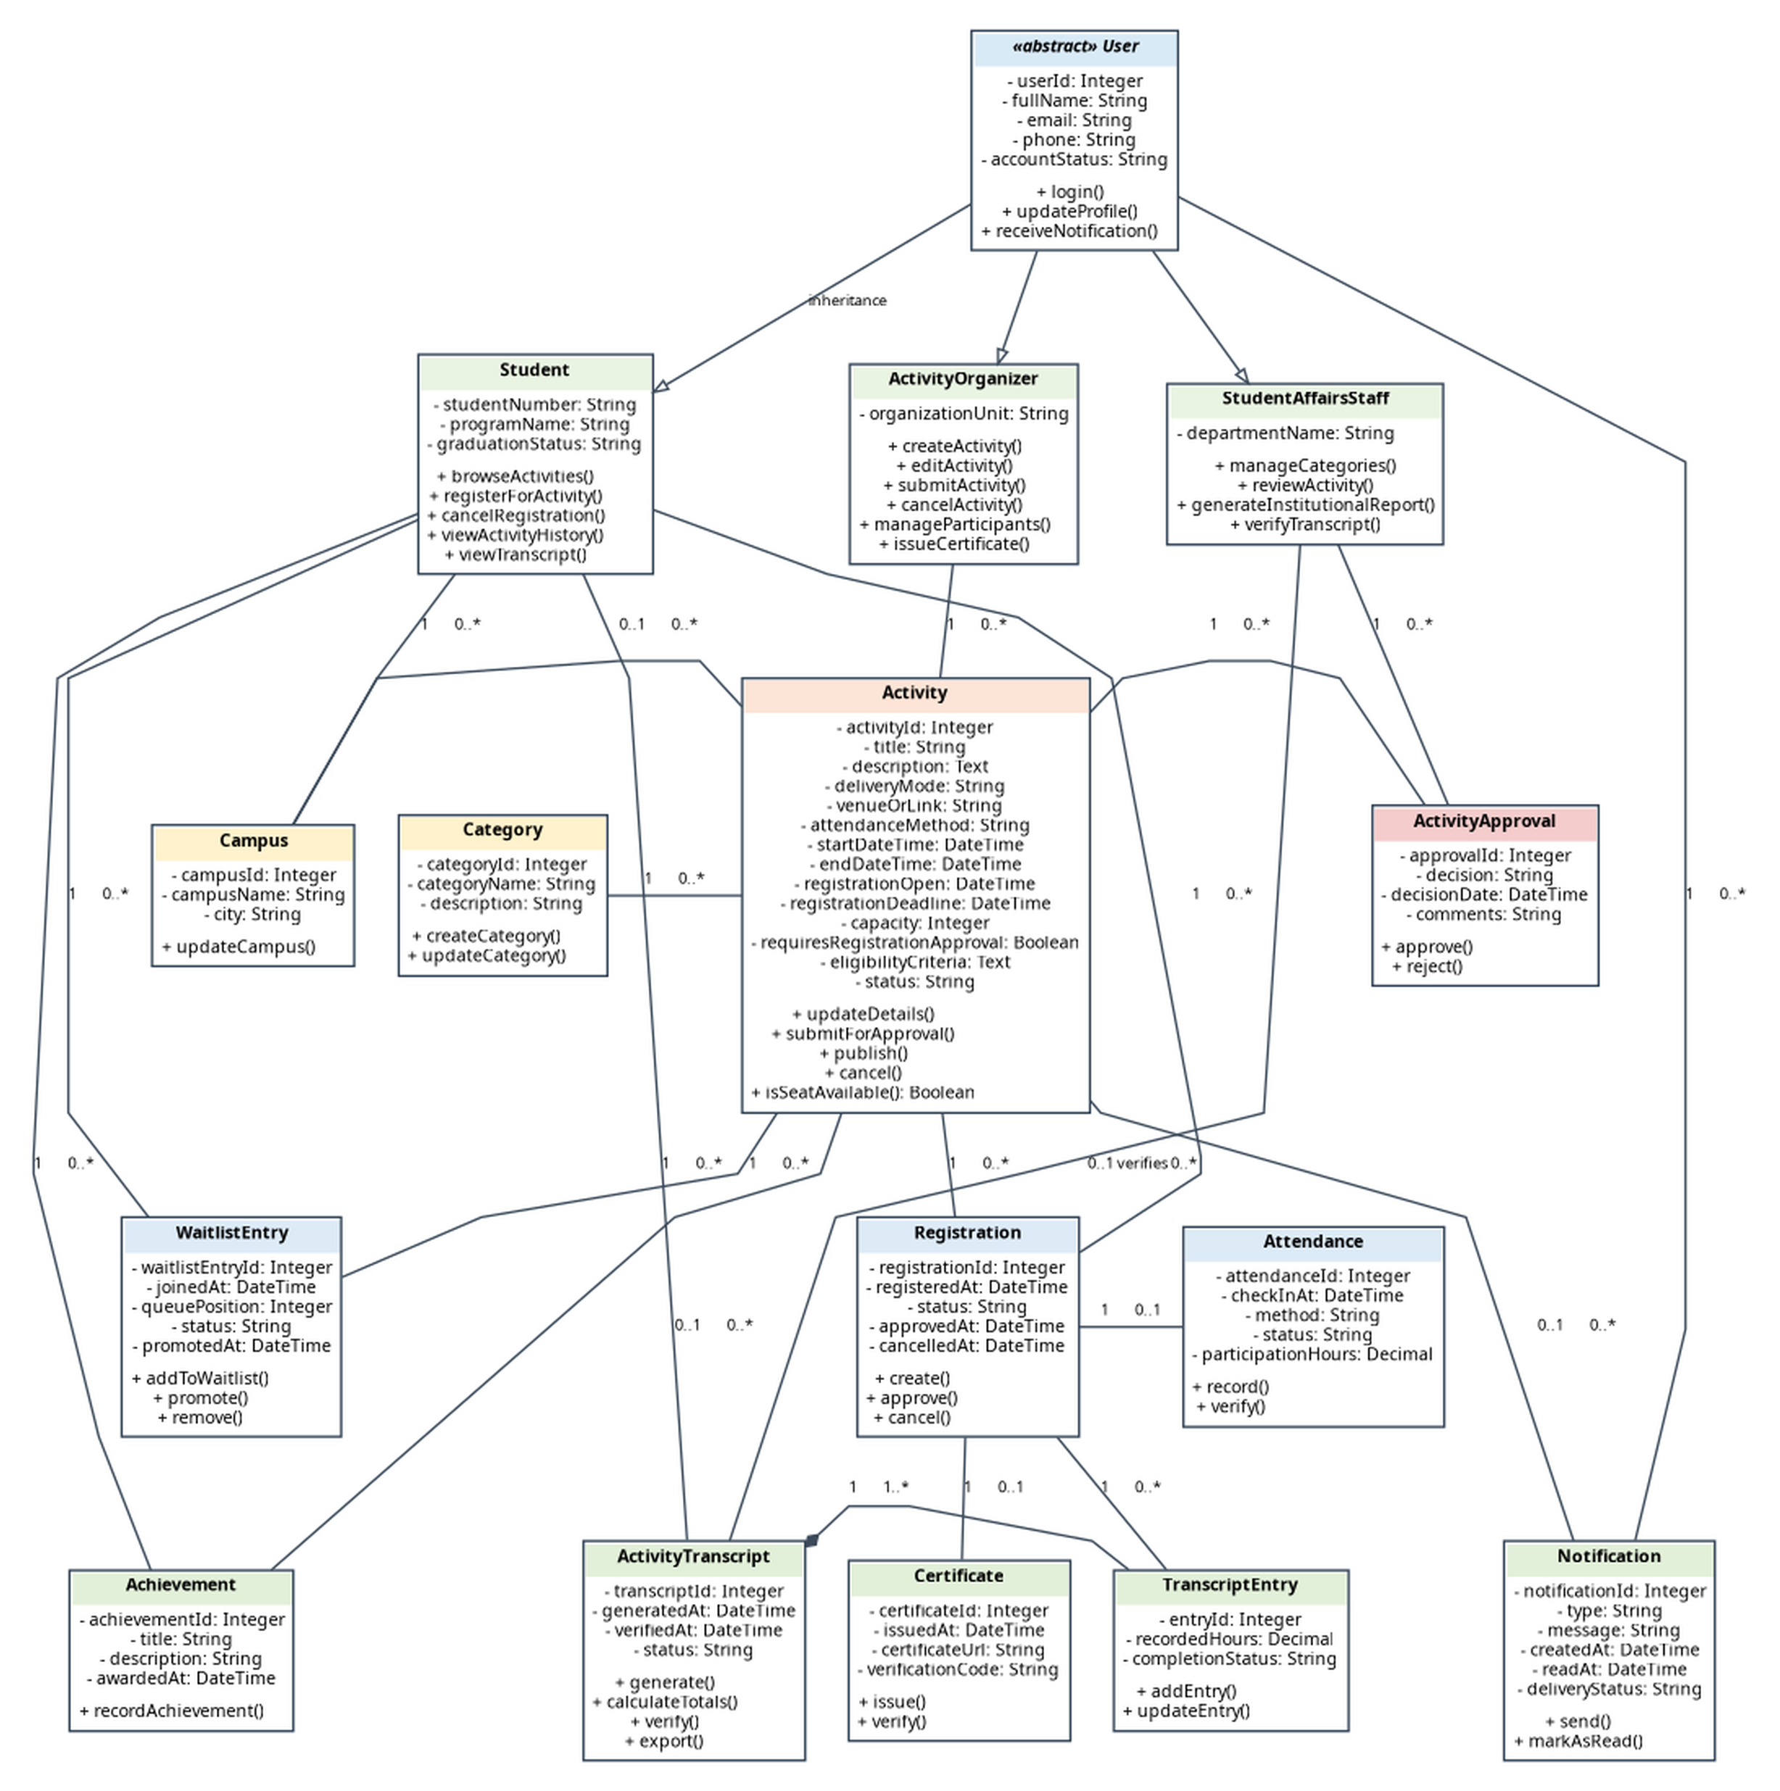
Figure 13. UML Class Diagram for the Student Activities Management System (SAMS).
Association, Multiplicity, and Inheritance Rules
Relationship | Multiplicity / Type | Meaning in SAMS
User → Student / ActivityOrganizer / StudentAffairsStaff | Generalization | The three specialized actors inherit common identity, profile, and notification behavior from the abstract User class.
Campus — Student | 1 to 0..* | Each student is assigned to one campus; a campus may have many students.
Campus — Activity | 0..1 to 0..* | A physical activity may be associated with one campus; a virtual activity may have no campus.
Category — Activity | 1 to 0..* | Each activity belongs to one category; a category may classify many activities.
ActivityOrganizer — Activity | 1 to 0..* | Each activity has one organizer; an organizer may manage many activities.
Activity — ActivityApproval | 1 to 0..* | An activity may have multiple review decisions over revision cycles.
StudentAffairsStaff — ActivityApproval | 1 to 0..* | Each approval decision is recorded by one staff member.
Student — Registration — Activity | 1 to 0..* / 1 to 0..* | Registration resolves the many-to-many relationship between students and activities.
Student — WaitlistEntry — Activity | 1 to 0..* / 1 to 0..* | WaitlistEntry records queue position and promotion status when capacity is reached.
Registration — Attendance | 1 to 0..1 | A confirmed registration may produce one attendance record.
Registration — Certificate | 1 to 0..1 | A completed eligible participation may produce one certificate.
Student — Achievement | 1 to 0..* | A student may earn multiple extracurricular achievements.
Activity — Achievement | 0..1 to 0..* | An achievement may be linked to the activity in which it was earned.
User — Notification | 1 to 0..* | A user may receive many confirmations, reminders, cancellations, and waitlist updates.
Student — ActivityTranscript | 1 to 0..* | A student may have generated transcript versions during the academic journey.
ActivityTranscript — TranscriptEntry | 1 to 1..* (composition) | A transcript is composed of entries derived from completed registrations.
StudentAffairsStaff — ActivityTranscript | 0..1 verifies 0..* | A transcript may be verified by Student Affairs before graduation.
Design Rationale and Consistency
- Registration and WaitlistEntry correspond directly to the registration and waitlist processes modeled in the Level-0 and Level-1 DFDs.
- ActivityApproval enforces the use-case and activity-diagram rule that an activity is published only after Student Affairs approval.
- Attendance and Certificate support electronic check-in, participation-hour recording, and certificate issuance.
- ActivityTranscript and TranscriptEntry support the graduation transcript without storing duplicated total values; totals are calculated from completed entries.
- Notification supports registration confirmations, reminders, cancellations, and automatic waitlist-promotion updates.

