Task 5
Develop two UML Activity Diagrams for two major business processes. [2 marks]
The two activity diagrams represent cross-role workflows that are central to SAMS. The registration workflow covers request validation, capacity control, optional organizer approval, waitlist placement, automatic promotion when a seat becomes available, and student notifications. The activity-management workflow covers creation, validation, Student Affairs review, rejection and revision, approval, publication, and notifications. Swimlanes separate actor responsibilities from automated SAMS actions, while guarded decision paths make alternative outcomes explicit. Together, the models remain consistent with the Task 4 use cases and the scenario business rules without adding functionality beyond the stated requirements.
Activity Diagram 1: Student Registration and Waitlist
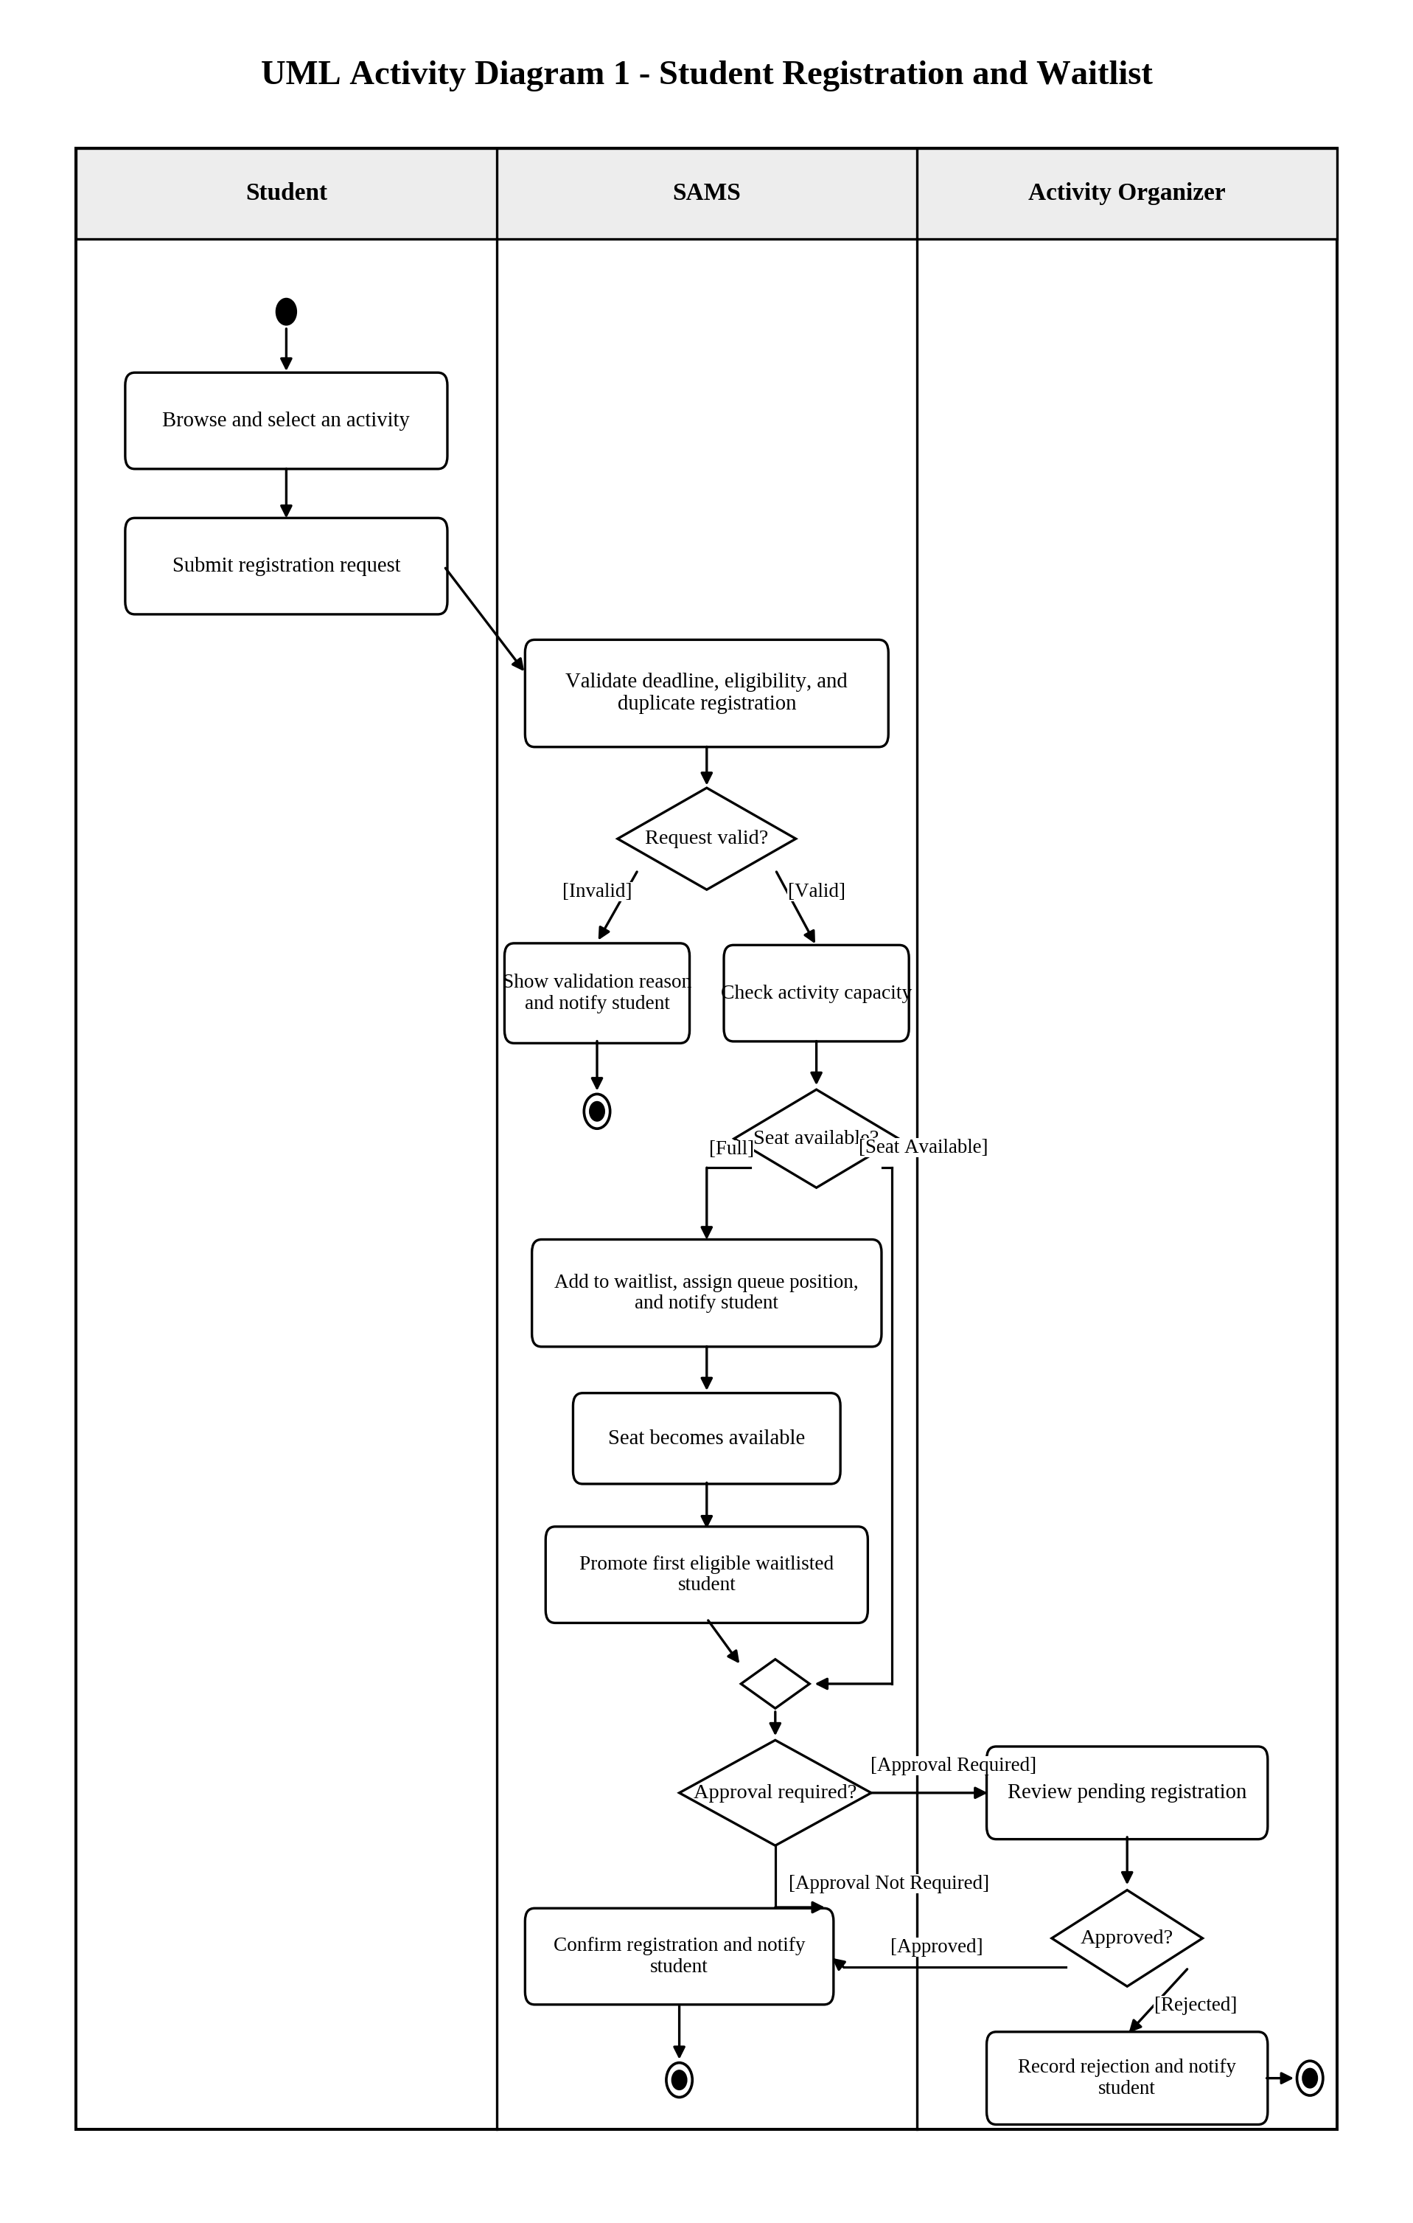
Figure 11. UML Activity Diagram for registration validation, capacity control, waitlist promotion, and optional approval.
Activity Diagram 2: Activity Creation, Approval, and Publication
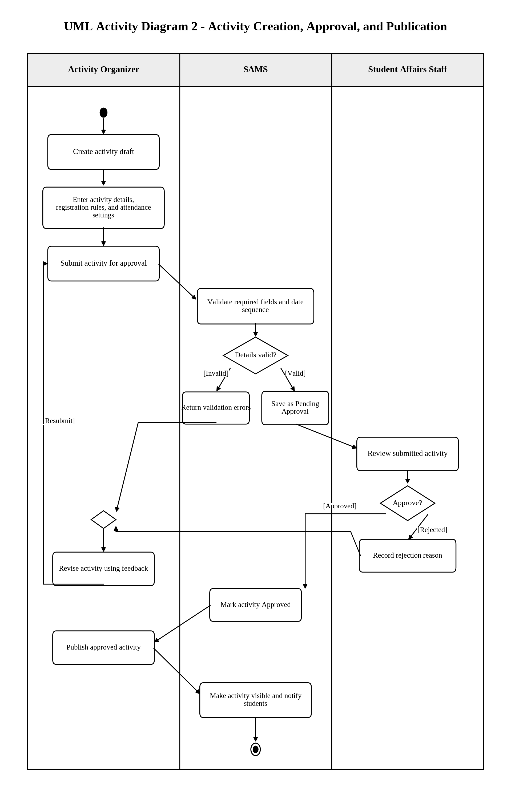
Figure 12. UML Activity Diagram for activity creation, validation, Student Affairs approval, revision, publication, and notification.

