Task 7
• Design the relational database,
• including tables,
• primary keys
• foreign keys
• appropriate data types
• and normalization
• (up to at least Third Normal Form). [3 marks]
The relational design is derived from the UML class model. All primary and foreign keys use compatible data types, role-specific data is separated from the common user record, and associative tables resolve student–activity relationships. The design also preserves approval history, waitlist promotion, electronic attendance, certificates, achievements, notifications, and activity-transcript records.
Relational Database Schema
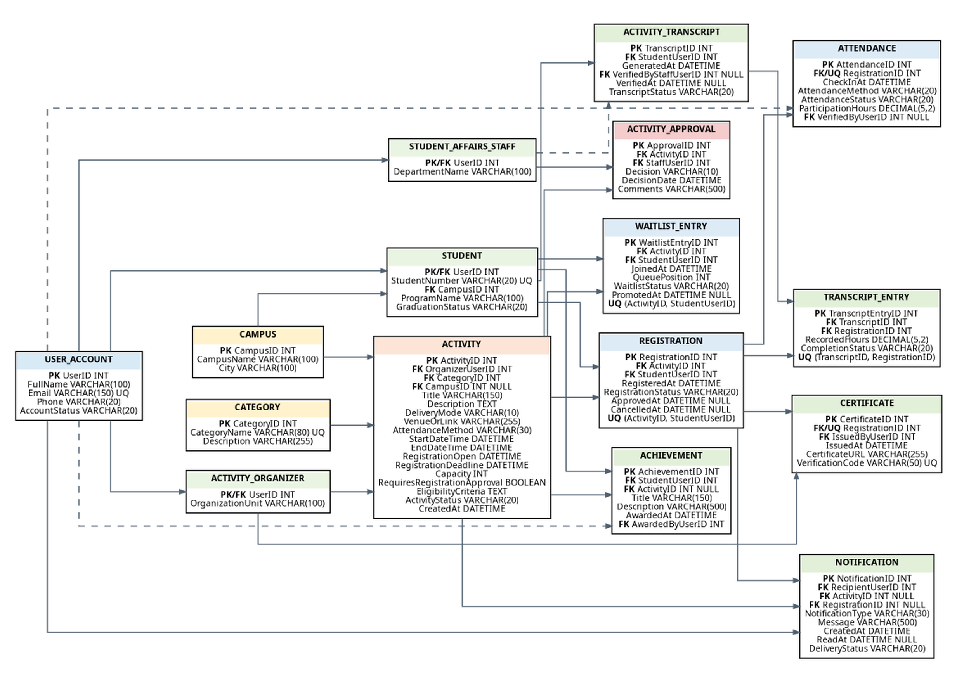
Figure 14. Normalized relational database schema for SAMS.
Table Definitions, Keys, and Data Types
Table | Columns and Data Types | Keys and Constraints
USER_ACCOUNT | UserID INT  FullName VARCHAR(100)  Email VARCHAR(150)  Phone VARCHAR(20)  AccountStatus VARCHAR(20) | PK: UserID  UQ: Email
CAMPUS | CampusID INT  CampusName VARCHAR(100)  City VARCHAR(100) | PK: CampusID
STUDENT | UserID INT  StudentNumber VARCHAR(20)  CampusID INT  ProgramName VARCHAR(100)  GraduationStatus VARCHAR(20) | PK/FK: UserID → USER_ACCOUNT  FK: CampusID → CAMPUS  UQ: StudentNumber
ACTIVITY_ORGANIZER | UserID INT  OrganizationUnit VARCHAR(100) | PK/FK: UserID → USER_ACCOUNT
STUDENT_AFFAIRS_STAFF | UserID INT  DepartmentName VARCHAR(100) | PK/FK: UserID → USER_ACCOUNT
CATEGORY | CategoryID INT  CategoryName VARCHAR(80)  Description VARCHAR(255) | PK: CategoryID  UQ: CategoryName
ACTIVITY | ActivityID INT  OrganizerUserID INT  CategoryID INT  CampusID INT NULL  Title VARCHAR(150)  Description TEXT  DeliveryMode VARCHAR(10)  VenueOrLink VARCHAR(255)  AttendanceMethod VARCHAR(30)  StartDateTime DATETIME  EndDateTime DATETIME  RegistrationOpen DATETIME  RegistrationDeadline DATETIME  Capacity INT  RequiresRegistrationApproval BOOLEAN  EligibilityCriteria TEXT  ActivityStatus VARCHAR(20)  CreatedAt DATETIME | PK: ActivityID  FK: OrganizerUserID → ACTIVITY_ORGANIZER  FK: CategoryID → CATEGORY  FK: CampusID → CAMPUS
ACTIVITY_APPROVAL | ApprovalID INT  ActivityID INT  StaffUserID INT  Decision VARCHAR(10)  DecisionDate DATETIME  Comments VARCHAR(500) | PK: ApprovalID  FK: ActivityID → ACTIVITY  FK: StaffUserID → STUDENT_AFFAIRS_STAFF
REGISTRATION | RegistrationID INT  ActivityID INT  StudentUserID INT  RegisteredAt DATETIME  RegistrationStatus VARCHAR(20)  ApprovedAt DATETIME NULL  CancelledAt DATETIME NULL | PK: RegistrationID  FK: ActivityID → ACTIVITY  FK: StudentUserID → STUDENT  UQ: (ActivityID, StudentUserID)
WAITLIST_ENTRY | WaitlistEntryID INT  ActivityID INT  StudentUserID INT  JoinedAt DATETIME  QueuePosition INT  WaitlistStatus VARCHAR(20)  PromotedAt DATETIME NULL | PK: WaitlistEntryID  FK: ActivityID → ACTIVITY  FK: StudentUserID → STUDENT  UQ: (ActivityID, StudentUserID)
ATTENDANCE | AttendanceID INT  RegistrationID INT  CheckInAt DATETIME  AttendanceMethod VARCHAR(20)  AttendanceStatus VARCHAR(20)  ParticipationHours DECIMAL(5,2)  VerifiedByUserID INT NULL | PK: AttendanceID  FK/UQ: RegistrationID → REGISTRATION  FK: VerifiedByUserID → USER_ACCOUNT
CERTIFICATE | CertificateID INT  RegistrationID INT  IssuedByUserID INT  IssuedAt DATETIME  CertificateURL VARCHAR(255)  VerificationCode VARCHAR(50) | PK: CertificateID  FK/UQ: RegistrationID → REGISTRATION  FK: IssuedByUserID → ACTIVITY_ORGANIZER  UQ: VerificationCode
ACHIEVEMENT | AchievementID INT  StudentUserID INT  ActivityID INT NULL  Title VARCHAR(150)  Description VARCHAR(500)  AwardedAt DATETIME  AwardedByUserID INT | PK: AchievementID  FK: StudentUserID → STUDENT  FK: ActivityID → ACTIVITY  FK: AwardedByUserID → USER_ACCOUNT
NOTIFICATION | NotificationID INT  RecipientUserID INT  ActivityID INT NULL  RegistrationID INT NULL  NotificationType VARCHAR(30)  Message VARCHAR(500)  CreatedAt DATETIME  ReadAt DATETIME NULL  DeliveryStatus VARCHAR(20) | PK: NotificationID  FK: RecipientUserID → USER_ACCOUNT  FK: ActivityID → ACTIVITY  FK: RegistrationID → REGISTRATION
ACTIVITY_TRANSCRIPT | TranscriptID INT  StudentUserID INT  GeneratedAt DATETIME  VerifiedByStaffUserID INT NULL  VerifiedAt DATETIME NULL  TranscriptStatus VARCHAR(20) | PK: TranscriptID  FK: StudentUserID → STUDENT  FK: VerifiedByStaffUserID → STUDENT_AFFAIRS_STAFF
TRANSCRIPT_ENTRY | TranscriptEntryID INT  TranscriptID INT  RegistrationID INT  RecordedHours DECIMAL(5,2)  CompletionStatus VARCHAR(20) | PK: TranscriptEntryID  FK: TranscriptID → ACTIVITY_TRANSCRIPT  FK: RegistrationID → REGISTRATION  UQ: (TranscriptID, RegistrationID)
Referential Integrity and Business Rules
Rule | Constraint
BR-01 | An activity references exactly one organizer and one category; CampusID is nullable for fully virtual activities.
BR-02 | A newly created activity may remain Draft. After submission, ActivityStatus remains Pending Approval until Student Affairs records a decision; rejected activities are not published.
BR-03 | The pair (ActivityID, StudentUserID) is unique in REGISTRATION, preventing duplicate registration.
BR-04 | When confirmed registrations reach Capacity, additional eligible students are inserted into WAITLIST_ENTRY in queue order. When a confirmed seat becomes vacant before the deadline, the earliest eligible active waitlist entry is promoted automatically.
BR-05 | The pair (ActivityID, StudentUserID) is unique in WAITLIST_ENTRY, preventing duplicate waiting-list positions. Application or transaction logic also prevents a student from holding an active registration and an active waitlist entry for the same activity at the same time.
BR-06 | A registration can have at most one attendance record and at most one certificate, enforced by unique RegistrationID values.
BR-07 | ParticipationHours must be non-negative and is recorded only for verified attendance.
BR-08 | A certificate is associated with a completed registration and has a unique verification code.
BR-09 | Notifications may refer to an activity, a registration, or both, supporting confirmations, reminders, cancellations, and waitlist updates.
BR-10 | When a student reaches graduation status, SAMS generates the activity transcript for verification by Student Affairs. Transcript totals are calculated from TRANSCRIPT_ENTRY and related completed registrations and are not duplicated in ACTIVITY_TRANSCRIPT.
Normalization to Third Normal Form (3NF)
Normal Form | How the Design Satisfies It
First Normal Form (1NF) | Every table has a primary key, each column contains a single atomic value, and repeating groups are separated. For example, registrations, waitlist positions, notifications, and transcript entries are stored as individual rows rather than repeated columns in STUDENT or ACTIVITY.
Second Normal Form (2NF) | All non-key attributes depend on the whole primary key. Most tables use a single-column surrogate key. Where a natural composite relationship exists, a unique constraint such as (ActivityID, StudentUserID) is applied, while registration status and dates remain dependent on that complete student–activity relationship.
Third Normal Form (3NF) | Transitive dependencies are removed. Campus and category details are not stored in ACTIVITY; role-specific attributes are not stored in USER_ACCOUNT; approval details are not stored in ACTIVITY; and certificate, attendance, achievement, and notification data are kept in their own tables. Derived totals such as total attended activities and total hours are calculated for the transcript instead of being stored redundantly.
Representative Functional Dependencies
Relation | Functional Dependency
USER_ACCOUNT | UserID → FullName, Email, Phone, AccountStatus
ACTIVITY | ActivityID → OrganizerUserID, CategoryID, CampusID, Title, Description, DeliveryMode, VenueOrLink, AttendanceMethod, dates, Capacity, RequiresRegistrationApproval, EligibilityCriteria, ActivityStatus, CreatedAt
REGISTRATION | RegistrationID → ActivityID, StudentUserID, RegisteredAt, RegistrationStatus, ApprovedAt, CancelledAt
ATTENDANCE | RegistrationID → CheckInAt, AttendanceMethod, AttendanceStatus, ParticipationHours, VerifiedByUserID
ACTIVITY_APPROVAL | ApprovalID → ActivityID, StaffUserID, Decision, DecisionDate, Comments
TRANSCRIPT_ENTRY | TranscriptEntryID → TranscriptID, RegistrationID, RecordedHours, CompletionStatus
Cross-Model Consistency Check
Process or Use Case | Supporting Tables
Manage Activities / Create and Submit Activity | ACTIVITY, CATEGORY, CAMPUS, ACTIVITY_APPROVAL, ACTIVITY_ORGANIZER, STUDENT_AFFAIRS_STAFF
Manage Registration and Waitlist / Register for Activity | REGISTRATION, WAITLIST_ENTRY, STUDENT, ACTIVITY, NOTIFICATION
Manage Attendance and Certificates | ATTENDANCE, CERTIFICATE, REGISTRATION, ACTIVITY_ORGANIZER
Student activity history and graduation transcript | ACHIEVEMENT, ACTIVITY_TRANSCRIPT, TRANSCRIPT_ENTRY, REGISTRATION, ATTENDANCE, CERTIFICATE
System notifications and reminders | NOTIFICATION linked to USER_ACCOUNT, ACTIVITY, and REGISTRATION

