Saudi Electronic University
College of Computing and Informatics
System Analysis and Design - IT-353
Task 3 - Data Flow Diagrams (DFDs)
Student Information
Student | Hessa Abdullah
Student ID | S240041770
CRN | 50268

Official Requirement
Develop the Data Flow Diagrams (DFDs): 1) Context Diagram, 2) Level-0 DFD, and 3) Three Level-1 DFDs for three major processes. [2.5 marks]
Modeling Scope and Conventions
The DFD model represents the logical movement of data through the Student Activities Management System (SAMS). The context boundary contains the three actors explicitly defined in the scenario: Student, Activity Organizer, and Student Affairs Department. Notification delivery is modeled as an internal SAMS responsibility because the scenario does not define a separate external notification actor.
• Processes use verb-object names; data flows and data stores use noun phrases.
• No external entity connects directly to a data store, and no data store connects directly to another data store.
• Five logical data stores are used consistently at every decomposition level: D1 Activity Data, D2 Category & Campus Data, D3 Registration & Waitlist Data, D4 Attendance & Certificate Data, and D5 Student Activity Records.
Decomposition Rationale
Processes 1.0 Manage Activities, 2.0 Manage Registration and Waitlist, and 3.0 Manage Attendance and Certificates are decomposed to Level-1 because they contain the main transactional rules and decision points in the scenario: activity approval and publication, eligibility and capacity checks, organizer approval, waitlist handling and promotion, electronic attendance, participation hours, and certificate issuance. Process 4.0 remains at Level-0 because the assignment requires exactly three Level-1 DFDs.

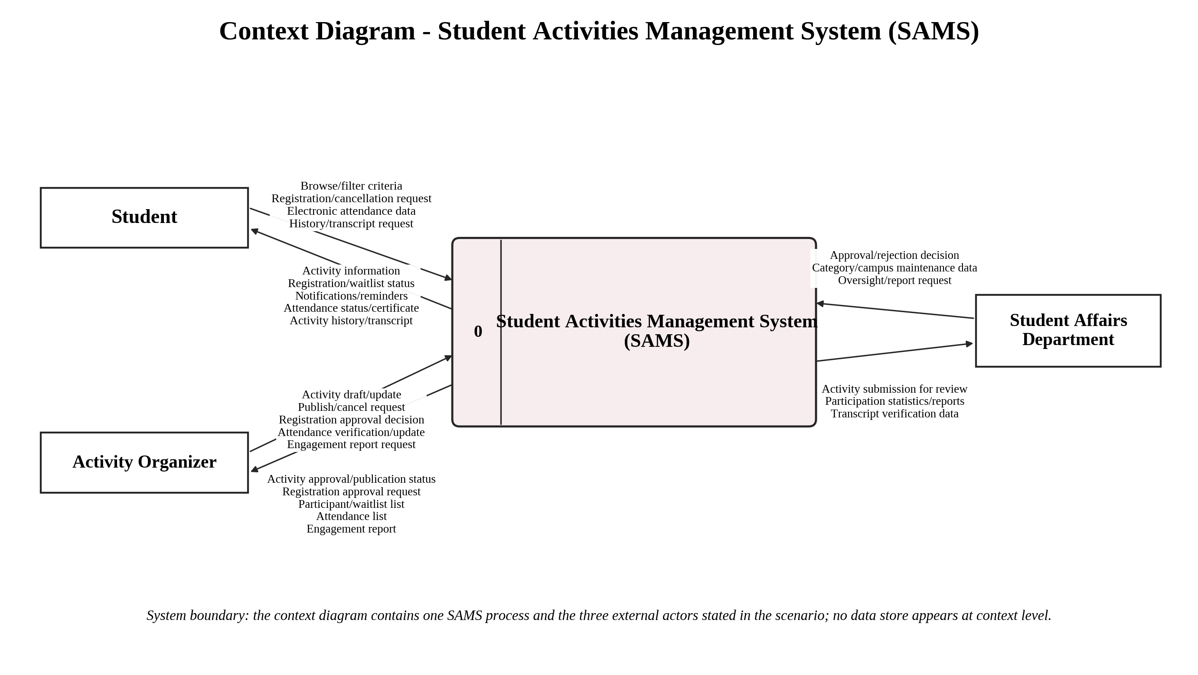
Figure 1. SAMS Context Diagram.
The context diagram defines the SAMS system boundary and shows only the external data exchanges supported by the project scenario.

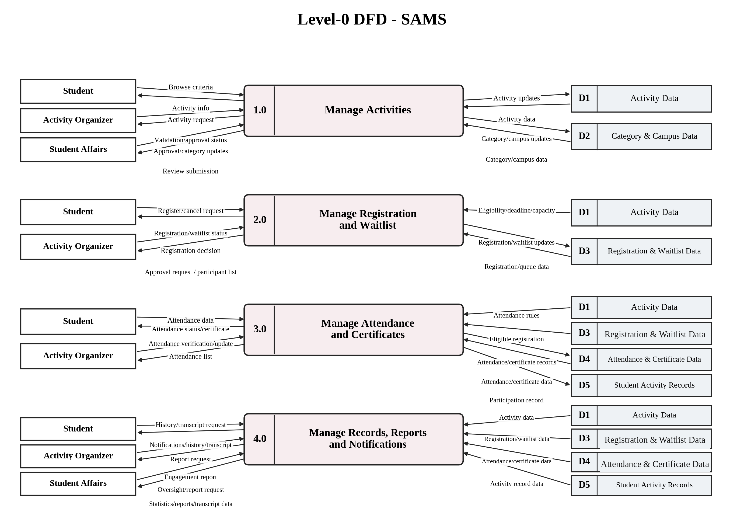
Figure 2. SAMS Level-0 DFD with four major processes and five logical data stores.
The Level-0 model distributes the context-level flows across four major processes while keeping all external interactions process-mediated.

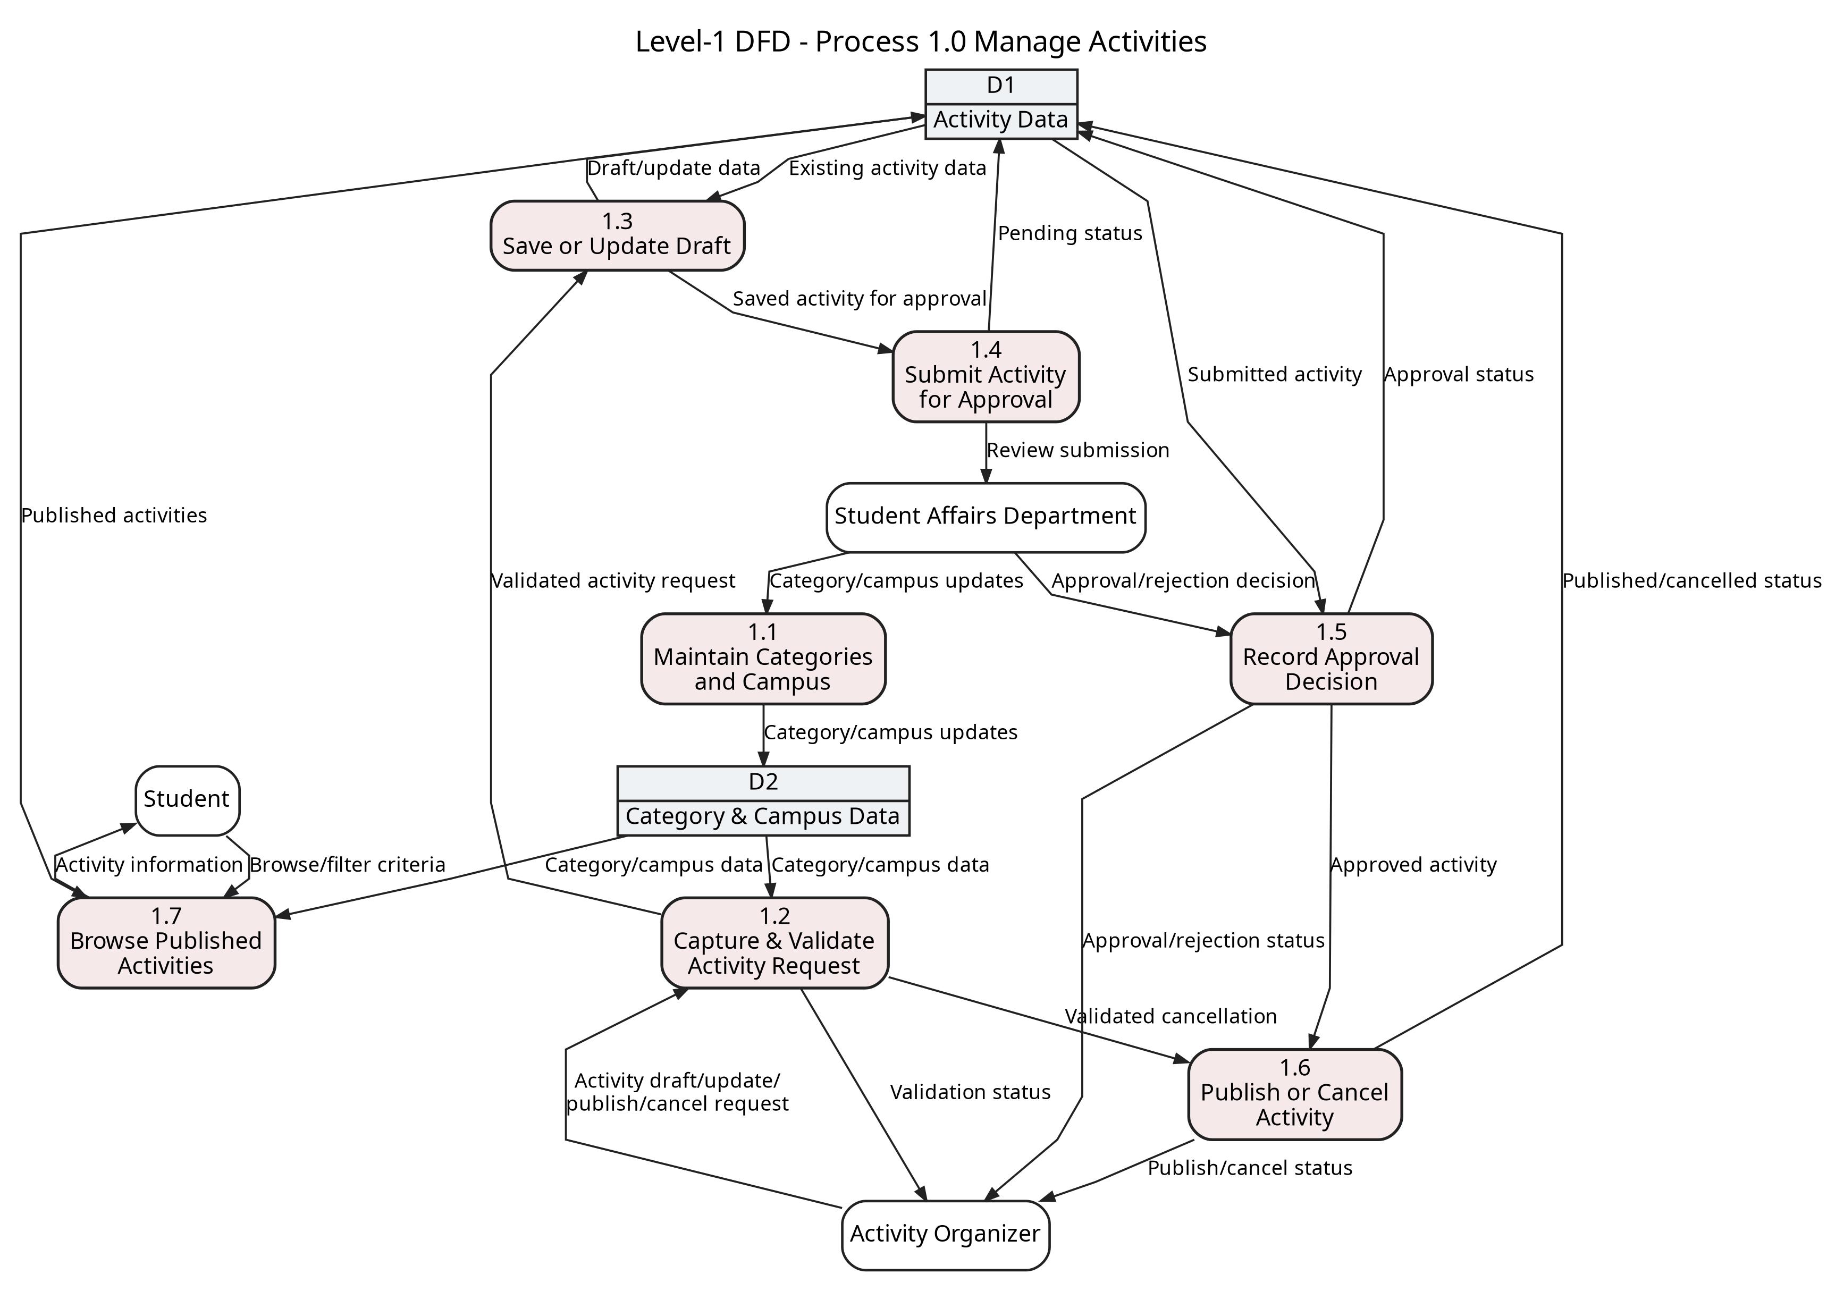
Figure 3. Level-1 decomposition of Process 1.0 Manage Activities.
Process 1.0 covers category/campus maintenance, activity validation, approval, publication/cancellation, and student browsing of published activities.

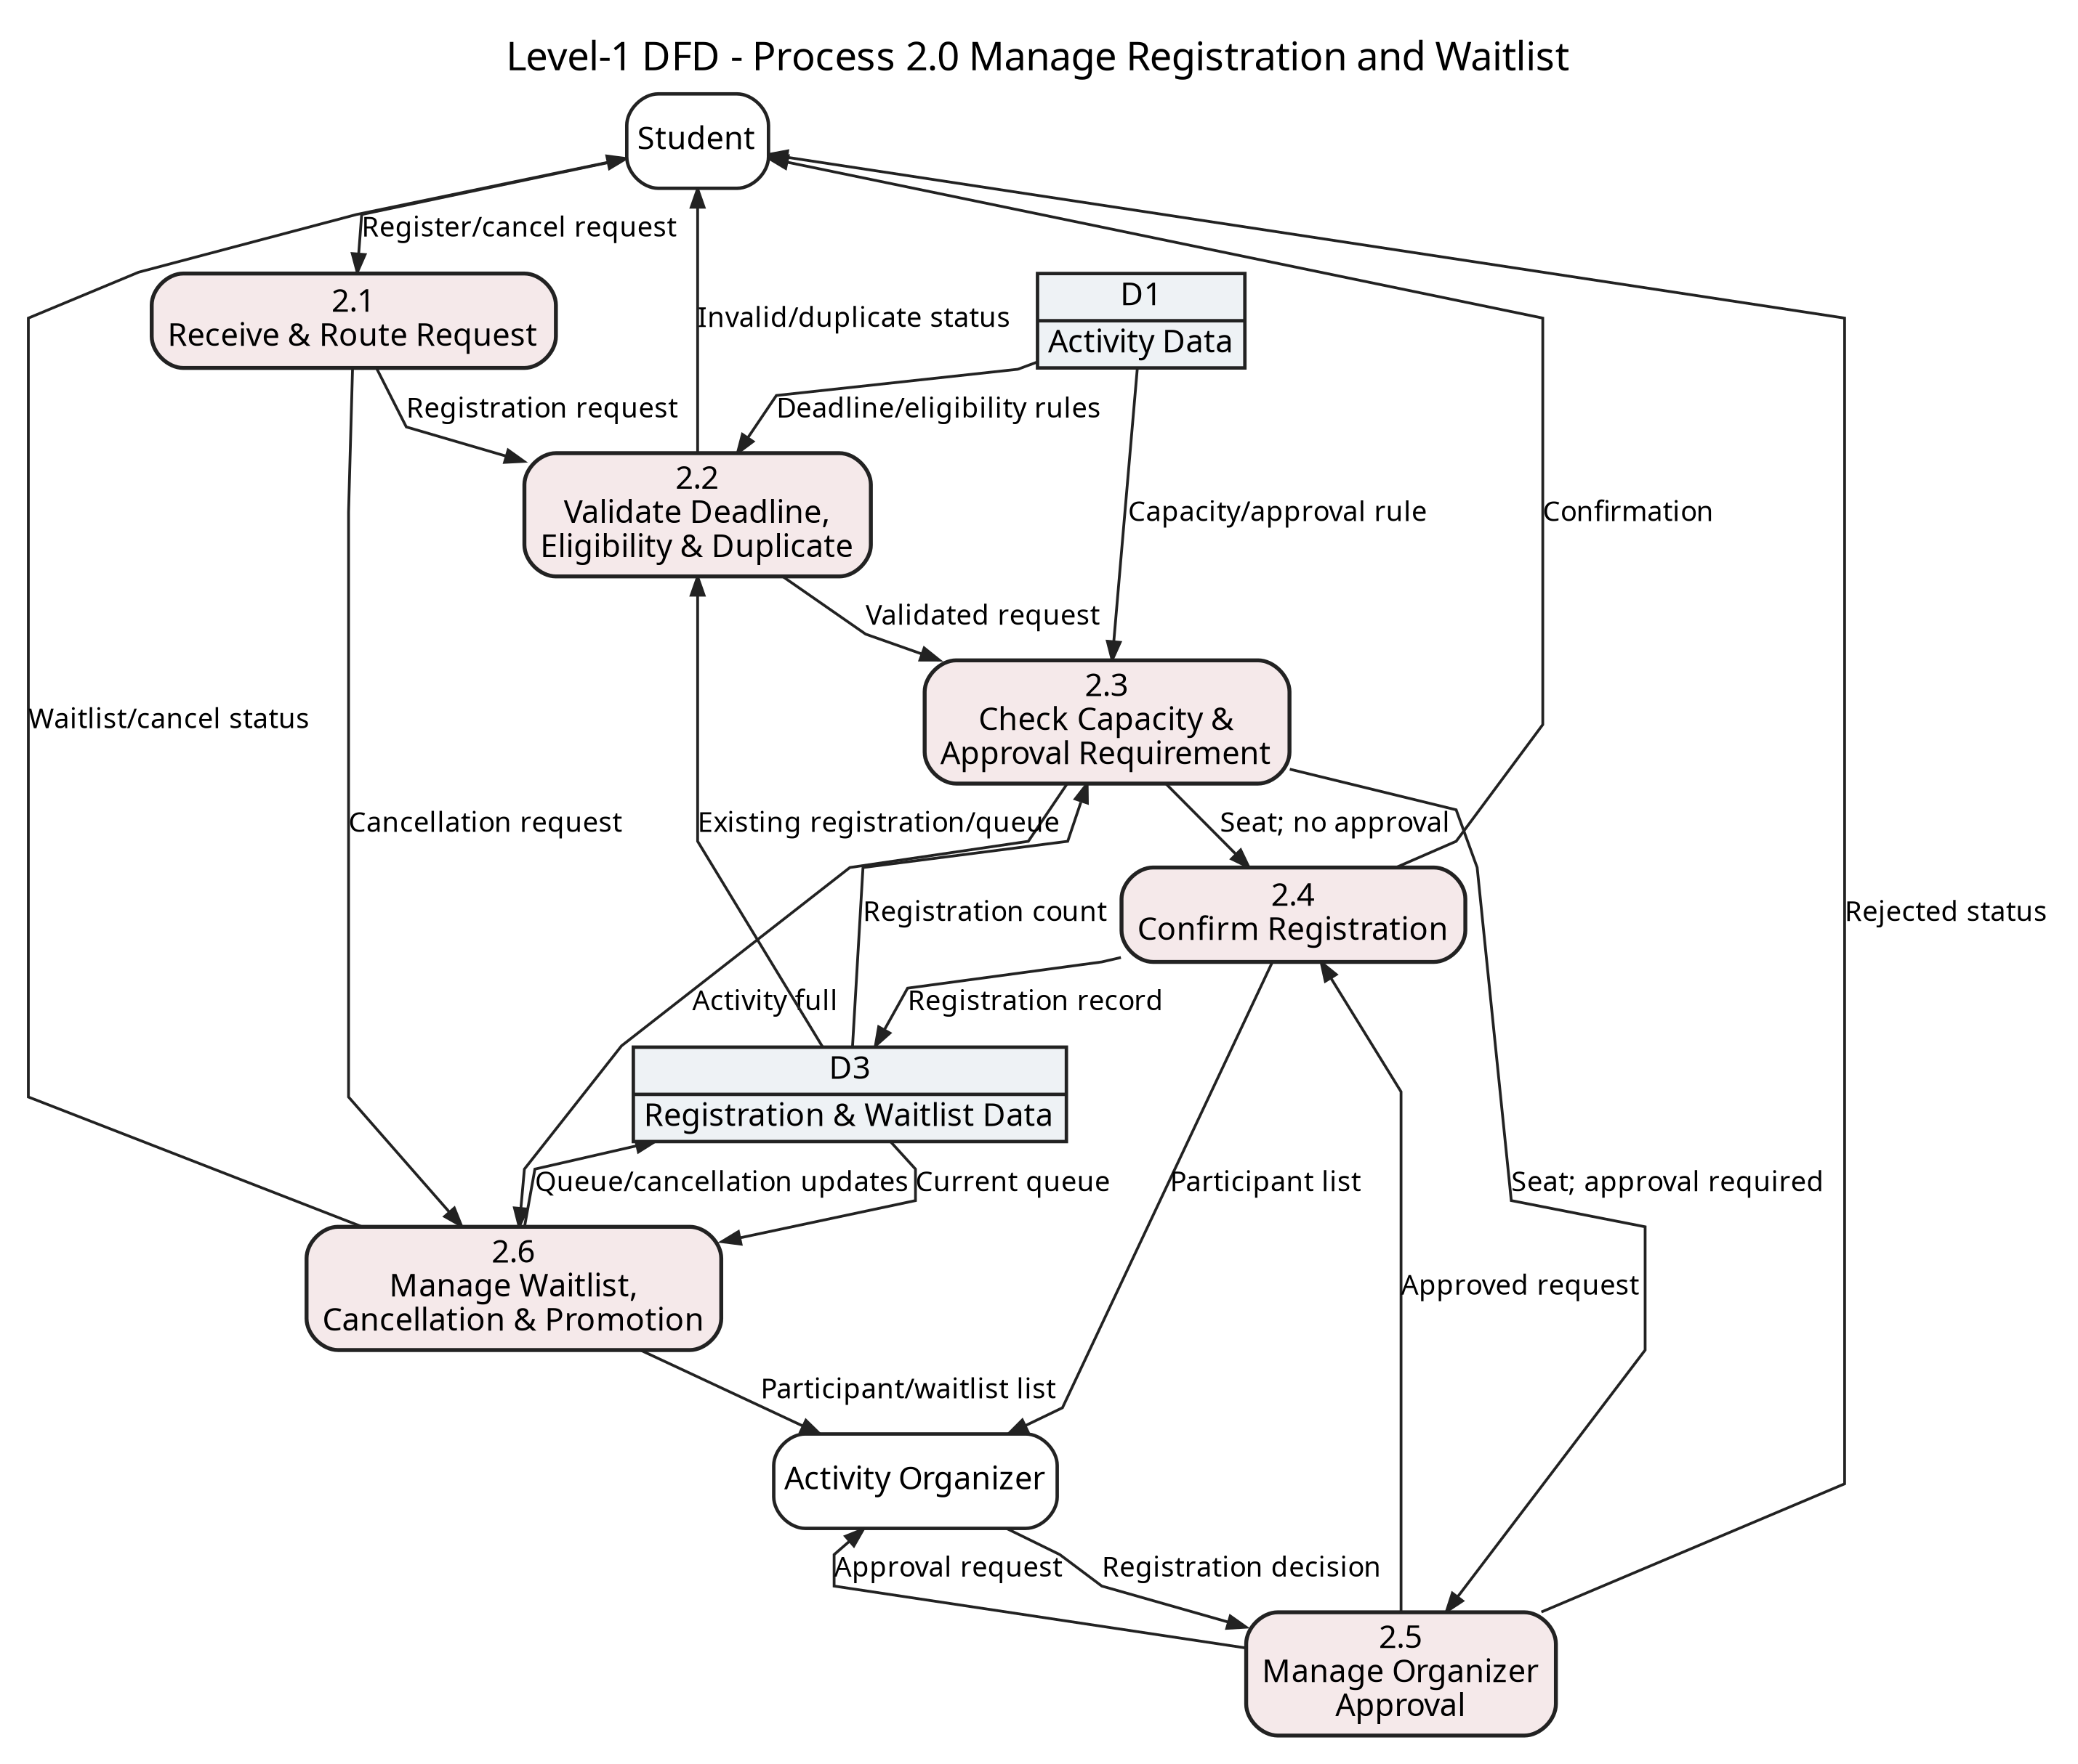
Figure 4. Level-1 decomposition of Process 2.0 Manage Registration and Waitlist.
Process 2.0 explicitly models deadlines, eligibility, duplicate prevention, capacity, organizer approval, waitlisting, cancellation, and automatic promotion.

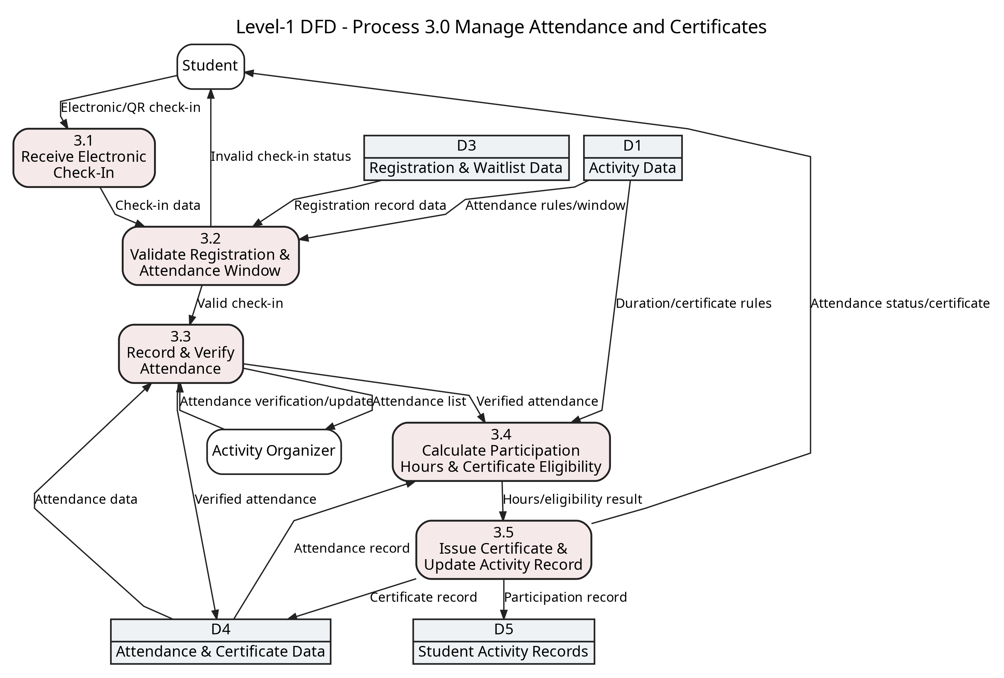
Figure 5. Level-1 decomposition of Process 3.0 Manage Attendance and Certificates.
Process 3.0 validates electronic attendance against confirmed registration and activity rules, records organizer verification, calculates participation hours, and issues certificates.

DFD Validation and Scenario Traceability
The following checks verify syntactic correctness, balancing, process integrity, and direct traceability to the SAMS scenario.
Validation criterion | Evidence in the final SAMS DFDs | Result
Context boundary | One SAMS process exchanges data only with Student, Activity Organizer, and Student Affairs Department. No data store appears at context level. | Pass
Context-to-Level-0 balance | All context inputs and outputs are preserved at Level-0: browsing, registration/cancellation, attendance, history/transcript, activity management, approvals, participant/attendance lists, notifications, and reporting. | Balanced
Level-0 syntax | Four major processes and five logical data stores are shown. There is no direct external-entity-to-data-store flow and no data-store-to-data-store flow. | Pass
Balance - Process 1.0 | Student browse criteria/activity information, organizer activity requests/status, and Student Affairs category/approval flows are preserved in the Level-1 decomposition. | Balanced
Balance - Process 2.0 | Student registration/cancellation requests and status plus organizer approval decisions/requests and participant-waitlist information are preserved. | Balanced
Balance - Process 3.0 | Student electronic attendance/status-certificate flows and organizer attendance verification/list flows are preserved. D4 communicates with the organizer only through Process 3.3. | Balanced
Process integrity | Every process has at least one input and one output, and each output is supported by sufficient incoming data and/or data-store inputs. Therefore, no black-hole, miracle, or gray-hole process is present. | Pass
Naming discipline | Processes use verb-object names; flows and stores use descriptive noun phrases; data-store identifiers D1-D5 remain consistent. | Pass
Scenario Coverage
Level-0 process | Scenario requirements represented
1.0 Manage Activities | Create/edit/publish/cancel activities; categories/campus; approval by Student Affairs; student browsing.
2.0 Manage Registration and Waitlist | Eligibility and deadlines; capacity; registration approval when required; cancellation; waitlist and promotion.
3.0 Manage Attendance and Certificates | Electronic/QR attendance; organizer verification; participation hours; certificate issuance; completed participation record.
4.0 Manage Records, Reports and Notifications | Student activity history/transcript; notifications/reminders; engagement and institutional reports; transcript verification.
Validation conclusion: the five required DFDs are complete, internally consistent, balanced across decomposition levels, and directly traceable to the SAMS scenario without adding Level-2 diagrams or other material outside the task requirements.

