System Analysis and Design
IT-353
Project
DEADLINE:
PHASE 1 (MID PROJECT PROGRESS REPORT) 26/07/2026 @ 23:59
PHASE 2 (FINAL PROJECT REPORT) 9/8/2026 @ 23:59
[Total Mark is 20]
• | You must submit two separate copies (one Word file and one PDF file) using the Assignment Template on Blackboard via the allocated folder. These files must not be in compressed format.
• | It is your responsibility to check and make sure that you have uploaded both the correct files.
• | Zero mark will be given if you try to bypass the SafeAssign (e.g. misspell words, remove spaces between words, hide characters, use different character sets, convert text into image or languages other than English or any kind of manipulation).
• | Email submission will not be accepted.
• | You are advised to make your work clear and well-presented. This includes filling your information on the cover page.
• | You must use this template, failing which will result in zero mark.
• | You MUST show all your work, and text must not be converted into an image, unless specified otherwise by the question.
• | Late submission will result in ZERO mark.
• | The work should be your own, copying from students or other resources will result in ZERO mark.
• | Use Times New Roman font for all your answers.

Student Details: | CRN: 50268
Name: Bushra Alshayeb | ID: S240057076
Name: Gala Algodah | ID: S240031741
Name: Hessa Abdullah | ID: S240041770
Name: Maha Alsubaie | ID: S240025765
Name: SHATHA KHALED BAQAIS | ID: S240067735

Task 4
Develop the Use Case Model: 1. Identify all system actors, 2. Create one complete Use Case Diagram, and 3. Fully document three use cases using the use case template. [3 marks]
System Actors
Actor | Responsibilities in SAMS
Student | Browses and filters activities, views details, registers or cancels, joins the waitlist, records electronic attendance, and views activity history, certificates, participation hours, and the activity transcript.
Activity Organizer | Creates and edits activities, submits them for approval, publishes or cancels approved activities, manages participants and registration approvals, records attendance, issues certificates, and generates engagement reports.
Student Affairs Staff | Acts on behalf of the Student Affairs Department to manage activity categories, approve or reject submitted activities, monitor participation statistics across university branches, generate institutional reports, and validate student activity records and transcripts.
Use Case Model Rationale
The use case model is derived directly from the three roles identified in the SAMS scenario: Student, Activity Organizer, and authorized Student Affairs Staff acting on behalf of the Student Affairs Department. Their responsibilities are separated to preserve clear role boundaries: students discover and participate in activities; organizers manage the activity lifecycle, registrations, attendance, certificates, and engagement reporting; and Student Affairs Staff provides governance, approval, institutional monitoring, and transcript validation. The system boundary contains only behavior performed by SAMS. The three fully documented use cases were selected because they represent complementary control points in the system: a student transaction (registration), an organizer workflow (activity submission), and an institutional governance decision (approval or rejection). Together, they demonstrate the core interactions and important alternative flows without extending beyond the project scenario.

Complete Use Case Diagram
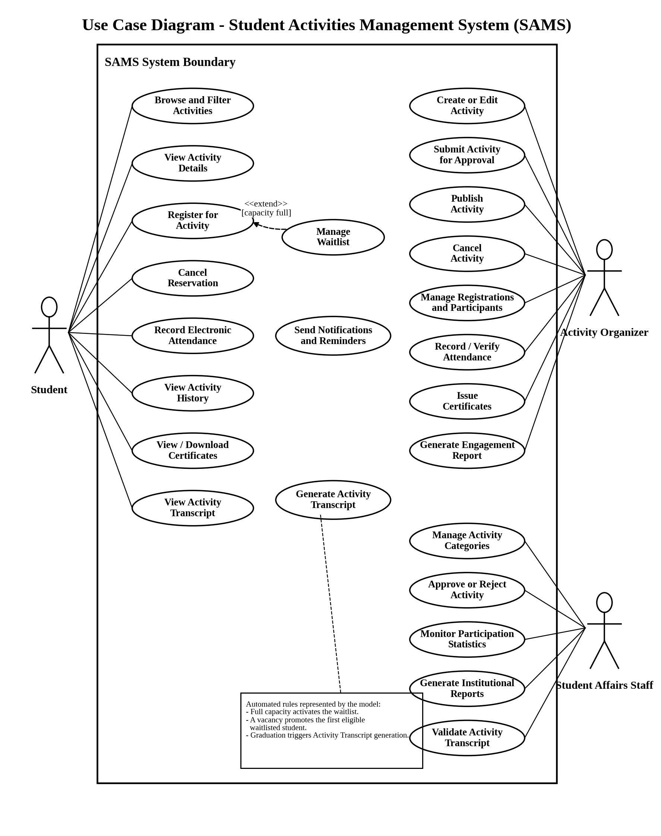
Figure 10. Complete SAMS Use Case Diagram.
Requirement-to-Use-Case Traceability
The following matrix verifies that the major functional requirements stated in the SAMS scenario are represented in the complete use case model.
Scenario Requirement | Actor | Corresponding Use Case(s)
Browse activities by category, campus, or date and view details | Student | Browse and Filter Activities; View Activity Details
Register, cancel before the deadline, and handle full capacity | Student | Register for Activity; Cancel Reservation; Manage Waitlist
Receive confirmations, reminders, cancellations, and waitlist updates | Student | Send Notifications and Reminders
Record electronic attendance and access participation history and certificates | Student / Activity Organizer | Record Electronic Attendance; Record / Verify Attendance; View Activity History; Issue / View Certificates
Create, edit, submit, publish, or cancel activities and manage participants | Activity Organizer | Create or Edit Activity; Submit Activity for Approval; Publish Activity; Cancel Activity; Manage Registrations and Participants
Approve activities, manage categories, and monitor university-wide participation | Student Affairs Staff | Approve or Reject Activity; Manage Activity Categories; Monitor Participation Statistics
Generate organizer and institutional reports | Activity Organizer / Student Affairs Staff | Generate Engagement Report; Generate Institutional Reports
Generate, view, and validate the graduation Activity Transcript | Student / Student Affairs Staff | Generate Activity Transcript; View Activity Transcript; Validate Activity Transcript
This traceability check confirms coverage of the scenario while keeping the detailed documentation limited to the three use cases required by the assignment.

Use Case 1: Register for Activity
Use Case ID | UC-01
Use Case Name | Register for Activity
Primary Actor | Student
Supporting Actor | Activity Organizer, when manual registration approval is required
Trigger | The student selects Register on the activity details screen.
Preconditions | 1. The student is authenticated.  2. The activity is published and its registration period is open.  3. The activity details and eligibility rules are available.
Minimal Guarantee | No duplicate or partial registration is created. If validation fails, the previous registration and capacity records remain unchanged.
Success Guarantee | SAMS records exactly one valid outcome for the request: a confirmed registration, a pending registration when organizer approval is required, or a waitlist entry when capacity is full. No duplicate active registration or waitlist entry is created, participant and capacity data remain consistent, and the student receives the corresponding status notification.
Main Success Scenario | 1. The student opens an activity and selects Register.  2. SAMS retrieves the student profile and activity rules, then validates the deadline, eligibility, and duplicate-registration status.  3. SAMS checks the available capacity.  4. If approval is not required, SAMS creates a confirmed registration.  5. If approval is required, SAMS creates a pending registration and sends it to the organizer.  6. After approval, SAMS updates the participant list and capacity record.  7. SAMS sends the resulting registration status to the student.
Alternative / Exception Flows | A1. Registration closed: SAMS rejects the request and displays the deadline status.  A2. Not eligible: SAMS rejects the request and displays the eligibility reason.  A3. Duplicate request: SAMS shows the existing status without creating a new record.  A4. Capacity reached: SAMS creates a waitlist entry, assigns a queue position, and notifies the student.  A5. Pending request rejected: SAMS records the rejection and notifies the student.  A6. Processing failure: SAMS rolls back the transaction and preserves the previous data.
Business Rules | 1. Confirmed registrations must not exceed the participant limit.  2. A student may hold only one active registration or waitlist entry for the same activity.  3. Cancelling a confirmed registration before the deadline automatically promotes the first eligible waitlisted student.

Use Case 2: Create and Submit Activity
Use Case ID | UC-02
Use Case Name | Create and Submit Activity
Primary Actor | Activity Organizer
Supporting Actor | Student Affairs Staff, acting on behalf of the Student Affairs Department
Trigger | The organizer selects Create Activity.
Preconditions | 1. The organizer is authenticated and authorized to manage activities.  2. Activity categories are available in SAMS.
Minimal Guarantee | Invalid information is not submitted for approval. A saved draft remains available to the organizer.
Success Guarantee | A complete activity record is stored with Pending Approval status and is made available to authorized Student Affairs Staff for review. It is not visible to students before approval and publication.
Main Success Scenario | 1. The organizer starts a new activity draft.  2. The organizer enters the title, description, category, schedule, participant limit, registration period, location, attendance method, and eligibility rules.  3. The organizer selects Submit for Approval.  4. SAMS validates required fields and the date sequence.  5. SAMS stores the activity with Pending Approval status.  6. SAMS routes the activity to authorized Student Affairs Staff for review.  7. SAMS confirms the submission to the organizer.
Alternative / Exception Flows | A1. Missing data: SAMS highlights the required fields and does not submit the activity.  A2. Invalid dates: SAMS displays the validation error and returns the activity for correction.  A3. Save as draft: SAMS retains the activity in Draft status without submitting it.  A4. Later rejection: the organizer receives the review reason, revises the activity, and resubmits it.
Business Rules | 1. The activity must define a participant limit, registration period, location, attendance method, and eligibility requirements.  2. Only an approved activity may be published to students.  3. Cancelling an activity must trigger a notification to affected students.

Use Case 3: Approve or Reject Activity
Use Case ID | UC-03
Use Case Name | Approve or Reject Activity
Primary Actor | Student Affairs Staff
Supporting Actor | Activity Organizer
Trigger | A staff member opens an activity with Pending Approval status.
Preconditions | 1. The staff member is authenticated and authorized to approve activities.  2. The submitted activity and its complete details are available.  3. The activity status is Pending Approval.
Minimal Guarantee | If the review is interrupted, the existing pending activity remains unchanged and is not published.
Success Guarantee | The decision and review note are stored, the organizer is notified, and an approved activity becomes eligible for publication.
Main Success Scenario | 1. Student Affairs Staff opens the pending-activity review list and selects an activity.  2. SAMS displays the activity details, schedule, capacity, location, registration period, attendance method, and eligibility requirements.  3. The staff member reviews the submission and selects Approve.  4. SAMS records the decision and changes the activity status to Approved.  5. SAMS notifies the organizer that the activity is eligible for publication.
Alternative / Exception Flows | A1. Rejection: the staff member selects Reject and enters a reason; SAMS stores the reason, changes the status to Rejected, and notifies the organizer.  A2. Revision: the organizer edits a rejected activity and submits a new version for review.  A3. Concurrent update: SAMS requires the reviewer to reload and assess the latest submitted version before recording a decision.
Business Rules | 1. Only authorized Student Affairs Staff may approve or reject submitted activities on behalf of the Student Affairs Department.  2. Every rejection must include a review reason.  3. Publication is allowed only after approval.

