ETL REJECT SPECIFICATION

Project | ETL REJECT
Author | Kévin, Intern, YE DIGITAL SUPPORT
Version | 2.0
Date | [02/09/2026]
Status | Pending Validation

Table des matières
1. Objective 2
2. Context 2
3. Flow Overview 3
3.1 Technical Summary 3
3.2 Flow Diagram 3
4. Data Sources 3
4.1. LOT_WAFER 4
4.2. REJET 4
5. Transformation and business Rules 5
6. Loading Method 5
6.1. Initial Load 5
6.2. Incremental Load 6
6.3. Status Update Management 6
7. Volume and Performance 6
8. Logging and Monitoring 6
9. Table Architecture 7
9.1. Mapping 8

Objective
Develop an ETL process to extract production data stored in DBLOGIDW, on reject data, transform it according to the defined business rules and load it into dmp to support reporting applications, Yield Enhancement activities, and advanced analytics.

Context
Currently, scrap data is distributed across several business tables in the DBLOGIDW database. The objective of this project is to centralize this information in the dmp and provide a reliable source for local engineering community.
The solution is divided into two complementary features.

Feature 1 – Reject Traceability
For a given production lot, the DataMart must make it possible to identify the wafers that have been rejected and reconstruct the corresponding reject event.

Feature 2 – Lot Filiation
During the manufacturing process, the composition and identity of a lot may change.
A lot can for example be:
- split into several lots,
- merged with another lot,
- reassigned to another lot identifier.
These transformations create relationships between parent and child lots.
The ETL must reconstruct these lot filiations in order to maintain wafer traceability even when the original lot identifier changes.

Flow Overview

Technical Summary

The ETL script will be developed in python, using version 3.12.
A GitLab repository will be created to host the source code, with a README.md file providing the necessary documentation.
A Confluence page will be also created to maintain the relevant project documentation.
The ETL process must:
- Extract reject data from DBLOGIDW tables.
- Identify relationships between lots, wafers, events and defects.
- Determine the status of each wafer based on available data. (crapped)
- Retrieve lots that have undergone a filiation event.
- Load the processed data into DataMart.

3.2 Flow Diagram

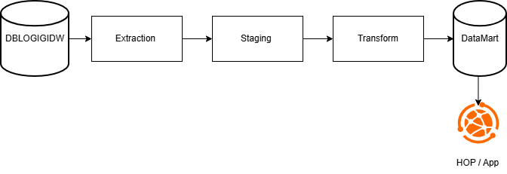

Data Sources

Source | Table(s)
DBLOGIDW | LOT_WAFER  REJET

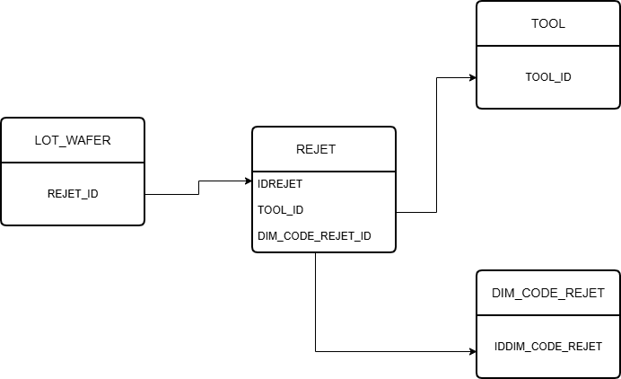

LOT_WAFER

Used to identify the scrapped wafer and its position within the lot
Attribute | Description | Example
LOT_NUM | The lot id | XL27040CXA
WAFER | The wafer id | VUD670K
REJET_ID | The reject reference | 44481
SLOT | The wafer position within the lot | 02
CATEGORIE | The reject category | Standard
QTY | Boolean whether the wafer is rejected | 0 / 1

REJET

Details of the declared reject
Attribut | Description | Exemple
IDREJET | The reject id | 44481
TOOL_ID | The impacted tool | 1
OPER | The operation step id | XCMPLCT1
GATE | The gate id | 0817
CDATE | The reject date | 2025-11-15 09:34:22
DEFAUT | The observed defect | Contamination
CODE_REJET_ID | The reject code id | 1
REAFECTATION | Boolean whether the wafer has been relaunched | Y / N
WORKCENTER

A dedicated program has been provided to identify production lots that have undergone a filiation change.
The program returns the lots affected by transformations such as:
- lot split,
- lot merge,
- lot reassignment.
This source is used to identify lot genealogy and reconstruct relationships between the different lot identifiers involved during the manufacturing lifecycle.
The resulting filiation information is then combined with reject data in order to maintain wafer reject traceability across lot transformations.

Transformation and business Rules

R1: Date Conversion
All dates must be stored in Europe time zone

R2: Quantity Business Rule
Table LOT_WAFER
Rule 1: QTY = 0 for Non-Relevant Rejects
- COMMENTAIRE contient "xfrelance16"
- TYPE = "Expedition manuelle"
- DEFAILLANCE = "Contrainte logistique Rejet relance"
- DEFAILLANCE = "V3 OPEN - Client (T18B)"
- DEFAILLANCE = "MX ILS - Client (T18B)"
- DEFAILLANCE = "Decision du client"
- DEFAILLANCE = "Fin de vie"
- CODE_REJET_ID ∈ (ANN, END, SWI, EXP, EXQ, PRV, INF)

Rule 2: QTY = 1 for downgrade events
- DEFAUT = Déclassement en 60
- DEFAUT = Déclassement en 90
- DEFAUT = Déclassement avec impact line yield

Rule 3: Otherwise QTY = QTY

Rule 4: SCRAP_CODE = 111 (reintegrated scrapped wafers)
Remove the line

R3: Duplicate Removal
Criteria:
LOT_NUM
WAFER
REJET_ID
CDATE
Keep only the most recent record

Loading Method

Initial Load

During the first deployment, only the last three years of available history from DBLOGIDW must be loaded into DataMart to build the lot and wafer history and reconstruct existing scrap events.

T0 -> Execution date

Incremental Load

After the initial load, newly created or modified data will process.
Criteria: LAST_UPDATE_DATE > LAST_SUCCESS_DATE
Frequency: Hourly

Status Update Management

Wafer status changes must be tracked and considered during each ETL execution.
Wafers that are reintegrated must be removed from the table.

Volume and Performance

Average Volume per day (scrapped wafers) | ~50
Maximum Volume per day (scrapped wafers) | ~1000
Frequency | Hourly
Target Duration | 1 sec

Logging and Monitoring

The ETL process must ensure full traceability of each execution to facilitate:
- Operational monitoring
- Auditability of processing
- Incident investigation
- Processed volume control

Alerts must be generated in the following cases:
- DBLOGIDW or DataMart connection failure
- Data extraction failure
- Data loading failure
- Abnormal scrap volume

9. Table Architecture

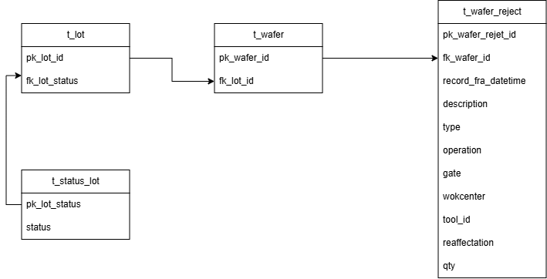

Attribute | Description | Example
Reject_event_id | The wafer rejects record id
fk_wafer_id | The wafer id
reject_fra_datetime | The Date and time when the reject was recorded
reject_description | The description of the reject | Tranche cassee
reject_type | The reject type | Pre-production
reject_operation | The operation where the reject occurred | XTLANALM
reject_tool_id | The tool id | DL62

Mapping

Source table | Source Column | Target Column
LOT_WAFER | WAFER | fk_wafer_id
REJET | CDATE | record_fra_datetime
REJET | OPER | Operation
REJET | GATE | gate
REJET | WORKCENTER | Workcenter
REJET | REAFFECTATION | reaffectation
DIM_CODE_REJET | DESCRIPTION | description
TOOL | The tool id | Tool_id

