Group project report
Group 13
2024 CICT high quality class
Group Project Report
Network security

Project  Title | Intrusion Detection System (Packet Sniffing)
Project  Area | Network Security
Students | ID | Name
 | B2206007 | Dương Đông Quang
 | B2205997 | Nguyễn Quang Nhật
 | B2206003 | Nguyễn Hồ Gia Phúc
Reporting Date | 18/12/2025

Ⅰ. Project Outline
- Title: Intrusion Detection System (Packet Sniffing)
- Group Information
Team Name
Team Composition |  | Name | Belong | Department | Position
Professor |  | Nguyen Huu Hoa | CICT |  | Rector
Instructor |  | Noh | CICT | IT Department | Instructor
Student | Team Leader | Duong Dong Quang | CICT | Department of Computer Science
 | Team member 2 | Nguyen Quang Nhat | CICT | Department of Computer Science
 | Team member 3 | Nguyen Ho Gia Phuc | CICT | Department of Computer Science
Team Photos
 |  |  |  | 
Duong Dong Quang |  | Nguyen Quang Nhat |  | Nguyen Ho Gia Phuc

II. Project Information

1. Purpose of Project
The purpose of this project is to build a simple Intrusion Detection System (IDS) that captures network packets, analyzes traffic behavior, and detects suspicious activities. By implementing packet sniffing, traffic monitoring, and basic attack simulation, the project helps students understand how network intrusions occur and how defensive systems can identify them.
Additionally, the project provides hands-on experience with Scapy, Flask, and Python-based traffic analysis, strengthening practical skills in cybersecurity and network forensics.

2. Project work flow (one model)
- Initialization
  - Prepare the environment, install required libraries (Scapy, Flask, Pandas), create a virtual environment, and set up the project directory.
- Implementation
  - Develop sniffer.py to capture packets and detect abnormal network behavior.
  - Develop dashboard.py to load and visualize generated alerts through a web interface.
- Execution
  - Run the sniffer using sudo python3 sniffer.py to start monitoring real-time packets.
  - Launch the dashboard using python3 dashboard.py to view detection results.
- Backtesting & Validation
  - Conduct network tests such as ICMP ping, TCP SYN packet injection, and UDP flooding to verify whether the sniffer correctly captures and logs suspicious traffic.

Ⅲ. Action Plan

1. Environments & resource
 |  | Details
S/W | OS | CentOS 7, Ubuntu 20, Kali_Linux
 | IDE | Redhat Linux, Debian Linux
 | language
 | tool | Snort, WireShark, TCPdump, barnyard2,
H/W | device | Personal PC
 | sensor
 | communication

2. Role arrangements
Student | Name | Role
1 | Duong Dong Quang | Plan & write report
2 | Nguyen Quang Nhat | Implement & test
3 | Nguyen Ho Gia Phuc | Presentation

3. Project Schedule
Division | Promotion contents | Schedule
 |  | 1/12 | 3/12 | 5/12 | 7/12 | 9/12 | 10/12
Plan | Role sharing and analysis software installation
Analysis | Software option analysis
Test | Analysis using Software function
Finish | Create result document through analysis
Offline meeting plan | Information sharing and progress confirmation of each other

Ⅳ. Expected Benefit

1. Performance Goals
- Ensure that the IDS components operate smoothly, including packet sniffing, detection logic, and real-time logging.
- Provide accurate traffic monitoring and basic forensic insights by capturing and analyzing different types of packets (ICMP, TCP, UDP).
- Validate detection accuracy through controlled backtest scenarios such as port scanning, SYN packets, and UDP flooding.
- Support visualization of alerts via a web-based dashboard for easier monitoring and analysis.

2. Benefit
- Protection Against Packet Sniffing Attacks
- Improved Network Confidentiality
- Real-Time Threat Awareness
- Hands-On Experience in Anti-Sniffing Techniques

Ⅴ. Practice Result

1. Source code full list
- sniffer.py
- dashboard.py

2. Running result
[step 1] Initialize
- Environment preparation
pip install scapy flask pandas
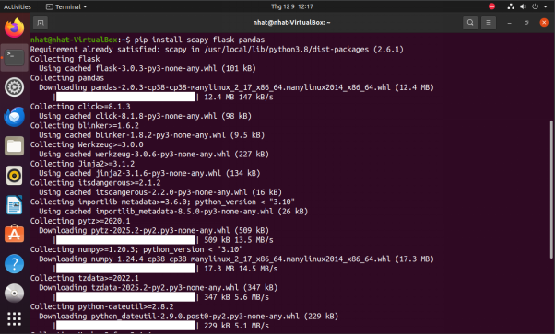
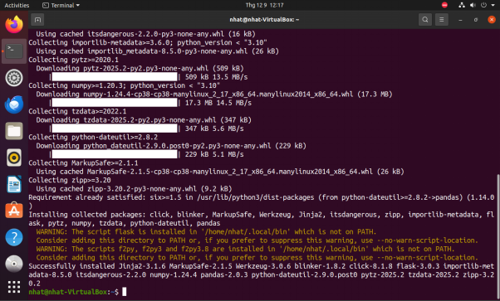
- Create project directory
mkdir ids_project
cd ids_project
- Activate virtual environment
python3 -m venv venv
source venv/bin/activate
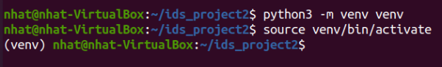
- Install essential tools
pip install scapy flask pandas
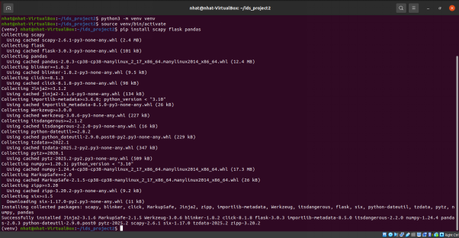
[step 2] Implement
- Create sniffer.py to capture packets and detect
$ gedit sniffer.py
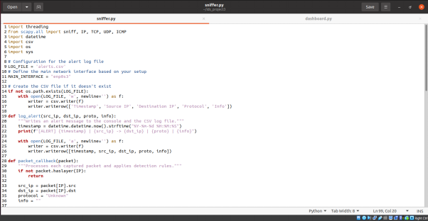
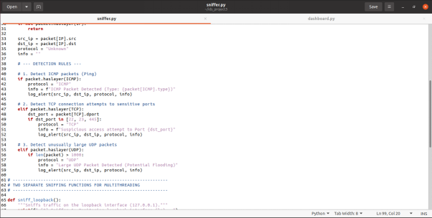
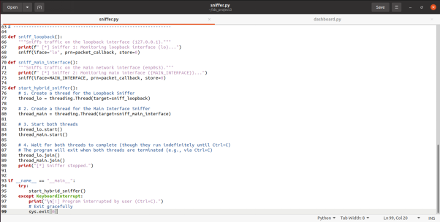

- Create dashboard.py to view alerts.csv in web interface
$ gedit dashboard.py
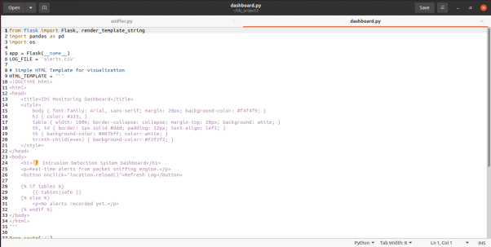
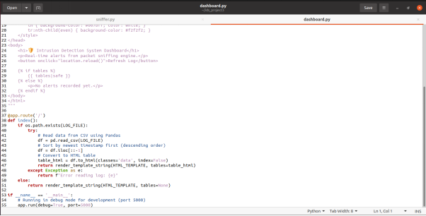
[step 3] Running
- Open sniffer file
sudo python3 sniffer.py
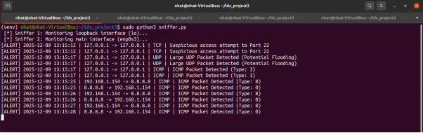
- Open dashboard
python3 dashboard.py
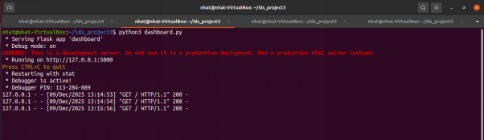
- Access the web though localhost or 127.0.0.1:5000
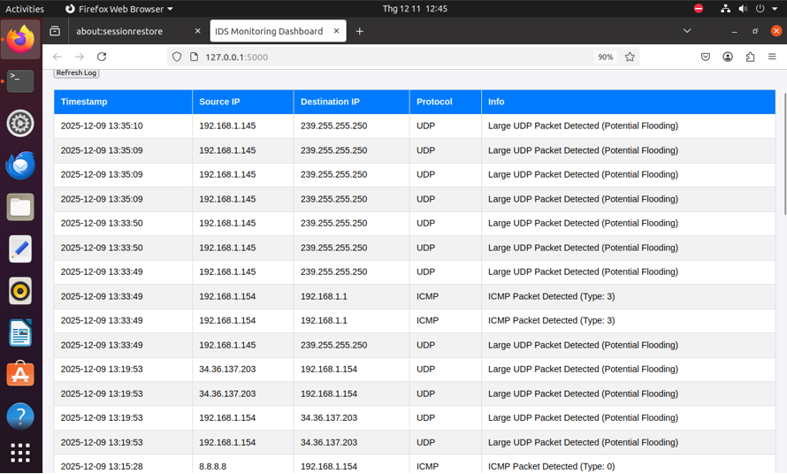
[step 4] Backtest
- Run some tests to check the sniffer
ping -c 3 8.8.8.8 (test ICMP)
sudo python3 -c "from scapy.all import IP, TCP, send; send(IP(dst='127.0.0.1')/TCP(dport=22, flags='S'))"
(test tcp - catch packet sent to suspicious port)
sudo python3 -c "from scapy.all import IP, UDP, send; send(IP(dst='127.0.0.1')/UDP(dport=53)/('X'*1500))"
(test udp flooding)
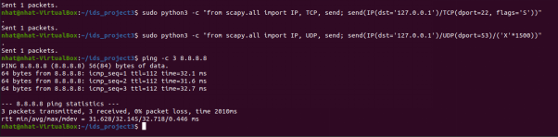
(the result of this test is in the previous screenshot)

Ⅵ. Problem and Solution

1. Technical issues during project development
- Single interface sniffing:
  - Scapy's native sniff() function is restricted to listening on only one network interface at a time. This limitation severely hampered comprehensive testing and monitoring capability.
  - Internal Testing (Loopback): Required setting the interface to lo to detect attacks targeting the localhost (127.0.0.1) (e.g., Port Scanning, UDP Flooding).
  - External Testing (Main Interface): Required setting the interface to enp0s3 to detect network probing from external sources (e.g., ICMP Ping).
- Operational Inefficiency:
  - The necessity to constantly stop the program, manually modify the code's iface parameter, and restart with sudo made the testing process inefficient and prone to error. This has undermined the goal of continuous and autonomous monitoring by the Intrusion Detection System.

2. Solution(how to solve the problems)
To overcome the single-interface limitation, the team implemented Multithreading to enable parallel monitoring, which significantly enhanced the system's robustness.
- Multithreading (Python Threading)
  - Utilized Python’s standard threading library to spawn two independent threads, allowing the IDS to monitor two interfaces simultaneously.
- Thread 1 (Loopback Sniffer)
  - Initialized a thread dedicated to sniff(iface="lo")
- Thread 2 (Main Interface Sniffer)
  - Initialized a thread dedicated to sniff(iface="enp0s3")

Ⅶ. References
Appendix (Topic No.1-10 cases, submit Source code)
Source code file 1
sniffer.py
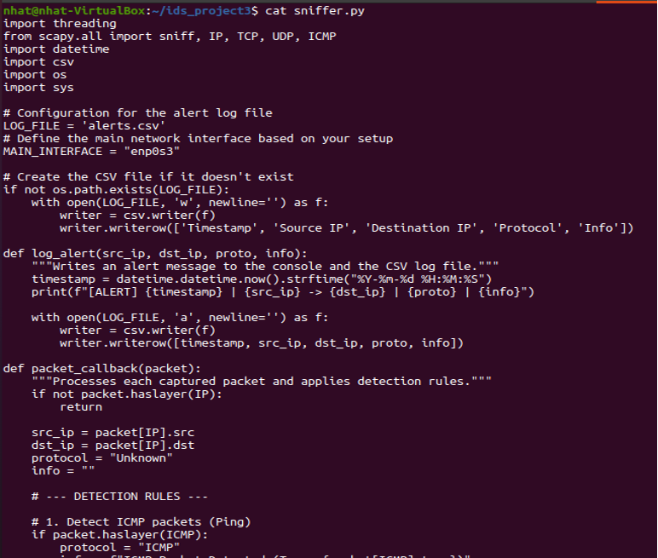
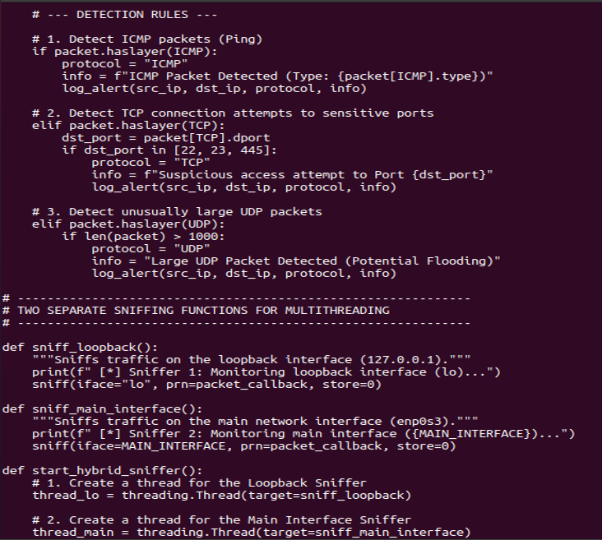
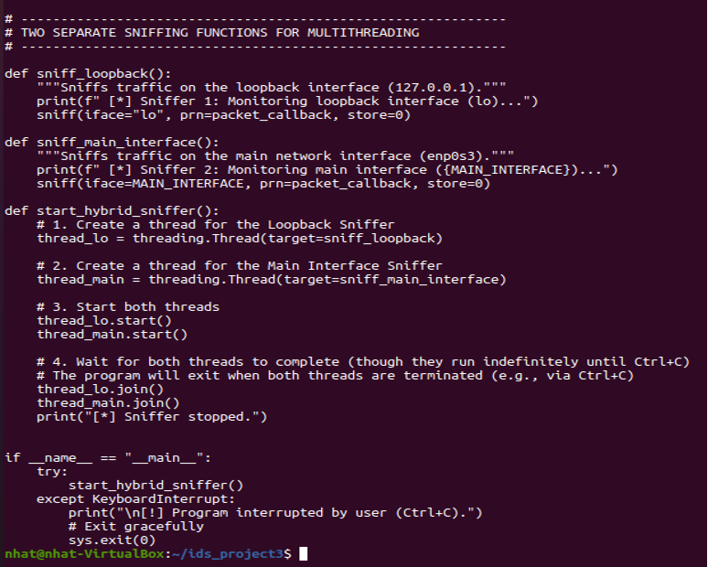
Source code file 2
dashboard.py
