**Homework Set 2**

**Solution**

**Problem 1 (Regression)**

Matlab Code:

X=load(‘Xtrain’);

Y=load(‘Ytrain’);

scatter(X,Y);

f=polyfit(X,Y,3);

x=0:0.01:1;

y=polyval(f,x);

plot(x,y);

y=polyval(f,X);

M=[X Y Y-y]

$$f\left(x\right)=53.925-41.835x-8.7643x^{2}+8.5588x^{3}$$

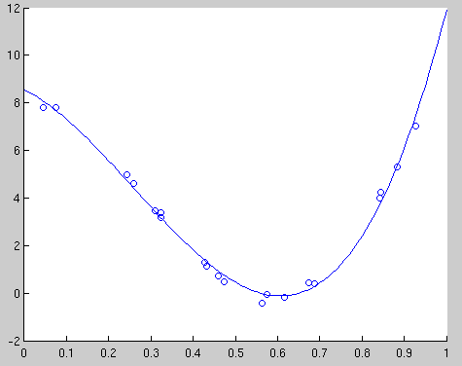 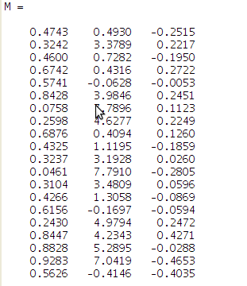

**X Y Error**

**Problem 2 (Regression)**

Note that 



**Problem 3 (Residue analysis)**

1. Generate a scatter plot of the yields vs maturity. Comment on the figures.

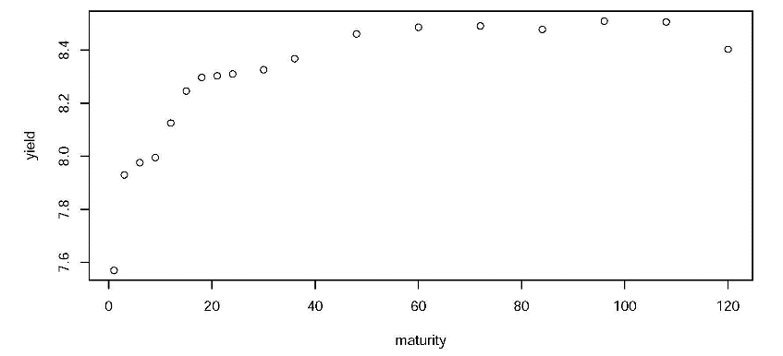

The yield increases as maturity increases when maturity is within about 50 months, and it approaches a stable level afterwards.

1. You want to fit a polynomial regression model to the data. Since you don't know the order you need, you fit six polynomial models, with orders from 1 to 6. Plot the $R^{2}$ vs the polynomial order $k$. Comment on the result.

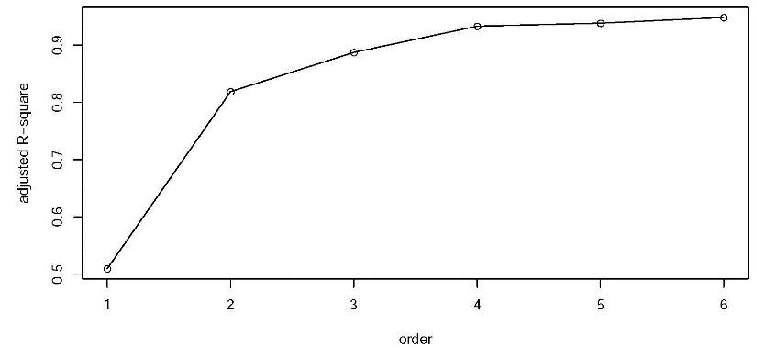

$R^{2}$ increase very fast as polynomial order increases at the beginning. However it increase slowly after polynomial order is greater than 3. $R^{2}$ is the highest at order 6, which suggests an order 6 polynomial model.

1. For the 4th-order polynomial model, draw a residual plot (vs maturity). Comment on it.

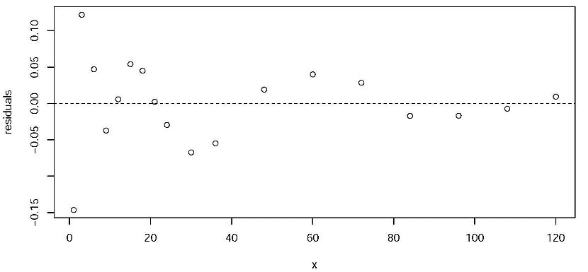

The residuals are centered around 0. However, for short maturity periods, the residual uctuates more than that of higher maturities.

1. Draw a histogram and a quantile-quantile (Q-Q) plot of the residuals. Comment on it.

