WEather
Product Design Specification
Version 0.1
04.24.2019

VERSION HISTORY

Whit this program you can find out the weather in different cities in the planet. This program should be very convenient and easy to use.
The product should have a function to display maximal and minimal temperature of different cities/countries at once, also show the details for a specific one.

Version  # | Implemented  By | Revision  Date | Approved  By | Approval  Date | Reason
0.1 | Anna Harutyunyan | 11.25.2018 | Anna | 12.20.2018 | Initial Design Definition draft
UP Template Version: 11/25/18

TABLE OF CONTENTS
1 Introduction 4
1.1 Purpose of The Product Design Specification Document 4
2 General Overview and Design Guidelines/Approach 4
2.1 Assumptions / Constraints / Standards 4
3 Architecture Design 4
3.1 Logical View 4
3.2 Software Architecture 5
3.3 Security Architecture 5
4 System Design 6
4.1 Use-Cases 6
4.2 Database Design 6
4.3 Weather info 6
5 Product Design Specification Approval 7

Introduction

Purpose of The Product Design Specification Document
The Whether app is an app to display the whether for different counties and cities.
A list of popular cities should be displayed in the left side of site so the user can easily chose on of them. After choosing a city it will appeared in recent used list under the menu in the left. Clicking any city from the menu should display the weather info in the middle of the page.

General Overview and Design Guidelines/Approach
An external API will be used to display forecast info for counties and/or cities.
In scope of UI design the app should be simple and easy to use.

Assumptions / Constraints / Standards
Initially have the app for well know cities like London, Paris and etc.

Architecture Design
The app consists of two sections – FE and API to work with the external API for getting forecast info.

Logical View
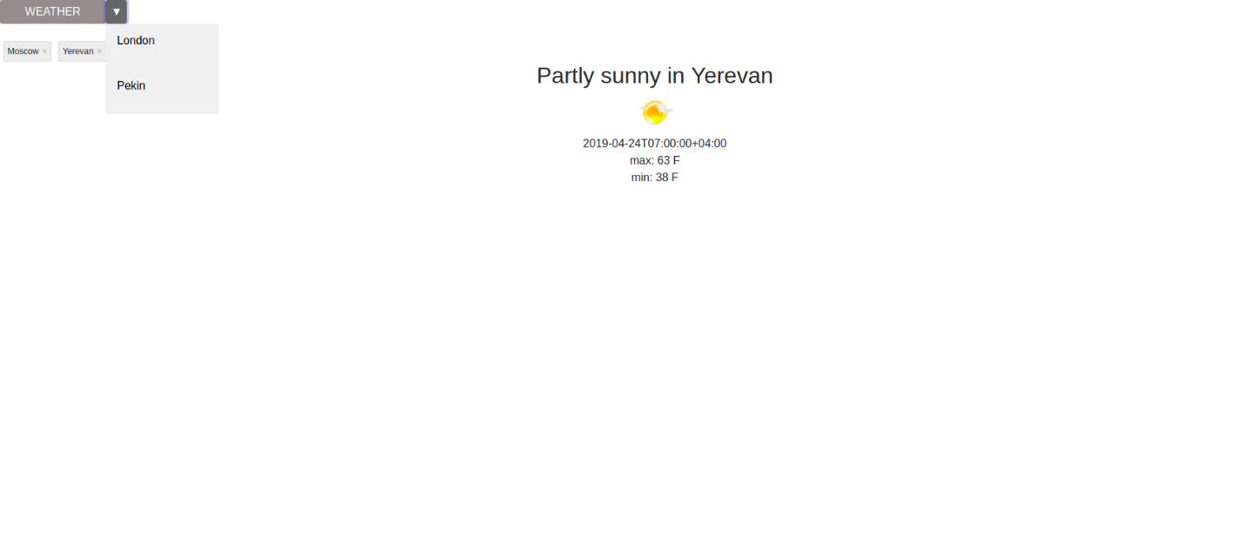
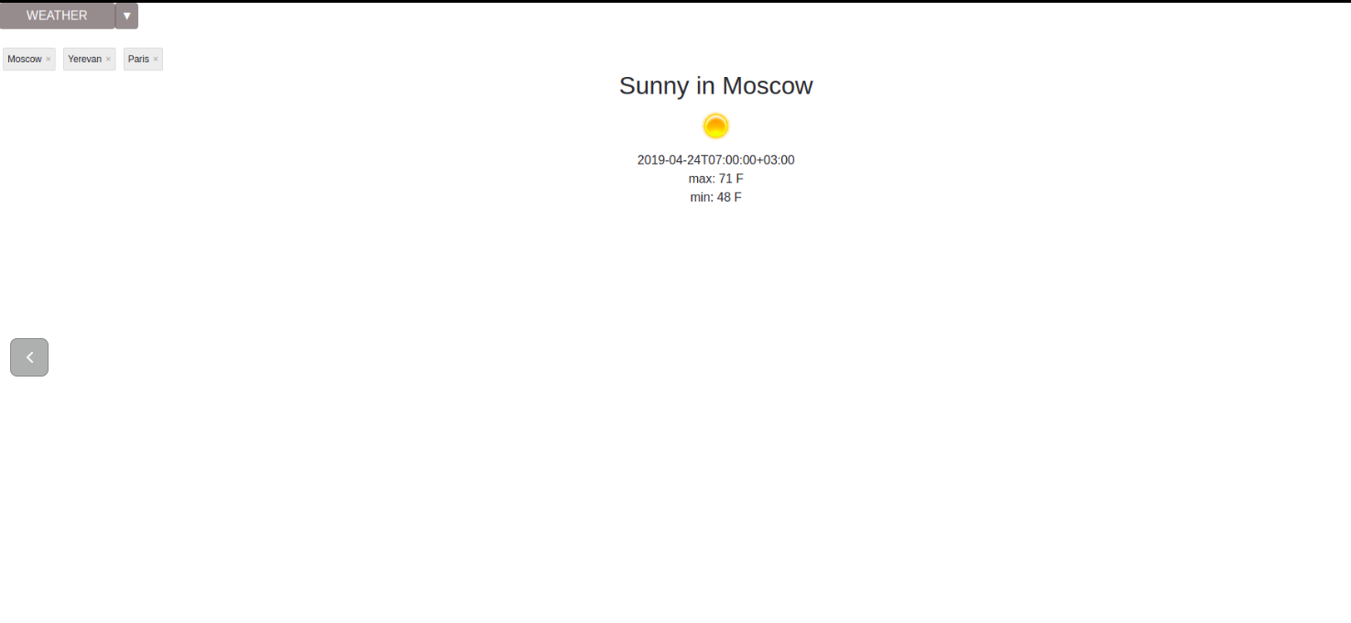

Software Architecture
[Insert any software architecture documents or provide a reference to where they are stored.]

Security Architecture
├── node_modules
├── package.json
├── package-lock.json
├── public
├── README.md
└── src
├── App.css
├── App.js
├── App.test.js
├── ForecastManager.js
├── index.css
├── index.js
├── logo.svg
└── registerServiceWorker.js

System Design

Use-Cases
The app used to display current weather info for different countries, like https://weather.com//

Database Design
No database.

Weather info
Use external accuweather to load forecast info.

Product Design Specification Approval
The undersigned acknowledge they have reviewed the WEATHER Product Design Specification document and agree with the approach it presents. Any changes to this Requirements Definition will be coordinated with and approved by the undersigned or their designated representatives.

Signature: |  | Date:
Print Name:
Title:
Role:

Signature: |  | Date:
Print Name:
Title:
Role:

Signature: |  | Date:
Print Name:
Title:
Role:

