Toward a Powered Flight Exoskeleton: A First-Principles Feasibility Analysis of the 'Iron Man' Suit
Nov 7, 2026 · @Alexi Choueiri
Independent Researcher

Abstract
A wearable, self-powered flight exoskeleton of the kind popularised by the fictional "Iron Man" suit is not forbidden by physics, but every subsystem except the propulsion concept sits far beyond today's engineering. We size a reference 200 kg system (80 kg pilot) from first principles. Hover requires about 2 kN of thrust and 90–280 kW of jet power depending on nozzle area. With 250 Wh/kg battery packs the electric design fails to close above roughly 9 minutes of hover at any mass; a kerosene micro-turbine design closes at 10–25 minutes with fuel fractions of 25–50%, consistent with existing jet suits. A compact fusion source would need negligible fuel (about 8 mg per hour) but its D–T neutron output would deliver a lethal dose to the wearer in milliseconds, and its waste heat (~450 kW) exceeds what a body-sized surface can reject by more than an order of magnitude. The binding constraint at high speed is aerodynamic power, which scales with the cube of airspeed and reaches megawatts near Mach 0.9. The binding constraint for the pilot is deceleration: armour does not protect against stopping too quickly, and keeping a 50 m/s impact under 20 g needs over 6 m of stopping distance. We conclude with a feasibility table and a technology roadmap.
Keywords: powered exoskeleton; personal flight; jet suit; momentum theory; energy density; compact fusion; thermal management; impact biomechanics; feasibility study
Disclaimer: this is an independent educational analysis. "Iron Man" is a trademark of Marvel; the author is not affiliated with Marvel or Disney, and the fictional suit is used only as a reference specification.
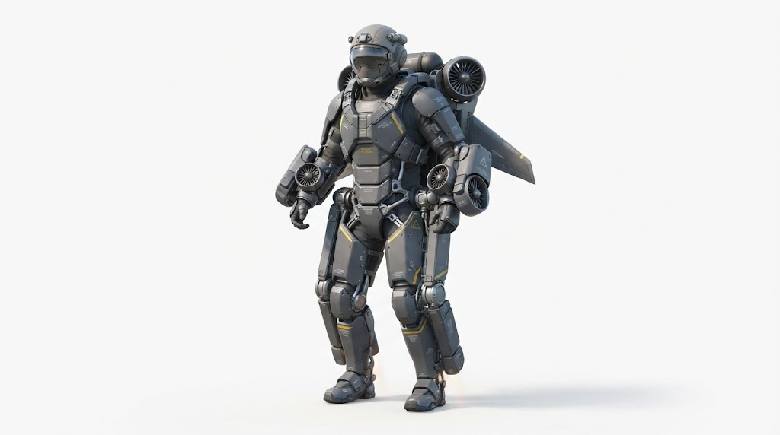
Figure 1. Concept illustration of the reference flight exoskeleton analysed in this paper: forearm and back-mounted ducted-fan thrust units, fold-out swept wings, a load-bearing exoskeleton frame at the hips and knees, segmented composite shell, and a single-visor helmet. AI-generated original design.

1. Introduction and scope
The question this paper answers is which laws of physics, rather than which missing inventions, stand between us and a powered flight exoskeleton. Fictional suits combine five capabilities in one wearable package: vertical take-off and hover, sustained high-speed flight, hours of endurance from a chest-mounted power source, strength amplification, and protection of the occupant.
Real precedents exist for some of these. Gravity Industries' Jet Suit uses five small gas turbines, rated at about 1,050 bhp and 144 kg of thrust, and flies for roughly 1–4 minutes (Flying; AOPA). Powered exoskeletons for industrial lifting and military load carriage have been demonstrated but not combined with flight.
We treat each capability with conservation of momentum and energy, standard heat-transfer relations, and published human-tolerance data. Weapons are out of scope. All results are order-of-magnitude estimates intended to identify binding constraints, not to produce a design.

2. Reference configuration and assumptions
We size a 200 kg take-off mass, which is optimistic but keeps every later result conservative in the suit's favour. Energy storage is excluded from this budget and added per power option in Section 4.
Item | Mass (kg) | Basis
Pilot | 80 | Adult male, 50th percentile
Shell / armour | 40 | 1.7 m² of 5 mm titanium alloy (Section 8)
Actuators, joints, frame | 25 | Full-body powered exoskeleton
Propulsion hardware | 25 | Four to five thrust units, ducts, mounts
Avionics, life support, cooling | 15 | Flight control, sensors, cooling garment
Subtotal (no energy store) | 185
Fixed constants: g = 9.81 m/s², sea-level air density ρ = 1.225 kg/m³, kerosene specific energy 43 MJ/kg. Hover thrust for 200 kg is T = mg ≈ 1,960 N.

3. Propulsion: hover thrust and jet power
Hover power is set by how much air the suit can push, and a wearable suit can only push a little air very fast, which is expensive. A jet of exit area A_e that accelerates still air to velocity v_e produces thrust T = ρ A_e v_e², carrying kinetic power P = ½ T v_e. Eliminating v_e gives the ideal hover power:
v_e = \sqrt{\frac{T}{\rho A_e}}, \qquad P_{jet} = \tfrac{1}{2} T v_e = \sqrt{\frac{T^{3}}{4 \rho A_e}}
Power scales as T^1.5, so every extra kilogram costs more than the last, and as A_e^−0.5, so small nozzles are penalised. For T = 1,960 N:
Configuration | Total exit area A_e (m²) | Exhaust velocity (m/s) | Ideal jet power (kW)
Micro-turbines, small nozzles | 0.02 | 283 | 278
Micro-turbines, typical | 0.04 | 200 | 196
Four 25 cm ducted fans | 0.20 | 90 | 88
Large open rotors (not wearable) | 1.00 | 40 | 39
These are ideal values; real units add losses. Ducted electric fans reach a figure of merit of roughly 0.6–0.7, while small turbojets convert only a few percent of fuel energy into jet power at hover.
Cross-check against a flying system. The Jet Suit produces 144 kgf (1,410 N) and carries 5.25 US gal of fuel for about four minutes (The Brighter Side). That is about 16 kg of kerosene in 240 s, or 0.066 kg/s, a chemical power of roughly 2.8 MW. Its ideal jet power at a 200 m/s exhaust is about 140 kW, so its fuel-to-jet efficiency is near 5%. This gap between rated power (1,050 bhp, about 780 kW) and useful jet power is typical of small turbojets running at low flight speed.
Control. Thrust must be vectored around the combined centre of mass. Real jet suits use arm-mounted units steered by the pilot; a fully enclosed suit would need fly-by-wire vectoring at a bandwidth of 10–20 Hz, comparable to multirotor drones.

4. Energy storage: batteries, hydrocarbons, compact fusion
Energy, not thrust, is what keeps the fictional suit fictional: present-day batteries cannot close a hover design beyond about 9 minutes at any mass. Adding energy adds mass, which raises hover power as m^1.5, which demands more energy.
Battery-electric. Using four 25 cm ducted fans (88 kW ideal at 200 kg) and a figure of merit of 0.65, electrical demand is P(m) ≈ 135 kW × (m/200 kg)^1.5. With pack specific energy e and fixed non-energy mass M₀ = 185 kg, the battery mass for hover time t must satisfy:
m = M_0 + b\,m^{3/2}, \qquad b = \frac{P_{200}\, t}{e\,(200\ \mathrm{kg})^{3/2}}, \qquad \text{closes only if } b \le \sqrt{\frac{4}{27\,M_0}}
The best commercial lithium-ion cells reach about 270 Wh/kg, and packs somewhat less once casing and cooling are added (Frith et al., 2023), so we take 250 Wh/kg as an optimistic pack value. The limit is then t ≈ 8.9 min, reached only at an absurd 555 kg. A practical 260 kg suit hovers about 5.6 minutes. Doubling to 500 Wh/kg, the target of current lithium-metal battery research (Liu et al., 2019), roughly doubles both figures.
Kerosene micro-turbines. Fuel burns off, so mass falls during flight and endurance follows a logarithm rather than hitting a wall. From the Jet Suit data in Section 3, hover consumes about 1.65 kg of fuel per kg of vehicle per hour, so t = ln(m₀/m₁) / 1.65 h. A 25% fuel fraction gives about 10 minutes; 50% gives about 25 minutes.
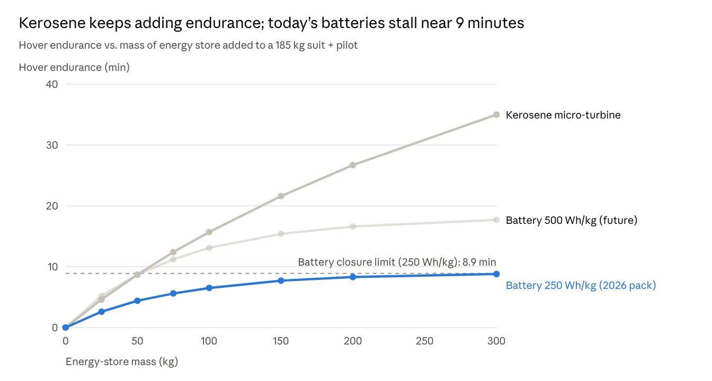
Computed in this paper (Section 4 equations); 185 kg fixed mass, sea-level hover
The chart shows why every flying jet suit today burns hydrocarbons: kerosene stores about 43 MJ/kg against 0.9 MJ/kg for a battery pack, which outweighs the turbine's poor efficiency.
Compact fusion (the "chest reactor"). One hour at 300 kW of useful power needs 1.08 GJ. Fuel mass is not the problem:
Source | Specific energy | Conversion efficiency (assumed) | Store mass for 1 h at 300 kW
Li-ion pack | 0.9 MJ/kg | 90% | 1,330 kg
Kerosene, hover micro-turbine | 43 MJ/kg | 5% | 500 kg
Kerosene, best-case turbine or fuel cell | 43 MJ/kg | 30% | 84 kg
Deuterium–tritium fusion fuel | 3.4 × 10⁸ MJ/kg | 40% | 8 mg
Plutonium-238 decay heat | 0.57 W/g thermal | 40% | 1,300 kg (power-limited)
The problem is the by-products. D–T fusion releases 80% of its 17.6 MeV per reaction as 14.1 MeV neutrons. At 750 kW of fusion power that is about 2.7 × 10¹⁷ neutrons per second. At 0.5 m from the source the flux is about 8.5 × 10¹² n/cm²·s; with a fluence-to-dose coefficient near 5 × 10⁻¹⁰ Sv·cm² for 14 MeV neutrons (ICRP 116), the wearer receives on the order of 4,000 Sv per second, a lethal dose within milliseconds. Shielding fast neutrons takes on the order of a metre of hydrogen-rich and dense material, which fails the mass budget by orders of magnitude.
Aneutronic fuels such as proton–boron-11 avoid most neutrons but need ion temperatures roughly ten times higher than D–T and suffer large bremsstrahlung losses. No fusion device of any size has yet delivered net electricity to a grid, so a wearable one is not a near-term engineering target.

5. Thermal management
A high-power suit can only dump its waste heat into the air it is already pushing; its own skin is far too small. Three heat loads matter.
- The pilot. A working human produces 100–400 W. An enclosed shell traps it, so the suit needs a liquid cooling garment of the kind used in spacesuits, plus a few hundred watts of heat rejection.
- The propulsion exhaust. Micro-turbine exhaust leaves at several hundred °C and about 200 m/s. Nozzles must be routed away from the legs and ground, and the pilot shielded from radiant heat.
- The power source. A 300 kW electrical output at 40% conversion leaves 450 kW of waste heat, comparable to the waste heat of two or three family cars at full throttle.
The body surface cannot reject 450 kW. Treating 2 m² of shell as a radiator at 600 K gives:
Q_{rad} = \varepsilon \sigma A T^{4} \approx 1 \times 5.67\times10^{-8} \times 2 \times 600^{4} \approx 15\ \mathrm{kW}
Forced convection helps in fast forward flight but gives almost nothing in hover, when relative airflow is near zero. The workable path is a compact heat exchanger inside the propulsive ducts. Four 25 cm fans move about 22 kg/s of air in hover, so 450 kW raises that stream by only:
\Delta T = \frac{Q}{\dot m\, c_p} = \frac{450\,000}{22 \times 1005} \approx 20\ \mathrm{K}
That is thermodynamically easy and even adds a little thrust, the principle of a thermal (ramjet-style) jet. Automotive-class heat exchangers reject very roughly 10 kW per kg, so this costs on the order of 45 kg, which again breaks the Section 2 budget.

6. Aerodynamics and high-speed flight
Fast flight is limited by drag power, which rises with the cube of airspeed. For a body with drag area CdA:
D = \tfrac{1}{2}\rho\, (C_d A)\, v^{2}, \qquad P_{drag} = D\,v = \tfrac{1}{2}\rho\, (C_d A)\, v^{3}
Skydiving data fix CdA. A belly-down skydiver of 80 kg falls at about 55 m/s, implying CdA ≈ 0.4 m²; head-down at about 80 m/s implies 0.2 m². We assume a smooth prone shell reaches 0.15 m².
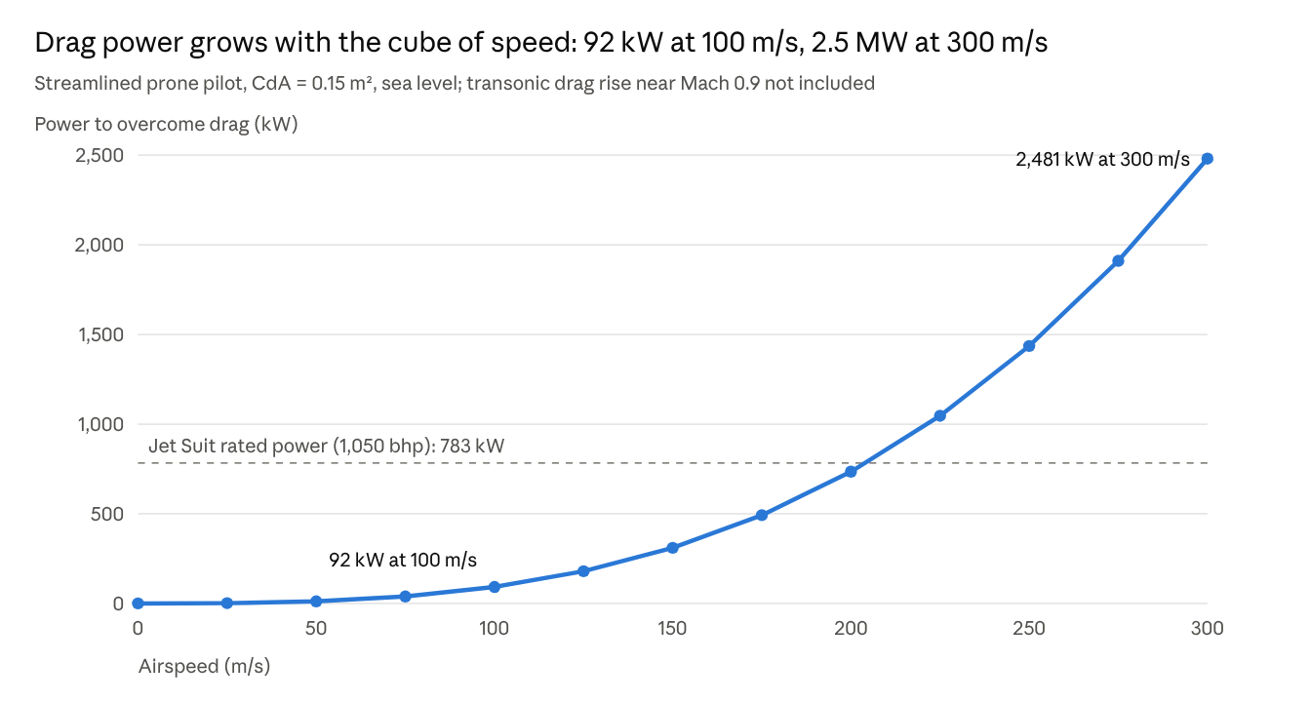
Computed in this paper from P = ½ρ(CdA)v³; Jet Suit rating from Flying and AOPA
A body without wings is a poor lifting surface. Even wingsuits glide at a lift-to-drag ratio of only about 2–3, so at cruise the suit also pays roughly W/(L/D) ≈ 650–1,000 N just to stay up. Near Mach 0.9 the drag coefficient rises two- to three-fold, pushing the power needed into the 5–10 MW range. A kerosene turbine at 20% overall efficiency would burn roughly 35–50 kg of fuel per minute there, so supersonic flight in a human-sized, wingless shell is ruled out by energy, not by any single component.
Flight speeds of 50–100 m/s (180–360 km/h) are the physically sensible envelope, roughly two to three times the current jet-suit record of 85 mph (38 m/s).

7. Pilot survivability: acceleration and impact
Armour protects the suit, not the person inside: the pilot's organs must decelerate with the shell, and the only defence is stopping distance. For a stop from speed v over distance d at constant deceleration:
a = \frac{v^{2}}{2d}, \qquad d_{\min} = \frac{v^{2}}{2\,a_{\max}}
Well-restrained humans have survived brief peaks above 40 g in rocket-sled tests (Stapp), but about 20 g is a reasonable limit for avoiding serious injury in a short pulse (Eiband). The table compares typical suit scenarios.
Scenario | Speed (m/s) | Stopping stroke (m) | Average deceleration (g) | Stroke needed for 20 g (m)
Drop from 10 m onto powered legs | 14 | 0.4 | 25 | 0.5
"Hero landing" from fast descent | 30 | 0.5 | 92 | 2.3
Collision at highway-plus speed | 50 | 0.5 | 255 | 6.4
Collision at cruise speed | 100 | 1.0 | 510 | 25.5
A rigid shell that does not deform transmits the full deceleration, so a stiffer suit is more dangerous to its wearer in a crash. Cars survive 15 m/s impacts with 0.5–0.7 m of crumple zone; a suit has a few centimetres of padding. Any practical design therefore needs active landing control, energy-absorbing leg stroke, and a ballistic parachute or airbag for failures, as on some light aircraft.
Manoeuvring loads. A seated pilot greys out at around 4–5 g headward without a g-suit. Flying prone puts loads chest-to-back, which humans tolerate much better. A 6 g turn at 100 m/s has a radius of about 170 m, far wider than the tight urban manoeuvres seen on screen.

8. Structure, armour mass and actuation
A full metal shell is affordable in mass only in light alloys or composites, and once worn it must be carried by powered joints. An adult's body surface is about 1.9 m²; we assume a shell covering 1.7 m² at a uniform 5 mm thickness, a structural and abrasion shell rather than a ballistic rating, which is outside this paper's scope.
Shell material | Density (g/cm³) | Shell mass, 1.7 m² × 5 mm (kg)
Steel | 7.85 | 67
Titanium alloy (Ti-6Al-4V) | 4.43 | 38
Aluminium alloy | 2.70 | 23
Carbon-fibre composite | 1.60 | 14
UHMWPE composite | 0.97 | 8
Actuation. On the ground, the suit's 100+ kg must be carried by its own legs, not the pilot's. Supporting about 120 kg above the knees with a 0.2 m moment arm needs roughly 235 N·m across both knees statically, and three to five times that in running or landing. Walking with that load costs on the order of 1–3 kW of actuator power, a further drain on the energy budget.
Range of motion. Rigid plates over joints must overlap and slide. The shoulder, with three rotational degrees of freedom and a moving shoulder blade, is the hardest joint to armour without blocking reach. Exoskeleton joints must also align with the wearer's own joint axes within a few millimetres, or the suit pushes against the body.

9. Discussion, feasibility summary and roadmap
The suit fails on energy and on human tolerance, not on any one missing gadget. Ranked from nearest to furthest:
Capability | Fictional spec | Physics limit found here | Status (2026) | Verdict
Hover and low-speed flight | Indefinite | 90–280 kW jet power for 200 kg | Flying today in minutes-long jet suits | Achievable
Strength amplification | Superhuman | 1–3 kW actuators, joint alignment | Industrial exoskeletons demonstrated | Achievable, heavy
Structural shell | Full coverage | 8–67 kg depending on material | Materials exist | Achievable within mass budget
Endurance | Hours | Batteries cap hover near 9 min; kerosene 10–25 min | Fuel-limited | Partly achievable
Waste-heat rejection | Unstated | ~450 kW needs in-duct heat exchangers | Concept only | Hard
High-speed and supersonic flight | Mach 1+ | 2.5 MW at 300 m/s before transonic rise | No wearable precedent | Not feasible in wearable form
Crash and hero landings | Unharmed | 20 g needs metres of stroke at 30+ m/s | Fixed by human biology | Not feasible
Chest fusion reactor | Gigawatt-class, safe | Lethal neutron dose in milliseconds | No net-electric fusion at any size | Not feasible
Roadmap for a realistic suit. The physics points to a different, achievable machine: a kerosene or hybrid jet suit with a powered exoskeleton, flying at 50–100 m/s for 15–30 minutes.
- Lengthen endurance with hybrid turbine-electric power: a turbine generator feeding ducted fans raises propulsive efficiency in hover.
- Add small fold-out wings to raise lift-to-drag in cruise and cut fuel burn.
- Integrate a load-carrying lower-body exoskeleton so the pilot never bears the suit's mass.
- Build in landing safety: fly-by-wire descent limiting, leg stroke, and a ballistic parachute.
- Revisit the energy store as batteries pass 500 Wh/kg at pack level; electric hover then reaches 15–18 minutes.
Limitations. All results are first-order estimates at sea level and standard temperature. Efficiencies, drag areas and tolerance limits are assumed, not measured, and could move individual numbers by a factor of two without changing any verdict.

10. Conclusion
A wearable flying suit is real physics today in a narrow form: minutes of kerosene-powered hover at modest speed. The fictional version fails on three hard limits. Stored energy per kilogram caps endurance, cubic drag growth caps speed, and human deceleration tolerance caps what any armour can protect against. A compact fusion source would solve the fuel problem but create a lethal radiation and heat problem in its place. The most useful engineering target is therefore a hybrid-powered, winged jet suit with a load-bearing exoskeleton and serious crash protection.

AI-assistance statement
This paper was prepared with the assistance of AI tools. A large language model was used for literature lookup, first-principles calculations, drafting of the text and generation of the charts. The concept illustration of the exoskeleton was produced with an AI image generator and is an original design, not a depiction of any existing or fictional suit.

References
- Eiband, A. M. (1959). Human Tolerance to Rapidly Applied Accelerations: A Summary of the Literature. NASA Memorandum 5-19-59E.
- Frith, J. T., Lacey, M. J., & Ulissi, U. (2023). A non-academic perspective on the future of lithium-based batteries. Nature Communications, 14, 420. https://doi.org/10.1038/s41467-023-35933-2
- Hill, P., & Peterson, C. (1992). Mechanics and Thermodynamics of Propulsion (2nd ed.). Addison-Wesley.
- ICRP (2010). Conversion Coefficients for Radiological Protection Quantities for External Radiation Exposures. ICRP Publication 116, Annals of the ICRP 40(2–5).
- Incropera, F. P., DeWitt, D. P., Bergman, T. L., & Lavine, A. S. Fundamentals of Heat and Mass Transfer. Wiley.
- Leishman, J. G. (2006). Principles of Helicopter Aerodynamics (2nd ed.). Cambridge University Press.
- Liu, J., Bao, Z., Cui, Y., et al. (2019). Pathways for practical high-energy long-cycling lithium metal batteries. Nature Energy, 4, 180–186. https://doi.org/10.1038/s41560-019-0338-x
- Wesson, J. (2011). Tokamaks (4th ed.). Oxford University Press.
- Jet Suit Maker Demonstrates High-Flying Tech in Military Applications, Flying.
- Jet suit rescue demonstrated, AOPA, October 2020.
- This New Space-Age Jet Suit Is Like Having a VTOL Strapped to Your Arms, The Brighter Side of News.

