Digital Image Processing - Course Project 2026
Document-Image Enhancement for OCR on Insurance Claim Invoices
Project HSR-AIML-004 (adapted to a DIP scope)
Shubham Verma (23CS3052) and Digdarshan Mishra (23CS3024)

1. Problem and motivation
Insurance claim forms and invoices reach an insurer as scans or phone photographs. They are often skewed, unevenly lit, noisy, blurred or faint, and every one of these defects raises the error rate of optical character recognition (OCR). This project measures which classical image-processing stages actually improve a modern OCR engine, and which do nothing or make things worse.
The measurable outcome is OCR accuracy, expressed as character error rate (CER) and word error rate (WER) against known ground-truth text.

2. Data
Real claim documents are private, so we generated synthetic A4 invoices (1240 x 1754 px, about 150 dpi). Each page has an insurer title, claim, policy, insured-person, claim-type and date lines, a six-row item table with quantity, rate and amount, a total, and a footer. Fonts, names, numbers and amounts are random. Because the text is generated, the exact ground truth is known and no manual labelling is needed.
We used 20 documents (random seed 2026). Each document was degraded under seven conditions:
Condition | Degradation applied
clean | No degradation
blur | Gaussian blur, sigma 2.2 px
noise | Gaussian noise, std 28, plus 2% salt-and-pepper
unevenLight | Directional brightness ramp down to 35% of full brightness
lowContrast | Grey range compressed to 140-190 (black maps to 140, white to 190)
skew | Rotation of 3-8 degrees, random direction
combined | Blur, contrast, light and noise at 40% severity, plus a 3-8 degree skew

3. Method

3.1 Pipeline
A page passes through a configurable chain of classical DIP stages and is then read by the RapidOCR engine, the only learned component. Figure 1 shows the chain. The stages and their parameters are listed in Table 2.
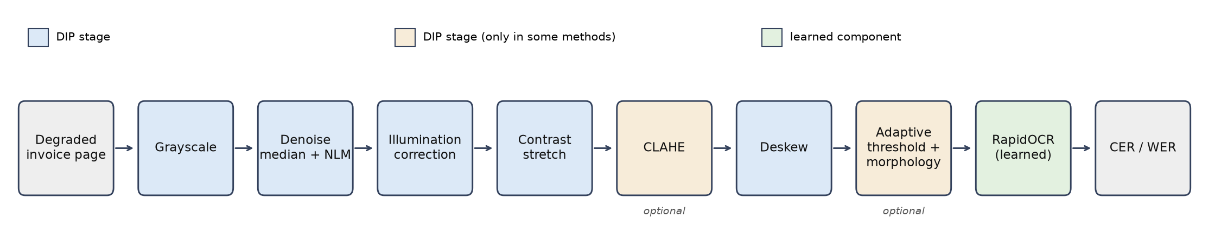
Figure 1: Processing pipeline. Orange stages are used only in some of the compared methods.
Stage | Operation and parameters | Purpose
Grayscale | Single-channel conversion | Reduces the page to intensity
Denoise | 3x3 median, then non-local means; strength follows the estimated noise sigma (clipped to 3-25); skipped when sigma < 2 | Removes salt-and-pepper and Gaussian noise without thinning strokes on clean pages
Illumination correction | Morphological closing (41 px ellipse) and 51 px median give the background; image divided by it | Flattens uneven lighting
Contrast stretch | Median maps to white, 0.05th percentile maps to black | Restores faint text
CLAHE (optional) | Clip limit 2.0, 8x8 tiles | Local histogram equalisation
Deskew | Projection-profile variance search on an Otsu text mask, +/-12 degrees, 0.5 then 0.1 degree steps; skipped below 0.3 degrees | Straightens rotated text lines
Adaptive threshold + morphology (optional) | Gaussian adaptive threshold (block 35, offset 15), then 2x2 opening and closing | Binarises and removes specks
Table 2: DIP stages.

3.2 Methods compared
- gray - the page converted to grayscale and read directly (baseline).
- otsu - grayscale followed by a global Otsu threshold (classical baseline).
- enhanced - grayscale, denoise, illumination correction, contrast stretch and deskew.
- enhancedClahe - enhanced with CLAHE added.
- enhancedBinary - enhanced followed by adaptive thresholding and morphology.

3.3 Evaluation protocol
The OCR output is grouped into lines by vertical position and compared with the ground truth. CER is computed after removing whitespace, so spacing choices of the engine are not counted as character errors; WER uses collapsed whitespace. We also report PSNR and SSIM against the clean page, which are defined only when the image size is unchanged, and the skew-estimation error in degrees. A leave-one-stage-out ablation was run on the combined condition.

4. Results
Table 3 gives the mean CER over 20 documents per condition (lower is better). Table 4 gives the mean WER.
Condition | gray | otsu | enhanced | enhancedClahe | enhancedBinary
clean | 0.015 | 0.034 | 0.015 | 0.015 | 0.313
blur | 0.024 | 0.657 | 0.019 | 0.017 | 0.258
noise | 0.030 | 0.137 | 0.047 | 0.093 | 0.339
unevenLight | 0.017 | 0.458 | 0.015 | 0.015 | 0.312
lowContrast | 0.017 | 0.030 | 0.071 | 0.068 | 0.274
skew | 0.264 | 0.266 | 0.016 | 0.016 | 0.039
combined | 1.000 | 0.992 | 0.937 | 0.944 | 0.983
Table 3: Mean character error rate.
Condition | gray | otsu | enhanced | enhancedClahe | enhancedBinary
clean | 0.086 | 0.115 | 0.086 | 0.086 | 0.583
blur | 0.322 | 0.936 | 0.350 | 0.359 | 0.781
noise | 0.204 | 0.579 | 0.364 | 0.604 | 0.641
unevenLight | 0.089 | 0.532 | 0.086 | 0.087 | 0.581
lowContrast | 0.092 | 0.116 | 0.269 | 0.263 | 0.671
skew | 0.357 | 0.377 | 0.092 | 0.095 | 0.202
combined | 1.000 | 0.999 | 0.992 | 0.996 | 1.000
Table 4: Mean word error rate.
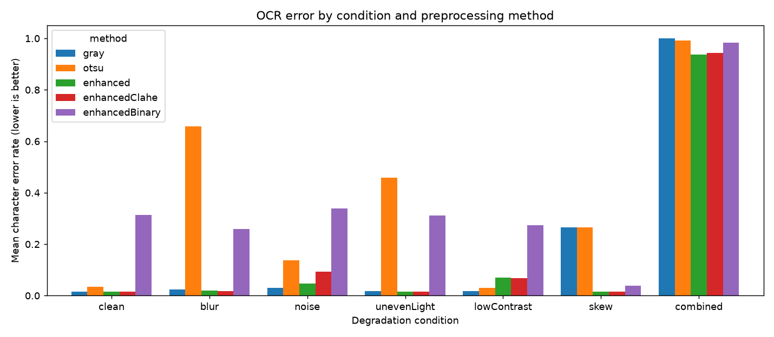
Figure 2: Mean CER by condition and method.
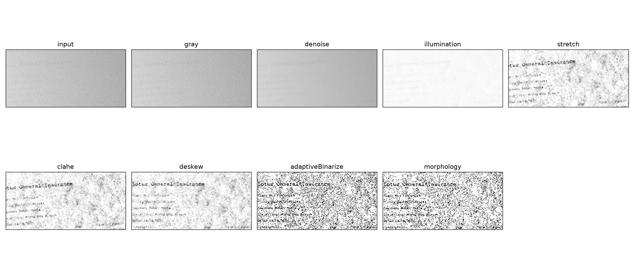
Figure 3: Intermediate images for one combined-condition page (cropped to the header region).
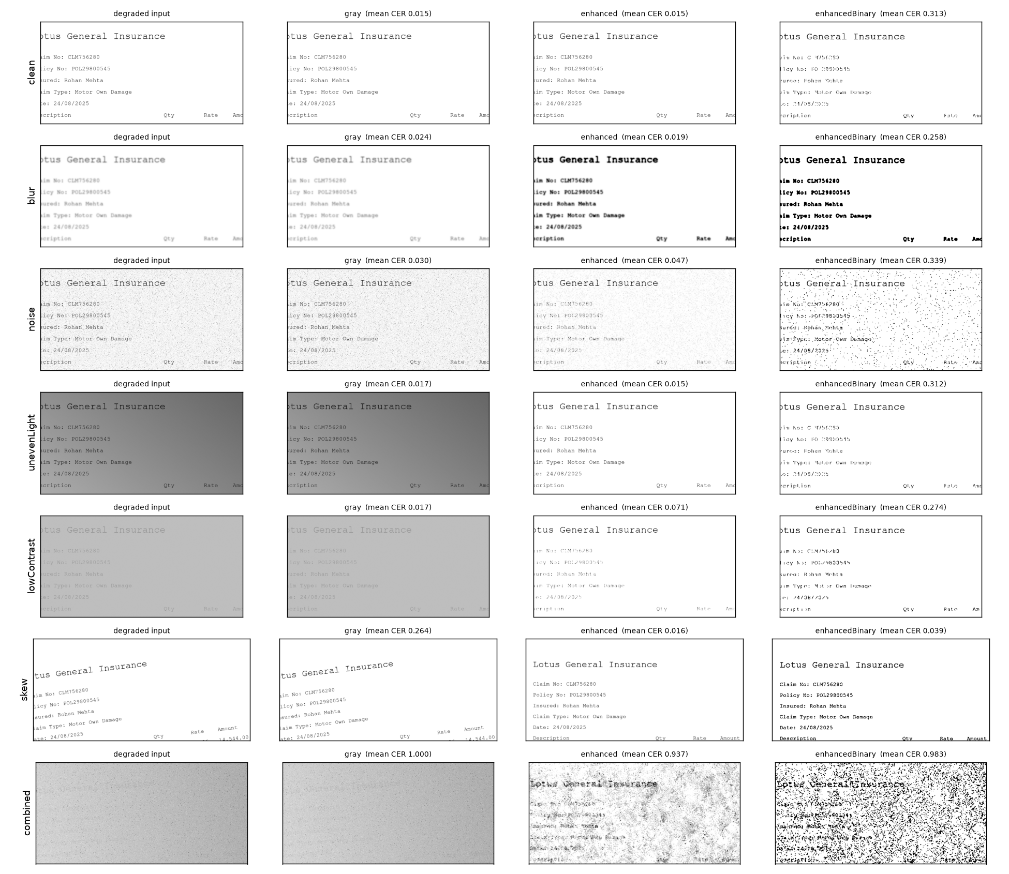
Figure 4: Degraded input and method outputs for each condition, with mean CER.
Other measurements for the enhanced method: the mean skew-estimation error is 0.028 degrees on the skew condition and 0.081 degrees on the combined condition. PSNR / SSIM against the clean page are 22.1 dB / 0.952 for blur, 26.3 dB / 0.666 for noise, 59.1 dB / 1.000 for uneven light and 28.8 dB / 0.987 for low contrast.

5. Analysis

5.1 Where the DIP stages help
- Skew: deskewing reduces CER from 0.264 to 0.016. The OCR engine does not read rotated lines reliably, and the projection-profile search recovers the angle to within about 0.03 degrees.
- Uneven light and blur against the Otsu baseline: a global threshold fails (CER 0.458 and 0.657), while the enhanced pipeline restores 0.015 and 0.019.

5.2 Where they do not help
- Against the untouched grayscale image, enhancement gives no gain on clean, blurred and unevenly lit pages. The learned OCR already handles these (CER 0.015-0.024).
- Noise and low contrast get worse with enhancement (noise 0.030 to 0.047; low contrast 0.017 to 0.071). The denoise and stretch stages remove or distort faint strokes. We did not investigate this further.
- Binarisation hurts badly (CER 0.31 on clean pages). Thresholding discards the grey-level cues the recogniser uses. It is meant for classical OCR engines, which we did not test.
- The combined condition is a failure case for every method (CER 0.94-1.00). On the worst pages the OCR returned no text at all.

5.3 Ablation
The leave-one-stage-out ablation on the combined condition (Figure 5) is uninformative: every variant sits at CER 0.98-0.99 except the one that removes adaptive thresholding (0.909). This is a floor effect, because the condition is nearly unreadable, and is not evidence that the other stages are unnecessary.
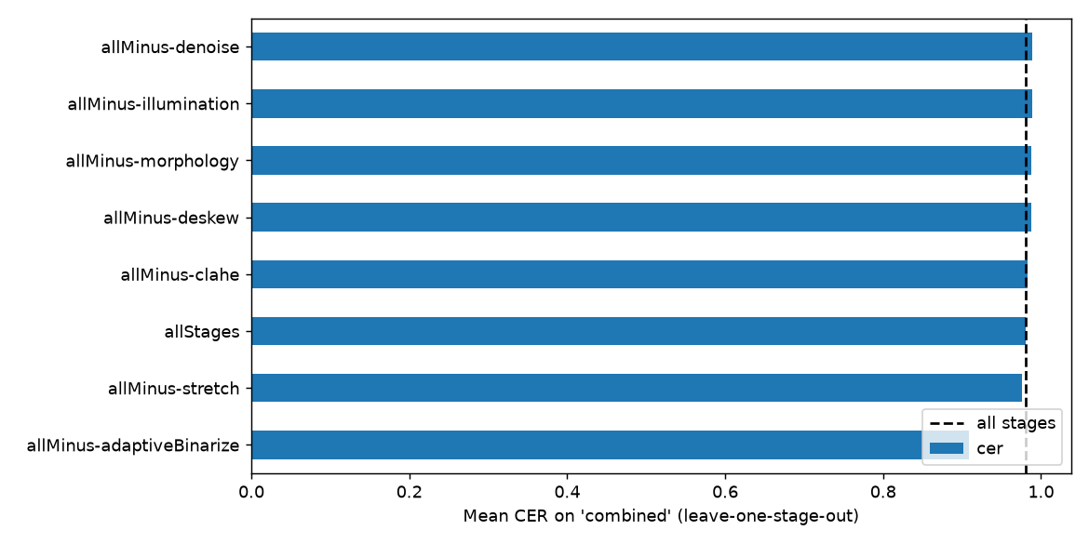
Figure 5: Leave-one-stage-out ablation on the combined condition.

6. Limitations
- The data is synthetic and the page layout is fixed, so the results may not transfer to real scans.
- Only one OCR engine (RapidOCR) was tested. A classical engine such as Tesseract would probably respond differently, especially to binarisation.
- Pipeline parameters were adjusted after inspecting pilot pages from the same generator (combined severity lowered, denoise and deskew skipped on clean pages, contrast-stretch anchors changed). No separate held-out set was used, so the tuned stages are likely to look better here than on new data.
- There are 20 pages per condition. Differences of a few thousandths in CER are not significant.

7. Conclusion
For a modern learned OCR engine, classical preprocessing is not a free improvement. Deskewing clearly pays off, and illumination correction rescues a simple global threshold, but on already-readable pages the engine does as well untouched, and denoising, contrast stretching and binarisation can reduce accuracy. Preprocessing should be applied selectively, according to measured page defects, and checked against the raw-image baseline.

8. Reproducibility
Source code, results and figures are in the project repository. After installing requirements.txt, the experiment is run with:
python src/runExperiment.py --docs 20 --seed 2026 --outputDir outputs
The run takes about 25 minutes on a CPU and writes results.csv, summary.csv, summary.md and the figures.

9. Team contributions
Area | Files | Lead
Synthetic invoices and degradations | syntheticInvoiceGenerator.py, imageDegradations.py, imageRotation.py | Shubham Verma
Evaluation and experiment runner | ocrEngine.py, evaluationMetrics.py, runExperiment.py | Shubham Verma
DIP enhancement stages | enhancementStages.py, enhancementPipeline.py, pipelineConfig.py | Digdarshan Mishra
Analysis, figures, report | experimentReport.py, outputs/, this report | Digdarshan Mishra
Both members can explain the complete pipeline.

