Software Requirements Specification (SRS)

for

LoanGauge - AI-Powered Financial Readiness & Loan Planning Platform
Version 1.0
Prepared by Project Team 33
Name | PRN
Aadil Ansari | 260240320001
Anusha Shyamkumar Karanje | 260240320024
Bhavik Sanjay Nijai | 260240320033
Neha Narendra Bodhade | 260240320084
Pankaj Dattatray Gaikwad | 260240320100
Vivek Chouhan | 260240320207

Centre for Development of Advanced Computing
Raintree Marg, Near Bharati Vidyapeeth, Opp. Kharghar Railway Station, Sector 7, CBD Belapur, Navi Mumbai - 400 614 - Maharashtra (India)
Phone: +91-22-27565303 Fax: +91-22-2756-0004

Table of Contents
Table of Contents ii
Revision History iii
1. Introduction 1
1.1 Purpose 1
1.2 Document Conventions 1
1.3 Intended Audience and Reading Suggestions 1
1.4 Product Scope 2
1.5 References 3
2. Overall Description 3
2.1 Product Perspective 3
2.2 Product Functions 4
2.3 User Classes and Characteristics 6
2.4 Operating Environment 8
2.5 Design and Implementation Constraints 9
2.6 User Documentation 10
2.7 Assumptions and Dependencies 10
3. External Interface Requirements 11
3.1 User Interfaces 11
3.2 Hardware Interfaces 12
3.3 Software Interfaces 12
3.4 Communications Interfaces 14
4. System Features 15
4.1 Authentication & User Management 15
4.2 Financial Profile Management 17
4.3 Financial Readiness Assessment 19
4.4 Financial Goal Planner & Assessment Comparison 28
4.5 AI Coach, Reports & Notifications 29
4.6 Administration & Advisor Management 30
5. Other Nonfunctional Requirements 32
5.1 Performance Requirements 32
5.2 Security Requirements 32
5.3 Reliability and Availability 33
5.4 Usability Requirements 33
5.5 Maintainability Requirements 34
5.6 Scalability Requirements 34
5.7 Portability Requirements 34
5.8 Backup and Recovery Requirements 35
6. Other Requirements 35
6.1 Database Requirements 35
6.2 Logging and Audit Requirements 35
6.3 Legal and Compliance Considerations 36
6.4 Future Enhancements 36
Appendix A: Glossary 36
Appendix B: Analysis Models 38
Appendix C: To Be Determined List 43

Revision History
Name | Date | Reason For Changes | Version
Project Team | 22-July-2026 | Initial draft of the Software Requirements Specification (SRS) | 1.0

Introduction

Purpose
The purpose of this Software Requirements Specification (SRS) is to define the functional and non-functional requirements of LoanGauge - AI-Powered Financial Readiness & Loan Planning Platform. This document serves as the primary reference for the development, testing, deployment, and maintenance of the system.
This document outlines the application's overall architecture, system functionality, external interfaces, business rules, security requirements, and quality attributes. Throughout the software development lifecycle, it is meant to guarantee that all stakeholders have a shared understanding of the project requirements.

Document Conventions
This Software Requirements Specification follows the IEEE Software Requirements Specification (SRS) standard.
This document uses the following conventions:-
- Section headings follow hierarchical numbering (for example, 1.1, 2.3, 4.2).
- Functional requirements are uniquely identified using the format REQ-XXX-### (for example, REQ-AUTH-001, REQ-ASSESS-005).
- The terms shall, should, and may are used according to standard software engineering conventions:
  - Shall indicates a mandatory requirement.
  - Should indicates a recommended requirement.
  - May indicates an optional or future enhancement.
- Important technical terms are written in bold when introduced for the first time.
- All monetary values are represented in Indian Rupees (₹) unless specified otherwise.
- Dates follow the DD/MM/YYYY format.
- Screenshots, diagrams, and architectural models referenced in this document are included in the appendices where applicable.

Intended Audience and Reading Suggestions
Readers are encouraged to review this document in the following order:
- Introduction
- Overall Description
- External Interface Requirements
- System Features
- Non-Functional Requirements
- Appendices
This sequence provides a progressive understanding of the project, beginning with the business problem and concluding with detailed technical requirements.

Stakeholder | Purpose
Project Guide | Review project objectives, architecture, and compliance with academic requirements.
Development Team | Understand system requirements, architecture, and implementation details.
Test Engineers | Prepare unit, integration, and system test cases based on the documented requirements.
Project Evaluators | Assess project scope, innovation, functionality, and software engineering practices.
Future Developers | Understand the existing system for future maintenance or enhancement.

Product Scope
LoanGauge is an AI-Powered Financial Readiness & Loan Planning Platform designed to assist users in understanding their financial health before applying for any type of loan.
The platform generates a comprehensive Financial Readiness Score by analyzing a user's financial profile, which includes income, expenses, liabilities, savings, investments, employment stability, and credit information. The assessment is based on several financial indicators, including EMI, FOIR (Fixed Obligation to Income Ratio), DTI (Debt-to-Income Ratio), Savings Ratio, Emergency Fund Coverage, Credit Utilization, and Employment Stability.
In addition to financial assessment, LoanGauge offers several intelligent features, including:
- Comprehensive Financial Profile Management
- Financial Readiness Assessment
- AI-Powered Financial Recommendations
- Financial Goal Planner
- Assessment Comparison and Progress Tracking
- Eligibility Report Generation
- Advisor Consultation
- PDF and Email Report Delivery
The platform is designed to help users in identifying financial strengths and weaknesses, increasing borrowing readiness, and making informed financial decisions.
LoanGauge is not a banking application; it does not process loan applications or guarantee loan approval. The platform is solely a financial decision-support system that provides analytical insights based on user-supplied financial data.

References
The following references were used during the analysis and design of the system:
- IEEE Recommended Practice for Software Requirements Specifications (IEEE 830).
- Spring Boot Official Documentation: https://docs.spring.io/spring-boot/index.html
- Spring Security Reference Documentation: https://spring.io/projects/spring-security
- React Official Documentation: https://react.dev/reference/react
- RabbitMQ Documentation: https://www.rabbitmq.com/docs
- MySQL Reference Manual: https://dev.mysql.com/doc/
- MongoDB Documentation: https://www.mongodb.com/docs/
- JSON Web Token (JWT) – RFC 7519: https://datatracker.ietf.org/doc/html/rfc7519
- OWASP Top 10 Web Application Security Risks.
- Swagger/OpenAPI Specification: https://swagger.io/docs/ https://developers.openai.com/api/docs
- Google Gemini API Documentation: https://ai.google.dev/gemini-api/docs

Overall Description

Product Perspective
LoanGauge is a standalone web-based application designed to help individuals in assessing and improving their financial readiness prior to applying for loans. The system serves as a financial decision-support platform, analyzing a user's financial profile and providing data-driven insights into their borrowing preparedness.
Unlike traditional loan eligibility calculators, which only estimate EMI or basic affordability, LoanGauge conducts a thorough financial assessment by examining a variety of financial indicators such as income, expenses, liabilities, savings, investments, employment stability, and credit score.
The application follows a microservices-based architecture, which divides responsibilities among independent services to improve scalability, maintainability, and reliability.
The major components of the system include:
- React-based Web Application (Frontend)
- API Gateway
- Authentication Service
- Financial Assessment Service
- Notification Service
- MySQL Database
- MongoDB Database
- RabbitMQ Message Broker
- Google Gemini API (AI Financial Coach)
The Notification Service uses RabbitMQ to communicate asynchronously with other services, such as email notifications and report delivery, which improves system responsiveness and reliability.

Product Functions
LoanGauge provides a comprehensive set of features that enable users to evaluate, improve, and monitor their financial readiness throughout their financial journey.
The major functions of the system include:

User Management
- User Registration
- User Authentication
- Role-Based Authorization
- Password Management
- Profile Management

Financial Profile Management
- Personal Information
- Employment Information
- Income Sources
- Monthly Expenses
- Existing Liabilities
- Savings & Investments
- Credit Profile

Financial Readiness Assessment
- EMI Calculation
- Fixed Obligation to Income Ratio (FOIR)
- Debt-to-Income Ratio (DTI)
- Savings Ratio
- Emergency Fund Coverage
- Credit Utilization Ratio
- Disposable Income Calculation
- Financial Stability Analysis
- Financial Readiness Score Generation
- Risk Classification

AI Financial Coach
- Personalized Financial Recommendations
- Debt Reduction Suggestions
- Savings Improvement Suggestions
- Financial Readiness Improvement Guidance

Financial Goal Planner
- Goal Creation
- Progress Tracking
- Monthly Savings Calculation
- Estimated Completion Timeline

Assessment Comparison
- Historical Assessment Tracking
- Financial Trend Analysis
- Comparative Charts
- AI-Based Progress Analysis

Reports
- Financial Assessment Report
- PDF Export
- Email Delivery

Advisor Module
- Consultation Requests
- Report Sharing
- Advisor Feedback

Administration
- User Management
- Loan Type Management
- Subscription Management
- Dashboard Analytics
- System Monitoring

User Classes and Characteristics
The application supports four different user roles with varying levels of access and responsibilities.

Administrator
The Administrator manages the overall platform and has complete access to system configuration and management functions.
Responsibilities include:
- Managing users
- Managing financial advisors
- Configuring loan types
- Managing subscriptions
- Monitoring reports and analytics
- Viewing system logs
Expected Technical Expertise: High

User
A User is an individual seeking to evaluate their financial readiness before applying for a loan.
Users can:
- Manage financial profiles
- Perform financial assessments
- View reports
- Track financial goals
- Compare assessments
Expected Technical Expertise: Basic computer and internet usage.

Premium User
A Premium User has access to all standard user features along with advanced capabilities.
Additional privileges include:
- Unlimited assessments
- AI Financial Coach
- Advanced analytics
- PDF report generation
- Email reports
- Advisor consultation
- Detailed assessment comparison
Expected Technical Expertise: Basic to Intermediate.

Financial Advisor
Financial Advisors assist users by reviewing financial assessments and providing professional guidance.
Responsibilities include:
- Reviewing shared reports
- Providing recommendations
- Managing consultation requests
- Tracking consultation history
Expected Technical Expertise: Intermediate financial knowledge and familiarity with web applications.

Operating Environment
LoanGauge is a web-based application designed to operate across modern web browsers without requiring client-side installation.

Client Environment
- Google Chrome (Latest)
- Microsoft Edge (Latest)
- Mozilla Firefox (Latest)

Server Environment
- Java 21
- Spring Boot 3.x
- Apache Maven
- RabbitMQ
- MySQL 8.x
- MongoDB
- Docker
- Jenkins
- Nginx

Operating Systems
Development:
- Windows 10/11
- Ubuntu 24.04 LTS
Deployment:
- Ubuntu Server (AWS EC2)

Internet Requirement
- Stable internet connection
- HTTPS enabled communication

Design and Implementation Constraints
The development of LoanGauge is subject to the following constraints:

Technology Constraints
- Frontend should be developed using React.js.
- Backend should be implemented using Spring Boot or ASP.NET.
- JWT should be used for authentication.
- RabbitMQ should be used for asynchronous communication.
- MySQL and MongoDB shall be used as the primary databases.
- RESTful APIs should be used for communication between frontend and backend.
- Swagger should be used for API documentation.

Security Constraints
- Passwords shall be encrypted using BCrypt.
- Sensitive APIs shall require JWT authentication.
- Role-Based Access Control shall be enforced.

Deployment Constraints
- Application shall be containerized using Docker.
- Deployment shall be performed on AWS EC2.

User Documentation
The following documentation will be provided with the system:
- User Manual
- Administrator Guide
- Installation Guide
- API Documentation (Swagger)
- Project Report
- Software Requirements Specification (SRS)
- Database Documentation
- Deployment Guide

Assumptions and Dependencies
The successful operation of LoanGauge depends on the following assumptions:

Assumptions
- Users provide accurate financial information.
- Users manually enter their CIBIL score (no direct integration with CIBIL).
- Internet connectivity is available during system usage.
- Email services remain operational for notification delivery.
- AI recommendations are advisory in nature and should not be considered professional financial or legal advice.

Dependencies
The application depends on the following external components:
- Google Gemini API for AI-generated financial recommendations.
- RabbitMQ for asynchronous message processing.
- SMTP Email Service for report delivery.
- MySQL Database Server.
- MongoDB Database Server.
- AWS Cloud Infrastructure for deployment.

External Interface Requirements

User Interfaces
LoanGauge provides a responsive and user-friendly web interface that enables users to perform financial assessments, monitor financial progress, and manage their profiles efficiently. The application follows modern UI/UX principles to ensure consistency, accessibility, and ease of use across different devices.
The graphical user interface (GUI) is designed using React.js and Tailwind CSS, providing a clean, responsive, and intuitive experience.

User Interface Characteristics
- Responsive design supporting desktops, laptops, tablets, and mobile devices.
- Consistent navigation using a top navigation bar and sidebar (where applicable).
- Form validation with clear live error messages and input guidance.
- Dashboard-based interface for quick access to important financial metrics.
- Interactive charts and graphs for financial trend analysis.
- Light and Dark mode support.
- Role-specific dashboards for Users, Premium Users, Financial Advisors, and Administrators.

Major Screens
The application includes the following primary user interfaces:
Screen | Description
Landing Page | Provides an overview of LoanGauge and its features.
Login Page | Authenticates registered users.
Registration Page | Allows new users to create an account.
User Dashboard | Displays Financial Readiness Score, recent assessments, goals, and recommendations.
Financial Profile | Enables users to enter and manage financial information.
Assessment Page | Performs financial readiness analysis and displays calculated metrics.
Goal Planner | Allows users to create and monitor financial goals.
Assessment Comparison | Displays comparison of historical assessments using charts.
AI Financial Coach | Displays AI-generated financial recommendations.
Reports | Allows viewing, downloading, and emailing financial reports.
Advisor Dashboard | Enables advisors to review consultation requests and provide recommendations.
Admin Dashboard | Allows administrators to manage users, subscriptions, loan types, and system analytics.

Hardware Interfaces
LoanGauge is a web-based software application and does not require direct interaction with specialized hardware devices.
Users access the application using standard computing devices such as desktops, laptops, tablets, or smartphones through modern web browsers that supports ES6+. No proprietary hardware, biometric devices, scanners, or external sensors are required.
The minimum client hardware requirements are:
- Desktop, Laptop, Tablet, or Smartphone
- Keyboard and Mouse (Desktop/Laptop)
- Internet Connectivity
- Minimum display resolution of 1366 × 768 pixels
The server infrastructure is hosted on cloud-based virtual machines and communicates through standard network protocols.

Software Interfaces
LoanGauge interacts with several software components and third-party services to provide secure authentication, financial analysis, AI-powered recommendations, messaging, and data persistence.

Frontend
- React.js
- React Router
- Redux Toolkit
- Tailwind CSS
- Axios
- React Hook Form
- Zod
- Lucide Icon
- Recharts

Backend
- Spring Boot
- Spring Security
- Spring Data JPA
- Hibernate ORM
- Bean Validation
- Swagger/OpenAPI

Databases
Database | Purpose
MySQL | Stores structured application data including users, financial profiles, assessments, goals, subscriptions, and loan information.
MongoDB | Stores AI-generated recommendations, financial assessment reports, notification logs, and audit logs.

Messaging System
RabbitMQ is used for asynchronous communication between microservices.
Primary use cases include:
- PDF report generation
- Email notifications
- Background processing
- Event-driven communication

AI Integration
Google Gemini API is used to generate personalized financial recommendations based on the user's financial profile and assessment results.

Email Service
SMTP is used for:
- Email verification
- Password reset
- Financial report delivery
- Notification emails

Communications Interfaces
The application communicates using secure internet protocols and RESTful APIs.

Client–Server Communication
- Protocol: HTTPS
- Data Format: JSON
- Architecture: RESTful APIs

Internal Service Communication
Microservices communicate through:
- REST APIs (synchronous)
- RabbitMQ (asynchronous messaging)

Authentication
Authentication is performed using JSON Web Tokens (JWT).
The JWT is included in the Authorization header using the Bearer Token format for accessing protected APIs.

External Communication
The application integrates with external services for:
- Google Gemini API (AI recommendations)
- SMTP Email Server (email notifications)
All external communications occur over encrypted HTTPS connections to ensure confidentiality and integrity.

System Features
The following sections describe the major functional features provided by the LoanGauge platform. Each feature includes a description, priority, stimulus/response sequence, and detailed functional requirements.

Authentication & User Management

Description and Priority

Description
The Authentication and User Management module provides secure access control and identity management for the LoanGauge platform. It enables users to register, authenticate, manage their profiles, and recover account access when necessary. The module uses JSON Web Token (JWT) based authentication and Role-Based Access Control (RBAC) to ensure that users can access only the resources permitted for their assigned roles.
The module supports four main user roles: Administrator, Standard User, Premium User, and Financial Advisor. Passwords are securely encrypted before storage using BCrypt, and all authenticated requests require a valid JWT for authorization.

Priority
High
This feature is critical because all protected services of the application depend on secure user authentication and authorization.

4.1.2 Stimulus / Response Sequence
Stimulus (User Action) | System Response
User selects Register. | System displays the registration form.
User submits registration details. | System validates the input, checks for duplicate email addresses, encrypts the password, creates the account, and stores the user information.
User attempts to log in. | System validates the credentials and generates a JWT upon successful authentication.
User accesses a protected resource. | System verifies the JWT and grants or denies access based on the assigned user role.
User updates profile information. | System validates the updated information and saves the changes.
User selects Forgot Password. | System generates a password reset token and sends a password reset link to the registered email address.
User resets the password using the reset link. | System validates the reset token, updates the encrypted password, and confirms successful password reset.
User logs out. | System invalidates the active session on the client by removing the authentication token.

4.1.3 Functional Requirements
Requirement ID | Functional Requirement
REQ-AUTH-001 | The system shall allow new users to register using a unique email address and password.
REQ-AUTH-002 | The system shall validate all mandatory registration fields before creating an account.
REQ-AUTH-003 | The system shall prevent duplicate user registration using the same email address.
REQ-AUTH-004 | The system shall encrypt user passwords using the BCrypt hashing algorithm before storing them.
REQ-AUTH-005 | The system shall authenticate registered users using their email address and password.
REQ-AUTH-006 | The system shall generate a JWT after successful authentication.
REQ-AUTH-007 | The system shall require a valid JWT to access protected APIs.
REQ-AUTH-008 | The system shall implement Role-Based Access Control (RBAC) for all protected resources.
REQ-AUTH-009 | The system shall allow authenticated users to view and update their profile information.
REQ-AUTH-010 | The system shall provide a secure password reset mechanism using email verification.
REQ-AUTH-011 | The system shall reject expired or invalid authentication tokens.
REQ-AUTH-012 | The system shall record authentication events for audit and monitoring purposes.

Financial Profile Management

Description and Priority

Description
The Financial Profile Management module enables users to create, maintain, and update a comprehensive financial profile that serves as the foundation for all financial assessments performed by the LoanGauge platform. The module collects essential financial information, such as personal details, employment information, income sources, monthly expenses, liabilities, savings, investments, and credit-related data.
The collected data is validated before being stored and is used by the Financial Readiness Assessment Engine to calculate financial indicators, generate personalized recommendations, and monitor financial progress over time. Users may update their financial profile whenever their financial situation changes to ensure that future assessments reflect their current financial status.

Priority
High
This feature is critical because accurate financial profile data is required to perform reliable financial readiness assessments and generate meaningful recommendations.

Stimulus / Response Sequence
Stimulus (User Action) | System Response
User navigates to the Financial Profile page. | System retrieves the existing financial profile or displays a blank profile form for first-time users.
User enters or updates personal and financial information. | System validates mandatory fields, verifies data formats, and highlights any validation errors.
User saves the financial profile. | System stores the validated information in the database and confirms successful profile creation or update.
User modifies financial information. | System updates the stored profile and makes the revised information available for future financial assessments.
User initiates a financial assessment. | System retrieves the latest financial profile for assessment calculations.
Stimulus (User Action) | System Response
User navigates to the Financial Profile page. | System retrieves the existing financial profile or displays a blank profile form for first-time users.

Functional Requirements
Requirement ID | Functional Requirement
REQ-PROFILE-001 | The system shall allow users to create and maintain a financial profile.
REQ-PROFILE-002 | The system shall collect personal information including age, marital status, number of dependents, and city type.
REQ-PROFILE-003 | The system shall collect employment information including employment type, employer category, work experience, and income stability.
REQ-PROFILE-004 | The system shall record multiple income sources including salary, business income, rental income, freelance income, investment income, and other recurring income.
REQ-PROFILE-005 | The system shall record monthly expenses categorized by housing, food, transportation, healthcare, education, insurance, utilities, entertainment, and miscellaneous expenses.
REQ-PROFILE-006 | The system shall record financial liabilities including existing loans, monthly EMI obligations, and outstanding credit card balances.
REQ-PROFILE-007 | The system shall maintain information related to savings, fixed deposits, investments, retirement funds, and emergency savings.
REQ-PROFILE-008 | The system shall allow users to enter and update credit-related information, including CIBIL score, credit utilization, active loans, and repayment history.
REQ-PROFILE-009 | The system shall validate mandatory fields and numeric values before storing financial information.
REQ-PROFILE-010 | The system shall allow users to update their financial profile at any time, and the updated profile shall be used for all subsequent financial assessments.
REQ-PROFILE-001 | The system shall allow users to create and maintain a financial profile.
REQ-PROFILE-002 | The system shall collect personal information including age, marital status, number of dependents, and city type.

Financial Readiness Assessment

Description and Priority

Description
The Financial Readiness Assessment module is the foundation component of the LoanGauge platform. It evaluates a user's financial health by analyzing multiple financial indicators derived from the user's financial profile and loan requirements. The module applies standard financial calculations together with a proprietary scoring methodology to determine the user's overall financial readiness.
Unlike traditional loan eligibility calculators that provide only a basic approval estimate, this module offers a comprehensive assessment of the user's financial condition. It identifies strengths and weaknesses across multiple financial dimensions, assigns a Financial Readiness Score, determines the user's financial risk level, and provides personalized recommendations for improvement.
The assessment engine is designed to support informed financial decision-making by helping users understand their financial preparedness before applying for a loan.

Priority
High
This feature represents the primary business functionality of LoanGauge and is essential for delivering meaningful financial insights and recommendations.

Stimulus / Response Sequence
Stimulus (User Action) | System Response
User selects Start Assessment. | System retrieves the latest financial profile from the database.
User enters loan amount, tenure, and interest rate. | System validates all input values.
User submits the assessment request. | System calculates financial indicators including EMI, FOIR, DTI, Savings Ratio, Emergency Fund Coverage, Credit Utilization, and Disposable Income.
Financial metrics are calculated. | System computes the Financial Readiness Score using the predefined assessment methodology.
Score calculation is completed. | System classifies the user into an appropriate financial risk category.
Assessment results are generated. | System displays financial metrics, score, risk classification, charts, and personalized recommendations.
User saves the assessment. | System stores the assessment for future comparison and report generation.
User selects Start Assessment. | System retrieves the latest financial profile from the database.

Assessment Workflow
The Financial Readiness Assessment follows a structured evaluation process to ensure consistent and reliable results.
The assessment workflow consists of the following stages:
- Retrieve the user's latest financial profile.
- Validate the financial and loan input values.
- Calculate individual financial indicators.
- Normalize calculated values where applicable.
- Compute the Financial Readiness Score using the weighted scoring model.
- Determine the financial risk category.
- Generate personalized financial recommendations.
- Store assessment results for future comparison.
- Display results through dashboards, charts, and downloadable reports.

Financial Metrics
The Financial Readiness Assessment module evaluates a combination of standard financial metrics to measure different aspects of a user's financial health. Each metric represents a specific financial characteristic, such as repayment capacity, debt burden, savings behavior, or liquidity. These metrics are calculated independently and are subsequently used as inputs to the Financial Readiness Score.

Equated Monthly Installment (EMI)
The Equated Monthly Installment (EMI) represents the fixed monthly amount a borrower is required to pay towards loan repayment. It provides an estimate of the monthly repayment obligation based on the requested loan amount, applicable interest rate, and loan tenure.

Inputs
- Loan Amount (P)
- Annual Interest Rate (R)
- Loan Tenure (N)

Formula

$$EMI=(P*r*(1+r)^n)/((1+r)^n-1)$$
Where:
- P = Principal Loan Amount
- r = Monthly Interest Rate
- n = Total Number of Monthly Installments

Business Rules
- Loan amount must be greater than zero.
- Interest rate must be positive.
- Loan tenure must be greater than zero.
- The calculated EMI is used in FOIR and affordability analysis.

Fixed Obligation to Income Ratio (FOIR)
FOIR measures the percentage of monthly income committed towards fixed financial obligations. It is one of the primary indicators used to evaluate whether a borrower can comfortably manage additional loan repayments.

Inputs
- Monthly Income
- Existing EMI
- Proposed EMI
- Other Fixed Obligations

Formula

$$FOIR=(Total Monthly Obligations/Monthly Income)*100$$

Interpretation
FOIR | Assessment
Below 40% | Excellent
40–50% | Acceptable
50–60% | Caution
Above 60% | High Financial Burden

Business Rules

- FOIR increases as monthly obligations increase.
- Higher FOIR reduces the Financial Readiness Score

Debt-to-Income Ratio (DTI)
Debt-to-Income Ratio (DTI) measures the proportion of a user's gross monthly income that is allocated toward debt repayment. It helps determine the user's ability to manage existing and future debt.
Inputs
- Monthly Income
- Existing EMI
- Proposed EMI
- Other Fixed Obligations

Formula

$$DTI=(Total Monthly Debt Payments/Gross Monthly Income)*100$$

Interpretation
DTI | Assessment
Below 30% | Low Debt
30–40% | Moderate
40–50% | High
Above 50% | Very High

Business Rules
- Lower DTI indicates stronger financial stability.
- Higher DTI negatively affects the overall assessment.

Savings Ratio
The Savings Ratio indicates the proportion of monthly income that is saved after meeting regular expenses. It reflects the user's saving habits and financial discipline.

Formula

$$Savings Ratio=(Monthly Savings/Monthly Income)*100$$

Interpretation
Savings Ratio | Assessment
Above 30% | Excellent
20–30% | Good
10–20% | Fair
Below 10% | Poor

Business Rules
- Lower DTI indicates stronger financial stability.
- Higher DTI negatively affects the overall assessment.

Emergency Fund Coverage
Emergency Fund Coverage measures how many months of essential expenses can be covered using the user's emergency savings.

Formula

$$Emergency Fund Coverage=Emergency Savings/Monthly Essential Expenses$$

Interpretation
Coverage | Assessment
≥ 6 Months | Excellent
3–6 Months | Adequate
1–3 Months | Limited
< 1 Month | Critical

Credit Utilization Ratio
Credit Utilization Ratio measures the percentage of available credit currently being used. It is an important indicator of responsible credit management.

Formula

$$Credit Utilization=(Outstanding Credit/Credit Limit)*100$$

Interpretation
Utilization | Assessment
Below 30% | Excellent
30–50% | Good
50–75% | High
Above 75% | Poor

Disposable Income
Disposable Income represents the amount remaining after deducting all recurring expenses and debt obligations from monthly income. It indicates the user's capacity to accommodate additional financial commitments.

Formula

$$Disposable Income=Monthly Income-(Monthly Expenses+Monthly Obligations)$$

Business Rules
- Higher disposable income contributes positively to the assessment.
- Negative disposable income significantly increases financial risk.

Employment Stability
Employment Stability is evaluated using employment type, years of experience, and tenure with the current employer. Although not calculated using a mathematical formula, it serves as a qualitative indicator of income consistency and repayment reliability.

Factor Considered

- Employment Type
- Years of Experience
- Years with Current Employer
- Income Stability

Business Rules
- Longer employment history contributes positively to the Financial Readiness Score.
- Stable employment is considered lower risk than irregular or seasonal income.

Financial Readiness Score
The Financial Readiness Score is a proprietary scoring model developed for the LoanGauge platform to evaluate a user's overall financial preparedness before applying for a loan. The score is calculated by combining multiple financial indicators into a single standardized value ranging from 0 to 100.
Unlike individual financial metrics that assess only one aspect of a user's finances, the Financial Readiness Score provides a holistic assessment by considering income stability, debt burden, savings behavior, liquidity, and credit management.

Assessment Methodology
The Financial Readiness Score is generated through a multi-stage evaluation process.
- Retrieve the user's latest financial profile.
- Validate financial and loan-related inputs.
- Calculate all financial metrics.
- Normalize the calculated values.
- Apply predefined weights to each metric.
- Calculate the overall Financial Readiness Score.
- Classify the user's financial risk level.
- Generate personalized recommendations.
- Store the assessment for future comparison and reporting.

Assessment Factors
The Financial Readiness Score considers multiple financial indicators. Each indicator contributes to the final score according to its relative importance.

Financial Indicator | Description
FOIR | Measures monthly repayment obligations against income.
DTI | Measures overall debt burden.
Savings Ratio | Evaluates saving habits.
Emergency Fund Coverage | Measures financial preparedness for unexpected expenses.
Credit Utilization | Evaluates responsible credit usage.
Disposable Income | Indicates monthly repayment capacity after expenses.
Employment Stability | Evaluates consistency of income and employment history.
Credit Profile | Considers CIBIL score, repayment history, and active loans.

Proposed Weight Distribution
The Financial Readiness Score is calculated using a weighted scoring approach. The following weights are proposed for the current version of the system.

Assessment Factor | Weight (%)
FOIR | 25
Debt-to-Income Ratio | 20
Credit Profile | 20
Savings Ratio | 10
Employment Stability | 10
Emergency Fund Coverage | 5
Credit Utilization | 5
Disposable Income | 5
Total | 100

Score Interpretation
The calculated Financial Readiness Score is mapped to predefined financial readiness categories to help users understand their current financial position.
Score Range | Category | Interpretation
90 – 100 | Excellent | Highly prepared for loan repayment with minimal financial risk.
75 – 89 | Good | Financially stable with manageable obligations.
60 – 74 | Moderate | Reasonably prepared but improvements are recommended before borrowing.
40 – 59 | Needs Improvement | Several financial weaknesses require attention.
Below 40 | High Risk | Significant financial risks exist; financial improvement is strongly recommended before taking additional debt.

Business Rules

- The Financial Readiness Score shall always be calculated on a scale of 0 to 100.
- The latest financial profile shall be used for every new assessment.
- All required financial metrics must be successfully calculated before generating the score.
- The score shall be recalculated whenever the user performs a new assessment using updated financial information.
- Historical assessment scores shall remain unchanged to preserve assessment history.

AI-Based Recommendation Generation

Description
After the Financial Readiness Score has been calculated, the system generates personalized financial recommendations using the integrated AI service. The recommendations are based on the user's financial metrics, identified risk factors, and overall financial readiness.
The AI-generated recommendations are intended to assist users in improving their financial health by suggesting practical actions such as reducing debt obligations, increasing savings, improving emergency funds, or managing credit utilization more effectively.

Stimulus / Response Sequence
Stimulus (User Action) | System Response
User views assessment results. | System prepares the assessment summary and financial metrics.
Assessment summary is submitted to the AI service. | AI analyzes the financial information and generates personalized recommendations.
AI response is received. | System validates and displays the recommendations to the user.
User saves the assessment. | AI recommendations are stored with the assessment record for future reference.

Functional Requirements
Requirement ID | Functional Requirement
REQ-AI-001 | The system shall generate personalized financial recommendations based on assessment results.
REQ-AI-002 | The system shall use the calculated financial metrics as inputs for AI-generated recommendations.
REQ-AI-003 | The system shall display AI recommendations along with the assessment results.
REQ-AI-004 | The system shall store generated recommendations with the corresponding assessment record.
REQ-AI-005 | The system shall allow regenerated recommendations when a new financial assessment is performed.

Financial Goal Planner & Assessment Comparison

Description and Priority

Description
The Financial Goal Planner & Assessment Comparison module enables users to define financial goals, monitor their progress, and evaluate improvements in their financial readiness over time. Based on the user's financial profile and target amount, the system estimates the monthly savings required to achieve each goal within the specified timeframe.
The module also maintains a history of completed financial assessments, allowing users to compare previous results with current assessments. This helps users identify improvements or deterioration in key financial indicators and track long-term financial progress.

Priority
Medium
This feature supports financial planning and long-term monitoring but is dependent on successful completion of financial assessments.

Stimulus / Response Sequence
Stimulus (User Action) | System Response
User creates a new financial goal. | System records the goal details and calculates the required monthly savings.
User updates an existing goal. | System recalculates the remaining savings target and expected completion timeline.
User selects Assessment History. | System retrieves all previous assessment records.
User selects two or more assessments for comparison. | System compares the selected assessments and displays trends in financial metrics and readiness scores.
User views progress dashboard. | System displays goal progress, assessment history, and financial trend charts.

Functional Requirements
Requirement ID | Functional Requirement
REQ-GOAL-001 | The system shall allow users to create, modify, and delete financial goals.
REQ-GOAL-002 | The system shall calculate the required monthly savings to achieve a financial goal within the specified duration.
REQ-GOAL-003 | The system shall maintain a history of completed financial assessments.
REQ-GOAL-004 | The system shall allow users to compare multiple assessment results.
REQ-GOAL-005 | The system shall display trends in financial metrics and Financial Readiness Scores using graphical visualizations.
REQ-GOAL-006 | The system shall track the completion status of financial goals.

AI Coach, Reports & Notifications

Description and Priority

Description
The AI Coach, Reports & Notifications module enhances the user experience by providing personalized financial guidance, downloadable assessment reports, and timely notifications. Based on the Financial Readiness Assessment, the integrated AI service analyzes the user's financial condition and generates recommendations to improve financial health.
The module also generates comprehensive assessment reports in PDF format and delivers them through email when requested. Notifications are used to inform users about important account activities, assessment completion, report availability, and advisor responses.

Priority
Medium
This feature improves usability and user engagement by providing intelligent recommendations and convenient access to financial reports.

Stimulus / Response Sequence
Stimulus (User Action) | System Response
User requests AI recommendations. | System submits assessment data to the AI service and retrieves personalized recommendations.
User downloads an assessment report. | System generates and downloads the report in PDF format.
User requests the report via email. | System queues the request and sends the report to the registered email address.
A significant account event occurs. | System generates and delivers the appropriate notification to the user.

Functional Requirements
Requirement ID | Functional Requirement
REQ-SERVICE-001 | The system shall generate AI-based financial recommendations using assessment results.
REQ-SERVICE-002 | The system shall generate downloadable PDF assessment reports.
REQ-SERVICE-003 | The system shall send assessment reports to the user's registered email address.
REQ-SERVICE-004 | The system shall notify users about important account and assessment events.
REQ-SERVICE-005 | The system shall maintain a record of generated reports and notifications.

Administration & Advisor Management

Description and Priority

Description
The Administration & Advisor Management module enables administrators to manage users, subscriptions, loan types, and overall system operations. It also provides Financial Advisors with access to user consultation requests, allowing them to review assessment reports and provide personalized financial guidance.
This module ensures efficient platform administration while facilitating expert consultation for users seeking professional financial advice.

Priority
Medium
This feature supports system administration and premium advisory services, contributing to efficient platform management and enhanced user support.

Stimulus / Response Sequence
Stimulus (User Action) | System Response
Administrator logs into the admin dashboard. | System authenticates the administrator and displays administrative controls.
Administrator manages users, subscriptions, or loan types. | System validates the requested operation and updates the corresponding records.
User requests a financial consultation. | System forwards the request to an available Financial Advisor.
Financial Advisor reviews an assessment. | System displays the user's financial assessment and supporting information.
Financial Advisor submits recommendations. | System stores the recommendations and notifies the user.

Functional Requirements
Requirement ID | Functional Requirement
REQ-ADMIN-001 | The system shall allow administrators to manage user accounts.
REQ-ADMIN-002 | The system shall allow administrators to manage subscription plans and loan categories.
REQ-ADMIN-003 | The system shall provide administrative dashboards displaying platform statistics and system activity.
REQ-ADMIN-004 | The system shall allow users to request financial advisor consultations.
REQ-ADMIN-005 | The system shall allow Financial Advisors to review assessment reports and submit personalized recommendations.
REQ-ADMIN-006 | The system shall notify users when advisor recommendations become available.

Other Nonfunctional Requirements
Non-functional requirements define the quality attributes and operational characteristics of the LoanGauge platform. These requirements specify how the system should perform under various conditions, ensuring reliability, security, usability, maintainability, and scalability.

Performance Requirements
The LoanGauge platform shall provide responsive and efficient performance to ensure a smooth user experience during financial assessments and report generation.

Performance Requirements
- The system shall process user authentication requests within 3 seconds under normal operating conditions.
- The Financial Readiness Assessment shall be completed within 5 seconds after the required information is submitted.
- AI-generated financial recommendations shall be displayed within 15 seconds, depending on external AI service response time.
- PDF assessment reports shall be generated within 10 seconds.
- The system shall support at least 100 concurrent users without significant degradation in performance.
- Database queries shall be optimized to minimize response time.

Security Requirements
The LoanGauge platform manages sensitive financial information; therefore, security is a primary system requirement.

Security Requirements
- User authentication shall be implemented using JSON Web Tokens (JWT).
- User passwords shall be encrypted using the BCrypt hashing algorithm.
- Communication between clients and servers shall use the HTTPS protocol.
- Role-Based Access Control (RBAC) shall restrict access to authorized users only.
- Sensitive financial information shall be accessible only to authenticated users.
- User input shall be validated to prevent common security vulnerabilities such as SQL Injection and Cross-Site Scripting (XSS).
- Password reset requests shall require email verification.
- User sessions shall expire after token expiration or logout.

Reliability and Availability
The LoanGauge platform shall provide reliable service and ensure the availability of financial assessment functionality.

Reliability Requirements
- The system shall ensure reliable asynchronous message delivery between microservices using RabbitMQ, preventing message loss during temporary service interruptions.
- The system shall recover gracefully from unexpected failures whenever possible.
- Assessment records shall not be lost due to application errors.
- The system shall maintain data consistency across all services.
- Failed transactions shall be logged for troubleshooting.

Availability Requirements
- The application shall be available 24 hours a day, 7 days a week, excluding scheduled maintenance periods.
- Routine maintenance activities shall be communicated to users in advance whenever applicable.

Usability Requirements
The system shall provide a simple, intuitive, and user-friendly interface for users with varying levels of technical knowledge.

Usability Requirements
- The application shall provide responsive layouts for desktop, tablet, and mobile devices.
- Navigation shall remain consistent across all pages.
- Forms shall provide clear validation messages and user guidance.
- Financial reports and assessment results shall be presented using tables, charts, and graphical indicators for improved readability.
- The interface shall minimize the number of steps required to complete common tasks.

Maintainability Requirements
The LoanGauge platform shall be designed to support future enhancements, bug fixes, and feature additions with minimal impact on existing functionality.

Maintainability Requirements
- The application shall follow a modular microservices architecture.
- Source code shall follow established coding standards and naming conventions.
- APIs shall be documented using Swagger/OpenAPI.
- Database schema changes shall maintain backward compatibility whenever feasible.
- Version control shall be managed using Git.

Scalability Requirements
The system shall support future growth in the number of users and application features.

Scalability Requirements
- Individual microservices shall be deployable independently.
- The architecture shall support horizontal scaling of backend services.
- Additional financial assessment modules may be integrated without significant architectural changes.
- The database design shall support increasing volumes of financial assessment records.

Portability Requirements
The LoanGauge platform shall operate across multiple software environments with minimal modification.

Portability Requirements
- The application shall support modern web browsers, including Google Chrome, Microsoft Edge, Mozilla Firefox, and Safari.
- Backend services shall be deployable on Windows or Linux servers.
- Docker containers shall be used to simplify deployment across different environments.

Backup and Recovery Requirements
The system shall ensure that important financial information can be recovered in the event of system failure.

Backup and Recovery Requirements
- User and financial data shall be backed up periodically.
- Assessment history shall be preserved during system maintenance or upgrades.
- Database restoration procedures shall support recovery after unexpected failures.
- Audit logs shall be retained for system monitoring and troubleshooting.

Other Requirements

Database Requirements
The LoanGauge platform shall utilize a hybrid database architecture consisting of MySQL and MongoDB.
- MySQL shall store structured transactional data, including user accounts, financial profiles, financial assessments, subscriptions, goals, loan categories, and advisor information.
- MongoDB shall store semi-structured and document-oriented data, including AI-generated recommendations, assessment reports, notification logs, and audit records.
- The database schema shall be normalized to at least Third Normal Form (3NF) where applicable to minimize data redundancy and maintain data integrity.
- Foreign key constraints shall be implemented to preserve referential integrity within relational data.

Logging and Audit Requirements
The system shall maintain audit logs for important system activities.
The following events shall be logged:
- User authentication
- Profile updates
- Financial assessments
- AI recommendation generation
- Report downloads
- Advisor consultations
- Administrative activities
Audit logs shall be accessible only to authorized administrators.

Legal and Compliance Considerations
The LoanGauge platform is intended for educational and decision-support purposes only.
- The Financial Readiness Score is a proprietary assessment developed for this project.
- Assessment results shall not be considered official loan approval or rejection decisions.
- Users remain responsible for financial decisions made using the system.
- Actual lending decisions are determined by financial institutions according to their respective lending policies.

Future Enhancements
The architecture has been designed to support future expansion.
Potential future enhancements include:
- Automatic Bank Statement Analysis
- Open Banking Integration
- Real-time CIBIL API Integration
- Investment Portfolio Analysis
- Mobile Application
- Multi-language Support
- AI-powered Budget Planning
- Predictive Financial Forecasting

Appendix A: Glossary
Term / Acronym | Definition
AI | Artificial Intelligence used to generate personalized financial recommendations.
API | Application Programming Interface used for communication between software components.
Assessment | The process of evaluating a user's financial readiness using predefined financial metrics.
BCrypt | Password hashing algorithm used to securely store user passwords.
CIBIL Score | Credit score issued by Credit Information Bureau (India) Limited indicating an individual's creditworthiness.
Credit Utilization | Percentage of available credit currently being used by the user.
DTI | Debt-to-Income Ratio, representing monthly debt payments as a percentage of monthly income.
EMI | Equated Monthly Installment paid towards loan repayment.
Emergency Fund | Savings reserved to cover unexpected financial emergencies.
FOIR | Fixed Obligation to Income Ratio representing fixed monthly obligations relative to income.
Financial Advisor | Authorized user responsible for reviewing financial assessments and providing recommendations.
Financial Profile | Collection of user financial information used for assessment.
Financial Readiness Score | Proprietary score developed by LoanGauge representing overall financial preparedness.
HTTPS | Hypertext Transfer Protocol Secure used for encrypted communication.
JWT | JSON Web Token used for user authentication and authorization.
MongoDB | NoSQL database used to store reports, AI recommendations, and logs.
MySQL | Relational database used to store structured application data.
PDF | Portable Document Format used for downloadable assessment reports.
RabbitMQ | Message broker enabling asynchronous communication between microservices.
RBAC | Role-Based Access Control used to restrict access based on user roles.
REST API | Architectural style used for communication between frontend and backend services.
Savings Ratio | Percentage of monthly income saved by the user.
SMTP | Simple Mail Transfer Protocol used for sending emails.
User Role | Classification of users such as Administrator, Standard User, Premium User, and Financial Advisor.

Appendix B: Analysis Models

ER Diagram

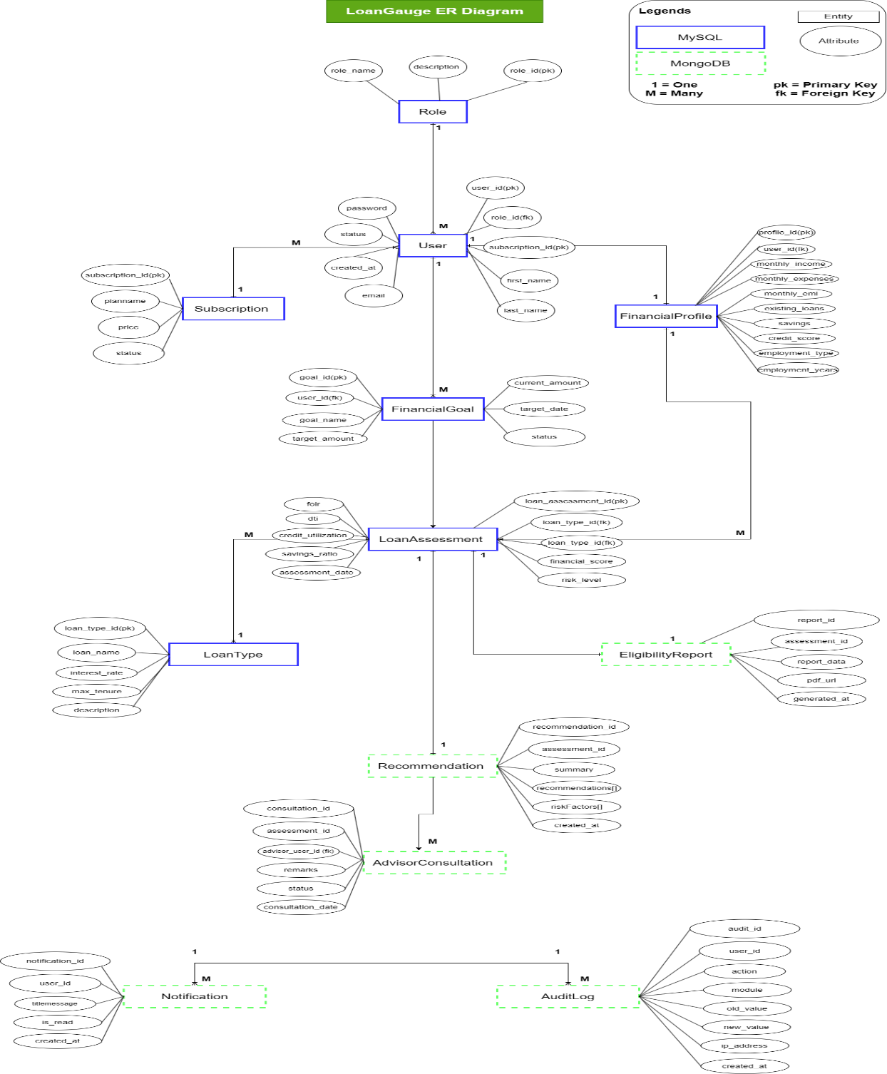

Class Diagram
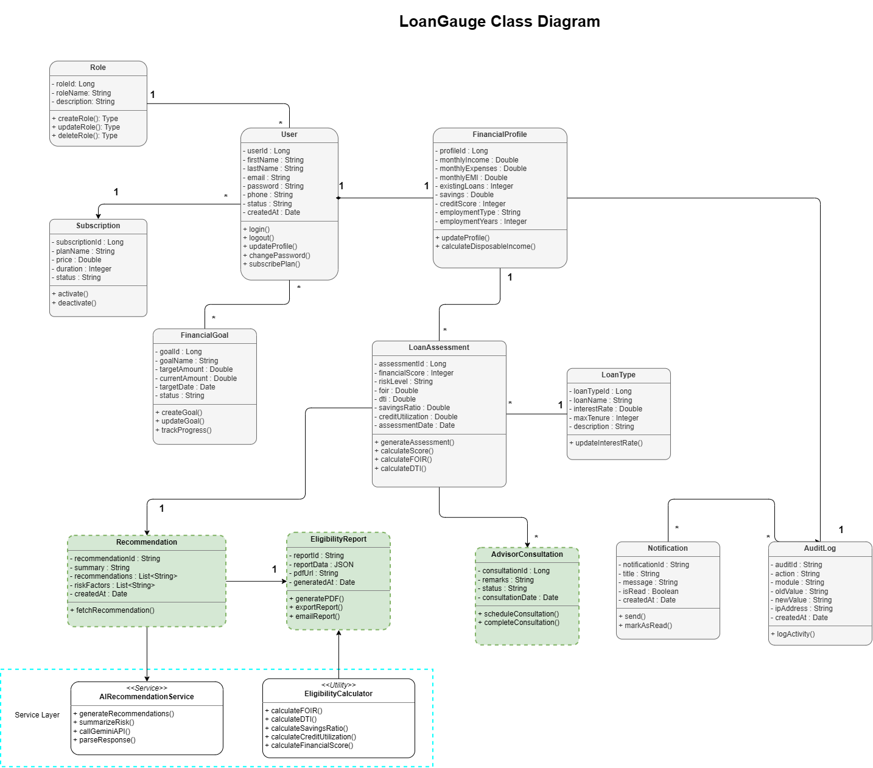

Use Case Diagram

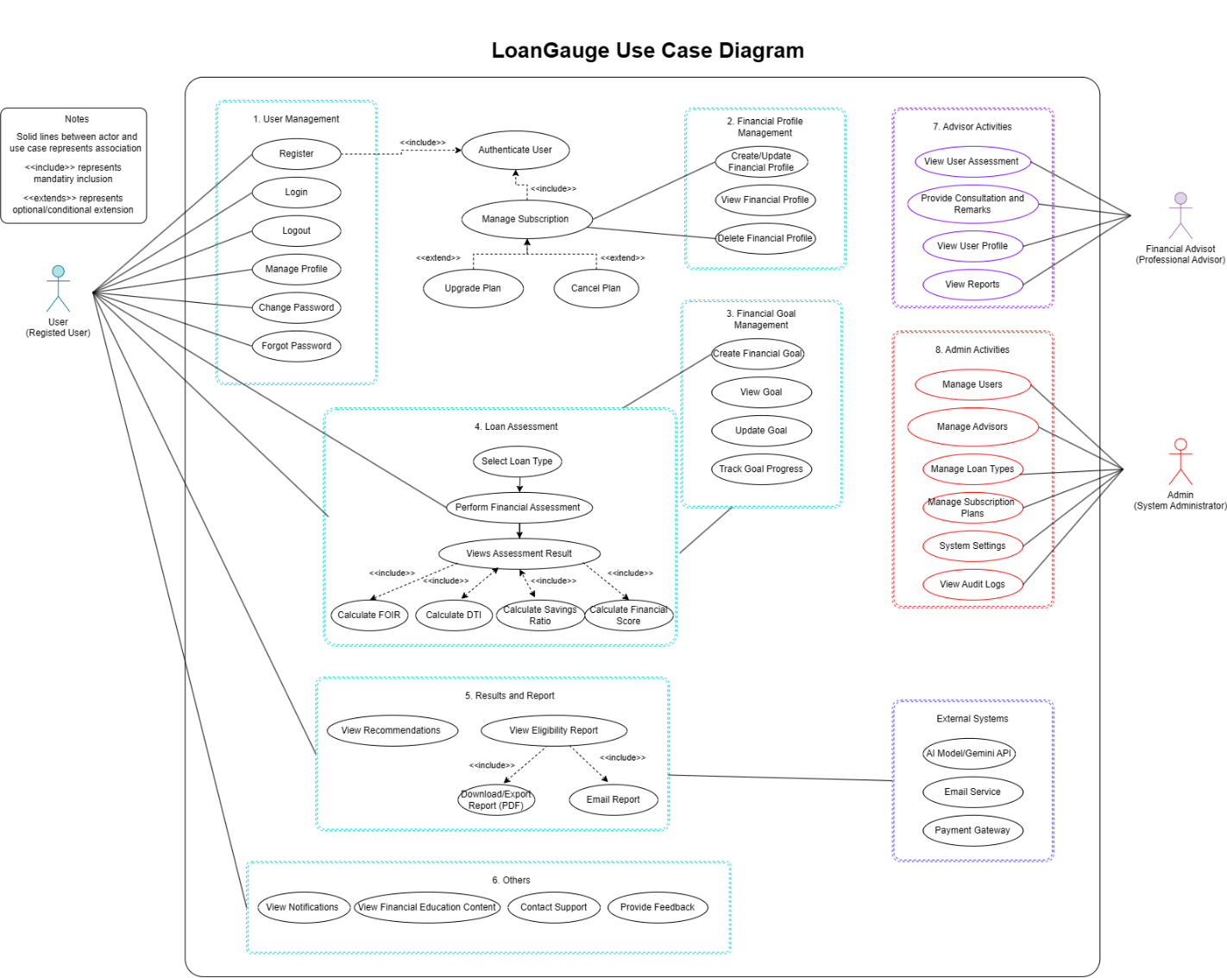

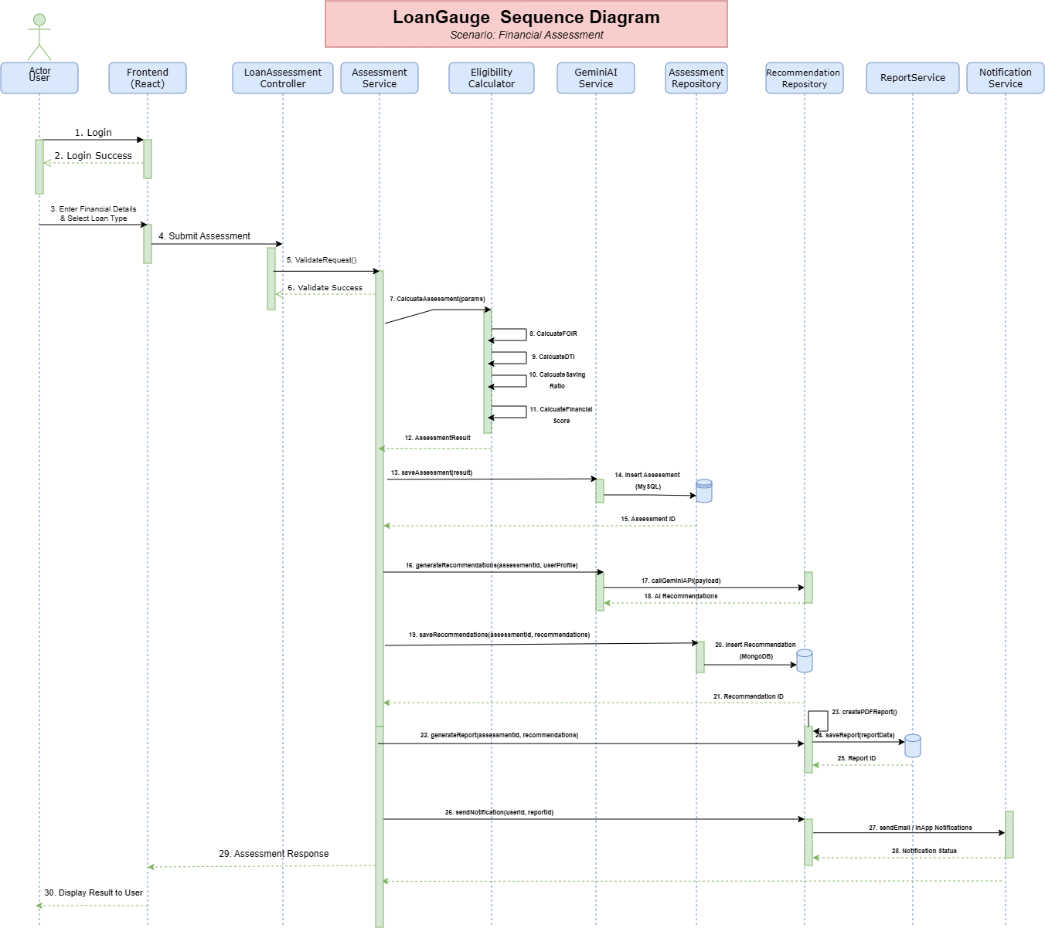
Sequence Diagram

Activity Diagram

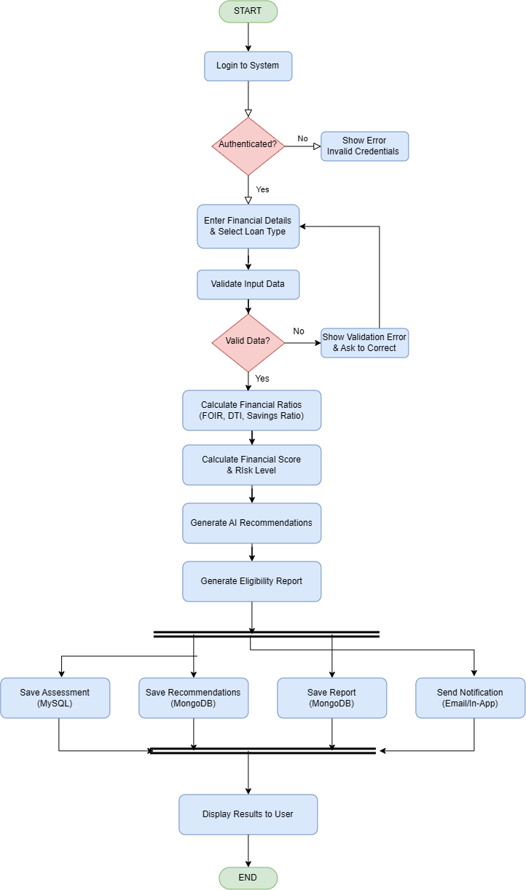

DFD Level 0 Diagram

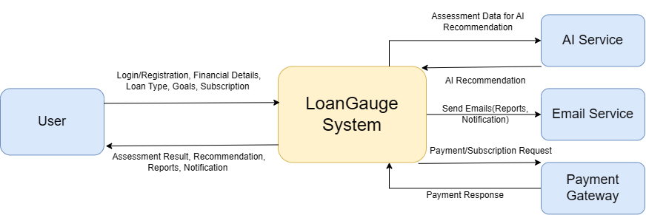

Appendix C: To Be Determined List
TBD ID | Description | Status
TBD-001 | Final weight distribution for the Financial Readiness Score may be refined after testing and expert validation. | Open
TBD-002 | Integration with live CIBIL APIs depends on the availability of suitable third-party services. | Future Enhancement
TBD-003 | Automatic bank statement analysis is reserved for a future release. | Future Enhancement
TBD-004 | Multi-language user interface support will be considered in future versions. | Future Enhancement

