**Question 1:**

Descriptive statistics for the original dataset:

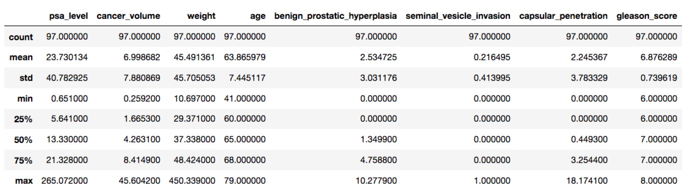

**Multiple Regression:**

Based on the description of the data, we can see that “seminal_vesicle_invasion” is a categorical variable, and others can be considered numerical variables.

So, for linear regression model, assume the full model is:



(y is psa_level; x1 is cancer_volumn; x2 is weight; x3 is age; x4 is benign_prostatic_hyperplasia; x5 is seminal_vasicle_invasion; x6 is capsular_penetration; x7 is gleason_score)

Fit the model and check the assumption:

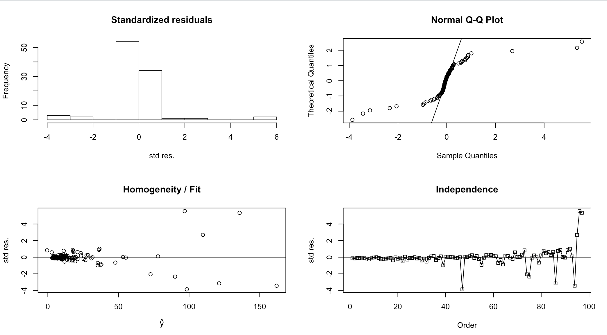

This is obviously not eligible for any further analysis (histogram and Q-Q plot show that it did not meet the normality requirement; and the spread of residuals were not constant; further, the pattern of independence check was almost discernable).

Although converting the response to logarithmic value may lead it to linear, we wouldn’t be able to get the predict interval of original response after such a transformation.

So, I plan to apply another model: Random Forest.

**Random Forest:**

Firstly, I did recursive feature elimination with k-fold (k=3) cross validation (RFECV) and default hyper-parameters for Random Forest Regression model. The reason of using 3-fold is that a small k value would lead to a small variance for cross validation result, which is good for model comparison and selection.

The RFECV shows the best predictor set would be: “age”, “weight”, “cancer_volumn”, “benign_prostatic_hyperplasia”, “seminal_vesicle_invasion” and “capsular_penetration”, which means “gleason_score” was not important and was abandoned.

Then, I used the selected predictors to do grid-search with 3-fold cross validation for hyper-parameter tuning. Since there are only 6 selected predictors, I didn’t tune the maximum of random selected features, and only tuned for the number of trees. The parameter grid was {number of trees: 25, 50, 100, 200, 400, 800, 1600}. The result showed that 400 was the best choice. And the out of bag R-square was 0.2882.

I then trained Random Forest with tuned hyper parameter and selected predictors, and using the full data set (97 samples), got an adjusted R-square of 0.8984 on the full data set.

Following figure is the predictor importance output by the trained model:

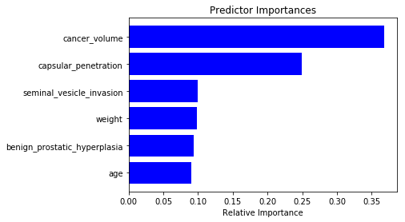

Interpretation: if “cancer_volumn” was removed, the R-square would decrease more than 0.35; if “capsular_penetration” was removed, the R-square would decrease about 0.25; If “seminal_vesicle_invasion” or “weight” or “benign_prostatic_hyperplasia” or “age” was removed, the R-square would decrease about 0.09.

To get the predict interval of input {cancer_volumn = 4.2633; weight = 22.783; age = 68; benign_prostatic_hyperplasia = 1.35; seminal_vesicle_invasion = 0; capsular_penetration = 0; gleason_score = 6}, I applied each of the decision trees (400 trees in total) in the random forest model to get 400 predict values, then generated 90% predict interval for it.

The result shows the 90% predict interval of “psa_level” is from 3.857 to 14.296.

**Question 2:**

Descriptive Statistics for the original data:

|  |  |  |  |  |  |  |  |  |  |  |  |  |  |  |  |  |  |
| --- | --- | --- | --- | --- | --- | --- | --- | --- | --- | --- | --- | --- | --- | --- | --- | --- | --- |
| Group | Data | | | | | | | | | | | | | | | Mean | Std. |
| Aromatics | 1.06 | 0.95 | 0.79 | 0.65 | 0.82 | 1.15 | 0.89 | 1.12 | 1.05 |  |  |  |  |  |  | 0.94 | 0.17 |
| Chloroalkanes | 1.58 | 1.12 | 1.45 | 0.91 | 0.57 | 0.83 | 1.16 | 0.43 |  |  |  |  |  |  |  | 1.01 | 0.40 |
| Esters | 0.29 | 0.43 | 0.06 | 0.06 | 0.51 | 0.09 | 0.44 | 0.10 | 0.17 | 0.55 | 0.53 | 0.17 | 0.61 | 0.34 | 0.60 | 0.33 | 0.21 |

**Analysis of Variance:**

Fit the data to regression model and check the assumption:

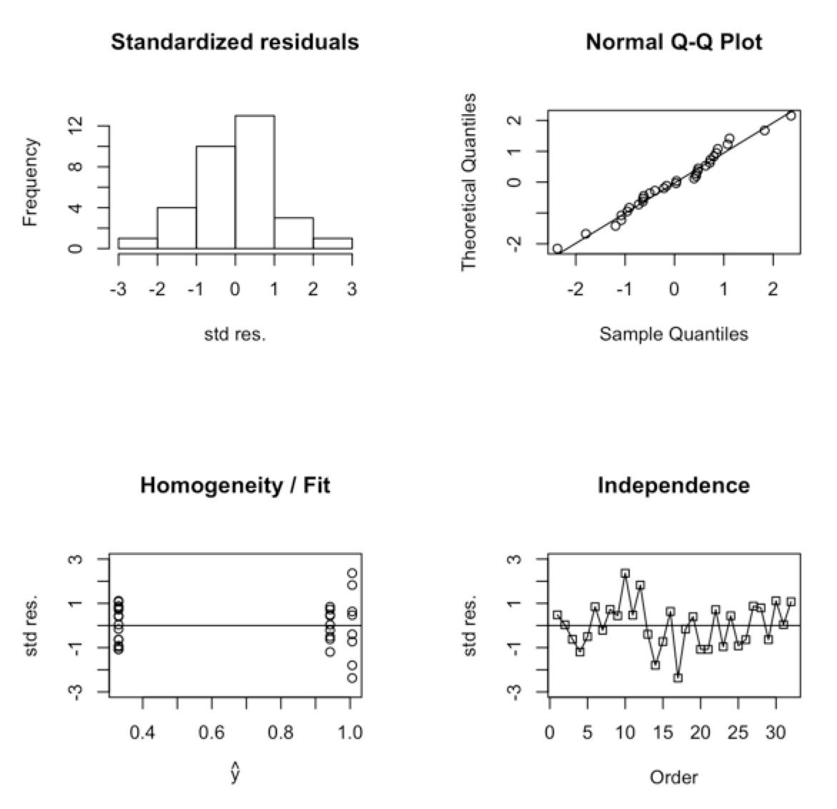

The assumption of homogeneity is obviously violated. The variance of Chloroalkanes is much larger than that of Aromatics and Esters. So, change the comparison strategy to t-test.

**T-test:**

Check the normality of three groups of data:

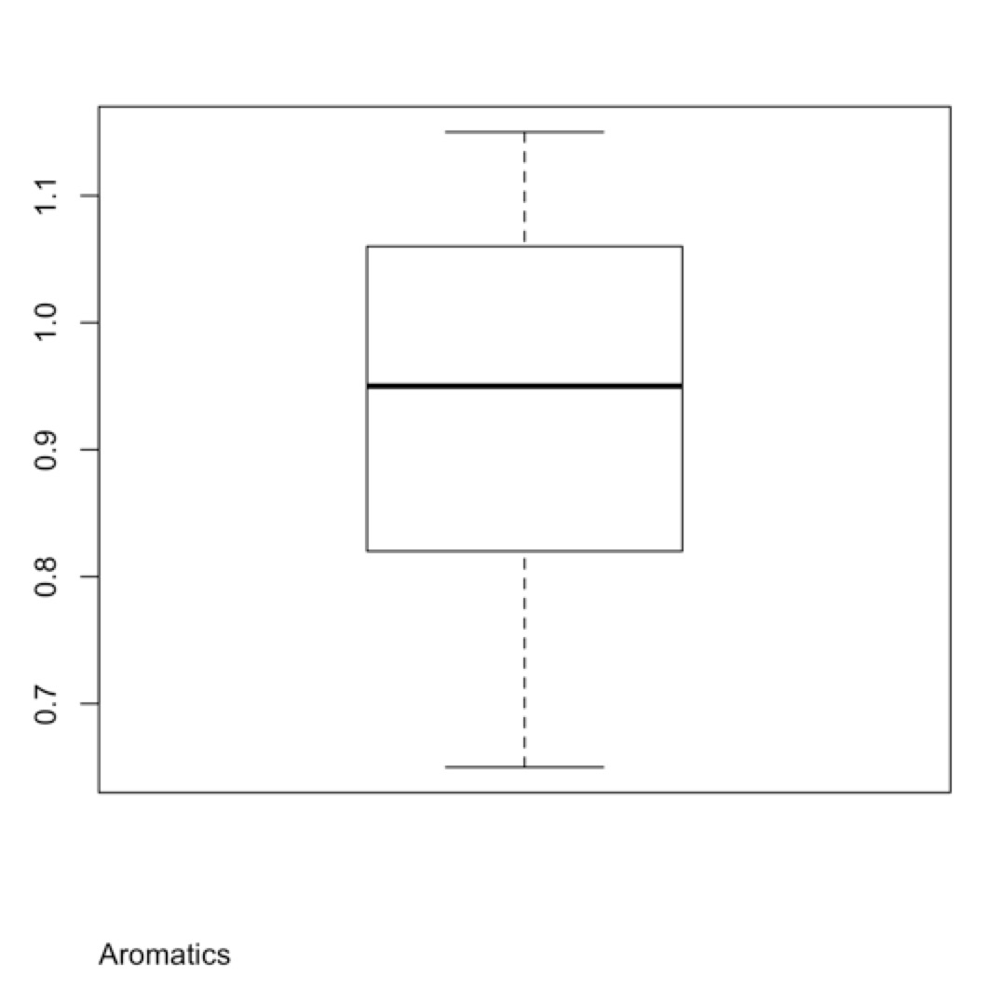 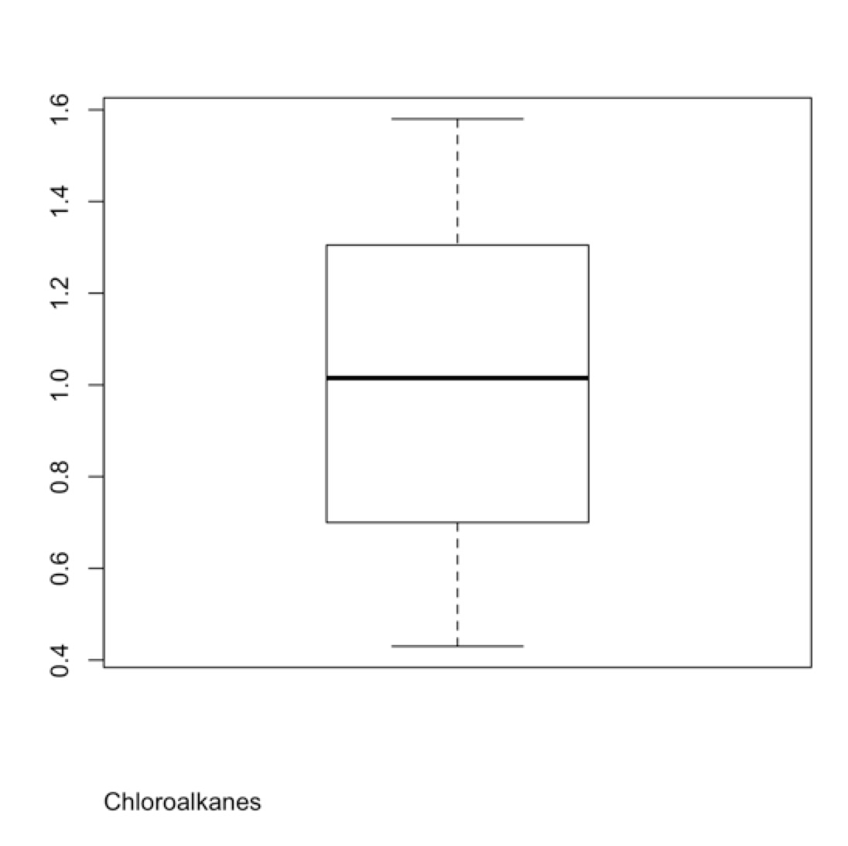 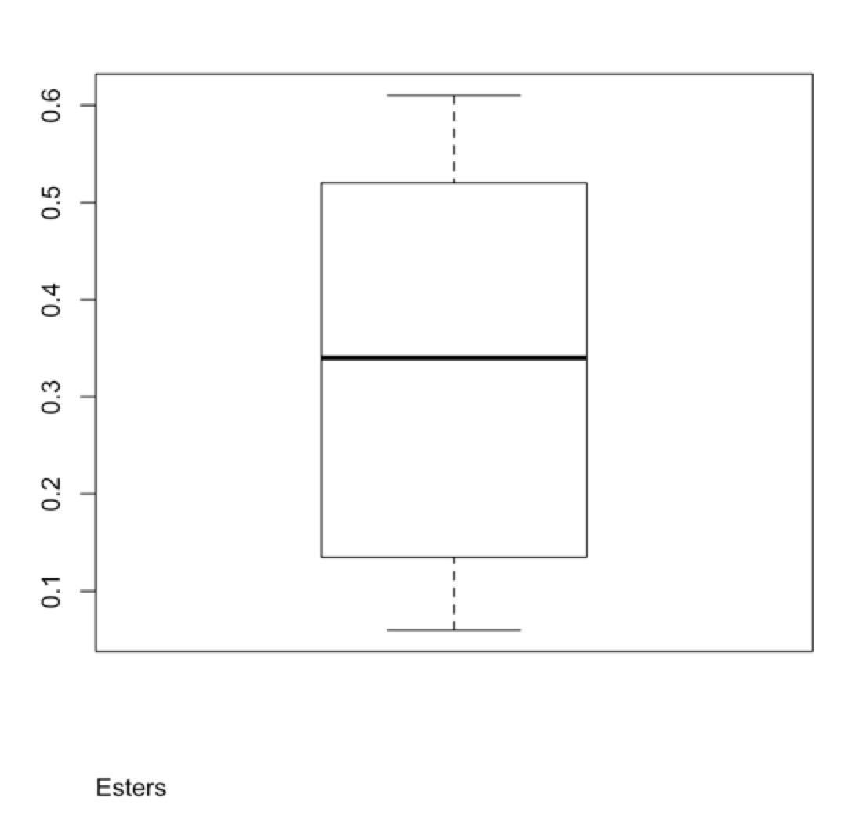

The boxplots are symmetric with whiskers of approximately the same length. There are no obvious violations of the assumptions.

T-test result:

|  |  |  |
| --- | --- | --- |
| Comparison Groups | P-Value | 95% Confidence Interval |
| Aromatics ~ Chloroalkanes | 0.6842 | [-0.41, 0.28] |
| Aromatics ~ Esters | 1.53*10-7 | [0.45, 0.77] |
| Chloroalkanes ~ Esters | 0.0016 | [0.33, 1.02] |

Therefore, based on the t-test, the mean values are the same between Aromatics and Chloroalkanes. But the mean values of Aromatics and Esters are different, that of Chloroalkanes and Esters are also different.