2012

Text 1:
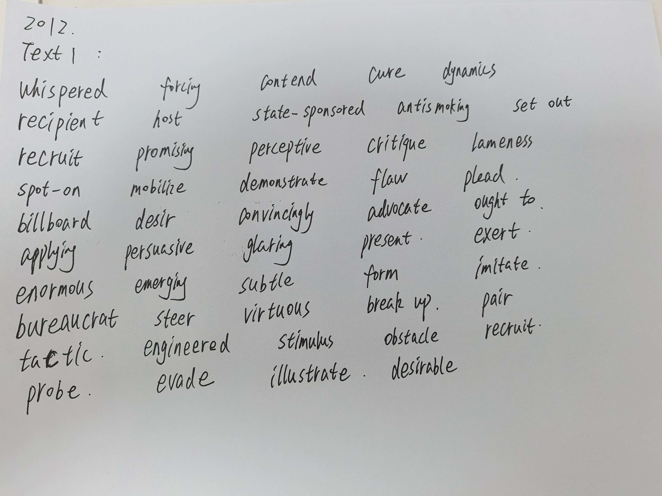
https://chatgpt.com/g/g-p-6a545b2d334c8191a6d4e872632b8259-ying-yu-zhen-ti/c/6a76a303-400c-83e8-8d95-37842fedf6b8?tab=sources
dynamic
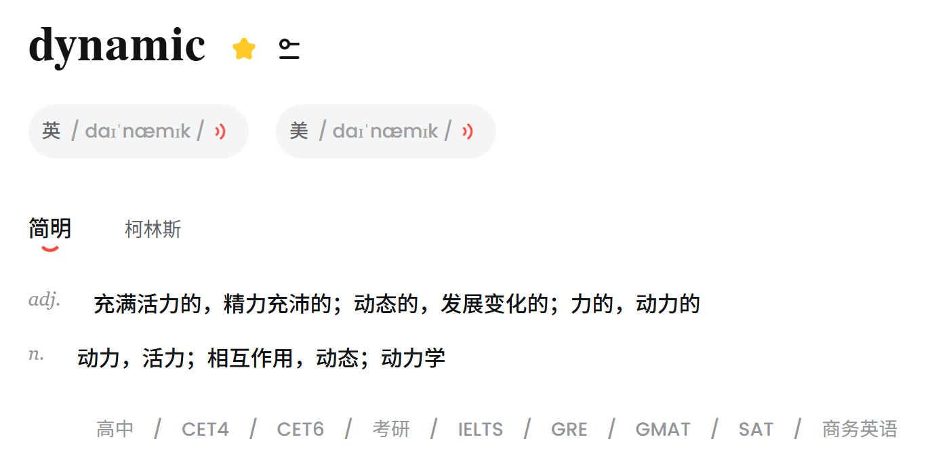
Spot:
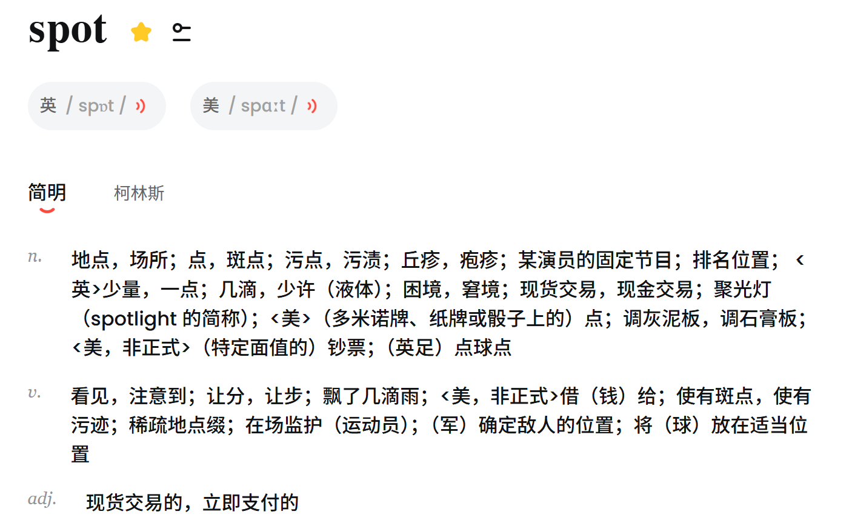
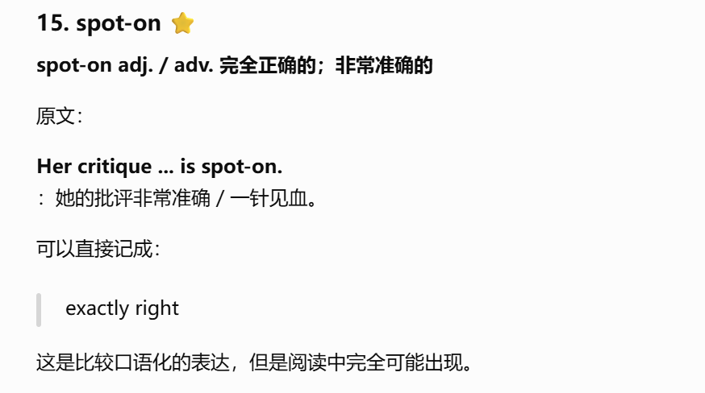
Plead:
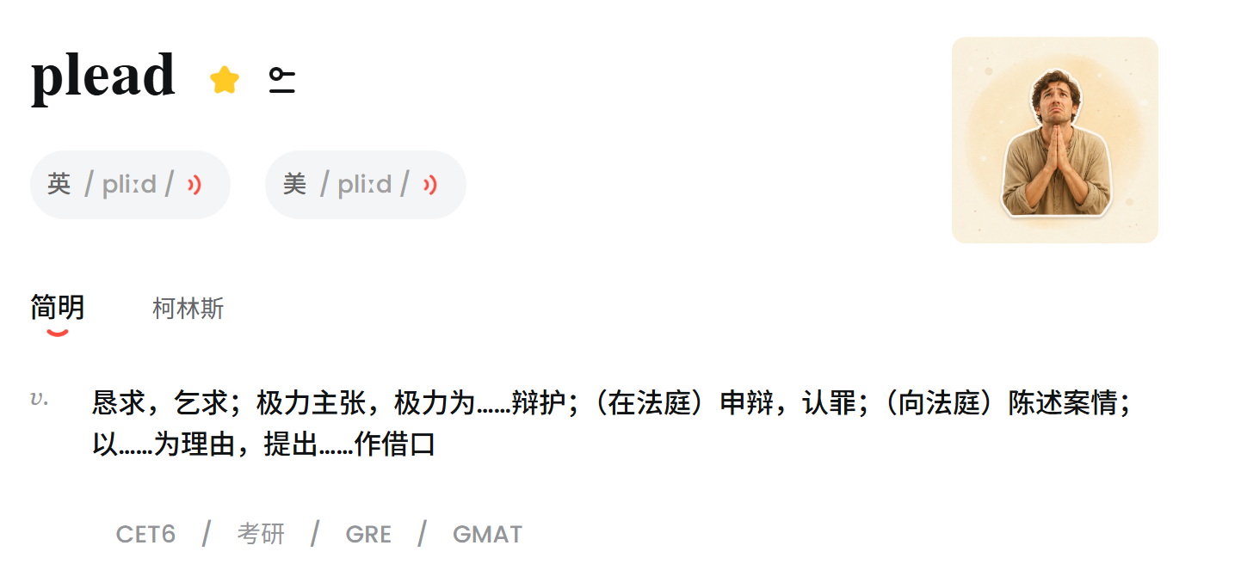
Take a page from:
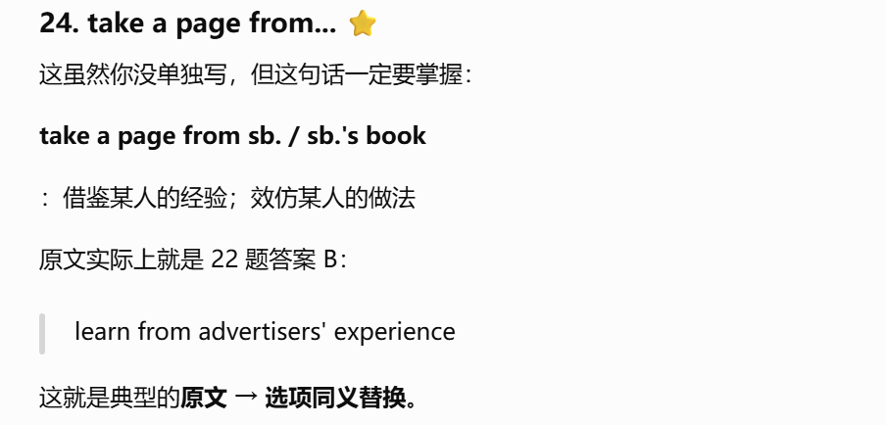
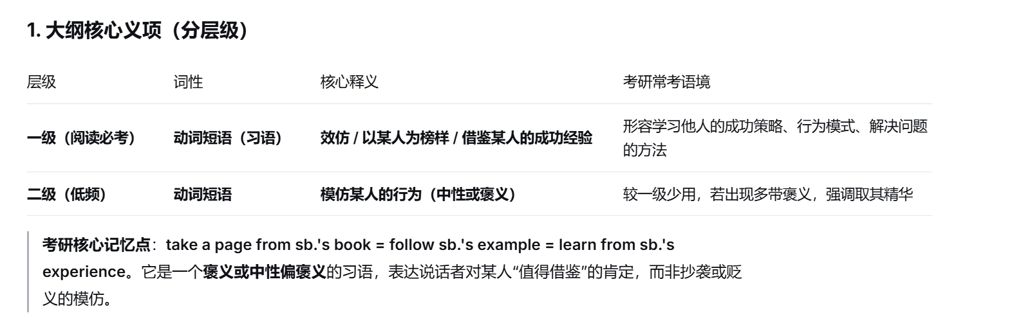
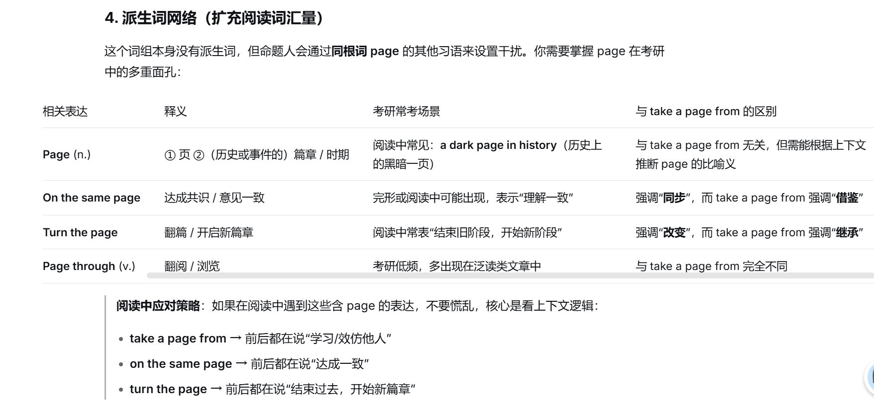
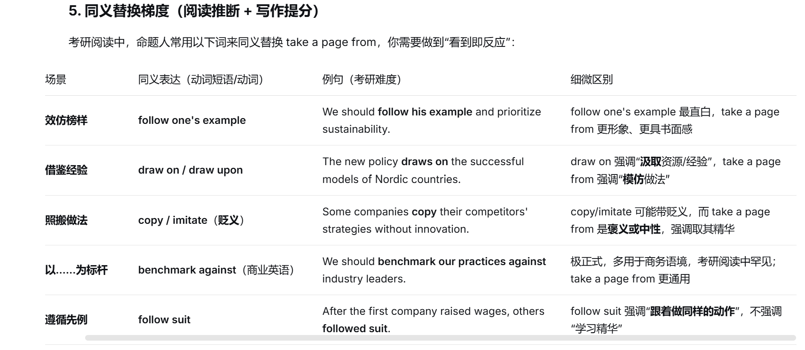
Imitate:
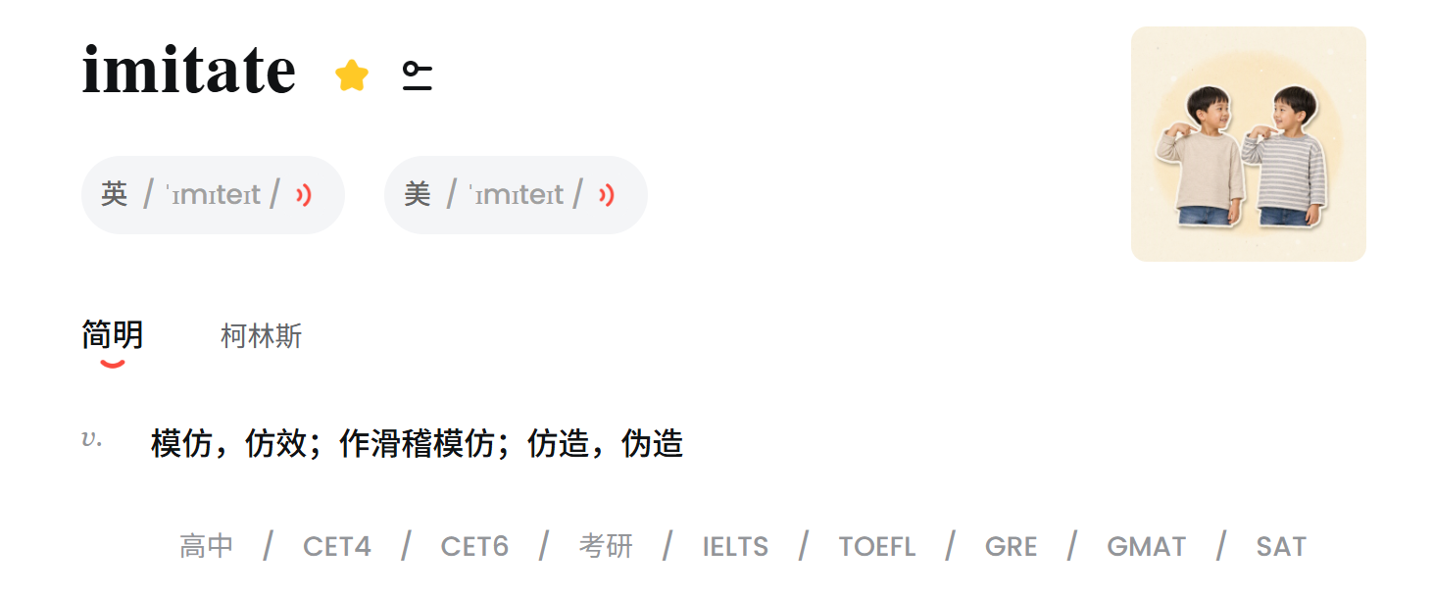
Conspicuous：
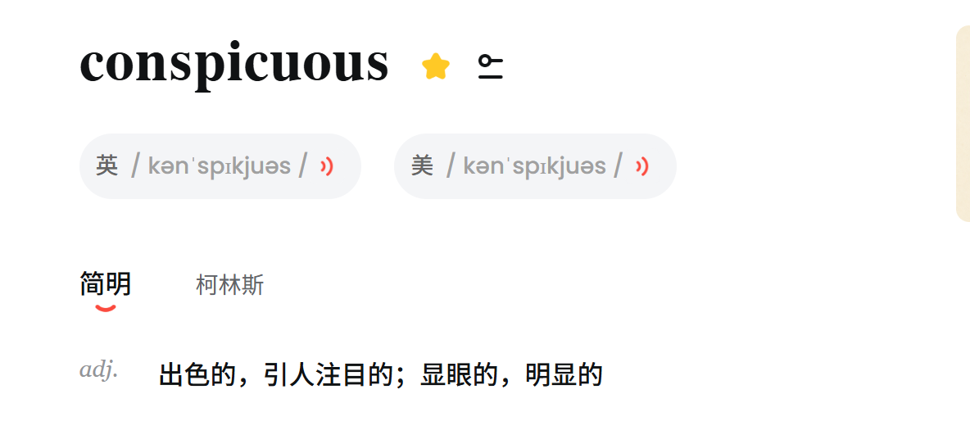
Glare:
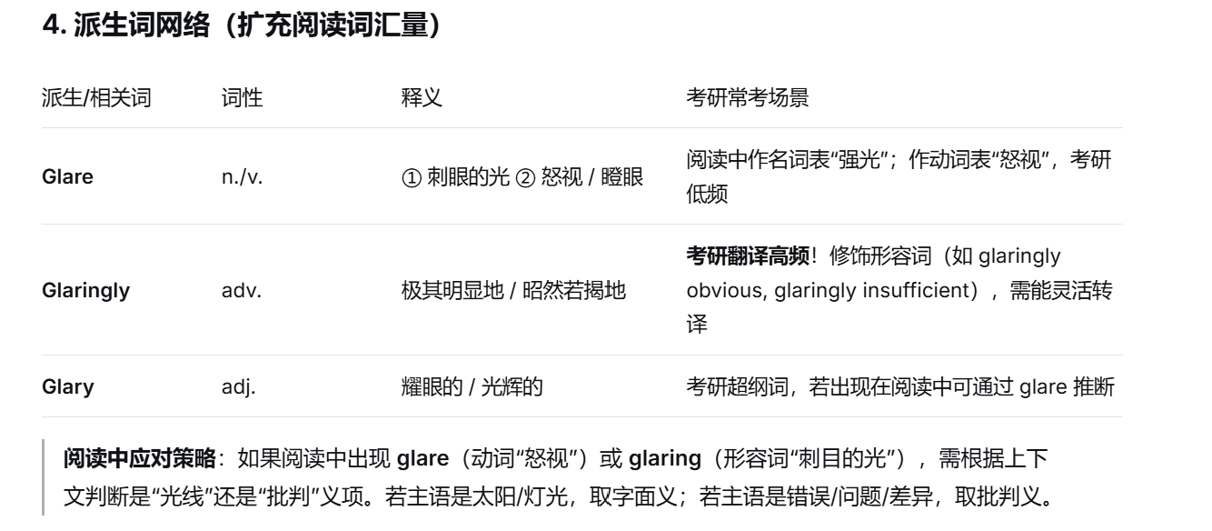
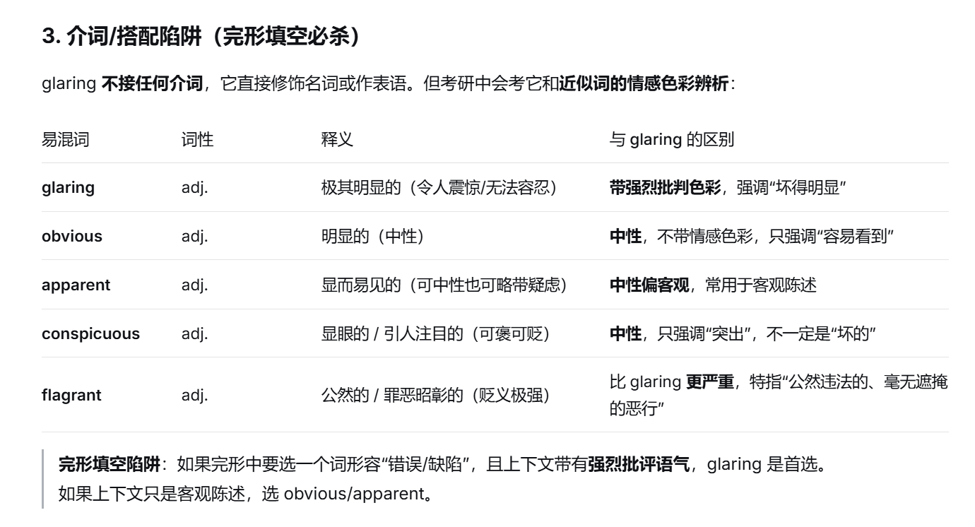
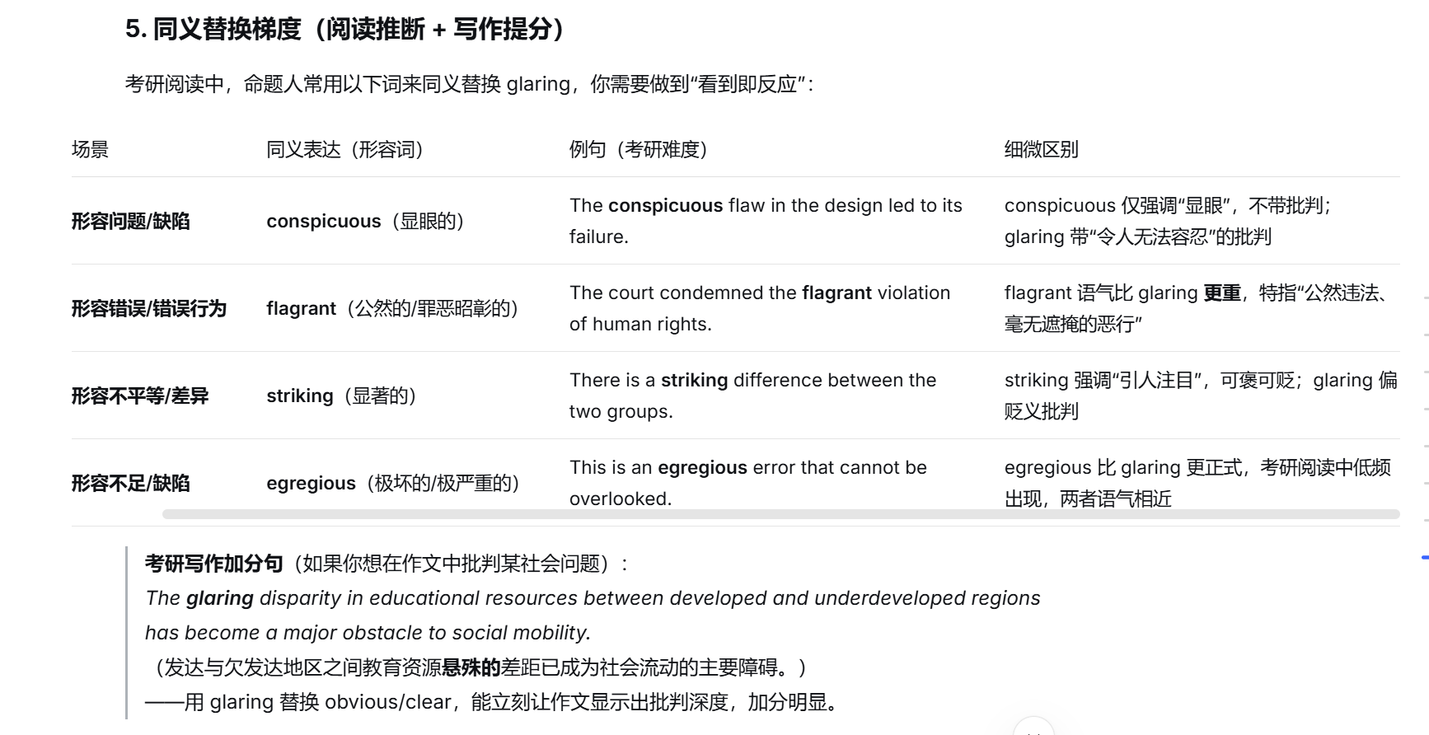
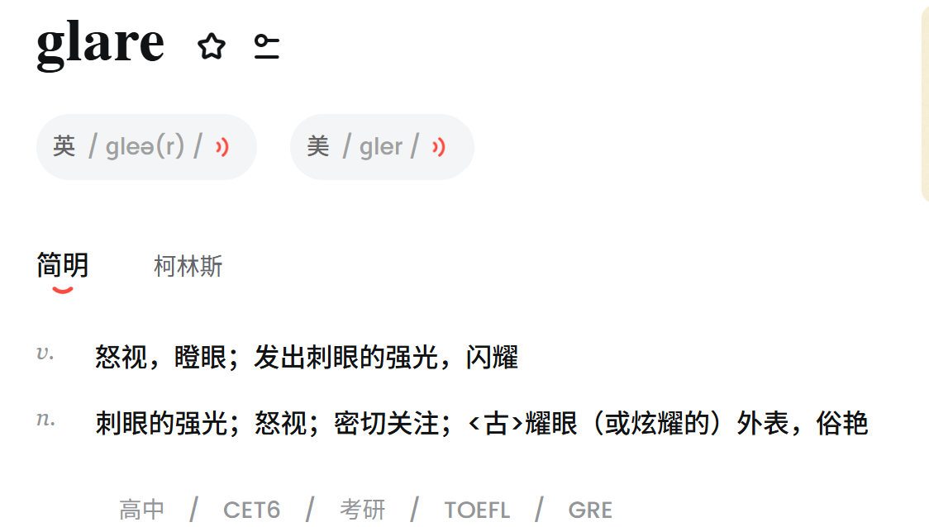
Exert:
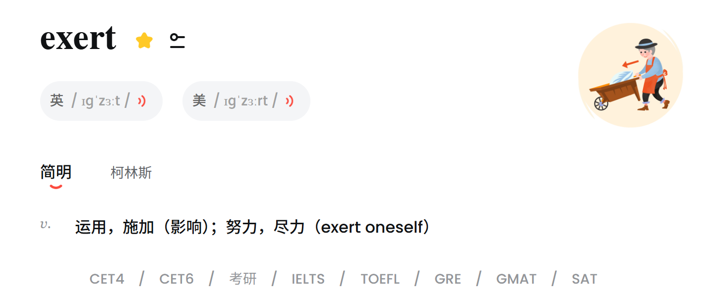
Emerge:
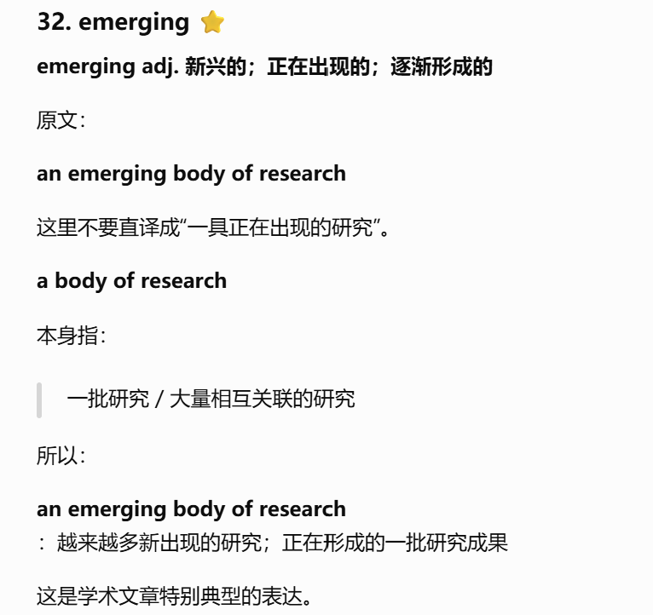
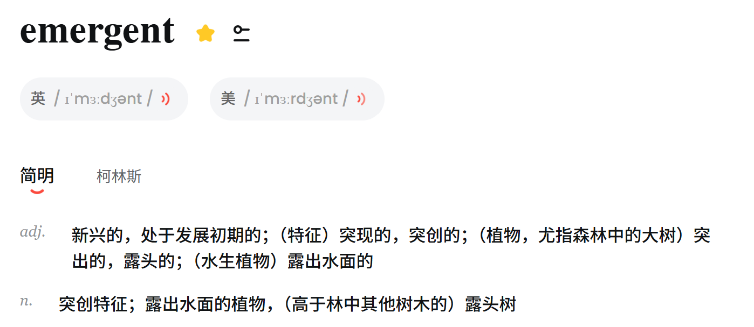
Subtle:
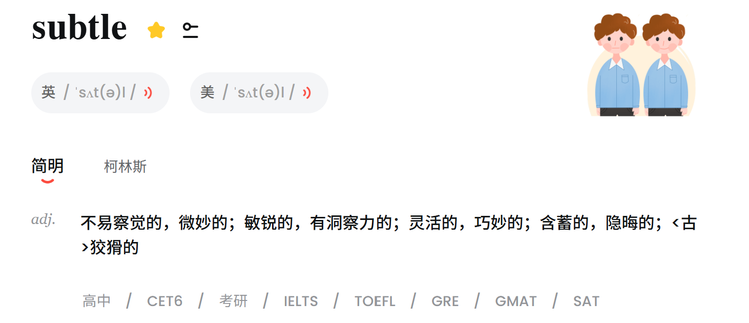
Steer:
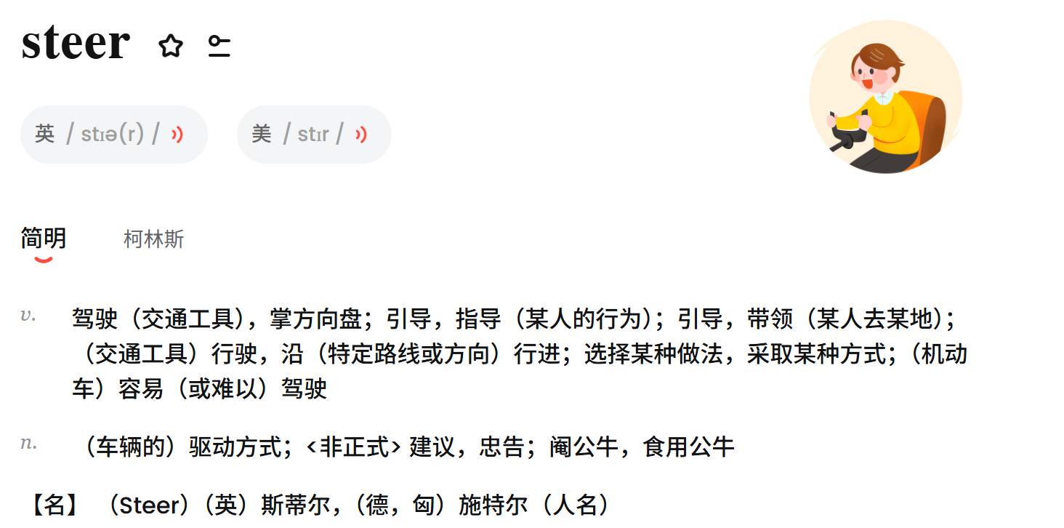
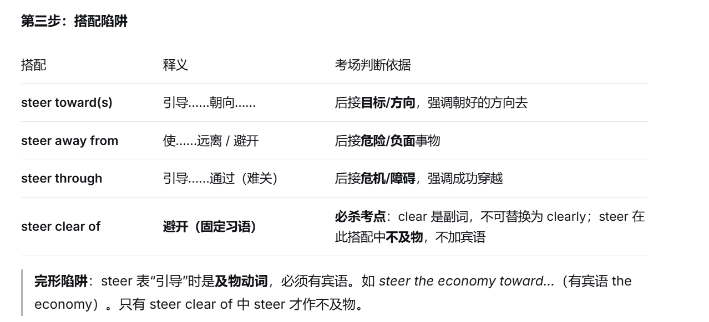
Virtuous:
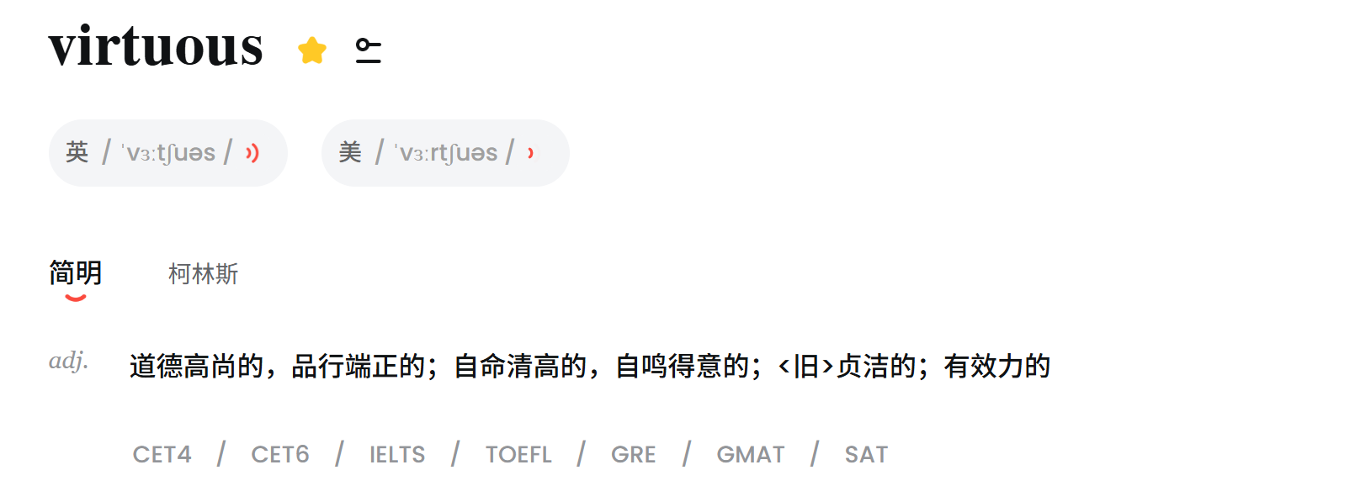
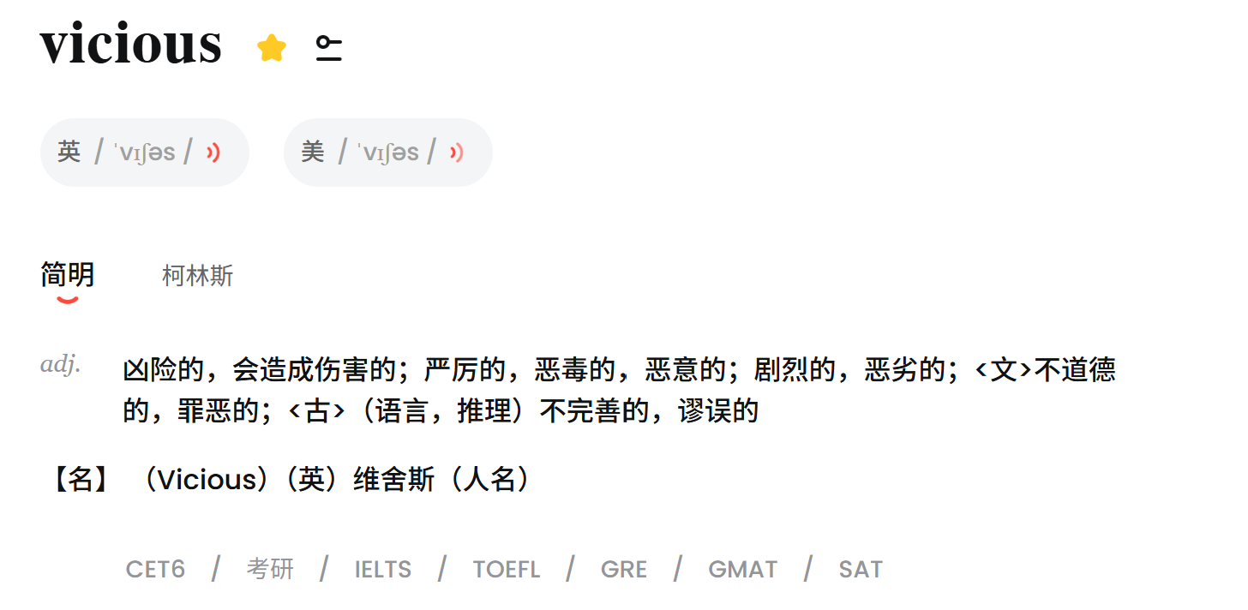
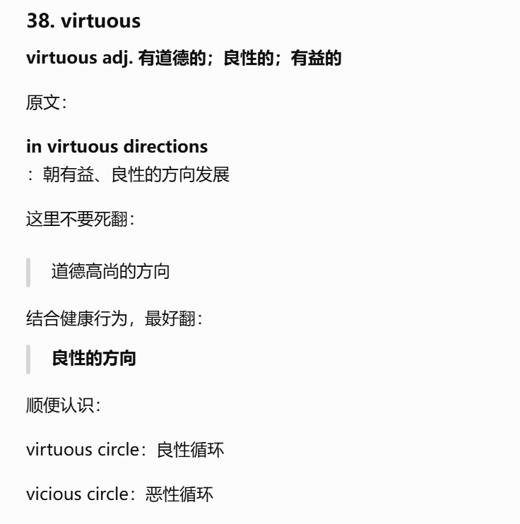
Pair:
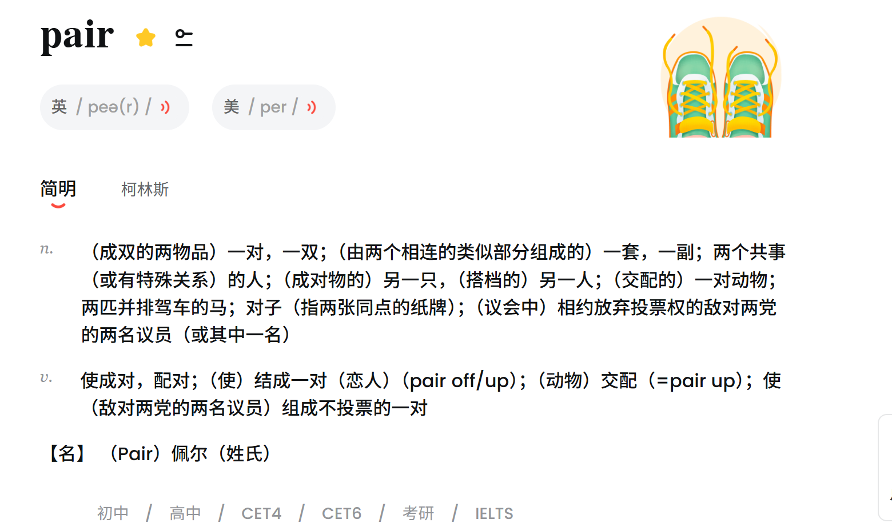
Tactic:
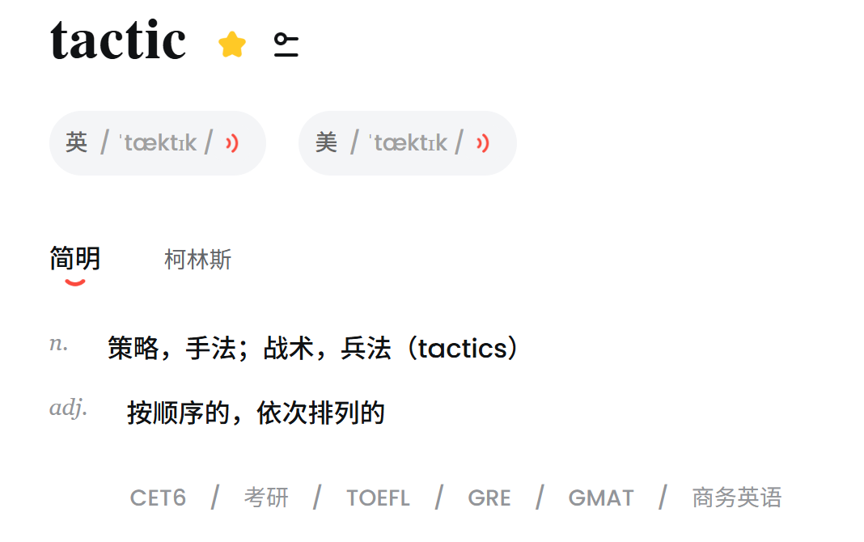

Text 2:
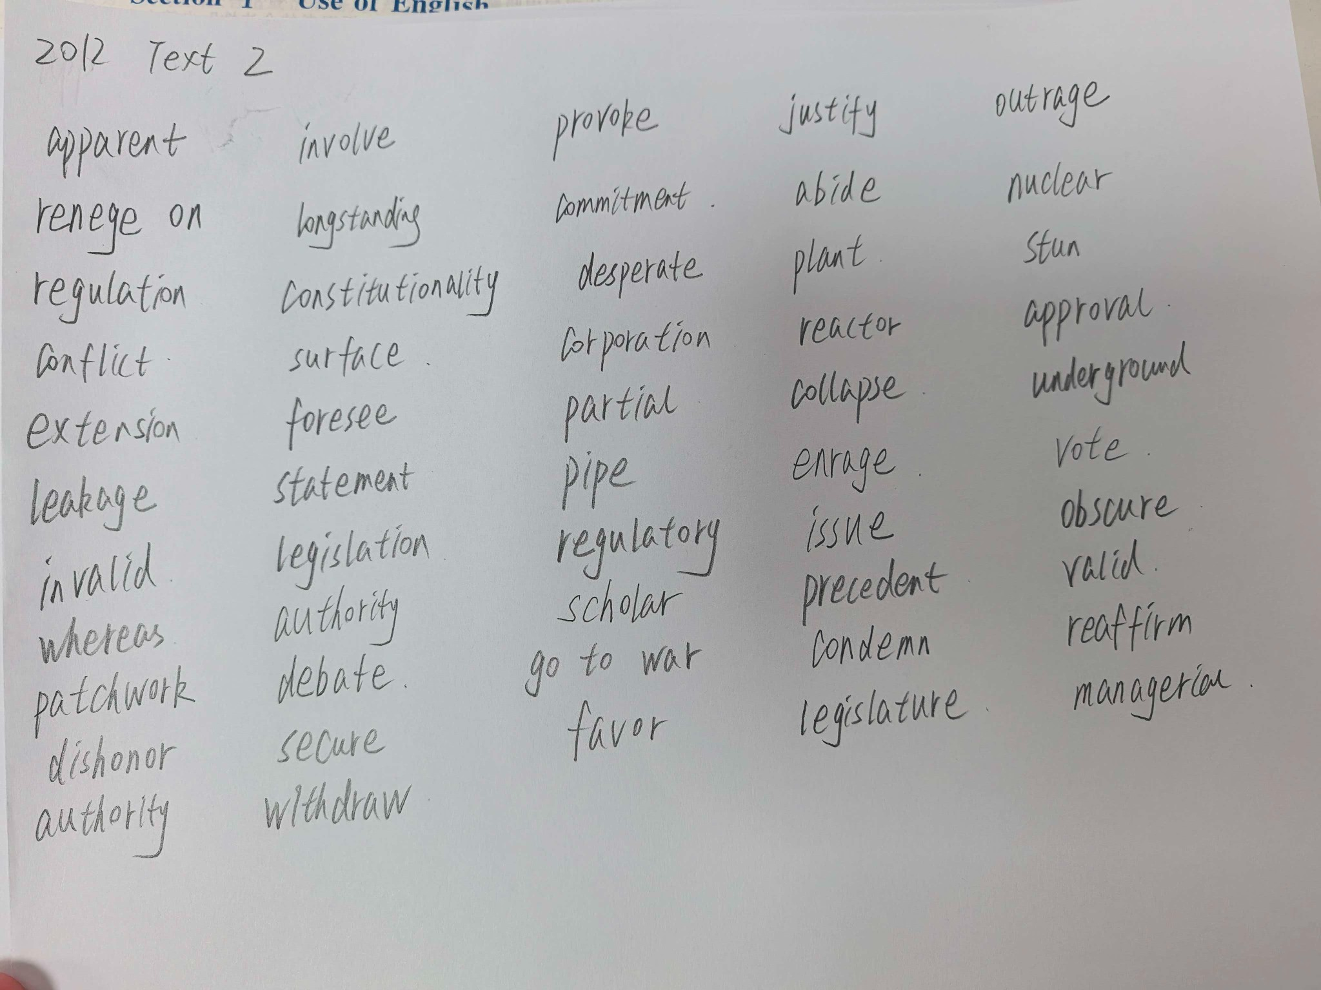
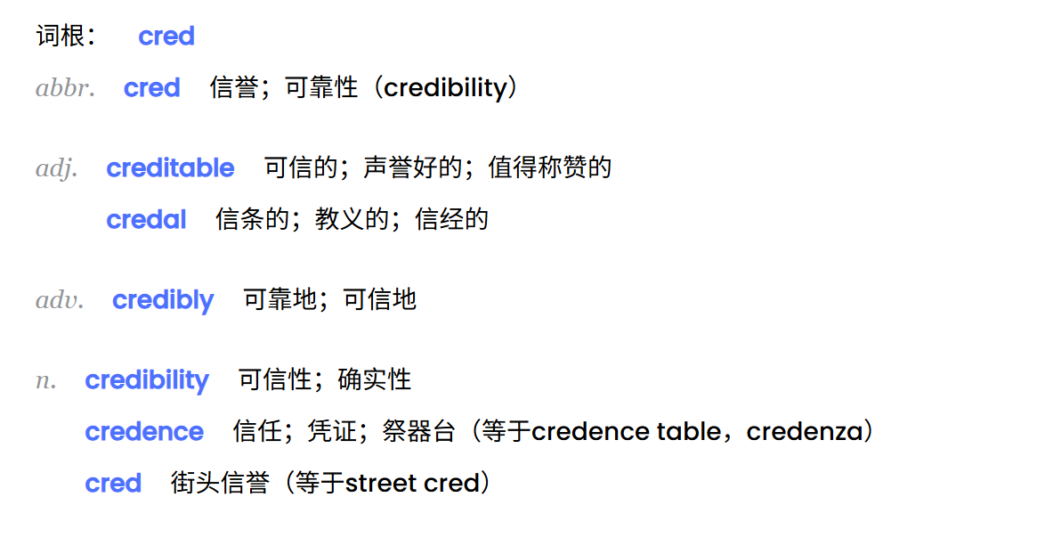
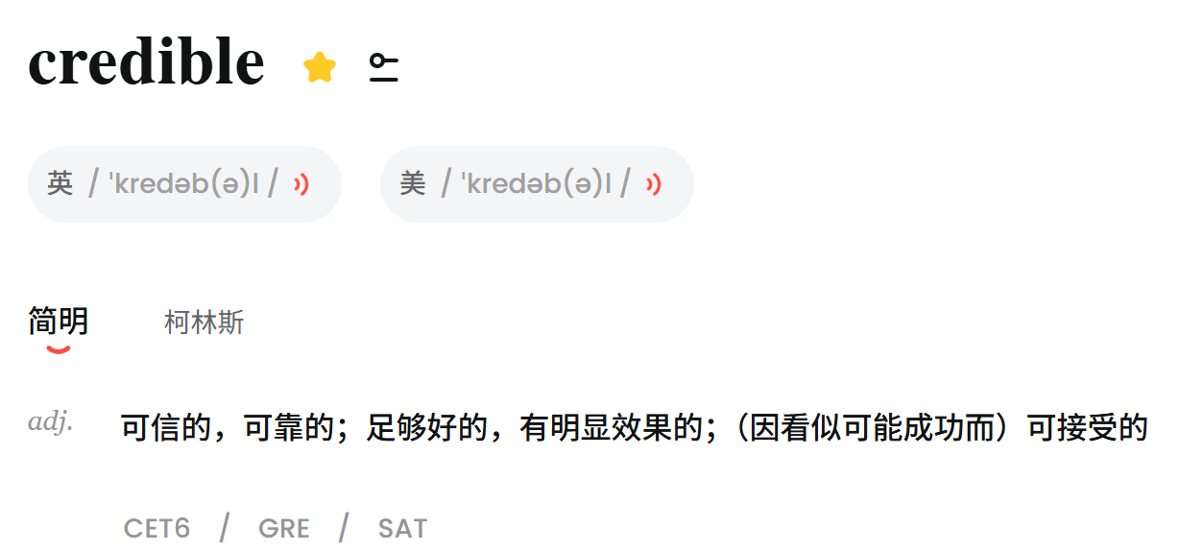
https://chatgpt.com/g/g-p-6a545b2d334c8191a6d4e872632b8259-ying-yu-zhen-ti/c/6a810e80-e2bc-83e8-91b7-31f3f6e0e05b

Text 3:
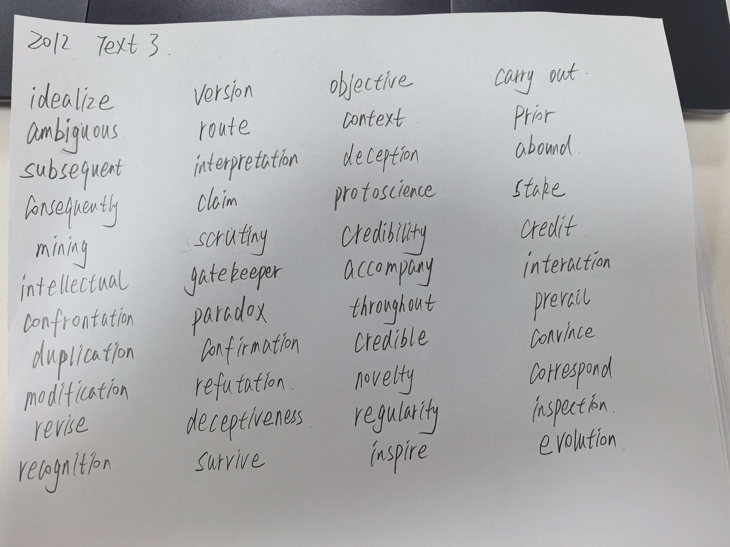
https://chatgpt.com/g/g-p-6a545b2d334c8191a6d4e872632b8259-ying-yu-zhen-ti/c/6a83110b-d1f0-83ee-b2ca-2ad812d2838d

Text 4:
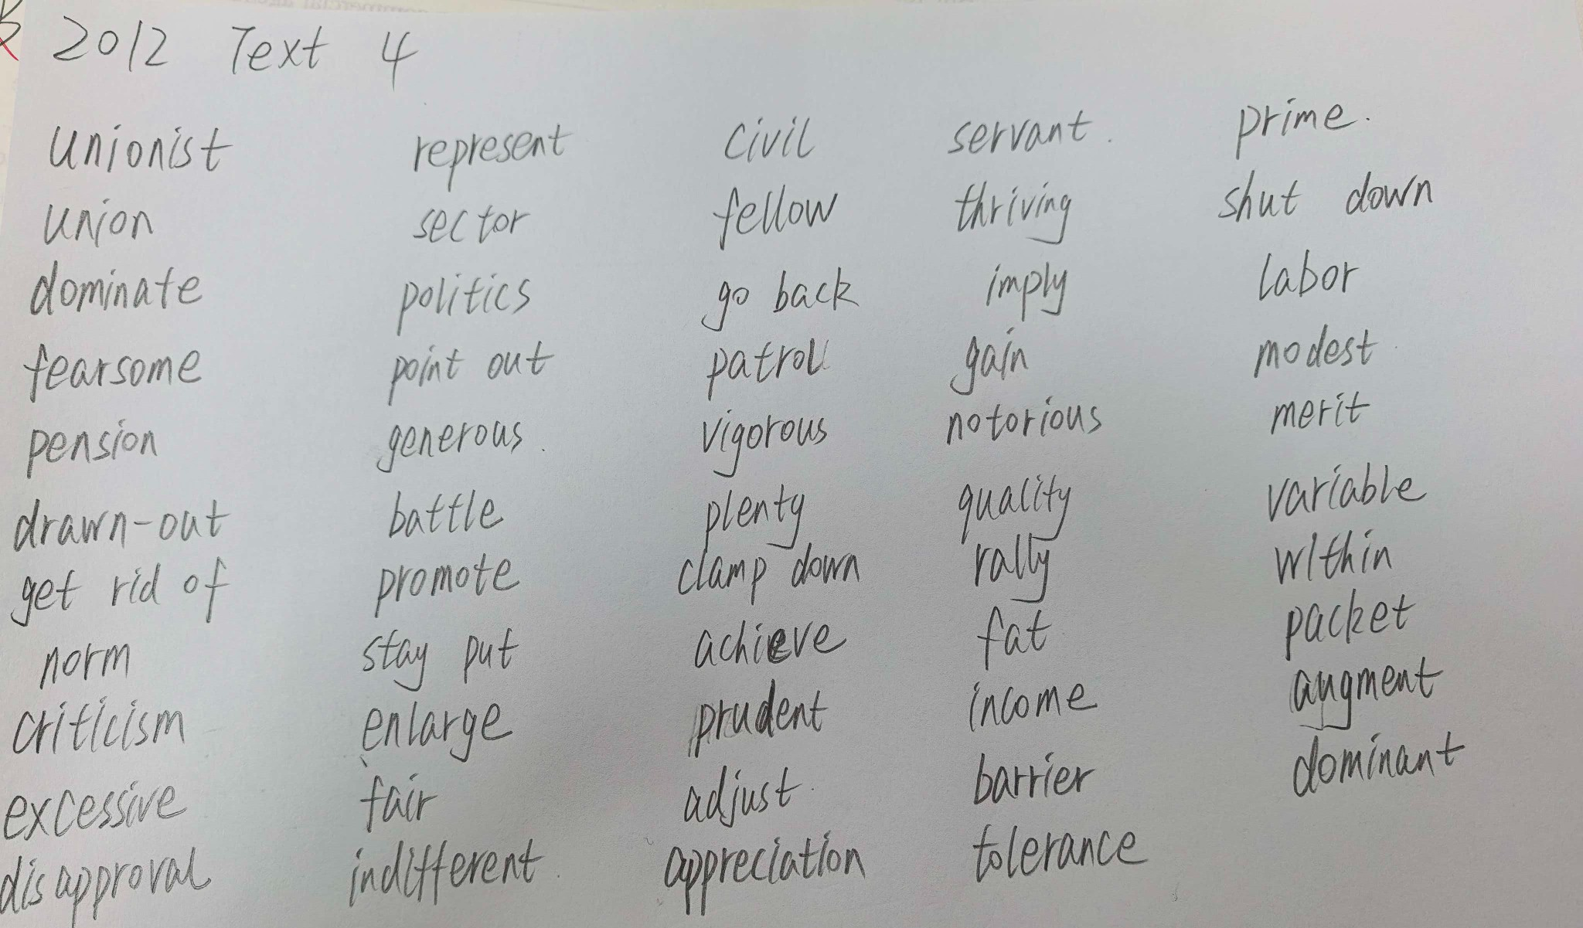
单词：https://chatgpt.com/g/g-p-6a545b2d334c8191a6d4e872632b8259-ying-yu-zhen-ti/c/6a8667c2-a1ac-83e8-95ce-0db5f6d92c2c
题：https://chatgpt.com/g/g-p-6a545b2d334c8191a6d4e872632b8259-ying-yu-zhen-ti/c/6a85b9d0-6630-83e8-8ba0-ee1d04cb2213
|（注：部分内容可能由 AI 生成）

