2013

Text 1:
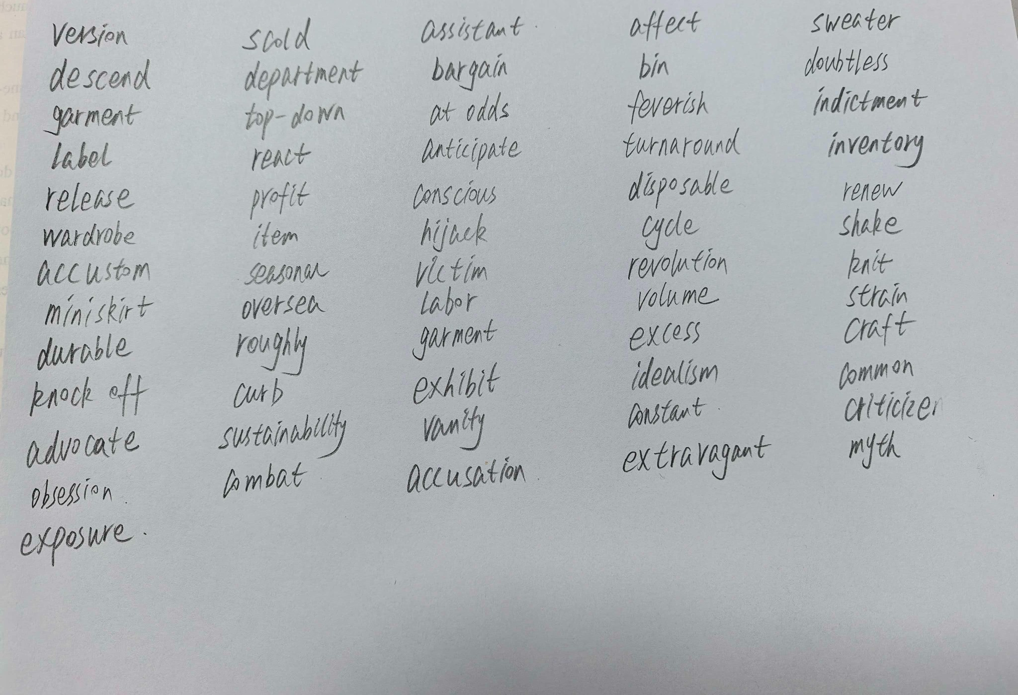
https://chatgpt.com/g/g-p-6a545b2d334c8191a6d4e872632b8259-ying-yu-zhen-ti/c/6a891419-4404-83ee-a602-45a3ad34346b

Text 2:

|（注：部分内容可能由 AI 生成）

