**Analysis of the effect of environmental temperature on the efficiency of thermal storage of solar thermal power plants.**

Max Plomer

Mechanical Engineering Graduate Student

University of Connecticut

**Abstract:**

The application will be to determine the efficiency of solar thermal power plants, by looking at the thermal energy storage.  Is there greater efficiency at low or high environmental temperatures?  In other words what recovery of the energy can we expect?

We will examine solutions to simple problems that will build an overall analysis. Our focus will be a simple analytical estimate of efficiency, with suggestions on how the model can be further improved upon in future work.

**Table of Contents:**

-Introduction

-Fundamental Solutions

-Final Analysis

-Results

-Conclusion

-References

**Introduction:**

To analyze this problem we could assume a salt hydrate phase change material (PCM) that is used for thermal storage in the power plants. The PCM melts at hotter temperatures and solidifies at colder temperatures. Salt hydrates are known to have a high thermal conductivity and latent heat of fusion, allowing for quick energy transfer and large capacity for energy storage.1

Can we do a quick analysis to look at the effect of thermal conductivity (k), latent heat of fusion (hL), and environmental temperature on a simple thermal storage system?

This project will aim to gain an overall general analysis of a solar thermal power plant, with applications from home to industrial scale. We will assume heat is transferred to a simple insulated storage with heat losses, and then later a sterling engine is powered from the stored thermal energy. A condensed reviewing of key problem solutions, associated with this project, will be the basis for our analysis. These topics include: heat loss through wall, Carnot efficiency, heat exchanger, phase change, phase front location/speed.

**Fundamental Solutions:**

The advantage of latent energy is that you can store extra energy without an increase in temperature

The sensible heat is calculated using c $∆$*T. The latent heat is calculated using m*hL . The environmental temperature must be below the melting temp for latent energy to be utilized.

The environmental temperature is affecting the starting temperature of the salt solution, and also effect heat losses.

When using the sterling engine the Carnot efficiency is affected by temperature of the environment.

Ultimately money and pollution per Joule of energy is what matters in terms of efficiency, but what we will focus on is for a certain amount of energy stored from the sun, how efficiently can it be used?

Our model will have 3 stages: initial storing of heat, storage with heat loss, and extraction of heat/energy.

The following are the fundamental solutions that were analyzed to calculate my analytical efficiency estimate:

Phase change boundary solution assuming linear temperature profile

From p427 of multiphase-faghri text:

-Governing equations of solidification problem2 (simulating the process of extraction of heat from the thermal energy storage)

The temperature in the solid phase must satisfy

$$\frac{∂^{2}T_{1}}{∂x^{2}}=\frac{1}{α_{1}}\frac{∂T_{1}}{∂t} 0<x<s\left(t\right), t>0$$

$$T_{1}\left(x,t\right)=T_{0} x=0 , t>0$$

For the liquid phase the governing equations are

$$\frac{∂^{2}T_{2}}{∂x^{2}}=\frac{1}{α_{2}}\frac{∂T_{2}}{∂t} s(t)<x<∞ t>0$$

$$T_{2}\left(x,t\right)→T_{i} x→∞ , t>0$$

$$T_{2}\left(x,t\right)=T_{i} x>0 , t=0$$

The boundary conditions at the interface are

$$T_{1}\left(x,t\right)=T_{2}\left(x,t\right)=T_{m} x=s\left(t\right), t>0$$

$$k_{1}\frac{∂T_{1}}{∂x}-k_{2}\frac{∂T_{2}}{∂x}=ρh_{sl}\frac{ds}{dt} x=s\left(t\right), t>0$$

Assume Linear temperature profile



Assume Ti=Tm, therefore



Energy equation becomes



Substitute linear temperature profile into energy equation, integrate, solve for s(t)

  

This phase boundary location, is a function of T0, which is going to be effected by the environmental temperature.

The speed of phase front affects the rate energy can be extracted when phase change is occurring. Other topics affecting this extraction rate (and ultimately the magnitude of our work out in units of Watts) are conduction in PCM and speed of heat exchangers.

This problem was solidification in a semi-inifinte PCM. This would relate to when we are trying to extract the energy, and we have a constant temperature T0 at the wall of the energy storage unit, which causes the PCM to cool and solidify.

Evaluation of Efficiency Claims

From p258 of thermodynamics-moran text:

-Diagram of power cycle performance claim3 (simulating the sterling engine converting the extracted heat from the PCM to mechanical energy)

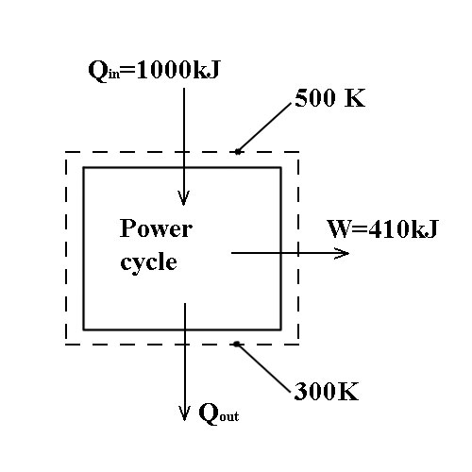

Efficiency claimed

$$η= \frac{410 kJ}{1000 kJ} =0.41 (41 \%)$$

Carnot efficiency

$$η_{max}= 1-\frac{T_{C}}{T_{H}} =1-\frac{300K}{500K}=0.40 (40 \%)$$

The efficiency claimed exceeded the Carnot efficiency, so is therefore false. In our system the temperature of the Carnot inlet, TH, will lower as we extract energy, which will lower our maximum efficiency.

1D Plane Wall Conduction With Convection At Both Surfaces

From p97 of heatmass-incropera text:

-Diagram of heat transfer4 (simulating the heat loss in our analysis). And thermal circuit diagrams.

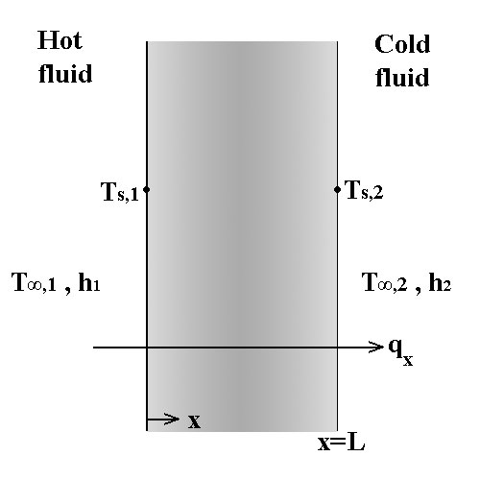

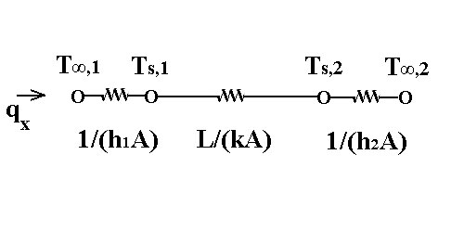

Integrate equation for steady state heat conduction in the wall two times.

C1 and C2 determined by surface energy balance

$${q"}_{cond}={q"}_{conv}$$

$${\left[-k\frac{dT}{dx}\right]}_{x=0}=h_{1}\left[T_{∞,1}-T(0)\right] {\left[-k\frac{dT}{dx}\right]}_{x=L}=h_{2}\left[T\left(L\right)-T_{∞,2}\right]$$

Differentiating: $dT/dx=C_{1}$

At x=0 At x=L

$$-kC_{1}=h_{1}\left[T_{∞,1}-C_{2}\right] -kC_{1}=h_{2}\left[C_{1}L+C_{2}-T_{∞,2}\right]$$

Solve for C1 by substitution,

$$-kC_{1}=h_{2}\left[C_{1}L+\left(\frac{kC_{1}}{h_{1}}+T_{∞,1}\right)-T_{∞,2}\right]$$

$$-kC_{1}=C_{1}h_{2}\left(L+\frac{k}{h_{1}}\right)+h_{2}\left(T_{∞,1}-T_{∞,2}\right)$$

$$C_{1}\left(-k-h_{2}\left(L+\frac{k}{h_{1}}\right)\right)=h_{2}\left(T_{∞,1}-T_{∞,2}\right)$$

$$C_{1}= \frac{h_{2}\left(T_{∞,1}-T_{∞,2}\right)}{-k-h_{2}\left(L+\frac{k}{h_{1}}\right)}=\frac{-\left(T_{∞,1}-T_{∞,2}\right)}{k\left(\frac{1}{h_{1}}+\frac{1}{h_{2}}+\frac{L}{k}\right)}$$

$$C_{2}=\frac{kC_{1}}{h_{1}}+T_{∞,1}$$

$${q"}_{x}=-k\frac{dT}{dx}=-kC_{1}$$

This analysis will be used to calculate our heat losses.

Heat Exchanger Performance

From p191 of thermodynamics-moran text:

Part (a) Calculate ratio of mass flow rates of the cooling water to condensing steam

Part (b) Rate of energy transfer from steam in kJ/kg

-Diagram of alternate flow heat exchanger3 (simulating the condenser of our sterling engine). And T-v diagrams.

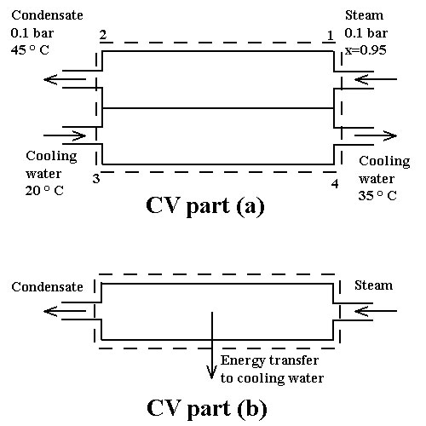

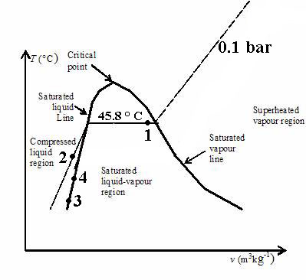

Steam and cooling water do not mix.

$${\dot{m}}_{1}={\dot{m}}_{2} and {\dot{m}}_{3}={\dot{m}}_{4}$$

Ratio ${\dot{m}}_{3}/{\dot{m}}_{1}$ found from steady-state energy rate balance:

$${\dot{Q}}_{CV}-{\dot{W}}_{CV}+{\dot{m}}_{1}\left(h_{1}+\frac{V_{1}^{2}}{2}+gz_{1}\right)+{\dot{m}}_{3}\left(h_{3}+\frac{V_{3}^{2}}{2}+gz_{3}\right)-{\dot{m}}_{2}\left(h_{2}+\frac{V_{2}^{2}}{2}+gz_{2}\right)-{\dot{m}}_{4}\left(h_{4}+\frac{V_{4}^{2}}{2}+gz_{4}\right)=0$$

Dropping terms equal to zero and simplifying (no significant heat transfer between overall condenser and surroundings ${\dot{W}}_{CV}=0$):

$${\dot{m}}_{1}\left(h_{1}-h_{2}\right)+{\dot{m}}_{3}\left(h_{3}-h_{4}\right)=0 \frac{{\dot{m}}_{3}}{{\dot{m}}_{1}}=\frac{h_{1}-h_{2}}{h_{3}-h_{4}}$$

From table for “Properties of Saturated Water (Liquid-Vapor): Pressure Table”

At 0.1 bar hf = 191.83 kJ/kg hg = 2584.7 kJ/kg

$$h_{1}=191.83+0.95*\left(2584.7-191.83\right)=2465.1 kJ/kg$$

Since $h\left(T,p\right)≈h_{f}\left(T\right)+v_{f}\left(T\right)\left[p-p_{sat}(T)\right]$ and $v_{f}\left(T\right)\left[p-p_{sat}(T)\right]$ terms is small.

Assume $h\left(T,p\right)≈h_{f}\left(T\right)$ therefore:

$$h_{2}≈h_{f}\left(T_{2}\right)=188.45\frac{kJ}{kg} h_{3}≈h_{f}\left(T_{3}\right) h_{4}≈h_{f}\left(T_{4}\right)$$

$$h_{4}-h_{3}=62.7 kJ/kg$$

Therefore:

$$\frac{{\dot{m}}_{3}}{{\dot{m}}_{1}}=\frac{2465.1-188.45}{62.7}=36.3$$

Solving for part (b) rate of heat transfer from steam starting with steady-state form of energy rate balance:

$${\dot{Q}}_{CV}-{\dot{W}}_{CV}+{\dot{m}}_{1}\left[\left(h_{1}-h_{2}\right)+\frac{\left(V_{1}^{2}-V_{2}^{2}\right)}{2}+g\left(z_{1}-z_{2}\right)\right]=0$$

Dropping terms equal to zero:

$${\dot{Q}}_{CV}={\dot{m}}_{1}\left(h_{2}-h_{1}\right)$$

Divide by mass flow rate

$$\frac{{\dot{Q}}_{CV}}{{\dot{m}}_{1}}=\left(h_{2}-h_{1}\right)=188.45-2465.1=-2276.7 kJ/kg$$

Energy is transferred from steam to cooling water.

Alternatively with constant heat capacity, c, $\left(h_{2}-h_{1}\right)$ can be evaluated as

$$h_{2}-h_{1}=c\left(T_{2}-T_{1}\right)+v(p_{2}-p_{1})$$

Also remember that h=u+pv and therefore similarly:

$$u_{2}-u_{1}=c\left(T_{2}-T_{1}\right)$$

This analysis will be the basis for the heat exchanger and heat sinks of my sterling engine, when I choose to include these into my design. The heat in a closed system sterling engine, must be transmitted through a series of heat exchangers and finally to a heat sink.5 The effect of this will lower the efficiency of our engine below Carnot efficiency.

**Final Analysis:**

From combining different aspects of these fundamental solutions, I looked for a solution using analytical simplifications helpful to analyzing efficiency of solar thermal storage systems. I did not utilize the solidification or heat exchanger solutions, but left them in this paper as a point for further improvement upon my basic model developed. If integrated, the moving boundary solution would affect the speed at which I could extract energy during phase change. And the heat exchanger problem could be added to act as the condenser section for my sterling engine.

**Charging Stage:**

Charging Diagram

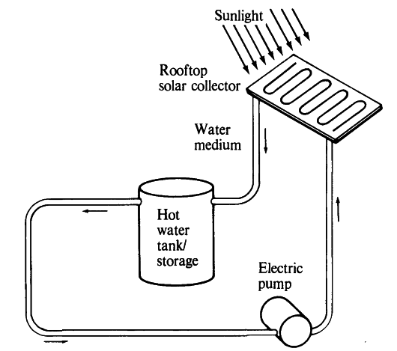

(Figure source: http://www.answers.com/topic/active-solar-heating)

Assume:

- is the environmental temperature.

-The tank contains mass m of water

-The temperature of the tank goes from $T_{env}→1273.15 K$

-A constant heat specific heat in units of J/(kg*K) (or other options could have been to try to calculate initial energy from steam tables, or integrate across a function for specific heat )

-There is a phase change material (PCM) mixed in the liquid that gives the liquid water latent heat properties, $h_{L}$ is the heat of fusion in J/kg, at melting temperature $T_{m}$ (liquid always stays liquid, therefore assume crystal formation or some cause of internal energy change, water does not turn to steam due to being pressurized.)

-Storage density

$$∆T=1273.15 K -T_{env}$$

If $T_{env}>T_{m}$

$$Q_{storage}=mc∆T$$

If $T_{env}<T_{m}$

$$Q_{storage}=mc∆T+mh_{L}$$

**Energy Storage Stage**

Heat loss diagram





(figure source: Redraw from Fundamentals of Heat and Mass Transfer, Incropera)

Assume:

-Wait $τ$ seconds between charging and utilizing energy, over which we experience heat loss

-Temperature of tank constant during this time, which will result in over estimate of losses. Alternatively and more difficultly could solve the equation:

$$A_{surface}*{q"}_{x}=mc\frac{dT_{∞,1}}{dt}$$

This would give us the decreasing ${q"}_{x}$ as time passes and the tank temperature decreases.

-Surface area is a function of mass of water, using density $ρ$, and geometry of hot water tank is a cube with heat loss on 5 of 6 sides

$$A_{surface}= 5* {\left[\sqrt[3]{\frac{m}{ρ}}\right]}^{2} where Volume=\frac{m}{ρ}$$

-Heat flux through wall given with convection heat transfer on both sides

$${q"}_{x}=\frac{\left(T_{∞,1}-T_{∞,2}\right)}{\left(\frac{1}{h_{1}}+\frac{1}{h_{2}}+\frac{L}{k}\right)}$$

-Heat loss during energy storage

- Convective heat transfer coefficient of the water/PCM is $h_{1}$, and air is $h_{2}$, in units of

- L is thickness of wall, and k is thermal conductivity of wall insulation in units of $W/(m *K)$

$$η_{Qloss}=\frac{Q_{storage}-Q_{loss}}{Q_{storage}}$$

**Powering Sterling Engine Stage**

Heat engine diagram

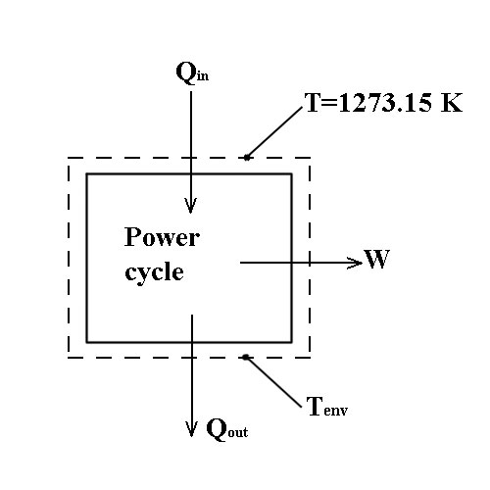

$$η_{max,carnot}=1-\frac{T_{C}}{T_{H}}=1-\frac{T_{env}}{1273.15K}$$

$$η_{total}=η_{Qloss}*η_{max,carnot}$$

**Results:**

Choose reasonable values for variables:

m = 104 kg of water and PCM

= 1000 kg/m3

k = 0.03 W/(m*K) (within the range of values for Aerogel insulation)

L = 0.0254 m (assume insulation thickness of 1 inch)

c = 15 ${10}^{3}$* J/(kg*K) (For constant heat capacity of our water over our temp range)

$h_{L}=300*{10}^{3} J/kg$ (This as our latent energy, chosen similar in magnitude to heat of fusion of water)

$T_{m}=373.15$ K (Our range of $T_{env}$ will cover 273.15K –> 373.15 K, therefore ignoring the case where no latent heat is used.)

Convective Heat Transfer Coefficients of water in tank, and free convection air cooling on outer surface:

$$h_{1} = 100 W/(m^{2} * K)$$

$$h_{2} = 10 W/(m^{2} * K)$$

Wait time, $τ$, range will be 0-12 hrs (12*3600 seconds)

Wait time $τ$ and environmental temp $T_{env}$ will be varied to find efficiency, the data is presented in a multiple line 2d graph.

**Matlab Code used**:

m = 10^4;%kg

roe = 1000; %kg/m^3

k = 0.03; %W/(m*K)

L = 0.0254; %m

c = 15*10^3; %J/kg

hL = 300*10^3; %J/kg

Tm = 373.15; %K, not used, unless change code to allow for Tenv above Tm

Tenv = 273.15:10:373.15; %K

h1 = 100; %W/(m^2*K)

h2 = 10; %W/(m^2*K)

t=0:3600:12*3600; %seconds

eta=zeros(length(Tenv),length(t)); %efficiency

for i=1:length(Tenv)

for j=1:length(t)

delT = 1273.15 -Tenv(i);

Qstorage = m*c*delT +m*hL;

qx = delT/(1/h1+1/h2+L/k);%per surface area

Asurf = 5*((m/roe)^(1/3))^2;

Qloss = Asurf*qx*t(j);

etaQloss = (Qstorage-Qloss)/Qstorage;

etamaxcarnot = 1 - Tenv(i)/1273.15;

eta(i,j) = etaQloss*etamaxcarnot;

end

end

plot(t/3600, eta(1,:),'-x')

hold on

plot(t/3600, eta(length(Tenv),:),'-o')

hold on

plot(t/3600, eta(6,:))

xlabel('time (hrs)');

ylabel('total efficiency');

**Figure:**

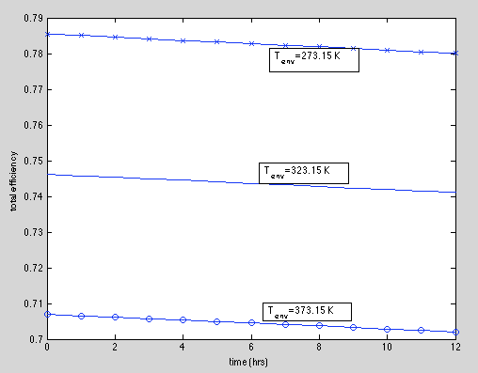

From this analysis we saw the efficiency drop a few percent due to heat losses during thermal storage up to 12 hrs. We also noticed a higher efficiency at lower environmental temperature.

After looking at this figure I decided it would also be interesting to look at how $η_{Qloss} \& { η}_{max,carnot}$ vary with time, at Tenv = 273.15 K. I left the original code intact and modified it into a new file. Obviously ${ η}_{max,carnot}$ will be a flat line because it does not vary with time, unless I want to account for the decrease of the tank temperature as time goes on.

**Matlab Code used**:

m = 10^4;%kg

roe = 1000; %kg/m^3

k = 0.03; %W/(m*K)

L = 0.0254; %m

c = 15*10^3; %J/kg

hL = 300*10^3; %J/kg

Tm = 373.15; %K, not used, unless change code to allow for Tenv above Tm

Tenv = 273.15; %K

h1 = 100; %W/(m^2*K)

h2 = 10; %W/(m^2*K)

t=0:3600:12*3600; %seconds

etaQloss=zeros(length(t),1); %efficiency

etamaxcarnot=zeros(length(t),1);

delT = 1273.15 -Tenv;

Qstorage = m*c*delT +m*hL;

qx = delT/(1/h1+1/h2+L/k);%per surface area

Asurf = 5*((m/roe)^(1/3))^2;

for j=1:length(t)

Qloss = Asurf*qx*t(j);

etaQloss(j) = (Qstorage-Qloss)/Qstorage;

etamaxcarnot(j) = 1 - Tenv/1273.15;

end

plot(t/3600, etaQloss,'-x')

hold on

plot(t/3600, etamaxcarnot,'-o')

xlabel('time (hrs)');

ylabel('efficiency');

**Figure:**

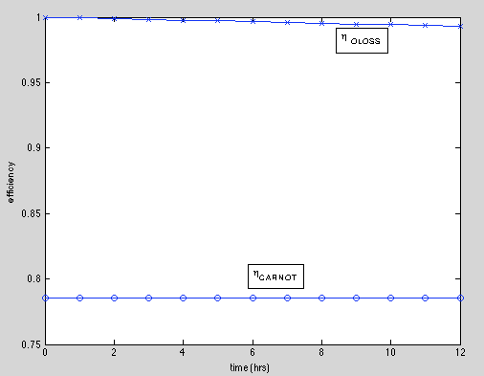

You can see the $η_{Qloss}$ linearly decreasing, if we wanted to solve the equation that allows for decreasing temperature of tank,

$$A_{surface}*{q"}_{x}=mc\frac{dT_{∞,1}}{dt}$$

Then our $η_{Qloss}$ line would no longer be linear, and neither would the Carnot efficiency line.

**Conclusion:**

We established a simple solar thermal model from which we derived efficiency. We found more efficiency at lower environment temperature, but we assumed a very good insulation, which would prevent heat losses at lower temperatures. The effect of the Carnot efficiency dominated the efficiency losses for the chosen reasonable parameters. As the model gets more complicated and realistic it will include many more opportunities for inefficiencies. Also in future work, I am interested in a model that involves calculating values for Qin and Qout of the Carnot engine, assuming heat exchangers and pipe networks.

**References:**

1. “A REVIEW OF THERMAL ENERGY STORAGE SYSTEMS WITH SALT HYDRATE PHASE CHANGE MATERIALS FOR COMFORT COOLING “ Justin Ning-Wei Chiu*, Dr. Viktoria Martin, and Prof. Fredrik Setterwall

2. Transport Phenomena in Multiphase Systems. Amir Faghri and Yuwen Zhang

3. Fundamentals of Engineering Thermodynamics. Moran, Shapiro, Boettner and Bailey.

4. Fundamentals of Heat and Mass Transfer. Incropera, DeWitt, Bergman and Lavine

5. http://en.wikipedia.org/wiki/Stirling_engine