**Analysis of the Stefan Problem: A boundary value problem with a phase boundary moving with time**

Max Plomer

Mechanical Engineering Graduate Student

University of Connecticut

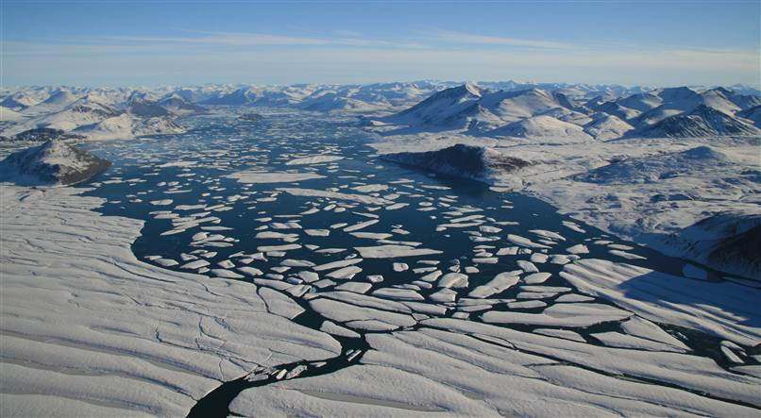

(source: http://www.msnbc.msn.com/id/44723746/ns/us_news-environment/t/canadas-arctic-ice-shelves-breaking-fast/#.ULUQZ3lYuQk)

Comment: In this picture of the Ward Hunt Ice shelf, we see a complex example of a moving phase boundary. With Climate Change being a serious issue, analysis of Stefan-type problems, will be crucial in both calculating the melting of artic ice, as well as energy storage in phase change materials such as salt hydrate for clean solar thermal energy.

**Abstract**: We consider a one-dimensional two-phase Stefan problem, modeling the melting of ice to liquid water. We analyze the error caused by the pseudo-steady state approximation of the temperature profile. The PSS approximation allows estimates for problems with no explicit analytical solution, such as with Newton cooling at the surface. The PSS approximation includes both linear and quadratic shaped temperature profiles.

**Table of Contents:**

-Introduction

-Governing Equations

-Solution Methods

-Results

-Conclusion

-References

-Descriptions of Matlab Files

**Introduction:**

The Stefan problem is an example of a free boundary problem, modeling the temperature distribution in a homogenous material undergoing a phase transformation. The heat equation is solved with an intial temperature distribution and a boundary condition called the stefan condition, that conserves energy in and out of the boundary between the two phases.1

Joseph Stefan introduced this type of problem around 1890 while studying ice formation. In 1889 Stefan had a paper on ice formation in polar seas that drew attention from scientific community.2 Stefan was born in Austria in 1835, and is most well known for the Stefan-Boltzmann law, which says that the energy radiated from a blackbody surface is proportional to the fourth power of the body’s temperature.

Some background information necessary to understand this problem is the latent heat of fusion for phase changes. The main point to understand about latent heat is that the liquid phase has a higher internal energy than the solid phase. Energy is produced by a liquid when it freezes and consumed by a solid when it melts.3

**Governing Equations:**

We will now discuss the governing equations for the classical Stefan problem with two phases.

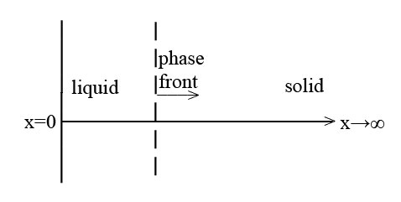

The problem setup consists of a semi infinite half plane, with a material initially solid and at the point of melting. When the surface temperature is rased, melting immediately takes place. Density is assumed to be constant for both phases, therefore no volume change with melting. Values for thermal conductivity, specfic heat, and latent heat of fusion are used.



Where TL is the temperature at x=0, T1 is the temperature distribution of the liquid, TF is the melting temperature, T2 the tempearture distribution of the ice, and TS is the temperature of the ice as x goes to infinity.



Where X is the position of the phase boundary, initially at position x=0.

 

This equation is for the transient heat condution of the liquid, is it valid from x=0 to x=X(t). Where  and  are the density, specific heat, and thermal conductivity of the liquid phase.



This boundary condition says that the temperature T1 at x=0 stays constant at TL.

 

This equation is for the transient heat condution of the solid, is it valid from x=X(t) to x goes to finity. Where  and  are the specific heat, and thermal conductivity of the solid phase. Density is constant for both phases, so  is used in this equation.



This boundary condition says that the temperature T2 at x goes to infinity stays constant at TS.



This boundary condition says that the temperature T1 and T2 at x=X(t) stays constant at TF.

Conserve thermal energy, using fouriers law, across the phase front, this is known as the stefan condition.

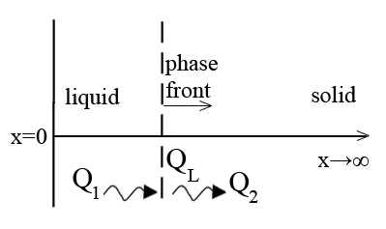





The speed of the phase front is directly proportional to the jump in heat flux across the boundary.

**Solution Methods:**

Explicit Solution4 –

There is an explicit analytical solution for a 2 phase stefan problem when the slab is initial at TF (Carslaw and Jaeger 1959).

The phase front location is given by

 where  is the thermal diffusivity 

 is the root of the transcendental equation 

This means that you need to find the value of  that makes the left side equal to the right side of the equation.



Is the stefan number, the ratio of sensible heat to latent heat.



Is the solution for temperature distribution, where erf() is the error function, a special S-shaped function.

Pseudo Steady State Approximation5 –

The pseudo steady state approximation is an analytic estimate that assumes the movement of the boundary is slower than the rate of diffusion. In other words the heat diffuses quickly and the distribution is assumed steady state, therefore linear. This allows us to neglect the time partial derivative in the diffusion equation. In the book 1-D Stefan Problems: An Introduction, they provide a derivation for this and other approximations, but the problem is normalized before the derivation, I choose to derive the same expressions, without any normalizing.

Our stefan condition becomes



because the  term goes to zero since T2 = TF for all x.

Our linear temperature distribution is



When we combine and integrate we get an expression for the position of the phase front, X(t).

  

Pseudo Steady State Approximation with Newton Cooling at x=0 –

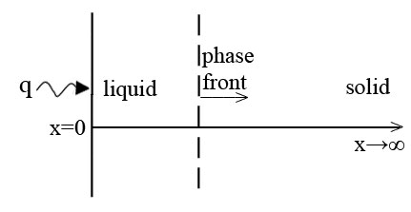

Now we will solve the same stefan problem, but instead of a constant temperature at boundary x=0, we will have a heat flux as determined by newton’s law of cooling.

The boundary condition becomes



Where T0 is the temperature of the air.

Our linear temperature will now be of the form



From these two equations we obtain

 and then 

Now combine the stefan condition, our linear temperature profile, and our expression for  and integrate.

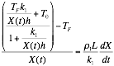 

To accomplish this algebraic simplifcation in the above step I used symbolic variables and the simple() matlab function, in file max_plomer_heatmassmatlabcode2.m .



 where C=0 because X(0)=0

Note: for the case of black body radiation, the boundary condition at x=0 becomes



Pseudo Steady State Approximation with Quadratic temperature profile –

We assume a solution of the form



We take the boundary condition  and differentiate with respect to time, using the definiton of the total derivative. We obtain



From this equation, the stefan condition, and equation for heat conduction in liquid phase we obtain



By taking the derivative of our quadratic solution form,  and  , and subsituting into the above equation, we obtain an expression relating A1 and A2.



Then we substiute this equation and the surface condition,  , back into the quadratic solution form.



Taking the negative root of the quadratic equation ensures T  TF



Now we can obtain X(t) from the Stefan Condition and our expression for A1, this is called Megerlin’s Method.

 

 where C=0 because X(0)=0

Enthalpy Method for Numerical Simulation4 –

I also explored an enthalpy method for numerical simulation of the Stefan problem. The results are not presented here, I received a significant error as compared to the analytical solution. The Numerical method would over predict the phase front location by a factor of 2. Within the time frame of this paper I could not confirm whether this was due to a code error, parameter error (delta x, delta time), scheme error (perhaps semi implicit would work better), an issue with material properties (stefan number, thermal diffusivity), or an issue with determining location of phase front (more difficult because numerial solution contains a mushy zone while analytical doesn’t). I would like to continue to debug and validate the code for this problem, presented in file max_plomer_heatmassmatlabcode_finiteelement.m, in future work.

The idea behind the numerical simulation is the enthalpy method, which conserves enthalpy between elements on a mesh.

Liquid has an enthalpy  (L is latent heat)

Solid has an enthalpy 

For thermal conductivity of material with enthalpy 0<h<L we use

k(h) = (k1+k2)/2 0<h<L

Relations between temperature and enthalpy

 

 

 

Conservation of energy and Fouriers Law

 

The procedure provided in the phase transformations book is an explicit finite difference scheme.





with stability requiring 

**Results:**

PSSA Validation –

A matlab code was developed, file max_plomer_heatmassmatlabcode1.m, that calulates the error in X(t) for a given time for both the analytical and pseudo steady state approximation. Matlab function fzero() is used to find .

For the following parameters:

|  |  |  |  |
| --- | --- | --- | --- |
| Parameter | Value | Meaning | Units |
| c1 | 4.1818 | heat capacity of water | J/(g*K) water at 20 deg C |
| Tl | 300 | temperature of liquid at x=0 | K |
| Tf | 273.15 | temperature of melting | K |
| L | 334 | latent heat of fusion | J/g of water |
| k1 | 0.58 | thermal conductivity of liquid water | W/(m*K) |
| rho1 | 0.99777e6 | density (constant for both phases) | g/m^3 |

We found Error in X(t) = 4.98% for all time.

Which is an expected behavior, since both the analytical and PSSA solutions are functions of the square root of time. The PSSA solution is expected and does overpredict X(t) for a given time, since assuming steady state assumes more heat is transferred to the boundary.

Using error equation: 

PSS vs PSS with Newton Cooling –

The values for the following graph are generated in file max_plomer_heatmassmatlabcode3.m, and then graphed in excel. Using same parameters as already mentioned.

Comment: As expected the effect of newton cooling causes the phase change front to move more slowly.

PSS vs PSS with Quadratic Temperature Profile vs Analytical Solution –

The values for the following graph are generated in file max_plomer_heatmassmatlabcode4.m, and then graphed in excel. Using same parameters as already mentioned.

Comment: As expected the PSS solution is greater than the analytical, the PSS with quadratic approximation has much less error and is slightly less than the analytical solution.

**Conclusion:**

The PSSA method proved to be very useful in solving stefan problems.

The pseudo steady state approximation technique was validated and found to have an error of about 5% in position of the phase front at a given time for the given parameters.

Newton Cooling was added to the problem, which has no analytical solution, and the results compared to PSS without newton cooling agreed with the expected trend that newton cooling would slow the progress of the phase front.

Then we explored assuming the temperature distribution has a quadratic form. This greating increased accuracy, but also added a level of complexity. A next step would be finding a solution for newton cooling with a quadratic temperature distribution. And also do a linear combination of newton cooling and radiation heat transfer to get a more accurate model of artic sea ice.

In future work I would like to explore more finite difference methods for this problem, and also extend these principals to other problems than can be solved using a stefan type solution, such as energy storage in a solar thermal plant.

**References:**

1. http://en.wikipedia.org/wiki/Stefan_problem

2. http://ta.twi.tudeln.nl/nw/users/vuik/wi1605/opgave1/stefan.pdf

3. http://en.wikipedia.org/wiki/Enthalpy_of_fusion

4. Phase Transformations.  Aifantis, Elias C. ; Gittus, John (1986)

5. One‐dimensional Stefan problems: An introduc:on.  Hill, J.M.  (1987)

**Descriptions of Matlab Files:**

|  |  |
| --- | --- |
| File | Description |
| max_plomer_heatmassmatlabcode1.m | calulates the error in X(t) for a given time for both the analytical and pseudo steady state approximation |
| max_plomer_heatmassmatlabcode2.m | simplifies the polynomial for the newton cooling pseudo-steady state aproximation stefan problem |
| max_plomer_heatmassmatlabcode3.m | compares X(t) for PSS, and PSS w/ newton cooling |
| max_plomer_heatmassmatlabcode4.m | compares the analytical stefan problem to the pseudo-steady state approximation, both linear and quadratic |
| max_plomer_heatmassmatlabcode_finiteelement.m | finite element stefan problem using the enthalpy method in book "Phase Transformations" |