XDC NETWORK
Liquid Staking Protocol
Technical Specification & Developer Guidance
Architecture, Business Logic & Implementation Roadmap

Version 1.5 | February 2026 | CONFIDENTIAL

Table of Contents

Executive Summary
This document defines the architecture, business logic, and technical specifications for the XDC Liquid Staking Protocol. It incorporates the XDC 2.0 Staking, Rewards and Burning Upgrade, and is grounded in confirmed behavior from the XDCValidator.sol source code (0x88 precompile).
The protocol enables XDC holders to stake tokens and receive bXDC, a liquid receipt token that appreciates as masternode rewards accrue. Under XDC 2.0, masternodes participate in a three-tier system: Core Validators (top 108), Protector Nodes (next 216), and Observer Nodes (unlimited). The protocol is designed to scale aggressively across all three tiers.

Design Principles
- Scale-first: Deploy masternodes across all tiers. Observer Nodes are the growth engine. More nodes = more total rewards.
- Simplified vault: MasternodeVault only handles KYC upload, propose, reward collection, resign, and withdraw. No top-up routing.
- Operator top-up is direct: Operators call vote()/unvote() on 0x88 directly from their own EOA. Bypasses vault entirely.
- On-chain truth: 0x88 distributes rewards on-chain. No off-chain oracle.
- KYC delegation: Vault reuses operator’s KYC hash via uploadKYC() before calling propose(). One-time per vault.
- Blended yield: bXDC exchange rate reflects the weighted average across all tiers.
- No oracle committee: Unlike Lido (9-member) and Rocket Pool (15+ Oracle DAO).

Confirmed from XDCValidator.sol
This spec is grounded in the actual 0x88 contract source code. Key confirmations:
• propose() checks onlyKYCWhitelisted on msg.sender (vault) — vault must call uploadKYC() first
• vote() has NO KYC requirement — operator can call directly from EOA
• resign() puts owner’s stake into withdrawsState — vault must call withdraw() after delay
• unvote() has separate voterWithdrawDelay — operator reclaims independently
• Capital separation is automatic at the 0x88 level — no settlement logic needed in vault

XDC 2.0 Reward Model
Under the XDC 2.0 Staking, Rewards and Burning Upgrade, the network introduces a three-tier node hierarchy. All three tiers earn meaningful rewards, and the protocol scales through all of them.

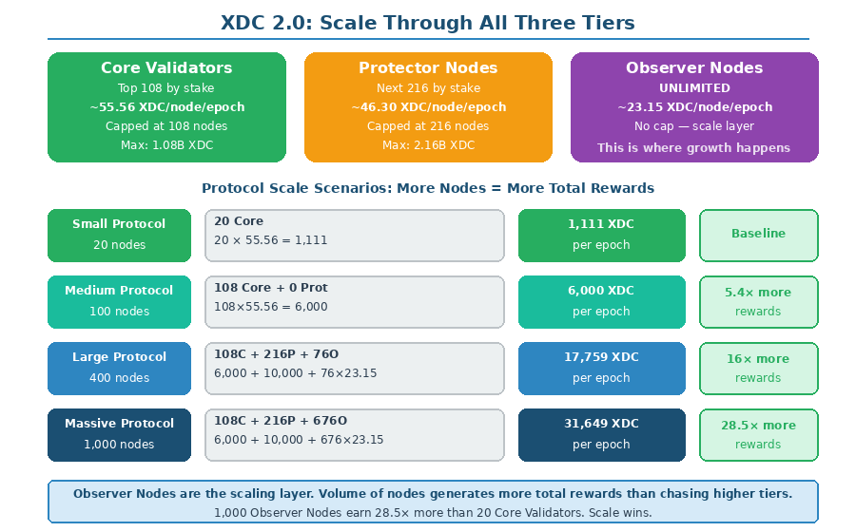

Three-Tier Node Structure
Role | Count | Selection | Reward Pool/Epoch | Per Node/Epoch | Annual (approx)
Core Validator | 108 | Top 108 by stake | 6,000 XDC | ~55.56 XDC | ~973,333 XDC
Protector Node | 216 (108×2) | Next 216 by stake | 10,000 XDC | ~46.30 XDC | ~811,111 XDC
Observer Node | Unlimited | All remaining | Half of Protector rate | ~23.15 XDC | ~405,555 XDC

Scale Economics
Scenario | Node Count | Composition | Total Rewards/Epoch | vs Baseline
Small | 20 nodes | 20 Core | 1,111 XDC | 1×
Medium | 100 nodes | 100 Core | 5,556 XDC | 5×
Large | 400 nodes | 108C + 216P + 76O | 17,759 XDC | 16×
Massive | 1,000 nodes | 108C + 216P + 676O | 31,649 XDC | 28.5×
Maximum | 5,000 nodes | 108C + 216P + 4,676O | 124,249 XDC | 112×

Observer Nodes are the unlimited scaling layer. At 1,000 masternodes the protocol earns 28.5× more than a 20-node deployment. Volume dominates tier.

Blended Yield
Protocol Size | Blended Yield/Node/Epoch | Total Yield/Epoch | APR on Total Staked
20 nodes (all Core) | 55.56 XDC | 1,111 XDC | ~4.87%
324 nodes (108C+216P) | 49.38 XDC | 16,000 XDC | ~4.49%
1,000 nodes (mixed) | 31.65 XDC | 31,649 XDC | ~2.88%
5,000 nodes (mixed) | 24.85 XDC | 124,249 XDC | ~2.26%

Token Burning
XDC 2.0 introduces transaction fee burning (percentage set by XDCDAO). If more is burned than minted, XDC becomes deflationary, enhancing bXDC value independently of staking rewards.

Epoch Timing
1 epoch = 900 blocks. 1 block = 2 seconds. 1 epoch ≈ 30 minutes. ~48 epochs/day. ~17,520 epochs/year.

XDCValidator.sol — Confirmed Behavior
The following is confirmed from the actual XDCValidator.sol source code at 0x88. This section serves as the ground truth for all vault interactions.

Contract Functions Used by Protocol
Function | Signature | Caller | Key Modifiers | Notes
uploadKYC | uploadKYC(string kychash) | Vault | None | Stores KYC hash against msg.sender. Required before propose().
propose | propose(address _candidate) payable | Vault | onlyKYCWhitelisted, onlyValidCandidateCap, onlyNotCandidate | msg.value ≥ minCandidateCap. Sets vault as owner.
vote | vote(address _candidate) payable | Operator EOA | onlyValidVoterCap, onlyValidCandidate | No KYC needed. Anyone can vote. Adds to candidate cap.
unvote | unvote(address _candidate, uint256 _cap) | Operator EOA | onlyValidVote | Partial withdrawal. voterWithdrawDelay applies.
resign | resign(address _candidate) | Vault | onlyOwner, onlyCandidate | Owner’s stake to withdrawsState. candidateWithdrawDelay.
withdraw | withdraw(uint256 _blockNumber, uint _index) | Vault or Operator | onlyValidWithdraw | After delay. msg.sender.transfer(cap).

onlyKYCWhitelisted Modifier
Source Code
require(KYCString[msg.sender].length != 0 || ownerToCandidate[msg.sender].length > 0);
Two ways to pass:
1. msg.sender has uploaded KYC (KYCString has entries)
2. msg.sender already owns a candidate (ownerToCandidate has entries)
For the first vault: must call uploadKYC() first.
For subsequent vaults from same address: passes via ownerToCandidate.

KYC Delegation Flow
Operators complete KYC through our OperatorRegistry during onboarding. Each operator’s KYC hash is stored. When a new vault is deployed, it reuses the operator’s KYC hash:

- Operator onboards: Completes KYC off-chain. KYC hash stored in OperatorRegistry.
- Vault deployed: StakingPool deploys EIP-1167 proxy vault.
- Vault calls uploadKYC(operatorKycHash): Now KYCString[vaultAddress].length > 0. Passes modifier.
- Vault calls propose(coinbase) with 10M: Vault becomes owner. validatorsState[coinbase].owner = vaultAddress.

For the SAME vault address deploying a second masternode, step 3 is unnecessary — ownerToCandidate[vaultAddress].length > 0 already passes the modifier. However, since each vault owns exactly one masternode, each vault needs its own uploadKYC() call.

resign() Behavior — Critical Detail
Source Code
uint256 cap = validatorsState[_candidate].voters[msg.sender];
validatorsState[_candidate].cap = ... .sub(cap);
validatorsState[_candidate].voters[msg.sender] = 0;
uint256 withdrawBlockNumber = candidateWithdrawDelay.add(block.number);
withdrawsState[msg.sender].caps[withdrawBlockNumber] = ... .add(cap);
Key: resign() only returns the OWNER’s voter amount (the 10M propose amount).
Other voters’ stakes remain untouched — they must call unvote() separately.
This means operator top-up (via vote) is automatically separated. No settlement logic needed.

vote() / unvote() — No KYC Required
vote() has only onlyValidVoterCap and onlyValidCandidate modifiers. No onlyKYCWhitelisted. This means any address can vote for any valid candidate by sending XDC. Operators call vote(coinbase) directly from their own EOA without going through the vault.
unvote() allows partial withdrawal — the operator specifies an exact amount. There’s a separate voterWithdrawDelay before they can call withdraw(). The entire operator top-up lifecycle is independent of the vault.

Capital Separation at 0x88
On resign: vault gets back its 10M (propose amount) via withdrawsState[vaultAddress].
Operator must call unvote() then withdraw() separately via withdrawsState[operatorEOA].
No settlement logic, no accounting reconciliation, no vault routing. 0x88 handles it natively.

System Architecture
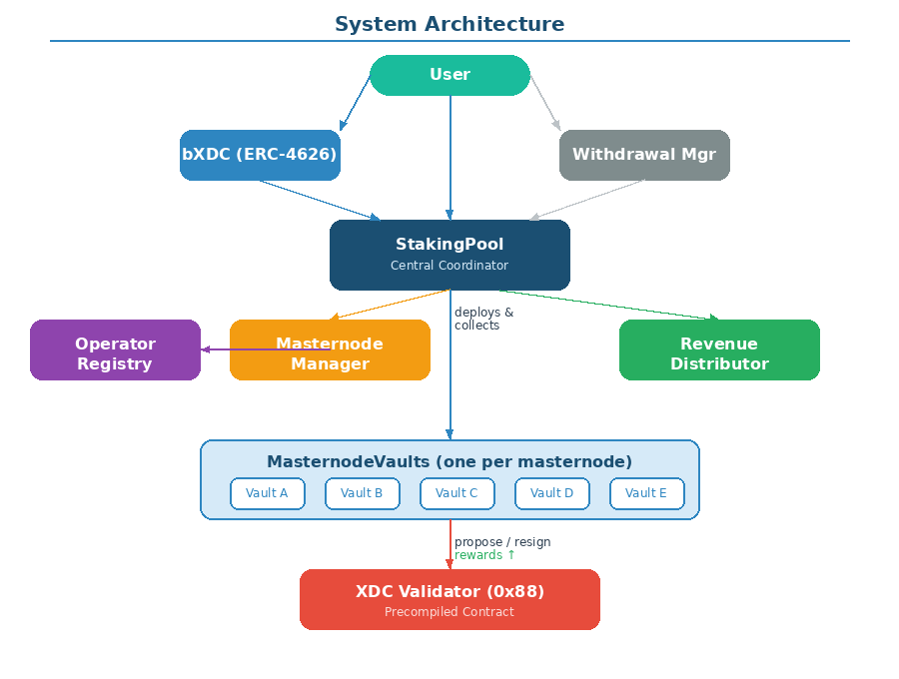

Contract Overview
Contract | Responsibility | Holds XDC?
StakingPool | Central coordinator, vault deployment/collection, revenue split, blended yield accounting | Yes
bXDC (ERC-4626) | Liquid receipt token, share-based exchange rate | No
OperatorRegistry | KYC lifecycle, coinbase management, KYC hash storage for vault delegation | No
MasternodeManager | Selection, deployment at scale, resignation only for withdrawals/offline | No
MasternodeVault | Per-masternode proxy. 5 functions: uploadKYC, propose, collectRewards, resign, withdraw. | Yes — rewards
WithdrawalManager | Withdrawal queue, NFT, buffer | No
RevenueDistributor | Operator commission accumulation + claims | Yes — commissions

Simplified MasternodeVault
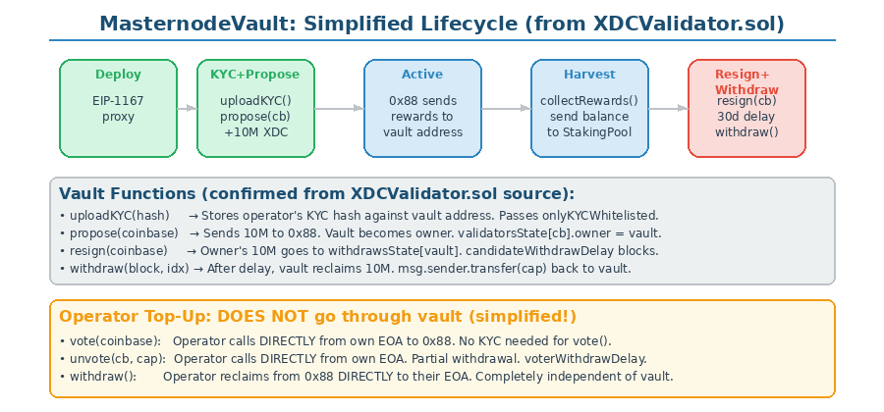

The vault is now minimal — five functions that interact with 0x88, plus receive() for rewards and collectRewards() for harvesting. No operator top-up routing.

Function | Calls on 0x88 | Purpose
setupAndPropose(kycHash, coinbase) | uploadKYC() then propose() | One-time setup. Stores KYC + stakes 10M. Vault becomes owner.
collectRewards() | N/A (just transfers balance) | Send accumulated reward balance to StakingPool. Tier-agnostic.
initiateResign(coinbase) | resign() | Owner’s 10M enters withdrawsState. candidateWithdrawDelay starts.
claimStake(blockNumber, index) | withdraw() | After delay, reclaims 10M. Sends to StakingPool.
receive() | N/A | Accepts XDC from 0x88 (epoch rewards).

What’s NOT in the Vault
No operatorTopUp(). No operatorWithdrawExcess(). No settlement logic.
Operators interact with 0x88 directly via vote()/unvote()/withdraw() from their own EOA.
This reduces vault attack surface and simplifies auditing.

Vault Lifecycle
Stage | Action | State
Deploy | StakingPool deploys EIP-1167 proxy (~45K gas) | Empty, linked to operator
Setup | vault.setupAndPropose(kycHash, coinbase) with 10M | 10M on 0x88. Vault = owner.
Active | 0x88 sends rewards each epoch (tier-dependent rate) | Accumulates rewards
Harvest | StakingPool calls vault.collectRewards() | Rewards sent to pool
Resign | vault.initiateResign(coinbase) | 10M in withdrawsState
Claim | vault.claimStake(blockNumber, index) after delay | 10M back to StakingPool

Inter-Contract Communication
Caller | Calls On | Functions
StakingPool | MasternodeVault | setupAndPropose(), collectRewards(), initiateResign(), claimStake()
MasternodeManager | StakingPool | deployAndPropose(), initiateResign()
Operator EOA | 0x88 directly | vote(), unvote(), withdraw() — bypasses vault
WithdrawalManager | StakingPool | transferForWithdrawal()
StakingPool | RevenueDistributor | depositCommission()
Keeper (any) | StakingPool | harvestRewards(), processClaimableStakes()
Operator | RevenueDistributor | claimCommission()

Competitive Staking & Operator Top-Up
Operator top-up is now confirmed as a direct interaction with 0x88, completely independent of the vault. This simplifies the protocol significantly.

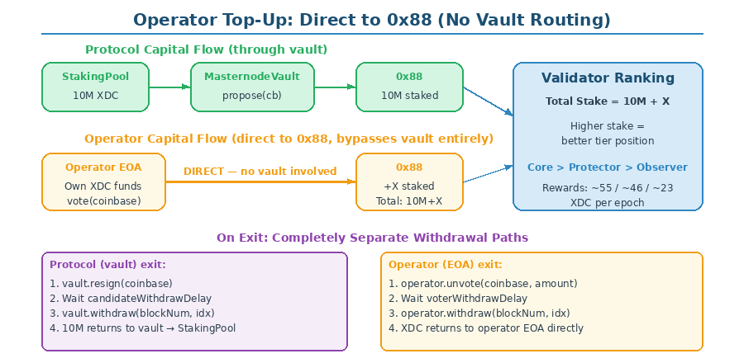

How It Works
- Protocol proposes: Vault calls propose(coinbase) with 10M. Vault becomes owner on 0x88.
- Operator tops up (optional): Operator calls vote(coinbase) directly from EOA with own XDC. No KYC needed.
- 0x88 totals the stake: validatorsState[coinbase].cap = 10M (vault) + X (operator vote). Higher total = better tier.
- Rewards go to vault: 0x88 sends rewards to the owner address (vault), not to voters. Operator top-up earns nothing directly.
- Operator reclaims independently: unvote(coinbase, amount) → voterWithdrawDelay → withdraw(). Funds go to operator EOA.

Capital | Source | 0x88 Function | Withdrawal Path | KYC Required?
Protocol 10M | User deposits | propose() via vault | resign() + withdraw() via vault | Yes (vault uploadKYC)
Operator top-up | Operator funds | vote() from EOA | unvote() + withdraw() from EOA | No

Tier Transition Economics
Transition | Commission Diff/Epoch @7% | Annual Diff | Top-Up 100K ROI | Top-Up 500K ROI
Core → Protector | ~0.65 XDC | ~11,388 XDC | 11.4% | 2.3%
Protector → Observer | ~1.62 XDC | ~28,389 XDC | 28.4% | 5.7%
Core → Observer | ~2.27 XDC | ~39,778 XDC | 39.8% | 8.0%

Operators decide independently whether to top up. The protocol functions perfectly at any tier.

Reward Flow & Revenue Distribution
Recipient | Range | Description
bXDC Holders | 85–92% | Added to totalPooledXDC. Reflects blended yield across all tiers.
Operator Commission | 5–10% | Per-vault. Based on actual vault earnings at whatever tier.
Protocol Treasury | 2–5% | Development, audits, insurance.

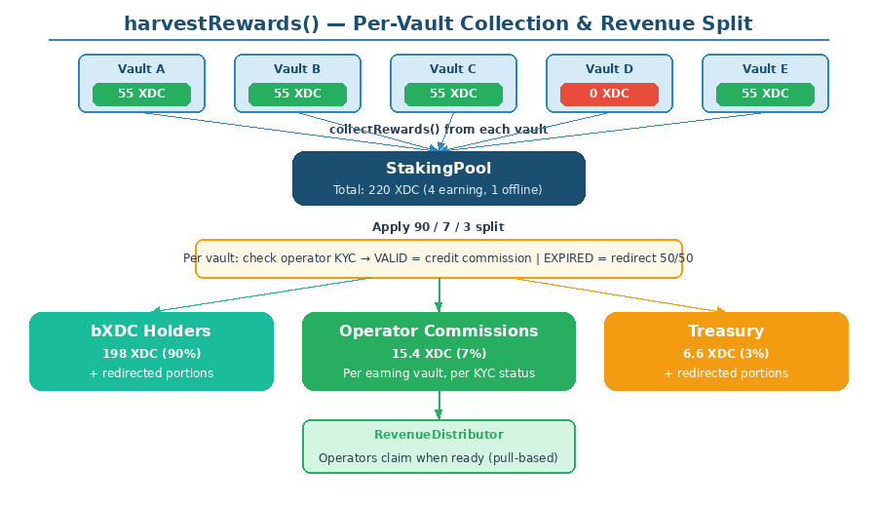

harvestRewards() collects from each vault. Amount varies by tier: Core ~55, Protector ~46, Observer ~23 XDC. Commission is proportional to actual vault earnings — naturally fair across all tiers.

Tier Detection from Vault Earnings
Vault Earnings/Epoch | Tier | Status
~55 XDC | Core Validator | Highest yield
~46 XDC | Protector Node | Strong yield (83% of Core)
~23 XDC | Observer Node | Real yield — scaling layer
0 XDC | Offline/Slashed | Only case requiring investigation

KYC Commission Redirection
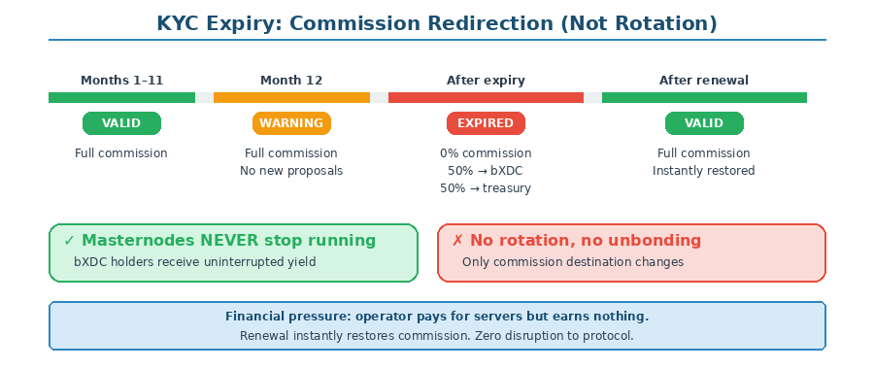

Expired KYC: masternodes keep running at whatever tier. Commission redirected 50% bXDC + 50% treasury. Instantly reversible on renewal.

RevenueDistributor
Field | Description
pendingCommission[operator] | Unclaimed XDC. Increases each harvest based on vault earnings across all tiers.
totalDistributed[operator] | Lifetime claimed.
perCoinbaseEarned[coinbase] | Lifetime per coinbase. Shows per-node performance and tier history.

Worked Example
50 masternodes. Company A: 15 Core. Company B: 10C + 8P. Company C: 5P + 10O. Company D: 2O (KYC expired).

Operator | Nodes | Vault Earnings/Epoch | KYC | Commission
Company A | 15 Core | 15 × 55.56 = 833 XDC | VALID | Full
Company B | 10C + 8P | 10×55.56 + 8×46.30 = 926 XDC | VALID | Full (mixed)
Company C | 5P + 10O | 5×46.30 + 10×23.15 = 463 XDC | VALID | Full (mixed)
Company D | 2 Observer | 2 × 23.15 = 46 XDC | EXPIRED | Redirected 50/50

Total: 2,268 XDC/epoch. Company C’s 10 Observer Nodes generate 231.5 XDC — valuable contribution. At scale, volume beats tier.

bXDC Token (ERC-4626 Vault)
Exchange Rate
Rate = totalPooledXDC / totalSupply(bXDC)
At launch: 1 bXDC = 1 XDC. Over time: 1 bXDC > 1 XDC.
Yield reflects the blended average across all tiers.

- DeFi composability: Share-based. Works everywhere ERC-4626 is supported.
- Blended yield: Users don’t need to know which tier any node is in.
- Scale benefit: More nodes = more total rewards = faster bXDC appreciation.
- Token burning upside: XDC 2.0 fee burning may make XDC deflationary.

Operator Registry
Tier | Action | Who | Frequency
Admin | KYC + approval + store kycHash | Admin (multi-sig) | Annual
Admin | Set maxMasternodes | Admin | On request
Admin | Set concentration limit | Admin | Governance
Operator | Register coinbase | Operator | Per node
Operator | Remove coinbase | Operator | Retiring HW
Operator | Top up own nodes (direct to 0x88) | Operator | Anytime

KYC Hash Storage
OperatorRegistry stores each operator’s kycHash. When StakingPool deploys a vault for that operator’s coinbase, it passes the kycHash to vault.setupAndPropose(). The vault calls uploadKYC(kycHash) on 0x88 before calling propose(). This is the KYC delegation mechanism.

KYC Lifecycle
Period | Status | Masternodes | Commission | Actions
Months 1–11 | VALID | Active at any tier | Full share | All: whitelist, propose
30d before expiry | WARNING | Active | Full share | No new proposals
After expiry | EXPIRED | Active | Redirected 50/50 | No proposals
After re-KYC | VALID | Active | Restored | Instantly restored

Masternode Manager

Deployment Strategy: Scale First
Every 10M XDC above the buffer threshold triggers a new masternode deployment. The protocol deploys into whatever tier is available — no tier optimization.

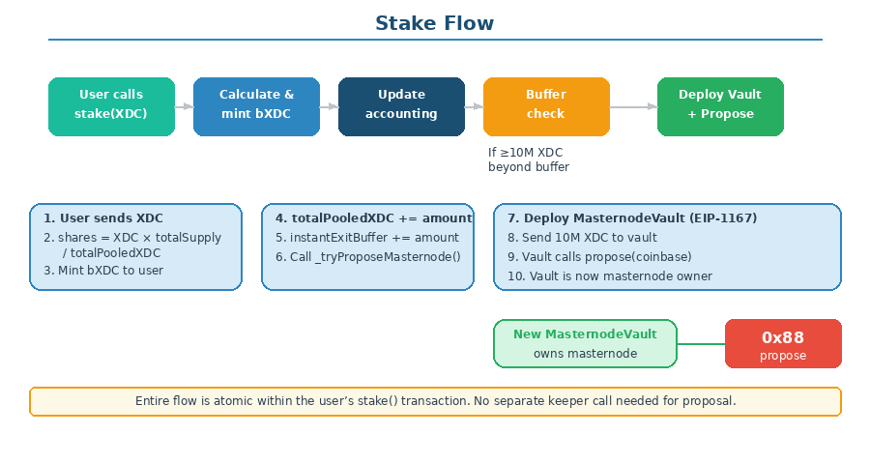

- Verify: ≥10M beyond buffer, eligible coinbase, KYC valid, below cap
- Select coinbase (capacity-balanced across operators)
- Deploy vault (EIP-1167 proxy)
- Vault calls setupAndPropose(kycHash, coinbase) with 10M
- Update accounting

Unstake Flow
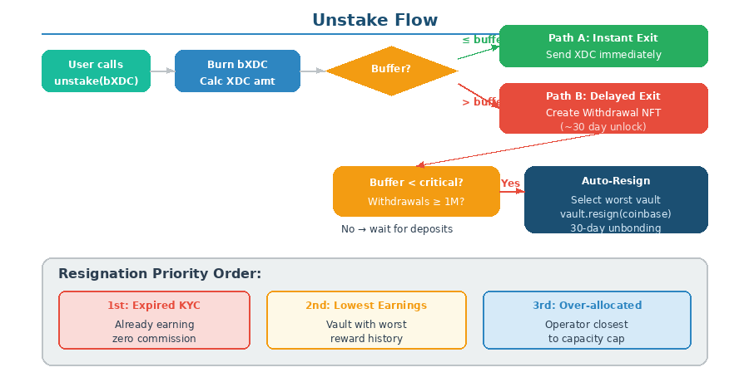

Resignation: Only for Withdrawals or Offline Nodes
Masternodes are ONLY resigned for two reasons:
- Withdrawal pressure: Buffer below critical + pending withdrawals exceed threshold.
- Offline nodes (0 earnings): Vault earning 0 XDC over consecutive epochs. Investigate and resign.

A masternode is NEVER resigned because of its tier. Observer Nodes earn real rewards and contribute to protocol yield.

Resignation Priority (When Forced)
- Offline nodes (0 earnings): Non-productive. Always first.
- Expired KYC operators: Commission already redirected.
- Lowest vault earnings: Observer < Protector < Core.

Resignation Flow (Confirmed from XDCValidator.sol)
- vault.initiateResign(coinbase): Calls resign() on 0x88. Owner’s 10M enters withdrawsState[vaultAddress] with candidateWithdrawDelay.
- Wait candidateWithdrawDelay blocks: ~30 days. Vault tracks the withdrawal block number.
- vault.claimStake(blockNumber, index): Calls withdraw() on 0x88. msg.sender.transfer(cap) sends 10M back to vault.
- Vault sends 10M to StakingPool: Protocol capital returned. Available for redeployment or withdrawal queue.

Operator Top-Up on Resign
If operator has voted on this coinbase, their stake is NOT affected by resign().
resign() only touches the owner’s (vault’s) voter amount.
Operator must independently call unvote() → wait voterWithdrawDelay → withdraw() to reclaim.
0x88 handles this natively — zero protocol intervention needed.

Staking Pool
Variable | Description
totalPooledXDC | Drives bXDC rate. Protocol capital only (excludes operator top-ups).
totalStakedInMasternodes | 10M × active vault count (across all tiers).
instantExitBuffer | Liquid XDC for instant exits.
activeVaults[] | All active MasternodeVault addresses.
vaultToOperator[vault] | Vault → operator mapping.
pendingResignations[vault] | Vaults in candidateWithdrawDelay. Track block numbers.

Accounting
totalPooledXDC = totalStakedInMasternodes + instantExitBuffer + sum(vault rewards) + (pendingResignations × 10M)
Operator top-ups excluded — not protocol capital. 0x88 separates them natively.

Withdrawal System
Instant exit if amount ≤ buffer. Otherwise delayed via ERC-721 NFT (candidateWithdrawDelay, transferable, FIFO queue).

Parameter | Recommended | Effect
minBufferPercent | 5–10% | Below: no new proposals (scale paused)
criticalBufferPercent | 2–3% | Below: resignations triggered

Automation & Keepers
Function | Frequency | Purpose
harvestRewards() | Every epoch (~30 min) | Collect from all vaults, attribute, split
processWithdrawalQueue() | After unbonding | Fulfill mature withdrawal NFTs
processClaimableStakes() | After candidateWithdrawDelay | Call vault.claimStake() for resigned vaults

No Oracle
Per-vault balance IS performance data. Vault earnings amount reveals tier. Zero off-chain infrastructure.

Access Control & Governance
Role | Held By | Permissions
DEFAULT_ADMIN_ROLE | Multi-sig (3/5+) | Grant/revoke roles.
GOVERNANCE_ROLE | Multi-sig + Timelock | Rates, buffer %, caps.
OPERATOR_ADMIN_ROLE | Multi-sig | Register operators, KYC, caps, kycHash storage.
MASTERNODE_MANAGER_ROLE | MasternodeManager | deployAndPropose(), initiateResign().
WITHDRAWAL_MANAGER_ROLE | WithdrawalManager | Draw XDC from StakingPool.
EMERGENCY_ROLE | Multi-sig (4/5+) | Pause only. Cannot move funds.

Security
NO emergencyWithdraw. Emergency = pause only via multi-sig.

Protocol Comparison
Aspect | Lido v2 | Rocket Pool Saturn 1 | XDC Liquid Staking
Oracle | 9-member quorum | Oracle DAO 15+ | None — per-vault on-chain
Per-node tracking | Oracle reports | Megapool/operator | MasternodeVault per node
Multi-tier support | N/A | N/A | Core/Protector/Observer
Scale strategy | Module-based | Megapool | Unlimited Observer Nodes
Operator top-up | N/A | N/A | Direct vote() on 0x88, no vault routing
Receipt token | stETH + wstETH | rETH | bXDC (ERC-4626)
KYC | Off-chain | Off-chain | On-chain via uploadKYC delegation
Gov token | LDO | RPL | None — rev-share
Capital separation | Complex accounting | Bond mechanism | Native at 0x88 level

Implementation Roadmap

Phase 1: Core Security + Vault (Weeks 1–3)
CRITICAL
- AccessControl + multi-sig. Remove emergencyWithdraw.
- MasternodeVault template (EIP-1167): setupAndPropose(), collectRewards(), initiateResign(), claimStake()
- Integration test: vault → uploadKYC() → propose() → reward collection → resign() → withdraw() on testnet

Phase 2: Operator Registry (Weeks 3–5)
CRITICAL
- Two-tier access, KYC lifecycle, kycHash storage for vault delegation
- Dynamic caps with concentration limits

Phase 3: Revenue Distribution (Weeks 5–7)
CRITICAL
- RevenueDistributor + per-vault harvest (tier-agnostic collection)
- KYC redirection (50/50). Pull-based operator claims.

Phase 4: Masternode Manager (Weeks 7–9)
CRITICAL
- Scale-first deployment: auto-propose on every 10M above buffer
- Selection algorithm: capacity-balanced across operators
- Resignation only for withdrawals or offline nodes

Phase 5: Withdrawal + Buffer (Weeks 9–11)
HIGH
- ERC-721 NFT, FIFO queue, dual exit path, buffer gates
- processClaimableStakes() keeper for resigned vaults

Phase 6: Governance & Audit (Weeks 11–13)
MEDIUM
- Timelock, multi-sig, keeper incentives, external audit
- Batch harvesting for large vault counts

Phase 7: Mainnet (Weeks 13–16)
MEDIUM
- Deploy, onboard operators, staged launch
- Scale up progressively as deposits grow

Remaining Open Questions
Most critical verification questions have been answered by the XDCValidator.sol source code review. Remaining items:

# | Question | Impact | Owner
1 | How do XDC 2.0 Protector/Observer rewards flow technically? Same 0x88? | Reward collection | Blockchain
2 | Is there a max Observer Node count or truly unlimited? | Scale ceiling | Blockchain
3 | What is candidateWithdrawDelay in blocks? | Withdrawal timing | Blockchain
4 | What is voterWithdrawDelay in blocks? | Operator top-up reclaim timing | Blockchain
5 | What is minVoterCap? | Minimum operator top-up amount | Blockchain
6 | Revenue split ratios (bXDC/operator/treasury)? | Yield vs sustainability | Governance
7 | Gas ceiling for batch harvest with 1000+ vaults? | Scale architecture | Engineering
8 | How many operators at launch? | Initial decentralization | Business
9 | Target scale? 100 / 500 / 1000+ masternodes? | Architecture sizing | Business

End of Document

