

**HOW TO CONDUCT A ONE-TIME WASTE SORT**

A one-time Waste Sort is conducted to assess school lunch waste and gather baseline data on the percentage of waste that is liquid, recyclable, compostable, landfill bound trash, and recoverable food. Below are guidelines for the leader who will initiate and oversee the Waste Sort.

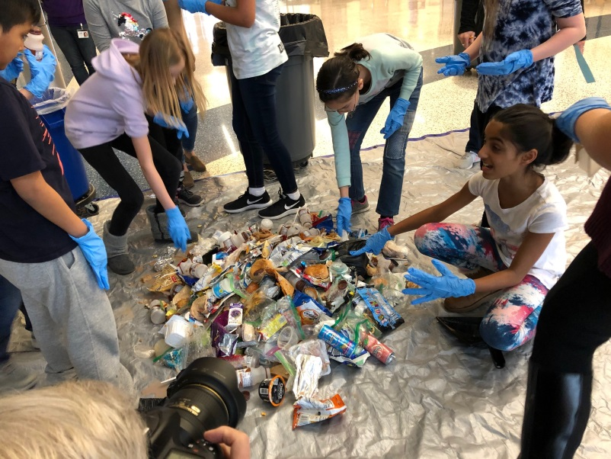**NEEDED SUPPLIES:**

* 1 large tarp
* Scale suitable for weighing containers and trash bags
* 1 five gallon bucket to collect liquids
* 1 recycling bin
* 1 bin for food waste and other compostable materials (paper towels, napkins, etc.)
* 1 trash can
* 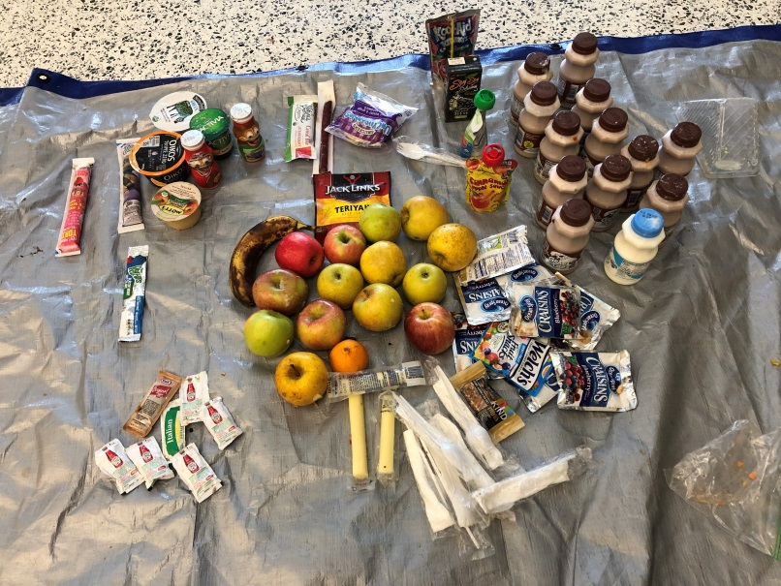A table or area to place recoverable food and other items: Unopened packaged food, unpeeled fruit, unopened milk, water, or juice, unopened condiment packets, unopened plastic-ware packets.
* Rubber or disposable gloves
* Recycling guidelines for your school or jurisdiction
* Camera
* Optional: disposable shoe covers

**PREPARATION:**

* **Meet with the School Principal** to get permission to conduct the Waste Sort and to set a date.
* **Meet with Building Services staff** to inform bags, that is fine as long as it is a good representative sample. If recyclables are normally collected, ask for those bags as well.
* **Recruit a small group of students and/or volunteers to conduct the sort.** This could be the school’s Green Team, or other student leadership team or club. Educate them about what they will be doing and why they are doing it.
  + Educate them about what is and is not recyclable in their school/jurisdiction.
  + Explain what items are compostable. For example, in addition to unpackaged food, usually paper napkins and paper towels are compostable. Some cardboard school trays and paper boats are also compostable. Find out what are acceptable compostable items from a compost services company in your area.
  + Tell them where they should put perfectly good recovered food: unopened packaged food, unpeeled fruit, and unopened bottles of milk, water, or juice.
* Consider inviting a **newspaper reporter and photographer** to attend the Waste Sort.
* Consider having someone **video the Waste Sort** and interview Students before and after.
* Designate someone to **take photos during the Waste Sort**.

**CONDUCTING THE WASTE SORT:**

* After the last lunch period, **spread out the tarp** in an open space in the cafeteria, or outside if weather permits.
* **Weigh the empty containers** that will be filled and weighed later. This usually includes the Compost Bin, the Liquids Bucket, and possibly the Recycling Bin. Record the weights as these will be subtracted after the sorted waste is weighed in their containers. The trash is usually in bags so the trash can itself does not need to be weighed.
* **Line up the Waste Sort Containers** in this order: Liquids bucket, Recycling Bin, Compost Bin, Trash Can.
* Have the students or volunteers **put on gloves** and shoe protectors if available.
* **Empty the first bag of trash** or Recyclables onto the tarp.
* **Before students start sorting**, hold up a few key items one at a time and **ask them where the items should go** to ensure they know what is recyclable and compostable and what is not.
* Students can then get started sorting the waste.
  + Any perfectly good unopened packaged food, unpeeled fruit, or beverages should be placed in the **Recovered Food area**. This could be a section of the tarp, or a nearby table.
  + **Partially full liquid containers should be opened and the contents should be poured in the liquids bucket.** If it is plastic bottle, the top should be replaced and put in the recycling container. If it is a glass bottle, the top and bottle should be put in the recycling bin separately. Any straws should be put in the trash.
  + **All partially eaten food, minus any wrappers, should be put in the compost bin**. If there is food in a bag or other packaging, the food should be removed and put in the compost bin and the packaging should be put in the trash.
* When all the trash bags have been emptied, **clean up the tarp with a broom and dustpan**. Someone will need to take the tarp home to clean and dry it.
* Take a **photo of all the perfectly good food that was recovered.**
* Take a **photo of all the sorted waste and the team of students and/or volunteers**.
* them about what the Waste Sort entails and ask them to set aside one-third to one-half of the lunch trash bags on the day of event. If you want to sort fewer

**DATA COLLECTION**

* Count up the number of milks, apples, desserts, yogurts, etc. that were recovered. Use these numbers to **estimate how many milks, apples, etc. are thrown out on one day, one week, and one year**. For example, if you sorted one-third of total trash bags, multiply the number of items times three for the totals for one day; multiply the day’s total times five for the estimated weekly total; and finally multiply the day’s total times the number of days in your school year for a school year total. These kind of estimates will help build a case for on-going waste sorting and food recovery.
* **Weigh and record the weights of all separated trash**: the trash bags, the recycling, the compost bin, the liquids bucket. Also weigh all the perfectly good unopened, unpeeled food that was recovered.
* **Subtract the weights of the empty containers** from the recorded weights.
* Add up all the weights of all the separated trash and recovered food. This is the **total weight of waste** that you sorted.
* **Calculate the percentages** of total weight that was liquids, recyclables, compostables, trash, and recovered food.
* Use spreadsheet software to represent this data as a pie chart.

**WRAP UP**

* **Food Waste:** Unless you have a compost facility or local farmer that has agreed to take the separated food waste, unfortunately this will need to be put in the trash.
* **Liquids:** Before pouring liquids down a drain, dilute them as much as possible with water.
* **Recyclables:** If the school already recycles, then the separated recyclables can be processed as usual; if not, these should be put in the trash.
* **Recovered Food:** Unless your school has an arrangement with a local farmer for the fruits or other unpackaged recovered food, all recovered food should be put in the trash.
* **Data:** Summarize your data and findings and present it to students, schools administrators, PTA members, reporters, and others who may be interested advancing efforts to reduce food waste in your school.