**Part I**

**1.** Create an html file with paragraph text, a submit button.

write a JavaScript program to modify the style of the paragraph text through code

1. Font,
2. font size
3. Color
4. background color

**2.** Using JavaScript object, write an appropriate code segment in the (displayattributes.html) file to display features of a person, like an example shown

in Figure (3 points)

**Javascript object**



Id - 123

firstName - John

LastName- Smith

Address- London

**Part II**

2. A two-page website is given in the Q2 folder which is provided with this exam. Page1 (register.html) is a login page, and Page2 is a homepage (homepage.html). Write JavaScript code to perform the following tasks on Page 1 which contains a login form like the example shown in Figure .

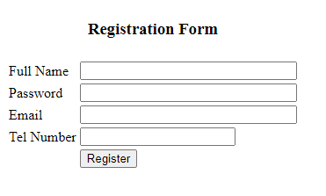

**Task 2.1:** Check for empty fields (full name, password and email,Tel_Number), generate an alert message for the user upon empty fields, and change the background colour of the empty fields (if any) to red.

**Note:use your first and last name as a valid entry. (1 point)**

**Task 2.2:** Check for the correct password using a regular expression (regEx=/[a-z]/). For an incorrect entry, display an alert message (e.g., Error: password must contain at least one lowercase letter (a-z)!) and change the background colour of the password’s field to red.

**Note: use abc as a valid entry.(2 points)**

**Task 2.3:** Check for the correct email address, using (**indexOf() and lastIndexOf()**) methods. For an incorrect entry, display an appropriate error message and change the background colour of the email's field to red.

**Note**: use **abc@gmail.com** as a valid entry **(1 points)**

**or**

If you check the correct email address using a regular expression (regEx=/[a-z]/).For an incorrect entry, display an alert message (e.g., Error: password must contain at least one lowercase letter (a-z)!) and change the background colour of the password’s field to red. **(2 points)**

**Task 2.4:** Upon a successful login, the user should navigate to Page 2 (homepage.html). **(2 points)**

**Part III**

Write JavaScript code to perform the following tasks on Page 2 (homepage.html) which contains a left-hand panel to display some mobile-phone images and a right-hand panel to select some relevant features. On the right-hand side panel, the user can perform the following actions (see Figure):

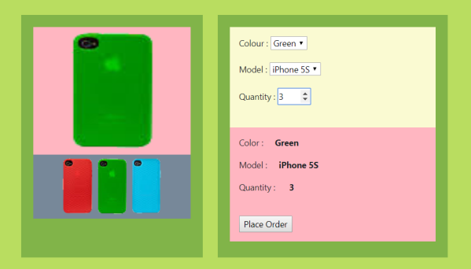

* **Select Colour** (from a given list of phone colours) - upon selecting a certain colour, the main phone image in the left-hand panel will change to the same colour, and value of the chosen colour will be displayed in the lower section of the right-hand panel. **(2 points)**
* **Select Model** (from a given list of phone models) - upon selecting a certain model, the corresponding value will be displayed in the lower section of the right-hand panel. **(2 points)**
* **Select Quantity** - upon choosing a certain quantity number, the value of the selected quantity number will be displayed in the lower section of the right-hand panel. **(2 points)**
* Upon clicking the button “Place Order”, some alert messages will be displayed sequentially. (1 point)

**Finally, at the end of your exam, please do not forget to:**

1. Compress your “FinalExam” folder

2. Upload copy of the compressed folder to your Moodle at Navitas online campus

3. Email copy of the compressed folder to