**Part III**: write CSS codes to generate animations like the ones given in the following images. (**10 Points**)

1. Use **daynight.html** file to generate the following animations (1, 2, 3, 4, 5, 6), **[6 Points]**

* Sky (2 Points)
* 1 grade for animation
* 1 grade for keyframes
* Sun (4 Points)
* 2 grades for #sun
* 2 grades for keyframes
* Clouds (4 Points)
* 2 points for animation
* 2 points for keyframes

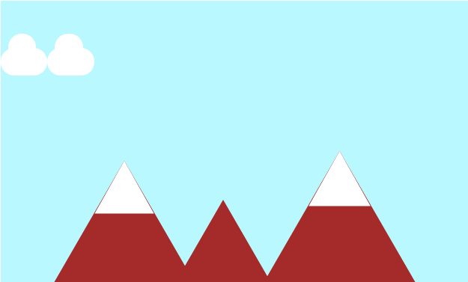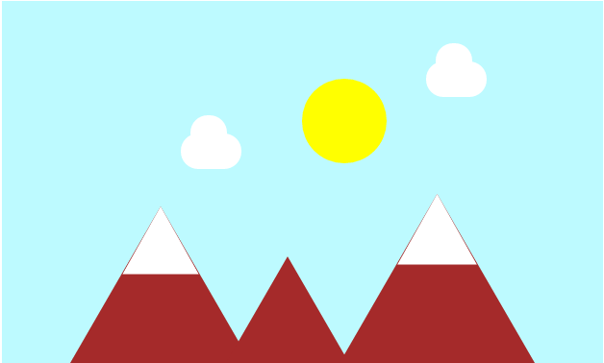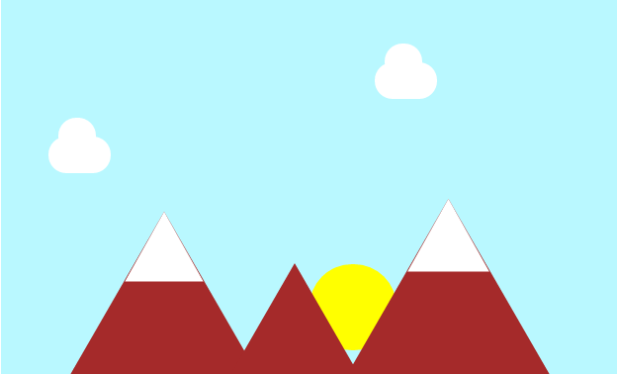



1. Use **sequares.html** file to generate the following animations (1, 2 and 3), **[4 Points]**

* Figure 1 – 1 point
* Figure 2 – 1 point
* Figure 3 – 2 points