Week-7

# React

## Exercise-1

**App.js**

// src/App.js

import React from 'react';

import ListofPlayers from './ListofPlayers';

import IndianPlayers from './IndianPlayers';

function App() {

  const flag = true; // Change to false to toggle

  return (

    <div style={{ padding: '20px' }}>

      <h1>Cricket App</h1>

      {flag ? <ListofPlayers /> : <IndianPlayers />}

    </div>

  );

}

export default App;

**IndianPlayers.js**

// src/IndianPlayers.js

import React from 'react';

const IndianPlayers = () => {

  const players = ['Virat', 'Rohit', 'Dhoni', 'Jadeja', 'Ashwin', 'Shikhar'];

  // Destructuring Odd and Even team players

  const oddPlayers = players.filter((_, index) => index % 2 === 0);

  const evenPlayers = players.filter((_, index) => index % 2 !== 0);

  // Merge two arrays using spread operator

  const T20players = ['Suryakumar', 'Ishan', 'Pant'];

  const RanjiTrophy = ['Pujara', 'Rahane', 'Karun'];

  const allMerged = [...T20players, ...RanjiTrophy];

  return (

    <div>

      <h2>Odd Team Players</h2>

      <ul>

        {oddPlayers.map((name, i) => <li key={i}>{name}</li>)}

      </ul>

      <h2>Even Team Players</h2>

      <ul>

        {evenPlayers.map((name, i) => <li key={i}>{name}</li>)}

      </ul>

      <h2>Merged Players (T20 + Ranji)</h2>

      <ul>

        {allMerged.map((name, i) => <li key={i}>{name}</li>)}

      </ul>

    </div>

  );

};

export default IndianPlayers;

**ListofPlayers.js**

// src/ListofPlayers.js

import React from 'react';

const ListofPlayers = () => {

  const players = [

    { name: 'Virat', score: 95 },

    { name: 'Rohit', score: 88 },

    { name: 'Dhoni', score: 45 },

    { name: 'Jadeja', score: 76 },

    { name: 'Ashwin', score: 35 },

    { name: 'Shikhar', score: 81 },

    { name: 'Kohli', score: 92 },

    { name: 'Bumrah', score: 64 },

    { name: 'Shami', score: 59 },

    { name: 'Gill', score: 99 },

    { name: 'Ishan', score: 100 }

  ];

  // Using map() to display all players

  const allPlayers = players.map((player, idx) => (

    <li key={idx}>{player.name} - {player.score}</li>

  ));

  // Using arrow function and filter

  const below70 = players.filter(player => player.score < 70);

  return (

    <div>

      <h2>All Players</h2>

      <ul>{allPlayers}</ul>

      <h3>Players with Score Below 70</h3>

      <ul>

        {below70.map((p, idx) => (

          <li key={idx}>{p.name} - {p.score}</li>

        ))}

      </ul>

    </div>

  );

};

export default ListofPlayers;

Output:

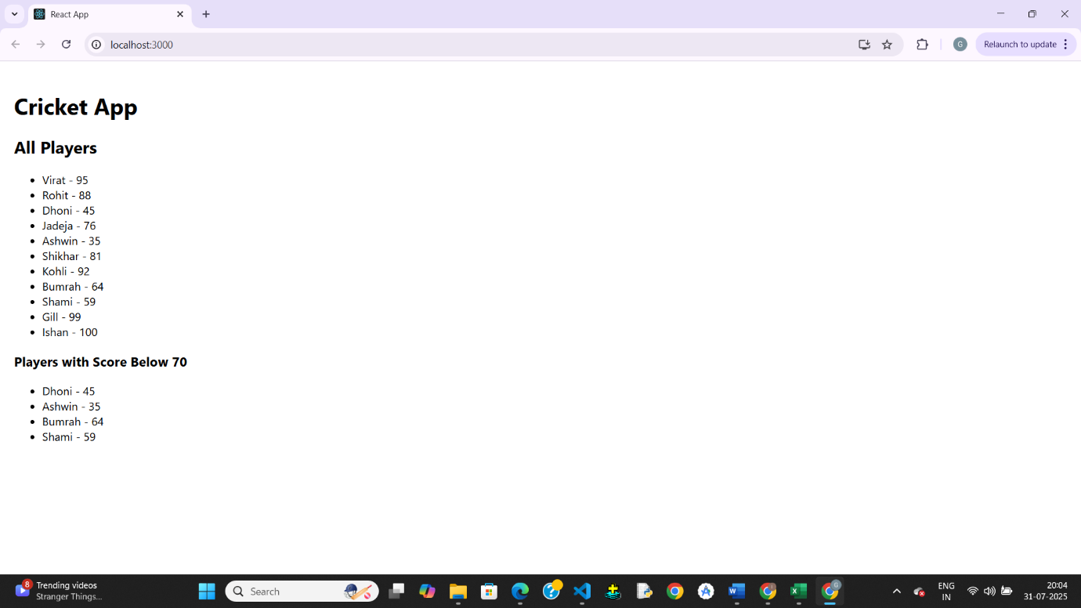

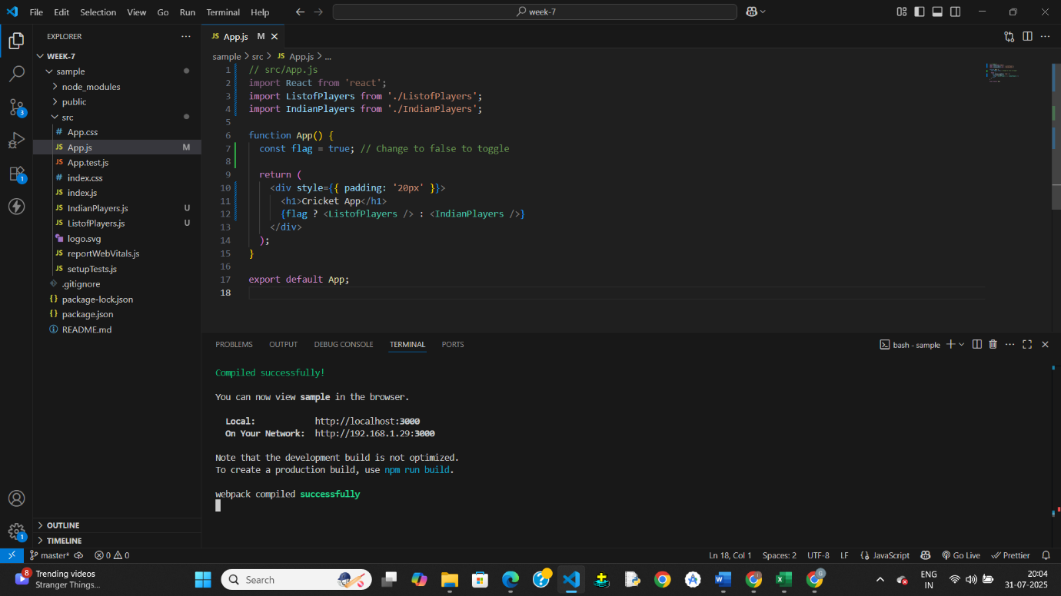

## Exercise-2

**App.js**

import React from 'react';

import './App.css';

function App() {

// Single office object

const office = {

name: 'Elite Office Space',

rent: 75000,

address: '123, Silicon Valley, CA',

image: 'https://via.placeholder.com/400x200?text=Office+Space'

};

// List of office objects

const officeList = [

{

name: 'Cozy Workspace',

rent: 50000,

address: '11B, Mumbai, India',

image: 'https://via.placeholder.com/300x150?text=Office+1'

},

{

name: 'Luxury Hub',

rent: 90000,

address: '22, London, UK',

image: 'https://via.placeholder.com/300x150?text=Office+2'

},

{

name: 'Budget Spot',

rent: 45000,

address: '77, Bangalore, India',

image: 'https://via.placeholder.com/300x150?text=Office+3'

}

];

return (

<div className="App">

{/* Page Heading using JSX */}

<h1>Office Space Rental App</h1>

{/* Office image */}

<img src={office.image} alt="Main Office" width="400" />

{/* Office object details */}

<h2>{office.name}</h2>

<p><strong>Rent:</strong>

<span style={{ color: office.rent < 60000 ? 'red' : 'green' }}> ₹{office.rent}</span>

</p>

<p><strong>Address:</strong> {office.address}</p>

<hr />

{/* Render list of offices using map */}

<h2>Available Office Spaces</h2>

{officeList.map((item, index) => (

<div key={index} style={{ border: '1px solid gray', padding: '10px', marginBottom: '10px' }}>

<img src={item.image} alt={item.name} width="300" />

<h3>{item.name}</h3>

<p>

<strong>Rent:</strong>

<span style={{ color: item.rent < 60000 ? 'red' : 'green' }}> ₹{item.rent}</span>

</p>

<p><strong>Address:</strong> {item.address}</p>

</div>

))}

</div>

);

}

export default App;

**App.css**

.App {

font-family: Arial, sans-serif;

padding: 20px;

}

Output:

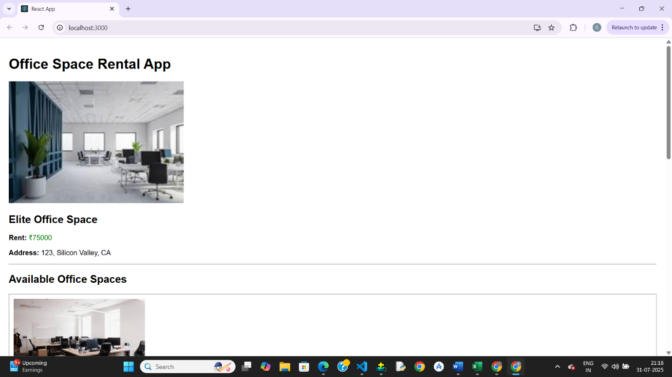

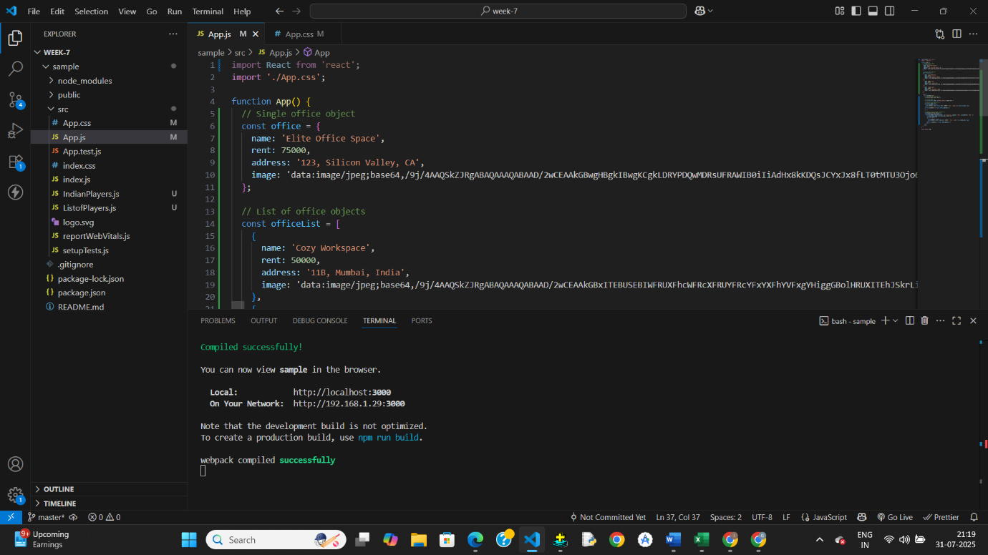

## Exercise-3

**App.js**

import React, { Component } from 'react';

import CurrencyConverter from './CurrencyConverter';

class App extends Component {

  constructor(props) {

    super(props);

    this.state = {

      counter: 0

    };

    // Binding this manually for class method

    this.handleDecrement = this.handleDecrement.bind(this);

    this.sayWelcome = this.sayWelcome.bind(this);

  }

  increment = () => {

    this.setState(prevState => ({ counter: prevState.counter + 1 }));

  };

  sayHello = () => {

    console.log("Hello! This is a static message.");

  };

  handleIncrementClick = () => {

    this.increment();

    this.sayHello();

  };

  handleDecrement() {

    this.setState(prevState => ({ counter: prevState.counter - 1 }));

  }

  sayWelcome(message) {

    alert(`Message: ${message}`);

  }

  handleClickEvent = (event) => {

    alert('I was clicked');

    console.log('Synthetic Event:', event); // Synthetic event object

  };

  render() {

    return (

      <div style={{ padding: "20px" }}>

        <h1>React Event Handling Lab</h1>

        <h2>Counter: {this.state.counter}</h2>

        <button onClick={this.handleIncrementClick}>Increment</button>

        <button onClick={this.handleDecrement}>Decrement</button>

        <br /><br />

        <button onClick={() => this.sayWelcome("Welcome!")}>Say Welcome</button>

        <br /><br />

        <button onClick={this.handleClickEvent}>OnPress</button>

        <br /><br />

        <CurrencyConverter />

      </div>

    );

  }

}

export default App;

**CurrencyConverter.js**

import React, { Component } from 'react';

class CurrencyConverter extends Component {

  constructor(props) {

    super(props);

    this.state = {

      rupees: '',

      euro: ''

    };

  }

  handleChange = (event) => {

    this.setState({ rupees: event.target.value });

  };

  handleSubmit = () => {

    const conversionRate = 0.011; // 1 INR = 0.011 EUR (example rate)

    const euroValue = (parseFloat(this.state.rupees) * conversionRate).toFixed(2);

    this.setState({ euro: euroValue });

  };

  render() {

    return (

      <div>

        <h2>Currency Converter (INR ➡️ EUR)</h2>

        <input

          type="number"

          value={this.state.rupees}

          onChange={this.handleChange}

          placeholder="Enter amount in INR"

        />

        <button onClick={this.handleSubmit}>Convert</button>

        {this.state.euro && (

          <p>Converted Amount: €{this.state.euro}</p>

        )}

      </div>

    );

  }

}

export default CurrencyConverter;

Output:

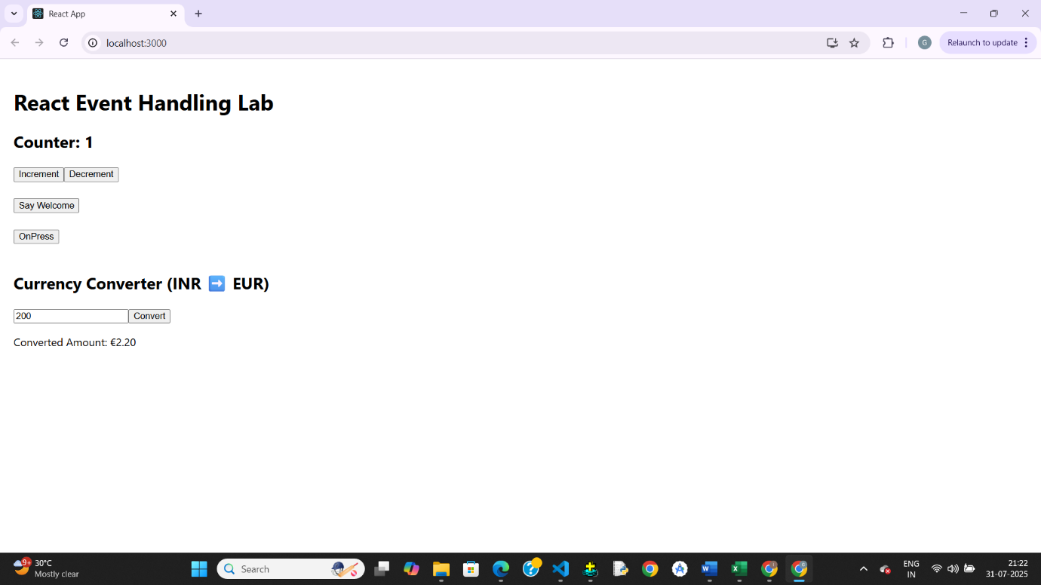

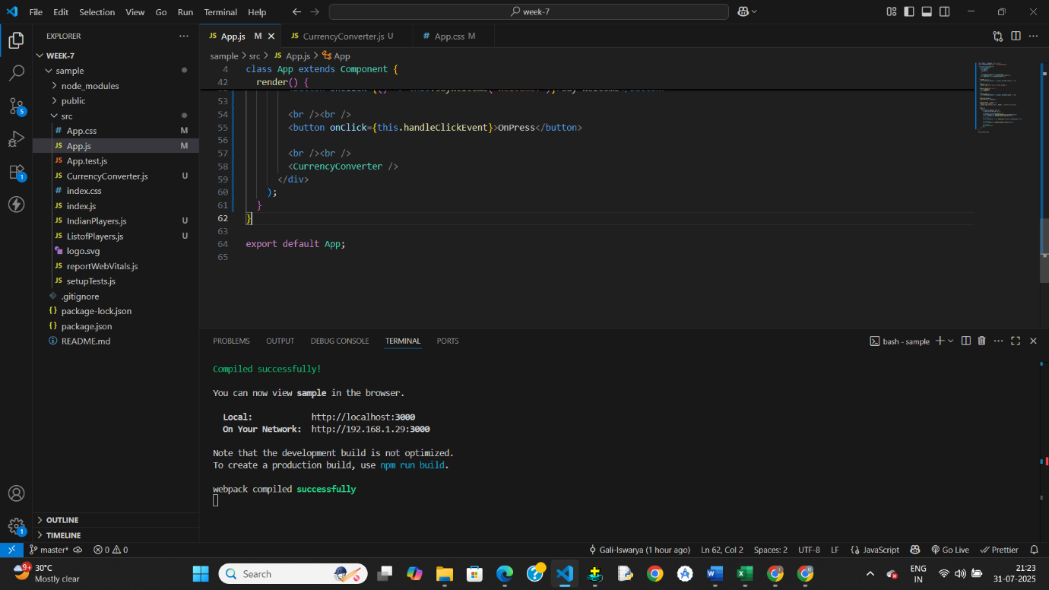

## Exercise-4

**App.js**

import React, { Component } from 'react';

import GuestPage from './GuestPage';

import UserPage from './UserPage';

class App extends Component {

  constructor(props) {

    super(props);

    this.state = {

      isLoggedIn: false

    };

  }

  handleLogin = () => {

    this.setState({ isLoggedIn: true });

  };

  handleLogout = () => {

    this.setState({ isLoggedIn: false });

  };

  render() {

    // Element variable for conditional rendering

    let pageContent;

    if (this.state.isLoggedIn) {

      pageContent = <UserPage />;

    } else {

      pageContent = <GuestPage />;

    }

    return (

      <div style={{ padding: '20px' }}>

        <h1> Ticket Booking App</h1>

        {/* Login/Logout button */}

        {

          this.state.isLoggedIn ? (

            <button onClick={this.handleLogout}>Logout</button>

          ) : (

            <button onClick={this.handleLogin}>Login</button>

          )

        }

        <hr />

        {/* Render appropriate content */}

        {pageContent}

      </div>

    );

  }

}

export default App;

**GusestPage.js**

import React from 'react';

const GuestPage = () => {

  return (

    <div>

      <h2>Welcome, Guest!</h2>

      <p>You can browse available flights below:</p>

      <ul>

        <li>Flight A - Delhi to Mumbai - ₹4000</li>

        <li> Flight B - Chennai to Bangalore - ₹3000</li>

        <li> Flight C - Hyderabad to Pune - ₹3500</li>

      </ul>

    </div>

  );

};

export default GuestPage;

**UserPage.js**

import React from 'react';

const UserPage = () => {

  return (

    <div>

      <h2>Welcome, User!</h2>

      <p>You can now book tickets for the following flights:</p>

      <ul>

        <li> Flight A - <button>Book Now</button></li>

        <li> Flight B - <button>Book Now</button></li>

        <li> Flight C - <button>Book Now</button></li>

      </ul>

    </div>

  );

};

export default UserPage;

Output:

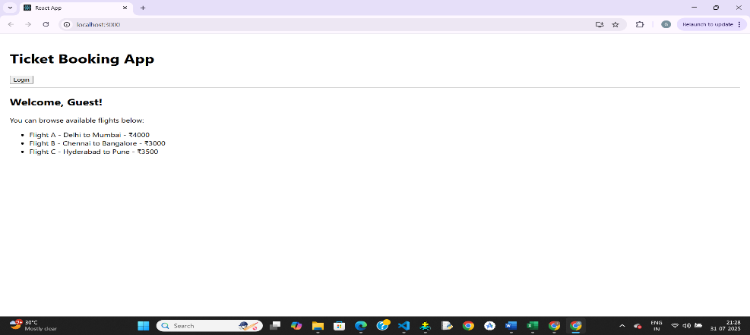

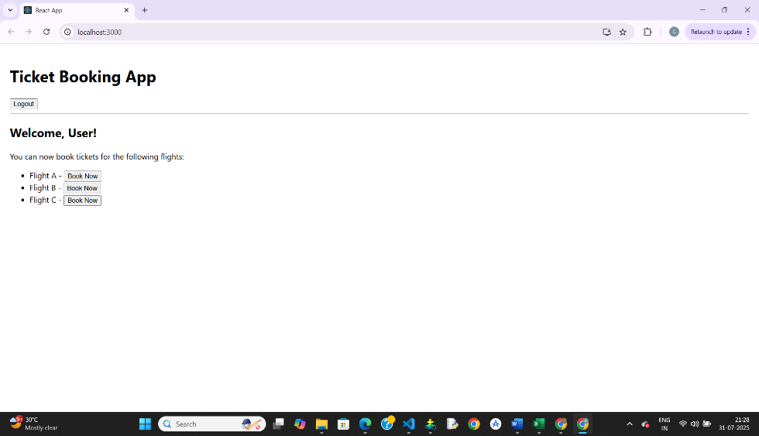

## Exercise-5

**App.js**

import React, { useState } from 'react';

import BookDetails from './BookDetails';

import BlogDetails from './BlogDetails';

import CourseDetails from './CourseDetails';

function App() {

  const [activeComponent, setActiveComponent] = useState("book");

  // Method 1: Using if-else

  let componentToRender;

  if (activeComponent === "book") {

    componentToRender = <BookDetails />;

  } else if (activeComponent === "blog") {

    componentToRender = <BlogDetails />;

  } else {

    componentToRender = <CourseDetails />;

  }

  return (

    <div style={{ padding: "20px" }}>

      <h1> Blogger App</h1>

      {/* Navigation */}

      <button onClick={() => setActiveComponent("book")}>Books</button>

      <button onClick={() => setActiveComponent("blog")}>Blogs</button>

      <button onClick={() => setActiveComponent("course")}>Courses</button>

      <hr />

      {/* Method 1: element variable */}

      {componentToRender}

      {/* Method 2: ternary operator */}

      {/* {activeComponent === "book" ? <BookDetails /> : activeComponent === "blog" ? <BlogDetails /> : <CourseDetails />} */}

      {/* Method 3: logical AND rendering */}

      {/* {activeComponent === "book" && <BookDetails />} */}

    </div>

  );

}

export default App;

**BlogDetails.js**

import React from 'react';

const BlogDetails = () => {

  const blogs = [

    { id: 101, title: "Getting Started with React", date: "2025-07-30" },

    { id: 102, title: "Why JSX Rocks", date: "2025-07-31" },

  ];

  return (

    <div>

      <h3> Blog Posts</h3>

      {blogs.map(blog => (

        <div key={blog.id}>

          <h4>{blog.title}</h4>

          <p>Date: {blog.date}</p>

        </div>

      ))}

    </div>

  );

};

export default BlogDetails;

**BookDetails.js**

import React from 'react';

const BookDetails = () => {

  const books = [

    { id: 1, title: "React for Beginners", author: "John Doe" },

    { id: 2, title: "Mastering JavaScript", author: "Jane Smith" },

  ];

  return (

    <div>

      <h3>Book List</h3>

      <ul>

        {books.map(book => (

          <li key={book.id}>

            <strong>{book.title}</strong> by {book.author}

          </li>

        ))}

      </ul>

    </div>

  );

};

export default BookDetails;

**CourseDetails.js**

import React from 'react';

const CourseDetails = () => {

  const courses = [

    { id: 'c1', name: "Fullstack React", duration: "3 Months" },

    { id: 'c2', name: "Frontend Basics", duration: "2 Months" },

  ];

  return (

    <div>

      <h3> Courses Offered</h3>

      <ul>

        {courses.map(course => (

          <li key={course.id}>

            {course.name} - {course.duration}

          </li>

        ))}

      </ul>

    </div>

  );

};

export default CourseDetails;

Output:

