INDUSTRY INTERNSHIP REPORT
On

JAVA FULL STACK



By

Gali Iswarya
(239X5A05L4)
Submitted in accordance with the requirement for the degree of B-Tech

Department of Computer Science and Engineering

G. PULLA REDDY ENGINEERING COLLEGE (Autonomous): KURNOOL

(Affiliated to JNTUA, ANANTHAPURAMU)

KURNOOL - 518007
2025–2026

Department of Computer Science and Engineering

G. PULLA REDDY ENGINEERING COLLEGE (Autonomous): KURNOOL

(Affiliated to JNTUA, ANANTHAPURAMU)



CERTIFICATE

This is to certify that the internship titled ‘Java Full Stack’ is a Bonafide record of work carried out by Gali Iswarya (239X5A05L4) , and the Internship report is submitted in partial fulfillment of requirements for the award of degree of Bachelor of Technology Computer Science and Engineering.

INTERNSHIP GUIDE HEAD OF THE DEPARTMENT
P. sunandha Dr. N. Kasiviswanath
Associate Professor, Professor and Head of the Department,
Department of CSE, Department of CSE,
G. Pulla Reddy Engineering College, G. Pulla Reddy Engineering College, (Autonomous), Kurnool. (Autonomous), Kurnool.

INTERNSHIP DETAILS

Name of the College: G. Pulla Reddy Engineering College

Department: Computer Science and Engineering
Name of the Student: GALI ISWARYA
Register Number: 239X5A05L4
Name of the Guide: Mr. S Monsoor Ali

Duration of the Internship: 15 weeks From : 15-12-2025 To : 10-04-2026

Name and address of the Organization: Codeon Technologies, reddy bhavan line, karkambadi road, Tirupati, 517501

Internship Title: Java Full Stack

Date of Internship Report Submission: 18-04-2026

Internship Coordinator
Dr.B.Geetha Vani Professor
CSE Department
GPREC

DECLARATION

I, Gali Iswarya, a student bearing the Roll No. 239X5A05L4 of the Department of Computer Science and Engineering, G. Pulla Reddy Engineering College, do here by declare that the I have completed the industry internship titled Java Full Stack from 15th December, 2025 to 10th April 2026 in, Codeon Technologies, Tirupati, under the Guideship of Mr. S Mansoor Ali, a mentor and key team member at Codeon technologies, Tirupati, who provides guidance in specialized training programs such as Full Stack Development.

(Student Signature and Date)

CERTIFICATE FROM ORGANIZATION


INTERNSHIP COMPLETION CERTIFICATE

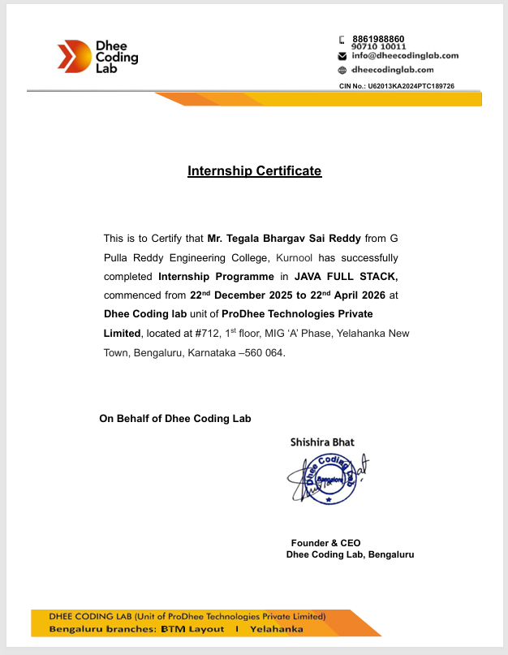

ACKNOWLEDGEMENT

I wish to express my deep sense of gratitude to my internal supervisor Dr. B. GeethaVani Professor of Computer Science and Engineering Department, G. Pulla Reddy Engineering College.
My sincere thanks to our Internship Coordinator Dr. B. Geetha Vani for her immaculate guidance, constant encouragement and cooperation which have made possible to bring out this internship work.
My sincere thanks to Mr. RAVI SHASTRY, Director, of Organization, for helping me and giving me the required information needed for my internship work.
I am thankful to our Head of the Department DR. N. KASIVISWANATH, for his whole hearted support and encouragement during the internship.
We are grateful to our Internship Dean DR. Y. V. SIVA REDDY and to our respected Principal DR. B. SREENIVASA REDDY for providing requisite facilities and helping us in providing such a good environment.
I wish to convey my acknowledgements to all the staff members of the Computer Science and Engineering Department for giving the required information needed for my internship work.
Finally, I wish to thank all our friends and well wishers who have helped me directly or indirectly during the course of this internship work.

Table of Contents
Chapter1: INTRODUCTION 1
  - About the Internship Company/Organization 3
  - Offline Internship details 5
Chapter2: WORK DONE DURING INTERNSHIP 7
  - About Course/Domain 8
  - Technologies learnt during internship 13
  - Assessments/Tasks assigned details 15
Chapter3: PROJECTS/MODULES COMPLETED 21
  - About Project1/Module1 22
  - About Project2/Module2. 31
  - About Project3/Module3. 35
Chapter4: ACTIVITY LOG 49
Chapter5: CONCLUSION 53
Evaluation Report 55
References…………………………………………………………………………………56
LIST OF FIGURES
FIGURE NO. | FIGURE NAME | PAGE NO.
2.1 | Phases of Full Stack Java Development | 9
2.2 | Benefits of Full Stack Java Development | 11
3.1 | Movie Ticket Booking System ConsoleApplication | 26
3.2 | E-Commerce Cart System Console Application | 27
3.3 | Eat Fit Blog Website | 31
3.4 | Interface Eat Fit Blog | 31
3.5 | Blog Sphere Home Page | 37
3.6 | Blog Sphere SignUp Page | 37
3.7 | Blog Sphere SignIn Page | 38
3.8 | Blog Sphere Home Page With Blog Post | 38
3.9 | Blog Sphere Home Page With Blog Details | 39
3.10 | Visual Chart | 43
3.11 | Backend Code Running | 43
3.12 | Final Output | 44

CHAPTER 1:

INTRODUCTION

1. INTRODUCTION

About the Internship Organization:
Codeon Technologies Pvt. Ltd. is a Tirupati-based, technology-driven organization dedicated to delivering innovative software solutions and transforming students into industry-ready software professionals through structured training programs. Established in 2019, the company focuses on building scalable SaaS applications and providing high-quality training in modern software development technologies.
Codeon Technologies is known for its strong emphasis on practical learning and real-world application development. The organization specializes in Java Full Stack Development, covering a wide range of technologies including frontend frameworks, backend development, and database management. With a team of experienced developers and mentors, the company ensures that students receive both technical guidance and industry exposure.

Real-World Project Exposure:
A key strength of Codeon Technologies is its focus on real-time project-based learning. Students are exposed to the complete software development lifecycle, including requirement analysis, design, development, testing, and deployment. The internship environment simulates real-world industry practices, where trainees work on projects, follow Agile methodologies, and collaborate as part of development teams.
This approach provides hands-on experience in handling real-time challenges, meeting deadlines, and working in a team-oriented environment, thereby preparing students for professional roles in the IT industry.
LEARNING OVERVIEW DURING THE INTERNSHIP:

During my internship at Codeon Technologies, I underwent a structured and practical learning journey that focused on building both technical expertise and professional skills. The training was divided into multiple stages, covering UI/UX design, frontend development, core programming, backend frameworks, and modern full-stack technologies.
Approach to Learning:
The internship followed a systematic and disciplined learning approach, where each concept was first explained by mentors and then implemented through hands-on coding practice. Regular assignments, coding challenges, and stage-wise tasks ensured continuous learning and reinforcement of concepts.
A major part of the learning process involved working on the CodeStack platform, where I practiced coding challenges and application-based tasks across different technologies such as Java, SQL, and frontend development. This helped in strengthening problem-solving skills, improving coding efficiency, and gaining confidence in applying concepts.
In addition, interactive sessions, discussions, and continuous mentor support helped in clearing doubts instantly and understanding complex topics effectively.

Practical Implementation:
The internship strongly emphasized learning through implementation. I worked on real-time projects that helped me understand how applications are designed, developed, and maintained in professional environments.
Through these projects, I also learned how to:
- Develop complete web applications using full-stack technologies
- Debug and resolve errors efficiently
- Integrate frontend, backend, and database components
- Work collaboratively in a team environment
- Follow Agile practices such as sprint planning, stand-ups, and reviews

1.2 Offline Internship Details
The Offline Internship Program at Codeon Technologies Pvt. Ltd. is a comprehensive, full-time training program designed to transform students into confident and industry-ready full-stack developers. This in-person internship provides an immersive learning experience through structured training, real-time projects, and continuous mentor guidance, ensuring both technical and professional growth.

Duration &Timings
- Total Duration: 15Weeks
- Timings: Monday to Friday, from 8:30AM to 6:30PM
- Location: Codeon Technologies, Tirupati

Program Structure
The internship program is carefully structured to simulate a real-world software development environment. It follows a stage-wise learning approach, where each phase focuses on building specific skills required for full-stack development.

Stage-wise Learning Approach

Stage 1: UI/UX & Frontend Development

Focused on UI/UX design principles and frontend technologies such as HTML, CSS, Bootstrap, and JavaScript to build responsive and user-friendly interfaces.

Stage 2: Core Java, SQL & Agile Fundamentals

Covered Core Java programming, database management using SQL, and introduction to Agile methodologies for understanding real-world development workflows.

Stage 3: Advanced Backend Development

Included Spring, Spring Boot, Spring MVC, REST APIs, Hibernate, JPA, and Data JPA for building scalable backend systems and enterprise-level applications.

Stage 4: Angular (Frontend Framework)

Focused on building dynamic and structured frontend applications using Angular, including component-based architecture and data binding.

Daily Learning +Practice
Interns actively participated in daily hands-on sessions involving coding, debugging, and developing real-world applications. Continuous practice was carried out through the CodeStack platform, which provided coding challenges and application-based tasks across multiple technologies such as Java, SQL, and frontend development.
This ensured:
- Strong conceptual understanding
- Improved coding efficiency
- Real-time problem-solving skills

Mentorship & Guidance
The training was guided by experienced mentors and industry professionals who provided continuous support throughout the internship. Their approach focused on practical implementation, doubt clarification, and real-world application of concepts, helping interns understand how technologies are used in industry environments.

Tech Stack &Tools
Interns worked on a wide range of modern technologies, including:
- Frontend: HTML, CSS, Bootstrap, JavaScript, Angular
- Backend: Core Java, Spring, Spring Boot, Spring MVC, REST APIs
- Databases: MySQL (SQL)
- Build Tools: Maven
- ORM Tools: Hibernate, JPA, Spring Data JPA
- Methodology: Agile (Sprints, Stand-ups, Reviews)

Learning Outcomes
By the end of the internship, I was able to:
- Develop complete Java Full Stack applications
- Understand the end-to-end software development lifecycle
- Gain hands-on experience in Agile development practices
- Integrate frontend, backend, and database components effectively
- Improve coding, debugging, and application design skills
- Work collaboratively in a team-based development environment
Certificate & Recognition
Upon successful completion of the internship, a certificate was awarded, recognizing the practical experience and technical skills gained during the training. This serves as a valuable addition to my resume and professional profile.
Overall, the offline internship at Codeon Technologies provided a structured, practical, and industry-oriented learning experience, enabling me to build strong technical foundations and gain real-world exposure required to succeed in the software development field.

CHAPTER 2:

WORK DONE DURING INTERNSHIP

2.WORK DONE DURING INTERNSHIP

ABOUT COURSE/DOMAIN
Introduction:
During my internship at Codeon Technologies Pvt. Ltd., I gained hands-on experience in Java Full Stack Development, a domain that focuses on building complete web applications by integrating frontend, backend, and database technologies. The training was designed to provide a strong foundation in programming along with exposure to modern frameworks and real-world development practices.
The learning journey followed a structured and stage-wise approach, starting from UI/UX design and frontend development, progressing to core programming and database concepts, and finally advancing to backend frameworks and modern frontend technologies like Angular. This comprehensive approach helped me understand how different layers of an application work together to deliver a seamless user experience.
Full Stack Java Development is a comprehensive approach to building modern web applications using Java technologies for both frontend (client-side) and backend (server-side) development. It encompasses various components, each critical for ensuring the functionality, performance, and scalability of software throughout its development lifecycle.
Frontend Development:
Frontend development focused on designing and developing interactive, responsive, and user-friendly interfaces. Technologies such as HTML, CSS, Bootstrap, and JavaScript were used to build structured and visually appealing web pages.
I learned how to:
• Create responsive layouts using Bootstrap
• Apply styling and animations using CSS
• Implement dynamic behavior using JavaScript and DOM manipulation
• Design user interfaces following basic UI/UX principles
In addition, I gained exposure to Angular, a modern frontend framework used for building dynamic and component-based applications. Angular helped in understanding concepts like two-way data binding, modular architecture, and structured application development.
Backend Development:
Backend development involved building the core logic and functionality of applications using Java and modern frameworks. The training covered:

• Core Java: Fundamentals such as OOP concepts, collections, exception handling, and file handling
• Advanced Java: JDBC, Servlets, and basic web application concepts
• Spring Framework: Spring Core, Spring MVC, and Spring Boot
• REST APIs: Designing and developing RESTful services for client-server communication
Using Spring Boot, I learned how to build scalable and efficient backend systems with features like dependency injection, REST API development, and simplified configuration.
Database Management:
Database management focused on storing and managing application data efficiently using MySQL.
I gained experience in:
• Writing SQL queries (CRUD operations, joins, constraints)
• Designing relational database schemas
• Integrating databases with backend applications using JDBC and Spring Data JPA
• Using Hibernate and JPA for Object-Relational Mapping (ORM), which simplifies database interaction by mapping Java objects to database tables
This helped me understand how data flows between the application and database in real-world systems.
Tools & Methodologies:
During the internship, I also worked with important tools and practices used in industry:
I learned how to:
• Maven: For project build and dependency management
• Agile Methodology: Worked in Agile teams, participated in sprint planning, stand-ups, and reviews
• CodeStack Platform: Practiced coding challenges and application-based tasks across multiple technologies
These tools helped me understand professional development workflows and team collaboration.

In summary, the Java Full Stack Development domain at Codeon Technologies provided a comprehensive and industry-oriented learning experience, enabling me to understand the complete application development lifecycle—from designing user interfaces to building backend services and managing databases—while combining theoretical knowledge with hands-on practice and real-time project development to strengthen my technical skills and prepare me to work effectively in real-world software development environments.

- HTML (HyperText Markup Language)

HTML is the standard markup language used to create the structure of web pages.
It defines the layout and content of a webpage using elements such as headings, paragraphs, links, images, and tables.
Key concepts learned include:
- Create structured web pages using semantic tags like <header>, <section>, <article>, and <footer>
- Design forms using input fields, labels, buttons, and validation attributes
- Embed multimedia elements such as images and videos
- Organize content using lists and tables
HTML acts as the foundation of web development, providing the basic structure on which styling and functionality are built.Basic Structure of HTML
Basic Structure of HTML
Every HTML document follows a standard structure:
<!DOCTYPE html>
<html>
<head>
<title>My Page</title>
</head>
<body>
<h1>Hello World</h1>
</body>
</html>
Important Tags
- <h1> to <h6> → Headings
- <p> → Paragraph
- <a> → Hyperlink
- <img> → Image
- <ul>, <ol>, <li> → Lists
- <table> → Tables

Forms in HTML:
Forms are used to collect user input:

<form>
Name: <input type="text" />
Password: <input type="password" />
<button>Submit</button>
</form>
Semantic HTML
Semantic tags improve readability and SEO:
- <header>: Defines the top section of a page or section (usually contains title, logo, navigation).
- <footer>: Defines the bottom section (usually contains copyright, links, contact info).
- <section>: Represents a thematic grouping of content (like a chapter or topic).
- <article>: Represents independent, self-contained content (like a blog post or news article).
- CSS (Cascading Style Sheets)
CSS is used to style and design web pages. It controls the appearance of HTML elements, including colors, layouts, fonts, spacing, and responsiveness.
Key concepts learned include:
- Applying styles using inline, internal, and external CSS
- Using selectors, classes, and IDs to target elements
- Implementing layouts using Flexbox and Grid
- Creating responsive designs using media queries
- Adding animations and transitions for better user experience
CSS enhances the visual appeal of web applications and ensures that applications are user-friendly and accessible across different devices.
Types of CSS
- Inline CSS
- Internal CSS
- External CSS
p { color: blue;
font-size: 16px;
}

Selectors
- Class selector → .className
- ID selector → #idName
Box Model
Every element consists of:
- Margin
- Border
- Padding
- Content
Flexbox
Used for layout alignment:
.container {
display: flex;
justify-content: center;
align-items: center;
}
- JavaScript:
JavaScript is a programming language used to add interactivity and dynamic behavior to web pages.
During the internship, I worked on:
- DOM manipulation to dynamically update content
- Event handling such as clicks, form submissions, and user inputs
- Form validation to ensure correct data entry
- Basic functions, loops, and conditional statements
- Handling asynchronous operations using callbacks and promises
Variables and Data Types:
Variables are used to store data values. JavaScript supports different types like string, number, boolean, etc.
Example:
let name = "Sai"; // String
let age = 22; // Number
let isStudent = true; // Boolean

Functions:
Functions are blocks of code that perform a specific task and can be reused.
Example:
function greet() {
console.log("Hello");
}
greet();
DOM Manipulation
DOM allows JavaScript to access and modify HTML elements dynamically.
Example:
document.getElementById("demo").innerHTML = "Updated Content";
This changes the content of an HTML element.
Event Handling
Events are user actions like clicking a button or submitting a form. JavaScript responds using event handlers.
Example:
button.onclick = function() {
alert("Clicked");
}
Form Validation
Form validation ensures that user inputs are correct before submission.
Example:
let name = "";
if(name === "") { alert("Name is required");}
Conditional Statements
Used to make decisions in a program.
Example:
let age = 18;
if(age >= 18) {
console.log("Eligible");
} else {
console.log("Not Eligible");
}
Loops
Loops are used to repeat a block of code multiple times.
Example:
for(let i = 1; i <= 3; i++) {
console.log(i);
}
Asynchronous Operations
Used to handle tasks like API calls without stopping execution.
Callbacks
function greet(callback) {
console.log("Hello");
callback();
}
- SQL (Structured Query Language)
SQL is used to manage and manipulate relational databases. It allows developers to store, retrieve, and manage data efficiently.
I learned how to:
- Create and manage databases and tables
- Use queries like SELECT, INSERT, UPDATE, and DELETE
- Apply constraints such as PRIMARY KEY and FOREIGN KEY
- Perform joins to combine data from multiple tables
- Use aggregate functions like COUNT, SUM, and AVG
SQL is essential for backend development as it ensures efficient data storage and retrieval.
- Java
Java is a powerful, object-oriented programming language used to build scalable and secure applications. During the internship, I developed a strong understanding of core Java concepts.
Java supports different types of variables based on their scope and usage:
- Local Variables: Declared inside methods and accessible only within that method.
- Instance Variables: Declared inside a class but outside methods; they belong to objects.
- Static Variables: Declared using the static keyword and shared among all instances of a class.

Example
int localVar = 10;
class Student {
int id; // instance variable
static String college = "GPREC"; // static variable
}
Data Types in Java
Java data types are broadly classified into two categories:
1. Primitive Data Types
Primitive data types are the basic building blocks of data in Java. They store simple values and are predefined by the language.
There are 8 primitive data types:
- int → stores integer values
- float → stores decimal values
- double → stores large decimal values
- char → stores a single character
- boolean → stores true or false
- byte, short, long → used for different ranges of integer values
These data types are efficient and consume less memory.
2. Non-Primitive Data Types
Non-primitive data types are more complex and are used to store multiple references to objects.
Examples include:
- String → used to store text
- Arrays → used to store multiple values of the same type
- Classes and Objects → used to define custom data structures
Unlike primitive types, non-primitive types store references (memory addresses) rather than actual values.
String name = "Sai";
int[] numbers = {1, 2, 3, 4};
class Student {
int id;
}
Type Casting in Java
Type casting is the process of converting one data type into another.
- Implicit Casting (Widening) → automatic conversion from smaller to larger type
- Explicit Casting (Narrowing) → manual conversion from larger to smaller type
- Syntax:
int a = 10;
double b = a; // implicit
double x = 10.5;
int y = (int) x; // explicit
Object-Oriented Programming (OOP)
Object-Oriented Programming is a programming approach that uses objects and classes to design software. It helps in organizing code, improving reusability, and making programs easier to manage.
Key Concepts of OOP
- Class
A class is a blueprint or template used to create objects. It defines properties (variables) and behaviors (methods).
Example:
class Student {
String name;
int age;
}

Object
An object is an instance of a class. It represents a real-world entity.
Example:
Student s1 = new Student();
s1.name = "Sai";
s1.age = 22;

Encapsulation
Encapsulation means wrapping data and methods together into a single unit and restricting direct access.
Achieved using private variables and public getters/setters.

Example:
class Student {
private String name;
public void setName(String name) {
this.name = name;
}
public String getName() {
return name;
}
}

Inheritance
Inheritance allows one class to reuse properties and methods of another class.
    - Promotes code reuse.
Example:
class Animal {
void sound() {
System.out.println("Animal makes sound");
}
}
class Dog extends Animal {
void bark() {
System.out.println("Dog barks");
}
}
- Polymorphism
Polymorphism means one method behaving in different ways.
Types:
- Method Overloading (compile-time)
- Method Overriding (runtime)
Example (Overloading):
class Math {
int add(int a, int b) {
return a + b;
}
int add(int a, int b, int c) {
return a + b + c;
}

Abstraction
Abstraction means hiding implementation details and showing only essential features.
Achieved using abstract classes or interfaces.
Example:
abstract class Vehicle {
abstract void start();
}
class Car extends Vehicle {
void start() {
System.out.println("Car starts with key");
}
}
Advantages of OOP
- Improves code reusability
- Makes code modular and easy to maintain
- Enhances security using encapsulation
- Helps in real-world modeling

Java Collections Framework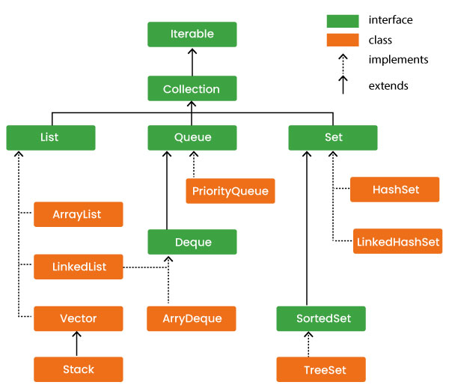
Multithreading (Java)
Multithreading is a process of executing multiple threads simultaneously to perform tasks efficiently.
A thread is a smallest unit of a program that runs independently.
It helps in:
- Improving performance
- Performing multiple tasks at the same time
- Better CPU utilization

- Thread
A thread is a lightweight process.
Example:
class MyThread extends Thread {
public void run() {
System.out.println("Thread is running");
}
}

- Creating Threads
Method 1: Extending Thread Class
class MyThread extends Thread {
public void run() {
System.out.println("Thread 1");
}
}
MyThread t1 = new MyThread();
t1.start();
Method 2: Implementing Runnable Interface
class MyRunnable implements Runnable {
public void run() {
System.out.println("Thread 2");
}
}
Thread t2 = new Thread(new MyRunnable());
t2.start();
- Thread Lifecycle
- New
- Runnable
- Running
- Waiting / Blocked
- Terminated
- Thread Methods
- start() → starts thread
- run() → contains logic
- sleep() → pauses execution
- join() → waits for thread to finish
Example:
Thread.sleep(1000); // sleep for 1 second

- Synchronization
Used to control access to shared resources and avoid conflicts.
Problem: Multiple threads accessing same data → inconsistency
Example:
synchronized void display() {
System.out.println("Safe thread execution");
}
- Advantages of Multithreading
- Faster execution
- Efficient resource usage
- Improves responsiveness (UI, web apps)
- Real-Time Example
- Downloading a file while watching a video
- Multiple users accessing a web application
- Backend APIs handling multiple requests

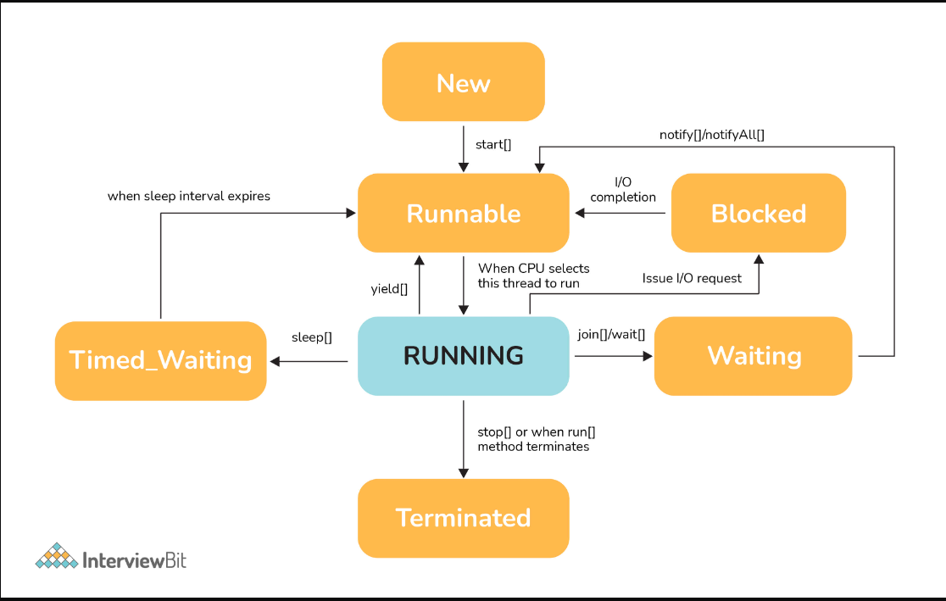

Exception Handling (Java)
Exception Handling is a mechanism used to handle runtime errors so that the program does not crash and continues execution smoothly.
It helps in:
- Preventing program termination
- Maintaining normal flow of application
- Handling unexpected situations
- Exception
An exception is an error that occurs during program execution.
Example:
int a = 10 / 0; // ArithmeticException
- Types of Exceptions
Checked Exceptions
- Checked at compile time
- Example: IOException, SQLException

Unchecked Exceptions
- Occur at runtime
- Example: ArithmeticException, NullPointerException
- try-catch Block
Used to handle exceptions safely.
Example:
try {
int a = 10 / 0;
} catch (Exception e) {
System.out.println("Error occurred");
}
- finally Block
The finally block always executes, whether exception occurs or not.
Example:
try {
int a = 10 / 0;
} catch (Exception e) {
System.out.println("Handled");
} finally {
System.out.println("Always executes");
}
- throw Keyword
Used to explicitly throw an exception.
Example:
throw new ArithmeticException("Invalid operation");
- throws Keyword
Used to declare exceptions that a method may throw.

Example:
void check() throws Exception {
// risky code
}
- Custom Exception
User-defined exception created by extending Exception class.
Example:
class MyException extends Exception {
MyException(String msg) {
super(msg);
}
}
Advantages of Exception Handling
- Maintains normal program flow
- Improves code readability
- Helps in debugging
- Separates error-handling code
- Advanced Java & Backend Development
Advanced Java
Advanced Java focuses on building dynamic and enterprise-level applications by extending core Java concepts into web and database-based applications.
Key concepts learned include:
- Database connectivity using JDBC
- Server-side programming using Servlets
- Handling data persistence and transactions
- Building scalable backend applications
Advanced Java acts as a bridge between core programming and real-world application development.
JDBC (Java Database Connectivity)
JDBC is used to connect Java applications with databases and perform operations like storing, updating, and retrieving data.
Key topics learned include:
- Establishing database connection
- Executing SQL queries (CRUD operations)

- Using Statement and PreparedStatement
- Handling ResultSet for data retrieval
- Managing transactions and exceptions
Connection con = DriverManager.getConnection("url","user","password");
PreparedStatement ps = con.prepareStatement("SELECT * FROM users");
ResultSet rs = ps.executeQuery();
JDBC enables communication between Java applications and databases.
Spring Framework
Spring is a powerful framework used to build scalable, modular, and maintainable applications.
Why Spring?
• Supports Dependency Injection (DI)
• Promotes loose coupling
• Easy integration with other technologies
• Simplifies enterprise application development
Important Topics in Spring
1. Dependency Injection (DI)
Automatically injects required objects.
2. Inversion of Control (IoC)
Controls object creation and lifecycle.
3. Spring Modules
• Spring Core
• Spring JDBC
• Spring ORM
• Spring MVC
Spring Boot
Spring Boot simplifies backend development by providing auto-configuration and ready-to-use features. It is widely used for building REST APIs and microservices.
Why Spring Boot?
• No XML configuration required
• Embedded server (Tomcat)
• Faster development
• Easy integration with databases
• Suitable for microservices
Important Topics in Spring Boot
1. Spring Boot Starters
Predefined dependencies to simplify setup.
• spring-boot-starter-web
• spring-boot-starter-data-jpa
• spring-boot-starter-security
2. Application Properties
Used to configure application settings.
server.port=8080
spring.datasource.url=jdbc:mysql://localhost:3306/db
3. REST Controllers
Used to handle HTTP requests and responses.
@RestController
public class MyController {
@GetMapping("/hello")
public String hello() {
return "Hello World";
}
}
4. Dependency Injection
Achieved using @Autowired.
@Autowired
private UserService service;
5. Spring Data JPA
Used for database operations without writing SQL.
Methods include:
• save()
• findAll()
• deleteById()
6. Entity and Repository
• Entity → Maps Java class to database table
• Repository → Interface for database operations

@Entity
class User {
@Id
private int id;
}
Spring Web MVC
Spring MVC is used to build web applications using the Model-View-Controller architecture.
Key Concepts
• Model → Data layer
• View → UI layer
• Controller → Handles requests
Features
• Separation of concerns
• Easy request handling
• Form processing and validation

- Methodologies

Agile Methodology
Agile is a modern approach to software development focused on iteration and collaboration.
Key Concepts
• Sprint planning
• Daily stand-ups
• Sprint reviews
• Continuous feedback
Agile helps teams deliver software faster and adapt to changes.
- Tools

Maven
Maven is a build and dependency management tool.
Why Maven?
• Manages dependencies automatically
• Simplifies project structure
• Automates build process

Key Features
• pom.xml configuration
• Build lifecycle (compile, test, package)
• Plugin management
<dependencies>
<dependency>
<groupId>org.springframework.boot</groupId>
<artifactId>spring-boot-starter-web</artifactId>
</dependency>
</dependencies>
In summary, Java Full Stack Development integrates frontend and backend technologies, frameworks, tools, and methodologies to build powerful and scalable web applications. By using technologies like Spring Boot, Hibernate, and modern frontend tools, along with Agile practices, developers can build efficient, maintainable, and industry-ready applications.

Five Phases of Full Stack Java Development:
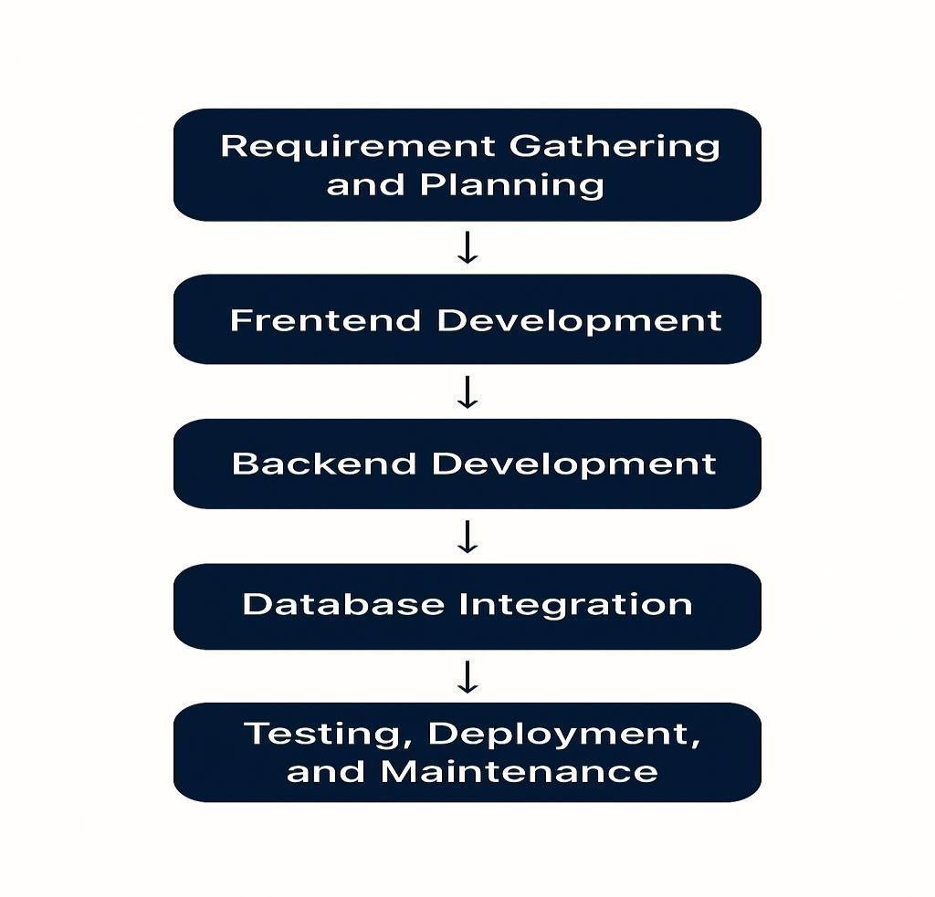
Fig 2.1.1: Phases of Full Stack Java Development

Concept and Design:
Competitor Analysis:
This involves analyzing existing applications and platforms to understand prevailing technologies, UI/UX trends, and performance standards. This helps developers identify what features are must-haves and where there’s room for innovation or improvement.
- Gaps in the Market: Identifying limitations in current solutions provides a pathway to develop better-performing or more user-friendly applications. These gaps may relate to performance issues, user experience flaws, or lack of specific functionalities.
- Customer Needs: Understanding user expectations is key to a successful full stack project. This involves gathering feedback through user research, focus groups, surveys, or analytical tools to create user personas and define system goals.
- Product Requirements: Establishing functional and non-functional requirements helps determine the structure of both front end and backend components. This includes defining modules, APIs, user roles, scalability goals, performance criteria, and security needs.

Development:
Frontend Development: This involves building the user interface (UI) and user experience (UX) using:
• Languages & Tools: HTML, CSS, JavaScript
• Frameworks: React, Angular, or Vue.js
• Focus areas include responsive design, form validation, routing, and state management.
Backend Development: The backend layer handles business logic, API creation, and data manipulation using:
• Core Language: Java
• Frameworks: Spring Boot, Spring MVC
• Tasks: Authentication, authorization, API design, session handling, business rules, and application logic.
Database Integration
• Relational: MySQL, PostgreSQL
• NoSQL: MongoDB
• Integrated with the backend using JPA (Java Persistence API) or Hibernate for object-relational mapping (ORM).

Prototype Development: Wireframes and working prototypes are created using tools like Figma or Balsamiq for frontend mockups and Postman for testing APIs. Early demos help validate technical choices and design flows.
Refinement Based on Feedback: Stakeholders and users test early builds. Based on usability, performance, and feedback, iterative improvements are made to frontend designs, backend logic, and system architecture.
Deployment and Maintenance:
• Application is packaged using tools like Maven or Gradle
• Security & Performance Testing: Using tools like JUnit, Selenium, SonarQube
• Deployment: On-premise, cloud (AWS, Azure, GCP), or using Docker and Kubernetes for containerized environments. Deployment pipelines are configured using CI/CD tools like Jenkins, GitHub Actions, or GitLab CI. Applications are then launched through platforms such as web portals, app stores, or internal deployment networks.
Service and Support:
Technical Support and Monitoring: Logging and monitoring are handled using tools such as ELK Stack (Elasticsearch, Logstash, Kibana) or Prometheus and Grafana to ensure stability, detect issues, and handle customer complaints.
Updates and Bug Fixes: Regular updates are rolled out with performance improvements, new features, and security patches. Agile or Scrum methodologies guide these incremental releases.

2.2 TECHNOLOGIES LEARNT DURING INTERNSHIP
Used Technologies:
- Core Java
- HTML
- CSS
- Java Script
- Advanced Java
1. Core Java:
• Core Java is the foundation of Java programming.
• It includes basic concepts such as object-oriented programming (OOP), data types, operators, control statements, and exception handling.
• Supports multithreading and memory management through built-in libraries.
• Widely used for building desktop applications and the back-end logic of web applications.
• Provides strong community support and a vast collection of APIs.
• Essential for understanding frameworks like Spring and Hibernate.
• Java's platform independence is enabled through the Java Virtual Machine (JVM).
2. HTML (HyperText Markup Language):
• Standard markup language for creating web pages.
• Structures the content on the web using elements like headings, paragraphs, images, and links.
• Works in conjunction with CSS and JavaScript for full front-end development.
• Easy to learn and widely supported by all browsers.
• Forms the skeleton of any website.
3. CSS (Cascading Style Sheets):
• Used for styling HTML content and improving visual presentation.
• Controls layout, colors, fonts, spacing, and responsiveness.
• Supports external, internal, and inline styling methods.
• Enables animations, transitions, and media queries for responsive design.
• Works closely with frameworks like Bootstrap for faster styling.
4. JavaScript:
• A client-side scripting language used for adding interactivity to web pages.
• Enables dynamic content updates, form validations, and event handling.
• Works well with HTML and CSS for complete front-end development.
• Popular frameworks and libraries include React, Angular, and Vue.
• Runs in browsers without any additional plugins.
• Essential for modern web application development.
5. Advanced Java:
• Extends Core Java by focusing on web and enterprise applications.
• Includes technologies like Servlets, JSP (Java Server Pages), JDBC, and EJB.
• Supports web-based solutions through Java EE and frameworks like Spring and Hibernate.
• Used for building server-side applications and connecting to databases.
• Facilitates MVC architecture and RESTful web services.
• Often used in combination with front-end technologies for full-stack development.
2.3 TASKS ASSIGNED DETAILS
During the internship at Codeon Technologies, regular tasks and structured activities were assigned to strengthen both theoretical knowledge and practical implementation skills. The training followed a stage-wise approach, where each phase included continuous practice, assignments, and real-time application development.
In the Spring, Spring Boot, Hibernate, and REST API phase, I worked on backend development tasks and framework-based implementations. Assignments and project work helped me understand how to build scalable applications, implement APIs, and integrate databases using JPA and Hibernate.
In the final phase, I learned Angular and worked on building dynamic frontend applications integrated with backend services. This phase helped me understand complete full-stack integration.
Overall, the internship included a combination of:
• Daily coding challenges on Codestack platform
• Stage-wise assignments after each module
• Mini projects and full-stack project development
• Agile-based team collaboration (stand-ups, sprints, reviews)
• Continuous hands-on practice with real-world applications
These activities significantly enhanced my full stack development skills, improved my logical thinking, strengthened my understanding of real-time project workflows, and prepared me to work effectively in a professional software development environment.

2.3 TASKS ASSIGNED DETAILS

.

3.PROJECTS/MODULES

COMPLETED

3.MODULE / PROJECT COMPLETED

3.1 About Module1/Project1: ProjectSphere
ProjectSphere is a comprehensive full-stack web application developed to simulate real-world project management environments and help users understand how Agile-based workflows operate in professional organizations. The project integrates both frontend and backend technologies along with database management to provide a complete solution for managing projects, teams, and tasks efficiently.
Introduction:
ProjectSphere is designed as a unified project management platform similar to tools like Jira. It enables organizations to manage projects, track progress, and facilitate collaboration among team members. The system supports multiple user roles such as Admin, Project Manager, and Team Member, each with specific responsibilities and access controls.
The application focuses on implementing Agile methodologies, particularly Scrumban (Scrum + Kanban), allowing users to manage workflows through product backlogs, sprint planning, and task boards. It provides a real-time working environment where users can create user stories, assign tasks, track progress, and analyze team performance.
Topics Covered:
1. Core Java (Logic Building & OOP Concepts):
• Core Java was used to build the fundamental logic of the application.
• Object-Oriented Programming (OOP) concepts such as classes, objects, inheritance, and polymorphism were used to design modular and reusable components.
• Exception handling ensured smooth execution and error management.
• Collections were used to manage and process data efficiently within the application.

2. Advanced Java Concepts:
• Spring Boot was used to develop backend services and RESTful APIs.
• It handled business logic, request processing, and communication between frontend and database.
• Dependency Injection (DI) and Inversion of Control (IoC) were used to maintain loose coupling.
• Implemented JWT-based authentication for secure login and role-based access control.
3. Spring Data JPA & Hibernate (ORM & Data Handling):
• Used for Object-Relational Mapping (ORM) to map Java objects with database tables.
• Simplified CRUD operations without writing complex SQL queries.
• Managed relationships between entities such as Users, Projects, Tasks, and Teams.
• Ensured data consistency, persistence, and efficient database interaction.
4. RESTful APIs:
• REST APIs were developed using HTTP methods (GET, POST, PUT, DELETE).
• Enabled seamless communication between Angular frontend and Spring Boot backend.
• Data was transferred in JSON format for efficient processing.
5. Angular (Frontend Development):
• Angular was used to build a dynamic and responsive user interface.
• Developed components such as dashboards, task boards, and forms.
• Implemented two-way data binding for real-time updates.
• Enabled drag-and-drop functionality for task management (Kanban board).
• Created interactive UI for better user experience and workflow visualization.
6. MySQL (Database Management):
• Used to store all application data including users, projects, tasks, and workflows.
• Designed relational schema to maintain data integrity and relationships.
• Supported efficient data retrieval and storage operations.
Brief Summary:
ProjectSphere provides a complete hands-on experience in Java Full Stack Development by integrating frontend, backend, database, and Agile practices into a single application. Core Java builds the logical foundation, Spring Boot and REST APIs handle backend operations, Angular delivers an interactive UI, and MySQL ensures reliable data storage.
By working on this project, I gained practical exposure to real-world development workflows, Agile methodologies, and enterprise-level application design. This project not only strengthened my technical skills but also prepared me to work effectively in team-based, Agile-driven software development environments.

Project 1 Title : ProjectSphere – Unified Project Management System (Full Stack Application)
Objective:
The objective of this project is to develop a full-stack web-based Project Management System that simulates real-world Agile workflows used in organizations. The system aims to provide a centralized platform where users can manage projects, track tasks, collaborate with teams, and monitor progress efficiently. It is designed to give hands-on experience in handling enterprise-level applications using modern technologies like Angular, Spring Boot, and MySQL while implementing Agile methodologies such as Scrumban.
Description:
1. ProjectSphere – Unified Project Management System:
The ProjectSphere is designed to replicate tools like Jira, enabling users to manage project workflows in an organized and efficient manner. The application supports multiple roles and provides a structured environment for handling tasks, tracking progress, and improving team collaboration.
Users of the system include:
• Admin
• Project Manager
• Team Member
The main features of the application include:
- User Authentication & Role Management:
• Secure login system implemented using JWT authentication
• Role-based access control for Admin, Project Manager, and Team Member
• Each role has specific permissions and functionalities

Admin Module:

• Admin dashboard displays:

Number of ongoing and completed projects

Number of teams and project managers

Create and manage users (Project Managers & Team Members)

Upload user data through Excel sheets

View all user profiles

Access and monitor all project workspaces

- Project Manager Module:
• View and manage assigned projects
• Monitor team performance and project progress
• Evaluate team members based on contributions
• Communicate with team members and team leads
• Approve and review completed tasks before marking them as done.
- Team Member Module:
• Create user stories and add them to Product Backlog
• Move tasks into active sprints
• Update task status in workflow
• Collaborate with team and contribute to project completion
- Agile Workflow (Scrumban Implementation):
• Combines Scrum and Kanban methodologies
• Manage user stories through Product Backlog
• Plan and execute tasks using Sprint Management
• Track completed and past work using Sprint History
• Organize tasks using Task Board
• Task Board includes columns like To Do, In Progress, Testing, and Completed
• Move tasks across workflow stages using drag-and-drop functionality
• Monitor progress and workflow in real-time
- Project Workspace:
• Centralized workspace for each project
• Access task board for managing workflows
• View sprint details and progress
• Track project timeline and activities
• View team information including roles and members
- Tracking & Data Management:
• Records every activity in the database
• Tracks task movement across stages
• Stores status updates and workflow changes
• Maintains history for monitoring progress

- Analytics & Reports:
• Displays developer contributions
• Shows number of defects raised and resolved
• Provides task completion statistics
• Helps in evaluating overall team performance

Technology | Purpose
Java(Core) | Used for implementing application logic, OOP concepts, and backend processing
Spring Boot | Used to develop backend services and RESTful APIs
Spring Data JPA & Hibernate | Used for Object-Relational Mapping (ORM) and database interaction
Angular | Used for building dynamic and responsive user interface
MySQL | Used for storing application data such as users, projects, and tasks
JWT Authentication | Used for secure login and role-based access control
REST APIs | Used for communication between frontend and backend
Tech Stack
Concepts Demonstrated :
Spring Boot Architecture: Each class encapsulates its data and exposes only required methods (e.g., Product, Cart, Booking, Services).
RESTful API Development: Implemented REST APIs using HTTP methods (GET, POST, PUT, DELETE) to enable communication between Angular frontend and backend.
ORM (Object Relational Mapping): Used Hibernate and JPA to map Java objects to database tables, reducing the need for manual SQL queries.
Spring Data JPA: Simplified database operations like save, update, delete, and fetch using repository interfaces.
JWT Authentication & Authorization: Implemented secure login and role-based access control for Admin, Project Manager, and Team Member.
Full Stack Integration: Integrated Angular frontend, Spring Boot backend, and MySQL database to build a complete end-to-end application.
Modular Design: Code is divided into multiple classes (models, services, main) for better organization and maintainability.

OUTPUT:

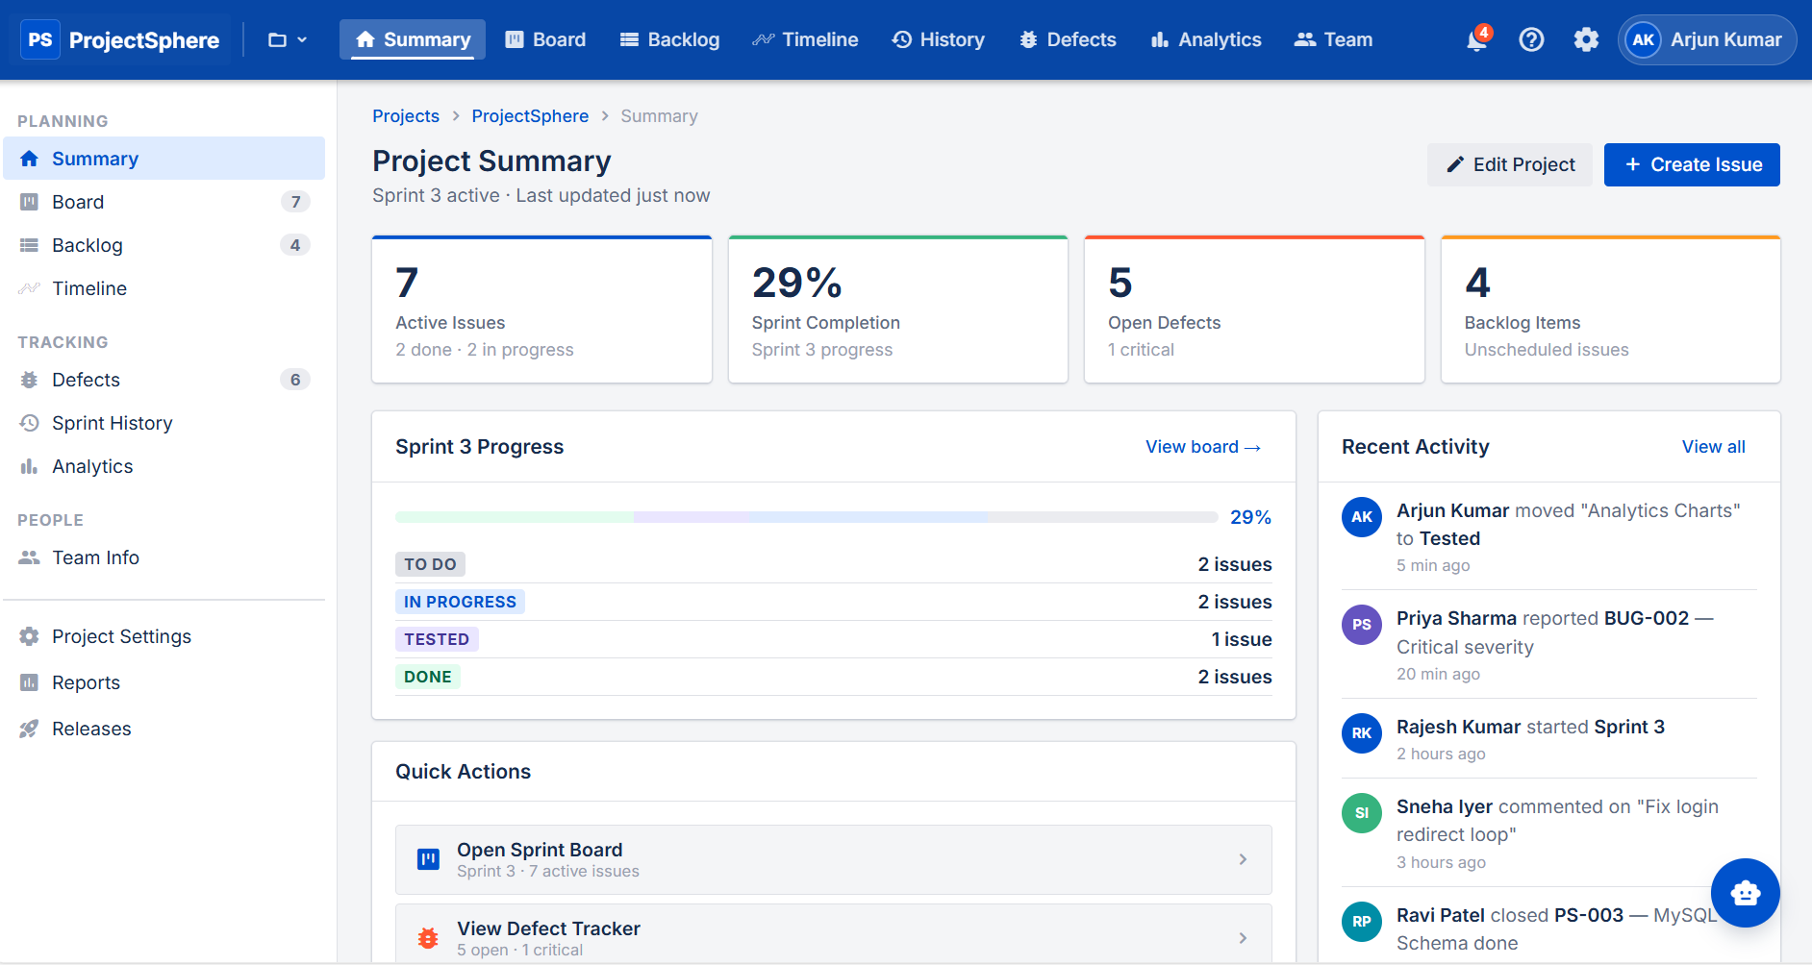
Fig 3.1.1 Movie Ticket Booking System Console Application

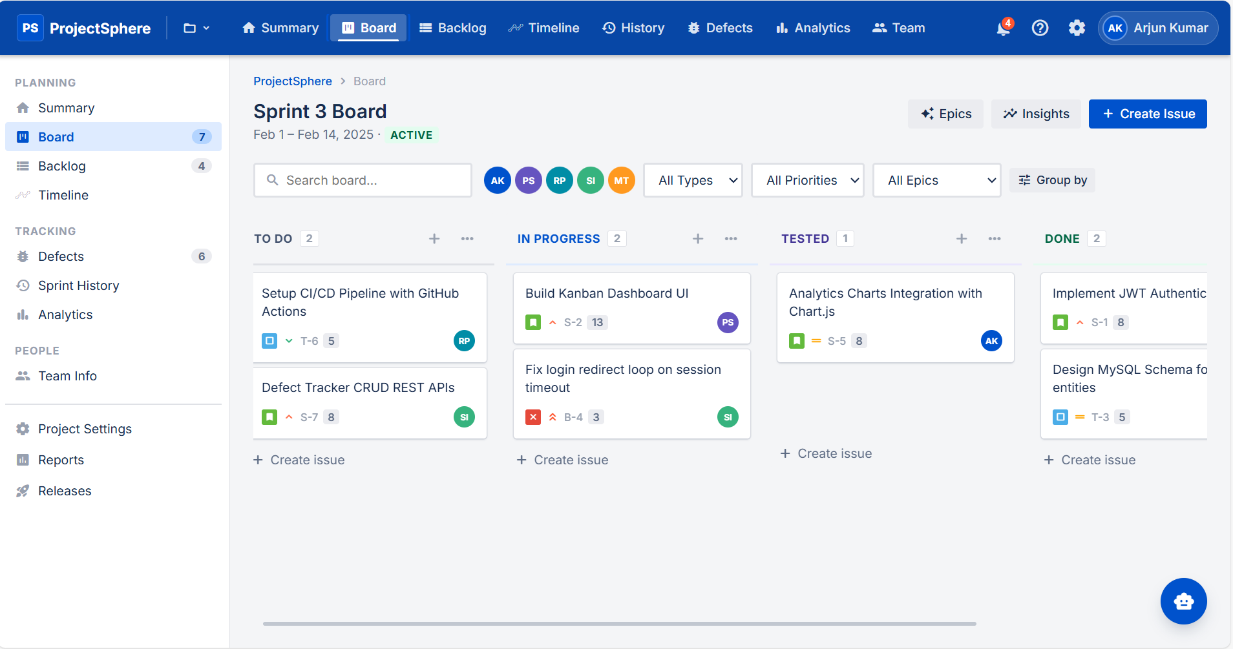

Fig 3.1.2: E-Commerce Cart System Console Application

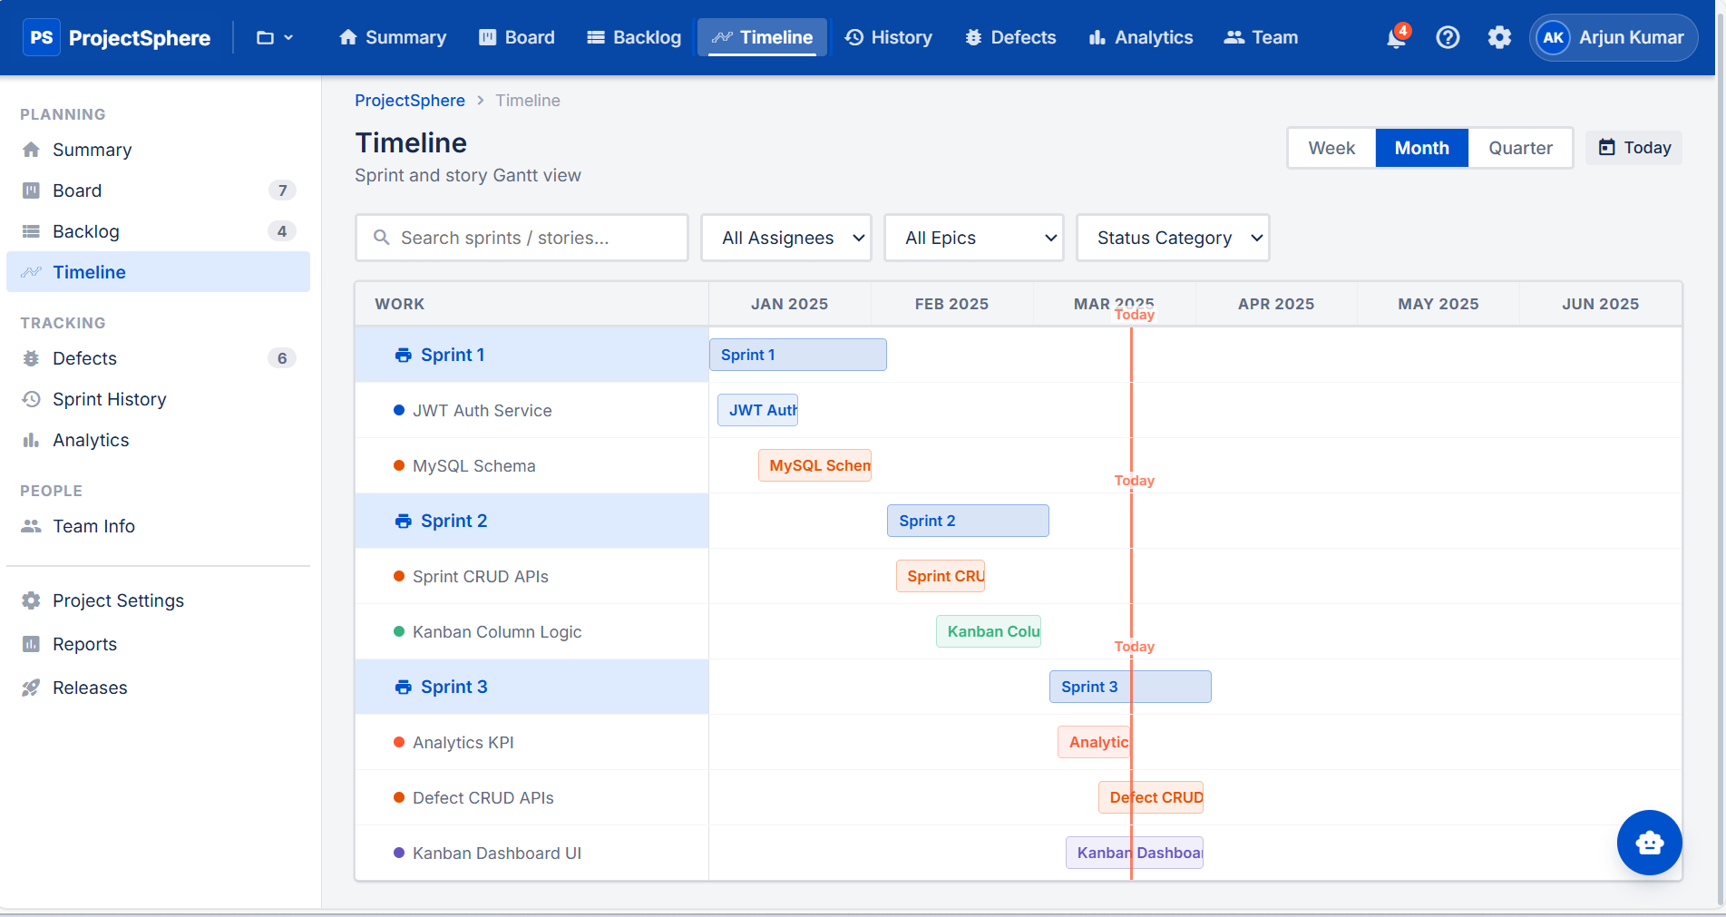

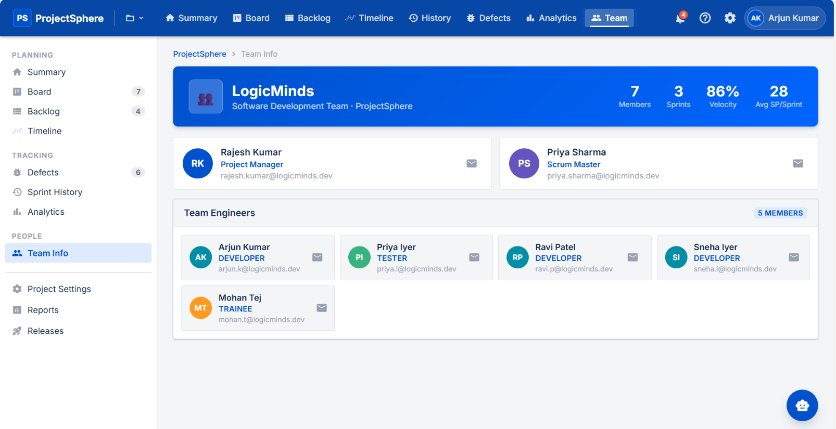
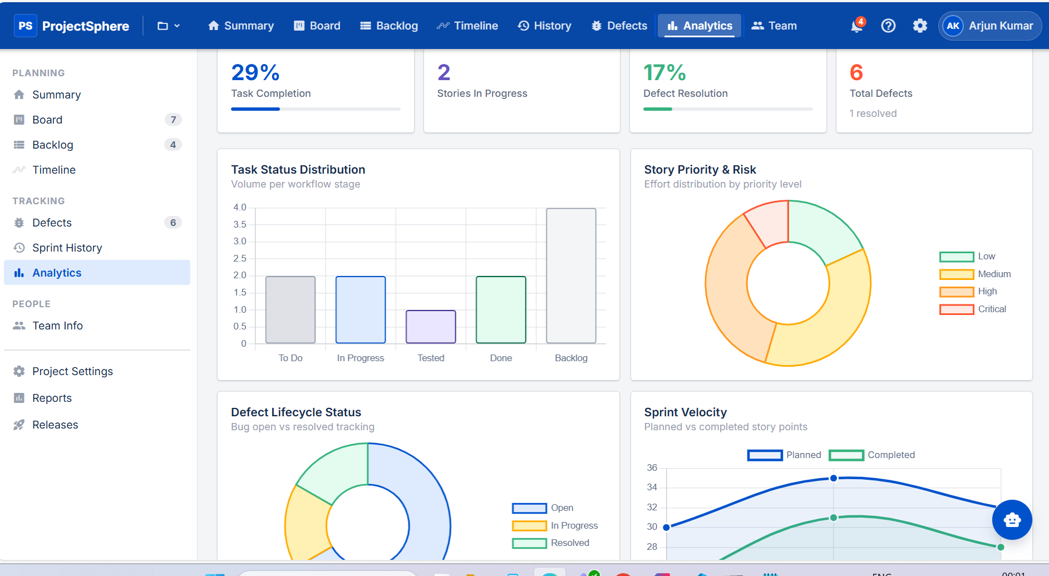

3.2. About Module2/Project2: Smart Temperature Converter
HTML, The Smart Temperature Converter is an interactive web application developed using HTML, CSS, Bootstrap, JavaScript, and OpenWeather API. This project combines real-time weather data with temperature conversion features to create a dynamic and user-friendly application. Each technology plays a specific role, and together they provide a complete and engaging web experience.
- HTML (HyperText Markup Language)
HTML forms the basic structure of the application. It is used to create the layout of the web page and organize all elements such as dropdowns, input fields, buttons, and display sections.
• Purpose: To structure the content and layout of the web page.
• Key Components:
Elements: Used to create dropdowns for state and city selection, input fields for temperature conversion, and sections to display weather data
Attributes: Used for defining properties like input types, IDs, and placeholders for user interaction
- CSS & Bootstrap (Styling & Responsiveness)
CSS and Bootstrap are used to design the visual appearance of the application and ensure responsiveness across devices. Bootstrap provides ready-made components, while CSS is used for custom styling and animations.
• Purpose: To style the application and make it responsive and visually appealing
• Key Components:
Selectors: Used to style HTML elements
Properties: Used for colors, layouts, fonts, spacing, and animations
Bootstrap Components: Cards, grids, and modals used to display weather details in structured formats
Responsive Design: Ensures proper display on mobile, tablet, and desktop devices
- JavaScript (JS)
JavaScript is used to make the web page interactive. It allows you to manipulate the content dynamically, handle user events (such as clicks or form submissions), and update the web page without reloading.
• Purpose: To add interactivity and dynamic behavior

• Key Components:
Variables: Store user inputs and API data
Functions: Handle temperature conversion and data processing
Events: Capture user actions like selecting a city or entering temperature
DOM Manipulation: Update weather details and results dynamically without reloading the page
- OpenWeather API (Real-Time Data Integration)
The OpenWeather API is used to fetch real-time weather data based on the selected city. This makes the application dynamic and practical.
• Purpose: To provide real-time weather information
• Key Components:
API Requests: Fetch data such as temperature, weather conditions, wind speed, and air details
JSON Data: Process and display fetched data in the UI
Integration: Connect frontend application with external weather service
HTML provides the structure, CSS and Bootstrap enhance the design and responsiveness, JavaScript adds interactivity and logic, and the OpenWeather API supplies real-time data. Together, they create a complete application that allows users to view live weather conditions and perform temperature conversions in an interactive and visually appealing way.
3.2.1 Project Title: Smart Temperature Converter – A Real-Time Weather & Conversion Web Application

Objective:

The objective of this project is to develop an interactive, responsive, and user-friendly web application that combines real-time weather data with temperature conversion functionality. The application aims to help users easily access current weather conditions of different cities and convert temperature values between Celsius, Fahrenheit, and Kelvin, all within a single platform. The project focuses on enhancing usability, accuracy, and visual experience using modern front-end technologies.

Description:
The Smart Temperature Converter is designed as a dynamic web application that integrates real-time data and interactive UI elements. It provides a seamless experience by combining weather tracking and temperature conversion features.
- Navigation Bar:
A well-structured interface allows users to select location details easily:
• Dropdown menus for selecting State and City
• Dynamic population of cities based on selected state
• Clean and intuitive layout for smooth navigation
This section ensures that users can quickly choose their desired location and fetch relevant weather data.
- Weather Information Display:
Once a city is selected, the application fetches real-time data and displays:
• Current temperature
• Weather condition (Sunny, Rainy, Cloudy, etc.)
• Wind speed and atmospheric details
• Humidity and air-related information
The data is presented using card-based UI components, making it visually organized and easy to understand.
- Temperature Conversion Module:
The application includes a dedicated module for conversion:
• Convert values between Celsius, Fahrenheit, and Kelvin
• Instant result display without page reload
• Input validation to ensure correct data entry
This feature makes the application both practical and educational.

- Dynamic Visual Features:
To enhance user experience, the application includes:
• Weather-based animations (sunny, rainy, cloudy effects)
• Thermometer-style indicator showing temperature levels
• Graphical comparison charts between cities
This feature makes the application both practical and educational.
- Responsive Design:
The application is fully responsive:
• Works smoothly on desktop, tablet, and mobile devices
• Uses flexible layouts and Bootstrap grid system
• Ensures consistent user experience across screen sizes

Tech Stack :

Technology | Purpose
HTML5 | Structuring the web page elements
CSS3 | Styling, layout design, and responsiveness
Bootstrap | Creating responsive and mobile-friendly UI
OpenWeather API | Fetching real-time weather data
JavaScript | Implementing logic, DOM manipulation, and interactivity

Concepts Demonstrated:
Responsive Design: The layout adapts to different screen sizes using CSS techniques like Flexbox.
API Integration: Real-time weather data is fetched using the OpenWeather API and displayed dynamically.
Styling and Layout: Use of CSS for colors, spacing, alignment, and visual design.
Data Visualization: Used charts and indicators to represent temperature comparisons and weather conditions.
Interactivity: Basic JavaScript used for dynamic behaviors like hover effects and smooth scrolling.

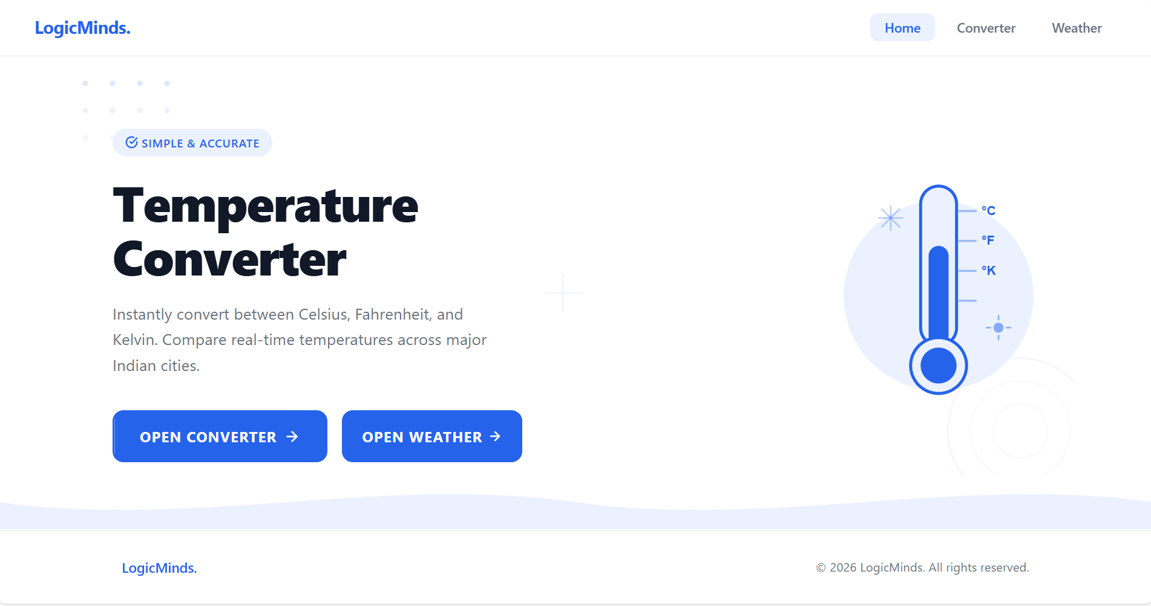
OUTPUT:

Fig 3.2.1:Eatfit Website interface
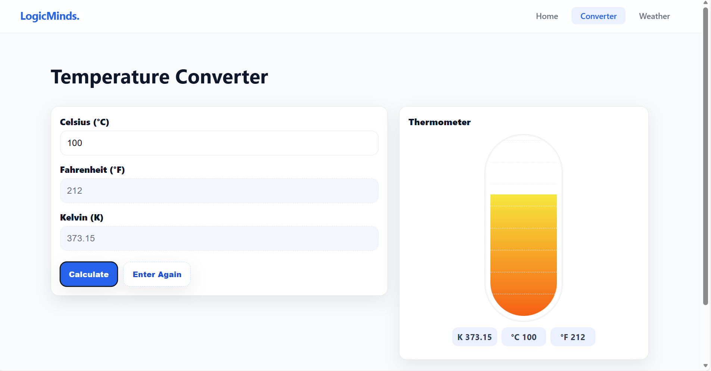

Fig 3.2.2: Footer Section
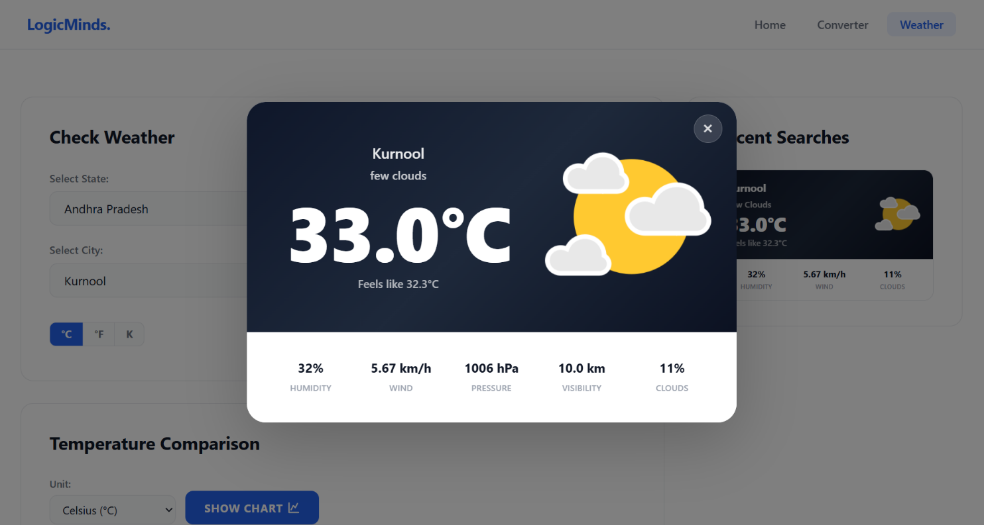
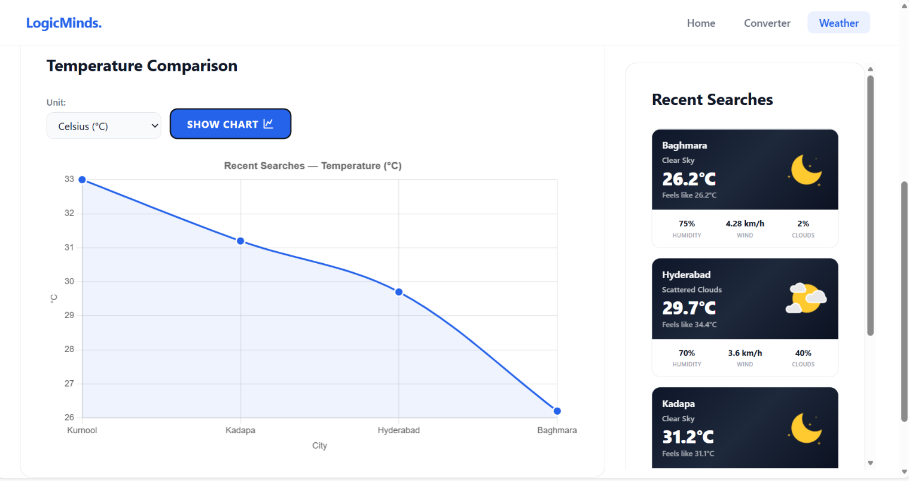

3. 3. About Module 3 / Project 3: To-Do Application

Project Title: To-Do Application – A Task Management Web Application using Spring MVC

Objective:
The objective of this project is to develop a dynamic and user-friendly To-Do web application that allows users to manage their daily tasks efficiently. The application focuses on implementing core backend concepts such as Spring Web MVC, Spring Data JPA, and database interaction, along with a simple and interactive frontend using JSP. It aims to provide functionalities like user authentication, task creation, updating, and deletion, ensuring a complete CRUD-based application.

Description:
The To-Do Application is designed as a full-stack web application that enables users to organize and track their tasks in an efficient manner. It provides a seamless experience by integrating authentication, task management, and database persistence.
- Login & Registration Module:
The application begins with secure user authentication:
• Users can register with their details
• Existing users can log in using credentials
• Authentication ensures only authorized access
• After successful login, users are redirected to the home page

This module ensures data security and personalized user experience.

- Home Page Dashboard:
After login, the user is welcomed with a personalized interface:
• Displays message like “Hello, Username”
• Provides options such as Add To-Do and Logout
• Clean and simple navigation for better usability

This acts as the central control panel for managing tasks.

- To-Do Display Section:
All tasks are displayed in an organized and visually appealing format:
• Tasks are shown using card-based layout
• Each card contains:
• Title
• Description
• Target Date
• Provides action buttons:
• Update
• Delete

This design improves readability and user interaction.

- Add To-Do Functionality:
Users can create new tasks easily:
• Clicking Add To-Do opens a form
• Users can enter title, description, and target date
• Data is saved into the database using Spring Data JPA

- Update & Delete Operations:
The application supports full CRUD operations:
• Update: Modify existing task details
• Delete: Remove tasks from the list
• Changes are reflected instantly on the UI

- Backend Processing:
The backend handles all business logic:
• Spring MVC manages request handling and routing
• Controllers process user actions
• Service layer handles business logic
• Repository layer interacts with the database

- Database Management:
• Uses Spring Data JPA for database operations
• Automatically handles CRUD operations
• Ensures efficient data persistence and retrieval

Tech Stack
Technology | Purpose
Spring Web MVC | Handles request processing and application flow
Spring Data JPA | Manage database Operations and Peristence
Hibernate (ORM) | Maps Java objects to database tables
MySQL | Database for storing user and task data
Maven | Project build and dependency management

Concepts Demomstrated:
MVC Architecture: Application is structured into Model, View, and Controller for better separation of concerns.
CRUD Operations: Implemented Create, Read, Update, and Delete functionalities for task management.
Authentication: Login and registration system ensures secure access.
ORM (Object Relational Mapping): Used Hibernate and JPA to map Java objects with database tables.
Data Persistence: Efficient storage and retrieval of user and task data using repositories.
Dynamic UI Rendering: JSP pages dynamically display data from the backend.
Form Handling: Handled user inputs for adding and updating tasks.

OUTPUT:

Figure 3.3.1 : Blog Sphere Home Page

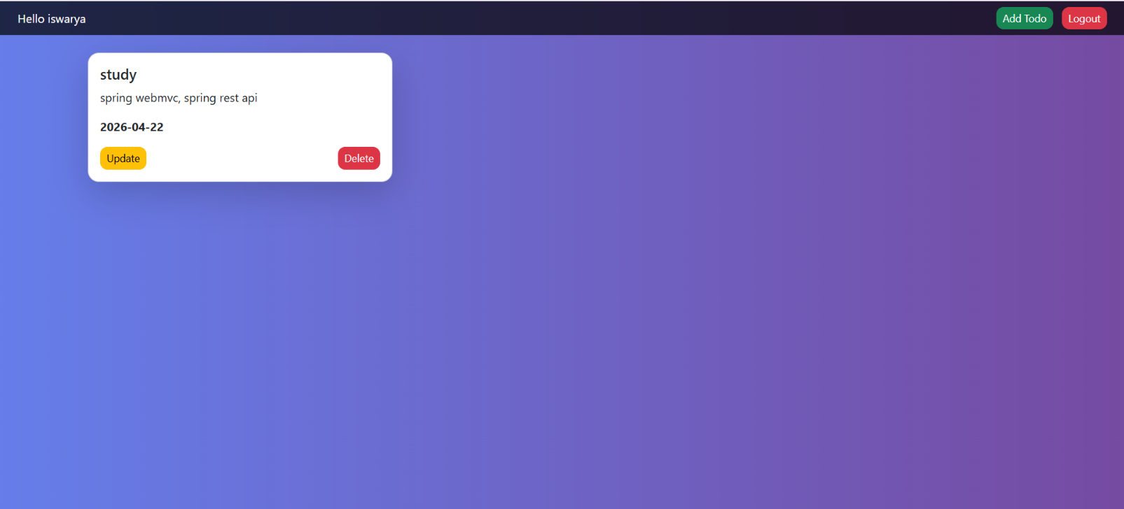

Figure 3.3.2 : Blog Sphere SignUp Page

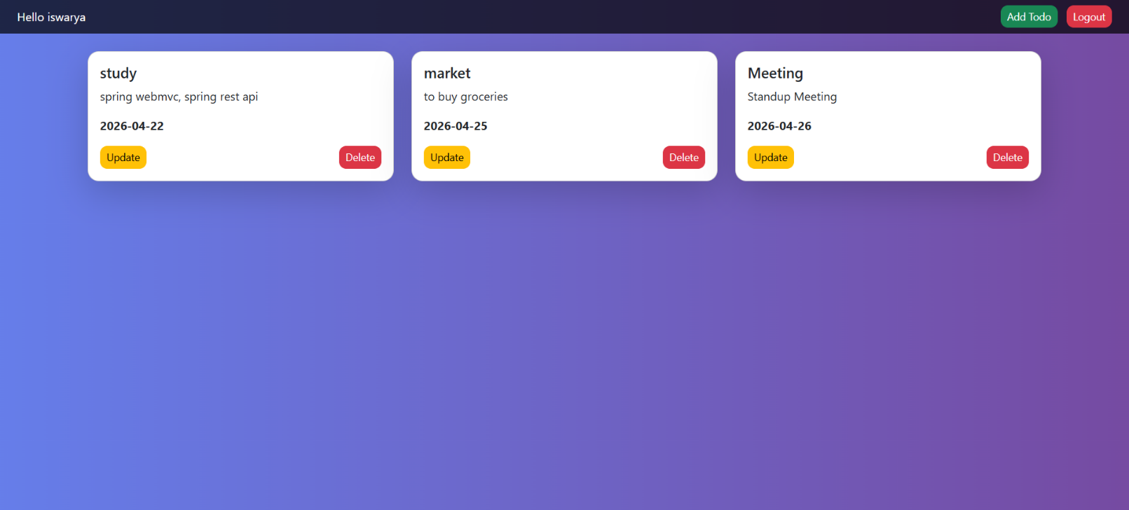

Fig 3.3.3 Blog Sphere SignIn Page

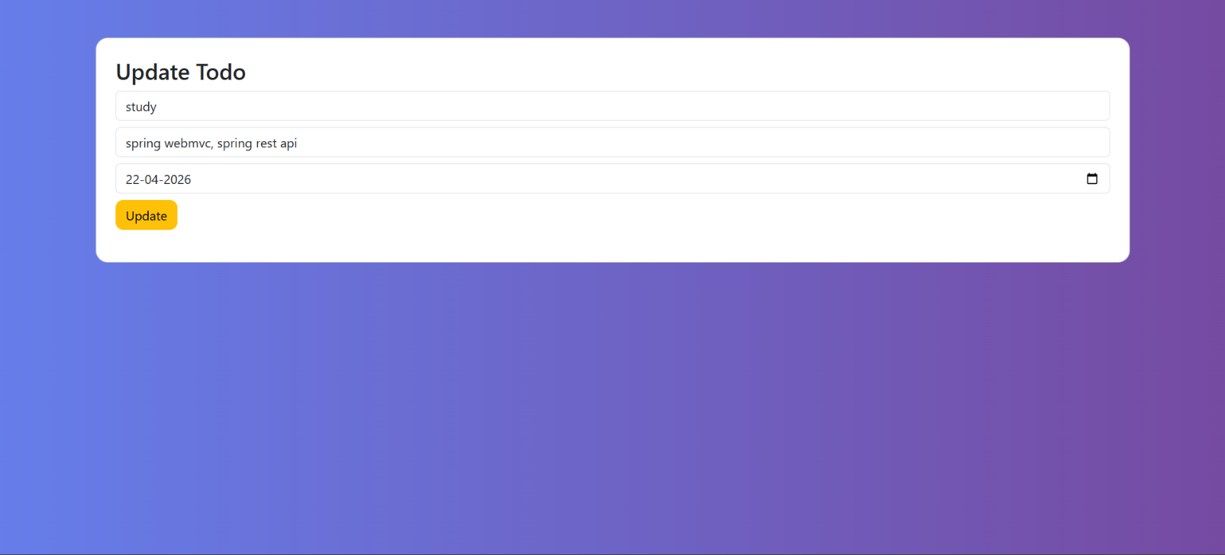

Fig 3.3.4 BlogSphere Home Page with Published Blog Post

- Activity Log

ACTIVITY LOG FOR THE WEEK

Weeks | Description of the daily activity | Learning Outcome | Person In- Charge Signature
Week 1 | Attended bootcamp orientation, explored the organization’s workflow, installed necessary software tools, and communicated with trainers, HR, and fellow trainees. | Developed communication skills, completed software installation and configuration, and adapted to the new environment.
Week 2 | Introduction to UI/UX design principles. Learned how to make websites interactive and attractive, focusing on user experience. Practiced application design using Figma. | Gained understanding of UI/UX fundamentals and hands-on practice in designing user-friendly interfaces.
Week 3 | Worked on application prototypes in Figma, creating interactive layouts and design flows for sample projects. | Improved design thinking and ability to translate user requirements into visual prototypes.
Week 4 | Started frontend development with HTML fundamentals including tags, forms, tables, and semantic elements. Created static web pages for practice. | Acquired knowledge of HTML structure and ability to design simple webpages.
Week 5 | Learned CSS fundamentals including selectors, box model, layouts, background, text styling, animations, and advanced layout techniques using CSS Grid. Also gained hands-on experience with Bootstrap to create responsive and mobile-friendly web pages using pre-built components. | Developed strong skills in styling, layout design, and responsive web development, improving the overall visual presentation and usability of web applications.

Week 6 | Studied JavaScript fundamentals including variables, data types, operators, control statements, functions, arrays, objects, loops, and DOM manipulation. Also implemented a basic calculator and developed interactive webpage elements using JavaScript. | Strengthened logic building, improved DOM manipulation skills, and gained hands-on experience in creating dynamic and interactive web applications.
Week 7 | Studied JavaScript fundamentals including variables, data types, operators, control statements, functions, arrays, objects, loops, and DOM manipulation. Also implemented a basic calculator and developed interactive webpage elements using JavaScript. | Strengthened logic building, improved DOM manipulation skills, and gained hands-on experience in creating dynamic and interactive web applications.
Week 8 | Started Java programming. Learned OOP concepts, constructors, inheritance, and event handling. Explored JDBC with Maven and pom.xml configuration. Connected Java applications with databases. | Strengthened Java fundamentals and problem-solving skills.  Learned database connectivity and project setup using Maven.
Week 9 | Studied SQL concepts including create table, insert, update, delete, and join operations. | Gained knowledge of database management and SQL queries.
Week 10 | Studied Spring framework fundamentals including dependency injection, Spring REST, and WebMVC architecture. Practiced building simple RESTful services and controllers to handle HTTP requests. | Gained knowledge of Spring core concepts, REST API development, and MVC-based web application structuring.
Week 11 | Mock Interviews and Technical Assesments. | Mock Interview
Week 12 | Explored Spring Boot for rapid application development. Learned JPA, Data JPA, and Hibernate for database integration and ORM. Implemented CRUD operations and connected backend services with persistent storage. | Acquired practical skills in Spring Boot, ORM with Hibernate, and efficient database handling using JPA/Data JPA.

Week 13 | Learned Angular fundamentals including components, modules, data binding, directives, and routing. Developed dynamic and responsive user interfaces and implemented features like form handling and API integration. | Gained strong skills in building structured, scalable, and interactive frontend applications using Angular.
Week 14 | Studied Agile (Scrumban) and participated in stand-ups, sprint planning, and task tracking using Jira.  Worked in team-based environment following real-time workflow practices. | Gained understanding of Agile process and teamwork.  Learned project tracking and task management using Jira..
Week 15 | Final project development: Project Sphere. Built the frontend using Angular and backend using Spring Boot with REST APIs and JPA. Completed testing and documentation. | Practical experience in full-stack development, integrating frontend and backend technologies into a complete project.

5. CONCLUSION
CONCLUSION
During my internship at Codeon Technologies Pvt. Ltd., I had the opportunity to work extensively in the Java Full Stack domain, which significantly enhanced my technical and professional skills. Throughout the program, I gained hands-on experience in developing real-world applications using technologies such as Core Java, Spring Boot, Hibernate, Spring Data JPA, MySQL, HTML, CSS, JavaScript, JSP, and Angular.
• Frontend Skills: Created responsive and interactive user interfaces using HTML, CSS, Bootstrap, and Angular, focusing on UI/UX design and dynamic content rendering.
• Java Programming: Gained deep understanding of Core Java, covering OOP concepts (inheritance, encapsulation, abstraction, polymorphism), constructors, method overloading/overriding, and exception handling.
• Advanced Java: Worked with JDBC, Jsp, and frameworks like Spring Boot, Spring MVC, and REST APIs to develop scalable backend services.
• Database Management: Gained practical experience in MySQL, performing CRUD operations, joins, normalization, and efficient data handling using JPA and Hibernate.
• Backend Integration: Implemented RESTful APIs and integrated frontend with backend using Spring Boot and Data JPA for seamless data flow.
• Hands-On Practice: Regularly practiced coding through platform-based challenges and assignments, improving logical thinking and debugging skills.
• Project Work: Developed multiple projects including ProjectSphere (Unified project management system), Smart Temperature Converter, and a To-Do application, demonstrating end-to-end full stack development.
• Agile & Tools: Worked in Agile (Scrumban) environment, participated in stand-ups, sprint planning, and used Jira for task tracking and collaboration.
The internship provided me with a comprehensive understanding of full-stack development, including frontend design, backend development, REST API creation, and database management. I also gained exposure to real-time development practices, teamwork, and project workflows followed in the industry.
Overall, Overall, this internship strengthened my technical foundation, improved my problem-solving abilities, and prepared me to confidently work on real-world software development projects. I am grateful to Codeon Technologies Pvt. Ltd. for providing me with this valuable learning experience and professional guidance.
EVALUATION REPORT

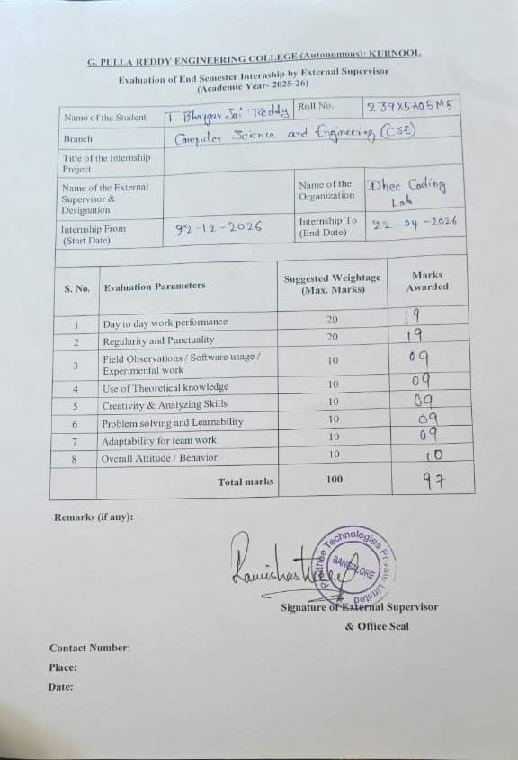
REFERENCES

Spring Initializr

https://docs.oracle.com/en/java/

https://spring.io/projects/spring-boot

https://hibernate.org/orm/documentation/

https://react.dev/

https://dev.mysql.com/doc/

https://www.w3schools.com/

https://developer.mozilla.org/

https://www.tutorialspoint.com/java/index.htm

Maven Repository: Search/Browse/Explore

