**Part 1 (Interview):**

For this section, I choose to have an interview with Jihoo as he is one of the main characters and to me, he has the most interesting story since he was in prison.  
  
Q: **What did you get sent to prison for?**

A: I was arrested for being at a protest. I wasn’t actually at that protest. I didn’t like attending the protests as I am a pacifist. They were going to let me go but they discovered a book that I was reading from North Korea, which meant it was banned.

Q: **How long would you say that you spent in prison?**

A: Well, I was arrested in 83, and released in 1992 when Kim Young Sam was elected to office and pardoned all of the protestors. So that was about 9 years.

Q: **9 years, that’s a lot. How did you spend your time in prison**?

A: Well, there wasn’t much to do in there, I mostly wrote poetry and talked to other protestors.

Q: **What were conditions like in the prison?**

A: They were pretty bad. Cramped Cells, poor food, and the guards were very abusive.

Q: **What would happen if you broke the rules?**

A: The most common thing that would happen is that you would get beaten pretty badly. Sometimes you would get chained to the wall in an isolated unit and sleep-deprived for a couple of days. Most of the time we didn’t get food while we were there either.

Q: **Did prisoners that received severe injuries get medical attention?**

A: If it was serious enough, they would get some medical treatment, but it wasn’t a lot. There were more than a few deaths in the prison. For minor injuries, medical aid was not given.

Q: **Were there any nice prison officials?**

A: There weren’t many but a couple of them would turn a blind eye if they saw something that was against prison rules.

Q: **Were there any bad inmates?**

A: For the most part not. There was the occasional police informant snuck in. Most of the people though were in there for the same reason as I was, because the government wanted to silence us. That gave us a common purpose and goal.

Q: **We heard that you were in charge of organizing prison strikes and riots. Were those ever traced back to you?**

A: They never did find out that I was the one organizing them, the other inmates never told anything to the guards. We had to be careful though since the police spies within the inmates might have gotten word of it.

Q: **What have you done now that you have been released from jail?**

A: I published most of the work that I did while in prison. I also fight for prison reform now that I’m out I don’t want anyone to be in the same situation that I was.

**Part 2 (Sketch):**The Scene I choose to sketch was when Gundo was standing in the street protesting alone for Jihoo's release. I felt like drawing this one because I feel like this is a big part of the book and because I also liked the background. I'm not the best at drawing.

**Part 3 (Excitement Graph):**

Grading Criteria:

1. Starts with Action  
2. Ends in Suspense  
3. Shows other points of view  
4. Introduces new information  
5. My personal opinion

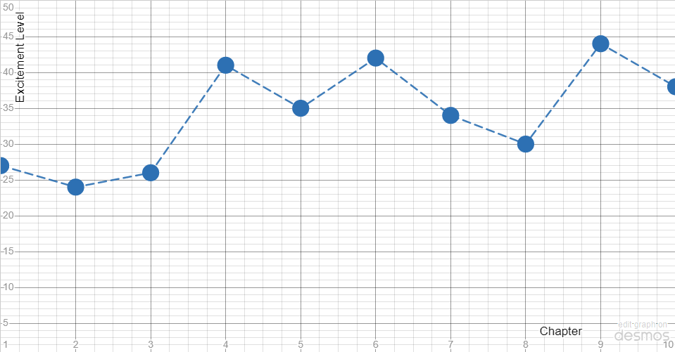

Chapter 1: 27/50

1. 6  
2. 3  
3. 1  
4. 10  
5. 7

Summary: At the beginning of the book the action and suspense aren't going to be as, big so I ranked the first to the middle. There weren’t any other perspectives in this chapter so that got a 1. However, it being the beginning of the book there was loads of new information so that gets a 10.

Chapter 2: 24/50

1. 5  
2. 5  
3. 3  
4. 5  
5. 6

Summary: In this part, I put the beginning action and end suspense in the middle at 5 that’s because they both showed some of the elements for these but they weren't as present as they could be. There weren’t a lot of other perspectives but there were more than in the last chapter giving it a 3 instead of a 1. Finally, there wasn't as much new information to drive the plot forward as we are still kind of introducing the character so I gave it a 5 right in the middle.

Chapter 3: 26/50

1. 3  
2. 9  
3. 4  
4. 5  
5. 5

Summary: At the beginning of this chapter they are only sitting in class talking so I gave the action a 3 since not much was happening. However, at the end of this chapter, it ends in Hoon missing which is pretty suspenseful so it gets a 9. Like the last chapter, there weren't many other perspectives so I gave it a 4. Also, like the last chapter, there wasn't much new information to drive the plot besides Hoon's disappearance so it gets a 5.

Chapter 4: 41/50

1. 9  
2. 8  
3. 8  
4. 6  
5. 10

Summary: This chapter really starts out with a lot of action picking up from the end of the last chapter showing Hoon getting interrogated. This chapter also ends with a lot of suspense with the police kicking down the door to the cafeteria where they are watching banned materials, and barely making it out, but leaving others behind in the process. It also advances the plot forward a lot so I gave that an 8. Finally, there were a lot more perspectives especially since the beginning we start at Hoon's perspective. At this point, this is the most exciting chapter in the book.

Chapter 5: 35/50

1. 6  
2. 7  
3. 6  
4. 8  
5. 8

Summary: This chapter doesn't start as action-filled as the last one but some action is thrown in there when the police censor walks into the room to look through the paper. This chapter also ends with some suspense with them having to sleep in the park and have us wonder what the next chapter will bring. There are some other perspectives in this but not as many as last time so it gets a 6. Finally, I feel that it brings us a lot of new information to use that helps move the plot along.

Chapter 6: 42/50

1. 6  
2. 10  
3. 10  
4. 7  
5. 9

Summary: This chapter starts with Hyun Sook going to the student council to help make Molotov cocktails which is fun but not together action filled so I gave it a 6. The end, however, is very suspenseful with the arrest of Jihoo and his almost being released. so that gets a 10. We are also switching between several perspectives in this chapter which I gave a 10. Finally, there was some information in this chapter so I gave it a 7. This was a pretty good chapter and very long too.

Chapter 7: 34/50

1. 7  
2. 8  
3. 7  
4. 5  
5. 7

Summary: Compared to the way the last chapter ended the start of this chapter doesn't really continue the momentum of action that the end of the last chapter had so it gets a 6. However, the end of the book ends with the turmoil in the book club, and uncertainty about the future was very suspenseful so I gave it an 8. As for other perspectives we see some perspective of a snitch with Agent Ok so I gave it a perspective score of 7. Finally, there wasn't as much information as I expected so I gave that a 5.

Chapter 8: 30/50

1. 6  
2. 7  
3. 3  
4. 8  
5. 6

Summary: This chapter started slow with not a lot of action happening so I gave it a 6. It didn't really have that much suspense but it did end with a nice heartfelt moment with Hyun Sook's parents, so I gave it a 7. I would say that it didn't stray very much from Hyun Sook's perspective so I gave it a three. However, we did get a lot of information, especially from Hyun Sook's dad that answers some questions about her backstory which helps advance the plot so I gave that an 8.

Chapter 9: 44/50

1. 8  
2. 10  
3. 8  
4. 9  
5. 9

Summary: This chapter starts with some action as Hoon gets riled up about Jihoo's arrest and also confronts the police snitch. Also, the end is suspenseful and full of action with the riot. This leaves us with the suspense of what happened to them so I gave this a 10. There were also a lot of different perspectives on this from Hoon to Yuni. Finally, as this is the climax I feel like we receive a lot of information from a lot of places that push the story progression. As this was the climax of the story this was the best chapter in the book.

Chapter 10: 38/50

1. 10  
2. 5  
3. 6  
4. 9  
5. 8

Summary: As we start with another riot 33 years in the future I would say that it starts pretty action-packed, I gave it a 10. As it's the end of the book there isn't supposed to be much suspense (especially because we aren't expecting a sequel), I gave it a 5. There is a little bit of perspective change at the beginning with Hoon so I give that a 6. Finally, I feel that we received a lot of information that we were looking for in the last chapter about what happened to everyone. It also gives us all the information about what happened in the 33 years that we skipped so I give it a 9.