Leading University
Department of Computer Science and Engineering
Program: B.Sc. of Computer Science and Engineering (CSE)

Final Evaluation Preparatory Assignment – Semester: Spring - 2023
Course Code: CSE-4233 Course Title: Machine Learning Full Marks: 125

Question#1 Marks - 15

Calculate the weights change using the back propagation algorithm in this 3 layers NN.
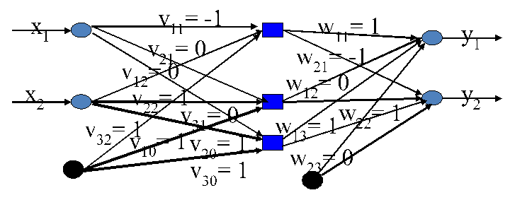
Figure 1: 3 layers Neural Network (input, 1-hidden, output)
All biases set to 1. Learning rate η=0.1, input [1,0] with target [0,1]. Use identity activation function, means no activation function, so g(a)=a. Consider the cost-function as Mean Square Error (MSE) to update weights. So, to change the weights through the back propagation algorithm use the equ.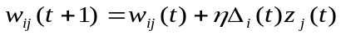, where w_{ij} (t+1) is the new weight in a connection, w_{ij}(t) is the current weight in a connection, is the learning rate, 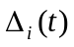 is the error made by a perceptron unit, 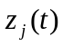 is the input to a perceptron unit

A | Consider the neural network in figure-1 and calculate the output using the forward propagation algorithm in the 3 layers NN. | 5
B | Consider the neural network in figure-1 and calculate the weights change using the back-propagation algorithm in the 3 layers NN | 5
C | Consider the neural network in figure-1 with updated weights using the back propagation in question no. 2. Calculate the output using the forward propagation algorithm with the updated weights in the 3 layers NN | 5

Question#2 Marks – 10

- Implement an ANN for XOR function. Use sigmoid activation function.
- Why do we need a back propagation algorithm? Mention brief steps of the back propagation algorithm.

Question#3 Marks – 10

- Consider the neural network in figure-2:
  - Label the neural network with input layer, hidden layer and output layer.
  - What are the dimension of weight matrixes: Ɵ⁽¹⁾ and Ɵ⁽²⁾?
  - How do you compute a⁽²⁾ and a⁽³⁾?

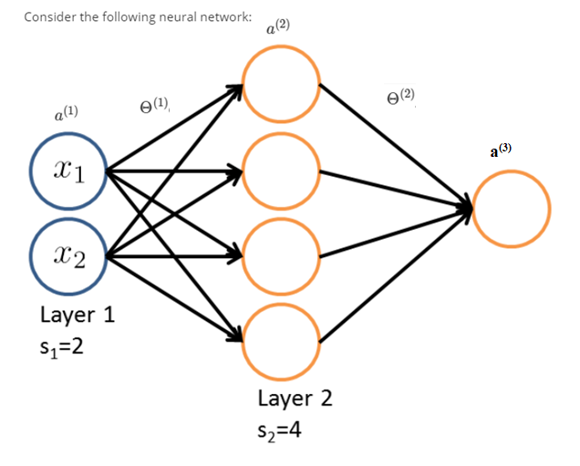
Figure: 2

Question#4 Marks – 10
(a)
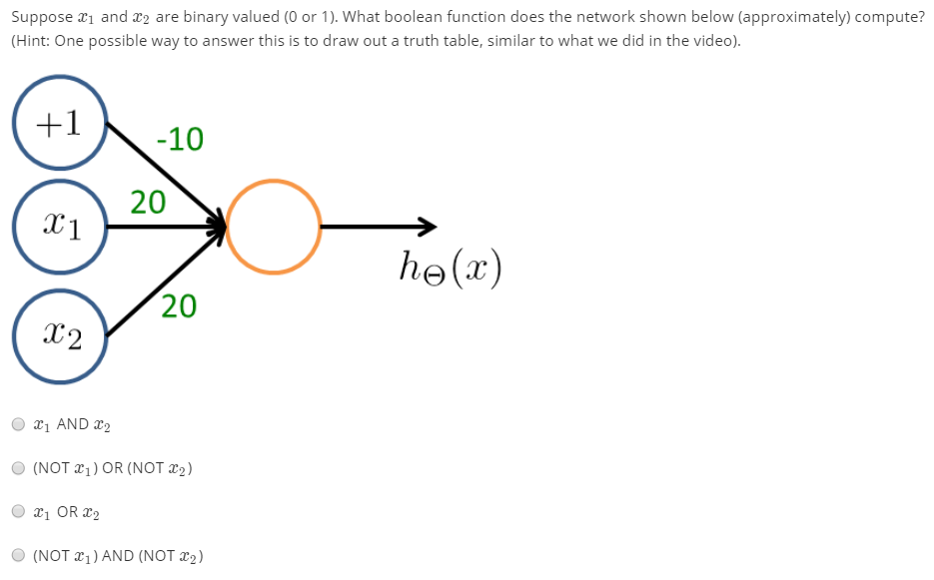

(b)
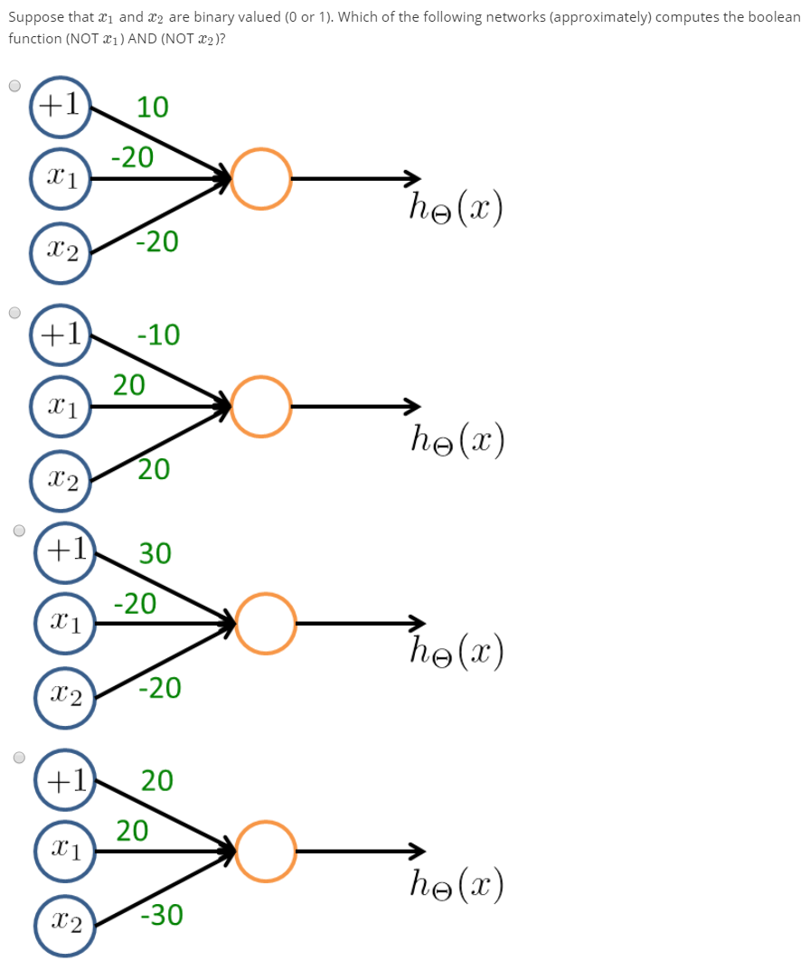

Question#5 Marks - 45

- What is the role of Kernel in SVM? Explain the different types of popular Kernel functions in SVM.
- Why SVM is called Large Margin Classifier? Briefly explain.
- What is the role of hyper-parameter C in SVM? Does it affect bias/variance?
- What is the role Gaussian Kernel’s parameter? Does it affect bias/variance?
- Compare the Logistic Regression and SVM approach based on the number of features and training dataset size.
- What is Linear Kernel in SVM? Explain the use of this kernel in SVM.
- Suppose you have trained an SVM classifier with a Gaussian kernel, and it learned the following decision boundary on the training set:

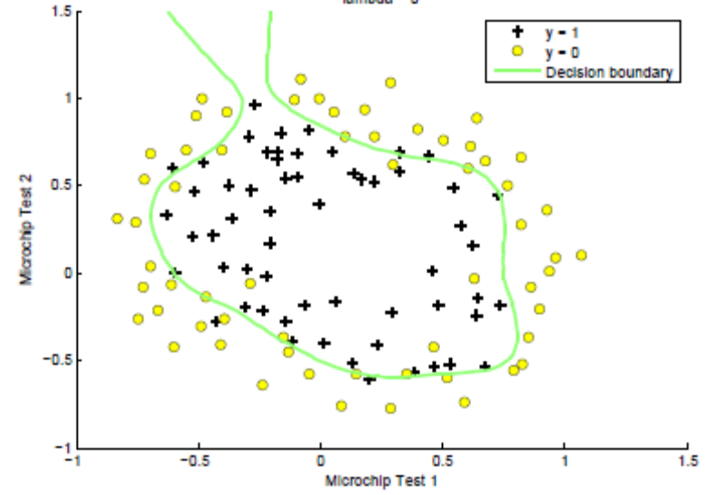
When you measure the SVM's performance on a cross validation set, it does poorly. Should you try increasing or decreasing C? Increasing or decreasing σ²?

- The SVM solves
where the functions cost₀​(z) and cost₁​(z) look like this:
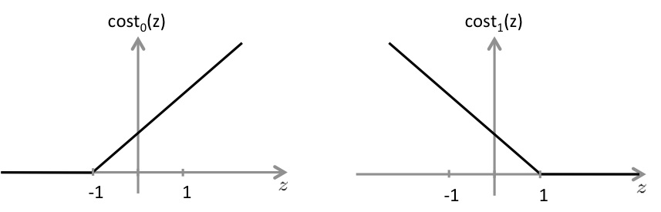
The first term in the objective is:
This first term will be zero if two of the following four conditions hold true. Which are the two conditions that would guarantee that this term equals zero?
- Suppose you have a dataset with n = 10 features and m = 5000 examples.
After training your logistic regression classifier with gradient descent, you find that it has underfit the training set and does not achieve the desired performance on the training or cross validation sets.
Which of the following might be promising steps to take? Check all that apply.

i) Use an SVM with a linear kernel, without introducing new features.
ii) Create / add new polynomial features.
iii) Increase the regularization parameter λ.
iv) Use an SVM with a Gaussian Kernel.

Question#6 Marks – 25

- What are the applications of K-means algorithms?
- Write the steps of the K-means algorithms?
- How do you choose K parameter in K-means algorithms? Explain.
- Why do we need random initialization of K cluster centroids in K-means?

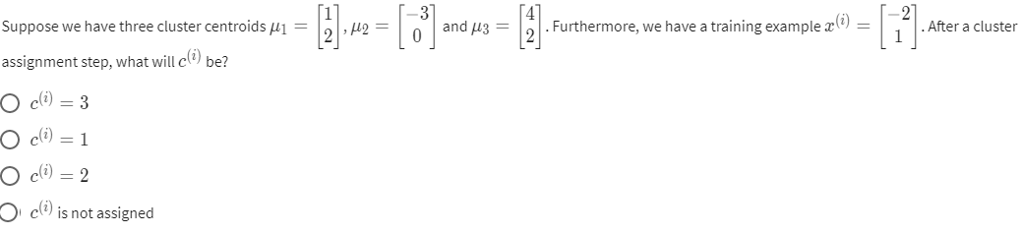

Question#7 Marks – 5

- What Is Collaborative Filtering? How to Find Similar Users on the Basis of Ratings in a memory-based/content-based approach?

Question#8 Marks – 5
- Why do we need mean normalization implementation in Collaborative Filtering?

