Design Document

Week 1 Assignment

By: Viktoria Peeva   
 Galin Karafiziev

Contents:

1. Web application topic

2. Target Audience

3. Sitemap

4. Wireframes

5. Visual Design

1. Web application topic

The topic of the website will be related to gaming events for several different multiplayer online games. It will be concentrated around some of the most famous and played games. The purpose of the site is to help people find tickets for events related to certain games easier and cheaper. Since the game companies already have their events we are simply offering an easier way to purchase and get up to date with the tickets and availability of the events, having all the games and their events at one place-our website.

1. Target audience

The audience we are targeting is players from all ages. The purpose of this site is to make it convenient for those who want to buy tickets for different game events and keep track on them.

1. Site Map
2. Wireframes:

* Home

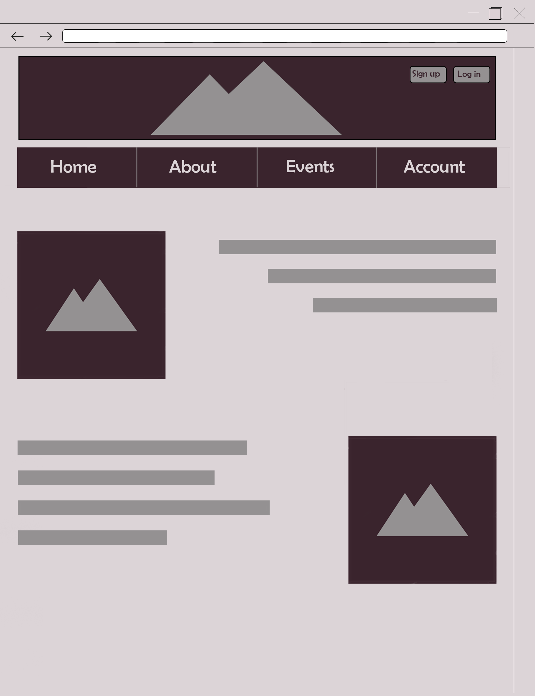

* About

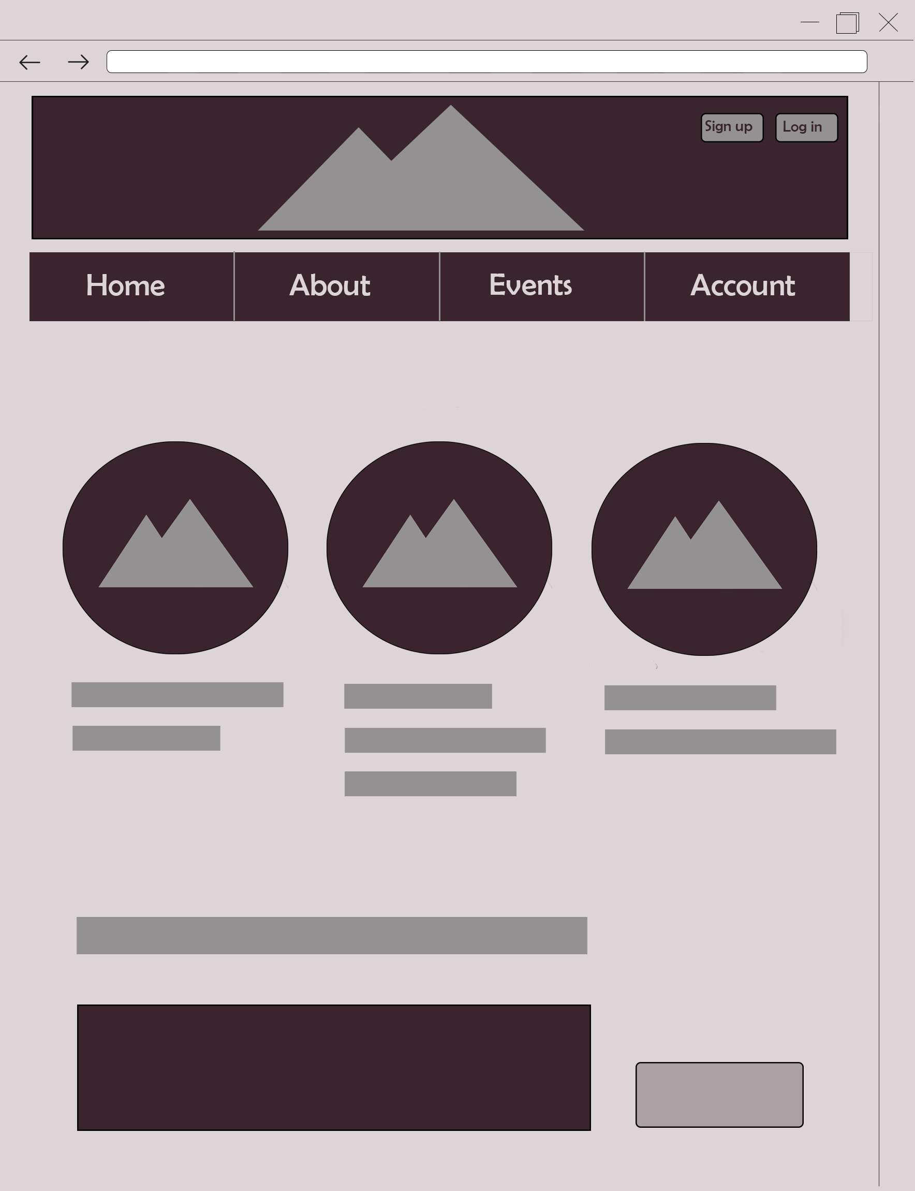

* Events

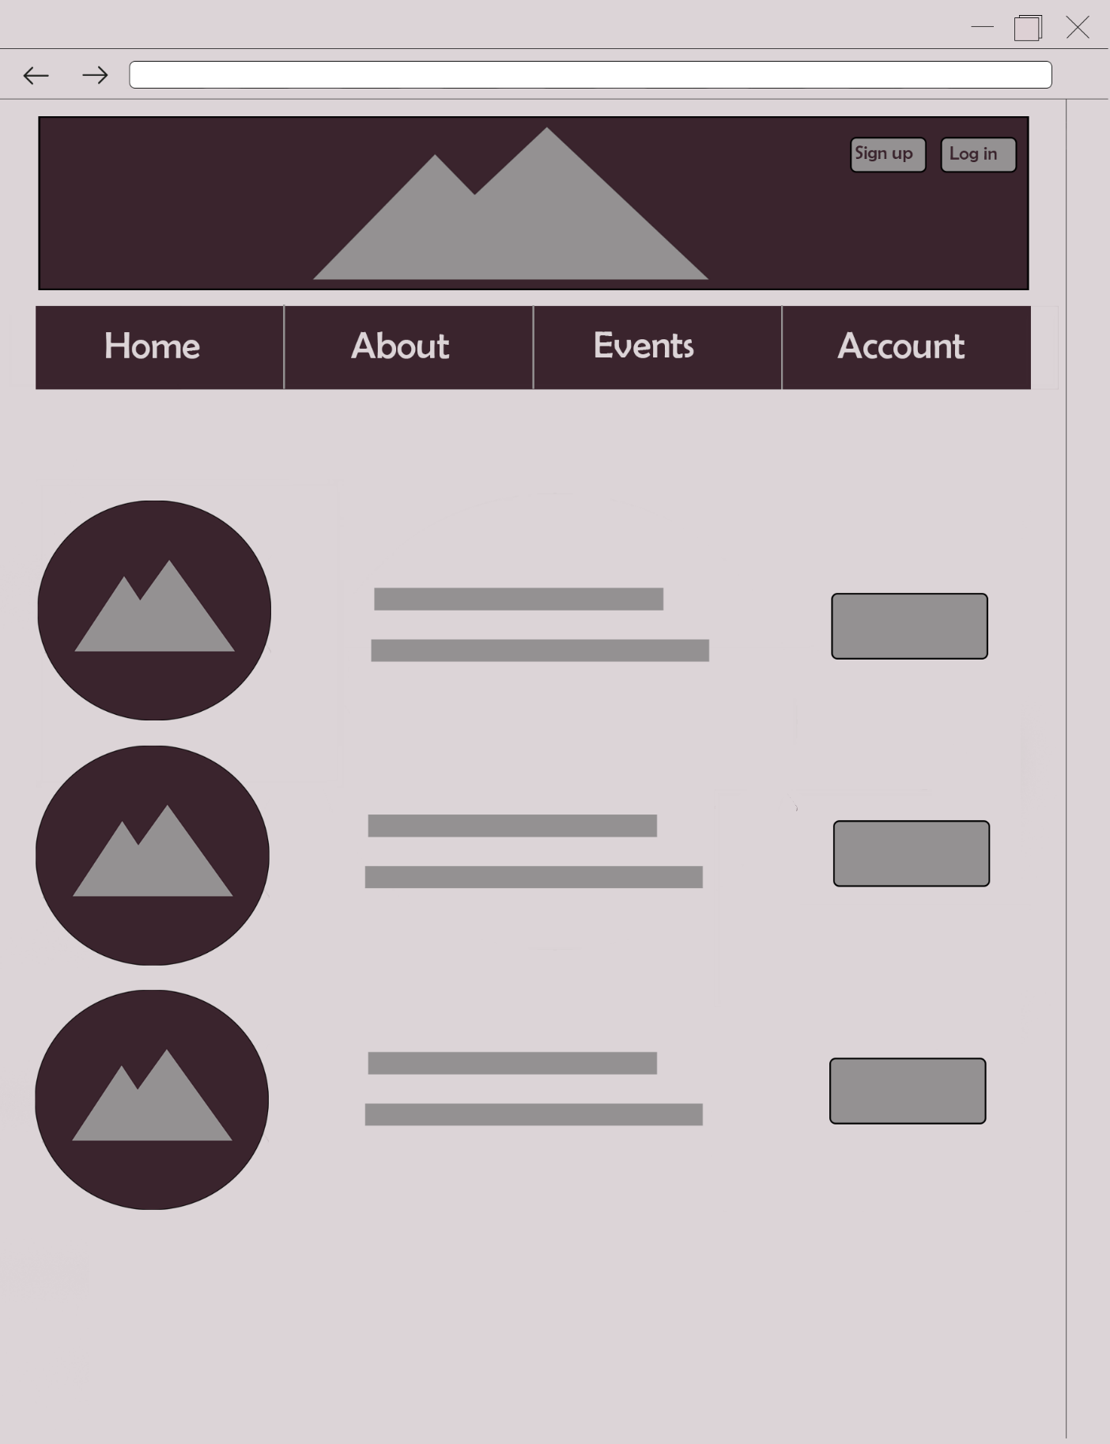

* Account:

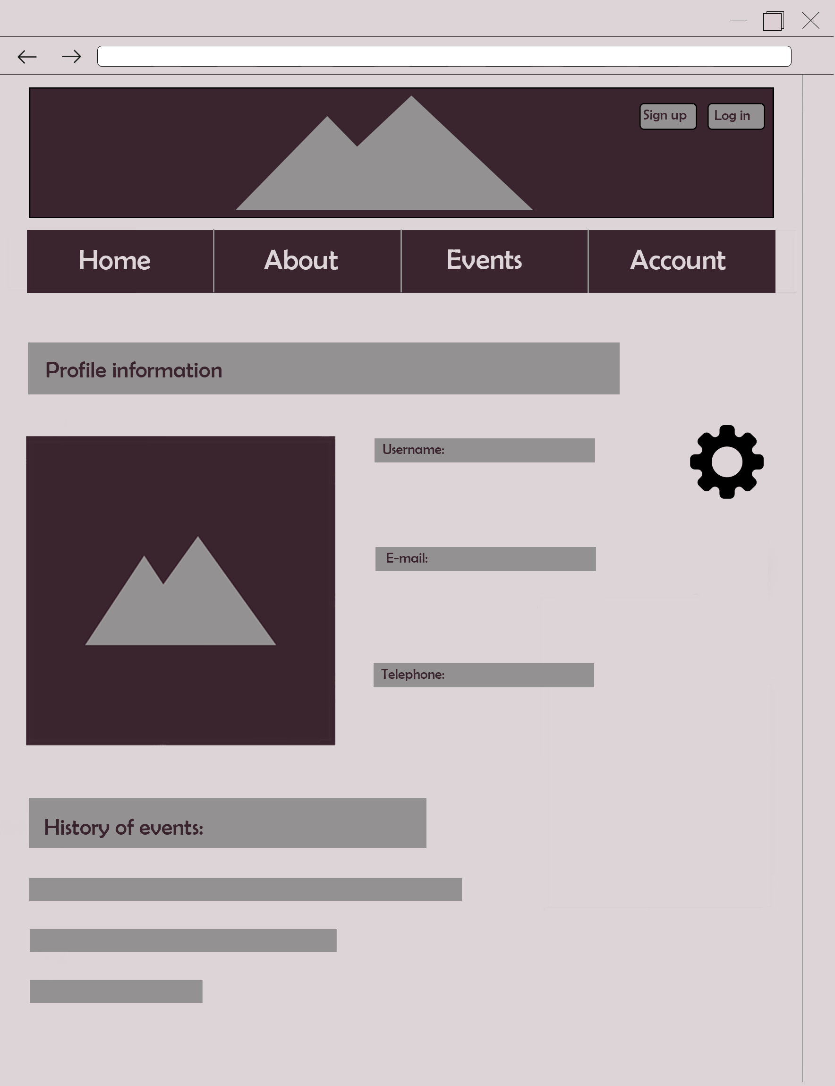

* Log in:

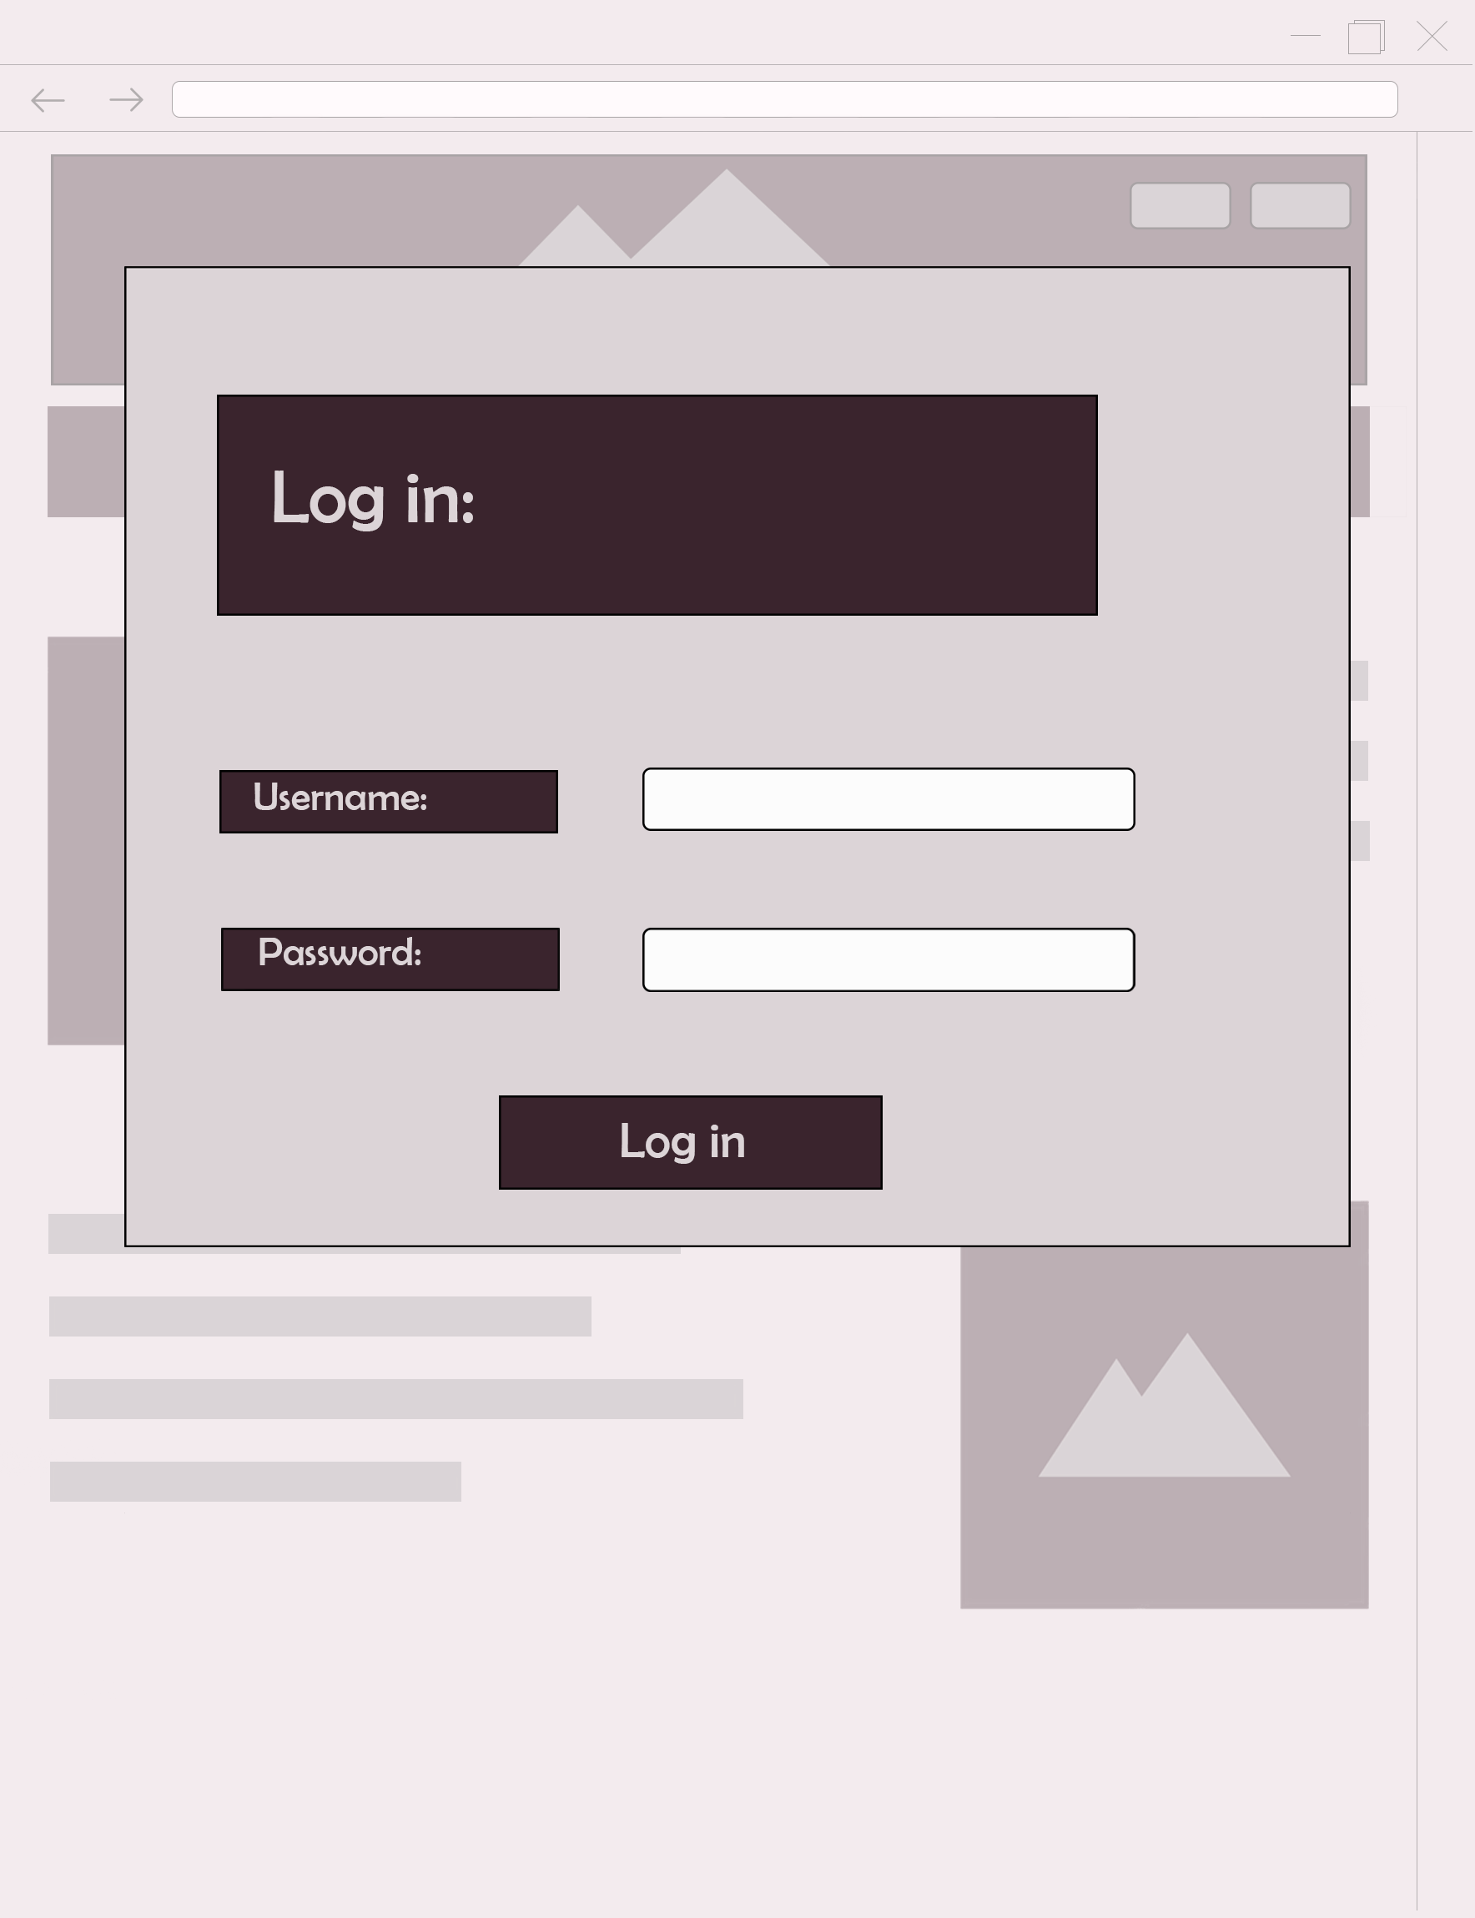

* Sign up:

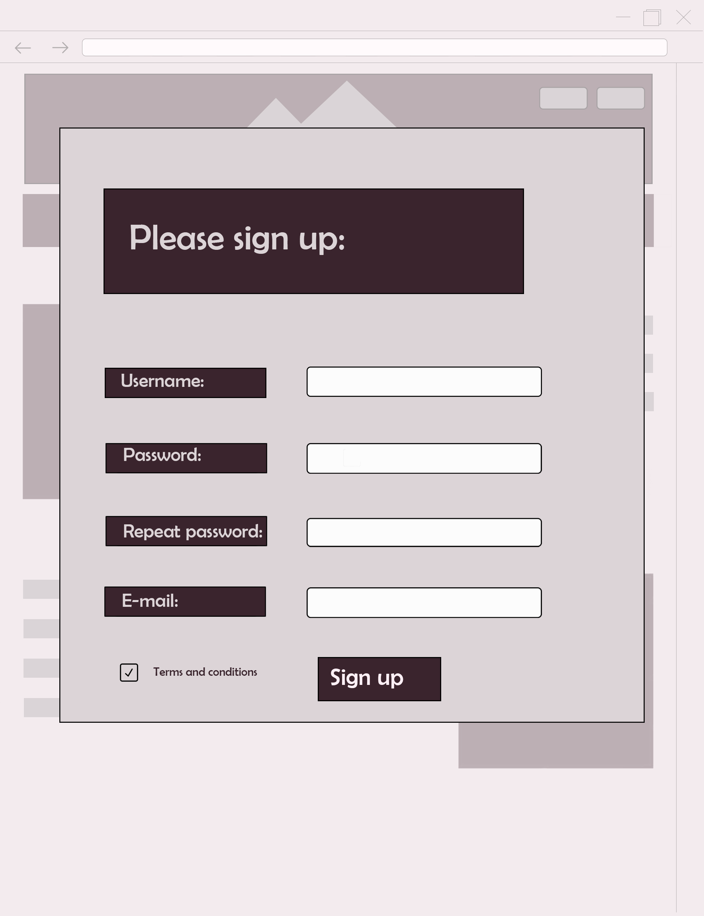

1. Visual design :

