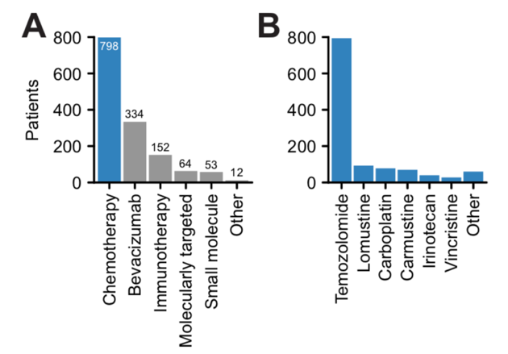

**Figure S1. Distribution of systemic therapies received.** **A)** The number of patients in cohort that received the indicated systemic therapies at any point during their clinical history, prior to cohort data freeze. Treatment lines were only considered molecularly targeted if administered based on the presence of a genetic alteration in the drug target or the signaling pathway targeted by the drug in a molecularly characterized patient specimen. **B)** Breakdown of the number of patients that received specified chemotherapeutic agent.

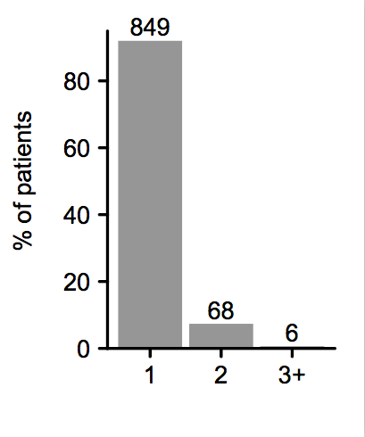

**Figure S2. Number of sequenced samples per patient.** The percentage of patients in the cohort for which the indicated number of surgical specimens were sequenced is shown. The absolute numbers are indicated.

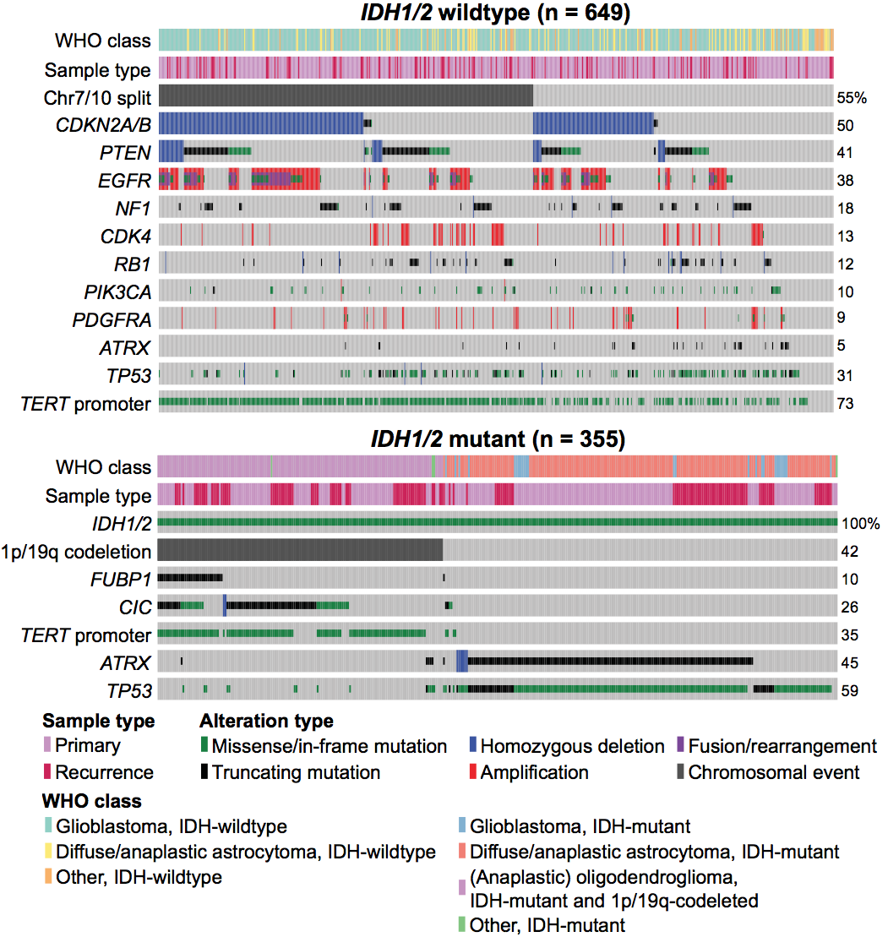

**Figure S3. Subgroup-defining genomic lesions in IDH-wildtype and -mutant gliomas.** The frequency and pattern of cardinal genomic alterations in IDH-WT (top) and IDH-mutant (bottom) gliomas in this cohort.

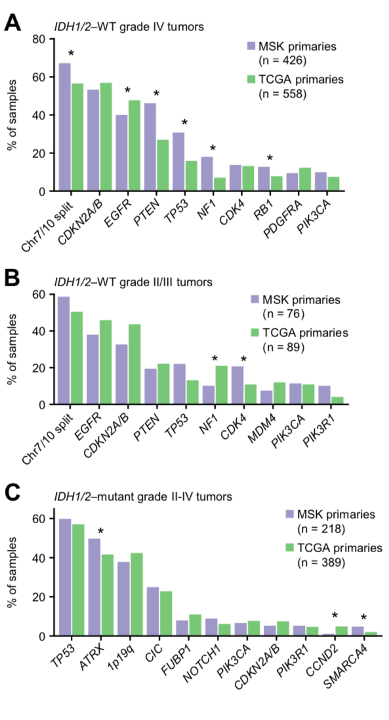

**Figure S4. Frequency of mutations in primary tumors.** The frequency of mutations in the primary tumors of the study cohort (MSK) compared to those profiled by The Cancer Genome Atlas (TCGA) LGG and GBM cohorts. **A)** WHO grade IV IDH-WT tumors. **B)** WHO grade II-III IDH-WT tumors. **c)** WHO grade II-IV IDH-mutant tumors. Asterisks indicate significant differences, *P*< 0.1. Alterations shown if they occur in at least 10% or 5% of either cohort in **A**, **B** or **C**, respectively.

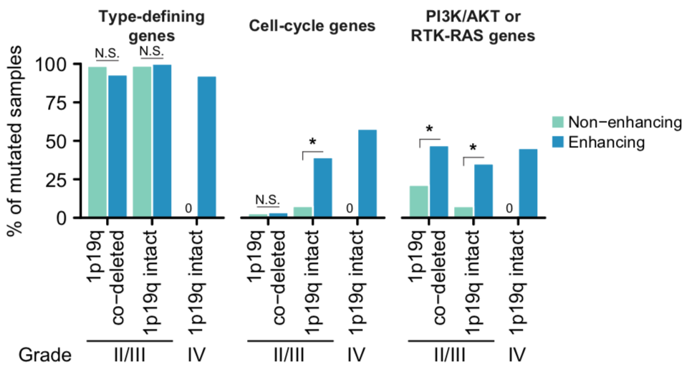

**Figure S5. Frequency of glioma type-defining genes.** The rate of mutations in glioma type-defining genes (*CIC*, *FUBP1* and *TERT* promoter for 1p19q co-deleted tumors; *ATRX* and *TP53* for 1p19q intact tumors), cell-cycle genes, and PI3K/AKT, or RTK-RAS pathway genes. Mutation rates are shown across the three types of IDH-mutant gliomas: grade II/III co-deleted tumors, grade II/III 1p19q intact tumors, and grade IV 1p19q intact tumors, stratified by enhancement. Asterisks indicate *P*<0.05 from Fisher’s exact test, N.S. not significant.

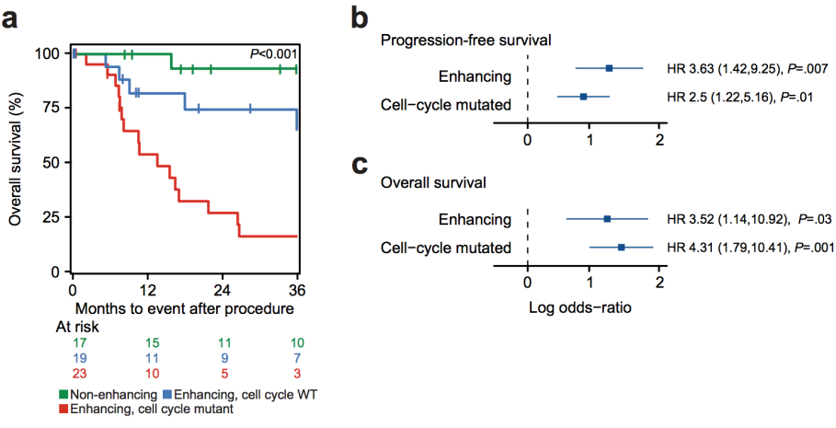

**Figure S6. Outcome by cell-cycle alteration status.** **A)** In patients with IDH-mutant 1p19q intact tumors, overall survival from the time of recurrent surgery is significantly shorter in patients whose recurrence exhibit pre-operative MRI enhancement and whose tumors harbored a cell-cycle alteration. In multivariate models of **(B)** progression-free and **(C)** overall survival in (**Fig. 2E** and panel **(A)**, respectively), MRI enhancement and cell-cycle mutations are independently associated with worse outcome.

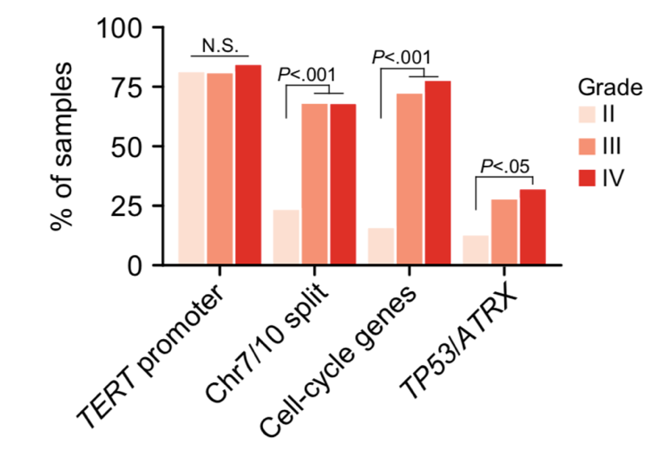



**Figure S7. Alterations in key functional groups in IDH-WT astrocytic tumors.** Common alteration types in IDH-WT gliomas of astrocytic origin are shown. Bars represent the percentage of samples with the indicated histological grade harboring each alteration. All tumor samples from patients with WHO classification of glioblastoma or diffuse/anaplastic astrocytoma were included. P-values indicate significance from pairwise comparison across grades. N.S. not significant.

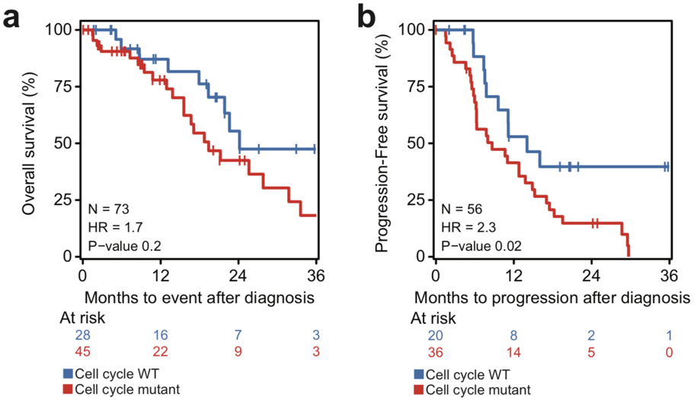

**Figure S8. Cell-cycle alterations and outcome in 1p19q-intact IDH-WT tumors.** The prognostic significance of cell-cycle alterations in primary grade II-III 1p19q intact IDH-WT gliomas with regards to **(A)** overall survival, and **(B)** progression-free survival from time of pathological diagnosis. P-values from log-rank test.

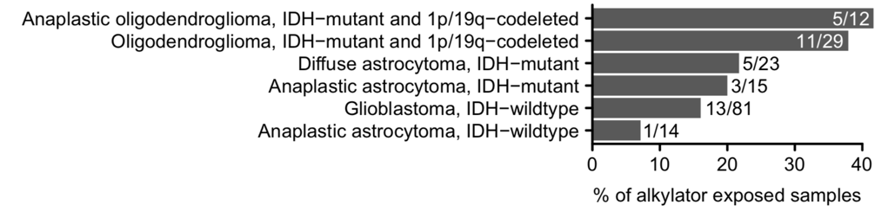

**Figure S9. Rate of alkylating therapy-induced hypermutation by WHO class.** The frequency of alkylating therapy-induced hypermutation by WHO classification, as a percentage of all sequenced specimens acquired post alkylator treatment. Absolute numbers as indicated.

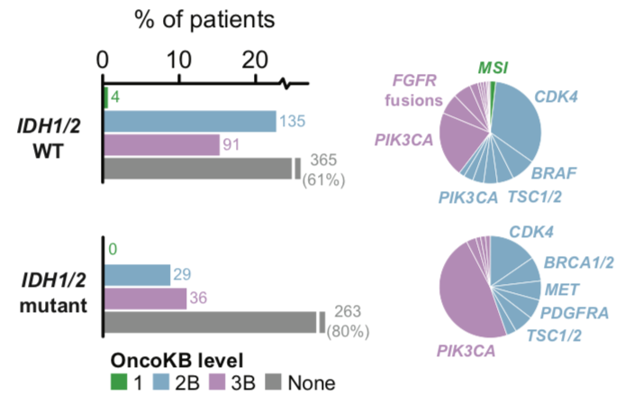

**Figure S10. Frequency of actionable alterations.** Therapeutically actionable alterations across glioma patients with IDH WT and IDH-mutant disease is shown. Bar chart shows highest level of actionability, according to OncoKB curation, detected in any sample from a patient. Pie charts show the most frequently altered and actionable molecular targets in this cohort, as a fraction of the total per subset of IDH-wildtype and -mutant tumors, respectively. Analysis excludes *IDH1/2* mutations.



**Figure S11. *BRAF* hotspot mutations in glioma.** Hotspot mutations in *BRAF* in the study cohort of prospectively sequenced cancer patients (top, MSK cohort) and a collection of glioma samples from public resources (see Methods). Circles represent absolute count of mutations at each protein residue.

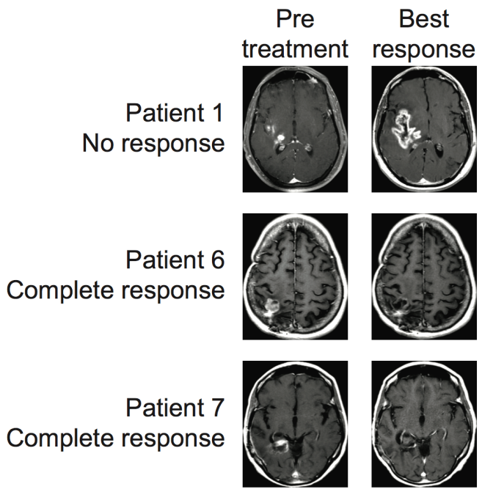

**Figure S12. MR brain images for three patients receiving MAPK-directed therapy.** Pre-treatment and on/post-treatment imaging from patients on MAPK-directed therapy. Numbers indicating patients as in **Fig. 4C**, ordered from the top**.**