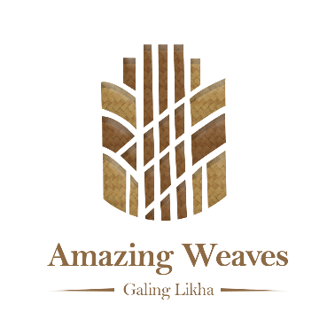
AWDA 2026 — Galing Likha | Document D — Annex D-2: Authenticity & Attribution Declaration
Gate 4 — Attribution Before Innovation: This declaration is mandatory for all entries. It establishes that the cultural knowledge behind the nominated weave belongs to the source community — not to the LGU, designer, or nominee.

Part A — Entry Identification
LGU Name
Weaving Tradition Name (local language)
Source Community (IP community / ethnic group / barangay)

Part B — Authenticity Declaration
I / We, the undersigned, hereby declare that:

- The nominated weave and all associated motifs, techniques, dyeing processes, and cultural narratives are authentic to the [weaving tradition name] tradition, as practiced by the [source community name] community.
- The physical swatch submitted (12" × 12") was produced by weavers of the identified community using the traditional process described in the application form.
- No portion of the swatch was produced by machine, by non-community members, or outside the LGU's jurisdiction, except as disclosed in the application form.
- The fiber composition declared in the application form (Part 3) is accurate to the best of our knowledge. We consent to independent validation by DOST-PTRI if our entry is shortlisted near a threshold boundary.
- The motifs used in the swatch have been correctly identified and named in the application form. Their cultural context is accurately represented.
- We have not misrepresented the weave as belonging to a tradition different from the community's actual practice.

Part C — Attribution Declaration
I / We further declare that:

- The cultural knowledge embodied in this entry — including motif vocabulary, weaving techniques, dyeing processes, and narrative — belongs to and originates from the [enter source community name] community. This knowledge is not claimed by the LGU, the cooperative president, the designer, or any individual nominee.
- The LGU and the cooperating organization participate in this nomination as stewards and market partners — not as owners of the cultural knowledge.
- Any innovation incorporated in this entry builds on the foundation of the source community's knowledge and is clearly attributed to that community in all marketing, exhibition, and commercial materials.
- The attribution statement below is true and will be reproduced verbatim on all product labels, exhibition materials, and media coverage associated with this entry.

Official IP Attribution Statement
(This statement will appear on all product labels, exhibition panels, and media associated with this entry.)

The [weaving tradition name] weaving tradition and all associated motifs, patterns, and cultural knowledge belong to the [source community name] community of [barangay, municipality, province]. The Local Government of [LGU name] and [cooperative / association name] participate as stewards and market partners under free, prior, and informed consent. No claim of ownership over this cultural knowledge is made by the LGU or any individual nominee.

Complete attribution statement as it will appear on the label: __________________________________________________

Part D — Signatures
Declared by Local Chief Executive:  Signature of LCE  Printed Name & Title  LGU Name · Date · Official Seal | Acknowledged by Community / Cooperative Leader:  Signature of Community Leader  Printed Name & Title  Organization · Date

