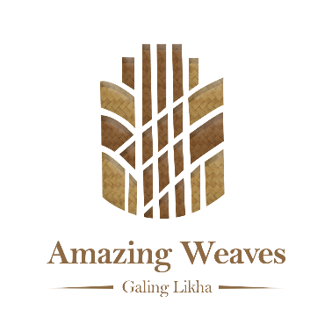
AWDA 2026 — Galing Likha | Document E — Annex D-3: Benefit-Sharing Statement

This document governs how prizes, commercial proceeds, and other benefits arising from AWDA 2026 participation are shared between the LGU and the weaving community. The weaving community must receive a minimum of 40% of all cash prizes. This arrangement is a Track A Community Impact scoring criterion.

Part A — Parties
LGU (Steward Party) | LGU Name: _________________________ LCE: _________________________ Address: _________________________
Community Partner (Beneficiary Party) | Community / Cooperative Name: _________________________ Leader: _________________________ Registration: _________________________
Entry / Nomination | Weaving Tradition: _________________________ Award Category: _________________________
Effective date
Term / renewal | ☐ Valid for AWDA 2026 cycle only ☐ Ongoing — renewable annually

Part B — Cash Prize Sharing Formula
The weaving community must receive at least 40% of ALL cash prizes at any award level. The community's share must be transferred directly to the cooperative's CDA-registered account or through a verified payment method — not held by the LGU.

Award level | Total prize (PhP) | LGU share | Community share (min 40%)
Island Finalist (PhP 30,000) | 30,000 | PhP _____ (___%) | PhP _____ (___%)
Island Winner (PhP 75,000) | 75,000 | PhP _____ (___%) | PhP _____ (___%)
National Winner (PhP 150,000) | 150,000 | PhP _____ (___%) | PhP _____ (___%)

Payment method / bank details for community share: __________________________________________________
Timeframe for transfer after award receipt: __________________________________________________

Part C — Commercial Proceeds Sharing
% of net retail proceeds per piece / meter retained by weavers | ____% (AWDA target for Score 5: ≥60%)
% of net proceeds from ASEAN Trade Show sales | ____%
How is the community's commercial share calculated? | ☐ % of wholesale price ☐ % of retail price ☐ Fixed per-piece rate: PhP _____
When is commercial share transferred? | ☐ Monthly ☐ Quarterly ☐ Per transaction ☐ Other: _____
Does the community have governance authority over commercial use? | ☐ Full (cooperative approves all commercial use) ☐ Partial — describe ☐ Advisory only

Part D — Recognition & Non-monetary Benefits
The parties agree that the weaving community will be credited and recognized as follows in all AWDA-related materials:
- The community is named as the source and rights-holder of the cultural knowledge in all documentation, exhibition panels, press releases, and media coverage.
- The official IP Attribution Statement (Annex D-2) is reproduced on all product labels and promotional materials.
- The community's name and location appear on all photographs, videos, and social media content related to this nomination.
- The community is separately represented in any ASEAN Trade Show booth or exhibition display — not subsumed under the LGU's name alone.

Additional agreed recognition terms:

Part E — Dispute Resolution
- The parties first attempt resolution through direct dialogue within 15 days of the dispute arising.
- If unresolved, the AWDA National Secretariat serves as mediator.
- If still unresolved, parties may seek mediation through the Cooperative Development Authority (CDA) for cooperative disputes, or through NCIP for IP-related disputes.
- In all cases, the minimum 40% community prize share is non-negotiable and enforceable.

Part F — Signatures & Witnesses
LGU Steward Party:  Signature of Local Chief Executive  Printed Name & Title  LGU Name · Date · Official Seal | Community Beneficiary Party:  Signature of Community / Cooperative Leader  Printed Name & Title / Position  Organization · Date
Witness 1:  Name, Title, Organization | Witness 2:  Name, Title, Organization

Received and noted by: AWDA 2026 National Secretariat

National Secretariat Representative · Date

