**Calling Python Functions from MATLAB:**

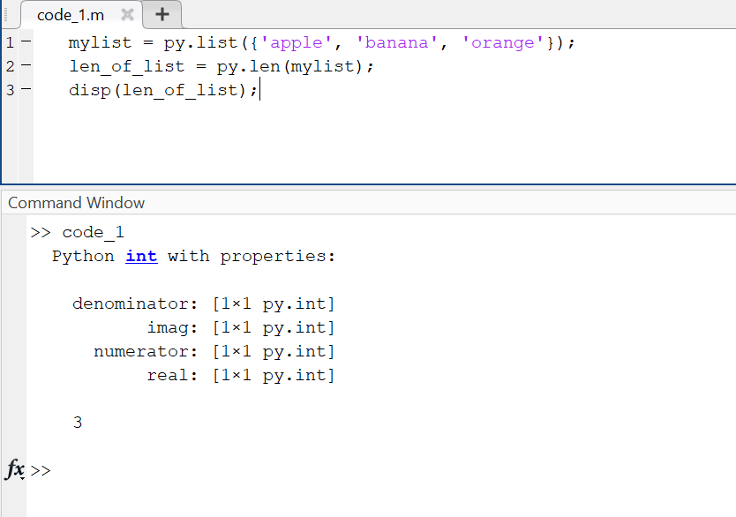

**Using Python Libraries in MATLAB:**

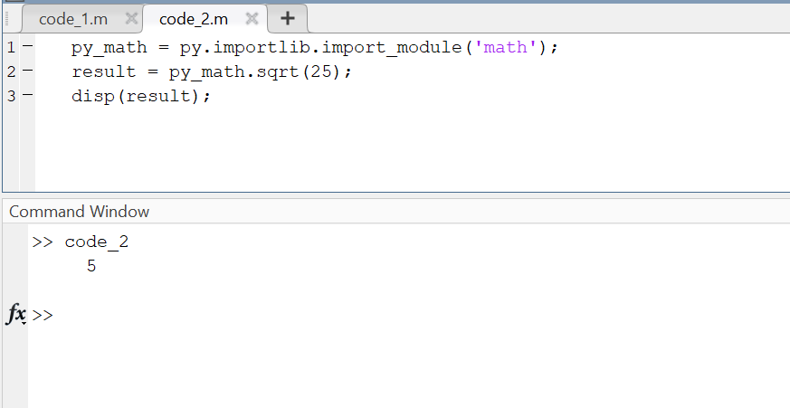

**Running Custom Python Scripts:**

