Int. Modelica Conf. 2015 Paper Title

Author Name1 Author Name2 Author Name3

1Department, University, Country, {name1,name3}@university.org

Company, Country, name2@company.com

Abstract

This template shows the guidelines on how to create a paper to be submitted to the International Modelica Conference. Templates are available for both the LaTeX and Microsoft Word environment. This particular template document should work for both Word and LibreOffice. Please send an email to peter.fritzson@liu.se if there are any questions or suggestions regarding this template

Keywords: keyword1, keyword2

# Introduction

In the following section, short style guidelines are given.

## Keyboard Shortcuts

Many of the styles used in this document can be applied using convenient keyboard shortcuts: push F8 1, for section level 1, F8 b for body text, F8 i for indented body text, etc.

These shortcuts works with all versions of Word, but there is Word bug that the shortcut bindings to keys are sometimes forgotten by Word, especially when starting a new document, or a new author starting to use this template. To re-activate missing keyboard shortcuts, see the next section. Save this document after re-activating.

## Menu Shortcuts & Selecting Styles by Menu

It is very convenient to have common commands available at the top of the Word tool window top title bar quick access toolbar. To add menu shortcuts to the top, click on the top on the small down-array (shown yellow in the small picture below), choose what you want. Notice that many of the more useful ones are shown under *more commands.*

A few of the more useful menu shortcuts are shown activated below, including font inspector with current font size showing, style menu with current style showing, and the paragraph style property editor.

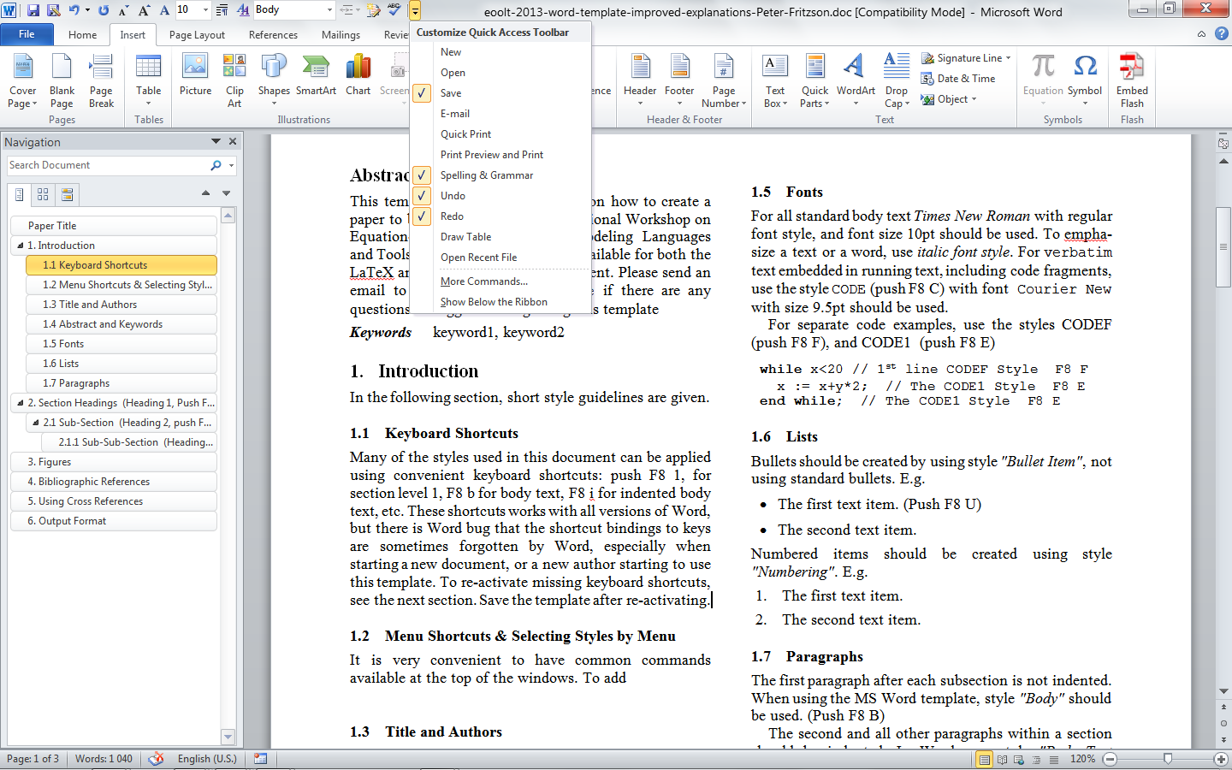

To change a style e.g. re-activating a keyboard-driven short-cut command, do the following:

First add the *Styles* quick access command to the top. (The symbol looks likes two AA partly on top of each other). Then click it and the *Styles* window will pop up:

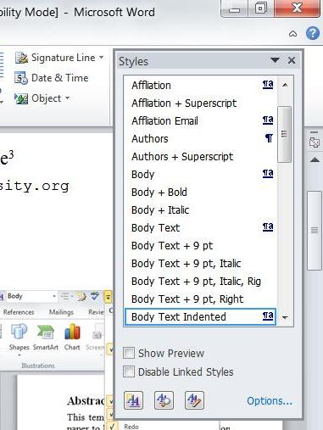

Then in the Styles window, click on the style to be modified (down-arrow at right), select *Modify*…, click on the *Keyboard shortcut* (lower left), click in *press new shortcut keys*, push the two buttons you wish, click Close, OK, etc., save in this document.

## Title and Authors

The title should be centered and use font *Times New Roman* with size 17pt. Words should be capitalized in the title, e.g., "This is an Example of a Correct Title".

The author information should at least include name, affiliation (department, university, country). Addresses and emails are optional but strongly recommended.

## Abstract and Keywords

The abstract should be written as one paragraph. It is not recommended to exceed 150 words.

Appropriate keywords describing the content of the paper should be supplied as a comma separated list.

Figure . An example of a figure that spans over two columns. To move it, click on its border, push shift, click again, move without releasing the mouse. Release shift if need to move it vertically. You can also use arrow buttons to move it.



## Fonts

For all standard body text *Times New Roman* with regular font style, and font size 10.5pt should be used. To emphasize a text or a word, use *italic font style*. For verbatim text embedded in running text, including code fragments, use the style CODE (push F8 C) with font Courier New with size 9.5pt should be used.

For separate code examples, use the styles CODEF (push F8 F), and CODE1 (push F8 E)

**while** x<20 // 1st line CODEF Style F8 F

x := x+y*2; // The CODE1 Style F8 E

**end** **while;** // The CODE1 Style F8 E

## Lists

Bullets should be created by using style *"Bullet Item"*, not using standard bullets. E.g.

* The first text item. (Push F8 U)
* The second text item.

Numbered items should be created using style *"Numbering"*. E.g.

1. The first text item.
2. The second text item.

## Paragraphs

The first paragraph after each subsection is not indented. When using the MS Word template, style *"Body"* should be used. (Push F8 B)

The second and all other paragraphs within a section should be indented. In Word, use style *"Body Text Indented"* for these paragraphs. (Push F8 I)

# Section Headings (Heading 1, Push F8 1)

Section headings should be numbered. Words in the headings should be capitalized. The, style *"Heading 1"* should be used for the main section headings.

## Sub-Section (Heading 2, push F8 2)

Subsections are numbered and style *"Heading 2"* should be used.

### Sub-Sub-Section (Heading 3, push F8 3)

It is possible to use sub-sub-sections (style *"Heading 3"*). However, if possible, only sections and sub-sections should be used.

# Figures

Figures should be numbered and include a description text. All figures should be referenced within the body text by an insert cross reference to Figure (onlylabel+number).



Figure . Example of figure text.

When using MS word, style *"Caption"* could be used, as shown in the example. The style "*Figure*" should be used for the line where the picture is placed[1].

It is recommended to copy a figure + caption such as the one below and modify the contents when creating a new figure.

The figure numbering will be automatically updated when selecting the whole article text by ctrl-A, and pushing alt/shift-U for the number updating.



Figure . Example of figure text.

This is another Body paragraph, followed by another Figure.



Figure . Example of figure text.

The following is an example table:

Table . Sizes of Compiler Phases, Lines of Code.

|  |  |
| --- | --- |
| *Compiler Phase* | *Lines* |
| BackEnd (from flat Modelica to sorted eq.syst.) | 29190 |
| Code generation (generated code) | 35971 |
| Code generation (template source code) | 8957 |
| FrontEnd (up to flat Modelica) | 92192 |
| OpenModelica scripting environment | 21883 |
| Template language Susan compiler | 12119 |
| Unparsing modules | 16984 |
| Utility modules | 12983 |
| *Total size (excl. generated code)* | *194218* |

# Equations

Equations should be numbered on the right side, such as:

|  |  |
| --- | --- |
| $$J\ddot{φ}=τ_{1}+τ_{2}$$ | (1) |

There can be also more complicated formulae:

|  |  |
| --- | --- |
|  | (2) |

# Bibliographic References

The bibliographic reference list are shown at the end of the paper; starting with an unnumbered heading *"References"*. The list of references should be sorted in alphabetic order according to the first author's surname.

Citations are stated within the body text by inserting at most two author names and the publication year in parenthesis, such as (Pantelides, 1988) or (Tuffin *et al*, 2001). Two or more citations can be combined, separated by semicolon: (Pantelides, 1988; Augustin, Fineberg et al 1967)

# Using Cross References

To insert a cross reference to a heading, use menu item Insert->Cross-reference, reference type Heading, select reference to paragraph number.

To insert a cross reference to a Figure, use menu item Insert->Cross-reference, reference type Figure, select reference to Only Label and number.

To update all cross-references and re-number figures, first select all text (ctrl-A), then perform the update command by pushing 3 keys simultaneously: Alt-Shift-u

# Output Format

The paper should be submitted as a PDF-file using page size A4 (not US Letter!). All fonts should be included in the PDF-file.

Note: When using PDF-generators such as Adobe Acrobat PDF generator, remember to enable high-quality output. If this option is not enabled, figures and photos may be reduced in quality, resulting in poor quality when printed.

Acknowledgements

The templates and instructions were created by Peter Fritzson with feedback from Martin Otter, based on an earlier EOOLT workshop version created by Peter Fritzson and David Broman.

References

*References are in 9.5 pt font size, and should be ordered alphabetically according to the surname of the first author. Shortcut key to apply a reference style is F8 R. It is recommended to supply a DOI at the end of the reference.*

Donald C. Augustin, Mark S. Fineberg, Bruce B. Johnson, Robert N. Linebarger, F. John Sansom, and Jon C. Strauss. The SCi Continuous System Simulation Language (CSSL). *Simulation*, No 9, pp. 281–303, 1967.

Iain S. Duff and John K. Reid. An Implementation of Tarjan’s Algorithm for the Block Triangularization of a Matrix. *ACM Transactions on Mathematical Software*, 4(2):137–147, 1978. doi:

Constantinos C. Pantelides (1988): The Consistent Initialization of Differential-Algebraic Systems. *SIAM Journal on Scientiﬁc and Statistical Computing*, 9(2):213–231, 1988.

Benjamin C. Pierce. *Types and Programming Languages*. The MIT Press. 2002. doi:10.1145/2593882.2593895.

B. Tuffin, D. S. Chen and K. Trivedi. Comparison of hybrid systems and fluid stochastic Petri nets. *Discrete Event Dynamic Systems*, 11 (1/2):77-95, 2001. doi:10.4271/2009-01-0746.

1. Footnotes should be numbered and located at the bottom of the column.