Accompanying master document
Containing the software’s documentation and supporting information including requirements, design artefacts, implementation notes and testing documentation; also the group work diary and peer review form

AI Transparency Scale declaration
The extent to which AI was used in this assignment was either at or below level 2 on the AI Transparency Scale.

Product goal
Product goal: to enable donors and charities to co-operate with sharing clothes and tracking carbon savings through a secure and performant web application.

Overview, other files and external evidence
This document, which is pointed to by the git repository’s README.md file, contains various pieces of required evidence but also serves as the master document, referencing and explaining anything else relevant to the grading of our work.
The git repository itself, containing the software and this document, is available at https://github.com/Galladite27/SHU-ASE-2025. Please see its README.md file for information concerning the usage of the delivered software (the website) itself.
The requirements, design artefacts, implementation notes, testing documentation, group work diary and peer review form are contained within this document. The video presentation is linked to within this document in its appropriate place.
Table of Contents
AI Transparency Scale declaration 1
Overview, other files and external evidence 1
Planning & implementation notes 1
Requriements 3
Design artefacts 4
Testing documentation 5
LSEPI Reflections 6
Video presentation 7
Group reflection and collaboration 8
Incorporation of formative feedback 9
Group work diary 10
Peer review form 11

Planning & implementation notes
Our tech stack consists of Next JS for the front and back end, with SQLite for our database.
We used Github for collaboration and version control. As required, we have a master branch for working and major versions (though not necessarily releases), a development branch for merging working changes into, and feature branches for day-to-day work; we also tried to ensure each merge request into the development branch had at least one review.
Our initial roles were as follows (although we tried to have people assist with other areas):
Role | Members
Frontend | Laurie, Alex, Ryan
Backend | Laurie, Ryan, Haris, Theo
Database | Haris, Theo
Documentation | Laurie

Requriements
User stories:
Title: Donation Processing | Priority: MUST | Estimate: --------
As a Donor, I want to be able to submit the details of the item(s) I wish to donate alongside an optional description and photo so that I can clearly view which item I have donated.
Acceptance Criteria
Given I am signed in as a donor.
When I wish to make a donation provide the correct information for my chosen item.
Then The system should:
- Update to include my item which has been successfully donated.
- Validate the details of the item which I choose to donate.
- Update the display to include my donated item.
Stage of Implementation

Title: Donor impact report | Priority: MUST | Estimate: --------
As a Donor, I want to be able to view the Co2 savings that I have made by visiting my profile so that I can view the environmental health contributions I have made by choosing to donate my clothing rather than discard it.
Acceptance Criteria
Given I have signed into my account and my donation has been successfully processed.
When I wish to view my personal Co2 savings.
Then the system should:
- Calculate my current carbon savings.
- Display my carbon savings to me.
Stage of Implementation

Title: View any branch specific stock updates to monitor store progress. | Priority: MUST | Estimate: --------
As a member of charity staff, I want to be able to view the donated stock including availability, categories and the quantity donated so that I can effectively manage the stock level for the store.
Acceptance Criteria
Given I have logged in to my account
When I select to view the inventory
Then I should easily be able to view the different categories such as:
- The current level of donated stock in total.
- A breakdown of the total stock level, broken down into specific categories for example, Jeans, T-Shirts, Jackets and Shirts.
Stage of Implementation

Title: View Branch specific stock and distribution information | Priority: MUST | Estimate: --------
As a member of Charity Staff, I want to be able to monitor incoming donations, view the current stock levels and a record of the distribution so that I the stock can be distributed further across stores depending on their differing stock levels. (i.e., if one store has low stock levels and another has very high stock levels, the items can be sent to the low-stock store).
Acceptance Criteria
Given I have successfully logged into my account.
When I view the dashboard for my store.
Then I should be able to view:
- Incoming donations.
- The current stock level of my specific store.
- A record of the distribution for my specific store.
Stage of Implementation

Title: Account view, removal and edit | Priority: MUST | Estimate: --------
As an administrator, I want to be able to oversee the system and manage user accounts so that I can edit and view user details when needed.
Acceptance Criteria
Given I have logged in successfully
When I select an account to edit or delete
Then I can perform the following database requests:

- Edit the information of the user
- Remove data (accounts) from the database
- View the user information within the system
Stage of Implementation

Title: Donation Trends | Priority: MUST | Estimate: --------
As an administrator, I want to be able to view the current donation trends as part of the analytic reports so that I can understand the current market and where we may need more or less stock in specific stores.
Acceptance Criteria
Given I have logged in as a member of administrative staff
When I view the report that has been generated
Then I can view:
- The donation trends across the stores
- Business-wide donation trends
Stage of Implementation

Title: Donor Account Registration | Priority: | Estimate: --------
As a donor, I want to be able to register for an account on the system so that I can donate my unwanted clothing to help the environment.
Acceptance Criteria
Given I have provided an email password that meets the criteria (password criteria including special characters, alongside a combination of uppercase and lowercase letters and numbers)
When I select the “Register” button.
Then The system should
- Greet me with a message
- Present me with my dashboard
Stage of Implementation

Title: Donor Log-In function | Priority: MUST | Estimate: --------
As a Donor, I want to be able to log into my account so that I can utilise my account to make donations and view my personal dashboard.
Acceptance Criteria
Given I have entered my information correctly
When I press the “Log In” button.
Then I can view:
- My up-to-date personal dashboard (incl. Co2 savings and information)
- Other pages such as pages to manage my account (e.g. account removal)
Stage of Implementation

Use case diagram:
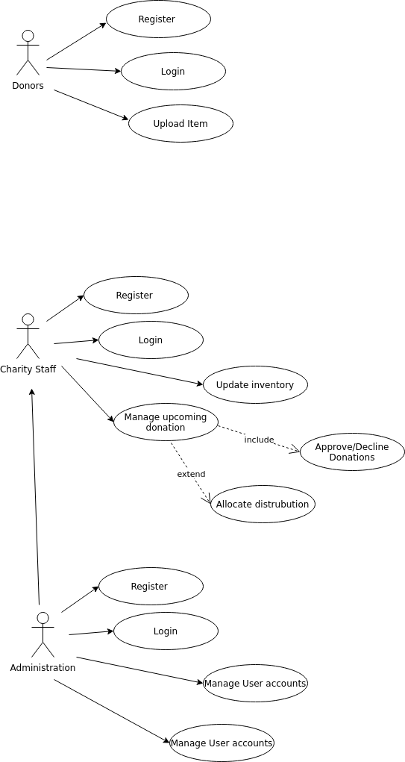

Design artefacts
Context diagram
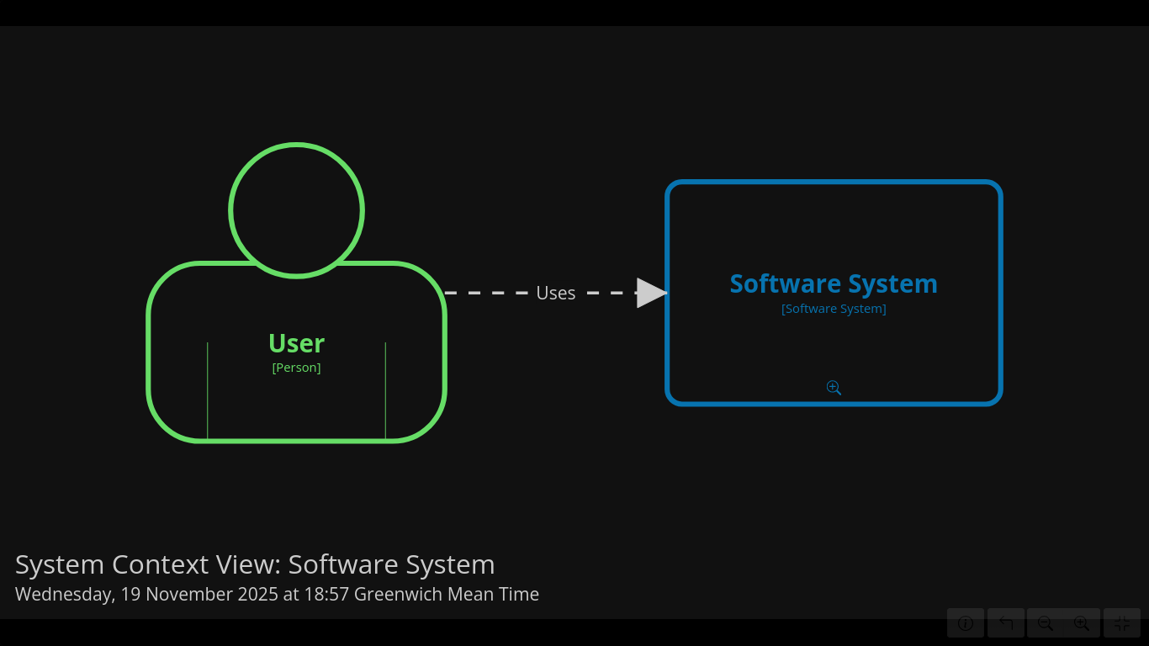
Container diagram
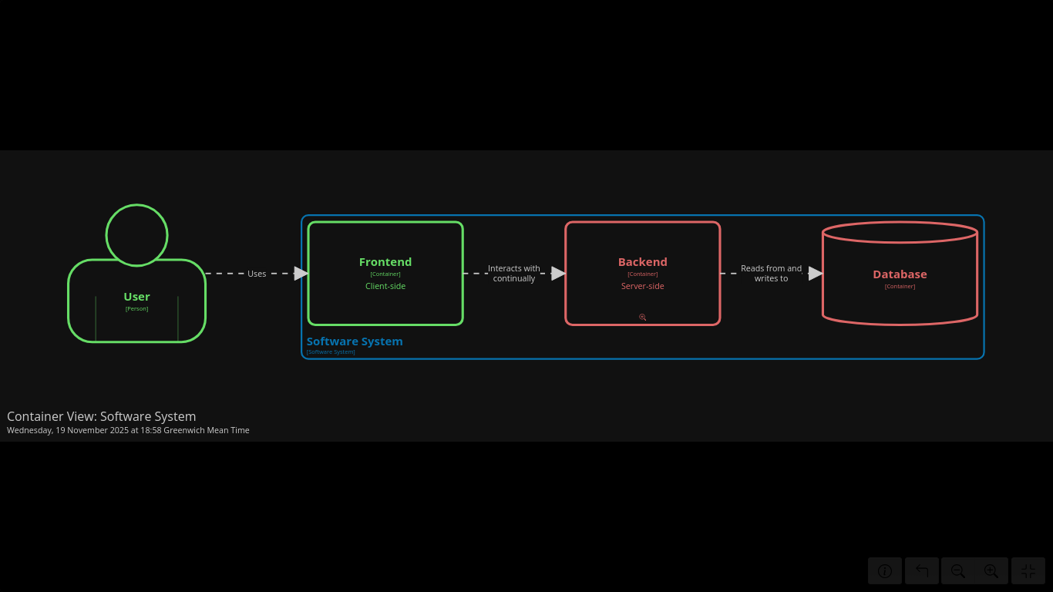

Component diagram (web app, database, APIs)
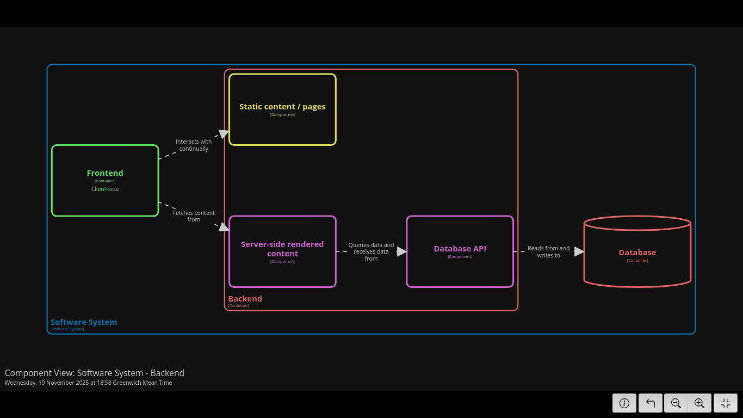
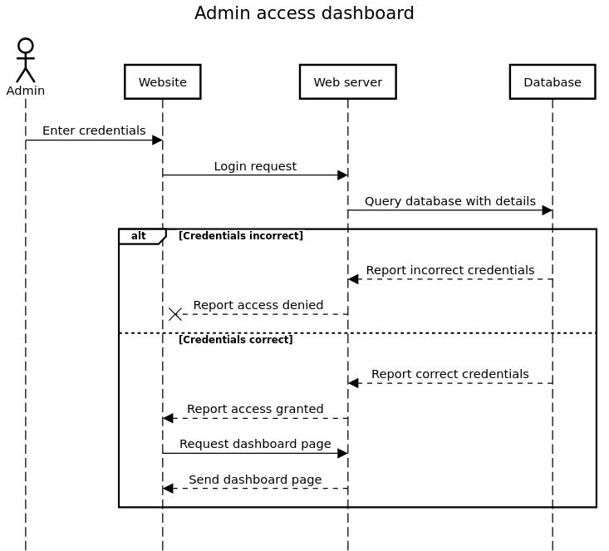
Sequence diagram (for an admin logging in):

Entity relationship diagram:
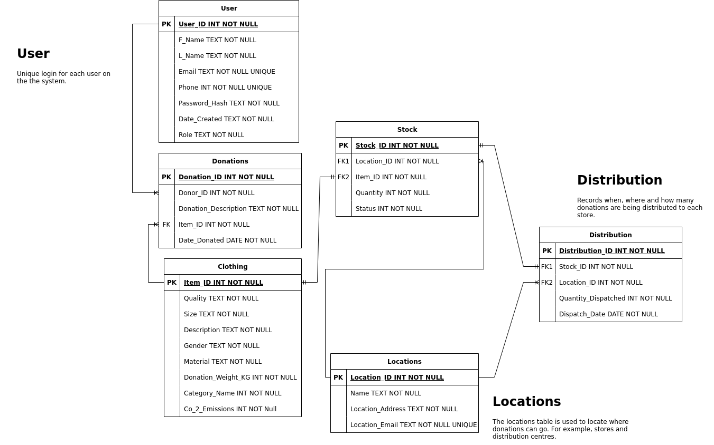
Wireframes:
https://rp.mockplus.com/team/invitation/xEeXM_6VJ/zrqflvnwud
https://rp.mockplus.com/team/invitation/bVIzRUSii/zrqflvnwud

Testing documentation
We didn't consider testing throughout using a shift-left approach, and so all our testing (besides continuous basic testing as features were added) was carried out near the end of the project.
We didn't implement unit tests, however we carried out acceptance tests (to do with the user stories), as well as some usability and security tests.
Test no. | Test type | Test description | Passed? | Resolution
1 | Functional | "Donation processing" (user story) | Y | N/A
2 | Functional | "View stock" (user story) | Y | N/A
3 | Functional | "Account view, removal, and edit" | Y | N/A
4 | Non-functional | Lighthouse accessibility report <95% | N | Theo reviewed and made certain changes to improve this score
5 | Non-functional | Role-based page access protection | Y | N/A

LSEPI Reflections
Firstly, one of the main issues that may be presented through the SustainWear system is an ethical issue. When users donate through the system, they are incentivised by being able to see their personal Co2 savings.
For us, this means that we must ensure that the carbon savings that we display are accurate. Otherwise, we could be accused of “Greenwashing”. According to (Cambridge, n.d.), “greenwashing” is “behaviour or activities that make people believe that a company is doing more to protect the environment than it really is”.
Greenwashing can lead to serious consequences. According to (Ireland, 2023) it can lead to “Loss of trust and credibility”, “Legal consequences”, “increased scrutiny” and “Lost competitive edge”. All of these could very badly affect the business.
In terms of social issues, we need to ensure that the donation system is accessible to different users such as people with disabilities, elderly donors and non-technical users. As our platform is web-based, we can address this by performing lighthouse checks on our site to ensure we have included facilities such as alternative text for images and our site is compatible with screen readers. We also strengthened accessibility by following WCAG guidelines, these support users with assistive technology needs by providing a simple, predictable navigation structure.
A third legal and ethical issue to consider is the secure handling of user data. To align with the GDPR legislation we used Clerk for authentication. Clerk processes sensitive information such as email addresses and account credentials within a secure audited system.
According to the Information Commissioner’s Office (ICO), organisations must implement “appropriate technical and organisational measures” to prevent unlawful processing or loss of personal data (ICO, n.d.). By using Clerk, we ensured the secure handling of user data as Clerk uses the most up to date encryption measures such as bcrypt which incorporates password salts and computational rounds to prevent brute-force and rainbow-table attacks. Furthermore, secure-routing via role-based access allows user protection which maintains compliant and trustworthy without building over complicated security layers for our small development team.
Overall, the project required us to address legal, ethical, social, professional, accessibility and sustainability considerations. By integrating secure authentication, accurate environmental data and an accessible design. The system reflects responsible and professional software engineering practices.
Bibliography
Cambridge. (n.d.). Cambridge Dictionary. Retrieved from Cambridge Dictionary: https://dictionary.cambridge.org/dictionary/english/greenwashing
Ireland, J. (2023, 10 04). False promises: the negative effects greenwashing can have on your business. Retrieved from Reed: https://www.reed.com/articles/the-negative-effects-of-greenwashing
ICO. (n.d.). Data protection principles. Retrieved from https://ico.org.uk/

Video presentation

Group reflection and collaboration
Overall, we worked quite well as a team although unfortunately one member didn't turn up very often and didn't want to participate in the presentation, saying he wasn't planning on coming back after Christmas.
Laurie: "My thoughts on the agile method is that it was quite useful for our team, and I'm sure that it was the better choice for our purposes than a traditional method, due to our small team, unusual timetable, need for continuous updates to give to tutors and lack of knowledge about how things would go. However, ironically I found that the agile method was (seemingly artificially) restrictive in some ways, such as how sprints were supposed to be the same length when this just didn't fit our project."
The main challenges we faced in this project were to do with communication, but it never got very bad because we ensured we had frequent (often at least weekly) in-person meetings and maintained online correspondence.
Alex: "One of the collaboration challenges that I personally faced which I feel affected the group was the difficulty of managing the GitHub branches. I found it difficult to keep track of who was working on which branch and therefore which branch I needed to branch from whilst I was doing certain tasks. Aside from this, GitHub worked really well for our team on the whole and I feel as if I learned a lot about how to use and manage it correctly from other group members such as Laurie."
Theo: "A challenge I faced during this was with the database as Ryan had originally designed the ERD diagram which would shape the database and backend for the project and then I looked and edited some parts normalising it and some parts replacing but didn’t completely redo. This is because I didn’t want to take over and undo everything that he did. This led to a Frankenstein of a database as it was two peoples vision of the database which in my opinion made it harder to use. I should of communicated and worked with Ryan to create a better solution."
Theo: "Also if we had more time we would of implemented an AI to help recognise the what piece of clothing was uploaded by the user. This could increase the donation speed and allow for greater CO2 savings. This could be done by using clarfai apparel classification ai, this recognises the clothes worn by the user and decides what category it should fit into. The drawback to this API is that it works best when the clothes are worn by the user and not layering down or on a coat hanger."
Theo: "Another AI categoriser that I think could have been beneficial to this project is velebit ai fabric pattern recognition this checks the pattern on clothing this could be stored and shown to the charity staff so that they could have more information on the clothes being donated before having to check the image."
Theo: "but even if we did use ai to help categorise it should be the priority to allow the user to change this as AI is not always perfect and the user would know more about the item."

Incorporation of formative feedback
Date | Feedback | Response
16/10/2025 | - Use case diagram needs boundary and name at the top  - Use case diagram should have a generic user who can log in, with other roles inheriting that  - User stories need more specific acceptance tests | - Use case diagram modified to accomodate these requests  - User stories elaborated
12/11/2025 | - We need to be focussing our sprints on meeting user stories | - Sprints from now will aim to specify which user stories are benefitted, and not just focus on technical details

Group work diary
We maintained a backlog in the file backlog.md, the history of which can be seen in our published releases on Github produced following each sprint. However a sprint-on-sprint record has also been maintained here for your convenience. In addition, we held brief daily scrums as requested, some contents of which have been presented below.
Sprint | Date | Length | Work completed
0 |  |  | Pre-sprint planning  - User stories (Alex)  - Use case diagram (Haris)  - Entity relationship diagram (Ryan)  - Wireframe (Alex)
1 | 14/10/2025 | 1 week | Goal: to complete the planning documentation and the framework for the rest of the documentation, and begin work on the most fundamental aspects of the system  - Page routing (Laurence)  - Dummy pages (Haris)  - Clerk authentication (Haris)  - Landing page login (Haris)  - Review of planning documentation consistency (Laurence)
2 | 21/10/2025 | 2 weeks | Goal: to create various graphical analytics components for the web app, create and populate a database with dummy values, and link the components to draw their data from the database  - Make working database version (Theo & Haris & Ryan (?))  - Ensure database matches ER (Laurie)  - Ensure database is write-protected (Laurie)  - Link analytics to database  - Admin analytics - view stock intake & donation trends (for user story)  - Admin (and donor) analytics - track sustainability metrics  - Admin analytics - generate report trends  - Admin analytics - monitor distribution performance
3 | 04/11/2025 | 1 week | Goal: to finish making the dashboards for all pages and link database to graphs  - Create dashboard for remaining pages  - Link analytics to database  - C4 diagrams
4 | 11/11/2025 | 2 weeks | Goal: to ensure that missing features are added and the application is functional  - Various administrator pages (user stories: admin report generation, admin donation trends)  - Charity pages, donation pages all working (user stories: various)  - LSEPI writing
5 | 25/11/2025 | 1 week | Goal: to continue ensuring that missing features are added and the application is fully functional; also to begin working on the presentation (user stories: admin report generation, admin donation trends  - Tie up loose ends  - Begin writing the presentation
6 | 2/12/2025 | 2 weeks | Goal: to finish writing and record the presentation  - Draft the presentation (Laurie)  - Individually flesh out sections  - Group call and record!

Peer review form

