Mobile Project Developer Diary 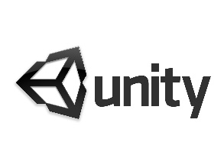

Stephen Gallagher G00314689

# Table of Contents

- GitHub Repo

- Unity Version used

- Description

- Day to Day Developer Diary

- controls

- conclusions

- References

# GitHub

<https://github.com/GallagherStephen/3dEndlessRunnerNew>

Unity version used

2019.3.10f1

# Description

Developer Diary for mobile app development 3 unity game Project

# Day to Day Developer Diary

# 1/11/2020 - 20/11/2020

Studied the Design Document and researched into the different areas needed to carry out the designed game.

With all my research into what was needed for my game I realised that the only area I would need to look further into was the multiplayer functionality.

As I have had no experience as of yet around multiplayer. This which will be a new learning experience. To date after all my research I have created a repository called 3dEndlessRunnerProject

where I initially created a game with a course my player would take. But I came into an issue with my game scene which had frozen and led me restarting my project with a new repository called "3dEndlessRunnerNew".

## 20/11/2020

* Project repository created and game started.
* I have created a plane that is being used as the main track of my 3dendless runner game.
* Then I went and created each triangular/pyramid structure using

3d cylinders to achieve the effect that was given in the design document pictures. These which I put in Pink to match.

* I then went and created the main player using different 3d shapes to match the character given in the design document pictures also. These steps which took some time in doing.
* I then added the player controller functionality where they could move using the wasd or arrow keyboard keys.
* I then imported an asset from the asset store of a skybox that gave my game a nice futuristic space like feel which the design theme set out for.
* I went and then added music to my game that plays at the beginning of the game for a "Cyberpunk 80s theme" feel as requested in the design document.

20/11/2020

* I went and added the functionality of the player being able to jump on request by the user when the spacebar is pressed.

## 02/12/2020

* I redone my Level 1 scene and this time I made the player and the camera move in the same direction in Sync (this done by two scripts.one for camera and one for player character).This which pushes the player forward in the correct way for an Infinite Runner Game.
* I also created another two levels identical to the first bar the enemies and pickups located on the players route. This which I have different in each level as I am distinguishing the difference in levels and what they should contain. For e.g.:

(level 1 for now has 1 enemy)

(level 2 for now has 3 enemy’s and one pickup)

(level 3 for now has 5 enemy’s and two pickups).

03/12/2020

Part (1)

* Added functionality to move between menus.

part (2)

* added better surrounding visuals to the gameplay scene. This where I got assets to have the following. Pyramids

(which I modified to add blue edges like image in design brief)

* planet which is also in the design brief photo, stars and clouds in the distance to make some realism. (moving objects). Added an image to the plane(ground) which makes the ground look like a grid as in design document image.

08/12/2020

* added pickups for the player to collect and destroy on collision. These "mail" pickups which when picked up will add up the score for the player. Making up the objective of the game to get a high score.
* Added scripts to game to make this possible (mailScript + pointScript)
* added a tile spawner that makes the game endless being a endless runner.
* fixed being able to die by enemies and pick up emails, which was an issue the way I had it setup
* Added a Volume toggle to the game with a "MuteManager" script
* fixed toggle volume on main menu
* removed unwanted scenes
* fixed quit button to quit the application by adding quit method in "buttonManager" script
* added load game -level select menu - with EASY, MODERATE & HARD levels
* added the pause menu overlaps the gameScene when "ESC" button is pressed.

09/12/2020

* created the following enemies: firewalls and baston servers
* created a high score UI element for player to see.
* created a Time UI element for player to see when in game. (created a Time Script for this which outputs time to two decimal spaces as passed in "f2" ...to four decimals would be "f4")
* added dialog popup box on "trigger enter" at start of each level - DialogeTrigger Cube element ("DialogeTriggerScript")
* added a trigger to load to the next level using a script I called "LoadLevelTrigger"
* linked all levels together with the level trigger at end. This making a completed game feel.
* added music to end game scene
* changed the plane ground on each level to distinguish changed levels

## 10/12/2020

* created sounds to play on awake at the start of each game scene
* added the correct powerups to each scene
* added a purple particle effect to instantiate when trigger the powerup object with player
* changed speed of the player for each level (to show change)
* added that each level enemy count is higher to make each level harder
* added 5 baston servers (enemy) to level 3

## 13/12/2020

* copied current "status" of scenes 1-3 including end game scene and renamed them to create a Local Multiplayer.
* linked all multiplayer scenes to transition between them by end of scene triggers and by button presses to load next scene.

14/12/2020

* added that you restart the "current" level you are on if you die in Multiplayer. For P1 & P2. (Like a checkpoint system)
* clamped the players movement between the values (-1.7f, 1.7f) on the x axis.

# Controls

To play the game:

To move the character “Agent-Xero” you will need to use the keyboard buttons

* “A” to move left
* “D” to move Right
* “spacebar” - to jump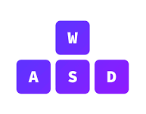

# conclusion

# Overall, I am happy with how the game turned out. A few areas I feel I could of polished off better , but when I refer back to the design brief and then look at my game I think I have achieved nearly exactly the feel and expectations wanted to be captured by the Designer when he wrote up that Design document. I have achieved a futuristic 80’s themed, cyberpunk look of a game that stands out to anybody viewing. I made the email pickups from scratch including the locks, player and enemies. This to capture the exact look that the Designer wanted. I even went and got sounds that play on awake at the start of each level that go with the theme and objective of the levels. For example, level one had “lets get to the mainframe”.

# I then went and made it an “endlessRunner” with a tile spawner but with endpoints/triggers that loads the next scene as stated by my Designer as he wanted, and I quote

# *“a single “Endless” level should probably be avoided. Instead opting for short levels that can be completed quickly “.*

I feel I also kept the menus as requested simple as I referred to the design document. As stated in the design document:

* “I wish to avoid complicated and cluttered menus”
* “I aim to keep everything simple and easy to understand through-out the game”

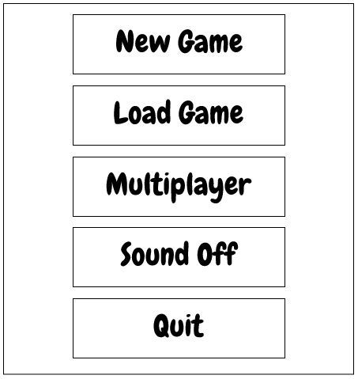Design brief: Game:

# 

For Multiplayer I feel I have created a good working game for two people (locally). This which In future can be upgraded to having online for multiple devices. But for a game that was made to get as close as possible to what the designer wanted to achieve; I feel I have done justice with this multiplayer for now. This multiplayer which I have the player one going first through the three levels then player two being asked to continue and play three levels and then displaying a score at the end. Stating who wins.

Each level I have made harder, showing to the user that the game is getting trickier as they progress. This which I have done by making the players horizontal movement faster as the higher the level. For ex : level 1 : 10 moveSpeed, level2 : 25 moveSpeed , level 3 : 40 moveSpeed.

I also made each level enemies correspond to the ***design brief level requirements***

Level 1 :

* 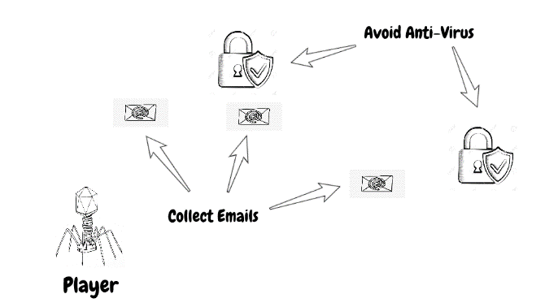-email pickups
* 9 locks -enemies

Level2 :

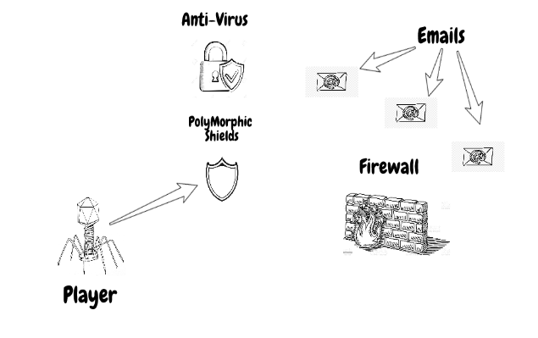

* -email - pickups
* 3 walls - enemies
* 12 locks -enemies

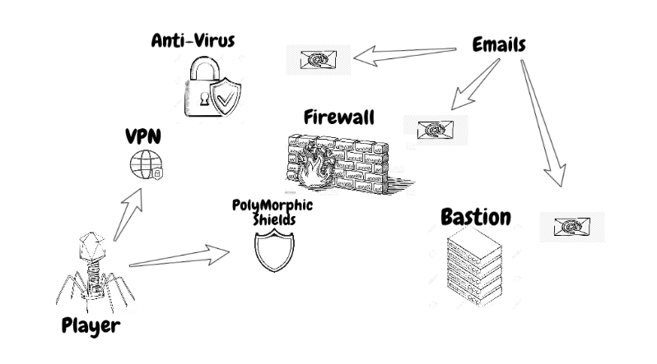

Level 3 :

* -email pickups
* 7 walls - enemies
* 11 locks -enemies
* -5 baston servers – enemies
* shield powerup
* Vpn – powerup

In relation to the user interface I think I have achieved the look and style wanted by my designer

Design Document: Game:

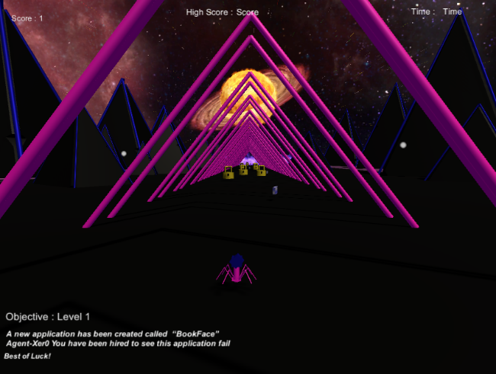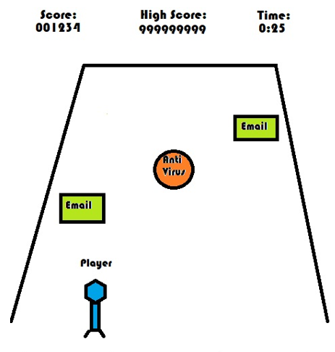

So, When I look at the game overall, I am quite happy with how it turned out. Despite not having everything 100% carried out. This which I am referring to the powerups. This which I had setup to be picked up but I never got to implement it carrying out an ability. I was going to make the player double in size or shrink in respect to picking it up but left it commented out as this didn’t go with the requirements that my designer stated in the design document(this implementation can be seen in both powerup scripts relating to each powerup ,one script for each) . But besides this I am happy with the end result and I’m sure anybody looking at the design document then at my game would also agree I did the game good justice in respect to the design document.

# References

* **main Player** - made him from scratch using different shapes **(to *match design brief)***
* **enemies** - made them from scratch using different shapes **(to *match design brief)***
* **materials** – I got images from google images for some objects and I also just made bright aluminous looking colours to match images for the look of the game in the design document

# **Pyramids** - asset taking from the asset store called “Desert Kits 64 Sample” then edited by adding cylinders to them to give them the blue edge

# (to ***look like the Design Brief )***

# https://assetstore.unity.com/packages/3d/environments/landscapes/desert-kits-64-sample-86482

* **music** – song taken from YouTube ***then shortened*** to just be the chorus using ***Audacity***

<https://www.youtube.com/watch?v=PVRqdlt2pqg&ab_channel=HEADSPLITTER>

* **skybox** – asset taking from the asset store called “Space Skies Free”

**(**to ***look like the Design Brief)***

<https://assetstore.unity.com/packages/2d/textures-materials/sky/spaceskies-free-80503>

* **shield powerup** – asset taking from the asset store called “Shield”

**(**to ***look like the Design Brief)***

<https://assetstore.unity.com/packages/3d/props/weapons/shield-61351>

* **vpn powerup** – asset taking from the asset store called “Ball Pack”

(***to look like the Design Brief)***

<https://assetstore.unity.com/packages/3d/props/ball-pack-446>

* **Sun/Planet -** asset taking from the asset store called “vast-outer-space”

(***to look like the Design Brief)***

<https://assetstore.unity.com/packages/3d/environments/sci-fi/vast-outer-space-38913>