There are three downloadable components in this project.

1. Web ova template – device intelligence diagnosis web service host.
2. DoctorJoeAgent installer – A light-weighted diagnosis agent with simplified UI for end user to start a diagnosis for peripheral devices. Installed on the horizon windows agent machine.
3. DoctorJoeClient installer – A light-weighted diagnosis plugin to be installed on horizon windows client machine

Notice:

We only support windows client and windows agent for device diagnosis in the current scope.

Generally, there are two ways to deploy the services and components in your horizon environment.

1. If you are inside VMware corporate network, you can skip the web ova deployment part. Only install the DJagent and DJclient is sufficient. We have set up a local web service (djintelligence.eng.vmware.com) for VMware internal users.
2. If you are external customer and users, you need to setup the web ova server and install the DJclient and DJAgent components in your local environment following the guides below.

**Web OVA deployment guide**

Download the web OVA file to your local machine. The ova file is compatible with VSphere 6.5 and later version. Login a VCenter or VSphere admin console， follow the deploy OVF template workflow to import the ova into your VSphere.

In the Select storage page, choose a valid datastore and Thin Provision for virtual disk format.

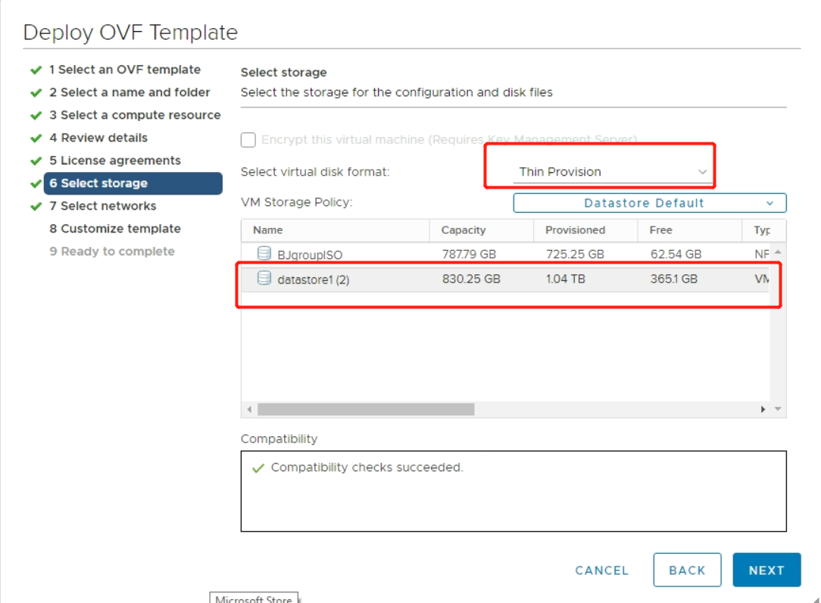

In the Select Network, choose a valid virtual network name in your setup (In the demo, it is VM Network). Choose Static-Manual as the IP allocation settings.

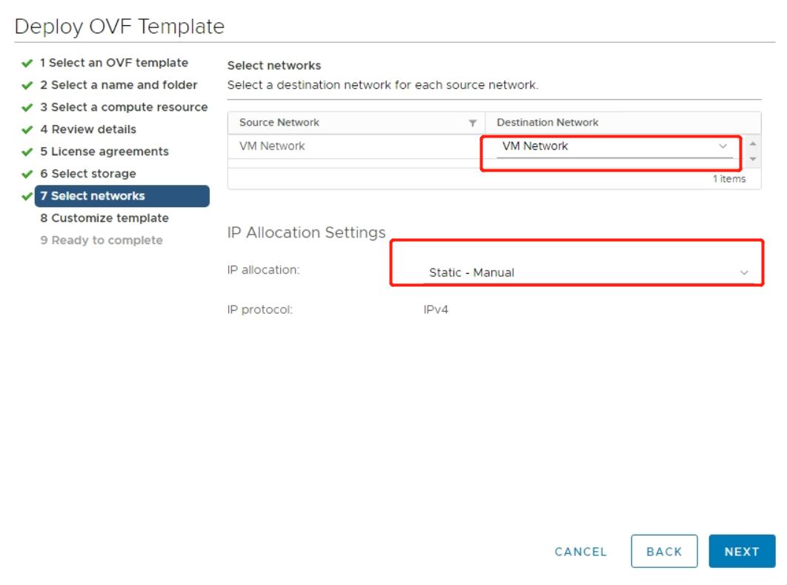

In the Customize template, there are 6 optional settings provided.

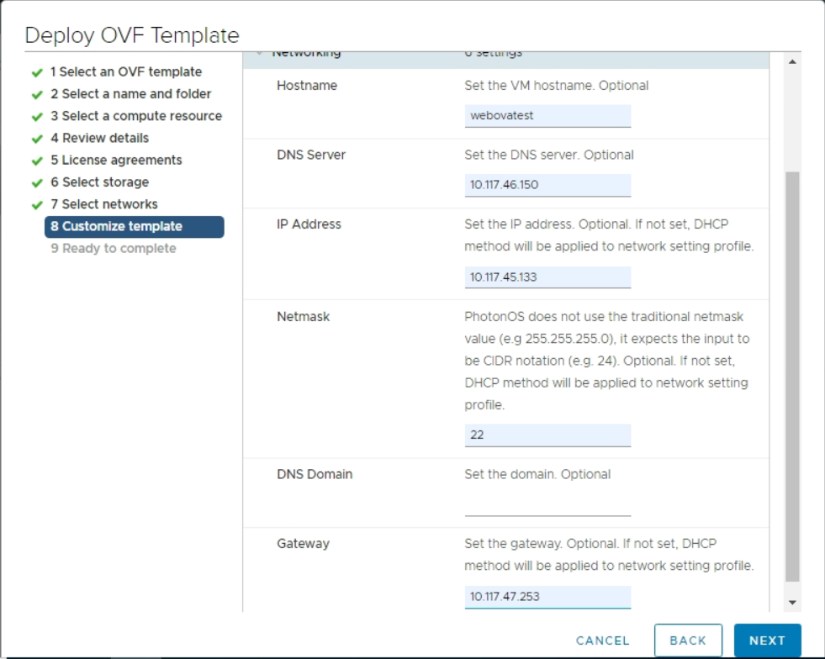**Hostname:**

If not configured, the default name djintelligence.eng.vmware.com will be used. We suggest set the hostname to a DNS resolvable name in your network environment.

**DNS Server/IP Address/Netmask/Gateway:**

If any of these 4 settings are not configured, DHCP network profile will be used for the ova deployment by default. Namely, you should either configure 4 settings as a whole to set a static network profile for the web ova or leave all of them empty to utilize the DHCP service in your network.

**DNS Domain:** Optional**.**

**Notice:**

1. We don’t provide necessary format and compatibility checks for these settings. Please pay attention to your inputs while configurating these settings carefully. For instance, wrong format of the IP address will result in invalid ip network after importing the ova which makes the web service unavailable after ova deployment.
2. After the ova is imported, power it on. The above customized network settings will be applied automatically in minutes. The web service will be auto-started as well.

**After web ova installation:**

Open the https://<webova_servername>:8090 , replace with your configured hostname of the web ova server.

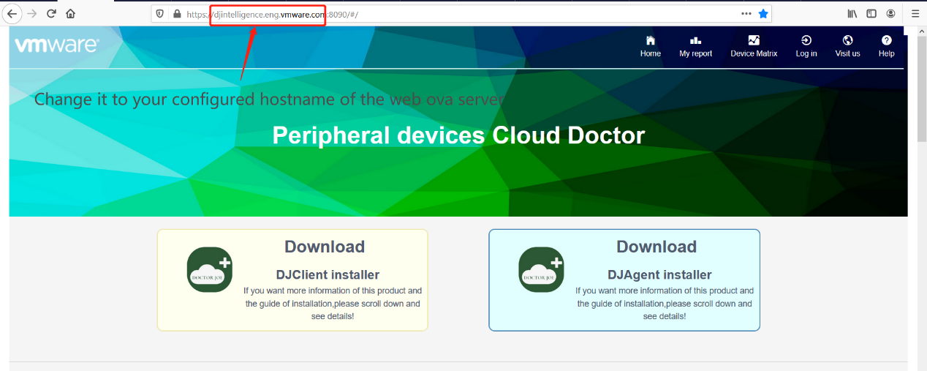

In the home page, users could download the DJAgent and DJclient installers. This is an easy way for horizon admin to distribute the installers to end users instead of asking horizon users to download them from the fling web site.

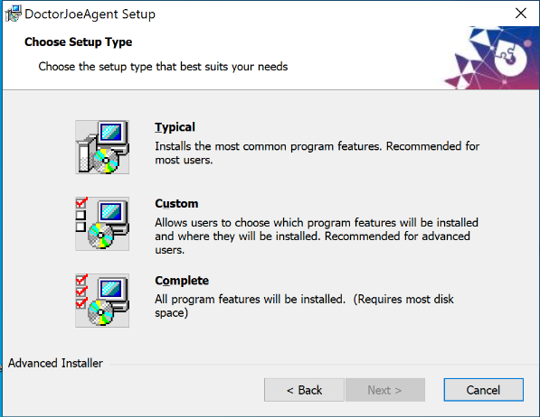**DJAgent Installer Guide**

**During the installation:**

This is the application to be installed on your Horizon agent machine. There are 3 options in the installer setup page – Typical/Custom/Complete. To make full use of the installer capabilities, we suggest you launch the installer with administrator privilege.

1. If you launch the installer with administrator privilege, choose either Typical or Complete option. Both are ok. The components selection page will be skipped. The Filecopy and Autolaunch components will be installed by default. Change the installation directory if you want. By default, it is C:\DoctorJoeAgent\ directory.
2. 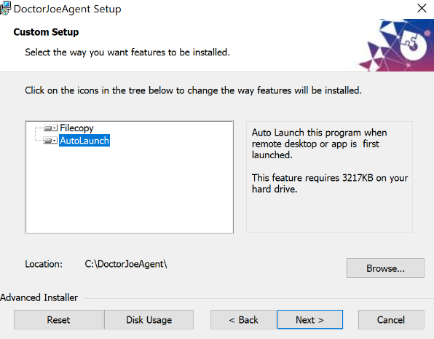If you launch the installer with ordinary user privilege, choose the Custom option. There are two components in the custom setup page – Filecopy and Autolaunch. Deselect the Autolaunch component. Click the Filecopy component, if you want to change the installation directory. By default, it is C:\DoctorJoeAgent\ directory. If you deselect the Autolaunch component, you need to manually click to launch the DJAgent.exe under installation directory.
3. Filecopy component will copy necessary files to the installation directory you choose.
4. Autolaunch component will add some registry entries in HKLM path. These registries make DJAgent.exe launch automatically whenever you freshly login a Horizon desktop or app session. The registries are –

"**HKLM\\Software\\VMware, Inc.\\VMware VDM\\UnityShell\\Run**"

**“HKLM\SOFTWARE\Microsoft\Windows\CurrentVersion\Run“**

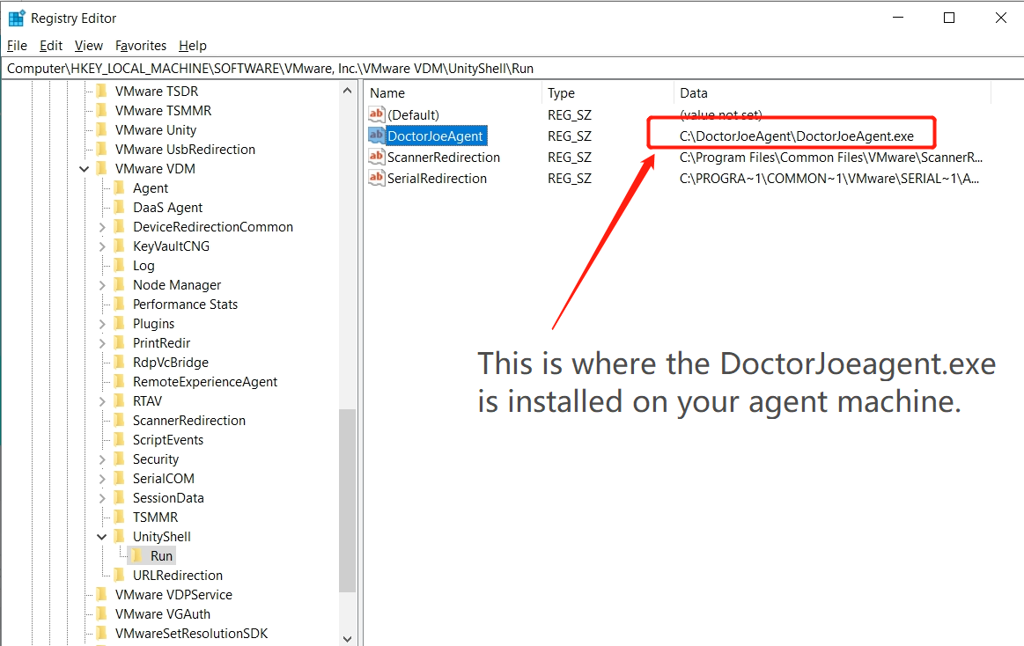

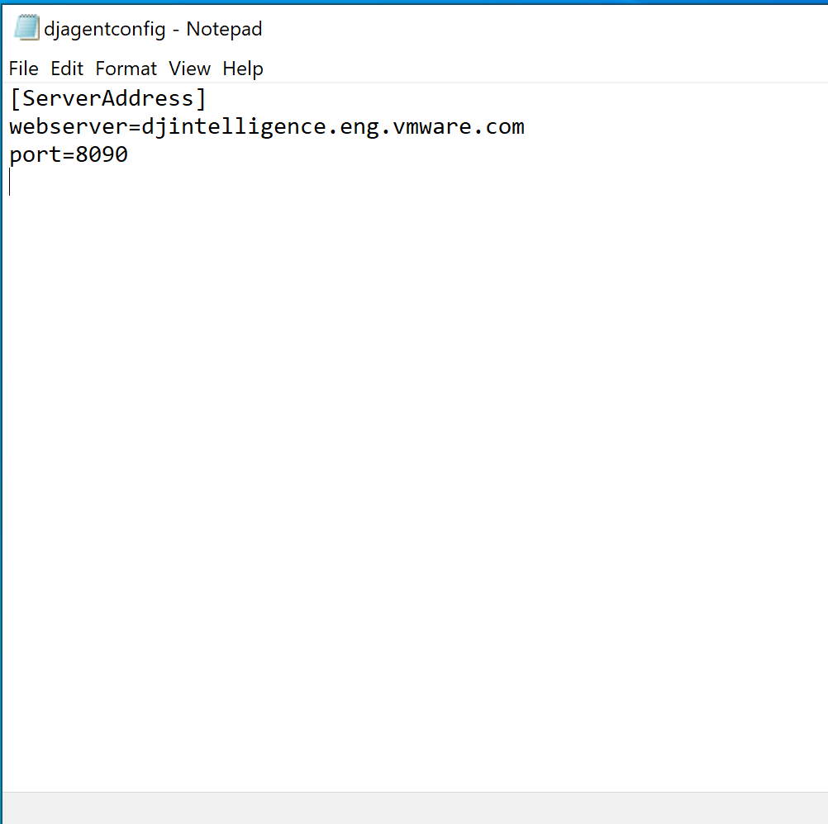**After the installation -**

Djagentconfig.ini under the installation folder contains the default web server address and port. Do not change them unless instructed by your administrator. They should be configured to the real FQDN of the web ova server and web port listening on that server.

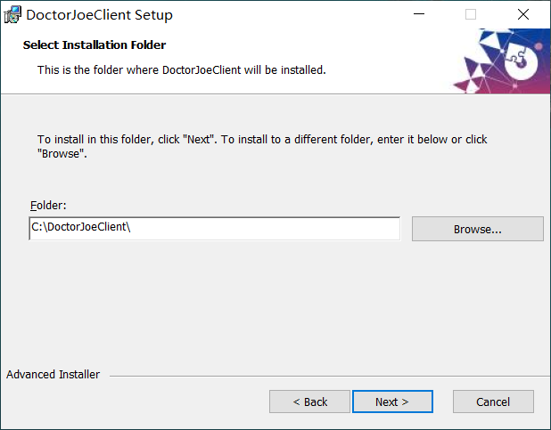**DJClient Installer Guide**

This is the installer to be run on your Horizon client machine.

You can choose the installation directory for DJClient. By default, it is C:\DoctorJoeClient.