Installation Guide for   
Horizon Peripherals Intelligence

Sep 2020

Table of Contents

Overview 1

System Requirement 1

Downloadable Components 2

Web OVA Deployment Guide 2

How to Install 2

After the Installation 5

HorizonPeripheralsAgent Install Guide 6

Installation 6

After the Installation 8

HorizonPeripheralsClient Install Guide 9

Uninstall 10

Change HTTPS Security Certificate Settings (Optional) 11

# Overview

This is the overall installation guide for Horizon Peripherals Intelligence.

## System Requirement

We only support Horizon Windows client and Windows agent for device diagnosis in current release.

The HorizonPeripheralsAgent and HorizonPeripheralsClient programs can be deployed on both 32bits and 64bits Windows OS that is compatible with VMware Horizon 7.x and later. Prerequisite: PowerShell version 3.0 or above.

Client OS - Windows 7, 10

Agent OS - Windows 7, 10, 2012, 2016, 2019

The web OVA is built on VMware Photon OS 3.0 which is compatible with ESXi 6.5 and later

## Downloadable Components

There are three downloadable components in this project.

1. Web OVA template – device intelligence diagnosis web service host.
2. HorizonPeripheralsAgent program – A light-weighted diagnosis agent with simplified UI for end user to start a diagnosis for peripheral devices. Installed on the Horizon Windows agent machine.
3. HorizonPeripheralsClient program – A light-weighted diagnosis plugin to be installed on Horizon Windows client machine

Generally, there are two ways to deploy the services and components in your Horizon environment.

1. Skip the web OVA deployment part if you are inside VMware corporation network.   
   We have set up a local web service (djintelligence.eng.vmware.com) for VMware internal users. So if you are inside VMware corporate network, you can skip the web OVA deployment part. It is sufficient to only install the HorizonPeripheralsAgent and HorizonPeripheralsClient. Follow the installation guides starting from HorizonPeripheralsAgent Install Guide.
2. Setup all of the three components if you are outside VMware corporation network.  
   If you are external customer and users, you need to setup the web OVA server and install the HorizonPeripheralsClient and HorizonPeripheralsAgent programs in your local environment following the guides below.

# Web OVA Deployment Guide

## How to Install

Download the web OVA file to your local machine. The OVA file is compatible with vSphere 6.5 and later version. Follow the general workflow to deploy the OVA template. You can refer to [vSphere guide](https://docs.vmware.com/en/VMware-vSphere/6.5/com.vmware.vsphere.vm_admin.doc/GUID-17BEDA21-43F6-41F4-8FB2-E01D275FE9B4.html). Please pay special attention to below steps and values.

In the Select storage page, choose a valid datastore and Thin Provision for virtual disk format.

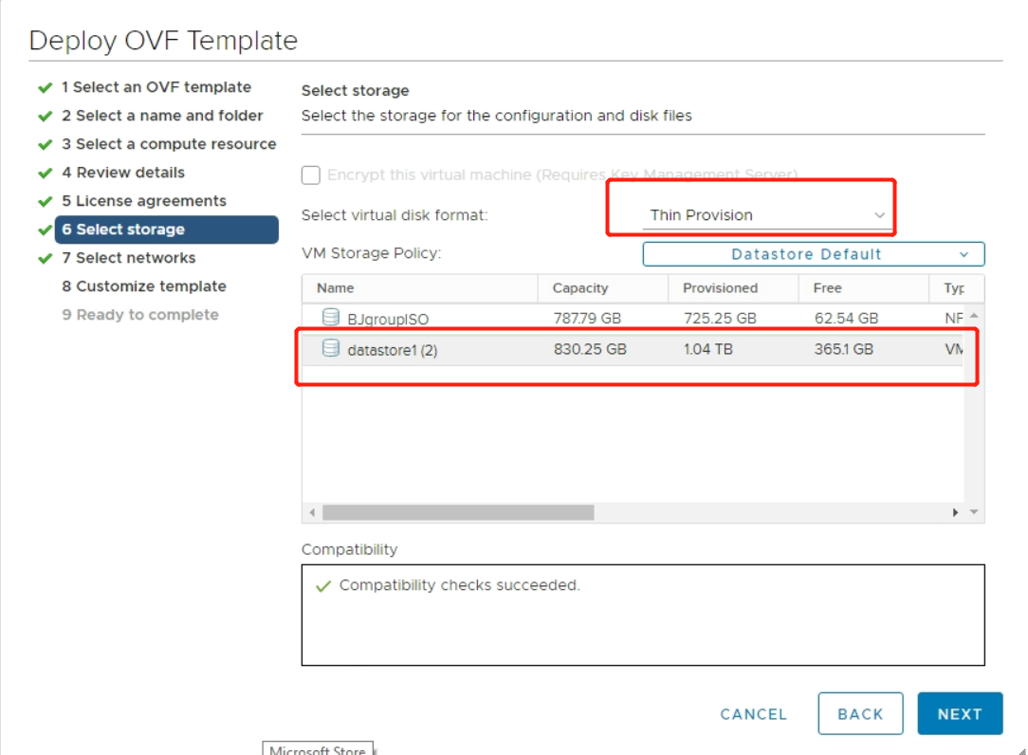

In the Select Network, choose a valid virtual network name in your setup (In this example, it is VM Network). Choose Static-Manual as the IP allocation settings.

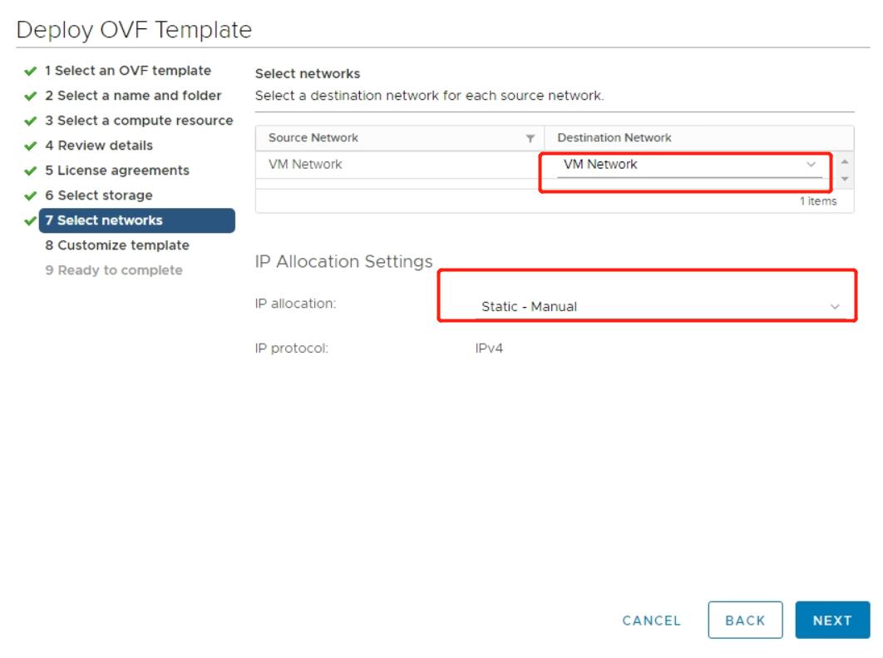

In the Customize template, there are 6 optional settings provided.

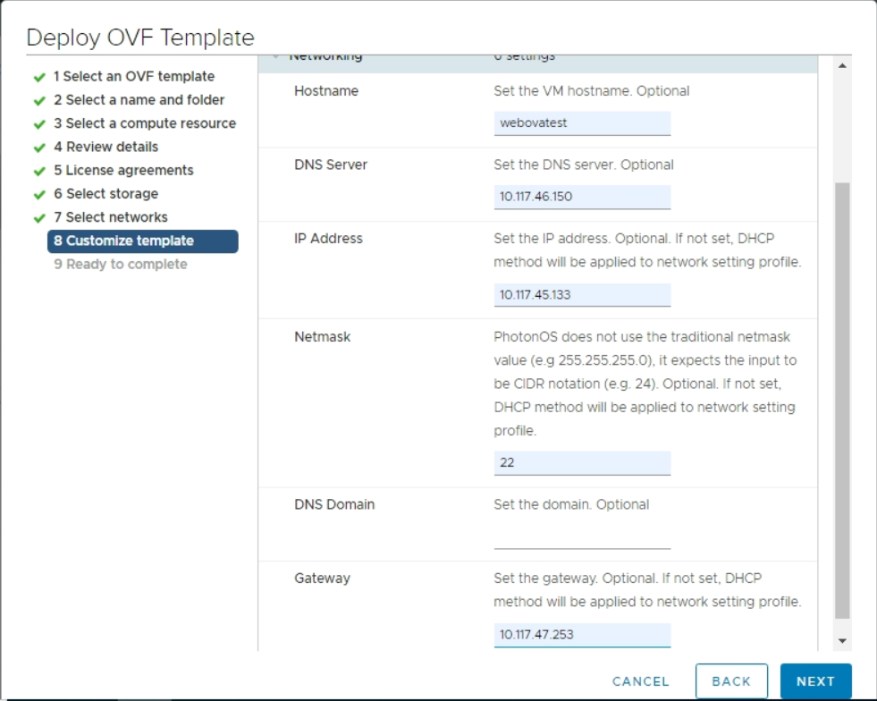Hostname**:**

If not configured, the default name djintelligence.eng.vmware.com will be used. We suggest set the hostname to a DNS resolvable name in your network environment.

IP Address/Netmask/Gateway:

If any of these 3 settings are not configured, the default DHCP network profile will be used for the OVA deployment. Namely, you should either configure the three settings all together to set a static network profile or leave all of them empty to utilize the DHCP service in your network.

DNS Domain:Optional**.**

DNS Server: Optional.

Notice:

1. Only IPv4 network is supported.
2. We don’t provide complete format and compatibility checks for these settings. Please pay attention to your inputs while configurating these settings carefully. For instance, wrong format of the IP address will result in invalid IP network after importing the OVA which makes the web service unavailable after OVA deployment.
3. After the OVA is imported, power it on. The above customized network settings will be applied automatically in minutes. The web service will be auto-started as well.

## After the Installation

Open the https://<webova_servername>:8090 , with your configured hostname of the web OVA server.

In the home page, users could download the HorizonPeripheralsAgent and HorizonPeripheralsClient installers. This is a convenient way for Horizon admin to distribute the HorizonPeripheralsClient and HorizonPeripheralsAgent programs to end users instead of asking them to download from the VMware Fling web site.

# HorizonPeripheralsAgent Install Guide

## Cmdline Installation

Run the following command in your command line:

msiexec /i  **C:/YourMsiLocation**  /quiet /qn APPDIR=”**C:/Program Files/HorizonPeripheralsAgent**” HOSTNAME=”**djintelligence.eng.vmware.com**” PORT=”**8090**”

* All the bold texts can be changed accordingly. For default silent installation, run:

msiexec /i C:/YourMsiLocation /quiet /qn

* + /quiet /qn can be changed.
    - Full UI: /qf (this is the default parameter used by the package)
    - Reduced UI: /qr (the user interface dose not show any wizard dialogs)
    - Basic UI: /qb, /passive (only a progress bar will be shown during the installation)
    - No UI: /qn, /quiet (no UI will be showed during the installation)
* HOSTNAME: Your web server address. This should be your self-deployed web OVA hostname. We provide a default web server address: djintelligence.eng.vmware.com.
* PORT: Port number for diagnosis web service. Do not need to change unless this port is occupied. By default, it is 8090.

## Normal Installation

There are two files in the downloaded HorizonPeripheralsAgent.zip installer – a zip file (HorizonPeripheralsAgent.zip) and a msi installer (HorizonPeripheralsAgent.msi). Use the zip file if you only have normal user permission in the remote agent desktop. Use the msi installer if you have admin user permission.

1. HorizonPeripheralsAgent.zip –

Use this zip file to deploy if the agent OS has some limitations to run MSI installer under normal user privilege. Unzip and extract the zip file to anywhere on your Horizon agent machine. In this way, the AutoLaunch registries and functions will not be available. You must manually launch the HorizonPeripheralsAgent.exe under the unzip folder. You will not be able to launch the program in Horizon remote app session since it cannot be auto launched.

1. HorizonPeripheralsAgent.msi

HorizonPeripheralsAgent.msi is the installer to be run on your Horizon agent machine. The web server address and port number need to be configured to the correct value firstly. If you don’t know the value, you can use the default one and change it after the installation by editing the config file – hpagentconfig.ini.

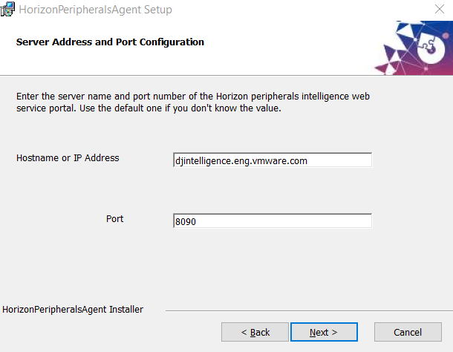

You can change the installation directory. By default, it is

**C:\Program Files\HorizonPeripheralsAgent\** directory.

There are two sub features of the msi installer – core and autolaunch. The zip file only contains the core feature.

* Core feature will copy all necessary files to the installation directory you choose.
* Autolaunch feature will add registry entries in HKLM path. These registries make HorizonPeripheralsAgent.exe launch automatically when you freshly login a Horizon desktop or app session.
* The registry entries are in the HKLM path. These registries make HorizonPeripheralsAgent.exe launch automatically whenever you freshly login a Horizon desktop or app session. The registries are –

***“HKLM\\Software\\VMware, Inc.\\VMware VDM\\UnityShell\\Run****”*

***“HKLM\SOFTWARE\Microsoft\Windows\CurrentVersion\Run*”**

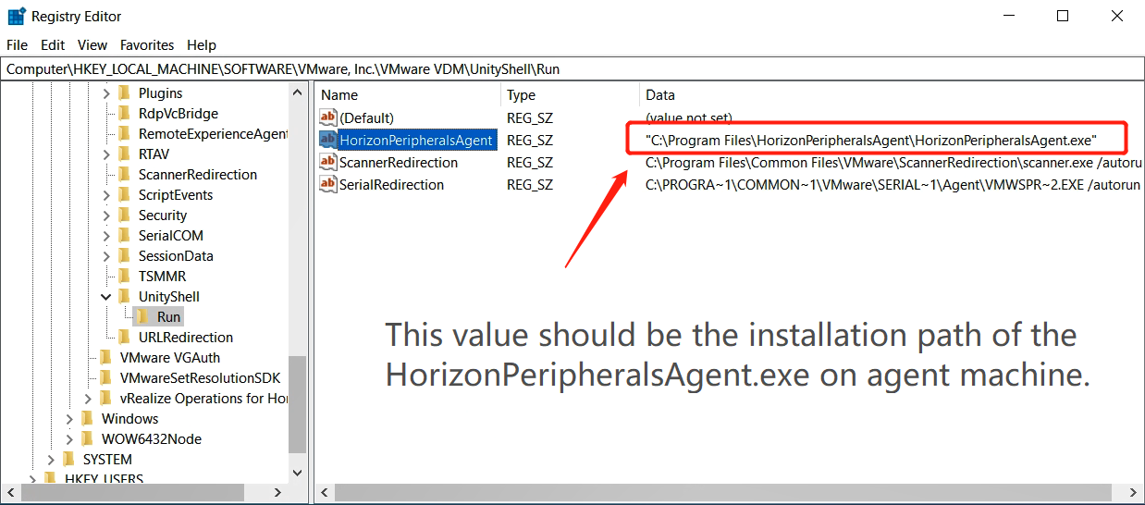

After the Installation

The hpagentconfig.ini under the installation folder contains the web server address and port which are configured during installation. If you don’t input them correctly during installation, you could manually change them by editing this config file.

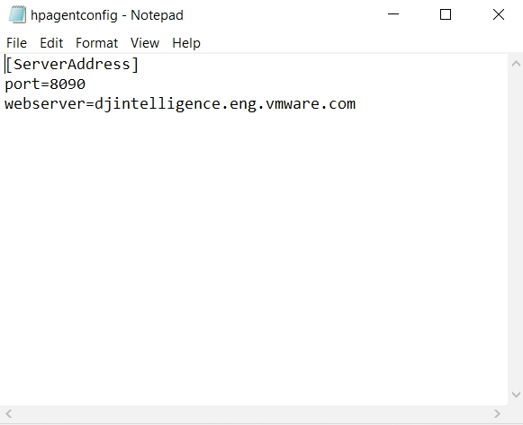

# HorizonPeripheralsClient Install Guide

## Cmdline Installation

Run the following command in your command line:

msiexec /i  **C:/YourMsiLocation**  /quiet /qn APPDIR="**C:/Program Files/HorizonPeripheralsClient**"

## Normal Installation

HorizonPeripheralsClient.msi is the installer to be run on your Horizon client machine. It requires the administrator privilege to run.

You can choose the installation directory for HorizonPeripheralsClient. By default, it is **C:\Program Files\HorizonPeripheralsClient\** directory.

# Uninstall

Go to the Uninstall a program entry in Control Panel. Uninstall the HorizonPeripheralsClient and HorizonPeripheralsAgent programs.

# Change HTTPS Security Certificate Settings (Optional)

By default, a valid certificate will be generated with the web OVA server’s FQDN signed by a VMware internal rootCA after the deployment of Web OVA. This cert is then used by the HTTPS communication between HorizonPeripheralsAgent and web OVA server.

If you want to replace the auto-generated cert with another valid cert singed by another well-known rootCA instead of the VMware rootCA, please follow the steps below manually.

1. Apply for a valid cert from a well-known rootCA. Get the private key (<fqdn>.key) and cert file (<fqdn>.crt) ready.
2. On web OVA server, copy the key and cert files to /etc/nginx/ folder. Edit the /etc/nginx/nginx.conf to replace the ssl_certificate and ssl_certificate_key options with <fqdn>.crt and <fqdn>.key. Reboot the web OVA server to apply the change.
3. Get the public certificate of the well-known rootCA (rootca.pem). Copy it to the HorizonPeripheralsAgent install directory on Horizon agent machine.
4. Relaunch HorizonPeripheralsAgent.exe to apply the change.