Horizon Peripherals Intelligence is an online self-serviced diagnosis service that can help increase the satisfaction when using peripheral devices with Horizon product by both the end users and the admin user. Currently, we support diagnosis for the following device categories – USB storage devices, USB printers, USB scanners, Cameras. We will continue to cover more device categories in the future.

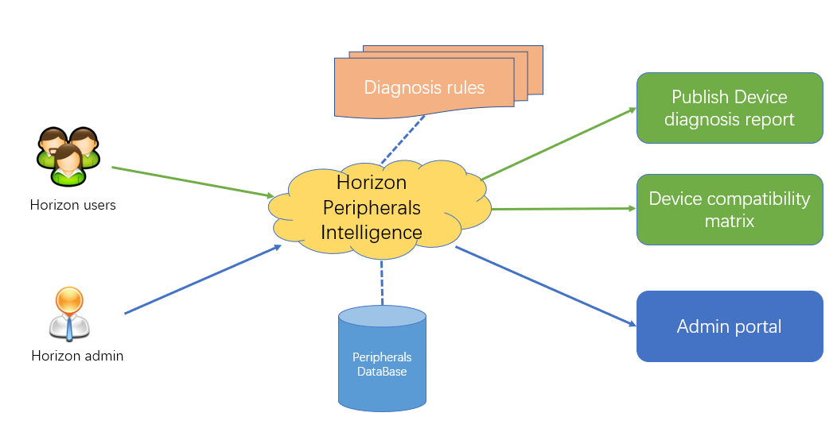

There are 3 main functions of Horizon Peripherals Intelligence.

1) Publish device diagnosis report promptly based upon the horizon end users’ requests. The report will be available for both Horizon users and admin in the web portal. Users could better understand the device usage issues with the report. Admin could be aware of the end users' issues and take actions to fix them based upon the suggestions provided in the report.

2) Maintain a device compatibility matrix. All users could search the matrix based on the device type, client OS type, agent OS type and other dimensions, etc. Horizon Peripherals Intelligence will present a filtered device support table per users search request.

3) The admin has the privilege to upload, modify, update, delete the meta data of each device category in the peripherals DB and maintain the device matrix. We provide an admin access to do it.

**How to start a diagnosis process?**

There are several pre-conditions to start a diagnosis process:

1. Successfully install and deploy the Horizon Peripherals Intelligence following the installation guide
2. With some specific peripheral devices attached to the Horizon Windows client to be diagnosed
3. Horizon client connects to a remote desktop or app session

Step1. Manually launch the HorizonPeripheralsAgent.exe from the installation directory on Horizon agent machine if it is not automatically launched after login. The HorizonPeripheralsAgent icon will appear in the right corner of Windows task bar. 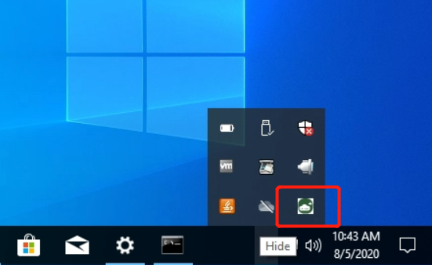

Step2. Click on the HorizonPeripheralsAgent icon to show up the menu. Click the diagnose option.

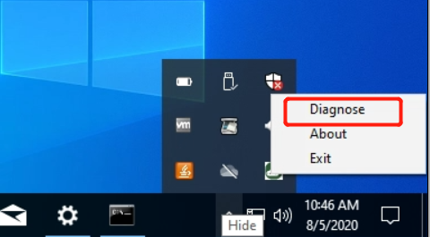

Step3. A report link message will pop up promptly. If the network connection with Horizon Peripherals Intelligence server is not very good, it may take a while.

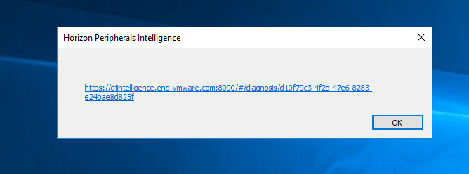

Step 4. Click the link message to use the default browser to open the device diagnosis report . Then select which device you want to diagnose from the device tree in the left navigator.

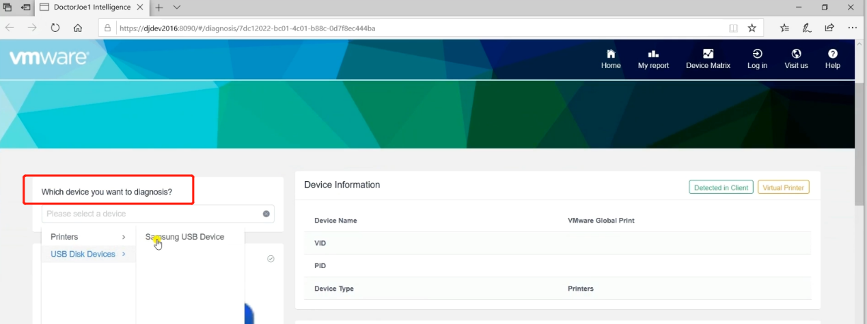

Step 5. Check and browse the device details, Horizon services details and the suggestions for device redirection on the same page.

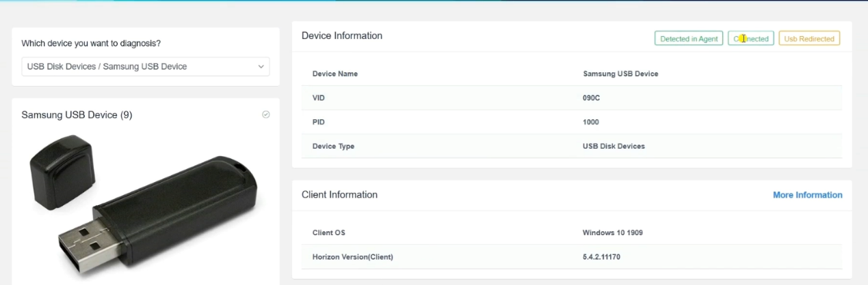

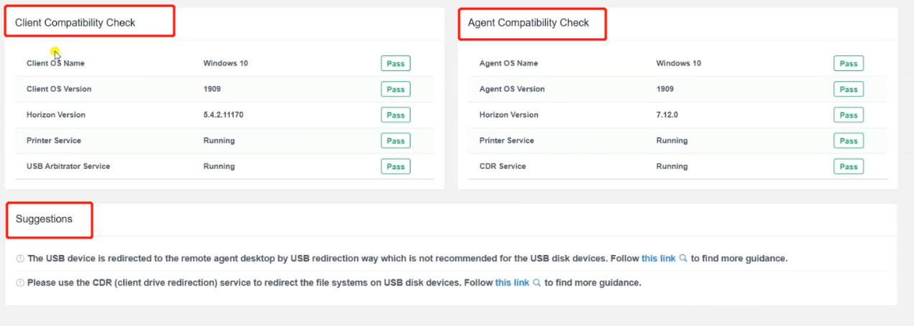

**How to check the device support matrix?**

Use any browser to open Horizon Peripherals Intelligence web server page, and no need to login. Then click the “Device Matrix” button on the top right.

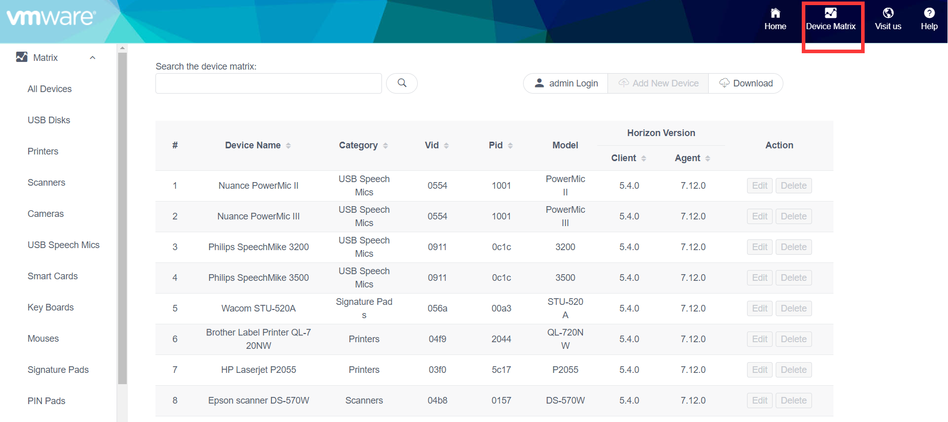

**How to login as Admin to maintain and edit the device support matrix?**

Use any browser to open Horizon Peripherals Intelligence web server page. On the device matrix page, click “Log In” button on the top.

The admin username is “admin”. The default password is “changeme”. When the admin logins for the 1st time, it is mandatory to change the admin password.

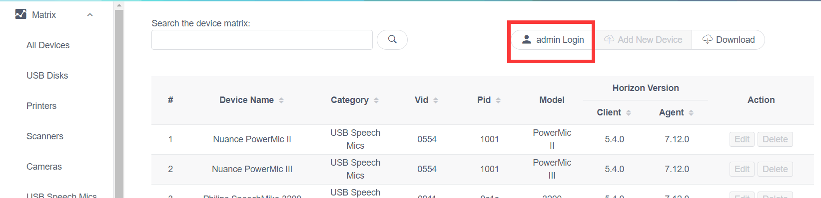



After changing the password, use the changed password to login to the Device Matrix page.



After admin logins the web site, the edit functions will be enabled on this page. Please be cautious when you edit any information on this page. The operations are irreversible.

