Review

Biogas upgrading technology solutions: conventional processes and emerging solutions for CO2 valorization

Matteo Galloni 1 and Gioele Di Marcoberardino 1,*

|  |
| --- |
| **Citation:** To be added by editorial staff during production.  Academic Editor: Firstname Lastname  Received: date  Revised: date  Accepted: date  Published: date    **Copyright:** © 2024 by the authors. Submitted for possible open access publication under the terms and conditions of the Creative Commons Attribution (CC BY) license (https://creativecommons.org/licenses/by/4.0/). |

1 Università degli Studi di Brescia;

**\*** Correspondence: gioele.dimarcoberardino@unibs.it; Tel.: (optional; include country code; if there are multiple corresponding authors, add author initials)

**Abstract:** A single paragraph of about 200 words maximum. For research articles, abstracts should give a pertinent overview of the work. We strongly encourage authors to use the following style of structured abstracts, but without headings: (1) Background: Place the question addressed in a broad context and highlight the purpose of the study; (2) Methods: briefly describe the main methods or treatments applied; (3) Results: summarize the article’s main findings; (4) Conclusions: indicate the main conclusions or interpretations. The abstract should be an objective representation of the article and it must not contain results that are not presented and substantiated in the main text and should not exaggerate the main conclusions.

**Keywords:** keyword 1; keyword 2; keyword 3 (List three to ten pertinent keywords specific to the article yet reasonably common within the subject discipline.)

0. How to Use This Template

The template details the sections that can be used in a manuscript. Note that each section has a corresponding style, which can be found in the “Styles” menu of Word. Sections that are not mandatory are listed as such. The section titles given are for articles. Review papers and other article types have a more flexible structure.

Remove this paragraph and start section numbering with 1. For any questions, please contact the editorial office of the journal or support@mdpi.com.

1. Introduction

It is crucial to shift the energy sector towards sources with a lower carbon footprint to lessen the harmful impacts on the global the environment caused by human activities. Renewable energy must account for about 40% of total energy generation in all sectors by 2030 [1] to align with the EU's carbon-neutral objective [2]. Biomass, obtained from organic materials including plant leftovers, animal waste, and the organic part of municipal solid waste (OFMSW), offers a promising opportunity for producing greener energy. Moreover, using biomass in this manner allows for the conversion of waste into a valuable resource, aligning with the circular economy principles [3]. The key advantages of biomass compared to other renewable sources are its independence from weather conditions and its ability to more easily meet electricity demand through physical accumulation [4].

Several ways exist for converting biomass into biofuel. The Figure xx displays the primary categories based on the type of process involved in the conversion.

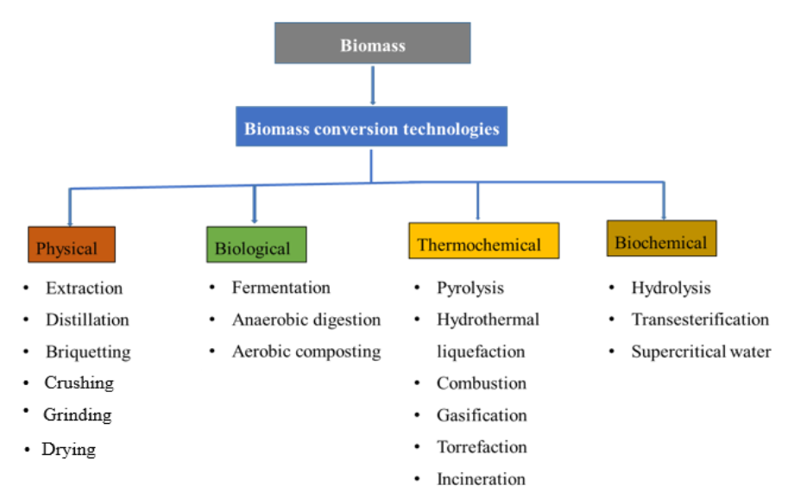

This work [5] presents technology focusing on the product's characteristics, together with a quick overview of the primary advantages and drawbacks. Physical biomass conversion involves modifying biomass by preprocessing activities, size reduction, drying, and densification. The method converts biomass into forms with enhanced characteristics, including increased mass density, energy density, and hydrophobicity compared to raw biomass. Biological processes often utilize microbial systems to improve the conversion of specific chemical products by triggering a series of reactions in a metabolic pathway. Biological conversion techniques are deemed eco-friendly. Moreover, it is generally advised to take an additional separation step in this scenario. Thermochemical processes often work under demanding conditions involving high temperatures and pressures. Thermochemical methods demand a significant initial investment and setup due to the required infrastructure. Additionally, these processes typically provide a variety of chemicals, necessitating a refining step. Biochemical conversion technologies combine biological and chemical mechanisms. This process utilizes microbes and biological catalysts to transform biomass into gas, specifically CO2 and CH4. It offers excellent selectivity in converting biomass into the desired end products. The selection of process technology is dependent upon the desired end product and the feedstocks supplied.

CERCA UNA FRASE DI COLLEGAMENTO (E DEI DATI) per giustificare il fatto che d’ora in poi ci si concentra solo su AD

Anaerobic digestion occurs in specialized reactors, where microbial consortia support a sequence of metabolic activities on the biomass. The reactions progress through various phases: hydrolysis, acidogenesis, acetogenesis, and methanogenesis. Every phase is defined by the decomposition of intricate organic molecules into more basic ones. The process produces biogas primarily composed of methane (CH4) and carbon dioxide (CO2), with small amounts of N2, H2S, H2O, and VOCs. Factors influencing the output and energy content of biogas produced by anaerobic digestion (AD) are the nutritional composition of biomass, operating temperature, operating pH, biomass loading rate, hydraulic retention time, and solid retention time [6]. . Anaerobic digestion is highly adaptable and may treat a variety of biomass sources including agricultural wastes, animal by-products, sewage sludge, landfill materials, and organic waste from municipal solid waste. 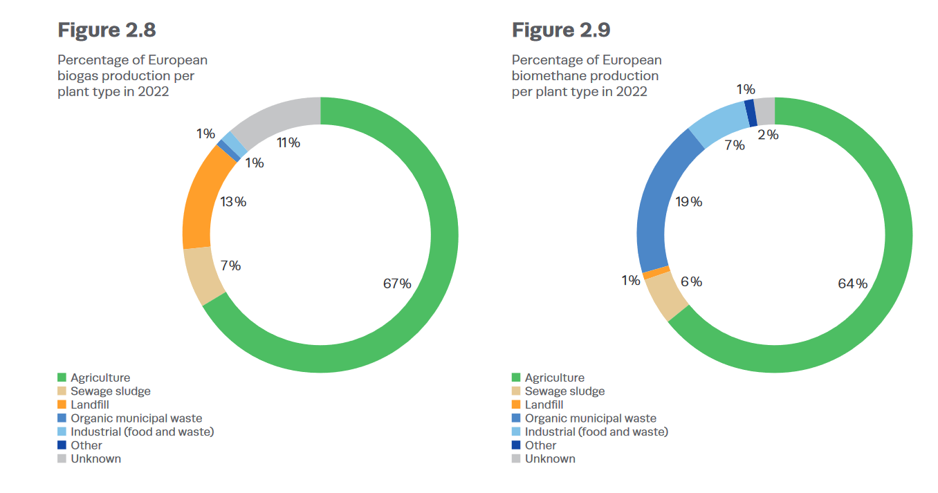

The biogas composition depends on the type of biomass used and the conditions and methods used during the conversion process, as can be seen in Tab yy. By strategically choosing biomass feedstock and optimising process parameters, biogas production efficiencies can be improved, making anaerobic digestion a more appealing choice for generating renewable energy.

|  |  |  |  |  |  |
| --- | --- | --- | --- | --- | --- |
| Component  % mol | Landifileld | AD from Agricoltural and cattle manure | AD from waste food from industry | Natural Gas |  |
| CH4 | 40-70 | 49-69 | 44-67 | 85-92 |  |
| CO2 | 25-40 | 29-44 | 30-44 | 0.2-1.5 |  |
| N2 | 0-17 | 0.6-13 | 0.1-6 | 0.3 |  |
| O2 | 0-3 | 0.2-3 | 0.1-3 |  |  |

Biogas can be directly fed in combined heat and power system (CHP) or it can be upgraded to biomethane. Direct combustion of biogas in a CHP system has superior environmental performance compared to an upgrading system, as show in this study [7]. However, producing biomethane allows for injection into the natural gas grid for usage in energy production or in hard to abate sectors, as transport and buildings producing a reduction in GHG emission [8]. The increasing size of the CHP system in the power plant improves efficiency and facilitates better integration with energy demand.

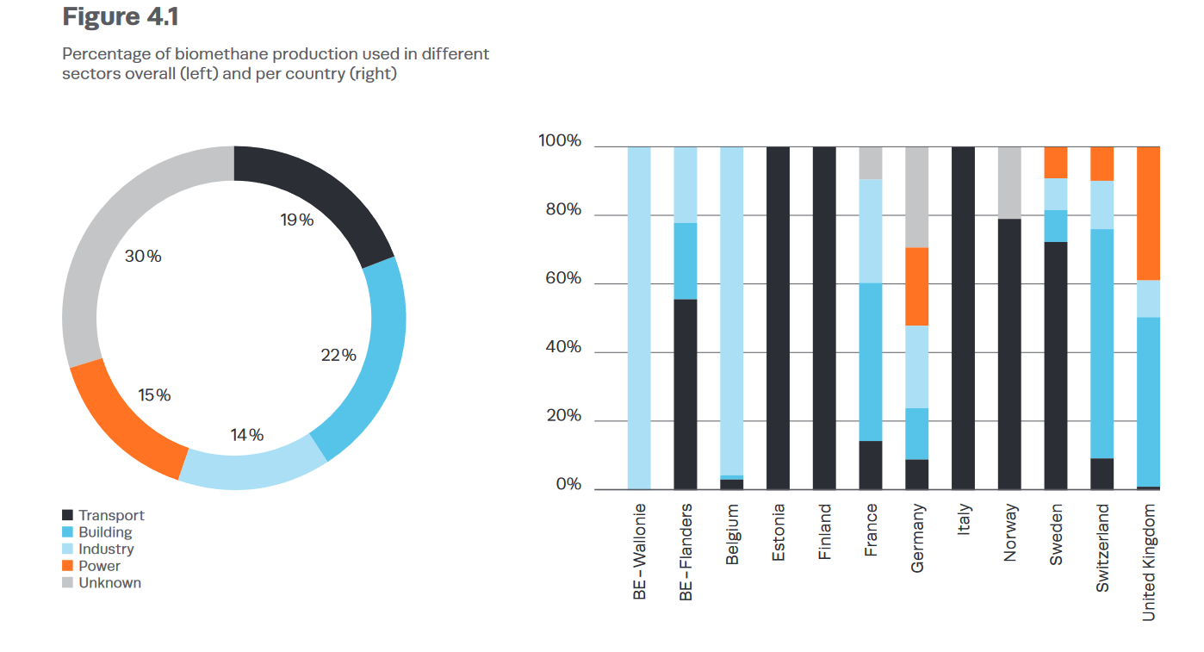

Different methods can be used to produce biomethane from biogas. Well-known technologies include Water Scrubbing (WS), Chemical Absorption (CA), Membrane Separations (MS), and Pressure Swing Adsorption. Cryogenic distillation (CD) is being considered as a potential alternative method for producing LCO2 as a byproduct in the future. Each technology has its advantages and limitations, typically related to the incoming biogas composition, size, and the required methane purity. The figure xx illustrates that membrane separation and water scrubbing are the predominant upgrading technologies in Europe.

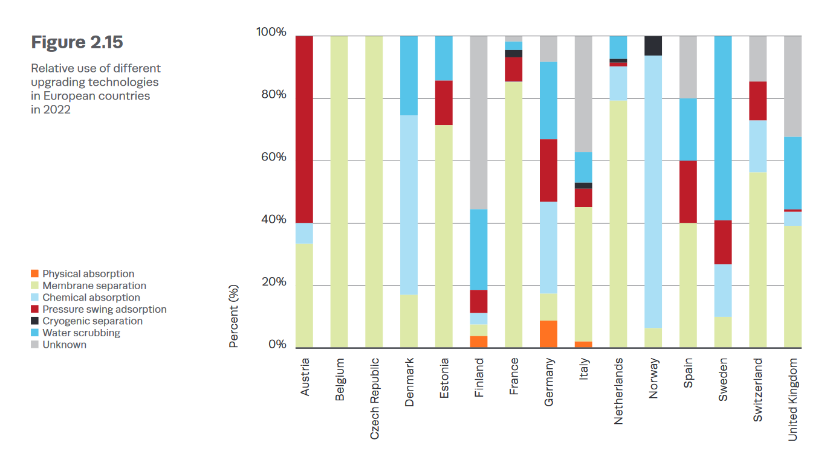

The biogas and biomethane business has been experiencing significant expansion in recent years due to substantial investments and favorable policies with incentives (cita RED II e incentive biometano). In 2022, biogas output reached 179 TWh and biomethane production was 44 TWh, showing a 16% growth from 2021.

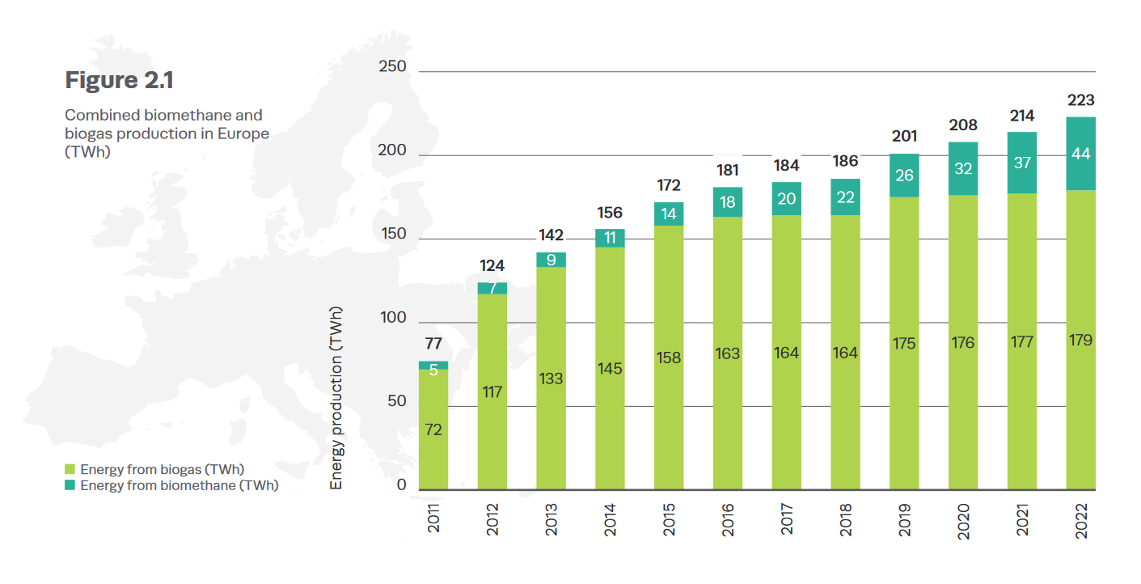

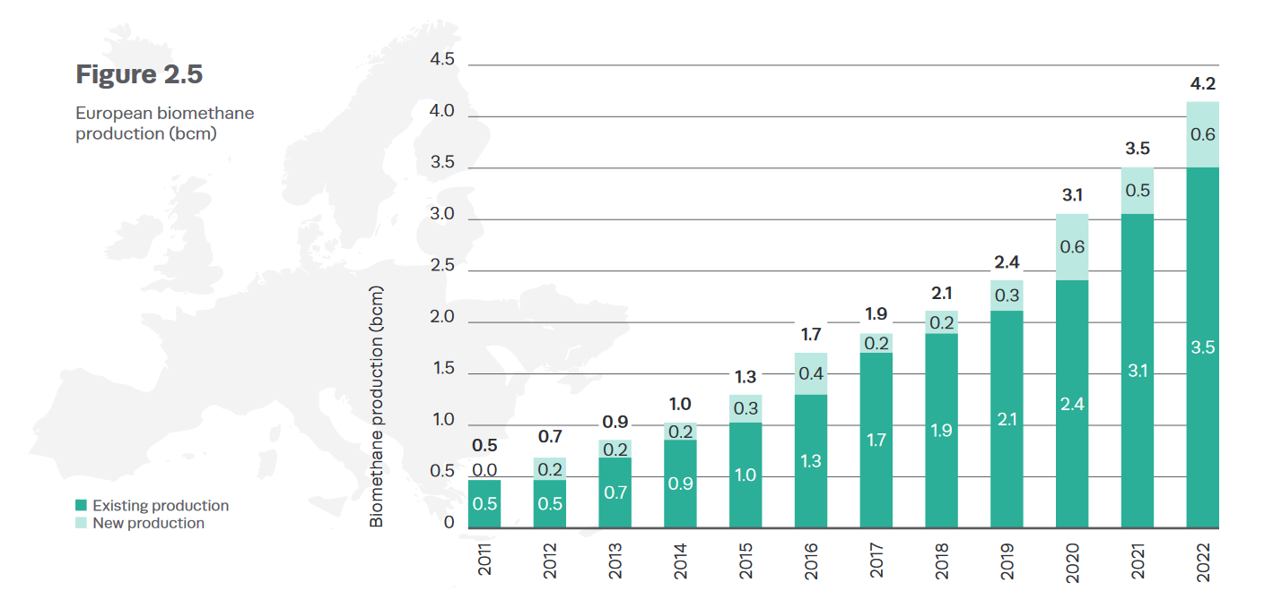

The conversion of biogas into biomethane involves an initial cleaning process to remove hydrogen sulphide, volatile organic compounds, and sometimes water. This is followed by an upgrading process to separate methane from carbon dioxide.

In the following sections, there is a concise overview of the cleaning procedures to remove H2s, NH3 and VOCs. Following a detailed examination of biogas upgrading technology, with a primary focus on existing industrial-scale systems and closing with promising growth.

1. Cleaning technologies

Proper cleaning is essential to meet EU criteria while producing biomethane. This procedure is essential for preventing damage to upgrading biogas technology such as the membrane during upgrades. The chemicals eliminated in this stage are primarily H2S, NH3, Siloxanes, and VOCs [9].

H2S Removal System

The H2S removal system can be categorised into two groups: one that utilises bacteria or microorganisms to convert the substance and produce products such as SO4-, and another that involves a filtration process where H2S is isolated from other chemical species without altering its molecular composition.

The H2S removal process can be categorised based on the microorganisms responsible for the conversion. In the Tab xx a categorization can be seen and some references.

|  |  |  |
| --- | --- | --- |
| bacteria | Final product | reference |
|  |  |  |
|  |  |  |
|  |  |  |

Biofiltration

Gas treatment involves exposing the gas to a biofilm in a fixed bed bioreactor. Biofiltration systems can be classified as either biofilters (BFs) or biotrickling filters (BTFs). Biological filters (BFs) and biological trickling filters (BTFs) are commonly utilised for treating biological waste gases. Both scenarios involve using a salt solution to keep the filters moist. In the BT design, the solution is injected internally into the filter. In contrast, in the BTFs arrangement, the solution flows continuously, is collected at the bottom, and recirculates. The effectiveness of pollutant breakdown in biofiltration systems depends on important variables such packing materials, biofilm properties, and operational parameters [10]. Plastic supports or porous ceramics are typically utilised in BTFs, instead natural filter bed materials are commonly employed in BFs.

The benefits of natural organic packing materials are low cost and easy availability.

The main disadvantages of natural organic packing materials compared to inert organic materials are compaction leading to channelling and a large pressure drop, as well as a shorter lifespan often lasting fewer than five years [11]. GREENEVO, DMT, and BiogasClean are some of the producers of this technology [12–14].

Bioscrubber

A bioscrubber (BS) comprises two main components: an absorption tower that absorbs pollutants like H2S in water, and a bioreactor unit where microorganisms transform the pollutants into end products [15]. Bioscrubbers can also be adapted to remove mixed pollutants by adjusting the reactor's design. High effectiveness in removing water-soluble contaminants and ability to function throughout a broad spectrum of situations. BSs have significant disadvantages such as creating secondary contamination from the liquid waste stream and being operationally and maintenanceally complicated [16]. Veolia and Paques are some producer [17,18].

NH3 Removal System

The NH3 removal systems exhibit similarities to H2S removal systems, with the distinction lying in the specific bacteria type or substance employed to react with NH3 [19].

* Bioreactor: Ammonia removal takes place in a bioreactor, whereas gas-liquid mass transfer occurs in a scrubber. Providing adequate time for gas-phase NH3 to interact with the scrubbing liquid enables NH3 to dissolve as NH4+ in the aqueous solution [20].
* Biological ammonium oxidation: This technique is strictly anaerobic and exothermic.

This method is widely accepted for the treatment of wastewater with a high concentration of NH3 and is commonly employed for the removal of NH3 in its gaseous phase.

* Bioconversion of NH3 occurs in two phases. Initially bacteria convert NH3 into nitrite (NO2), followed subsequently convert NO2 into nitrate (NO3). NH3 serves as the electron donor in these bioconversion processes, whereas CO2 and O2 function as the carbon source and electron acceptor, respectively. pH has a crucial role in microbial development and the effective conversion of NH3 through mass transfer from the gaseous to liquid phase [21].
* Biofiltration techniques, such as BFs and BTFs, are primarily used to treat exhaust air that contains high levels of NH3 emissions from agricultural and livestock farms [22].

Siloxanes and VOCs removal

Organosiloxanes are polymers that consist of Si-O-Si bonds, with organic groups (such as methyl or ethyl) attached to the Si atom. The substance possesses exceptional physico-chemical characteristics, such as a low surface tension, high thermal stability, and strong resistance to environmental oxidation. Organosiloxanes undergo volatilization and enter the biogas as volatile methyl siloxanes (VMS) during anaerobic digestion. VMS are commonly categorised into two types, linear and cyclic, according to their structures.

Volatile organic compounds (VOCs) are organic compounds that readily evaporate at room temperature due to their high vapour pressure [23]. VOCs are accountable for the aromatic characteristics of smells and perfumes, as well as the presence of pollutants. While the majority of VOCs do not pose immediate toxicity, they can have adverse long-term health effects. However, certain VOCs can be hazardous to human health and can also cause harm to the environment. Various factors influence the biodegradability of VOCs including the presence of a well-adapted microbial community capable of using VOCs as a carbon source, the transfer of mass between gas-liquid and liquid-biofilm phases affected by VOCs properties like solubility, molecular size, and biodegradation order, and the interactions between compounds where the presence of one can impact the removal of others.

Mainly used physical-chemical procedures for removing both Siloxanes and VOCs include activated carbon adsorption, phosphoric acid absorption, and water washing [9,24–30]. Biological methods such as BF), BTFs, and BSs have primarily been evaluated in laboratory settings. The bioreactors exhibited a low removal efficiency in the majority of cases due to extended gas residence times. Of the bioreactor configurations mentioned, BTFs exhibit superior VOCs. Furthermore, BTFs provide effective management in terms of regulating nutrient delivery, pH levels, and the elimination of harmful byproducts.

1. Upgrading technologies

wdwdwdwdwdw

4. Discussion

Authors should discuss the results and how they can be interpreted from the perspective of previous studies and of the working hypotheses. The findings and their implications should be discussed in the broadest context possible. Future research directions may also be highlighted.

5. Conclusions

This section is not mandatory but can be added to the manuscript if the discussion is unusually long or complex.

6. Patents

This section is not mandatory but may be added if there are patents resulting from the work reported in this manuscript.

**Supplementary Materials:** The following supporting information can be downloaded at: www.mdpi.com/xxx/s1, Figure S1: title; Table S1: title; Video S1: title.

**Author Contributions:** For research articles with several authors, a short paragraph specifying their individual contributions must be provided. The following statements should be used “Conceptualization, X.X. and Y.Y.; methodology, X.X.; software, X.X.; validation, X.X., Y.Y. and Z.Z.; formal analysis, X.X.; investigation, X.X.; resources, X.X.; data curation, X.X.; writing—original draft preparation, X.X.; writing—review and editing, X.X.; visualization, X.X.; supervision, X.X.; project administration, X.X.; funding acquisition, Y.Y. All authors have read and agreed to the published version of the manuscript.” Please turn to the [CRediT taxonomy](https://img.mdpi.org/data/contributor-role-instruction.pdf) for the term explanation. Authorship must be limited to those who have contributed substantially to the work reported.

**Funding:** Please add: “This research received no external funding” or “This research was funded by NAME OF FUNDER, grant number XXX” and “The APC was funded by XXX”. Check carefully that the details given are accurate and use the standard spelling of funding agency names at https://search.crossref.org/funding. Any errors may affect your future funding.

**Data Availability Statement:** We encourage all authors of articles published in MDPI journals to share their research data. In this section, please provide details regarding where data supporting reported results can be found, including links to publicly archived datasets analyzed or generated during the study. Where no new data were created, or where data is unavailable due to privacy or ethical restrictions, a statement is still required. Suggested Data Availability Statements are available in section “MDPI Research Data Policies” at https://www.mdpi.com/ethics.

**Acknowledgments:** In this section, you can acknowledge any support given which is not covered by the author contribution or funding sections. This may include administrative and technical support, or donations in kind (e.g., materials used for experiments).

**Conflicts of Interest:** Declare conflicts of interest or state “The authors declare no conflicts of interest.” Authors must identify and declare any personal circumstances or interest that may be perceived as inappropriately influencing the representation or interpretation of reported research results. Any role of the funders in the design of the study; in the collection, analyses or interpretation of data; in the writing of the manuscript; or in the decision to publish the results must be declared in this section. If there is no role, please state “The funders had no role in the design of the study; in the collection, analyses, or interpretation of data; in the writing of the manuscript; or in the decision to publish the results”.

**Appendix A**

The appendix is an optional section that can contain details and data supplemental to the main text—for example, explanations of experimental details that would disrupt the flow of the main text but nonetheless remain crucial to understanding and reproducing the research shown; figures of replicates for experiments of which representative data is shown in the main text can be added here if brief, or as Supplementary data. Mathematical proofs of results not central to the paper can be added as an appendix.

**Appendix B**

All appendix sections must be cited in the main text. In the appendices, Figures, Tables, etc. should be labeled starting with “A”—e.g., Figure A1, Figure A2, etc.

References

1. IRENA_RE_Capacity_Statistics_2022.Pdf.

2. European Climate Law - European Commission Available online: https://climate.ec.europa.eu/eu-action/european-climate-law_en (accessed on 28 March 2024).

3. Achinas, S.; Willem Euverink, G.J. Rambling Facets of Manure-Based Biogas Production in Europe: A Briefing. *Renewable and Sustainable Energy Reviews* **2020**, *119*, 109566, doi:10.1016/j.rser.2019.109566.

4. Johansson, V.; Lehtveer, M.; Göransson, L. Biomass in the Electricity System: A Complement to Variable Renewables or a Source of Negative Emissions? *Energy* **2019**, *168*, 532–541, doi:10.1016/j.energy.2018.11.112.

5. Tshikovhi, A.; Motaung, T.E. Technologies and Innovations for Biomass Energy Production. *Sustainability* **2023**, *15*, 12121, doi:10.3390/su151612121.

6. Náthia-Neves, G.; Berni, M.; Dragone, G.; Mussatto, S.I.; Forster-Carneiro, T. Anaerobic Digestion Process: Technological Aspects and Recent Developments. *Int. J. Environ. Sci. Technol.* **2018**, *15*, 2033–2046, doi:10.1007/s13762-018-1682-2.

7. Florio, C.; Fiorentino, G.; Corcelli, F.; Ulgiati, S.; Dumontet, S.; Güsewell, J.; Eltrop, L. A Life Cycle Assessment of Biomethane Production from Waste Feedstock Through Different Upgrading Technologies. *Energies* **2019**, *12*, 718, doi:10.3390/en12040718.

8. Marconi, P.; Rosa, L. Role of Biomethane to Offset Natural Gas. *Renewable and Sustainable Energy Reviews* **2023**, *187*, 113697, doi:10.1016/j.rser.2023.113697.

9. Das, J.; Ravishankar, H.; Lens, P.N.L. Biological Biogas Purification: Recent Developments, Challenges and Future Prospects. *Journal of Environmental Management* **2022**, *304*, 114198, doi:10.1016/j.jenvman.2021.114198.

10. Das, J.; Rene, E.R.; Dupont, C.; Dufourny, A.; Blin, J.; van Hullebusch, E.D. Performance of a Compost and Biochar Packed Biofilter for Gas-Phase Hydrogen Sulfide Removal. *Bioresource Technology* **2019**, *273*, 581–591, doi:10.1016/j.biortech.2018.11.052.

11. Kennes, C.; Veiga, M.C. Inert Filter Media for the Biofiltration of Waste Gases - Characteristics and Biomass Control. *Reviews in Environmental Science and Biotechnology* **2002**, *1*, 201–214, doi:10.1023/A:1021240500817.

12. Greenevo 2023.

13. DMT Clear Gas Solutions: Biogas Upgrading to Renewable Natural Gas Available online: https://www.dmt-cgs.com/ (accessed on 29 March 2024).

14. Biogasclean | Biogas Cleaning, H2S Removal & Desulphurization Available online: https://biogasclean.com/ (accessed on 29 March 2024).

15. Le Borgne, S.; Baquerizo, G. Microbial Ecology of Biofiltration Units Used for the Desulfurization of Biogas. *ChemEngineering* **2019**, *3*, 72, doi:10.3390/chemengineering3030072.

16. Ren, B.; Zhao, Y.; Lyczko, N.; Nzihou, A. Current Status and Outlook of Odor Removal Technologies in Wastewater Treatment Plant. *Waste Biomass Valor* **2019**, *10*, 1443–1458, doi:10.1007/s12649-018-0384-9.

17. Technologies Available online: https://www.veoliawatertechnologies.com/en/technologies-1 (accessed on 29 March 2024).

18. Home - PAQUES Available online: https://en.paques.nl/ (accessed on 29 March 2024).

19. González-Cortés, J.J.; Almenglo, F.; Ramírez, M.; Cantero, D. Simultaneous Removal of Ammonium from Landfill Leachate and Hydrogen Sulfide from Biogas Using a Novel Two-Stage Oxic-Anoxic System. *Science of The Total Environment* **2021**, *750*, 141664, doi:10.1016/j.scitotenv.2020.141664.

20. Wang, Y.; Chang, M.; Pan, Y.; Zhang, K.; Lyu, L.; Wang, M.; Zhu, T. Performance Analysis and Optimization of Ammonium Removal in a New Biological Folded Non-Aerated Filter Reactor. *Science of The Total Environment* **2019**, *688*, 505–512, doi:10.1016/j.scitotenv.2019.06.188.

21. Pal, P. Chapter 3 - Biological Treatment Technology. In *Industrial Water Treatment Process Technology*; Pal, P., Ed.; Butterworth-Heinemann, 2017; pp. 65–144 ISBN 978-0-12-810391-3.

22. Van der Heyden, C.; Volcke, E.I.P.; Brusselman, E.; Demeyer, P. Comparative 1-Year Performance Study of Two Full-Scale Biotrickling Filters for Ammonia Removal Including Nitrous Oxide Emission Monitoring. *Biosystems Engineering* **2019**, *188*, 178–189, doi:10.1016/j.biosystemseng.2019.10.014.

23. US EPA, O. Technical Overview of Volatile Organic Compounds Available online: https://www.epa.gov/indoor-air-quality-iaq/technical-overview-volatile-organic-compounds (accessed on 2 April 2024).

24. Accettola, F.; Guebitz, G.M.; Schoeftner, R. Siloxane Removal from Biogas by Biofiltration: Biodegradation Studies. *Clean Techn Environ Policy* **2008**, *10*, 211–218, doi:10.1007/s10098-007-0141-4.

25. Boada, E.; Santos-Clotas, E.; Bertran, S.; Cabrera-Codony, A.; Martín, M.J.; Bañeras, L.; Gich, F. Potential Use of *Methylibium* Sp. as a Biodegradation Tool in Organosilicon and Volatile Compounds Removal for Biogas Upgrading. *Chemosphere* **2020**, *240*, 124908, doi:10.1016/j.chemosphere.2019.124908.

26. Calbry-Muzyka, A.; Madi, H.; Rüsch-Pfund, F.; Gandiglio, M.; Biollaz, S. Biogas Composition from Agricultural Sources and Organic Fraction of Municipal Solid Waste. *Renewable Energy* **2022**, *181*, 1000–1007, doi:10.1016/j.renene.2021.09.100.

27. Paolini, V.; Petracchini, F.; Carnevale, M.; Gallucci, F.; Perilli, M.; Esposito, G.; Segreto, M.; Occulti, L.G.; Scaglione, D.; Ianniello, A.; et al. Characterisation and Cleaning of Biogas from Sewage Sludge for Biomethane Production. *Journal of Environmental Management* **2018**, *217*, 288–296, doi:10.1016/j.jenvman.2018.03.113.

28. Santos-Clotas, E.; Cabrera-Codony, A.; Boada, E.; Gich, F.; Muñoz, R.; Martín, M.J. Efficient Removal of Siloxanes and Volatile Organic Compounds from Sewage Biogas by an Anoxic Biotrickling Filter Supplemented with Activated Carbon. *Bioresource Technology* **2019**, *294*, 122136, doi:10.1016/j.biortech.2019.122136.

29. Wang, G.; Zhang, Z.; Hao, Z. Recent Advances in Technologies for the Removal of Volatile Methylsiloxanes: A Case in Biogas Purification Process. *Critical Reviews in Environmental Science and Technology* **2019**, *49*, 2257–2313, doi:10.1080/10643389.2019.1607443.

30. Yang, L.; Corsolini, S.I. Online Removal of Volatile Siloxanes in Solid-State Anaerobic Digester Biogas Using a Biofilter and an Activated Carbon Filter. *Journal of Environmental Chemical Engineering* **2019**, *7*, 103284, doi:10.1016/j.jece.2019.103284.

**Disclaimer/Publisher’s Note:** The statements, opinions and data contained in all publications are solely those of the individual author(s) and contributor(s) and not of MDPI and/or the editor(s). MDPI and/or the editor(s) disclaim responsibility for any injury to people or property resulting from any ideas, methods, instructions or products referred to in the content.