Jessica Gallo

CSC715 Database

Prof. Chi

October 14, 2021

Problem 3

1. Find the names of all students who are friends with someone named Gabriel.

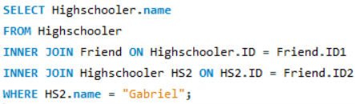

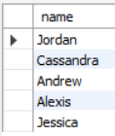

1. For every student who likes someone 2 or more grades younger than themselves, return that student's name and grade, and the name and grade of the student they like.

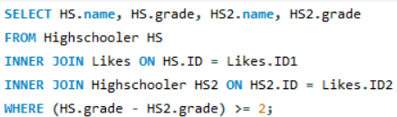



1. For every pair of students who both like each other, return the name and grade of both students. Include each pair only once, with the two names in alphabetical order.



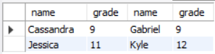

1. Find all students who do not appear in the Likes table (as a student who likes or is liked) and return their names and grades. Sort by grade, then by name within each grade.

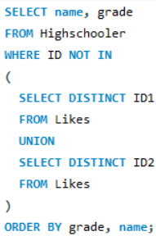

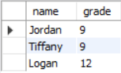

1. For every situation where student A likes student B, but we have no information about whom B likes (that is, B does not appear as an ID1 in the Likes table), return A and B's names and grades.

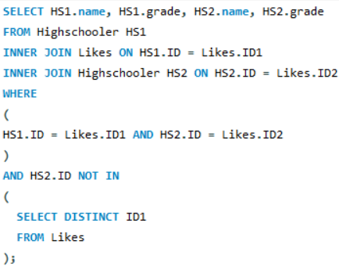

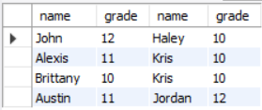

1. Find names and grades of students who only have friends in the same grade. Return the result sorted by grade, then by name within each grade.

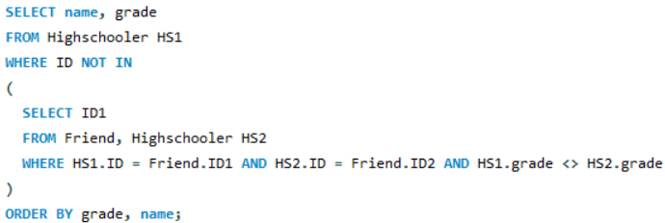

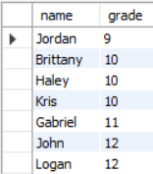

1. For each student A who likes a student B where the two are not friends, find if they have a friend C in common (who can introduce them!). For all such trios, return the name and grade of A, B, and C.

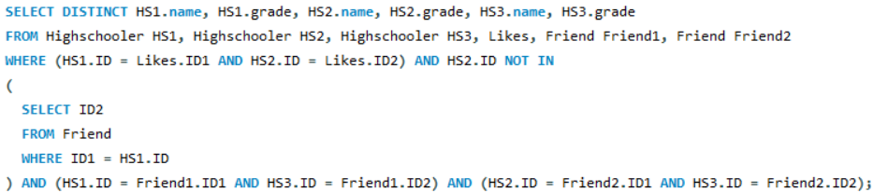

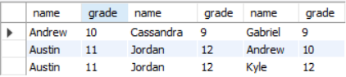

1. Find the difference between the number of students in the school and the number of different first names.



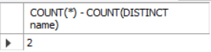

1. Find the name and grade of all students who are liked by more than one other student.

